This text was adapted by The Saylor Foundation under a Creative Commons Attribution-NonCommercial-ShareAlike 3.0 License without attribution as requested by the work’s original creator or licensee.

Preface
Our text is a comprehensive introduction to the vital subject of American government and politics. Governments decide who gets what, when, how (See Harold D. Lasswell, Politics: Who Gets What, When, How, [New York: McGraw-Hill, 1936]); they make policies and pass laws that are binding on all a society’s members; they decide about taxation and spending, benefits and costs, even life and death.
Governments possess power—the ability to gain compliance and to get people under their jurisdiction to obey them—and they may exercise their power by using the police and military to enforce their decisions. However, power need not involve the exercise of force or compulsion; people often obey because they think it is in their interest to do so, they have no reason to disobey, or they fear punishment. Above all, people obey their government because it hasauthority; its power is seen by people as rightfully held, as legitimate. People can grant their government legitimacy because they have been socialized to do so; because there are processes, such as elections, that enable them to choose and change their rulers; and because they believe that their governing institutions operate justly.
Politics is the process by which leaders are selected and policy decisions are made and executed. It involves people and groups, both inside and outside of government, engaged in deliberation and debate, disagreement and conflict, cooperation and consensus, and power struggles.
In covering American government and politics, our text
- introduces the intricacies of the Constitution, the complexities of federalism, the meanings of civil liberties, and the conflicts over civil rights;
- explains how people are socialized to politics, acquire and express opinions, and participate in political life;
- describes interest groups, political parties, and elections—the intermediaries that link people to government and politics;
- details the branches of government and how they operate; and
- shows how policies are made and affect people’s lives.

A Media Approach
Appreciating and learning these subjects can be a challenge. Inspired by students’ familiarity with mass media and their fluent use of new communication technologies, such as YouTube, Facebook, Twitter, live streaming, and the iPad, we have chosen an approach that connects our subject matter with these media and technologies.
Many students acquire political information from the dramatic and dynamic news cycle with its twenty-four-hours-a-day, seven-days-a-week coverage of events. More and more students obtain news online, including from the websites of mainstream news organizations such as the New York Times and CNN. But the web also provides them with information that repeats, amplifies, challenges, or even contradicts the news they get from the mainstream media.
Many students connect with government and politics through media entertainment. They watch The Daily Show with Jon Stewart, The Colbert Report, and the late-night television talk shows of Jay Leno, David Letterman, and Conan O’Brien. They tune in to television and radio commentators such as Glenn Beck, Bill O’Reilly, Rachel Maddow, and Rush Limbaugh. They watch television competitions, reality shows, dramas, and comedies, most of which have political aspects. They may have seen one or more of Michael Moore’s polemical documentaries (e.g., Fahrenheit 9/11), or a movie about social issues, such as Crash. They may have listened to music with political messages, for example Lee Greenwood’s Proud to be an American and Bruce Springsteen’s Born in the USA. They may read the satirical newspaper The Onion.
Although most political information still originates in the mainstream media—newspapers, magazines, television, radio, and movies—even these media are being transformed by new forms of communication. Information can now be transmitted much more quickly and subjected to far more individual control, initiative, and choice than ever before. Digital technologies support new media formats, such as blogs, podcasts, and wikis, which blend interpersonal with mass communication, through e-mail and instant messaging.
Yet students are often unfamiliar with the causes of the media’s contents, especially the importance of ownership, profits, and professionalism. They may not fully grasp the influence on the media of outside forces, such as interest groups, political parties and candidates, and policymakers, most of whom are media savvy and use the new technologies to try to maximize their positive and minimize their negative coverage.
We have therefore organized our text to connect students’ media-saturated daily lives to the world of politics and government. We want students to learn how the media interact with and depict the American political system; to recognize the similarities and differences between these media depictions and the real world of government and politics; and to understand the consequences these interactions and depictions can have for the public, politics, government, and public policies. We want students to learn how the media, including new media, can help them intervene productively in politics and get things done.

Incorporating the Media

We devote Chapter 1 "Communication in the Information Age" to detailing the system of communication, the organization of media, and the transmission of information in the United States. Then we integrate relevant mass media and new-media material throughout every chapter.
Each chapter opens with an anecdote that ties media to the particular institution, process, or policy area under study. For example, Chapter 4 "Civil Liberties" starts by showing how the television reality show Cops depicts the police as working effectively to stop crime but downplays the civil liberties of individuals, including the rights of the accused.
Each chapter presents the most common media depictions of its subject. In some chapters, a few depictions dominate: most news coverage portrays the US Supreme Court and its decisions as above politics (except when the president has nominated a new member); and the entertainment media depict the judicial system unrealistically. In other chapters, depictions are split. For example, inChapter 4 "Civil Liberties", we see that journalists’ diligent defense of the civil liberties that are central to their job does not carry through to their stories about crime or war.

Boxes

Each chapter contains two boxes designed to reveal how the media are involved in and influence politics.
The “Enduring Image” box captures a chapter’s subject visually. Instantly recognizable, these images are part of our media-induced collective memory of government and politics. Each box explains the original meaning of the image, why it was so important, and its contemporary relevance. For example, the enduring image in Chapter 8 "Participation, Voting, and Social Movements" is of Dr. Martin Luther King Jr. making his “I Have a Dream” speech from the steps of the Lincoln Memorial to the vast crowd participating in the March on Washington for Jobs and Freedom in August 1963, at the height of the civil rights movement.
The media do not simply hold a mirror up to political reality. A “Comparing Content” box presents differences among media depictions of a subject. The box may compare a political event to reports about it in the news, compare depictions of the same political event in various media outlets, or compare changes in media depictions over time. For example, the content-comparison box in Chapter 11 "Campaigns and Elections" shows how and explains why portrayals of candidates in fiction and documentary films are dramatically different.

Interactions and Effects

Within each chapter, we cover the interactions between people in the media and those involved in politics and government—specifically in the institutions, processes, or policy areas described in that chapter. These interactions help explain why some depictions are more common in the media than others. Thus in Chapter 13 "The Presidency" we describe how the media, particularly the White House press corps, are organized to report on the presidency. Then we discuss how presidents and their staff devise and deploy communication strategies and tactics to try to manage the media to obtain positive coverage.
We then identify the probable results of these interactions and depictions. For example, in Chapter 11 "Campaigns and Elections", we discuss their effects on the election prospects of the presidential candidates.

Pedagogical Aids and Supplements
Each section of every chapter includes learning objectives, key takeaways, and key terms. These specify what material in that chapter is critical, both when read the first time and when reviewed.
For those students who want to explore a particular topic further, each chapter includes an annotated set of readings, an annotated list of noteworthy fiction and nonfiction films, and other visuals that depict the chapter’s subject.
Each chapter also contains photographs, tables, and figures that we use to further our discussion. Captions explain each one’s political meaning. We include links to video and audio clips, political and media websites, and research databases to further enrich the teaching and learning experience.

What Our Text Does and Does Not Do
Our text is a comprehensive introduction to American politics and government; it covers all the basics. Then it goes beyond the basics to explain how and why, in this information age, government and politics are most commonly depicted in the media.
In each chapter, we compare the reality of American government and politics with the media’s most common depictions (acknowledging that there are differences between and among the media and in their political content). We show that the depictions range from accurate and revealing to inaccurate and misleading. We distinguish the telling accounts and insights from partial truths, false impressions, and distortions.
We do not inflate the importance of the media. We recognize that much of politics and government occurs under the media’s radar screen and that the consequences of the media’s coverage vary widely.
We avoid the temptation of gee-whiz utopian celebrations of new technologies. Rather, we discuss their possibilities, their limitations, and their dangers: they can and do lower the costs of political activity and organization but do not necessarily turn people into thoughtful, full-fledged activists.
Finally, we recognize that people variously accept, ignore, reject, or rework the media’s contents. Above all, in today’s information age, they are able to hash and rehash the meaning and impact of what is covered and not covered in the media.

Our Concern for Civic Education
One of our goals in writing this book is to encourage students to participate in civic life. In appropriate chapters, we add a “Civic Education” box showing how young people have become involved in politics, government, and the making of public policies, as well as how the media, old and new, can help and hinder civic work.
We hope that our students will come to understand, appreciate, question, and criticize the realities of American politics and government and the media depictions of these realities. We also hope that they will learn how to use the media to intervene effectively in the American political system on their own terms.

The Plan of the Book
Chapter 1 "Communication in the Information Age" describes the communication system of the United States; accounts for its contents of news, entertainment, and opinion; discusses how people in politics and government interact with and respond to the media; and considers the importance of the new media.
Chapter 2 "The Constitution and the Structure of Government Power" covers the foundations and structures of authority established by the US Constitution in 1789. We explain the origin, contents, development, and contemporary importance of the Constitution, noting that while American society has changed greatly in the last two centuries, the political system established by the Constitution still underlies and determines much of American government and politics. Next, in Chapter 3 "Federalism", we describe American federalism and its complex interweaving of national, state, and local governments. Chapter 4 "Civil Liberties" and Chapter 5 "Civil Rights" cover the conflicts and disputes, debates, and decisions over the constitutional provisions establishing Americans’ liberties and the right to be free of discrimination. Throughout this first part of the book, we show that the US communication system is intimately linked to, and has often buttressed, these foundations of American government and politics.
The following part of the book focuses on the public. Chapter 6 "Political Culture and Socialization" describes American political culture and how Americans acquire their politically relevant values, beliefs, attitudes, and opinions. Chapter 7 "Public Opinion" covers public opinion. Chapter 8 "Participation, Voting, and Social Movements" describes the many ways that Americans participate in politics. These chapters explain how and when the media are and are not a resource for the public in making sense of and influencing politics and government.
The third part of the book describes the three intermediaries—interest groups (Chapter 9 "Interest Groups"), political parties (Chapter 10 "Polritical Parties"), and campaigns and elections (Chapter 11 "Campaigns and Elections")—that connect the people to government and also link officials within government. Participants in these intermediaries often rely heavily on the media for much of their information, while also seeking to avoid media coverage of their less appealing activities.
The penultimate part of the book examines the central institutions of the federal government—Congress (Chapter 12 "Congress"), the presidency (Chapter 13 "The Presidency"), the federal bureaucracy (Chapter 14 "The Bureaucracy"), and the federal judicial system (Chapter 15 "The Courts")—taking them in order of their appearance in the Constitution. People in these institutions spend considerable time, energy, and resources in dealing with the media, although the ways in which they do so vary depending on their responsibilities and powers and on the media’s highly uneven interest in their actions.
The book’s final part brings all of these strands together to analyze policymaking and the contents of public policies. Chapter 16 "Policymaking and Domestic Policies" describes the policymaking process and looks at social and economic policies. Chapter 17 "Foreign and National Security Policies" is concerned with foreign and defense policies. We show where the media have, and have not, been influential in shaping policy outcomes in the United States.
Our ultimate goal is for students to increase their knowledge of the people, processes, institutions, and policies that make up the American political system; to become more aware of the influence and political effects of the old and new media; and to understand how they, as members of the public, can participate in politics.

Chapter 1

Communication in the Information Age

Preamble
On the evening of April 2, 2003, the television networks’ nightly news aired a brief night-vision video, supplied by the Defense Department, of US forces carrying Private Jessica Lynch to safety after rescuing her from behind enemy lines in Iraq. The next day, in an exclusive on its front page that read like a Hollywood screenplay outline, the Washington Post reported her heroic story. Written from Washington, DC, and based on information supplied by unnamed officials, it told how, after “fighting to the death” and shooting several enemy soldiers, the young maintenance clerk was seriously wounded, captured, and taken to an enemy hospital. A few days later she was daringly rescued by US commandos. ^{[1]} The story echoed through the broadcasting and print news media in the United States, throughout the world, and on the web. The television networks’ morning news shows sent reporters to West Virginia to interview Lynch’s family and friends. A website was established to receive and share tributes to her gallantry and feats. ^{[2]}
Although the Post’s report mentioned that the story had yet to be confirmed, the Pentagon reaped favorable publicity for the war with this tale of a Rambo-type exploit by an ordinary American girl in the battle against tyranny. This frame, or point of view, was widely used in many accounts of the event. (We explain frames and framing in detail in the section “Media Influences on Politics, Government, and Public Policies” in Section 1.3 "Opinion and Commentary").
Media companies bargained for the rights to Private Lynch’s story. Viacom offered her a package: a prime-time news interview on its CBS television network; a book deal with its publishing house, Simon and Schuster; a music-video host spot on its cable channel MTV2; and a movie contract. ^{[3]} Eventually she signed with NBC, which had indicated that it was going to make a TV movie about her whether it had the rights to her story or not. NBC aired its made-for-TV movie Saving Jessica Lynch soon after the Veteran’s Day publication of a book about her ordeal written by a former New York Times reporter with whom she split a $1 million advance. ^{[4]} Promoting the book, Ms. Lynch appeared on ABC’s Primetime Live for an interview with Diane Sawyer, NBC’s Today Show, the CBS Late Show with David Letterman, and on CNN’s Larry King Live. She was the subject of a cover story in Time magazine and was featured in Glamourmagazine as one of its women of the year.
Accounts in both mass and new media, statements by Private Lynch herself, and a commentary by the Post’s ombudsman (the individual at the newspaper charged with evaluating its stories) almost three months after the original story, indicated that the facts, to the extent they could be verified, were far less heroic.^{[5]} Lynch’s gun had jammed and not been fired. She did not fight or shoot at any enemy soldiers. The rescue may not have been necessary because the Iraqi army had fled from the hospital the previous day, although it probably still controlled the town. Hospital staff had escorted the commandos to her ward. Blogs dissecting and arguing about the media’s rethinking mushroomed. Over two years after the initial event, a former deputy commander at the United States Central Command wrote an op-ed column in the New York Timesreminding people that Private Lynch had never claimed to be a hero and denying that the military had played up her rescue for its publicity purposes. ^{[6]}
The Jessica Lynch story graphically reveals the interconnection of communication, information, and the media, as well as their significance for government and politics. These are the subjects of this chapter.

[1] Susan Schmidt and Vernon Loeb, “‘She Was Fighting to the Death’; Details Emerging of W. V. Soldier’s Capture and Rescue,” Washington Post, April 3, 2003, A1.
[2] Scott Drake, webmaster of Jessica-Lynch.com, e-mail to Tim Cook, March 6, 2005.
[3] Jim Rutenberg, “To Interview Former P.O.W., CBS Offers Stardom,” New York Times, June 16, 2003, A1.
[4] Rick Bragg, I Am a Soldier, Too: The Jessica Lynch Story (New York: Alfred A. Knopf, 2003).
[5] Dana Priest, William Booth, and Susan Schmidt, “A Broken Body, a Broken Story, Pieced Together…,” Washington Post, June 17, 2003, A1 and Michael Getler, “A Long, and Incomplete, Correction,” Washington Post, June 29, 2003, B6.
[6] Michael DeLong, “Politics During Wartime,” New York Times, April 27, 2007, A7.

1.1 Communication, Information, and the Media

LEARNING OBJECTIVES
After reading this section, you should be able to answer the following questions:
- What are communication, information, and mass and new media?
- How do economics, government and politics, and technology shape the media and their contents?
- What are the main criticisms directed at the media industry?
- What are the types of mass media?
Communication is a central activity of everyone engaged in politics—people asserting, arguing, deliberating, and contacting public officials; candidates seeking to win votes; lobbyists pressuring policymakers; presidents appealing to the public, cajoling Congress, addressing the leaders and people of other countries. All this communication sparks more communication, actions, and reactions.
What people communicate is information about subjects and events, people and processes. ^{[1]} It can be true or false, fiction or nonfiction, believable or not. We define it broadly to encompass entertainment, news, opinion, and commentary.
The bulk of information that Americans obtain about politics and government comes through the mass and new media. Mass media are well-established communication formats, such as newspapers and magazines, network television and radio stations, designed to reach large audiences. Mass media also encompass entertainment fare, such as studio films, best-selling books, and hit music.
New media are forms of electronic communication made possible by computer and digital technologies. They include the Internet, the World Wide Web, digital video cameras, cellular telephones, and cable and satellite television and radio. They enable quick, interactive, targeted, and potentially democratic communication, such as social media, blogs, podcasts, websites, wikis, instant messaging, and e-mail.
The media, old and new, are central to American politics and government in three ways that we highlight throughout this book. First, they depict the people, institutions, processes, issues, and policies involved in politics and government. Second, the way in which participants in government and politics interact with the media influences the way in which the media depict them. Third, the media’s depictions can have effects.

Economics, Government and Politics, and Technology
Three interrelated factors are central to the development of the US media industry and its political contents. They are economics, government and politics, and technology.
We start with economics. Journalist A. J. Liebling wrote, “The function of the press…is to inform, but its role is to make money.” ^{[2]} Even when profit is not the motive, the media need financing to survive. The commercial media rely on advertising, sales, and subscriptions, and so the content of their diverse products is aimed at attracting audiences desirable to advertisers. Unlike other countries, the United States has no media primarily financed by government.
Government is involved with the media as a regulator, censor, and enabler. Regulation often involves decisions on technology: the Federal Communications Commission (FCC) has given away approximately $70 billion worth of digital spectrum, the wireless airwaves that carry television and radio broadcasts, to major media companies. Government censors by restricting content it deems obscene or by punishing media for producing such content. Government enables when, for example, it waives the antitrust laws for media companies or subsidizes and thus lowers the postage costs for mailing newspapers and magazines.
Technological innovation can change media economics, relations with politicians and government, and the media’s political contents. Thus the development of television made it easier for candidates to communicate directly with voters and temporarily reduced the importance of political parties in elections.
Economics, government, and technology interact. The degree to which a technology influences politics depends on the way in which the technology is used. This in turn is shaped by the economic realities of the marketplace and by government policies concerning who can use a medium and for what purpose. Although the technology of television, even before cable, could have allowed for multiple and diverse channels, the economic search for a big audience to attract advertising revenue, paired with government regulation that favored private for-profit ownership, created the “three-network system” that endured until the 1980s. This system provided airtime for presidents to present their programs to a huge national audience. When cable television offered more alternatives for viewers, it became harder for presidents to be heard above the clamor of competing programs—a difficulty furthered by the emergence of new media.

The Media Industry
A few multinational conglomerates dominate the mass media; indeed, they are global media empires. Between them, they own the main television networks and production companies, most of the popular cable channels, the major movie studios, magazines, book publishers, and the top recording companies, and they have significant ownership interests in Internet media. Other large corporations own the vast majority of newspapers, major magazines, television and radio stations, and cable systems. Many people live in places that have one newspaper, one cable-system owner, few radio formats, and one bookstore selling mainly best sellers. ^{[3]} Furthering consolidation, in January 2011 the Federal Communications Commission (FCC) approved the merger of Comcast, the nation’s largest cable and home Internet provider, with NBC Universal, one of the major producers of television shows and movies and the owner of several local stations as well as such lucrative cable channels as MSNBC, CNBC, USA, Bravo, and SyFy.
Some scholars criticize the media industry for pursuing profits and focusing on the bottom line. They accuse it of failing to cover government and public affairs in depth and of not presenting a wide range of views on policy issues. ^{[4]}
The reliance of most of the mass media on advertising as their main source of revenue and profit can discourage them from giving prominence to challenging social and political issues and critical views. Advertisers usually want cheery contexts for their messages.
Nonetheless, the mass media contain abundant information about politics, government, and public policies. Here is the essential information about the main types of mass media and their political contents.

Newspapers
The core of the mass media of the departed twentieth century was the newspaper. Even now, newspapers originate the overwhelming majority of domestic and foreign news.
During recent years, sales have plummeted as many people have given up or, as with the young, never acquired the newspaper habit. Further cutting into sales are newspapers’ free online versions. Revenue from advertising (automotive, employment, and real estate) has also drastically declined, with classified ads moving to Craigslist and specialist job-search sites. As a result, newspapers have slashed staff, closed foreign and domestic bureaus (including in Washington, DC), reduced reporting, and shrunk in size.
Nonetheless, there are still around 1,400 daily newspapers in the United States with estimated combined daily circulations of roughly forty million; many more millions read the news online. Chains of newspapers owned by corporations account for over 80 percent of circulation.
A few newspapers, notably the Wall Street Journal (2.1 million), USA Today (1.8 million), and the New York Times (877,000), are available nationwide.
The Wall Street Journal, although it has erected a pay wall around its Internet content, claims an electronic readership of 450,000. Its success suggests that in the future some newspapers may go completely online—thus reducing much of their production and distribution costs.
Most newspapers, including thousands of weeklies, are aimed at local communities. But after losing advertising revenue, their coverage is less comprehensive. They are being challenged by digital versions of local newspapers, such as AOL’s Patch.com. ^{[5]} It has seven hundred sites, each in an affluent community, in nineteen states and the District of Columbia. AOL has hired journalists and equipped each of them with a laptop computer, digital camera, cell phone, and police scanner to publish up to five items of community news daily. Some of their stories have achieved prominence, as, for example, a 2009 report about the hazing of high school freshmen in Millburn, New Jersey. But the most popular posts are about the police, schools, and local sports; and “often the sites are like digital Yellow Pages.” ^{[6]}

Magazines
There are roughly five thousand magazines published on every conceivable subject. Five publishers account for around one-third of the total revenue generated. Political and social issues are commonly covered in news weeklies such as Time and also appear in popular magazines such as People and Vanity Fair.
To survive, journals of political opinion usually depend on subsidies from wealthy individuals who support their views. The Weekly Standard, the voice of Republican neoconservatives and one of the most influential publications in Washington, with a circulation of approximately 75,000, loses around $5 million annually. It was initially owned and funded by media mogul Rupert Murdoch’s News Corporation, which makes big profits elsewhere through its diverse holdings, such as Fox News and the Wall Street Journal. In 2009, it sold the Weekly Standard to the conservative Clarity Media Group.

Television
People watch an average of thirty-four hours of television weekly. Over one thousand commercial, for-profit television stations in the United States broadcast over the airwaves; they also are carried, as required by federal law, by local cable providers. Most of them are affiliated with or, in fewer cases, owned by one of the networks (ABC, CBS, NBC, and Fox), which provide the bulk of their programming. These networks produce news, public affairs, and sports programs.
They commission and finance from production companies, many of which they own, the bulk of the entertainment programming shown on their stations and affiliates. The most desired viewers are between eighteen and forty-nine because advertisements are directed at them. So the shows often follow standard formats with recurring characters: situation comedies, dramas about police officers and investigators, and doctors and lawyers, as well as romance, dance, singing, and other competitions. Sometimes they are spin-offs from programs that have done well in the audience ratings or copies of successful shows from the United Kingdom. “Reality” programming, heavily edited and sometimes scripted, of real people put into staged situations or caught unaware, has become common because it draws an audience and usually costs less to make than written shows. The highest-rated telecasts are usually football games, exceeded only by the Academy Awards.
Unusual and risky programs are put on the air by networks and channels that may be doing poorly in the ratings and are willing to try something out of the ordinary to attract viewers. Executives at the relatively new Fox network commissioned The Simpsons. Matt Groening, its creator, has identified the show’s political message this way: “Figures of authority might not always have your best interests at heart.…Entertain and subvert, that’s my motto.” ^{[7]} The show, satirizing American family life, government, politics, and the media, has become one of television’s longest running and most popular series worldwide.
Cable is mainly a niche medium. Of the ninety or so ad-supported cable channels, ten (including USA, TNT, Fox News, A&E, and ESPN) have almost a third of all the viewers. Other channels occasionally attract audiences through programs that are notable (Mad Men on American Movie Classics) or notorious (Jersey Shore on MTV). Cable channels thrive (or at least survive) financially because they receive subscriber fees from cable companies such as Comcast and Time-Warner.
The networks still have the biggest audiences—the smallest of them (NBC) had more than twice as many viewers as the largest basic cable channel, USA. The networks’ evening news programs have an audience of 23 million per night compared with the 2.6 million of cable news.
Politics and government appear not only on television in news and public-affairs programs but also in courtroom dramas and cop shows. In the long-running and top-rated television show (with an audience of 21.93 million viewers on January 11, 2011), NCIS (Naval Criminal Investigative Service), a team of attractive special agents conduct criminal investigations. The show features technology, sex, villains, and suspense. The investigators and their institutions are usually portrayed positively.

Public Broadcasting
The Corporation for Public Broadcasting (CPB) was created by the federal government in 1967 as a private, nonprofit corporation to oversee the development of public television and radio. ^{[8]} CPB receives an annual allocation from Congress. Most of the funds are funneled to the more than three hundred public television stations of the Public Broadcasting Service (PBS) and to over six hundred public radio stations, most affiliated with National Public Radio (NPR), to cover operating costs and the production and purchase of programs.
CPB’s board members are appointed by the president, making public television and radio vulnerable or at least sensitive to the expectations of the incumbent administration. Congress sometimes charges the CPB to review programs for objectivity, balance, or fairness and to fund additional programs to correct alleged imbalances in views expressed. ^{[9]} Conservatives charge public broadcasting with a liberal bias. In 2011 the Republican majority in the House of Representatives sought to withdraw its federal government funding.
About half of public broadcasting stations’ budgets come from viewers and listeners, usually responding to unremitting on-air appeals. Other funding comes from state and local governments, from state colleges and universities housing many of the stations, and from foundations.
Corporations and local businesses underwrite programs in return for on-air acknowledgments akin to advertisements for their image and products. Their decisions on whether or not to underwrite a show tend to favor politically innocuous over provocative programs. Public television and radio thus face similar pressure from advertisers as their for-profit counterparts.
Public broadcasting delves into politics, particularly with its evening news programs and documentaries in its Frontline series. National Public Radio, with an audience of around twenty-seven million listeners weekly, broadcasts lengthy news programs during the morning and evening with reports from domestic and foreign bureaus. NPR has several call-in current-events programs, such as The Diane Rehm Show. Guests from a spectrum of cultural life are interviewed by Terry Gross on her program Fresh Air. On the Media analyzes the news business in all its aspects; and Ira Glass’s This American Life features distinctive individuals delving into important issues and quirky subjects. Most of these programs are available via podcast from iTunes. Public Radio Exchange, PRX.org, has an abundance of programs from independent producers and local NPR stations.

Commercial Radio
Around ten thousand commercial FM and AM radio stations in the United States broadcast over the airwaves. During the 1990s, Congress and the Federal Communications Commission (FCC) dropped many restrictions on ownership and essentially abandoned the requirement that stations must serve the “public interest.” This led to the demise of much public affairs programming and to a frenzy of mergers and acquisitions. Clear Channel Communications, then the nation’s largest owner, bought the second largest company, increasing its ownership to roughly 1,150 stations. The company was sold in 2008 to two private equity firms.
Most radio programming is aimed at an audience based on musical preference, racial or ethnic background and language, and interests (e.g., sports). Much of the news programming is supplied by a single company, Westwood One, a subsidiary of media conglomerate Viacom. Even on all-news stations, the reports are usually limited to headlines and brief details. Talk radio, dominated by conservative hosts, reaches large audiences. We discuss it in more detail inSection 1.3 "Opinion and Commentary".

Music
Four major companies produce, package, publicize, advertise, promote, and merchandise roughly 5,000 singles and 2,500 compact discs (CDs) each year. A key to success is getting a music video on MTV or similar stations. Around twelve million CDs used to be sold nationwide every week. This number has significantly decreased. The companies and performers now make music that is cheaply available online through services such as Apple’s iTunes store. Many people, especially students, download music from the Internet or burn CDs for themselves and others.
Music often contains political content. Contrast Green Day’s scathing 2005 hit song “American Idiot” and its lyric “One nation controlled by the media” with Lee Greenwood’s patriotic “God Bless the USA.” Some rap lyrics celebrate capitalism and consumerism, promote violence against women, and endorse—or even advocate—attacks on the police and other authority figures.

Films
The movie business is dominated by six major studios, which finance and distribute around 130 feature films each year. Mass-market logic usually pushes them to seek stories that “are sufficiently original that the audience will not feel it has already seen the movie, yet similar enough to past hits not to be too far out.” ^{[10]} Superheroes, science fiction and fantasy, sophomoric comedies, and animation dominate. Sequels are frequent. Special effects are common. In Robert Altman’s satire The Player, the protagonist says that the “certain elements” he needs to market a film successfully are violence, suspense, laughter, hope, heart, nudity, sex, and a happy ending.
It can cost well over $100 million to produce, advertise, and distribute a film to theaters. These costs are more or less recouped by US and overseas box office sales, DVD sales (declining) and rentals, revenue from selling broadcast rights to television, subscription cable, video on demand, and funds received from promoting products in the films (product placement). Increasingly important are Netflix and its competitors, which for a monthly charge make movies available by mail or streaming.
Many independent films are made, but few of them are distributed to theaters and even fewer seen by audiences. This situation is being changed by companies, such as Snag Films, that specialize in digital distribution and video on demand (including over the iPad). ^{[11]}
It is said in Hollywood that “politics is box office poison.” The financial failure of films concerned with US involvement in Iraq, such as In the Valley of Elah, appears to confirm this axiom. Nonetheless, the major studios and independents do sometimes make politically relevant movies. We refer to many of them in this book and provide a list at the end of each chapter. The five nominees for the 2005 Oscar for best picture all contained political content—Brokeback Mountain (homosexuality), Capote (a fiction writer’s complex relationship to two murderers he befriends and writes about), Crash (racial tension in Los Angeles), Good Night and Good Luck (CBS’s response to the Red Scare of the early 1950s), and Munich (Israeli–Palestinian relations).

Books
Some 100,000 books are published annually. About “seventy percent of them will not earn back the money that their authors have been advanced.” ^{[12]} There are literally hundreds of publishers, but six produce 60 percent of all books sold in the United States. Publishers’ income comes mainly from sales. A few famous authors command multimillion-dollar advances: President Bill Clinton received more than $10 million and President Bush around $7 million to write their memoirs.
E-books are beginning to boom. The advantage for readers is obtaining the book cheaper and quicker than by mail or from a bookstore. For publishers, there are no more costs for printing, shipping, warehousing, and returns. But digital books could destroy bookstores if, for example, publishers sold them directly to the iPad. Indeed, publishers themselves could be eliminated if authors sold their rights to (say) Amazon.
Books featuring political revelations often receive widespread coverage in the rest of the media. They are excerpted in magazines and newspapers. Their authors appear on television and radio programs. An example is President George W. Bush’s former press secretary Scott McClellan, who, while praising the president in his memoir as authentic and sincere, also accused him of lacking in candor and competence. ^{[13]}

KEY TAKEAWAYS
The subjects of this section are communication, information, and the media. We have explained how economics, government and politics, and technology shape the media and their contents. Market domination by a few conglomerates limits competition and, arguably, the wide availability and range of media contents. The main types of mass media are newspapers, magazines, television, public broadcasting, commercial radio, music, films, and books. Their contents relevant to politics and government are entertainment, news, and opinion. They are largely aimed at a vast, undifferentiated audience.

EXERCISES
- Where do you get most of your information? How do you think the type of media you consume affects the kind of information you get?
- How does the need to attract a large audience for advertisements influence media content?

[1] This section draws on Bruce Bimber, Information and American Democracy: Technology in the Evolution of Political Power (New York: Cambridge University Press, 2003), especially 9–12.
[2] A. J. Liebling, The Press (New York: Ballantine, 1964), 7.
[3] C. Edwin Baker argues for the importance of media diversity in Media Concentration and Democracy: Why Ownership Matters (New York: Cambridge University Press, 2007).
[4] Ben H. Bagdikian, The New Media Monopoly (Boston: Beacon Press, 2004).
[5] Verne G. Kopytoff, “AOL Bets on Hyperlocal News, Finding Progress Where Many Have Failed,” New York Times, January 17, 2011, B3.
[6] Ken Auletta, “You’ve Got News,” The New Yorker, January 24, 2011, 33.
[7] Quoted in Sanjiv Bhattacharya, “Homer’s Odyssey,” Observer Magazine, August 6, 2000, 19.
[8] William Hoynes, Public Television for Sale (Boulder, CO: Westview Press, 1994); and Marilyn Lashley, Public Television (New York: Greenwood, 1992).
[9] Twentieth-Century Fund Task Force on Public Television, Quality Time (New York: Twentieth-Century Fund Press, 1993), 36.
[10] Mark Litwak, Reel Power (New York: Morrow, 1986), 74.
[11] Michael Cieply, “A Digital Niche for Indie Film,” New York Times, January 17, 2011, B5.
[12] Ken Auletta, “Publish or Perish,” The New Yorker, April 26, 2010, 24–31, is the source for much of this discussion; the quotation is on p. 30.
[13] Scott McClellan, What Happened: Inside the Bush White House and Washington’s Culture of Deception (New York: Public Affairs, 2008).

1.2 News

LEARNING OBJECTIVES
After reading this section, you should be able to answer the following questions:
- What is news?
- What is objectivity?
- How do journalists acquire the news?
- How is the news presented?
- How do people in public life try to influence their depictions by and in the media?
- What are three common ways journalists cover people in public life?
Information about or relevant to politics, government, and public policies commonly appears in the mass media in the form of news. News is a selective account of what happens in the world. Common subjects are violence (wars), crime (school shootings), natural disasters (earthquakes, hurricanes), and scandals (sexual, financial). The statements and actions of powerful or prominent people are news. So are human interest stories, such as the rescue of Private Jessica Lynch.
News is timely, a breaking event, like an assassination attempt on a president. Or newly revealed information, such as a presidential candidate’s drunk-driving conviction, even if it happened years ago. Slow-moving processes that may be of vital importance (e.g., the spread of AIDS or global warming) take time to become news, often requiring a “peg”—the release of an alarmist study, a congressional hearing, or presidential speech—on which to hang the story.

Journalists
News is reported by journalists. They work under time pressure with tight deadlines to come up with stories around the clock. This job has become more difficult in recent years as budget cuts have led news organizations to demand more stories for more outlets from fewer reporters.
A majority of journalists are white, middle class, middle-aged, and male. Women now compose about one-third of the press corps and racial minorities around one-tenth. In a survey, 36 percent identified themselves as Democrats, 33 percent as Independents, and 18 percent as Republicans. ^{[1]} Reporters tend to be pro-choice, for gay rights, and in favor of protecting the environment. But they try to refrain from showing their preferences in their stories.
Any influence of reporters’ characteristics and opinions on their stories is limited by the norms of objectivity they learn in journalism school or on the job. Specified in the profession’s code of ethics, these include reporting accurate information, not deliberately distorting or plagiarizing, and separating reporting from advocacy. ^{[2]} Journalists are expected to report different sides of an issue, be impartial and fair, and exclude their personal opinions. ^{[3]}
If they are found out, journalists who deliberately and blatantly violate the profession’s ethics are punished. New York Times reporter Jayson Blair was dismissed after it was discovered that he had fabricated or plagiarized around forty of the six hundred articles he had written for the paper; editors resigned in the wake of the discoveries. Jack Kelly was the star foreign correspondent forUSA Today and had worked for the paper for over twenty years when he resigned in January 2004, accused of plagiarism and of inventing parts or all of some of his stories.

Comparing Content
Depictions of Journalists
Many of our impressions of journalists, their behavior, importance, and trustworthiness come from the media. ^{[4]} Media depictions repeat two types best captured in the classic film His Girl Friday: reporter Hildy Johnson (Rosalind Russell) and her editor Walter Burns (Cary Grant).
The first type exemplified by Hildy is the journalist as intrepid seeker after truth and crusader for justice. The most famous real-life equivalents are Bob Woodward and Carl Bernstein, the Washington Post reporters who helped uncover the Watergate scandal and wrote a book about it, All the President’s Men, which was turned into a popular Hollywood movie. Even some caustic satires of the news business contain versions of the journalist as noble loner. In Network, Peter Finch plays a television news anchor who begins to go insane on camera, shouting “I’m mad as hell, and I’m not going to take it anymore.” In the movie, his pain and anguish are exploited by amoral network executives. In real life, his battle cry became the theme of citizens’ tax revolts in the late seventies and could be heard at Tea Party rallies thirty years later.
The second type of journalist, characterized by Walter Burns, is more common in the entertainment media. At their worst, as in Billy Wilder’s classic Ace in the Hole, such reporters cynically and callously exploit the disasters of the human condition. But even less bitter films show reporters as inevitably led astray from their devotion to the truth to the point that they destroy lives and reputations in their reckless search for an exclusive story ahead of other reporters (a scoop) that is dramatic and shocking. InAbsence of Malice, Sally Field plays a reporter who ends up besmirching a good man’s (Paul Newman) reputation. In Broadcast News, William Hurt and Albert Brooks compete to become a news anchor. Hurt—good-looking, smooth, unscrupulous, and none too bright—wins out over the dumpier, knowledgeable, and dedicated Brooks.
A contemporary example of the second type is Rita Skeeter. Introduced by J. K. Rowling in her vastly popular Harry Potter series, Skeeter writes for theDaily Prophet, Witch Weekly, and other publications. She is untrustworthy, unscrupulous, vindictive, and vile. She justifies her behavior with the motto “Our readers have a right to the truth.” But her news stories are error-strewn and full of lies. They destroy friendships, inflict pain and suffering, and deprive decent people of their jobs. Rita Skeeter gets scoops by turning herself into a bug. The moral is that such journalists are nasty bugs. ^{[5]}

Acquiring the News
Journalists follow standard procedures to obtain the news. They go to the scene, especially of wars and disasters. They talk to people who have participated in, witnessed, or claim to know what happened. They dig into records. Easing their job, many events, such as press conferences, trials, and elections, are scheduled ahead of time.

Beats
News organizations guarantee stories by assigning reporters to cover distinctbeats such as the White House or specific subjects such as environmental policy. Institutions and subjects not on reporters’ beats (off the beaten track, so to speak) generate few stories unless they do something to become newsworthy. Sometimes events thrust them into prominence, as when the banking crisis of 2008 raised questions about the regulatory effectiveness of the Securities and Exchange Commission.

Sources
Journalists interact with and rely extensively on sources—generally people in government and politics, especially those in high positions of authority—to provide them with scoops and quotations. Other sources are whistle-blowers, who reveal information they have about dubious activities, outrages, or scandals. Depending on their motives, sources either provide information openly and unreservedly or leak it subject to various conditions such as anonymity. ^{[6]}
Often the reporter-source relationship is symbiotic: they need each other. Reporters need sources for news. Sources need reporters to get their views and information into the news, to obtain favorable coverage.
Sometimes the relationship is adversarial, with reporters pressing a reluctant source for information. Sources must often respond to reporters’ ideas of what is news. Information from one beat may inspire a news story that another beat wants to keep quiet. Refusal to reveal information may result in negative coverage and in sources becoming targets in reporters’ and columnists’ stories.

Government Reports
Legislative committees, regulatory agencies, and governmental departments and commissions conduct investigations, hold hearings, and issue reports and press releases. Journalists sometimes draw on these sources for their stories. Typical is a New York Times’s front page story headlined “Terror Suspects Buying Firearms, Report Finds” (in the United States), based on an investigation by the Government Accountability Office. ^{[7]}

Investigative Reporting
Some journalists specialize in investigative reporting, pursuing information that may involve legal or ethical wrongdoing and that is likely to be concealed.^{[8]} This reporting requires detailed and thorough digging into a story. It is often time consuming and expensive. The New York Times, Washington Post, theNew Yorker, Rolling Stone, and Mother Jones are some of the publications that still engage in it, as do the nonprofit Center for Public Integrity, which in November 2010 absorbed the Huffington Post’s “Investigative Fund,” Pro-Publica, and the Center for Investigative Reporting. Examples of award-winning investigative stories include exposure of secret Central Intelligence Agency prisons in Eastern Europe, the torture of Iraqi prisoners by US forces, appalling care in veterans’ hospitals, and job-related deaths of Mexican workers in the United States.

News Services
The mass media rely on the wire services for much of their international and national news. Wire services cover and transmit stories worldwide from their own staff and from reporters who work for the many newspapers and other organizations that belong to the services. Prominent wire services are the Associated Press (AP) and Reuters. The AP sends news to approximately 1,700 newspapers, 5,000 radio and television stations, and 8,500 other media outlets in over 100 countries.
Video feeds supplied by the AP and Reuters are the source of much of the televised international news. Subscribers are sent video accompanied by natural sound without narration and brief printed informational scripts. Four of CBS’s eight foreign correspondents are based in London doing voice-overs for these feeds for broadcast on the network’s news programs.

Prominence and Presentation
As a result of widely agreed-upon criteria of newsworthiness, the process of gathering the news, and the use of news services, the news media often report many of the same stories. Only a few stories are featured prominently due to limitations in broadcast prime time and front-page print space.
Nonetheless, there are some differences among the media in the range and type of news on which they focus. For example, the New York Times, with its stable of reporters in Washington, DC, and foreign correspondents, emphasizes government and politics in the United States and abroad. Cable news channels focus more on crimes and celebrities. Aside from a few stories, such as the war in Iraq and natural disasters, they give short shrift to foreign stories. In fact, the Fox News Channel has a segment titled “Around the World in 80 Seconds.”
The media also differ stylistically in how they present the news. The Times does it with relative sobriety. Cable channels dramatize their reports by announcing “breaking news,” using graphic captions, accompanying stories with pulsating music, engaging in fast-paced editing, and repeatedly admonishing viewers to “stay with us.”
Television news is picture driven: stories with appealing, dramatic, or even available camera footage are more likely to be played prominently than those without. Viewers are unaware of what is not shown, what happened before or after the picture was taken, and whether or not the shot was staged. Camera angles, distance from the subject, especially close-ups, length of shot, camera movement, and editing all influence viewers’ impressions. A picture may be worth a thousand words, but it can also mislead, as reveals.

Enduring Image
The Overthrow of Saddam Hussein
The toppling of a dictator’s statue is an enduring image, symbolizing the literal collapse of a regime’s authority and the massive uprising and joy of a population freed at last from tyranny. On April 9, 2003, a US mechanized vehicle using a cable pulled down Saddam Hussein’s mammoth statue in Baghdad’s Firdos Square. The square was sealed off by US marines. The few people in it were US soldiers, Iraqis from the United States, promoted “Free Iraqi Forces Militia” (comprising exiles who had recently been returned to the country by the Pentagon), and journalists.
On television the statue falls, the crowd cheers. On the front pages of newspapers in the United States and around the world, the Reuters news-agency photograph shows the toppling of Saddam Hussein’s statue under the watchful eye of an American soldier. The images symbolize the US defeat of the dictator and his regime and the Iraqi people celebrating their newfound freedom. Wider shots of the square, revealing that only a handful of people were in the plaza, were far less common. ^{[9]}
News Reporting propaganda Baghdad Saddam Statue
The first photograph of the statue being pulled down reflects news values of vividness, drama, and conflict. It spectacularly hearkens back to the removal of statues of Lenin and Stalin after the collapse of communism in the Soviet Union. The alternative photos, showing much more of the relatively empty square, lacked dramatic news values and thus their symbolic effects.
Because the news media found the dramatic image to be irresistible, they reinforced a frame, pushed by the Bush administration, of a jubilant Iraqi population welcoming its liberators. But the meaning of an image can change. Now, for many people, the falling statue represents the illusion of a US military success that turned into a quagmire of frustration.

Interactions and Types of Coverage
As we document throughout our book, people involved in public life understand that their election and reelection, their effectiveness in elected and appointed office, and their ability to achieve their policies often depend on how they and their deliberations and debates, disagreements and conflicts, cooperation and consensus, actions and inactions, and struggles for power, are portrayed by the media. They know that media depictions can influence people’s opinions, understandings of policy problems and notions of solutions, and can encourage or discourage participation in politics.
They know that information is power. The more of it they have before others the better. They have aides who gather, synthesize, and summarize the news from newspapers and television, from talk shows, political publications (Roll Call andThe Hill), polls, websites, and blogs. ^{[10]} So they and their staff interact with media personnel to try to manage and manipulate the news and influence journalists’ selection of stories and how they are framed. They present (spin) their behavior, activities, and actions, and policies and decisions, as positively as possible; they conceal, minimize, or put the best gloss on their mistakes and blunders.
They engage in public appearances, make speeches, hold press conferences, and stage newsworthy events. They also deploy an arsenal of savvy techniques such as brief, pithy phrases known as sound bites. Behind the scenes they bestow favors, such as giving access to sympathetic journalists; persuade; apply pressure; and engage in intimidation. ^{[11]}
Despite these attempts at manipulation, the news media’s coverage of people in public life is not necessarily favorable. Three common types of coverage are lap-dog, watch-dog, and attack-dog journalism.

Lap Dogs
Journalists usually rely on policymakers as knowledgeable and convenient sources of information. Much news, therefore, consists of the debates about issues and policies among officials and politicians. Political scientist Lance Bennett and his colleagues call this indexing. The news media serve aslap dogs when the government’s perspective dominates. This can take place when leaders of the opposition party and other politicians do not continually criticize and challenge the government’s policies or do not articulate an alternative viewpoint to reporters to include in their stories. ^{[12]}
A notable example of the news media as lap dogs was their coverage of the Bush administration’s claims in 2002–2003 that Iraq must be attacked because it possessed weapons of mass destruction. Leaders of the Democratic Party did not forcefully challenge the White House’s official story, plans, and rationale. Most of the news media then transmitted the administration’s arguments without subjecting them to sustained analysis and criticism.

Watchdogs
The news media are sometimes watchdogs, holding people in government and other powerful institutions accountable by scrutinizing and reporting their statements, activities, claimed accomplishments, and failures. This type of coverage can be provoked by dramatic events, such as Hurricane Katrina, to which the Bush administration responded unconvincingly. Journalists went to the scene, saw the devastation and havoc for themselves, and showed it directly to viewers. Outraged reporters asked so many impassioned questions of administration officials about their inadequate response to Katrina that the Salon website compiled a “Reporters Gone Wild” video clip. ^{[13]}

Attack Dogs
The news media can be attack dogs. President Richard M. Nixon observed, based on his many years in public life, that “for the press, progress is not news—trouble is news.” ^{[14]} The news about government and politics is often negative, about blunders and disasters, scandals and corruption. This “gotcha” journalism can provoke a feeding frenzy in which reporters, like a pack of dogs, search for, uncover, and chew over every morsel of the story. ^{[15]} News coverage of President Clinton’s relationship with White House intern Monica Lewinsky exemplified such a feeding frenzy.

KEY TAKEAWAYS
In this section, we have explained how journalists decide what is news, how they acquire news (through beats, sources, investigative reporting, and other ways), and how they present news. We have described the techniques that people in public life use to manage and manipulate the news media to obtain positive and avoid negative depictions. And we have specified three ways that the news media can behave toward people in government and politics: as lap dogs, watchdogs, or attack dogs.

EXERCISES
- What makes something news? How do journalists decide what to report as news?
- Why was the close-up photograph of the statue of Saddam Hussein being pulled down so much more widely used in the media than the wide-angle shot? How does the need to tell an interesting story affect how the news gets reported?
- What factors determine how journalists cover politics? When is their coverage of politicians more likely to be favorable, and when is it more likely to be critical?

[1] For journalists’ backgrounds, see David H. Weaver, Randal A. Beam, Bonnie J. Brownlee, Paul S. Voakes, and G. Cleveland Wilhoit, The American Journalist in the 21st Century(Mahwah, NJ: Lawrence Erlbaum, 2007), 20.
[2] Society of Professional Journalists, Code of Ethics, adopted September 1996.
[3] David T. Z. Mindich, Just the Facts: How “Objectivity” Came to Define American Journalism(New York: New York University Press, 1998).
[4] For a study of movie depictions of American journalism, see Matthew C. Ehrlich,Journalism in the Movies (Champaign: University of Illinois Press, 2004).
[5] J. K. Rowling, Harry Potter and the Goblet of Fire (New York: Scholastic Press, 2000), especially 433–53, 511–15, 611–15, and 726–28; the quotation is on p. 450.
[6] Stephen Hess, The Government/Press Connection: Press Officers and Their Offices(Washington, DC: Brookings Institution, 1984), chap. 7.
[7] Eric Lichtblau, “Terror Suspects Buying Firearms, Report Finds,” New York Times, March 8, 2005, A1.
[8] James S. Ettema and Theodore L. Glasser, Custodians of Conscience: Investigative Journalism and Public Virtue (New York: Columbia University Press, 1998).
[9] The differences between the photographs was brought to our attention in the May/June 2003 issue of Extra!, p. 8.
[10] Ashley Parker, “Where News Is Power, a Fight to Be Well-Armed,” New York Times, January 18, 2011, A14, 17.
[11] Timothy E. Cook, Governing with the News: The News Media as a Political Institution, 2nd ed. (Chicago: University of Chicago Press, 2005), and David L. Paletz, The Media in American Politics: Contents and Consequences, 3rd ed. (New York: Longman, 2012).
[12] W. Lance Bennett, “An Introduction to Journalism Norms and Representations of Politics,” Political Communication 13, no. 4 (October–December 1996): 373–84.
[13] See W. Lance Bennett, Regina G. Lawrence, and Steven Livingston, When the Press Fails: Political Power and the News Media from Iraq to Katrina (Chicago: University of Chicago Press, 2007) for a thoughtful analysis of when and why the news media are lap dogs and watchdogs (the “Gone Wild” example is on p. 167).
[14] Quoted in William Safire, “The Press is the Enemy: Nixon and the Media,” New York, January 27, 1975, 44.
[15] Larry J. Sabato, Feeding Frenzy: How Attack Journalism Has Transformed American Politics (New York: Free Press, 1991).

1.3 Opinion and Commentary

LEARNING OBJECTIVES
After reading this section, you should be able to answer the following questions:
- Where in the media can you find opinion and commentary?
- What are the leading conservative and liberal cable news channels?
- What are the leading comedy programs about the media and politics?
- What are the four leading influences of the media on politics and government?
The media do far more than report the news. They are full of pundits, talking heads, and partisans who are busy expressing opinions and commenting on the news. These reactions and responses can contribute to a marketplace of ideas, informed public discussion, and greater understanding of politics, government, and public policies. Often, however, they result in conflict and cacophony: topics are broached too briefly in too little time, assertions dominate analysis, and shouting and squabbling drown out thought.

Location
In this section, we tell you where to find opinion and commentary in the media about politics, government, and public policies.

Print
Most newspapers contain editorials expressing opinions about the events of the day. The New York Times’s stance is liberal; the Wall Street Journal’s is conservative. They supplement their editorials with opinion columns from regular contributors. A few newspapers add op-eds. These are opinions from people unaffiliated with the paper. Some newspapers carry a range of opinions, others are ideologically monolithic. Cartoons, when the newspaper features them, often comment critically on public officials, policies, and current events. Comic strips are sometimes politically provocative, for example Gary Trudeau’s sardonic Doonesbury and Aaron McGruder’s scathing The Boondocks. These strip writers first published their work in their campus newspapers at Yale and the University of Maryland, respectively.
The nonpartisan magazines National Journal and Congressional Quarterly Weekly Report cover government and politics focusing on Washington, DC. Other magazines provide a spectrum of analysis and opinion, ranging from the conservative National Review and Weekly Standard, through the New Republic, to the liberal Nation and Progressive. All have relatively small readerships.

Television
After much debate among members of Congress, televised coverage of floor proceedings via the Cable Satellite Public Affairs Network (C-SPAN) was established in the US House of Representatives in 1979 and in the Senate in 1986 (C-SPAN2) to transmit gavel-to-gavel coverage of floor action. These channels plus C-SPAN3 also air an array of political events, including election debates, political advertisements, press conferences, discussion forums, and interviews with news makers, journalists, and authors.
The television networks’ Sunday morning interview programs usually feature prominent policymakers, including government officials and well-known politicians. There is Meet the Press, Face the Nation, and This Week. In the face of sometimes aggressive questioning by the host and interview panelists, guests strive to set the news agenda and get their messages across to viewers. The programs, which have small audiences, are influential because they are widely watched in Washington, DC, otherwise known as “inside the beltway,” and by people interested in government and politics.
There are also shows featuring journalists discussing current events among themselves, whether more combatively (The McLaughlin Group) or less (Washington Week).
Twenty-four-hour cable-television news channels report the news. For example, CNN has The Situation Room with Wolf Blitzer. But they have a lot of time to fill and only a limited number of reporters and news-gathering resources. So they employ opinionated anchors and fill their news programs with commentary and opinion, often from pundits, political consultants, party strategists, and people from interest groups and ideological think tanks. These guests, many of whom appear regularly (no matter how wrong their past observations), disagree forcefully with each other, speak in sound bites, and are adept at memorizing and delivering “spontaneous” quips. ^{[1]} Even though these shows have relatively small audiences, the people watching “are the news junkies, the ones who get the buzz going.” ^{[2]}
For a mainly conservative, pro-Republican, anti-Democrat perspective there is cable’s most popular news channel, Fox Cable News. ^{[3]} Despite its claims to separate news from opinion, the two often blend together. The channel features partisan, opinionated talk-show hosts and commentators, notably the combative Sean Hannity, the sophistic Glenn Beck, and the pugilistic populistBill O’Reilly. Stating his opinions bluntly and skewering some of his guests, O’Reilly has made his Fox show cable television’s most popular public affairs program. All three use multiple media platforms in addition to the Fox News Channel—radio talk shows, books, and websites—to spread their messages.Media Matters for America attacks the programs and positions of Fox News, especially Glenn Beck, and is attacked in return.
MSNBC is cable’s liberal opposition to the conservative Fox News. Its leading programs are Hardball with the disputatious Chris Matthews and The Rachel Maddow Show.

Radio
Over two thousand radio stations employ a news-talk format. Hosts have ample time to vent their opinions and cultivate, cajole, and castigate their callers and listeners. ^{[4]} The bulk of the talk-radio audience listens to hosts who express conservative opinions, are pro-Republican and hostile to liberals, Democrats, and feminists. The most conspicuous is Rush Limbaugh. This caustic conservative is the most widely heard (on more than six hundred stations with an estimated weekly audience of more than 13.5 million) and influential of all radio commentators. Promoting the conservative side, he castigates liberals with humor, often sliding into insult, sneer, and exaggeration. ^{[5]}
From a countervailing, liberal-radical perspective, there is the Pacifica Network, particularly its evening news program Democracy Now, hosted by Amy Goodman and Juan Gonzalez and heard on approximately nine hundred stations. It reports stories and interviews people rarely hear on mainstream, let alone conservative, media.
There are approximately 1,500 Christian programming stations. In addition to their inspirational religious content and music, they broadcast programs on marriage and family issues and advice for the troubled. Some of their content is relevant to politics and public policy, especially their espousal of and support for traditional views and values.

Comedy
Comedy can venture where other entertainment forms fear to tread. Comedy has a point of view, presents an argument, and often lacerates, usually from a liberal perspective (as, for example, Saturday Night Live’s fake news segment).
Comedy Central’s The Daily Show with Jon Stewart satirizes the news media and the politics and government they depict, especially the president. Jon Stewart, the acerbic yet charming host, confronts and analyzes the dissembling pronouncements of people in government. The show’s fake correspondents parody the behavior of real reporters to reveal the limitations of news formats and of objectivity. The show’s effects are achieved through Stewart’s comments and interjections, the incisive writing, and the clever editing of videos. ^{[6]}
On rare occasions, Stewart has tried to influence public policy. In December 2010, he effectively pushed (embarrassed, shamed) congressional Republicans to pass a bill they had been blocking that would approve funding for medical benefits to firefighters, police officers, and health workers who had become sick from working at Ground Zero on and after 9/11. In one program he interviewed four of the first responders who had become ill.
The most irreverent and cogent critique of newspapers appears in the weeklyThe Onion. ^{[7]} January 2011 saw the debut on the IFC cable channel of the television version titled Onion News Network.

Link
The Onion
As headlines from The Onion show, this fake newspaper can produce an audacious commentary on the news media and American government and politics.
Learn more about The Onion and the Onion News Network at the following links:
http://www.theonion.com
http://feeds.theonion.com/onionnewsnetwork
Comedy focusing on government and politics also comes from The Colbert Report on Comedy Central and Bill Maher’s Real Time on HBO. These two cable channels, although owned by a media conglomerate, are known for their edgy content. Bolstering these shows’ impact, as with The Daily Show, are their appeal to young adults.

Media Influences on Politics, Government, and Public Policies
The media, old and new, influence politics, government, and public policies in five important ways, all of which we will apply throughout our book. We now introduce them.

Agenda Setting
A series of experiments has demonstrated that when television news places more attention and emphasis on certain issues, such as crime, the public tends to see those issues as more important problems requiring government action. The public then judges politicians according to how well they respond to the issues. ^{[8]}
Consider the television show 24. It told its viewers that terrorists were a constant threat to the United States and likely to strike with horrible destructiveness anywhere at any time. At its peak, the show had a weekly audience of approximately fifteen million viewers and reached millions more through DVD sales.
This agenda-setting power of the media, in effect, tells people what to think about. The flip side of agenda setting is that when the media ignore issues or policy areas, so too does the public. Thus for people involved in government or politics, getting an issue in the media, or keeping it out of the media, is important; the agenda influences the public’s understandings of what should be done by policymakers.

Framing
The media are not simply important in getting people to think about an issue; they influence how people think about it. Scholars refer to this media power asframing. ^{[9]}
Journalists bring a perspective to bear on events, highlight certain aspects at the expense of others, to create a coherent narrative. ^{[10]} Such a narrative names protagonists and antagonists, identifies some of the causes of the event described, outlines moral judgments, and may suggest solutions. Framing is inherent in the process of selecting, editing, organizing, and presenting stories. It is often expressed in the television anchorperson’s introduction and in newspaper headlines and opening paragraphs.
The meaning of an event can change dramatically based on how it is framed by and in the media. For example, the public understands a demonstration quite differently depending on whether the news frames it as an exercise of freedom of speech or as a threat to law and order.
Of course, some frames are more convincing than others. A frame’s impact may depend on who is promoting it, what other frames it is competing against, and how frequently it is repeated.
Often, though, news frames are predictable. ^{[11]} They express widely shared assumptions and values. The news media framed the events of 9/11 as terrorist attacks on the United States with a response from Americans of national heroism, horror, and mourning.
Out of habit and to simplify complex subjects, journalists tend to cover government and politics with a relatively small repertoire of familiar frames. Relations within and between the branches of government are typically framed as conflicts. Stories often frame politicians as motivated by partisanship and the desire for reelection. Stories about government agencies are frequently framed around bureaucratic incompetence, waste, and corruption.
Framing influences politics by reinforcing or changing what people think of an issue. Different frames call for different policy solutions. Thus 24 told its viewers that in the grim choice between security and liberty, coercion must prevail, that torture is essential to extract information from terrorists to forestall (usually just in time) their lethal schemes. According to Human Rights First, the number of acts of torture on prime-time television increased from fewer than four before 9/11 to more than a hundred. It used to be the villains who tortured, now it is the heroes. ^{[12]}

Priming
Media frames can provide criteria that audience members use to make judgments about government institutions, public officials, and issues. This is called priming. It can occur when news stories identify the person or institution to blame for an event, such as the damage wrought by Hurricane Katrina on New Orleans. The president is often held responsible for the nation’s problems. Priming effects are strongest “when the news frames a problem as if it were the president’s business, when viewers are prepared to regard the problem as important, and when they see the problem as entangled in the duties and obligation of the presidency.” ^{[13]}
Because of its intrinsic importance, reemphasized by the news and entertainment media, fighting terrorism continues as a prominent issue. The president is seen as primarily responsible. Presidential candidates’ competence to combat terrorism thus becomes an important criterion by which the electorate judges them. Note, in this respect, that some of 24’s presidents could not be trusted to execute that duty and obligation effectively.

Mobilizing
The media affect what people think about in politics and how they think about it. They also influence what, if anything, people do about politics, problems, and policies.
Media contents can mobilize individuals to engage in political behavior, from contacting public officials, to voting, to protesting, to committing violence. In the 1960s, television coverage increased participation in the nonviolent protests of the civil rights movement against segregation in the South. ^{[14]}Continuous coverage of the 2009 health care legislation contributed to generating a wide range of participation by the public. Partisan media particularly foster citizen engagement in politics, as Fox News did for the Tea Party.
The media can influence people in politics without the public being involved at all. Politicians are far more voracious consumers of the news than is the average American. When issues are heavily covered in the media, officials take such prominence as a sign that they may well be called to account for their actions, even if the public has not yet spoken out. And they speak and behave differently than they did when the issues were obscure. Media attention tends to encourage action and speed up the policy process, if only for politicians to get the issue off the table.

KEY TAKEAWAYS
In this section, we have identified the incidence of opinion and commentary in the media. They are prevalent in newspapers and magazines, on television and radio, and in comedy. We then described four leading influences of the media on politics, government, and public policies. These are agenda setting, framing, priming, and mobilizing.

EXERCISES
- What is the value of having opinion and commentary in the media? Do you think it makes it easier or harder for people to develop their own opinions about politics?
- How do media set the political agenda by choosing what issues to focus on? What do you think the media treat as the most important political issues right now?
- How can humor be used to influence public opinion? Why might satire be more effective than straight opinion in making political points?

[1] David Brooks, “Live from 400,” The New Yorker, November 13, 2000, 122.
[2] Marlin Fitzwater quoted in Martha Joynt Kumar, Managing the President’s Message: The White House Communications Operation (Baltimore: Johns Hopkins University Press, 2007), 197.
[3] A documentary film exposing what it sees as the pro–Republican and Bush administration coverage by the Fox News Channel is Outfoxed: Rupert Murdoch’s War on Journalism.
[4] Annie M. Brewer, Talk Shows & Hosts on Radio, 2nd ed. (Dearborn, MI: Whitefoord Press, 1993).
[5] For a study of the similarities and relationships of Limbaugh, Fox News and the Wall Street Journal, see Kathleen Hall Jamieson and Joseph N. Cappella, Echo Chamber: Rush Limbaugh and the Conservative Media Establishment (New York: Oxford University Press, 2008).
[6] For a thoughtful analysis, see Geoffrey Baym, “The Daily Show: Discursive Integration and the Reinvention of Political Journalism,” Political Communication 22, no. 3 (July–September 2005): 259–76; and Jeffrey P. Jones, Entertaining Politics: New Political Television and Civic Culture (Lanham, MD: Rowman & Littlefield, 2005).
[7] Susannah B. F. Paletz, “The Irreverent Onion,” Political Communication 21, no. 1 (January–March 2004): 131–34; and for a collection of headlines, see Scott Dickens, ed.,The Onion Presents Our Dumb Century (New York: Three Rivers Press, 1999).
[8] Shanto Iyengar and Donald R. Kinder, News That Matters: Television and American Opinion (Chicago: University of Chicago Press, 1987).
[9] Brian F. Schaffner and Patrick J. Sellers, Winning with Words: The Origins and Impact of Political Framing (New York: Routledge, 2010).
[10] Stephen D. Reese, Oscar H. Gandy Jr., and August E. Grant, eds., Framing Public Life: Perspectives on Media and Our Understanding of the Social World (Mahwah, NJ: Lawrence Erlbaum, 2001).
[11] Daniel C. Hallin, The Uncensored War: The Media and Vietnam (New York: Oxford University Press, 1986), 116–17.
[12] See Jane Mayer, “Whatever It Takes,” The New Yorker, February 19 & 26, 2007, 66–82, esp. 66 and 68.
[13] Shanto Iyengar and Donald R. Kinder, News That Matters: Television and American Opinion (Chicago: University of Chicago Press, 1987), 97 and 110.
[14] Taeku Lee, Mobilizing Public Opinion: Black Insurgency and Racial Attitudes in the Civil Rights Era (Chicago: University of Chicago Press, 2002).

1.4 New Media

LEARNING OBJECTIVES
After reading this section, you should be able to answer the following questions:
- What are the four ways the new media are changing the relationship between communication on the one hand and government and politics on the other?
- What is WikiLeaks.org?
- What limits the ability of the new media to improve citizen education and enhance public life?
- What is the political potential of the new media?
The early 1980s saw the development of what we call the new media: new technologies and old technologies in new combinations. They are muddying if not eliminating the differences between media. On the iPad, newspapers, television, and radio stations look similar: they all have text, pictures, video, and links.
Increasingly, Americans, particularly students, are obtaining information on tablets and from websites, blogs, discussion boards, video-sharing sites, such as YouTube, and social networking sites, like Facebook, podcasts, and Twitter. And of course, there is the marvel of Wikipedia, the free encyclopedia to which so many people (four hundred million every month) go to for useful, if not always reliable, information.

Changing Relationships
New media are changing the relationship between communication and government and politics in four significant ways.

Making More Information Available and Accessible
Julian Paul Assange founded WikiLeaks.org in 2007 to expose the secrets of governments, corporations, and other institutions. In 2010 he released a classified video showing a US helicopter killing civilians, including two journalists, in Baghdad—an edited version was viewed several million times on YouTube. ^{[1]} He has since released thousands of intelligence and military field reports from the war in Afghanistan and from the front lines of the conflict in Iraq.
Assange followed up in November 2010 with a dump of classified cables sent by US diplomats from their embassies during the last three years. The cables detailed the diplomats’ dealings with and honest assessments of both the foreign countries where they were stationed and their leaders, revealing the reality beneath the rhetoric: that Saudi Arabia has urged that Iran be bombed, that Shell dominates the government of Nigeria, that China launched a cyber attack on Google, and that the US State Department urged its employees to collect biometrical information on foreign diplomats serving at the United Nations.
WikiLeaks released the material to selected leading newspapers in the United States (New York Times), the United Kingdom (Guardian), and elsewhere, deferring to the journalists to decide which ones were news, which could be made public, and whether to redact names from them. Nonetheless, their release could damage the careers of some US diplomats and discloses the names of informants, thereby endangering them. The cables could be subject to foreign governments’ and private companies’ data-mining and pattern-analysis programs. Consequently, the US Justice and Defense Departments and other organizations tried to stop Assange, to avoid further leaks, and to punish the leakers.
News organizations, with their legitimacy and experienced journalists, have gone online. They often add details and links missing from their broadcast or published versions of their stories. Their sophisticated technology keeps their sites fresh with the latest news, photos, and real-time audio and video. In February 2011, Rupert Murdoch’s News Corporation announced the arrival ofThe Daily, a general-interest publication for tablet computers. It will cost ninety-nine cents weekly or forty dollars for a year. ^{[2]}
Journalists incorporate the Internet into their reporting. They read the sites of other news organizations, get story ideas, background information, check facts, search for and receive press releases, and download data.
The nonprofit investigative site Pro-Publica—which has exposed the involvement of doctors in torture, the contamination of drinking water through gas drilling, and other outrages—is generating and sharing content with many print publications that have cut back their investigative reporting.
Talking Points Memo was primarily responsible for tenacious investigative journalism, pursuing and publicizing the firing of eight US attorneys by the Bush administration’s Justice Department. The result was a scandal that sparked interest by the mainstream media and led to the resignation of President Bush’s attorney general, Alberto Gonzales, in 2008. The ideologically conservativeDrudge Report came to fame when Matt Drudge used his web portal to spread the latest news and rumors about the relationship between President Bill Clinton and Monica Lewinsky. The site is now looked to by television producers, radio talk-show hosts, and reporters, for scoops, the latest leaks, gossip, and innuendo.
Andrew Breithbart, a former colleague of Matt Drudge, founded his site in 2005. It aggregates news from the wire services and is viewed by an average of 2.4 million people monthly. He is also responsible for the websites Big Hollywood, Big Government, and Big Journalism, which provide some original reporting and commentary from a conservative perspective by unpaid bloggers, as well as references to articles on other sites.
Breithbart made a splash with videos posted on Big Government in September 2009 regarding ACORN (Association of Community Organizations for Reform Now). Since 2006, conservatives had attacked ACORN, accusing it of voter fraud. This became the dominant frame and set the agenda for media coverage of the organization. Now the hidden-camera, heavily edited footage (the complete original video footage has never been fully disclosed) showed ACORN employees offering advice to a man and woman, who were posing as a pimp and a prostitute, proposing to bring underage Salvadoran girls into the United States to be sexually enslaved. The footage became a top story on the Glenn Beck Show, the rest of Fox News, and conservative talk radio. In December 2009, the Congressional Research Service issued a report exonerating ACORN of any wrongdoing. A few months later, ACORN went out of business. ^{[3]}

Narrowcasting
The new media can aim at more discrete, specialized audiences, narrowcasting rather than broadcasting. Often controlled by individual communicators, their content is usually aimed at smaller and more socially, economically, and perhaps politically distinct audiences than the mass media. This fragmentation of the mass audience means that the old mass-media pursuit of lowest-common-denominator content may no longer be financially necessary or viable.
There are cable channels devoted to women, African Americans, and Hispanics, as well as for buffs of news, weather, history, and sports. DVDs and CDs enable the cheap reproduction of a wide range of films and recordings that no longer have to find a mass market to break even. Although the recording industry is selling fewer and fewer CDs and is phasing out music formats with small audiences (e.g., classical, jazz), artists can produce their own CDs and find a far-flung audience, particularly through web-based commerce such as Amazon.
Satellite radio is the fastest growing radio market. It uses technology that broadcasts a clear signal from space to receivers anywhere in the world. Providers XM and Sirius offer uninterrupted programming for a subscription fee. Listeners have hundreds of program options. Broadcast radio stations are no longer limited by the range of a signal across terrain but through the web can reach listeners who make up an audience that is less bounded by geography than by shared cultural, social, and political interests.
For people interested in government, politics, and public affairs, there are web magazines such as Slate, Salon, and Politico with its staff of established political reporters.

Creating Content
As major news organizations have gone online, they have hired technologically skilled young people. At first, these people would primarily reprocess content. Now they create it, as they know how to take advantage of the technology. Thanks to cell-phone cameras, webcams, and social networks, ordinary people can create, store, sort, share, and show digital videos. YouTube is the go-to website for finding obscure and topical streaming video clips. Home videos, remixes, and television excerpts are posted by users (also by the television networks). YouTube has millions of videos and daily viewers.
People can use video clips to hold politicians accountable by revealing their gaffes, showing the contradictions in their statements and behavior, and thereby exposing their dissembling, their exaggerations, and even their falsehoods. Democratic candidate Hillary Clinton had to say that she had misremembered when her claim that she had been under sniper fire at the airport during her 1996 visit to Bosnia as First Lady was refuted by videos shown on YouTube that attained millions of views.
People can become citizen journalists and create contents by reporting on subjects usually ignored by the news media. Examples include OneWorldTV’s human rights and development site and short videos on subjects such as land expropriation in Kenya, gang reform in Ecuador, and LiveLeak’s coverage of executions in Saudi Arabia.
People can become citizen journalists as eyewitnesses to events. Examples of their reporting include the earthquake and tsunami that hit Japan in 2011, Hurricane Katrina that hit the US Gulf Coast in 2005, and the massacre of students at Virginia Tech University in 2006. They showed some of what happened and documented the effectiveness or ineffectiveness of the authorities’ responses. Mainstream media have incorporated citizen journalism into their news products. CNN’s “iReport,” in which “you take control of the news,” encourages average people to submit stories with accompanying images. Reports span numerous topics, including candidates on the campaign and pet stories.
The Free Press now has a site called MediaFail where people can post egregious examples of media derelictions and failures.

Blogging
Blogs are online diaries whose authors post information, including ideas and opinions. Blogs may permit feedback from readers and provide hyperlinks to other online contents that may enrich the discussion. Many people blog; the most popular political blog sites, Instapundit and DailyKos, claim over 75,000 visitors per day, but few are widely read. Nonetheless, there are thousands of political blogs on the web: the Huffington Post, a news aggregator with some original material, claims more than eighteen hundred bloggers—none of them paid.
Blogging can be seen as a new form of journalism without deadlines or broadcast schedules. But it does not replace reporting. Most bloggers rely on material issued elsewhere for their information: domestic and foreign newspapers, government documents, academic papers, and other media.
Nonetheless, the “blogosphere” can hold public officials accountable by amplifying and spreading information, especially when many bloggers cover the same subject, a phenomenon known as “blogswarm.” For example, Mississippi Republican senator Trent Lott, at a reception honoring his South Carolina colleague Strom Thurmond’s hundredth birthday, spoke approvingly of the latter’s prosegregationist 1948 presidential campaign: “When Strom Thurmond ran for president we voted for him. We’re proud of it. And if the rest of the country had followed our lead we wouldn’t have had all these problems over all of these years either.” The journalists in attendance little noted his comment. Bloggers saw the quote in a story on ABC News’s daily online comment “The Note.” They highlighted and linked it to previous statements on racial issues by Thurmond and Lott. The bloggers’ comments were picked up by the news media. As a result, Lott subsequently resigned as Senate Majority Leader.
Bloggers can hold the news media accountable. One important way is by challenging the media’s framing of a story. For example, conservative bloggers criticize reporters for framing stories about abortion, gay rights, and religion from a liberal perspective.
Bloggers also challenge the media’s stories themselves. On the 60 Minutes Wednesday segment of September 8, 2005, anchor Dan Rather presented documents purportedly showing that President George W. Bush had received preferential treatment in joining the Texas Air National Guard in the early 1970s and thus avoided military service in Vietnam. The report was a scoop that had been rushed onto the air. Conservative Internet forums and bloggers immediately pointed out that, because of their format and typography, the documents were forged. The accusation quickly gained national attention by the news media and was soon corroborated. Rather’s long career at CBS was ended sooner than he and the network had planned.

Limitations
The ability of new media to realize their potential and promise for improving citizen education and enhancing public life is limited in five ways.
First, political websites and bloggers generally lack the resources of the news media and the knowledge and expertise of journalists to cover and investigate government, politics, and public policies in depth. They react to rather than originate the news.
Second, the new media encourage people to expose themselves to contents (people and perspectives) they already agree with. The audience for Fox News is overwhelmingly Republican, while Democrats gravitate to MSNBC and Comedy Central. Liberals find stories that support their views on the Huffington Post, conservatives on the National Review Online. Liberal blogs link to other liberal blogs, conservative blogs to other conservative blogs.
Third, the new media are rife with muddle and nonsense, distortion and error. When the journalist Hunter S. Thompson died, an Internet site reported President Nixon’s opinion that Thompson “represented the dark, venal and incurably violent side of the American character.” In fact, Thompson said that about Nixon.
Worse, the new media are a fount of rumor, innuendo, invective, and lies. The Indian wire service Press Trust quoted an anonymous Indian provincial official stating that President Obama’s official state visit to India would cost $2 billion ($200 million a day). The story was picked up by the Drudge Report, other online sites, and conservative talk-radio hosts such as Rush Limbaugh and Michael Savage. Glenn Beck presented the trip as a vacation accompanied by thirty-four warships and three thousand people. Congresswoman Michele Bachmann (R-MN) repeated the claim to Anderson Cooper on his CNN program. This inspired him to track it down, reveal its falsity, and show how it had been perpetuated. ^{[4]}
Even worse, the new media can promote and express anger, hatred, rage, and fanaticism. When American journalist Daniel Pearl was beheaded by his Al Qaeda captors in Pakistan in May 2002, the action was videotaped and distributed over the Internet on a grainy video titled “The Slaughter of the Spy-Journalist, the Jew Daniel Pearl.” ^{[5]}
Fourth is the possibility of the new media falling increasingly under the control of media conglomerates and giant corporations. Google has purchased YouTube. This could eventually subject them to the same demands placed on the mass media: how to finance the production of content and make a profit. Indeed, advertising has become far more prevalent in and on the new media. Of course acquisitions don’t always succeed: Rupert Murdoch’s News Corporation bought and then sold MySpace after failing to make it a financial or social networking success.
Fifth, the new media are a threat to privacy. Google logs all the searches made on it and stores the information indefinitely. Relatedly, the new media tend to defer to government. AOL, Microsoft, and Yahoo, but not Google, have complied with requests from the US Justice Department for website addresses and search terms. Google in China omits links to sites that the Chinese government does not want its citizens to see.
In the United States there are Gawker and its network, including the gossip sites Jezebel and Deadspin. They have no compunctions about breaching people’s privacy—even if it means violating journalistic norms by paying for information, as they did in the case of the sex diary written in the form of a thesis of a recent Duke University graduate and also a story concerning quarterback Brett Favre’s sexual behavior.

Political Potential
Relatively few Internet users attend to politics or government or public policies.^{[6]} Nonetheless, the new media are rife with political potential. They can convey a wide range of information and views. There are sites for people of every political persuasion interested in any policy issue (e.g., drugs, education, health, environment, immigration). These sites can encourage discussion and debate, stimulate political participation, raise funds, mobilize voters, and inspire civic engagement.
The new media allow politicians, political parties, interest and advocacy groups, as well as individuals to bypass the traditional media and reach the public. They can try to control their image by deciding what information to release and selecting congenial media through which to communicate it—to their benefit but not necessarily our enlightenment. Sarah Palin, for example, uses Twitter, Facebook, appearances on Fox News (the network paid for a television studio in her home), a reality television show, newspaper columns, and two best-selling books to communicate her message. She usually avoids appearing on shows whose hosts may be hostile to or even critical of her. (The belief that public figures, including Palin, personally write everything issued in their names is questionable; President Obama has admitted that he doesn’t write his Twitter feeds).
The new media offer people the potential opportunity to transcend the mass media. As newspaper columnist Thomas L. Friedman wrote rather hyperbolically, “When everyone has a blog, a MySpace page or Facebook entry, everyone is a publisher. When everyone has a cell phone with a camera in it, everyone is a paparazzo. When everyone can upload video on YouTube, everyone is a filmmaker. When everyone is a publisher, paparazzo or filmmaker, everyone else is a public figure.” ^{[7]}

KEY TAKEAWAYS
In this section we have seen how the new media are changing the relationship between communication on the one hand and government and politics on the other. They make more information than ever before accessible and available. They facilitate narrowcasting, the creation of content, and blogging. Despite limitations on their ability to improve citizen education and enhance public life, the new media are rife with political potential, particularly for civic education. ^{[8]}

EXERCISES
- How do new media make it difficult for governments to keep secrets? What effect do you think that will have on politics?
- How does blogging differ from traditional journalism? What are the advantages of blogging as a form of journalism? What are the disadvantages?
- In what sense do new media make everyone potentially a journalist? Do you agree that this also makes everyone potentially a public figure?

Civic Education
You Can Be a Journalist
The emerging communications system in the United States, with its heady mix of traditional mass media and new media, offers a startling array of opportunities for citizens to intervene and get something done in politics and government. The opportunities are especially rich for young people who are well versed in new technologies, and they are charting new paths in political discourse.
Scoop08.com, the “first-ever daily national student newspaper,” was launched on November 4, 2007—a year before the presidential election. The goal of the paper was to bring a youthful focus to campaign news and political issues, as well as to cover topics and political personalities that escaped mainstream media attention. There were almost fifty beats covering aspects of the 2008 election including major and minor political parties, gender and sexuality, the environment, technology, and even sports.
Reporters and editors came from over four hundred high schools and colleges nationwide. Their backgrounds were ethnically and socially diverse. All volunteers, students who wanted to become involved responded to an open invitation on the website’s homepage: “This is your newsroom—Get involved.” Scoop08’s web-based platform allowed its young reporters to file conventional stories as well as to post videos, blog entries, cartoons, and instant polls.
The online newspaper was founded by coeditors Alexander Heffner, seventeen, a senior at Phillips Academy in Andover, Massachusetts, and Andrew Mangino, twenty, a junior at Yale University. The two met when they were interns on Senator Hillary Clinton’s Senate reelection campaign. With people aged eighteen to twenty-nine making up 25 percent of the 2008 electorate, Heffner and Magino wanted to provide a mechanism for generating student interest and activity during the election. “We noticed there was a void when it came to national, grassroots, student journalism that really could have an impact on issues of importance. This is an increasingly politically engaged generation that is able to network online and to work professionally, academically, and socially in this venue,” stated Heffner. ^{[9]}
Contributors to Scoop08 found the experience fulfilling. Hadley Nagel, a correspondent from Nightengale-Bamford School, stated, “If our generation is the future, we who write for Scoop08 will be shaping history.” A comment by Zoe Baker from Kennebunk High School reflected the ideals expressed by many of the young reporters: “Scoop08 has the opportunity to reassert journalistic integrity.”

[1] See Raffi Khatchadourian, “No Secrets,” The New Yorker, June 7, 2010, 40–51.
[2] Jeremy W. Peters and Brian Stelter, “News Corp Heralds Debut of The Daily, an iPad-Only Newspaper,” New York Times, February 3, 2011, B1 and 4.
[3] Peter Dreier and Christopher R. Martin, “How ACORN Was Framed: Political Controversy and Media Agenda Setting,” Perspectives on Politics 8, no. 3 (September 2010): 761–92; the statement that the complete original video has “never been fully disclosed” is on p. 780.
[4] Reported by Thomas L. Friedman in “Too Good to Check,” his column in the New York Times, October 17, 2010, A27.
[5] Mariane Pearl’s memoir of her husband, A Mighty Heart (New York: Scribner, 2004), was made into a film released in 2007.
[6] For a critical view of the political effectiveness of the Internet, see Matthew Hindman,The Myth of Digital Democracy (Princeton, NJ: Princeton University Press, 2008).
[7] Thomas L. Friedman, “The World Is Watching,” International Herald Tribune, June 28, 2007, 6.
[8] On the importance of civic education for young people, see Peter Levine, The Future of Democracy: Developing the Next Generation of American Citizens (Medford, MA: Tufts University Press, 2007).
[9] Laura Smith-Spark, “Young US Voters May Get Scoop in 2008,” BBC News, November 4, 2007.

1.5 Recommended Reading
Bennett, W. Lance. News: The Politics of Illusion, 8th ed. New York: Longman, 2008. A lively, wide-ranging critique and explanation of the failure of the news media to serve democracy.
Bimber, Bruce. Information and American Democracy: Technology in the Evolution of Political Power. New York: Cambridge University Press, 2003. A sweeping overview of American politics in different “information ages.”
Chadwick, Andrew. Internet Politics: States, Citizens, and New Communication Technologies. New York: Oxford University Press, 2006. A thoughtful overview of the political implications, issues, and influence of the Internet.
Compaine, Benjamin M., and Douglas Gomery. Who Owns The Media? 3rd ed. Mahwah, NJ: Lawrence Erlbaum, 2000. A detailed account of the organization and financing of the media.
Edelman, Murray. From Art to Politics: How Artistic Creations Shape Political Conceptions. Chicago: University of Chicago Press, 1995. A surprisingly upbeat account of political communication through art and fiction.
Hamilton, James T. All the News That’s Fit to Sell: How the Market Transforms Information into News. Princeton, NJ: Princeton University Press, 2003. A compelling and detailed application of economic theory to explain the contents of news.
Schudson, Michael. Advertising, the Uneasy Persuasion: Its Dubious Impact on American Society. New York: Basic Books, 1984. A distinctive discussion of the role of advertising in American society and economy.
West, Darrell M. The Rise and Fall of the Media Establishment. Boston: Bedford/St. Martin’s, 2001. A brief history of professional journalism from its inception to what the author claims is its current loss of power.

1.6 Recommended Viewing
All the President’s Men (1976). Through investigative journalism, twoWashington Post reporters uncover the Watergate affair and bring down President Nixon’s men. Based on their book.
Battleship Potemkin (1925). Soviet director Sergei Eisenstein’s stirring tale of an incident in the abortive 1905 Russian revolution, a brilliant illustration of how to make a film with collective protagonists (notably, the people of Odessa).
Citizen Kane (1941). Orson Welles’s investigation of the life of a media mogul is matchless moviemaking.
Duck Soup (1933). The Marx Brothers’ anarchic send-up of the incompetence and hypocrisy of governments and of the folly of war. Groucho becomes leader of the country of Freedonia and leads it into a comedic war.
Good Night and Good Luck (2005). Based on the real-life conflict in the 1950s in which television newsman Edward R. Murrow defied corporate pressure and brought down demagogic senator Joseph McCarthy.
His Girl Friday (1939). In this wise-cracking comedy, cynical editor (Cary Grant) uses his wiles to keep his star reporter and ex-wife (Rosalind Russell) from leaving the newspaper.
The Man Who Shot Liberty Valance (1962). Director John Ford’s meditative western in which the news makes the myth that establishes the wrong man as the hero and successful politician.
Network (1976). Television company executives exploit an anchorman’s madness on the air to boost ratings.
The Player (1992). Robert Altman’s delightful satire of Hollywood, its filmmakers, and its films.
Rashomon (1950). Four versions of an ambush, rape, and murder are shown in Japanese director Akira Kurosawa’s famous exploration of the elusive nature of truth.
Shattered Glass (2003). Fictionalized version of the true story of a journalist who is fired from The New Republic magazine when it is discovered that he has fabricated many of his stories.
The Social Network (2010). A fascinating account, partly factual and partly fictional, of the founding of Facebook.
Star Wars (1977). The first of the multipart saga applies themes from the American Revolution to planetary political systems.
Sullivan’s Travels (1941). Director Preston Sturges’s tale of a director of mindless Hollywood studio films who wants to make films of social commentary but discovers the value of comedy.
Triumph of the Will (1935). Hitler’s favorite filmmaker, Leni Riefenstahl, made this propaganda documentary of the 1934 Nazi party rally in Nuremberg, a celebration of the fascist state.

Chapter 2

The Constitution and the Structure of Government Power

Preamble
On the day after the presidential election of 2000, the news on ABC World News Tonight was anything but routine: candidates George W. Bush and Al Gore disputed the election results. Victory addresses and concession speeches were postponed, as the arduous process of challenging the vote in the pivotal state of Florida commenced.
As anchor Peter Jennings noted at the outset of the evening broadcast, “Uncertainty, intrigue and partisan politics make for a volatile mix.” But he ended the broadcast with a reassuring note, much as anchors had done following previous elections: “Finally, this evening, a very brief personal note. A colleague and I who have covered the transfer of power in many unfortunate parts of the world, very often at the point of a gun, agree today on the marvel of this democracy. For all the turmoil last night and today and perhaps tomorrow, Americans, unlike so many others, take the peaceful and orderly transition of power, ultimately, for granted. A gift from the founding fathers.” ^{[1]}
Jennings reiterated the conventional wisdom and reinforced public opinion about the wondrous design of American government contained in the Constitution. Yet his praise of the founders was misleading: in fact, the Constitution helped produce the “turmoil” of the 2000 presidential election. Presidents are selected by an Electoral College, a process whereby the winner of the popular vote in a state usually takes all of its electoral votes. Bush was able to win a scant majority in the Electoral College, even as more people voted for Gore nationwide.
The media have long been enthusiastic about the Constitution. They provided crucial assistance in the processes leading up to its adoption in the 1780s. They continue to venerate it today.

[1] “World News Tonight” transcript, November 8, 2000, quotations on pp. 1 and 9.

2.1 The First American Political System

LEARNING OBJECTIVES
After reading this section, you should be able to answer the following questions:
- What was the Stamp Act Congress?
- What was the Continental Congress?
- What are the principles contained in the Declaration of Independence?
- What were the Articles of Confederation?
We can understand what the Constitution was designed to accomplish by looking at the political system it replaced: the Articles of Confederation, the United States’ first written constitution, which embodied political ideals expressed by the Declaration of Independence.

From Thirteen Colonies to United States
By the mid-eighteenth century, Britain’s thirteen colonies on North America’s east coast stretched from Georgia to New Hampshire. Each colony had a governor appointed by the king and a legislature elected by landholding voters. These colonial assemblies, standing for the colonialists’ right of self-government, clashed with the royal governors over issues of power and policies. Each colony, and the newspapers published therein, dealt with the colonial power in London and largely ignored other colonies.

The Stamp Act Congress
British policy eventually pushed politics and news across colonial boundaries. In 1763, the British antagonized the colonialists in two important ways. A royal proclamation closed off the frontier to colonial expansion. Second, the British sought to recoup expenses borne defending the colonies. They instituted the first ever direct internal taxes in North America. The most famous, the Stamp Act, required the use of paper embossed with the royal seal to prove that taxes had been paid.
Such taxes on commerce alienated powerful interests, including well-off traders in the North and prosperous planters in the South, who complained that the tax was enacted in England without the colonists’ input. Their slogan, “No taxation without representation,” shows a dual concern with political ideals and material self-interest that persisted through the adoption of the Constitution.
Among the opponents of the Stamp Act were printers who produced newspapers and pamphlets.

The arduous technology of typesetting and hand-printing individual pages did not permit sizable production. ^{[1]} Newspapers reached large audiences by being passed around—“circulated”—or by being read aloud at taverns. ^{[2]} Printers’ precarious financial condition made them dependent on commissions from wealthy people and official subsidies from government, and thus they were eager to please people in power. Crusading journalism against government authorities was rare.^{[3]} The Stamp Act, however, was opposed by powerful interests and placed financial burdens on printers, so it was easy for newspaper printers to oppose it vigorously with hostile stories.
During the Stamp Act crisis, news began to focus on events throughout the thirteen colonies. Benjamin Franklin, postmaster of the British government for the colonies, developed a system of post roads linking the colonies. Printers now could send newspapers to each other free of charge in the mail, providing content for each other to copy. Colonial legislatures proposed a meeting of delegates from across the colonies to address their grievances. This gathering, the Stamp Act Congress, met for two weeks in 1765. Delegates sent a petition to the king that convinced British authorities to annul the taxes.

Link
Declaration of Rights
See the text of the Stamp Act Congress’s Declaration of Rights athttp://www.constitution.org/bcp/dor_sac.htm.

The Continental Congress
In 1773, the British government awarded the East India Company a monopoly on importing and selling tea to the American colonies. This policy, too, hurt powerful interests: colonial traders and merchants. Rebellious Bostonians ransacked the East India Company’s ships and pushed cartons of tea overboard. The British reacted harshly to this “Boston Tea Party”: they closed the port of Boston, deported rebels to England for trial, and restricted settlement in and trade to the west of the country.
Once again, delegates from the various colonies met, this time in a gathering known as the Continental Congress, to address the difficulties with Britain. But this congress’s petitions, unlike those of the Stamp Act Congress, were rebuffed. Repressive policies were kept in place. The Continental Congress launched a boycott of British products, initiated the Revolutionary War, and passed the Declaration of Independence. ^{[4]}

The Declaration of Independence
The Declaration of Independence, issued on July 4, 1776, announced that the thirteen colonies were independent of Britain. It was designed to be read aloud in public and to be sent to international audiences. Its point-by-point charges against British rule give equal weight to how the king damaged America’s economic interests and how he ignored principles of self-government.
Figure 2.2
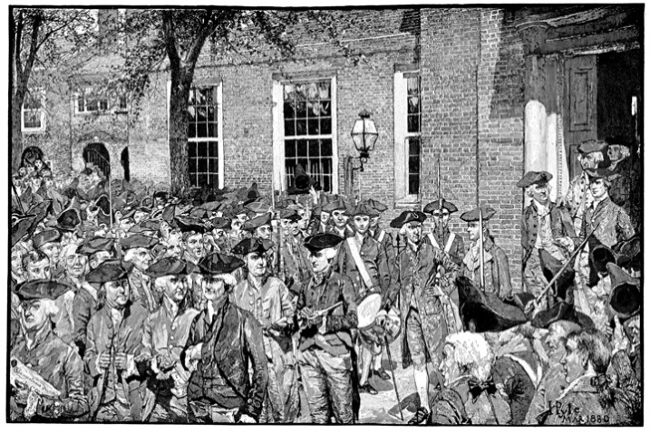
The soaring phrases of the Declaration were crafted in part to be declaimed in public. Indeed, one of the copies owned by Jefferson himself—not a confident public speaker—shows where he marked the document to pause, perhaps for laudatory huzzahs and applause.
© Thinkstock
The Declaration is a deeply democratic document. ^{[5]} It is democratic in what itdid—asserting the right of the people in American colonies to separate from Britain. And it is democratic in what it said: “We hold these truths to be self-evident, that all men are created equal” and have inviolable rights to “life, liberty, and the pursuit of happiness.” The Declaration concludes that the people are free to “alter or abolish” repressive forms of government. Indeed, it assumes that the people are the best judges of the quality of government and can act wisely on their own behalf.

Link
The Declaration of Independence
For more information on the Declaration of Independence, visit the National Archives online athttp://www.archives.gov/exhibits/charters/declaration.html.

The Articles of Confederation
Drafted in 1777, the Articles of Confederation were the first political constitution for the government of the United States. They codified the Continental Congress’s practices and powers. The United States of America was aconfederation of states. Although the confederation was superior to the individual states, it had no powers without their consent.

Link
The Articles of Confederation
For the text of the Articles of Confederation, seehttp://www.earlyamerica.com/earlyamerica/milestones/articles/text.html.
Under the Articles, the Continental Congress took over the king’s powers to make war and peace, send and receive ambassadors, enter into treaties and alliances, coin money, regulate Indian affairs, and run a post office. But the confederation could not raise taxes and relied on revenues from each of the states. There was no president to enforce the laws and no judiciary to hear disputes between and among the states.
Each state delegation cast a single vote in the Continental Congress. Nine states were needed to enact legislation, so few laws were passed. States usually refused to fund policies that hampered their own interests. ^{[6]} Changes in the Articles required an all-but-impossible unanimous vote of all thirteen delegations. The weakness of the Articles was no accident. The fights with Britain created widespread distrust of central authority. By restricting the national government, Americans could rule themselves in towns and states. Like many political thinkers dating back to ancient Greece, they assumed that self-government worked best in small, face-to-face communities.

KEY TAKEAWAYS
The first American political system, as expressed in the Articles of Confederation, reflected a distrust of a national government. Its powers were deliberately limited in order to allow Americans to govern themselves in their cities and states.

EXERCISES
- What was it about the Stamp Act and the decision to award a monopoly on the sale of tea to the East India Company that helped bring the American colonies together? What were the motivations for forming the first Congresses?
- In what way is the Declaration of Independence’s idea that “all men are created equal” a democratic principle? In what sense are people equal if, in practice, they are all different from one another?
- What were the weaknesses of the Articles of Confederation? Do you think the American government would be able to function if it were still a confederation? Why or why not?

[1] See Stephen Botein, “‘Meer Mechanics’ and an Open Press: The Business and Political Strategies of Colonial American Printers,” Perspectives in American History 9 (1975): 127–225; and “Printers and the American Revolution,” in The Press and the American Revolution, ed. Bernard Bailyn and John B. Hench (Worcester, MA: American Antiquarian Society, 1980), 11–57. Also, Charles E. Clark, The Public Prints: The Newspaper in Anglo-American Culture (New York: Oxford University Press, 1994), chap. 9; and “The Press the Founders Knew,” in Freeing the Presses: The First Amendment in Action, ed. Timothy E. Cook (Baton Rouge: Louisiana State University Press, 2005).
[2] Thomas C. Leonard, News for All: America’s Coming-of-Age with the Press (New York: Oxford University Press, 1995), chap. 1.
[3] For amplification of this argument, Timothy E. Cook, Governing with the News: The News Media as a Political Institution (Chicago: University of Chicago Press, 1998), chap. 2.
[4] See Jack N. Rakove, The Beginnings of National Politics: An Interpretive History of the Continental Congress (New York: Knopf, 1979).
[5] Staughton Lynd, The Intellectual Origins of American Radicalism (New York: Vintage, 1969); Garry Wills, Inventing America: Jefferson’s Declaration of Independence (New York: Vintage, 1979); and Pauline Maier, American Scripture: Making the Declaration of Independence (New York: Knopf, 1997).
[6] Keith L. Dougherty, Collective Action under the Articles of Confederation (New York: Cambridge University Press, 2001), chaps. 4–5.

2.2 Creating and Ratifying the Constitution

LEARNING OBJECTIVES
After reading this section, you should be able to answer the following questions:
- What was Shays’s Rebellion?
- What was the Constitutional Convention?
- What were the three cross-cutting divides at the Constitutional Convention?
- What were the main compromises at the Constitutional Convention?
- Who were the Federalists and the Anti-Federalists?
- What factors explain ratification of the Constitution?
The Constitution was a reaction against the limitations of the Articles of Confederation and the democratic experiments begun by the Revolution and the Declaration of Independence.

The Case against the Articles of Confederation
The Articles could not address serious foreign threats. In the late 1780s, Britain denied American ships access to British ports in a trade war. Spain threatened to close the Mississippi River to American vessels. Pirates in the Mediterranean captured American ships and sailors and demanded ransom. The national government had few tools to carry out its assigned task of foreign policy.r ^{[1]}
There was domestic ferment as well. Millions of dollars in paper money issued by state governments to fund the Revolutionary War lost their value after the war.^{[2]} Financial interests were unable to collect on debts they were owed. They appealed to state governments, where they faced resistance and even brief armed rebellions.
Newspapers played up Shays’s Rebellion, an armed insurrection by debt-ridden farmers to prevent county courts from foreclosing mortgages on their farms. ^{[3]}Led by Captain Daniel Shays, it began in 1786, culminated with a march on the federal arsenal in Springfield, Massachusetts, and wound down in 1787.
The Continental Congress voted unanimously to raise an army to put down Shays’s Rebellion but could not coax the states to provide the necessary funds. The army was never assembled. ^{[4]}

Link
Shays’s Rebellion
To learn more about Shays’s Rebellion, visit the National Park Service online at http://www.nps.gov/spar/historyculture/shays-rebellion.htm.
Leaders who supported national government portrayed Shays’s Rebellion as a vivid symbol of state governments running wild and proof of the inability of the Articles of Confederation to protect financial interests. Ordinary Americans, who were experiencing a relatively prosperous time, were less concerned and did not see a need to eliminate the Articles.

Calling a Constitutional Convention
The Constitutional Convention was convened in 1787 to propose limited reforms to the Articles of Confederation. Instead, however, the Articles would be replaced by a new, far more powerful national government.
Twelve state legislatures sent delegates to Philadelphia (Rhode Island did not attend). Each delegation would cast a single vote.

Who Were the Delegates?
The delegates were not representative of the American people. They were well-educated property owners, many of them wealthy, who came mainly from prosperous seaboard cities, including Boston and New York. Most had served in the Continental Congress and were sensitive to the problems faced by the United States. Few delegates had political careers in the states, and so they were free to break with existing presumptions about how government should be organized in America.

Link
Constitutional Convention
To learn more about the delegates to the Constitutional Convention, visithttp://www.archives.gov/exhibits/charters/constitution_founding_fathers.html.
The Constitutional Convention was a mix of great and minor characters. Exalted figures and brilliant intellects sat among nonentities, drunkards, and nincompoops. The convention’s driving force and chief strategist was a young, bookish politician from Virginia named James Madison. He successfully pressured revered figures to attend the convention, such as George Washington, the commanding officer of the victorious American revolutionaries, and Benjamin Franklin, a man at the twilight of a remarkable career as printer, scientist, inventor, postmaster, philosopher, and diplomat.
Figure 2.3
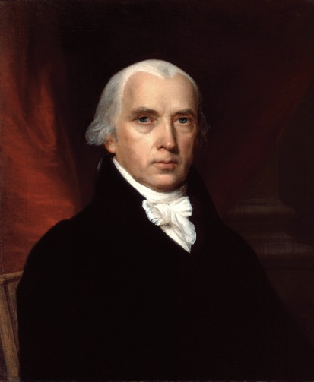
The unassuming and slight James Madison made an unusual teammate for the dashing, aristocratic ex-soldier Alexander Hamilton and the august diplomat John Jay. But despite these contrasts and some political divides, they merged their voices in the Federalist papers, published in New York newspapers under the pseudonym “Publius.” Soon after the ratification of the Constitution, The Federalist was widely republished in book format. Scholars now regard it as the fullest explication of the logic underlying the Constitution.
Source: Photo courtesy of the White House Historical Association,http://commons.wikimedia.org/wiki/File:James_Madison.jpg.
Madison drafted the first working proposal for a Constitution and took copious notes at the convention. Published after his death in 1836, they are the best historical source of the debates; they reveal the extraordinary political complexity of the deliberations and provide remarkable insight into what the founders had in mind. ^{[5]}
Once the Constitution was drafted, Madison helped write and publish a series of articles in a New York newspaper. These Federalist papers defend the political system the Constitutional Convention had crafted.

Interests and the Constitution
In the early twentieth century, historian Charles Beard asserted that the Constitution was “an economic document for economic ends,” pushed by investors and industrialists who would profit more from a national economic and political system than from one favoring small-scale agricultural interests.^{[6]} Research has not upheld Beard’s stark division of reaction to the Constitution into well-off supporters and poor, democratic adversaries. Many local, well-to-do patriarchs opposed the Constitution; many small merchants wanted a national government.
But Beard’s focus on economic and social interests is revealing. Paper money, debt relief, and Shays’s Rebellion concerned those committed to existing economic and social orders. Consider Federalist No. 10, the most famous of Madison’s Federalist papers. In it, he decried the dangers of democracy; he started with “a rage for paper money” and “an abolition of debts,” then the specter of “an equal division of property,” all of which he found an “improper or wicked project.” Madison paid attention to the right to acquire and maintain property, which the Declaration brushed aside. He claimed that political systems were created to maintain liberty—including the liberty to accumulate wealth. Political equality meant only that each person had a right to express himself or herself.

Ideas and the Constitution
The Constitutional Convention responded to ideas, not just interests. Delegates doubted that the people could wisely rule. They sought to replace democracywith a republic, in which officials would be chosen to act on the people’s behalf. Federalist No. 10 makes the case.
Madison was concerned with threats to order and stability from what he calledfactions, groups pursuing their self-interest above the public good. For Madison, factions were inevitable. His worst nightmare was of a faction becoming a political majority, trampling on the rights of its helpless opponents, and quickly enacting its program. He favored a large republic, which, he believed, would discourage a faction’s rise to power. Madison expected that in a republic, the number of locally oriented interests would increase and diversify, which would make it harder for any one of them to dominate. Minority factions could pass legislation by forming temporary majorities, Madison reasoned, but these diverse majorities would not be able to agree on a single project long enough to be oppressive.

Drafting the Constitution
Delegates to the Constitutional Convention first gathered on May 25, 1787, in what is now called Independence Hall in Philadelphia. Their goal was to devise aconstitution, a system of fundamental laws and principles outlining the nature and functions of the government. George Washington presided. Delegates worked in an intimate setting without committees. The structure of power created by the Constitution in Philadelphia resulted from a deeply political process. ^{[7]}

The Secrecy of the Constitutional Convention
Deliberations took place in secret, as delegates did not want the press and the public to know the details of what they were considering (Note 2.16 "Comparing Content"). Newspapers hardly mentioned the convention at all, and when they did, it was in vague references praising the high caliber of the delegates. ^{[8]}

Comparing Content
The Convention’s Gag Rule
Press coverage of the Constitutional Convention cannot be compared because one of the first decisions made in the Constitutional Convention was that “nothing spoken in the House be printed, or otherwise published or communicated.” ^{[9]} The delegates feared that exposure through newspapers would complicate their work. The delegate who is today regarded as the great defender of civil liberties, George Mason, wrote to his son approvingly: “This I think myself a proper precaution to prevent mistakes and misrepresentation until the business shall have been completed, when the whole may have a very different complexion from that in the several crude and indigested parts might in their first shape appear if submitted to the public eye.” ^{[10]}
This gag rule was rigorously enforced. One day the presiding officer, George Washington, noticed that an inattentive delegate had dropped his notes on the floor when leaving the hall. Washington broke his usual silence and rebuked the unknown infractor: “I am sorry to find that some one Member of this Body, has been so neglectful of the secrets of the convention as to drop in the State House a copy of their proceedings, which by accident was picked up and delivered to me this morning. I must entreat Gentlemen to be more careful, least [sic] our transactions get into the News Papers, and disturb the public repose by premature speculations.”
Throwing the notes on the table, Washington exclaimed, “I know not whose Paper it is, but there it is, let him who owns it take it.” Delegate William Pierce, who recorded this tale, noted that Washington “bowed, picked up his Hat, and quitted the room with a dignity so severe that every Person seemed alarmed.” ^{[11]}
The founders were not unanimous about the threat posed by the press. Thomas Jefferson was in Paris as an ambassador. In August 1787, he wrote to his counterpart in London, John Adams, that there was no news from the convention: “I am sorry they began their deliberations by so abominable a precedent as that of tying up the tongues of their members. Nothing can justify this example but the innocence of their intentions, & ignorance of the value of public discussions. I have no doubt that all their other measures will be good & wise.” ^{[12]}
In 1787, the powers of the press were identified in ways we recognize in the twenty-first century. Washington was concerned that news about the political process might produce rumors, confusion, worry, and public opposition to worthwhile policies. But as Jefferson recognized, the news can also lead to productive public debate, dialogue, and deliberation.

Figure 2.4
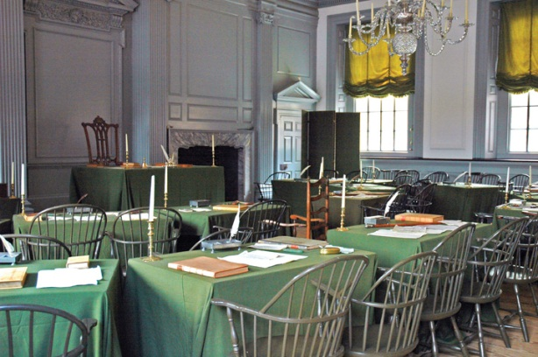
The membership of the Constitutional Convention was so small—never more than fifty on a given day—that they could proceed largely in “a committee of the whole.” This size enabled them to continue their discussions in private at their preferred boardinghouses and taverns—and to keep a tight lid on public discussion.
Source: Photo taken by Dan Smith,http://commons.wikimedia.org/wiki/File:Independence_Hall_Assembly_Room.jpg.

The Cross-Cutting Divides
The delegates immediately discarded the Continental Congress’s mandate that they recommend amendments to the Articles of Confederation. They agreed to draft a new Constitution from scratch in order to create a national government superior to and independent of the states.
This crucial decision was followed by disagreement about exactly how to create a national government. The states varied widely in economic bases, population sizes, and numbers of slaves.
Three cross-cutting divides existed among the states:
- Large states versus small states ^{[13]}
- Cosmopolitan, centrally located states (Connecticut to Virginia) versus parochial states on the northern and southern borders
- Southern states, reliant on slavery in their economies, versus Northern states, which were not
The powers and structures of the Constitution resulted from a series of compromises designed to bridge these three divides.

Large and Small States
The most threatening split in the convention emerged initially between large and small states.
Large states fired the first salvo. The Virginia Plan, drafted by Madison, foresaw a strong national government that could veto any state laws it deemed contrary to the national interest. The central institution was a bicameral (two-chamber) legislature. The people would elect the lower house, which would in turn select the members of the upper house; the two chambers together would then elect the executive and judiciary. Breaking with the Articles of Confederation’s equal representation of states, the Virginia Plan allotted seats to both chambers of the legislature by population size alone. ^{[14]}
Cosmopolitan, centrally located states, provided strong initial support for the Virginia Plan against scattered opposition from border states. But Madison could not hold this coalition behind both a strong national government and a legislature allocated by population. Delegates from the small states of New Jersey, Delaware, and Maryland liked a strong national government, but they feared being overpowered. Delegates from populous Massachusetts and three fast-growing Southern states joined the two largest states, Virginia and Pennsylvania, to support legislative districts based on population, but they disliked the Virginia Plan’s sweeping powers for the national government.
On June 15, the small states proposed an alternative. The New Jersey Planenhanced the national government’s powers to levy taxes and regulate commerce but left remaining powers to the states. The plan had a federal executive, elected by the legislature, to enforce states’ compliance with national law, and a federal judiciary to settle disputes among the states and between the states and the national government. Any national law would become “the supreme law of the respective States.” The New Jersey Plan preserved the core of the Articles of Confederation—equal representation of states in a unicameral (single-chamber) legislature.
Only three states voted for the New Jersey Plan, but the Virginia Plan’s vulnerability was exposed. Facing an impasse, delegates from Connecticut suggested a compromise. Borrowing the Virginia Plan’s idea of a bicameral legislature, they proposed that one chamber, the House of Representatives, be made up of representatives from districts of equal population, while in the Senate each state would be equally represented with two senators.
ThisConnecticut Compromise (also known as the Great Compromise) was adopted by the convention with only Virginia and Pennsylvania in opposition. Thus the configuration of today’s Congress emerged not so much from principled deliberations between the Constitution’s founders as from the necessity for compromise between competing state interests. In essence, the founders decided to split the difference. ^{[15]}

North and South
After this vote, North versus South displaced the divide between large and small states. The convention became preoccupied by how the new government would be empowered to deal with slavery. Northerners feared the South’s growth and room for expansion. Southerners worried that the North would threaten the practice of slavery, which, although legal in all states, was a central part only of Southern economies.
Northern interests in a strong national government acceded to Southern demands on slavery. Southerners argued that slaves should be counted when allocating legislative seats. Eventually, the convention settled on a three-fifths clause: 60 percent of the enslaved population would be counted for purposes of representation. Northern delegates, convinced that the largest slave-holding states would never have a majority in the Senate, gave in.

Link
The Three-Fifths Clause
Aaron Magruder’s comic strip The Boondocks ran this installment during the 2004 presidential campaign. Showing a depressed black man talking about the three-fifths clause, it powerfully illustrates the Constitution’s long-lasting affront to African Americans, almost all of whom were enslaved and thus, for the purpose of the census (and of representation in Congress and the Electoral College), would be counted as three-fifths of a person.
Read the comic at http://www.gocomics.com/boondocks/2004/10/21.
As the convention considered the national government’s powers, an alliance of delegates from New England and the Deep South emerged to defend local control and their states’ economic self-interest. Southerners sought to maintain slavery, while New Englanders wanted national tariffs to protect their commerce. They struck a deal that resulted in New England delegates voting to require the return of fugitive slaves and to prevent Congress from regulating the slave trade until 1808.
The delegates did not confront slavery head on (indeed, the word “slavery” is not directly mentioned in the Constitution). As a result, the issue of slavery would overshadow much of federal politics until its bloody resolution in the Civil War of the 1860s.

The Executive
By now, the Constitutional Convention could not break down, because the document had something for everybody. Small states liked the security of a national government and their equal representation in the Senate. The Deep South and New England valued the protection of their economic bases. Pennsylvania and Virginia—the two most populous, centrally located states—foresaw a national government that would extend the reach of their commerce and influence.
The convention’s final sticking point was the nature of the executive. The debate focused on how many people would be president, the power of the office, the term of the office, how presidents would be elected, and whether they could serve multiple terms.
To break the logjam on the presidency, the convention created theElectoral College as the method of electing the president, a political solution that gave something to each of the state-based interests. The president would not be elected directly by the popular vote of citizens. Instead, electors chosen by state legislatures would vote for president. Small states got more electoral votes than warranted by population, as the number of electors is equal to the total of representatives and senators. If the Electoral College did not produce a majority result, the president would be chosen by the popularly elected House, but with one vote per state delegation. ^{[16]} With all sides mollified, the convention agreed that the office of president would be held by one person who could run for multiple terms.

Bargaining, Compromise, and Deal Making
The Constitutional Convention began with a principled consensus on establishing a stronger national government; it ended with bargaining, compromise, and deal making. State delegations voted for their political and economic self-interests, and often worked out deals enabling everyone to have something to take home to constituents. Some complex matters, such as the structures of the executive and judicial branches, were left up to the new congress. As one scholar writes, the Constitution is “a patch-work sewn together under the pressure of both time and events by a group of extremely talented…politicians.” ^{[17]}

Link
The Constitution
To learn more about the Constitution, visit the National Constitution Center at http://constitutioncenter.org.

Ratifying the Constitution
The signing of the Constitution by the delegates on September 17, 1787, was just the beginning. The Constitution would go into effect only after being approved by specially elected ratifying conventions in nine states.
Ratification was not easy to win. In most states, property qualifications for voting had broadened from landholding to taxpaying, thereby including most white men, many of whom benefited from the public policies of the states. Popular opinion for and against ratification was evenly split. In key states like Massachusetts and Virginia, observers thought the opposition was ahead. ^{[18]}

The Opposition to Ratification
The elections to the ratifying conventions revealed that opponents of the Constitution tended to come from rural inland areas (not from cities and especially not from ports, where merchants held sway). They held to the ideals of the Declaration of Independence, which favored a deliberately weak national government to enhance local and state self-government. ^{[19]} They thought that the national government’s powers, the complex system of government, lengthy terms of office, and often indirect elections in the new Constitution distanced government from the people unacceptably.
Opponents also feared that the strength of the proposed national government posed a threat to individual freedoms. They criticized the Constitution’s lack of aBill of Rights—clauses to guarantee specific liberties from infringement by the new government. A few delegates to the Constitutional Convention, notably George Mason of Virginia and Elbridge Gerry of Massachusetts, had refused to sign the document in the absence of a Bill of Rights.

The Campaign for Ratification
Despite such objections and obstacles, the campaign for ratification was successful in all thirteen states. ^{[20]} The advocates of the national political system, benefiting from the secrecy of the Constitutional Convention, were well prepared to take the initiative. They called themselves not nationalists butFederalists. Opponents to the Constitution were saddled with the name ofAnti-Federalists, though they were actually the champions of a federation of independent states.
By asking conventions to ratify the Constitution, the Federalists evaded resistance from state legislatures. Federalists campaigned to elect sympathetic ratifiers and hoped that successive victories, publicized in the press, would build momentum toward winning ratification by all thirteen states.

Figure 2.5
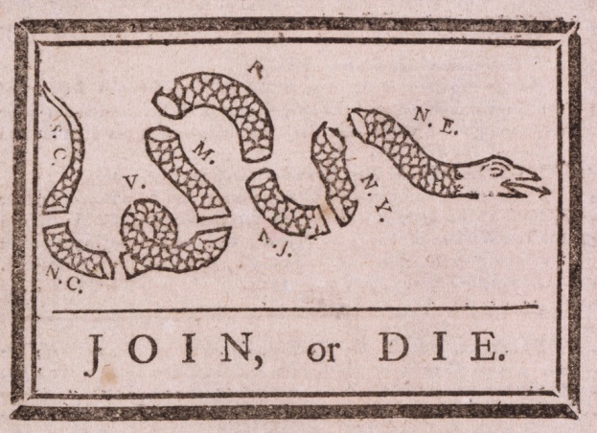
The Federalists’ media strategies included images, too. A famous woodcut at the start of the Revolution was of a serpent cut into thirteen sections with the admonition “Join or Die.” Federalists provided a new twist on this theme. They kept track of the ratification by an edifice of columns, elevated one by one as each state ratified. The next state convention on the list would be represented by a hand lifting the column, often accompanied by the confident motto “Rise It Will.”
Source: http://commons.wikimedia.org/wiki/File:Franklin_join_or_die.jpg.
Anti-Federalists did not decry the process by which the Constitution was drafted and ratified. Instead, they participated in the ratification process, hoping to organize a new convention to remedy the Constitution’s flaws.

Newspapers and Ratification
The US newspaper system boosted the Federalist cause. Of the approximately one hundred newspapers being published during the ratification campaign of 1787–88, “not more than a dozen…could be classed as avowedly antifederal.”^{[21]} Anti-Federalist arguments were rarely printed and even less often copied by other newspapers. ^{[22]} Printers followed the money trail to support the Federalists. Most newspapers, especially those whose stories were reprinted by others, were based in port cities, if only because arriving ships provided good sources of news. Such locales were dominated by merchants who favored a national system to facilitate trade and commerce. Newspapers were less common in rural interior locations where Anti-Federalist support was greatest.
Federalists also pressured the few Anti-Federalist newspapers that existed. They wrote subscribers and advertisers and urged them to cancel. Anti-Federalist printers often moved to other cities, went out of business, or began reprinting Federalist articles. Federalists hailed such results as the voice of the people. When an Anti-Federalist paper in Philadelphia halted publication, Federalists exulted, “There cannot be a greater proof that the body of the people are federal, that the antifederal editors and printers fail of support.” ^{[23]}
Today the most famous part of this newspaper campaign is the series of essays (referred to earlier) written by Alexander Hamilton, John Jay, and James Madison, and published in New York newspapers under the collective pseudonym “Publius.” The authors used their skills at legal argumentation to make the strongest case they could for the document that emerged from the Constitutional Convention. These Federalist papers, steeped in discussion of political theory and history, offer the fullest logic for the workings of the Constitution. However, they were rarely reprinted outside New York and were a minor part of the ratification campaign.

Link
The Federalist
Read The Federalist at the Library of Congress online athttp://thomas.loc.gov/home/histdox/fedpapers.html.
Newspapers instead played on public sentiment, notably the adulation of George Washington, presiding officer of the convention, and his support of the Constitution. ^{[24]} The most widely disseminated story concerned his return trip from Philadelphia to Virginia. A bridge collapsed but Washington escaped unharmed. The tale implied that divine intervention had ensured Washington’s leadership by “the providential preservation of the valuable life of this great and good man, on his way home from the Convention.” ^{[25]}
Not all states were eager to ratify the Constitution, especially since it did not specify what the federal government could not do and did not include a Bill of Rights. Massachusetts narrowly voted in favor of ratification, with the provision that the first Congress take up recommendations for amending the Constitution. New Hampshire, Virginia, and New York followed this same strategy. Once nine states had ratified it, the Constitution was approved. Madison was elected to the first Congress and proposed a Bill of Rights, the first ten amendments to the Constitution. Only after the Congress had approved the Bill of Rights did North Carolina and Rhode Island ratify the Constitution.

KEY TAKEAWAYS
We have shown that the Constitution was a political document, drafted for political purposes, by skillful politicians who deployed shrewd media strategies. At the Constitutional Convention, they reconciled different ideas and base self-interests. Through savvy compromises, they resolved cross-cutting divisions and achieved agreement on such difficult issues as slavery and electing the executive. In obtaining ratification of the Constitution, they adroitly outmaneuvered or placated their opponents. The eighteenth-century press was crucial to the Constitution’s success by keeping its proceedings secret and supporting ratification.

EXERCISES
- From what James Madison says in Federalist No. 10, what economic interests was the Constitution designed to protect? Do you agree that the liberty to accumulate wealth is an essential part of liberty?
- What did James Madison mean by “factions,” and what danger did they pose? How did he hope to avoid the problems factions could cause?
- Why were the Constitutional Convention’s deliberations kept secret? Do you think it was a good idea to keep them secret? Why or why not?
- What were the main divisions that cut across the Constitutional Convention? What compromises bridged each of these divisions?

[1] A synopsis is Jack N. Rakove, Original Meanings: Politics and Ideas in the Making of the Constitution (New York: Knopf, 1996), 25–28. More generally, see Max M. Edling, A Revolution in Favor of Government: Origins of the U.S. Constitution and the Making of the American State (New York: Oxford University Press, 2004).
[2] Gordon S. Wood, “Interests and Disinterestedness in the Making of a Constitution,” inBeyond Confederation: Origins of the Constitution and American National Identity, ed. Richard Beeman, Stephen Botein, and Edward C. Carter II (Chapel Hill: University of North Carolina Press, 1987), 69–109.
[3] See Leonard A. Richards, Shays’s Rebellion: The American Revolution’s Final Battle(Philadelphia: University of Pennsylvania Press, 2002).
[4] See Keith L. Dougherty, Collective Action under the Articles of Confederation (New York: Cambridge University Press, 2001), chap. 6.
[5] The standard edition of Madison’s notes is in The Records of the Federal Convention of 1787, ed. Max Farrand, 3 vols. (New Haven, CT: Yale University Press, 1937).
[6] Charles A. Beard, An Economic Interpretation of the Constitution of the United States (New York: Macmillan, 1913).
[7] Political scientists have revealed the degree to which the Constitutional Convention and the ratification conventions can be understood to be the result of manipulation of parliamentary rules, strategic voting, shifting coalitions, and the “agenda-setting” and “framing” use of mass communication. Our analysis draws on these authors, especially John P. Roche, “The Founding Fathers: A Reform Caucus in Action,” American Political Science Review 55 (December 1961): 799–816; Calvin C. Jillson, Constitution Making: Conflict and Consensus in the Federal Convention of 1787 (New York: Agathon Press, 1988); and William H. Riker, The Strategy of Rhetoric: Campaigning for the American Constitution(New Haven, CT: Yale University Press, 1996).
[8] See John K. Alexander, The Selling of the Constitutional Convention: A History of News Coverage (Madison, WI: Madison House, 1990).
[9] Max Farrand, ed., The Records of the Federal Convention of 1787 (New Haven, CT: Yale University Press, 1937), vol. 1, 17.
[10] Max Farrand, ed., The Records of the Federal Convention of 1787 (New Haven, CT: Yale University Press, 1937), vol. 3, 28.
[11] Max Farrand, ed., The Records of the Federal Convention of 1787 (New Haven, CT: Yale University Press, 1937), vol. 3, 86–87.
[12] Max Farrand, ed., The Records of the Federal Convention of 1787 (New Haven, CT: Yale University Press, 1937), vol. 3, 76.
[13] The terms “large state” and “small state” are misleading. Some small states had larger populations than large states. The small states all shared economic vulnerability and an inability to grow, usually because they were boxed in by other states on their western edge, which made it impossible to hope for westward expansion.
[14] The text of the Virginia Plan (and its main rival, the New Jersey Plan) can be found in Clinton Rossiter, 1787: The Grand Convention (New York: Macmillan, 1966), 361–63 and 369–71.
[15] David Brian Robertson, “Madison’s Opponents and Constitutional Design,” American Political Science Review 99 (2005): 225–44.
[16] The quoted phrase comes from John P. Roche, “The Founding Fathers: A Reform Caucus in Action,” American Political Science Review 55 (December 1961): 810.
[17] John P. Roche, “The Founding Fathers: A Reform Caucus in Action,” American Political Science Review 55 (December 1961): 815; see also David Brian Robertson, “Madison’s Opponents and Constitutional Design,” American Political Science Review 99 (2005): 225–44
[18] Jackson Turner Main, The Antifederalists: Critics of the Constitution, 1781–1788 (Chapel Hill: University of North Carolina Press, 1961), 249; Evelyn C. Fink and William H. Riker, “The Strategy of Ratification” in The Federalist Papers and the New Institutionalism, ed. Bernard Grofman and Donald Wittman (New York: Agathon Press, 1989), 220–55.
[19] See Herbert Storing, What the Anti-Federalists Were For (Chicago: University of Chicago Press, 1988).
[20] Pauline Maier, Ratification: The People Debate the Constitution, 1787–1788 (New York: Simon & Schuster, 2010).
[21] Robert Allen Rutland, The Ordeal of the Constitution: The Antifederalists and the Ratification Struggle of 1787–1788 (Norman: University of Oklahoma Press, 1966), 38.
[22] William H. Riker, The Strategy of Rhetoric: Campaigning for the American Constitution(New Haven, CT: Yale University Press, 1996), 26–28.
[23] More specifically, see Robert A. Rutland, “The First Great Newspaper Debate: The Constitutional Crisis of 1787–88,” Proceedings of the American Antiquarian Society (1987): 43–58. These examples come from Robert Allen Rutland, The Ordeal of the Constitution: The Antifederalists and the Ratification Struggle of 1787–1788 (Norman: University of Oklahoma Press, 1966), 73–74, 135–38, 265–66; and John P. Kaminski and Gaspare J. Saladino, eds.,Commentaries on the Constitution, Public and Private (Madison, WI: State Historical Society of Wisconsin, 1981), vol. 1, xxxii–xxxix.
[24] On the most commonly reprinted articles, see William H. Riker, The Strategy of Rhetoric: Campaigning for the American Constitution (New Haven, CT: Yale University Press, 1996), chap. 6, esp. table 6.1.
[25] John P. Kaminski and Gaspare J. Saladino, eds., Commentaries on the Constitution, Public and Private (Madison, WI: State Historical Society of Wisconsin, 1981), vol. 1, 243.

2.3 Constitutional Principles and Provisions

LEARNING OBJECTIVES
After reading this section, you should be able to answer the following questions:
- What is the separation of powers?
- What are checks and balances?
- What is bicameralism?
- What are the Articles of the Constitution?
- What is the Bill of Rights?

The Principles Underlying the Constitution
While the Constitution established a national government that did not rely on the support of the states, it limited the federal government’s powers by listing (“enumerating”) them. This practice of federalism (as we explain in detail in ) means that some policy areas are exclusive to the federal government, some are exclusive to the states, and others are shared between the two levels.
Federalism aside, three key principles are the crux of the Constitution: separation of powers, checks and balances, and bicameralism.

Separation of Powers
Separation of powers is the allocation of three domains of governmental action—law making, law execution, and law adjudication—into three distinct branches of government: the legislature, the executive, and the judiciary. Each branch is assigned specific powers that only it can wield (see ).
Table 2.1 The Separation of Powers and Bicameralism as Originally Established in the Constitution
Branch of Government | Term | How Selected | Distinct Powers
Legislative
House of Representatives | 2 years | Popular vote | Initiate revenue legislation; bring articles of impeachment
Senate | 6 years; 3 classes staggered | Election by state legislatures | Confirm executive appointments; confirm treaties; try impeachments
Executive
President | 4 years | Electoral College | Commander-in-chief; nominate executive officers and Supreme Court justices; veto; convene both houses of Congress; issue reprieves and pardons
Judicial
Supreme Court | Life (during good behavior) | Presidential appointment and Senate confirmation (stated more or less directly in Federalist No. 78) | Judicial review (implicitly in Constitution but stated more or less directly in Federalist No. 78)
Figure 2.6
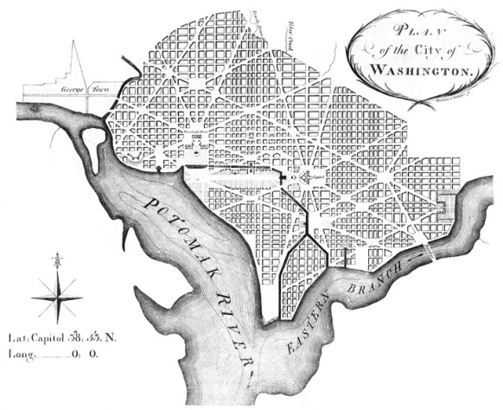
In perhaps the most abiding indicator of the separation of powers, Pierre L’Enfant’s plan of Washington, DC, placed the President’s House and the Capitol at opposite ends of Pennsylvania Avenue. The plan notes the importance of the two branches being both geographically and politically distinct.
Source: http://commons.wikimedia.org/wiki/File:L'Enfant_plan_original.jpg.
This separation is in the Constitution itself, which divides powers and responsibilities of each branch in three distinct articles: Article I for the legislature, Article II for the executive, and Article III for the judiciary.

Checks and Balances
At the same time, each branch lacks full control over all the powers allotted to it. Political scientist Richard Neustadt put it memorably: “The Constitutional Convention of 1787 is supposed to have created a government of ‘separated powers.’ It did nothing of the sort. Rather, it created a government of separated institutions sharing powers.” ^{[1]} No branch can act effectively without the cooperation—or passive consent—of the other two.
Most governmental powers are shared among the various branches in a system of checks and balances, whereby each branch has ways to respond to, and if necessary, block the actions of the others. For example, only Congress can pass a law. But the president can veto it. Supreme Court justices can declare an act of Congress unconstitutional through judicial review. shows the various checks and balances between the three branches.
Figure 2.7 Checks and Balances
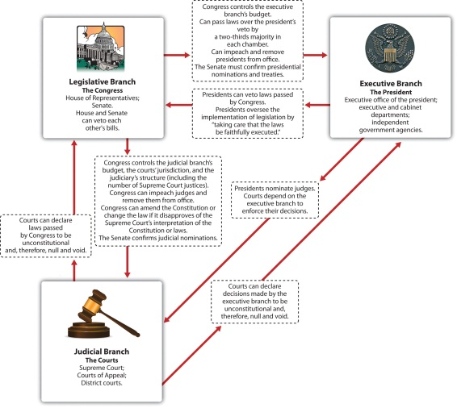
Source: Adapted from George C. Edwards, Martin P. Wattenberg, and Robert L. Lineberry, Government in America: People, Politics, and Policy (White Plains, NY: Pearson Longman, 2011), 46.
The logic of checks and balances echoes Madison’s skeptical view of human nature. In Federalist No. 10 he contends that all individuals, even officials, follow their own selfish interests. Expanding on this point in Federalist No. 51, he claimed that officeholders in the three branches would seek influence and defend the powers of their respective branches. Therefore, he wrote, the Constitution provides “to those who administer each department the necessary constitutional means and personal motives to resist encroachments of the others.”

Bicameralism
Government is made yet more complex by splitting the legislature into two separate and distinct chambers—the House of Representatives and the Senate. Such bicameralism was common in state legislatures. One chamber was supposed to provide a close link to the people, the other to add wisdom. ^{[2]} The Constitution makes the two chambers of Congress roughly equal in power, embedding checks and balances inside the legislative branch itself.
Bicameralism recalls the founders’ doubts about majority rule. To check the House, directly elected by the people, they created a Senate. Senators, with six-year terms and election by state legislatures, were expected to work slowly with a longer-range understanding of problems and to manage popular passions. A story, possibly fanciful, depicts the logic: Thomas Jefferson, back from France, sits down for coffee with Washington. Jefferson inquires why Congress will have two chambers. Washington asks Jefferson, “Why did you pour that coffee into your saucer?” Jefferson replies, “To cool it,” following the custom of the time. Washington concludes, “Even so, we pour legislation into the senatorial saucer to cool it.” ^{[3]}

The Bias of the System
The US political system is designed to prevent quick agreement within the legislature and between the branches. Senators, representatives, presidents, and Supreme Court justices have varying terms of offices, distinctive means of selection, and different constituencies. Prospects for disagreement and conflict are high. Accomplishing any goal requires navigating a complex obstacle course. At any point in the process, action can be stopped. Maintaining the status quo is more likely than enacting significant changes. Exceptions occur in response to dire situations such as a financial crisis or external attacks.

What the Constitution Says
The text of the Constitution consists of a preamble and seven sections known as “articles.” The preamble is the opening rhetorical flourish. Its first words—“We the People of the United States”—rebuke the “We the States” mentality of the Articles of Confederation. The preamble lists reasons for establishing a national government.
The first three articles set up the branches of government. We briefly summarize them here, leaving the details of the powers and responsibilities given to these branches to specific chapters.
Article I establishes a legislature that the founders believed would make up the heart of the new government. By specifying many domains in which Congress is allowed to act, Article I also lays out the powers of the national government that we examine in .
Article II takes up the cumbersome process of assembling an Electoral College and electing a president and a vice president—a process that was later modified by the Twelfth Amendment. The presidential duties listed here focus on war and management of the executive branch. The president’s powers are far fewer than those enumerated for Congress.
The Constitutional Convention punted decisions on the structure of the judiciary below the Supreme Court to the first Congress to decide. Article III states that judges of all federal courts hold office for life “during good Behaviour.” It authorizes the Supreme Court to decide all cases arising under federal law and in disputes involving states. Judicial review, the central power of the Supreme Court, is not mentioned. Asserted in the 1804 case of Marbury v. Madison(discussed in , ), it is the ability of the Court to invalidate a law passed by Congress or a decision made by the executive on the basis that it violates the Constitution.
Article IV lists rights and obligations among the states and between the states and the national government (discussed in ).
Article V specifies how to amend the Constitution. This shows that the framers intended to have a Constitution that could be adapted to changing conditions. There are two ways to propose amendments. States may call for a convention. (This has never been used due to fears it would reopen the entire Constitution for revision.) The other way to propose amendments is for Congress to pass them by a two-thirds majority in both the House and Senate.
Then there are two ways to approve an amendment. One is through ratification by three-fourths of state legislatures. Alternatively, an amendment can be ratified by three-fourths of specially convoked state conventions. This process has been used once. “Wets,” favoring the end of Prohibition, feared that the Twenty-First Amendment—which would have repealed the Eighteenth Amendment prohibiting the sale and consumption of alcohol—would be blocked by conservative (“dry”) state legislatures. The wets asked for specially called state conventions and rapidly ratified repeal—on December 5, 1933.
Thus a constitutional amendment can be stopped by one-third of either chamber of Congress or one-fourth of state legislatures—which explains why there have been only twenty-seven amendments in over two centuries.
Article VI includes a crucial provision that endorses the move away from a loose confederation to a national government superior to the states. Lifted from the New Jersey Plan, the supremacy clause states that the Constitution and all federal laws are “the supreme Law of the Land.”
Article VII outlines how to ratify the new Constitution.

Constitutional Evolution
The Constitution has remained essentially intact over time. The basic structure of governmental power is much the same in the twenty-first century as in the late eighteenth century. At the same time, the Constitution has been transformed in the centuries since 1787. Amendments have greatly expanded civil liberties and rights. Interpretations of its language by all three branches of government have taken the Constitution into realms not imagined by the founders. New practices have been grafted onto the Constitution’s ancient procedures. Intermediary institutions not mentioned in the Constitution have developed important governmental roles. ^{[4]}

Amendments
Many crucial clauses of the Constitution today are in the amendments. The Bill of Rights, the first ten amendments ratified by the states in 1791, defines civil liberties to which individuals are entitled. After the slavery issue was resolved by a devastating civil war, equality entered the Constitution with the Fourteenth Amendment, which specified that “No State shall…deny to any person within its jurisdiction the equal protection of the laws.” This amendment provides the basis for civil rights, and further democratization of the electorate was guaranteed in subsequent ones. The right to vote became anchored in the Constitution with the addition of the Fifteenth, Nineteenth, Twenty-Fourth, and Twenty-Sixth Amendments, which stated that such a right, granted to all citizens aged eighteen years or more, could not be denied on the basis of race or sex, nor could it be dependent on the payment of a poll tax. ^{[5]}

Link
The Full Text of the Constitution
Find the full text of the Constitution at the National Archives online athttp://www.archives.gov/exhibits/charters/constitution.html.

Constitutional Interpretation
The Constitution is sometimes silent or vague, making it flexible and adaptable to new circumstances. Interpretations of constitutional provisions by the three branches of government have resulted in changes in political organization and practice. ^{[6]}
For example, the Constitution is silent about the role, number, and jurisdictions of executive officers, such as cabinet secretaries; the judicial system below the Supreme Court; and the number of House members or Supreme Court justices. The first Congress had to fill in the blanks, often by altering the law. ^{[7]}
The Supreme Court is today at center stage in interpreting the Constitution. Before becoming chief justice in 1910, Charles Evans Hughes proclaimed, “We are under a Constitution, but the Constitution is what the Court says it is.” ^{[8]} By examining the Constitution’s clauses and applying them to specific cases, the justices expand or limit the reach of constitutional rights and requirements. However, the Supreme Court does not always have the last word, since state officials and members of the national government’s legislative and executive branches have their own understanding of the Constitution that they apply on a daily basis, responding to, challenging, and sometimes modifying what the Court has held. ^{[9]}

New Practices
Specific sections of the Constitution have evolved greatly through new practices. Article II gives the presidency few formal powers and responsibilities. During the first hundred years of the republic, presidents acted in limited ways, except during war or massive social change, and they rarely campaigned for a legislative agenda. ^{[10]} Article II’s brevity would be turned to the office’s advantage by President Theodore Roosevelt at the dawn of the twentieth century. He argued that the president is “a steward of the people…bound actively and affirmatively to do all he could for the people.” So the president is obliged to do whatever is best for the nation as long as it is not specifically forbidden by the Constitution. ^{[11]}

Intermediary Institutions
The Constitution is silent about various intermediary institutions—political parties, interest groups, and the media—that link government with the people and bridge gaps caused by a separation-of-powers system. The political process might stall in their absence. For example, presidential elections and the internal organization of Congress rely on the party system. Interest groups represent different people and are actively involved in the policy process. The media are fundamental for conveying information to the public about government policies as well as for letting government officials know what the public is thinking, a process that is essential in a democratic system.

KEY TAKEAWAYS
The Constitution established a national government distinguished by federalism, separation of powers, checks and balances, and bicameralism. It divided power and created conflicting institutions—between three branches of government, across two chambers of the legislature, and between national and state levels. While the structure it created remains the same, the Constitution has been changed by amendments, interpretation, new practices, and intermediary institutions. Thus the Constitution operates in a system that is democratic far beyond the founders’ expectations.

EXERCISES
- Why was conflict between the different branches of government built into the Constitution? What are the advantages and disadvantages of a system of checks and balances?
- How is the Constitution different from the Articles of Confederation? How did the authors of the Constitution address the concerns of those who worried that the new federal government would be too strong?
- What do you think is missing from the Constitution? Are there any constitutional amendments you would propose?

[1] Richard E. Neustadt, Presidential Power (New York: Wiley, 1960), 33. Of course, whether the founders intended this outcome is still open to dispute.
[2] Gordon S. Wood, The Creation of the American Republic (Chapel Hill: University of North Carolina Press, 1969), chap. 6.
[3] This version comes from Richard F. Fenno Jr., The United States Senate: A Bicameral Perspective (Washington, DC: American Enterprise Institute, 1982), 5.
[4] Bruce Ackerman, The Failure of the Founding Fathers: Jefferson, Marshall and the Rise of Presidential Democracy (Cambridge, MA.: Belknap Press of Harvard, 2005).
[5] See Alexander Keyssar, The Right to Vote: The Contested History of Democracy in the United States (New York: Basic Books, 2000).
[6] The power of all three branches to develop the vague language of the Constitution is well documented in Neal Devins and Louis Fisher, The Democratic Constitution (New York: Oxford University Press, 2004).
[7] David P. Currie, The Constitution in Congress: The Federalist Period, 1789–1801 (Chicago: University of Chicago Press, 1997).
[8] Hughes was then Governor of New York. Quoted in Edward S. Corwin, The Constitution and What It Means Today (Princeton, NJ: Princeton University Press, 1954), xiii.
[9] See Neal Devins and Louis Fisher, The Democratic Constitution (New York: Oxford University Press, 2004).
[10] See Jeffrey Tulis, The Rhetorical Presidency (Princeton, NJ: Princeton University Press, 1987).
[11] Jeffrey K. Tulis, “The Two Constitutional Presidencies,” in The Presidency and the Political System, 6th ed., ed. Michael Nelson (Washington, DC: CQ Press, 2000), 93–124.

2.4 The Constitution in the Information Age

LEARNING OBJECTIVES
After reading this section, you should be able to answer the following questions:
- How do the media portray the Constitution?
- How do the media depict the politicians charged with fulfilling the Constitution’s vision of public life?
- What are the effects of the media’s depiction of the Constitution?
We have seen that the Constitution is a political document adopted for political reasons in a highly political process. Yet the text of the Constitution, and the structure of power it created, are almost entirely above political controversy. It is an object of pride for almost all Americans.

The Constitution as a Sacred Document
The official presentation of the Constitution in public buildings show it as asacred document, demonstrating its exalted status. The original document is ensconced in what is called a “Shrine” at the National Archives.
Figure 2.8
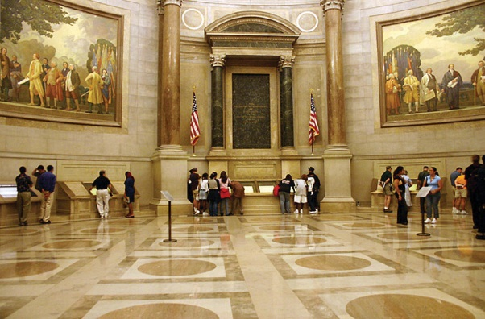
Not far from the “Shrine” in the National Archives, the twentieth-century re-creation by Howard Chandler Christy hangs in the US Capitol. The eye is carried toward the beatific glow around the document itself, George Washington standing proudly as its guardian. The atmosphere is of nobility, grandeur, and calm, not base self-interest and conflict—though the latter characterized the convention at least as much.
Source: Photo taken by Kelvin Kay,http://commons.wikimedia.org/wiki/File:ArchivesRotunda.jpg.
The media rarely show the Constitution or the structure of the political system as a cause of political problems. However, media depictions of the politicians charged with fulfilling the Constitution’s vision in public life are far less positive.
Let us return to our discussion at the beginning of this chapter. The news declared a “constitutional crisis” during the aftermath of the 2000 presidential election. The covers of Time, Newsweek, and US News & World Report all displayed the manuscript of the Constitution and its boldly emblazoned preamble, “We the People.” The stories reported the 4–3 vote by the Florida Supreme Court, which ordered a statewide recount of that state’s vote (the vote that would decide the national outcome), and the US Supreme Court’s 5–4 order to halt the recount and hear the Bush campaign’s appeal. BothNewsweek and US News & World Reportsuperimposed the word “CHAOS” on the Constitution; Newsweek showed the word looming menacingly beneath the torn, seemingly fragile document.
All three news magazines lamented that the Constitution was threatened by unscrupulous, self-interested politicians intruding into the realm of dispassionate principle. To quote Newsweek, “The endless election has not been a grand contest of famous legal gladiators contesting broad constitutional principles…[but] a local fight, a highly personal shoving match driven by old grudges and vendettas.” ^{[1]} Yet it was the complex electoral and federal system devised in the Constitution itself that caused much of the crisis.
Entertainment media occasionally present stories about the Constitution and the structure of power it created. Consider the familiar tale of a lone individual bravely fighting to restore a wayward political system to its virtuous roots. In the 1930s, Director Frank Capra perfected the genre in a series of Hollywood movies that reached its height in the classic 1939 film Mr. Smith Goes to Washington (Note 2.43 "Enduring Image").

Enduring Image
Mr. Smith Goes to Washington
James Madison’s portrayal in the Federalist papers of sacrosanct institutions and fallible politicians finds its movie version in Frank Capra’sMr. Smith Goes to Washington. ^{[2]} Upon its 1939 release, it was hugely popular and a critical success, second only to Gone with the Wind in box-office receipts and Oscar nominations. The title alone has recurred repeatedly in political talk across the decades ever since.
Mr. Smith begins when a senator dies. The governor, pushed to appoint either a party hack or a reformer, picks instead his sons’ “Boy Ranger” leader, resonantly named Jefferson Smith (James Stewart). The naive Smith heads to the capital under the wing of the state’s senior senator, Joseph Paine (Claude Rains), who entrusts Smith to the dead senator’s cynical secretary, Clarissa Saunders (Jean Arthur). Paine is a onetime associate of Smith’s father, a crusading editor, and has sold out to the state’s political boss. At Paine’s urging, Smith submits a bill proposing a national boys’ camp but later learns that the site has been bought by the boss to sell at a huge profit to the government for a dam Paine is proposing. Smith refuses to back down, and a fake corruption charge is launched against him with devastating results. About to resign in disgrace, Smith visits the Lincoln Memorial. Sustained by the love and political know-how of Saunders, Smith fights back by a filibuster on the Senate floor. The Washington reporters who had earlier scorned his innocence are transformed into his supporters by his idealism. But his home state hears little of this: the boss controls all radio stations and newspapers and brutally quashes any support. Smith faints in exhaustion when confronted with baskets full of trumped-up hate mail, but is saved when the guilt-ridden Paine tries to shoot himself and confesses to the corrupt scheme. The movie ends in a blaze of jubilation as the Senate president, apparently satisfied with Smith’s vindication, gives up gaveling for order.
Many observers see the message of Mr. Smith as reassuring: the system works, preserved by the idealist individual American hero. The founders and their handiwork are viewed as above criticism. During the climactic filibuster, Smith reads the Declaration of Independence and the Constitution, lecturing the senators, “Great principles don’t get lost once they come to light—they’re right here.”
The film endures because it is richly challenging: Mr. Smith is both a celebration in theory and an indictment in practice of the American political system.

Figure 2.9 Mr. Smith (James Stewart) Speaking in the Senate Chamber
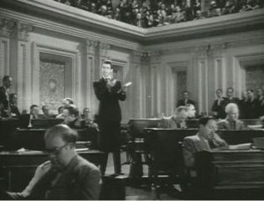
Source:http://commons.wikimedia.org/wiki/File:James_Stewart_in_Mr._Smith_Goes_to_Washington _trailer_2.JPG.
Mr. Smith has been a template for media depictions of the American political system. The Reese Witherspoon vehicle Legally Blonde 2: Red, White and Blonde (2003) follows the same formula of an idealistic individual going to Capitol Hill and redeeming the promise of the political system against crooked politicians.

Media Interactions: Why the Media Love the Constitution
Why do the media today present a rosy picture of the Constitution and the political system it created? One historic reason is that opposition to the Constitution collapsed after the Bill of Rights was added to it in 1791. Within a few years, the Constitution was no longer an object of political controversy. Even during the Civil War, the ultimate “constitutional crisis,” both sides were faithful to the cherished principles of the Constitution—at least as each side read them.
The Constitution is the essential framework for the work of reporters as well as politicians. Reporters rely on order and regularity to perform their job day in, day out. The procedures established by the Constitution—such as how presidents are elected; how a bill becomes a law; how the president, Congress, and the Supreme Court vie for power—are the basis for continuing sagas that reporters narrate across days, months, even years. ^{[3]}
The Constitution also gives the media an easy symbol with which they can display their idealism, a perhaps unattainable (and un-Madisonian) political system in which officials work efficiently, cooperatively, and selflessly in the public interest.

Media Consequences
This positive media portrayal of the Constitution encourages reverence for the political system even when there is much criticism of the officials in that system.^{[4]} Typical are the results of a public opinion poll conducted during 1992, a year marked by high public unhappiness with government. Not surprisingly, the survey showed that the public was highly critical of how the president and members of Congress were handling their jobs. But the public did not criticize the institutions of Congress and the presidency themselves. Ninety-one percent said they approved of “the constitutional structure of government.” ^{[5]} Political scientists John Hibbing and Elizabeth Theiss-Morse who conducted the research concluded, “People actually see two quite different political systems…Anything associated with the constitutional system elicits a positive response…To the extent there are problems with the political system it is because we have deviated from what was outlined in the Constitution, not because that outline was flawed.” ^{[6]}
Yet many of the media’s indictments against politicians are for behaviors encouraged by the Constitution. Reporters and the mass media often criticize American politicians for “squabbling” and “bickering.” But the separation of powers, as the founders designed it, is supposed to encourage conflict within the legislature and between the three branches.
The Constitution is a remarkably terse document. Generations have worked to evolve its meanings in over two centuries of politics and policies. Americans may rarely question the Constitution itself, but they surely disagree and debate over how its principles should be applied. In the chapters to follow, we will see many contemporary examples of politics around the Constitution in the information age—from constitutional amendments, to disputes between the branches over the powers of each, to the meanings of the Constitution’s clauses when applied in public policy.

KEY TAKEAWAYS
The media usually portray the Constitution and most of the institutions it established favorably and above politics. Yet, the Constitution was—and remains—a political document created and developed in political ways for political purposes. In part because of the media’s presentation, the public finds little to criticize in the Constitution, even as it is quick to disparage public officials. Nonetheless, the Constitution continues to be the object of political engagement in the twenty-first century.

EXERCISES
- Think about the movies you’ve seen. Do any of them present the Constitution in a negative light? What do they see as the source of problems with the American political system, if not the Constitution?
- Why do you think Americans tend to idealize the Constitution? Do you think there are disadvantages to having an idealized view of the Constitution?

Civic Education
Gregory Watson and the Twenty-Seventh Amendment
The message of civic education is the relevance and importance of politics. If the workings of the American political system are not what we like, there are ways to change structures, policies, and political practices.
An unusual example is provided by Gregory Watson. ^{[7]} In 1982, as a sophomore at the University of Texas at Austin, Watson found a stimulating topic for a government class essay: The Bill of Rights, as drafted by Madison and passed by Congress, originally included twelve amendments. Only ten were ratified by the states and included in the Constitution.
In 1982, congressional pay raises were controversial, and Watson concluded that this issue made one of the two unratified amendments pertinent: “No law, varying the compensation for the services of the Senators and Representatives, shall take effect, until an election of Representatives shall have intervened.” Only six of the thirteen states had ratified this amendment by 1791. But Watson noticed that the amendment had no time limit. In his essay, he laid out the history of the amendment and urged that it be ratified by thirty-two more states. His instructor, dubious that a constitutional amendment could be revived after almost two hundred years, gave Watson’s paper a C.
Undeterred, Watson launched a campaign to get state legislatures to pass this congressional compensation amendment. His first successes were with Maine in 1983 and Colorado in 1984. The news media began paying attention. The story of legislators voting themselves pay raises and news of scandals over congressional perks of office resonated with the public; the momentum shifted in Watson’s favor. In 1992, Michigan became the thirty-eighth state to ratify the amendment. Congress recognized Watson’s efforts in what became the Twenty-Seventh Amendment to the Constitution—203 years after their congressional forebears had passed it.

[1] Evan Thomas and Michael Isikoff, “Settling Old Scores in the Swamp,” Newsweek(December 18, 2000), 36–44, quotations on 38.
[2] Insightful analyses of the film include Brian Rose, An Examination of Narrative Structure in the Films of Frank Capra (New York: Arno Press, 1980), chap. 3; and Charles J. Maland,Frank Capra (Boston: Twayne, 1980), chap. 4.
[3] See Mark Fishman, Manufacturing the News (Austin: University of Texas Press, 1980).
[4] See Samuel P. Huntington, American Politics: The Promise of Disharmony (Cambridge, MA: Harvard University Press, 1981).
[5] John R. Hibbing and Elizabeth Theiss-Morse, Congress as Public Enemy: Public Attitudes toward American Political Institutions (New York: Cambridge University Press, 1995), 59.
[6] John R. Hibbing and Elizabeth Theiss-Morse, Congress as Public Enemy: Public Attitudes toward American Political Institutions (New York: Cambridge University Press, 1995), 87, 104.
[7] This example is taken from Richard B. Bernstein and Jerome Abel, Amending America: If We Love the Constitution So Much, Why Do We Keep Trying to Change It? (New York: Times Books, 1993), chap. 13.

2.5 Recommended Reading
Belkin, Carol. A Brilliant Solution: Inventing the American Constitution. New York: Harcourt, 2002. An astute, readable account of the creation of the Constitution.
Davis, Sue, and J. W. Peltason. Corwin and Peltason’s Understanding the Constitution, 16th ed. Belmont, CA: Wadsworth, 2003. An indispensable clause-by-clause guide to the Constitution.
Devins, Neal, and Louis Fisher. The Democratic Constitution. New York: Oxford University Press, 2004. A sweeping, persuasive account of how everyone in American politics helps define the meaning of the Constitution.
Riker, William H. The Strategy of Rhetoric: Campaigning for the American Constitution. New Haven, CT: Yale University Press, 1996. A distinguished political scientist’s posthumously published work recounting the many tactics of the ratification campaign.
Storing, Herbert. What the Anti-Federalists Were For. Chicago: University of Chicago Press, 1988. A valuable appreciation of the Anti-Federalist approach to governance.

2.6 Recommended Viewing
Founding Brothers (2002). This History Channel documentary based on Joseph Ellis’s best-selling account explores the policies and personalities of post-Revolutionary America.
The Great McGinty (1940). Preston Sturges’s first effort as director is a comedy about a hobo rising through the ranks of a party machine to become governor and spoiling it all by going honest.
Mr. Smith Goes to Washington (1939). Frank Capra’s classic drama of a lone, idealistic individual single-handedly (but with a woman’s love and help) fighting corrupt individuals within a sacrosanct political system.
The Patriot (2000). A South Carolina farmer and veteran of the wars with France (Mel Gibson) reluctantly takes up arms as a guerrilla fighter in the Revolution and struggles with his political identity and the meaning of self-government.
Rebels and Redcoats (2003). A lively four-hour documentary featuring a British military historian’s perspective of the Revolution as a bloody civil war.
1776 (1972). The movie adaptation of the Broadway musical comedy hit vividly portrays the high-minded and self-interested political struggles leading to the Declaration of Independence.

Chapter 3

Federalism

Preamble
The war in Iraq was dragging on long past President George W. Bush’s declaration in May 2003 of the end of formal hostilities. In 2004, the Defense Department, wary of the political pain of reviving the military draft, called up most of the National Guard. The Guard consists of volunteers for state military units headed by the state’s governor but answerable to the commander in chief, the president. Most Guard volunteers expect to serve and keep the peace at home in their states, not fight in a war overseas.
State and local governments made it known that they were being adversely affected by the war. At the 2004 annual meeting of the National Governors Association, governors from both political parties fretted that the call-up had slashed the numbers of the National Guard available for states’ needs by as much as 60 percent. Their concerns made the front page of the New York Times. The story began, “Many of the nation’s governors complained…that they were facing severe manpower shortages in guarding prisoners, fighting wildfires, preparing for hurricanes and floods and policing the streets.” ^{[1]}
Governors mingling-speaking at the National Governors Association. The annual meeting of the National Governors Association provides an opportunity for state officials to meet with each other, with national officials, and with reporters.
Source: http://www.flickr.com/photos/taedc/4374097036/.
This involvement of state governors in foreign policy illustrates the complexity of American federalism. The national government has an impact on state and local governments, which in turn influence each other and the national government.
The story also shows how the news media’s depictions can connect and affect different levels of government within the United States. The governors meet each year to exchange ideas and express common concerns. These meetings give them an opportunity to try to use the news media to bring public attention to their concerns, lobby the national government, and reap policy benefits for their states.
But the coverage the governors received in the Iraq case was exceptional. The news media seldom communicate the dynamic complexity of government across national, state, and local levels. Online media are better at enabling people to negotiate the bewildering thicket of the federal system and communicate between levels of government.
Federalism is the allocation of powers and responsibilities among national, state, and local governments and the intergovernmental relations between them. The essence of federalism is that “all levels of government in the United States significantly participate in all activities of government.” ^{[2]} At the same time, each level of government is partially autonomous from the rest. ^{[3]}

[1] Sarah Kershaw, “Governors Tell of War’s Impact on Local Needs,” New York Times, July 20, 2004, A1.
[2] See Morton Grodzins’s classic book The American System: A New View of Government in the United States (Chicago: Rand McNally, 1966), 13.
[3] We follow the founders who reserved “national government” for the legislative, presidential, and judicial branches at the national level, saving “federal government” for the entity consisting of national, state, and local levels. See Paul E. Peterson, The Price of Federalism (Washington, DC: Brookings, 1995), 13–14.

3.1 Federalism as a Structure for Power

LEARNING OBJECTIVES
After reading this section, you should be able to answer the following questions:
- What is federalism?
- What powers does the Constitution grant to the national government?
- What powers does the Constitution grant to state governments?
The Constitution and its amendments outline distinct powers and tasks for national and state governments. Some of these constitutional provisions enhance the power of the national government; others boost the power of the states. Checks and balances protect each level of government against encroachment by the others.

National Powers
The Constitution gives the national government three types of power. In particular, Article I authorizes Congress to act in certain enumerated domains.

Exclusive Powers
The Constitution gives exclusive powers to the national government that states may not exercise. These are foreign relations, the military, war and peace, trade across national and state borders, and the monetary system. States may not make treaties with other countries or with other states, issue money, levy duties on imports or exports, maintain a standing army or navy, or make war.

Concurrent Powers
The Constitution accords some powers to the national government without barring them from the states. These concurrent powers include regulating elections, taxing and borrowing money, and establishing courts.
National and state governments both regulate commercial activity. In itscommerce clause, the Constitution gives the national government broad power to “regulate Commerce with foreign Nations, and among the several States and with the Indian tribes.” This clause allowed the federal government to establish a national highway system that traverses the states. A state may regulate any and all commerce that is entirely within its borders.
National and state governments alike make and enforce laws and choose their own leaders. They have their own constitutions and court systems. A state’s Supreme Court decision may be appealed to the US Supreme Court provided that it raises a “federal question,” such as an interpretation of the US Constitution or of national law.

Implied Powers
The Constitution authorizes Congress to enact all laws “necessary and proper” to execute its enumerated powers. This necessary and proper clause allows the national government to claim implied powers, logical extensions of the powers explicitly granted to it. For example, national laws can and do outlaw discrimination in employment under Congress’s power to regulate interstate commerce.

States’ Powers
The states existed before the Constitution, so the founders said little about their powers until the Tenth Amendment was added in 1791. It holds that “powers not delegated to the United States…nor prohibited by it [the Constitution] to the States, are reserved to the States…or to the people.” States maintain inherent powers that do not conflict with the Constitution. Notably, in the mid-nineteenth century, the Supreme Court recognized that states could exercisepolice powers to protect the public’s health, safety, order, and morals. ^{[1]}

Reserved Powers
Some powers are reserved to the states, such as ratifying proposed amendments to the Constitution and deciding how to elect Congress and the president. National officials are chosen by state elections.
Congressional districts are drawn within states. Their boundaries are reset by state officials after the decennial census. So the party that controls a state’s legislature and governorship is able to manipulate districts in its favor. Republicans, having taken over many state governments in the 2010 elections, benefited from this opportunity.

National Government’s Responsibilities to the States
The Constitution lists responsibilities the national government has to the states. The Constitution cannot be amended to deny the equal representation of each state in the Senate. A state’s borders cannot be altered without its consent. The national government must guarantee each state “a republican form of government” and defend any state, upon its request, from invasion or domestic upheaval.

States’ Responsibilities to Each Other
Article IV lists responsibilities states have to each other: each state must give “full faith and credit” to acts of other states. For instance, a driver’s license issued by one state must be recognized as legal and binding by another.
No state may deny “privileges and immunities” to citizens of other states by refusing their fundamental rights. States can, however, deny benefits to out-of-staters if they do not involve fundamental rights. Courts have held that a state may require newly arrived residents to live in the state for a year before being eligible for in-state (thus lower) tuition for public universities, but may not force them to wait as long before being able to vote or receive medical care.
Officials of one state must extradite persons upon request to another state where they are suspected of a crime.
States dispute whether and how to meet these responsibilities. Conflicts sometimes are resolved by national authority. In 2003, several states wanted to try John Muhammad, accused of being the sniper who killed people in and around Washington, DC. The US attorney general, John Ashcroft, had to decide which jurisdiction would be first to put him on trial. Ashcroft, a proponent of capital punishment, chose the state with the toughest death-penalty law, Virginia.

“The Supreme Law of the Land” and Its Limits
Article VI’s supremacy clause holds that the Constitution and all national laws are “the supreme law of the land.” State judges and officials pledge to abide by the US Constitution. In any clash between national laws and state laws, the latter must give way. However, as we shall see, boundaries are fuzzy between the powers national and state governments may and may not wield. Implied powers of the national government, and those reserved to the states by the Tenth Amendment, are unclear and contested. The Constitution leaves much about the relative powers of national and state governments to be shaped by day-to-day politics in which both levels have a strong voice.

A Land of Many Governments
“Disliking government, Americans nonetheless seem to like governments, for they have so many of them.” ^{[2]} Table 3.1 "Governments in the United States"catalogs the 87,576 distinct governments in the fifty states. They employ over eighteen million full-time workers. These numbers would be higher if we included territories, Native American reservations, and private substitutes for local governments such as gated developments’ community associations.
Table 3.1 Governments in the United States
National government | 1
States | 50
Counties | 3,034
Townships | 16,504
Municipalities | 19,429
Special districts | 35,052
Independent school districts | 13,506
Total governmental units in the United States | 87,576
Source: US Bureau of the Census, categorizing those entities that are organized, usually chosen by election, with a governmental character and substantial autonomy.

States
In one sense, all fifty states are equal: each has two votes in the US Senate. The states also have similar governmental structures to the national government: three branches—executive, legislative, and judicial (only Nebraska has a one chamber—unicameral—legislature). Otherwise, the states differ from each other in numerous ways. These include size, diversity of inhabitants, economic development, and levels of education. Differences in population are politically important as they are the basis of each state’s number of seats in the House of Representatives, over and above the minimum of one seat per state.
States get less attention in the news than national and local governments. Many state events interest national news organizations only if they reflect national trends, such as a story about states passing laws regulating or restricting abortions. ^{[3]}
A study of Philadelphia local television news in the early 1990s found that only 10 percent of the news time concerned state occurrences, well behind the 18 percent accorded to suburbs, 21 percent to the region, and 37 percent to the central city. ^{[4]} Since then, the commitment of local news outlets to state news has waned further. A survey of state capitol news coverage in 2002 revealed that thirty-one state capitols had fewer newspaper reporters than in 2000. ^{[5]}

Native American Reservations
In principle, Native American tribes enjoy more independence than states but less than foreign countries. Yet the Supreme Court, in 1831, rejected the Cherokee tribe’s claim that it had the right as a foreign country to sue the state of Georgia. The justices said that the tribe was a “domestic dependent nation.” ^{[6]}As wards of the national government, the Cherokee were forcibly removed from land east of the Mississippi in ensuing years.
Native Americans have slowly gained self-government. Starting in the 1850s, presidents’ executive orders set aside public lands for reservations directly administered by the national Bureau of Indian Affairs (BIA). During World War II, Native Americans working for the BIA organized to gain legal autonomy for tribes. Buttressed by Supreme Court decisions recognizing tribal rights, national policy now encourages Native American nations on reservations to draft constitutions and elect governments. ^{[7]}
Figure 3.1 Foxwoods Advertisement
The image of glamour and prosperity at casinos operated at American Indian reservations, such as Foxwoods (the largest such casino) in Connecticut, is a stark contrast with the hard life and poverty of most reservations.
© Thinkstock
Since the Constitution gives Congress and the national government exclusive “power to regulate commerce…with the Indian tribes,” states have no automatic authority over tribe members on reservations within state borders. ^{[8]} As a result, many Native American tribes have built profitable casinos on reservations within states that otherwise restrict most gambling. ^{[9]}

Local Governments
All but two states are divided into administrative units known as counties. ^{[10]} States also contain municipalities, whether huge cities or tiny hamlets. They differ from counties by being established by local residents, but their powers are determined by the state. Cutting across these borders are thousands of school districts as well as special districts for drainage and flood control, soil and water conservation, libraries, parks and recreation, housing and community development, sewerage, water supply, cemeteries, and fire protection. ^{[11]}

KEY TAKEAWAYS
Federalism is the American political system’s arrangement of powers and responsibilities among—and ensuing relations between—national, state, and local governments. The US Constitution specifies exclusive and concurrent powers for the national and state governments. Other powers are implied and determined by day-to-day politics.

EXERCISES
- Consider the different powers that the Constitution grants exclusively to the national government. Explain why it might make sense to reserve each of those powers for the national government.
- Consider the different powers that the Constitution grants exclusively to the states. Explain why it might make sense to reserve each of those powers to the states.
- In your opinion, what is the value of the “necessary and proper” clause? Why might it be difficult to enumerate all the powers of the national government in advance?

[1] License Cases, 5 How. 504 (1847).
[2] Martha Derthick, Keeping the Compound Republic: Essays on American Federalism(Washington, DC: Brookings, 2001), 83.
[3] John Leland, “Abortion Foes Advance Cause at State Level,” New York Times, June 3, 2010, A1, 16.
[4] Phyllis Kaniss, Making Local News (Chicago: University of Chicago Press, 1991), table 4.4.
[5] Charles Layton and Jennifer Dorroh, “Sad State,” American Journalism Review, June 2002,http://www.ajr.org/article_printable.asp?id=2562.
[6] Cherokee Nation v. Georgia, 30 US 1 (1831).
[7] See Charles F. Wilkinson, American Indians, Time, and the Law: Native Societies in a Modern Constitutional Democracy (New Haven, CT: Yale University Press, 1987); George Pierre Castile, To Show Heart: Native American Self-Determination and Federal Indian Policy, 1960–1975 (Tucson: University of Arizona Press, 1998); and Kenneth R. Philp, Termination Revisited: American Indians on the Trail to Self-Determination, 1933–1953 (Lincoln: University of Nebraska Press, 1999).
[8] Worcester v. Georgia, 31 US 515 (1832).
[9] Montana v. Blackfeet Tribe of Indians, 471 US 759 (1985); California v. Cabazon Band of Indians, 480 US 202 (1987); Seminole Tribe of Florida v. Florida, 517 US 44 (1996).
[10] The two exceptions are Alaska, which has boroughs that do not cover the entire area of the state, and Louisiana, where the equivalents of counties are parishes.
[11] The US Bureau of the Census categorizes those entities that are organized (usually chosen by election) with a governmental character and substantial autonomy. US Census Bureau, Government Organization: 2002 Census of Governments 1, no. 1: 6,http://www.census.gov/prod/2003pubs/gc021x1.pdf.

3.2 The Meanings of Federalism

LEARNING OBJECTIVES
After reading this section, you should be able to answer the following questions:
- How has the meaning of federalism changed over time?
- Why has the meaning of federalism changed over time?
- What are states’ rights and dual, cooperative, and competitive federalism?
The meaning of federalism has changed over time. During the first decades of the republic, many politicians held that states’ rights allowed states to disobey any national government that in their view exceeded its powers. Such a doctrine was largely discredited after the Civil War. Then dual federalism, a clear division of labor between national and state government, became the dominant doctrine. During the New Deal of the 1930s, cooperative federalism, whereby federal and state governments work together to solve problems, emerged and held sway until the 1960s. Since then, the situation is summarized by the term competitive federalism, whereby responsibilities are assigned based on whether the national government or the state is thought to be best able to handle the task.

States’ Rights
The ink had barely dried on the Constitution when disputes arose over federalism. Treasury Secretary Alexander Hamilton hoped to build a strong national economic system; Secretary of State Thomas Jefferson favored a limited national government. Hamiltonian and Jeffersonian factions in President George Washington’s cabinet led to the first political parties: respectively, the Federalists, who favored national supremacy, and the Republicans, who supported states’ rights.

Compact Theory
In 1798, Federalists passed the Alien and Sedition Acts, outlawing malicious criticism of the government and authorizing the president to deport enemy aliens. In response, the Republican Jefferson drafted a resolution passed by Kentucky’s legislature, the first states’ rights manifesto. It set forth a compact theory, claiming that states had voluntarily entered into a “compact” to ratify the Constitution. Consequently, each state could engage in “nullification” and “judge for itself” if an act was constitutional and refuse to enforce it. ^{[1]} However, Jefferson shelved states’ rights when, as president, he directed the national government to purchase the enormous Louisiana Territory from France in 1803.

Links
Alien and Sedition Acts
Read more about the Alien and Sedition Acts online athttp://www.loc.gov/rr/program/bib/ourdocs/Alien.html.
Jefferson’s Role
Read more about Jefferson’s role online athttp://www.loc.gov/exhibits/jefferson/jefffed.html.

Slavery and the Crisis of Federalism
After the Revolutionary War, slavery waned in the North, where slaves were domestic servants or lone farmhands. In the South, labor-intensive crops on plantations were the basis of Southern prosperity, which relied heavily on slaves. ^{[2]}
In 1850, Congress faced the prospect of new states carved from land captured in the Mexican War and debated whether they would be slave or free states. In a compromise, Congress admitted California as a free state but directed the national government to capture and return escaped slaves, even in free states. Officials in Northern states decried such an exertion of national power favoring the South. They passed state laws outlining rights for accused fugitive slaves and forbidding state officials from capturing fugitives. ^{[3]} The Underground Railroad transporting escaped slaves northward grew. The saga of hunted fugitives was at the heart of Harriet Beecher Stowe’s 1852 novel Uncle Tom’s Cabin, which sold more copies proportional to the American population than any book before or since.

Figure 3.2 Lithograph from Uncle Tom’s Cabin
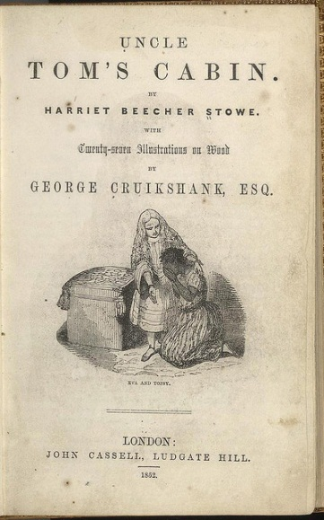
The plight of fugitive slaves, vividly portrayed in the mega best seller of the 1850s, Uncle Tom’s Cabin, created a crisis in federalism that led directly to the Civil War.
Source:http://www.flickr.com/photos/48734803@N00/252322873/.
In 1857, the Supreme Court stepped into the fray. Dred Scott, the slave of a deceased Missouri army surgeon, sued for freedom, noting he had accompanied his master for extended stays in a free state and a free territory. ^{[4]} The justices dismissed Scott’s claim. They stated that blacks, excluded from the Constitution, could never be US citizens and could not sue in federal court. They added that any national restriction on slavery in territories violated the Fifth Amendment, which bars the government from taking property without due process of law. To many Northerners, the Dred Scott decision raised doubts about whether any state could effectively ban slavery. In December 1860, a convention in South Carolina repealed the state’s ratification of the Constitution and dissolved its union with the other states. Ten other states followed suit. The eleven formed the Confederate States of America (see ).

Links
The Underground Railroad
Learn more about the Underground Railroad online athttp://www.pbs.org/wgbh/aia/part4/4p2944.html.
The Dred Scott Case
Learn more about the Dred Scott case from the Library of Congress athttp://www.loc.gov/rr/program/bib/ourdocs/DredScott.html.

Enduring Image
The Confederate Battle Flag
The American flag is an enduring image of the United States’ national unity. The Civil War battle flag of the Confederate States of America is also an enduring image, but of states’ rights, of opposition to a national government, and of support for slavery. The blue cross studded with eleven stars for the states of the Confederacy was not its official flag. Soldiers hastily pressed it into battle to avoid confusion between the Union’s Stars and Stripes and the Confederacy’s Stars and Bars. After the South’s defeat, the battle flag, often lowered for mourning, was mainly a memento of gallant human loss. ^{[5]}
The flag’s meaning was transformed in the 1940s as the civil rights movement made gains against segregation in the South. One after another Southern state flew the flag above its capitol or defiantly redesigned the state flag to incorporate it. Over the last sixty years, a myriad of meanings arousing deep emotions have become attached to the flag: states’ rights; Southern regional pride; a general defiance of big government; nostalgia for a bygone era; racist support of segregation; or “equal rights for whites.” ^{[6]}
Confederate Flag
© Thinkstock
The battle flag appeals to politicians seeking resonant images. But its multiple meanings can backfire. In 2003, former Vermont governor Howard Dean, a candidate for the Democratic presidential nomination, addressed the Democratic National Committee and said, “White folks in the South who drive pickup trucks with Confederate flag decals on the back ought to be voting with us, and not them [Republicans], because their kids don’t have health insurance either, and their kids need better schools too.” Dean received a rousing ovation, so he probably thought little of it when he told the Des Moines Register, “I still want to be the candidate for guys with Confederate flags in their pickup trucks.” ^{[7]} Dean, the Democratic front runner, was condemned by his rivals who questioned his patriotism, judgment, and racial sensitivity. Dean apologized for his remark. ^{[8]}
The South’s defeat in the Civil War discredited compact theory and nullification. Since then, state officials’ efforts to defy national orders have been futile. In 1963, Governor George Wallace stood in the doorway of the University of Alabama to resist a court order to desegregate the all-white school. Eventually, he had no choice but to accede to federal marshals. In 1994, Pennsylvania governor Robert Casey, a pro-life Democrat, decreed he would not allow state officials to enforce a national order that state-run Medicaid programs pay for abortions in cases of rape and incest. He lost in court. ^{[9]}

Dual Federalism
After the Civil War, the justices of the Supreme Court wrote, “The Constitution, in all its provisions, looks to an indestructible Union, composed of indestructible States.” ^{[10]} They endorsed dual federalism, a doctrine whereby national and state governments have clearly demarcated domains of power. The national government is supreme, but only in the areas where the Constitution authorizes it to act.
The basis for dual federalism was a series of Supreme Court decisions early in the nineteenth century. The key decision was McCulloch v. Maryland (1819). The Court struck down a Maryland state tax on the Bank of the United States chartered by Congress. Chief Justice Marshall conceded that the Constitution gave Congress no explicit power to charter a national bank, ^{[11]} but concluded that the Constitution’s necessary-and-proper clause enabled Congress and the national government to do whatever it deemed “convenient or useful” to exercise its powers. As for Maryland’s tax, he wrote, “the power to tax involves the power to destroy.” Therefore, when a state’s laws interfere with the national government’s operation, the latter takes precedence. From the 1780s to the Great Depression of the 1930s, the size and reach of the national government were relatively limited. As late as 1932, local government raised and spent more than the national government or the states.

Link
McCulloch v. Maryland
Read more about McCulloch v. Maryland (1819) online athttp://www.pbs.org/wnet/supremecourt/antebellum/landmark_mcculloch.html.
On two subjects, however, the national government increased its power in relationship to the states and local governments: sin and economic regulation.

The Politics of Sin
National powers were expanded when Congress targeted obscenity, prostitution, and alcohol. ^{[12]} In 1872, reformers led by Anthony Comstock persuaded Congress to pass laws blocking obscene material from being carried in the US mail. Comstock had a broad notion of sinful media: all writings about sex, birth control, abortion, and childbearing, plus tabloid newspapers that allegedly corrupted innocent youth.
Figure 3.3
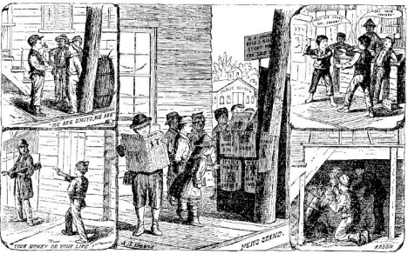
The first book by Anthony Comstock, who headed the New York Society for the Suppression of Vice, aimed at the supposedly corrupting influence of the tabloid media of the day on children and proposed increasing the power of the national government to combat them.
Source: Morone, James A.,Hellfire Nation: The Politics of Sin in American History, (New Haven, CT: Yale University Press, 2003), 233.
As a result of these laws, the national government gained the power to exclude material from the mail even if it was legal in individual states.
The power of the national government also increased when prostitution became a focus of national policy. A 1910 exposé in McClure’s magazine roused President William Howard Taft to warn Congress about prostitution rings operating across state lines. The ensuing media frenzy depicted young white girls torn from rural homes and degraded by an urban “white slave trade.” Using the commerce clause, Congress passed the Mann Act to prohibit the transportation “in interstate commerce…of any woman or girl for the purpose of prostitution or debauchery, or for any other immoral purpose.” ^{[13]}The bill turned enforcement over to a tiny agency concerned with antitrust and postal violations, the Bureau of Investigations. The Bureau aggressively investigated thousands of allegations of “immoral purpose,” including unmarried couples crossing state lines to wed and interracial married couples.
The crusade to outlaw alcohol provided the most lasting expansion of national power. Reformers persuaded Congress in 1917 to bar importation of alcohol into dry states, and, in 1919, to amend the Constitution to allow for the nationwide prohibition of alcohol. Pervasive attempts to evade the law boosted organized crime, a rationale for the Bureau of Investigations to bloom into the Federal Bureau of Investigation (FBI), the equivalent of a national police force, in the 1920s.
Prohibition was repealed in 1933. But the FBI under J. Edgar Hoover, its director from the 1920s to the 1970s, continued to call attention through news and entertainment media to the scourge of organized crime that justified its growth, political independence, and Hoover’s power. The FBI supervised film depictions of the lives of criminals like John Dillinger and long-running radio and television shows like The FBI. The heroic image of federal law enforcement would not be challenged until the 1960s when the classic film Bonnie and Clyderomanticized the tale of two small-time criminals into a saga of rebellious outsiders crushed by the ominous rise of authority across state lines.

Economic Regulation
Other national reforms in the late nineteenth century that increased the power of the national government were generated by reactions to industrialization, immigration, and urban growth. Crusading journalists decried the power of big business. Upton Sinclair’s 1906 novel The Jungle exposed miserable, unsafe working conditions in America’s factories. These reformers feared that states lacked the power or were reluctant to regulate railroads, inspect meat, or guarantee food and drug safety. They prompted Congress to use its powers under the commerce clause for economic regulation, starting with the Interstate Commerce Act in 1887 to regulate railroads and the Sherman Antitrust Act in 1890 to outlaw monopolies.
The Supreme Court, defending dual federalism, limited such regulation. It held in 1895 that the national government could only regulate matters directlyaffecting interstate commerce. ^{[14]} In 1918, it ruled that Congress could not use the commerce clause to deal with local matters like conditions of work. The national government could regulate interstate commerce of harmful products such as lottery tickets or impure food. ^{[15]}

Cooperative Federalism
The massive economic crises of the Great Depression tolled the death knell for dual federalism. In its place, cooperative federalism emerged. Instead of a relatively clear separation of policy domains, national, state, and local governments would work together to try to respond to a wide range of problems.

The New Deal and the End of Dual Federalism
Elected in 1932, Democratic president Franklin Delano Roosevelt (FDR) sought to implement a “New Deal” for Americans amid staggering unemployment. He argued that the national government could restore the economy more effectively than states or localities. He persuaded Congress to enact sweeping legislation. New Deal programs included boards enforcing wage and price guarantees; programs to construct buildings and bridges, develop national parks, and create artworks; and payments to farmers to reduce acreage of crops and stabilize prices.
Figure 3.4 Dorothea Lange Photograph
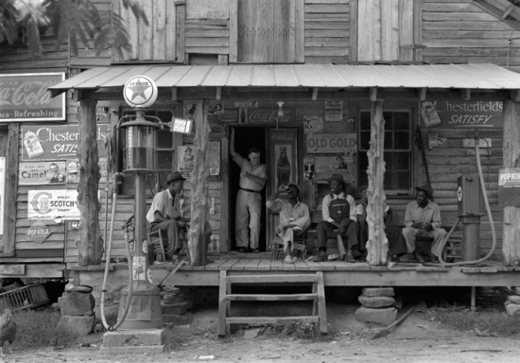
The 1930s New Deal programs included commissioning photographers to document social conditions during the Great Depression. The resultant photographs are both invaluable historical documents and lasting works of art.
Source: Photo courtesy of the US Farm Security Administration,http://commons.wikimedia.org/wiki/File:Dorothea_Lange,_Country_store_on_dirt _road,_Gordonton,_North_Carolina,_1939.jpg.
By 1939, national government expenditures equaled state and local expenditures combined. ^{[16]} FDR explained his programs to nationwide audiences in “fireside chats” on the relatively young medium of radio. His policies were highly popular, and he was reelected by a landslide in 1936. As we describe in , the Supreme Court, after rejecting several New Deal measures, eventually upheld national authority over such once-forbidden terrain as labor-management relations, minimum wages, and subsidies to farmers. ^{[17]} The Court thereby sealed the fate of dual federalism.

Links
The New Deal
Learn more about the New Deal online athttp://www.archives.gov/research/alic/reference/new-deal.html.
Fireside Chats
Read the Fireside Chats online athttp://docs.fdrlibrary.marist.edu/firesi90.html.

Grants-in-Aid
Cooperative federalism’s central mechanisms were grants-in-aid: the national government passes funds to the states to administer programs. Starting in the 1940s and 1950s, national grants were awarded for infrastructure (airport construction, interstate highways), health (mental health, cancer control, hospital construction), and economic enhancement (agricultural marketing services, fish restoration). ^{[18]}
Grants-in-aid were cooperative in three ways. First, they funded policies that states already oversaw. Second, categorical grants required states to spend the funds for purposes specified by Congress but gave them leeway on how to do so. Third, states’ and localities’ core functions of education and law enforcement had little national government supervision. ^{[19]}

Competitive Federalism
During the 1960s, the national government moved increasingly into areas once reserved to the states. As a result, the essence of federalism today is competition rather than cooperation. ^{[20]}

Judicial Nationalizing
Cooperative federalism was weakened when a series of Supreme Court decisions, starting in the 1950s, caused states to face much closer supervision by national authorities. As we discuss in and , the Court extended requirements of the Bill of Rights and of “equal protection of the law” to the states.

The Great Society
In 1963, President Lyndon Johnson proposed extending the New Deal policies of his hero, FDR. Seeking a “Great Society” and declaring a “War on Poverty,” Johnson inspired Congress to enact massive new programs funded by the national government. Over two hundred new grants programs were enacted during Johnson’s five years in office. They included a Jobs Corps and Head Start, which provided preschool education for poor children.
The Great Society undermined cooperative federalism. The new national policies to help the needy dealt with problems that states and localities had been unable or reluctant to address. Many of them bypassed states to go straight to local governments and nonprofit organizations. ^{[21]}

Link
The Great Society
Read more about the Great Society online athttp://www.pbs.org/johngardner/chapters/4.html.

Obstacles and Opportunities
In competitive federalism, national, state, and local levels clash, even battle with each other. ^{[22]} Overlapping powers and responsibilities create friction, which is compounded by politicians’ desires to get in the news and claim credit for programs responding to public problems.
Competition between levels of federalism is a recurring feature of films and television programs. For instance, in the eternal television drama Law and Order and its offshoots, conflicts between local, state, and national law enforcement generate narrative tension and drama. This media frame does not consistently favor one side or the other. Sometimes, as in the film The Fugitiveor stories about civil rights like Mississippi Burning, national law enforcement agencies take over from corrupt local authorities. Elsewhere, as in the action film Die Hard, national law enforcement is less competent than local or state police.

Mandates
Under competitive federalism, funds go from national to state and local governments with many conditions—most notably, directives known asmandates. ^{[23]} State and local governments want national funds but resent conditions. They especially dislike “unfunded mandates,” according to which the national government directs them what to do but gives them no funds to do it.
After the Republicans gained control of Congress in the 1994 elections, they passed a rule to bar unfunded mandates. If a member objects to an unfunded mandate, a majority must vote to waive the rule in order to pass it. This reform has had little impact: negative news attention to unfunded mandates is easily displaced by dramatic, personalized issues that cry out for action. For example, in 1996, the story of Megan Kanka, a young New Jersey girl killed by a released sex offender living in her neighborhood, gained huge news attention. The same Congress that outlawed unfunded mandates passed “Megan’s Law”—including an unfunded mandate ordering state and local law enforcement officers to compile lists of sex offenders and send them to a registry run by the national government.

KEY TAKEAWAYS
Federalism in the United States has changed over time from clear divisions of powers between national, state, and local governments in the early years of the republic to greater intermingling and cooperation as well as conflict and competition today. Causes of these changes include political actions, court decisions, responses to economic problems (e.g., depression), and social concerns (e.g., sin).

EXERCISES
- What view of federalism allowed the Confederate states to justify seceding from the United States? How might this view make it difficult for the federal government to function in the long run?
- What are the differences between dual federalism and cooperative federalism? What social forces led to the federal state governments working together in a new way?
- How is federalism portrayed in the movies and television shows you’ve seen? Why do you think it is portrayed that way?

[1] Forrest McDonald, States’ Rights and the Union: Imperium in Imperio, 1776–1876(Lawrence: University Press of Kansas, 2000), 38–43.
[2] This section draws on James M. McPherson, Battle Cry of Freedom: The Civil War Era(New York: Oxford University Press, 1988).
[3] Thomas D. Morris, Free Men All: The Personal Liberty Laws of the North, 1780–1861(Baltimore, MD: Johns Hopkins University Press, 1974).
[4] An encyclopedic account of this case is Don E. Fehrenbacher, The Dred Scott Case: Its Significance in American Law and Politics (New York: Oxford University Press, 1978).
[5] See especially Robert E. Bonner, Colors and Blood: Flag Passions of the Confederate South (Princeton, NJ: Princeton University Press, 2002).
[6] For overviews of these meanings see Tony Horwitz, Confederates in the Attic: Dispatches from the Unfinished Civil War (New York: Random House, 1998) and J. Michael Martinez, William D. Richardson, and Ron McNinch-Su, eds., Confederate Symbols in the Contemporary South (Gainesville: University of Florida Press, 2000).
[7] All quotes come from “Dems Battle over Confederate Flag,” CNN, November 2, 2003,http://www.cnn.com/2003/ALLPOLITICS/11/01/elec04.prez.dean.confederate.flag.
[8] “Dean: ‘I Apologize’ for Flag Remark,” CNN, November 7, 2003,http://www.cnn.com/2003/ALLPOLITICS/11/06/elec04.prez.dean.flag.
[9] David L. Shapiro, Federalism: A Dialogue (Evanston, IL: Northwestern University Press, 1995), 98 n. 139.
[10] Texas v. White, 7 Wall. 700 (1869).
[11] McCulloch v. Maryland, 4 Wheat. 316 (1819).
[12] This section draws on James A. Morone, Hellfire Nation: The Politics of Sin in American History (New Haven, CT: Yale University Press, 2003), chaps. 8–11.
[13] Quoted in James A. Morone, Hellfire Nation: The Politics of Sin in American History (New Haven, CT: Yale University Press, 2003), 266.
[14] United States v. E. C. Knight, 156 US 1 (1895).
[15] Hammer v. Dagenhart, 247 US 251 (1918). A similar logic prevented the US government from using taxation powers to the same end. Bailey v. Drexel Furniture Company, 259 US 20 (1922).
[16] Thomas Anton, American Federalism & Public Policy: How the System Works(Philadelphia, PA: Temple University Press, 1988), 41.
[17] Respectively, National Labor Relations Board v. Jones & Laughlin Steel, 301 US 1 (1937);United States v. Darby, 312 US 100 (1941); Wickard v. Filburn, 317 US 111 (1942).
[18] David B. Walker, The Rebirth of Federalism: Slouching toward Washington(Washington, DC: CQ Press, 1999), 99.
[19] Martha Derthick, Keeping the Compound Republic: Essays on American Federalism(Washington, DC: Brookings, 2001), 17.
[20] Paul E. Peterson, Barry George Rabe, and Kenneth K. Wong, When Federalism Works(Washington, DC: Brookings, 1986), especially chap. 5; Martha Derthick, Keeping the Compound Republic: Essays on American Federalism (Washington, DC: Brookings, 2001), chap. 10.
[21] David B. Walker, The Rebirth of Federalism: Slouching toward Washington(Washington, DC: CQ Press, 1999), 123–25.
[22] The term “competitive federalism” is developed in Thomas R. Dye, American Federalism: Competition among Governments (Lexington, MA: Lexington Books, 1990).
[23] This definition is drawn from Michael Fix and Daphne Kenyon, eds., Coping with Mandates: What Are the Alternatives? (Washington, DC: Urban Institute Press, 1988), 3–4.

3.3 Why Federalism Works (More or Less)

LEARNING OBJECTIVES
After reading this section, you should be able to answer the following questions:
- How do national, state, and local governments interact to make federalism work more or less?
- How are interest groups involved in federalism?
- What are the ideological and political attitudes toward federalism of the Democratic and Republican parties?
When Hurricane Katrina hit New Orleans and the surrounding areas on August 29, 2005, it exposed federalism’s frailties. The state and local government were overwhelmed, yet there was uncertainty over which level of government should be in charge of rescue attempts. Louisiana governor Kathleen Blanco refused to sign an order turning over the disaster response to federal authorities. She did not want to cede control of the National Guard and did not believe signing the order would hasten the arrival of the troops she had requested. President Bush failed to realize the magnitude of the disaster, then believed that the federal response was effective. In fact, as was obvious to anyone watching television, it was slow and ineffective. New Orleans mayor C. Ray Nagin and state officials accused the Federal Emergency Management Agency (FEMA) of failing to deliver urgently needed help and of thwarting other efforts through red tape.
Hurricane Katrina was an exceptional challenge to federalism. Normally, competition between levels of government does not careen out of control, and federalism works, more or less. We have already discussed one reason: a legal hierarchy—in which national law is superior to state law, which in turn dominates local law—dictates who wins in clashes in domains where each may constitutionally act.
There are three other reasons. ^{[1]} First, state and local governments provide crucial assistance to the national government. Second, national, state, and local levels have complementary capacities, providing distinct services and resources. Third, the fragmentation of the system is bridged by interest groups, notably the intergovernmental lobby that provides voices for state and local governments. We discuss each reason.

Applying Policies Close to Home
State and local governments are essential parts of federalism because the federal government routinely needs them to execute national policy. State and local governments adjust the policies as best they can to meet their political preferences and their residents’ needs. Policies and the funds expended on them thus vary dramatically from one state to the next, even in national programs such as unemployment benefits. ^{[2]}
This division of labor, through which the national government sets goals and states and localities administer policies, makes for incomplete coverage in the news. National news watches the national government, covering more the political games and high-minded intentions of policies then the nitty-gritty of implementation. Local news, stressing the local angle on national news, focuses on the local impact of decisions in distant Washington (see ).

Comparing Content
Passage of No Child Left Behind Act
The No Child Left Behind (NCLB) Act vastly expanded the national government’s supervision of public education with requirements for testing and accountability. Amid the final push toward enacting the law, Washington reporters for national newspapers were caught up in a remarkable story: the bipartisan coalition uniting staunch opponents President George W. Bush and liberal senator Edward Kennedy (D-MA) civilly working together on a bold, historic piece of legislation. Dana Milbank’s Washington Post story was typical. Milbank termed the bill “the broadest rewriting of federal education policy in decades,” and he admired “Washington’s top bipartisan achievement of 2001.” ^{[3]} The looming problems of funding and implementing the act were obscured in the national media’s celebration of the lovefest.
By contrast, local newspapers across the country calculated the benefits and costs of the new legislation on education in their states and localities—in particular, how much money the state would receive under NCLB and whether or not the law’s requirements and deadlines were reasonable. On January 9, 2002, the Boston Globe’s headline was “Mass. Welcomes Fed $$; Will Reap $117M for Schools, Testing,” and the Denver Post noted, “Colorado to Get $500 million for Schools.” ^{[4]}
Local newspapers sought out comments of state and local education officials and leaders of local teachers’ unions, who were less smitten by the new law. The Sacramento Bee published a lengthy front-page story by reporter Erika Chavez on January 3, shortly before Bush signed the law. Chavez contrasted the bill’s supporters who saw it as “the most meaningful education reform in decades” with opponents who found that “one crucial aspect of the legislation is nothing more than a pipe dream.” Discussing the bill’s provision that all teachers must be fully credentialed in four years, a staffer at the State Department of Education was quoted as saying “The numbers don’t add up, no matter how you look at them.” The California Teachers’ Association’s president called it “fantasy legislation,” adding, “It’s irresponsible to pass this kind of law and not provide the assistance needed to make the goals attainable. I can’t understand the reason or logic that went into this legislation. It’s almost a joke.” ^{[5]}

Complementary Capacities
The second reason federalism often works is because national, state, and local governments specialize in different policy domains. ^{[6]} The main focus of local and state government policy is economic development, broadly defined to include all policies that attract or keep businesses and enhance property values. States have traditionally taken the lead in highways, welfare, health, natural resources, and prisons. ^{[7]} Local governments dominate in education, fire protection, sewerage, sanitation, airports, and parking.
The national government is central in policies to serve low-income and other needy persons. In these redistributive policies, those paying for a service in taxes are not usually those receiving the service. ^{[8]} These programs rarely get positive coverage in the local news, which often shows them as “something-for-nothing” benefits that undeserving individuals receive, not as ways to address national problems. ^{[9]}
States cannot effectively provide redistributive benefits. It is impossible to stop people from moving away because they think they are paying too much in taxes for services. Nor can states with generous benefits stop outsiders from moving there—a key reason why very few states enacted broad health care coverage^{[10]}—and why President Obama pressed for and obtained a national program. Note, however, that, acknowledging federalism, it is the states’ insurance commissioners who are supposed to interpret and enforce many of the provisions of the new federal health law
The three levels of government also rely on different sources of taxation to fund their activities and policies. The national government depends most heavily on the national income tax, based on people’s ability to pay. This enables it to shift funds away from the wealthier states (e.g., Connecticut, New Jersey, New Hampshire) to poorer states (e.g., New Mexico, North Dakota, West Virginia).
Taxes of local and state governments are more closely connected to services provided. Local governments depend mainly on property taxes, the more valuable the property the more people pay. State governments collect state income taxes but rely most on sales taxes gathered during presumably necessary or pleasurable consumer activity.

Link
Tax and Budget Information for Federal, State, and Local Governments
Find more information about government budgets and taxes.
Federal
http://www.census.gov/compendia/statab/cats/federal_govt_finances_employment.html
State
http://www.census.gov/compendia/statab/cats/state_local_govt_finances_employment/state_government_finances.html
Local
http://www.census.gov/compendia/statab/cats/state_local_govt_finances_employment/local_government_finances.html
The language of “no new taxes” or “cutting taxes” is an easy slogan for politicians to feature in campaign ads and the news. As a result, governments often increase revenues on the sly, by lotteries, cigarette and alcohol taxes, toll roads, and sales taxes falling mostly on nonresidents (like hotel taxes or surcharges on car rentals). ^{[11]}

The Intergovernmental Lobby
A third reason federalism often works is because interest groups and professional associations focus simultaneously on a variety of governments at the national, state, and local levels. With multiple points of entry, policy changes can occur in many ways. ^{[12]}
In bottom-up change, a problem is first identified and addressed, but not resolved at a local level. People, and often the media, then pressure state and national governments to become involved. Bottom-up change can also take place through an interest group calling on Congress for help. ^{[13]} In 1996, pesticide manufacturers, fed up with different regulations from state to state, successfully pushed Congress to set national standards to make for more uniform, and less rigorous, regulation.
In top-down change, breaking news events inspire simultaneous policy responses at various levels. Huge publicity for the 1991 beating that motorist Rodney King received from Los Angeles police officers propelled police brutality onto the agenda nationwide and inspired many state and local reforms.^{[14]}
Policy diffusion is a horizontal form of change. ^{[15]} State and local officials watch what other state and local governments are doing. States can be “laboratories of democracy,” experimenting with innovative programs that spread to other states. They can also make problems worse with ineffective or misdirected policies.
These processes—bottom-up, top-down, and policy diffusion—are reinforced by the intergovernmental lobby. State and local governments lobby the president and Congress. Their officials band together in organizations, such as the National Governors Association, National Association of Counties, the US Conference of Mayors, and the National Conference of State Legislatures. These associations trade information and pass resolutions to express common concerns to the national government. Such meetings are one-stop-shopping occasions for the news media to gauge nationwide trends in state and local government.

Democrats, Republicans, and Federalism
The parties stand for different principles with regard to federalism. Democrats prefer policies to be set by the national government. They opt for national standards for consistency across states and localities, often through attaching stringent conditions to the use of national funds. Republicans decry such centralization and endorse devolution, giving (or, they say, “returning”) powers to the states—and seeking to shrink funds for the national government.
Principled distinctions often evaporate in practice. Both parties have been known to give priority to other principles over federalism and to pursue policy goals regardless of the impact on boundaries between national, state, and local governments. ^{[16]}
So Republicans sometimes champion a national policy while Democrats look to the states. In 2004, the Massachusetts Supreme Court ruled that the state could not deny marriage licenses to same-sex couples, and officials in cities like San Francisco defied state laws and began marrying same-sex couples. Led by President George W. Bush, Republicans drafted an amendment to the US Constitution to define marriage as between a man and a woman. Bush charged that “activist judges and local officials in some parts of the country are not letting up in their efforts to redefine marriage for the rest of America.” ^{[17]}Democrats, seeking to defuse the amendment’s appeal, argued that the matter should be left to each of the states. Democrats’ appeal to federalism swayed several Republican senators to vote to kill the amendment.
“The American Recovery and Reinvestment Act,” enacted in February 2009, is another example. This was a dramatic response by Congress and the newly installed Obama administration to the country’s dire economic condition. It included many billions of dollars in a fiscal stabilization fund: aid to the states and localities struggling with record budget deficits and layoffs. Most Democratic members of Congress voted for the legislation even though it gave the funds unconditionally. Republicans opposed the legislation, preferring tax cuts over funding the states.

Economic Woes
The stimulus package was a stopgap measure. After spending or allocating most of the federal funds, many states and localities still faced a dire financial situation. The federal government, running a huge budget deficit, was unlikely to give the states significant additional funding. As unemployment went up and people’s incomes went down, states’ tax collections decreased and their expenditures for unemployment benefits and health care increased. Many states had huge funding obligations, particularly for pensions they owed and would owe to state workers.
State governors and legislators, particularly Republicans, had promised in their election campaigns not to raise taxes. They relied on cutting costs. They reduced aid to local governments and cities. They fired some state employees, reduced pay and benefits for others, slashed services and programs (including welfare, recreation, and corrections), borrowed funds, and engaged in accounting maneuvers to mask debt.
At the University of California, for example, staff were put on furlough, which cut their pay by roughly 8 percent, teaching assistants were laid off, courses cut, library hours reduced, and recruitment of new faculty curtailed. Undergraduate fees (tuition) were increased by over 30 percent, provoking student protests and demonstrations.
At the local level, school districts’ budgets declined as they received less money from property taxes and from the states (about one quarter of all state spending goes to public schools). They fired teachers, hired few new ones (resulting in a horrendous job market for recent college graduates wanting to teach), enlarged classes, cut programs, shortened school hours, and closed schools.

KEY TAKEAWAYS
The federal system functions, more or less, because of the authority of national over state laws, which trump local laws; crucial assistance provided by states and local governments to execute national policy; the complementary capacities of the three levels of government; and the intergovernmental lobby. The functioning of the system is being challenged by the economic woes faced by government at all levels. The Democratic and Republican parties differ ideologically about federalism, although these differences can be changed to achieve political objectives.

EXERCISES
- How do the perspectives of national, state, and local governments complement one another? What are the strengths of each perspective?
- Why do you think Democrats are more likely to prefer to make policy at the national level? Why are Republicans more likely to prefer to leave policymaking to state and local governments?
- How did conflicts between the national government and state and local governments contribute to damage caused by Hurricane Katrina? Why do you think federalism broke down in that case?

[1] See also John D. Nugent, Safeguarding Federalism: How States Protect Their Interests in National Policymaking (Norman: University of Oklahoma Press, 2009).
[2] Thomas R. Dye, American Federalism: Competition among Governments (Lexington, MA: Lexington Books, 1990), chap. 2; Paul E. Peterson, The Price of Federalism (Washington, DC: Brookings, 1995), chap. 4.
[3] Dana Milbank, “With Fanfare, Bush Signs Education Bill,” Washington Post, January 9, 2002, A3.
[4] Ed Hayward, “Mass. Welcomes Fed $; Will Reap $117M for Schools, Testing,” Boston Globe, January 9, 2002, 7; Monte Whaley, “Colorado to Get $500 Million for Schools,”Denver Post, January 9, 2002, A6.
[5] Erika Chavez, “Federal Teacher Goal is Blasted; Congress’ Mandate that Instructors Get Credentials in 4 Years is Called Unrealistic,” Sacramento Bee, January 3, 2002, A1.
[6] This section draws on Paul E. Peterson, The Price of Federalism (Washington, DC: Brookings, 1995).
[7] Thomas Anton, American Federalism & Public Policy: How the System Works(Philadelphia, PA: Temple University Press, 1988), table 3.3.
[8] This definition comes from Paul E. Peterson, Barry George Rabe, and Kenneth K. Wong,When Federalism Works (Washington, DC: Brookings, 1986), 15.
[9] Paul E. Peterson, Barry George Rabe, and Kenneth K. Wong, When Federalism Works(Washington, DC: Brookings, 1986), 19.
[10] Mark C. Rom and Paul E. Peterson, Welfare Magnets: A New Case for a New National Standard (Washington, DC: Brookings, 1990).
[11] Glenn R. Beamer, Creative Politics: Taxes and Public Goods in a Federal System (Ann Arbor: University of Michigan Press, 1999), chap. 4.
[12] Thomas Anton, American Federalism & Public Policy: How the System Works(Philadelphia, PA: Temple University Press, 1988), chap. 5.
[13] David R. Berman, Local Government and the States: Autonomy, Politics, and Policy(Armonk, NY: M.E. Sharpe, 2003), 20.
[14] Regina G. Lawrence, The Politics of Force: Media and the Construction of Police Brutality(Berkeley: University of California Press, 2000).
[15] Jack L. Walker, “Diffusion of Innovations among American States,” American Political Science Review 63 (1969): 880–99.
[16] Paul L. Posner, The Politics of Unfunded Mandates: Whither Federalism? (Washington, DC: Georgetown University Press, 1998), 223.
[17] Carl Hulse, “Senators Block Initiative to Ban Same-Sex Unions,” New York Times, July 15, 2004, A1.

3.4 Federalism in the Information Age

LEARNING OBJECTIVES
After reading this section, you should be able to answer the following questions:
- What are the strengths and weaknesses of the media in covering federalism?
- How are some public officials in the federal system able to use the media to advance their political agendas?
- What effects could the new media have on people’s knowledge of and commitment to federalism?
Federalism gives the American political system additional complexity and dynamism. The number of governments involved in a wide sweep of issues creates many ways for people in politics to be heard. These processes are facilitated by a media system that resembles federalism by its own merging and mingling of national, state, and local content and audiences.

Media Interactions
National, state, and local news and entertainment outlets all depict federalism. Now they are joined by new technologies that communicate across geographical boundaries.

National News Outlets
News on network television, cable news channels, and public broadcasting is aimed at a national audience. A few newspapers are also national. Reporters for these national outlets are largely based in New York and Washington, DC, and in a smattering of bureaus here and there across the country.

Local News Outlets
Local television stations transmit the news programs of the national networks to which they are affiliated. They broadcast local news on their own news shows. These shows are not devoid of substance, although it is easy to make fun of them as vapid and delivered by airheads, like Will Ferrell’s character Ron Burgundy in the 2004 comic film Anchorman. But they have only scattered national and international coverage, and attention to local and state government policies and politics is overshadowed by stories about isolated incidents such as crimes, car chases, and fires.
Almost all newspapers are local. Stories from the wire services enable them to include national and international highlights and some state items in their news, but most of their news is local. As their staff shrinks, they increasingly defer to powerful official sources in city hall or the police station for the substance of news. The news media serving smaller communities are even more vulnerable to pressure from local officials for favorable coverage and from advertisers who want a “feel-good” context for their paid messages.

From National to Local
Local newspapers and television stations sometimes have their own correspondents in Washington, DC. They can add a local angle by soliciting information and quotes from home-state members of Congress. Or, pooling of resources lets local television broadcasts make it look as though they have sent a reporter to Washington; a single reporter can send a feed to many stations by ending with an anonymous, “Now back to you.”

From Local to National
Some local stories become prominent and gain saturation coverage in the national news. Examples are the shootings at Columbine High School in Littleton, Colorado, in 1999; the murder of pregnant Laci Peterson in California on Christmas Eve 2002; the kidnapping in Utah of Elizabeth Smart in 2003; and the 2005 battle over the fate of the comatose Terri Schiavo in Florida. The cozy relationships of local officials and local reporters are dislodged when national reporters from the networks parachute in to cover the event.
In 2011, federalism took center stage with the efforts of Republican governor Scott Walker of Wisconsin, and related steps by the Republican governors of Indiana and Ohio, to save funds by stripping most of the collective bargaining power of the state’s public employee unions. Stories reported on the proposed policies, Democratic legislators’ efforts to thwart them, and the workers’ and supporters’ sit-ins and demonstrations.
Such stories expand amid attention from local and national news outlets and discussion about their meaning and import. National, state, and local officials alike find they have to respond to the problems evoked by the dramatic event.^{[1]}

State News and State Politics
Except for certain governors and attorneys general, the local media give little space in their news to state governments and their policies. One reason is that there are only a few truly statewide news outlets like New Hampshire’sManchester UnionLeader or Iowa’s Des Moines Register. Another reason is that most state capitals are far from the state’s main metropolitan area. Examples such as Boston and Atlanta, where the state capital is the largest city, are unusual. The four largest states are more typical: their capitals (Sacramento, Austin, Tallahassee, and Albany) are far (and in separate media markets) from Los Angeles, Houston, Miami, and New York City.
Capital cities’ local news outlets do give emphasis to state government. But those cities are relatively small, so that news about state government usually goes to people involved with state government more than to the public in the state as a whole.
State officials do not always mind the lack of scrutiny of state government. It allows some of them to get their views into the media. Governors, for example, have full-time press officers as key advisors and routinely give interviews and hold news conferences. According to governors’ press secretaries, their press releases are often printed word-for-word across the state; and the governors also gain positive coverage when they travel to other cities for press events such as signing legislation. ^{[2]}

Media Consequences
The variety and range of national and local media offer opportunities for people in politics to gain leverage and influence. National policymakers, notably the president, use national news and entertainment media to reach a national public. But because local news media serve as a more unfiltered and thus less critical conduit to the public, they also seek and obtain positive publicity from them.
State governors and big-city mayors, especially when they have few formal powers or when they face a state legislature or city council filled with opponents, can parlay favorable media attention into political power. ^{[3]} At best, a governor (as one wrote in the 1960s) “sets the agenda for public debate; frames the issues; decides the timing; and can blanket the state with good ideas by using access to the mass media.” ^{[4]}
Some state attorneys general are particularly adept and adroit at attracting positive media coverage through the causes they pursue, the (sometimes) outrageous accusations they announce, and the people they prosecute. One result is to put intolerable pressure on their targets to settle before trial. Another is reams of favorable publicity that they can parlay into a successful campaign for higher office, as Eliot Spitzer did in becoming governor of New York in 2006, and Andrew Cuomo in 2010.
But to live by the media sword is sometimes to die by it, as Governor Spitzer discovered when the media indulged in a feeding frenzy of stories about his engaging the services of prostitutes. He resigned from office in disgrace in March 2008. (See the documentary Client 9, listed in our “Recommended Viewing.”) Indeed, news attention can be unwanted and destructive. After he was arrested in December 2008 for corruption, the widespread negative coverage Illinois governor Rod Blagojevich received in the national, state, and local media contributed to his speedy impeachment and removal from office by the state legislature the next month.
The media are also important because officials are news consumers in their own right. State legislators value news exposure to communicate to other legislators, the governor, and interest groups and to set the policy agenda. ^{[5]} Thus legislative staffers in Illinois conclude that news coverage is a better indicator of public opinion than polls. ^{[6]} The news may more heavily and quickly influence officials’ views of problems and policy issues than the public’s.

New Media and Federalism
New technologies that enable far-flung individuals quickly to obtain news from many locales can help people understand the many dimensions of federalism. People in politics in one state can, with a few keystrokes, find out how an issue is being dealt with in all fifty states, thus providing a boost for ideas and issues to travel more quickly than ever across state lines. The National Conference of State Legislatures, as part of its mission to “offer a variety of services to help lawmakers tailor policies that will work for their state and their constituents,” maintains a website, http://www.ncsl.org, with a motto “Where Policy Clicks!” allowing web surfers to search the latest information from a whole range of states about “state and federal issues A to Z.”
But new media create a challenge for federalism. They erode the once-close connection of media to geographically defined communities. Consumers can tune in to distant satellite and cable outlets as easily as local television stations. Cell phones make it as convenient (and cheap) to call across the country as across the street. The Internet and the web, with their listservs, websites, weblogs, chat rooms, and podcasts, permit ready and ongoing connections to groups and communities that can displace individuals’ commitment to and involvement in their physical surroundings.
In one sense, new technologies simply speed up a development launched in the 1960s, when, as one scholar writes, “one type of group—the place-based group that federalism had honored—yielded to groups otherwise defined, as by race, age, disability, or orientation to an issue or cause.” ^{[7]}
Yet the vitality of state and local governments, presenting so many opportunities for people in politics to intervene, reminds us that federalism is not about to wither and die. In the end, the new technologies may enable individuals and groups more efficiently to manage the potentially overwhelming amount of information about what is going on in policymaking—and to navigate quickly and adroitly the dazzling and bemusing complexity of American federalism.

KEY TAKEAWAYS
The US media system blends national, state, and local outlets. Issues and stories move from one level to another. This enables people in politics to gain influence but can undermine them. New media technologies, fostering quick communication across vast expanses, allows people to learn and understand more about federalism but challenge federalism’s geographical foundation. Federalism seems like a daunting obstacle course, but it also opens up many opportunities for political action.

EXERCISES
- How do the perspectives of the national and local media differ? Why is there relatively little coverage of state politics in the national and local media?
- Do you get any of your news from new media? How does such news differ from the news you get from the traditional media?

Civic Education
Michael Barker versus the School Board
As Hamilton predicted in Federalist No. 28, if the people are frustrated at one level of government, they can make their voice heard and win policy battles at another. Federalism looks like a daunting obstacle course, yet it opens up a vast array of opportunities for political action.
Michael Barker did not set out to push the Louisiana state legislature for a new law. In 2003, Barker, a seventeen-year-old high school junior from the town of Jena, had wondered if his school district might save money on computer equipment by making smarter purchases. He sent four letters to the LaSalle Parish School Board requesting information about computer expenditures. He was rebuffed by the superintendent of schools, who notified him that a state law allowed public officials to deny requests for public records from anyone under the age of eighteen.
Barker did not understand why minors—including student journalists—had no right to access public information. Stymied locally, he aimed at the state government. He conducted an Internet search and discovered a statewide nonprofit organization, the Public Affairs Research Council (PAR), that promotes public access. Barker contacted PAR, which helped him develop a strategy to research the issue thoroughly and contact Jena’s state representative, Democrat Thomas Wright. Wright agreed to introduce House Bill 492 to strike the “age of majority” provision from the books. Barker testified in the state capital of Baton Rouge at legislative hearings on behalf of the bill, saying, “Our education system strives daily to improve upon people’s involvement in the democratic process. This bill would allow young people all over the state of Louisiana to be involved with the day-to-day operations of our state government.”
But Barker’s crusade had just begun. A state senator who had a personal beef with Representative Wright tried to block passage of the bill. Barker contacted a newspaper reporter who wrote a story about the controversy. The ensuing media spotlight caused the opposition to back down. After the bill was passed and signed into law by Governor Kathleen Blanco, Barker set up a website to share his experiences and to provide advice to young people who want to influence government. ^{[8]}

[1] Benjamin I. Page, Who Deliberates? (Chicago: University of Chicago Press, 1996).
[2] Charles Layton and Jennifer Dorroh, “Sad State,” American Journalism Review, June 2002,http://www.ajr.org/article_printable.asp?id=2562.
[3] This section draws from Thad L. Beyle and Lynn R. Muchmore, eds., “The Governor and the Public,” in Being Governor: The View from the Office (Durham, NC: Duke University Press, 1983), 52–66; Alan Rosenthal, Governors and Legislatures: Contending Powers (Washington, DC: CQ Press, 1990), 24–27; and Phyllis Kaniss, Making Local News (Chicago: University of Chicago Press, 1991), chap. 6.
[4] Former governor of North Carolina, Terry Sanford, Storm over the States (New York: McGraw-Hill, 1967), 184–85, quoted in Thad L. Beyle and Lynn R. Muchmore, eds., “The Governor and the Public,” in Being Governor: The View from the Office (Durham, NC: Duke University Press, 1983), 52.
[5] Christopher A. Cooper, “Media Tactics in the State Legislature,” State Politics and Policy Quarterly 2 (2002): 353–71.
[6] Susan Herbst, Reading Public Opinion: How Political Actors View the Democratic Process(Chicago: University of Chicago Press, 1998), chap. 2.
[7] Martha Derthick, Keeping the Compound Republic: Essays on American Federalism(Washington, DC: Brookings, 2001), 152.
[8] This information comes from Jan Moller, “Teen’s Curiosity Spurs Open-Records Bill,” New Orleans Times-Picayune, April 14, 2004; and Wendy Scahetzel Lesko, “Teen Changes Open-Records Law,” Youth Activism Project, E-News, July 2004,http://www.youthactivism.com/newsletter-archives/YA-July04.html.

3.5 Recommended Reading
Berman, David R. Local Government and the States: Autonomy, Politics, and Policy. Armonk, NY: M. E. Sharpe, 2003. An overview of the relationship between state and local governments.
Derthick, Martha. Keeping the Compound Republic: Essays on American Federalism. Washington, DC: Brookings, 2001. A set of discerning essays on intergovernmental relations.
Kaniss, Phyllis. Making Local News. Chicago: University of Chicago Press, 1991. A pathbreaking account of how politicians and journalists interact to produce local news.
Lawrence, Regina G. The Politics of Force: Media and the Construction of Police Brutality. Berkeley: University of California Press, 2000. An eye-opening example of how local issues do and do not spread to national news and politics.
Peterson, Paul E. The Price of Federalism. Washington, DC: Brookings, 1995. An astute assessment of the contributions that national, state, and local levels can and do make to government.
Posner, Paul L. The Politics of Unfunded Mandates: Whither Federalism?Washington, DC: Georgetown University Press, 1998. A concise account of the ups and downs of unfunded mandates.
Shapiro, David L. Federalism: A Dialogue. Evanston, IL: Northwestern University Press, 1995. A distinguished legal scholar debates with himself on the pros and cons of federalism.

3.6 Recommended Viewing
Amistad (1997). This Steven Spielberg dramatization of the legal aftermath of a revolt on a slave ship examines interactions between local, state, national, and international law.
Anchorman (2004). This vehicle for comedian Will Ferrell, set in the 1970s, spoofs the vapidity of local television news.
Bonnie and Clyde (1967). Small-time criminals become romanticized rebels in this famous revisionist take on the expansion of national authority against crime in the 1930s.
Cadillac Desert (1997). A four-part documentary about the politics of water across state lines in the American West.
Client 9: The Rise and Fall of Eliot Spitzer (2010). Alex Gibney’s interviews-based documentary about the interweaving of hubris, politics, enemies, prostitution, the FBI, and the media.
The FBI Story (1959). James Stewart stars in a dramatized version of the Bureau’s authorized history, closely overseen by FBI director J. Edgar Hoover.
First Blood (1982). When Vietnam vet John Rambo clashes with a monomaniacal local sheriff in this first “Rambo” movie, it takes everyone from the state troopers, the National Guard, and his old special forces colonel to rein him in.
George Wallace: Settin’ the Woods on Fire (2000). A compelling documentary on the political transformations of the Alabama governor who championed states’ rights in the 1960s.
Mystic River (2003). A state police officer investigating the murder of the daughter of a childhood friend faces “the law of the street” in a working-class Boston neighborhood.

Chapter 4

Civil Liberties

Preamble
The mass media are obsessed with law and order. Police shows and news about the police abound. The opening voice-over of the Fox television network seriesCops intones that the show “is filmed on location with the men and women of law enforcement.” Camera crews accompany police officers through the streets of America’s cities, shooting many hours of real-life video to edit down to half-hour programs showing police catching culprits. The police officers are the only narrators. Series producers say, “The goal is to put you in the passenger seat with them so you can experience what it is like to be a cop.” ^{[1]}
Cops’ approach to criminal justice is summarized in its theme music: “Bad boys, bad boys, what’cha gonna do? What’cha gonna do when they come for you?” The outcome is always the same: the “bad boys” (and bad girls) are shown to be criminals deserving to be hauled in. The end of each episode reassures us that the police are working hard to stop crime. Other central concerns of American politics—and specifically the civil liberties of individuals—are submerged. Suspects are seldom informed of their rights, rarely request a lawyer, and are not “presumed innocent until proven guilty.”

Video Clip
http://www.youtube.com/watch?v=GQeKLospZI8

Cops Intro from 1989 Minneapolis, Minnesota
Opening Credits of Cops
Civil liberties do appear in the media. The news media sometimes spotlight police abuses of people’s liberties: for example, in 1991 they repeatedly aired a clip of Los Angeles police officers beating Rodney King violently with their batons—an incident that was caught on videotape by a bystander. A familiar plot in fiction is the plight of the wrongly accused.
Indeed, the media are often stalwart defenders of civil liberties because freedom of the press is so crucial to their own activities. Civil liberties are the rights and freedoms of individuals that the Constitution says government should not infringe on. What these freedoms entail is much disputed in American politics and affects a wide range of policies.

[1] Quoted in Aaron Doyle, “‘Cops’: Television Policing as Policing Reality,” in Entertaining Crime: Television Reality Programs, ed. Mark Fishman and Gray Cavender (New York: Aldine de Gruyter, 1998), 95–116, quote at 101.

4.1 The Bill of Rights

LEARNING OBJECTIVES
After reading this section, you should be able to answer the following questions:
- What is the Bill of Rights?
- What historical periods were central to the evolution of civil liberties protections?
- What is the relationship of the Fourteenth Amendment to civil liberties?
The foundation of civil liberties is the Bill of Rights, the ten amendments added to the Constitution in 1791 to restrict what the national government may do.
The state conventions that ratified the Constitution obtained promises that the new Congress would consider adding a Bill of Rights. James Madison—the key figure in the Constitutional Convention and an exponent of the Constitution’s logic in the Federalist papers—was elected to the first House of Representatives. Keeping a campaign promise, he surveyed suggestions from state-ratifying conventions and zeroed in on those most often recommended. He wrote the amendments not just as goals to pursue but as commands telling the national government what it must do or what it cannot do. Congress passed twelve amendments, but the Bill of Rights shrank to ten when the first two (concerning congressional apportionment and pay) were not ratified by the necessary nine states.

Link
The Bill of Rights
View the Bill of Rights online athttp://www.archives.gov/exhibits/charters/bill_of_rights.html.
The first eight amendments that were adopted address particular rights. The Ninth Amendment addressed the concern that listing some rights might undercut unspoken natural rights that preceded government. It states that the Bill of Rights does not “deny or disparage others retained by the people.” This allows for unnamed rights, such as the right to travel between states, to be recognized. We discussed the Tenth Amendment in Chapter 3 "Federalism", as it has more to do with states’ rights than individual rights.

The Rights
Even before the addition of the Bill of Rights, the Constitution did not ignore civil liberties entirely. It states that Congress cannot restrict one’s right to request a writ of habeas corpus giving the reasons for one’s arrest. It bars Congress and the states from enacting bills of attainder (laws punishing a named person without trial) or ex post facto laws (laws retrospectively making actions illegal). It specifies that persons accused by the national government of a crime have a right to trial by jury in the state where the offense is alleged to have occurred and that national and state officials cannot be subjected to a “religious test,” such as swearing allegiance to a particular denomination.
The Bill of Rights contains the bulk of civil liberties. Unlike the Constitution, with its emphasis on powers and structures, the Bill of Rights speaks of “the people,” and it outlines the rights that are central to individual freedom. ^{[1]}
The main amendments fall into several broad categories of protection:
- Freedom of expression (I)
- The right to “keep and bear arms” (II)
- The protection of person and property (III, IV, V)
- The right not to be “deprived of life, liberty, or property, without due process of law” (V)
- The rights of the accused (V, VI, VII)
- Assurances that the punishment fits the crime (VIII)
- The right to privacy implicit in the Bill of Rights

The Bill of Rights and the National Government
Congress and the executive have relied on the Bill of Rights to craft public policies, often after public debate in newspapers. ^{[2]} Civil liberties expanded as federal activities grew.

The First Century of Civil Liberties
Figure 4.1 Frederick Douglass and the North Star
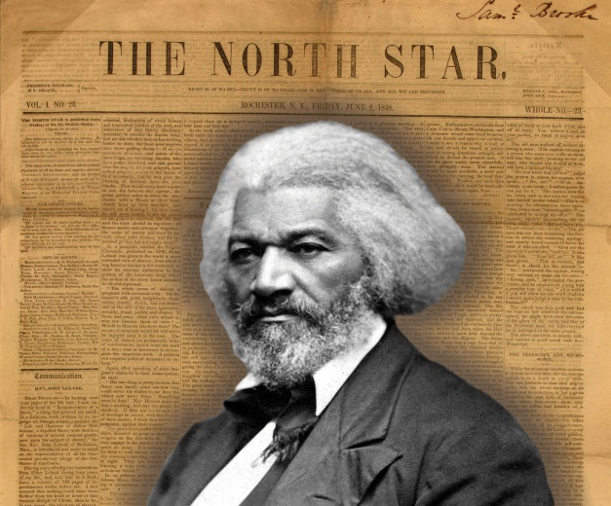
The ex-slave Frederick Douglass, like many prominent abolitionists, published a newspaper. Much of the early debate over civil liberties in the United States revolved around the ability to suppress such radical statements.
Source:http://www.loc.gov/exhibits/odyssey/archive/02/0210001r.jpg andhttp://commons.wikimedia.org/wiki/File:Frederick_Douglass_portrait.jpg.
The first big dispute over civil liberties erupted when Congress passed the Sedition Act in 1798, amid tension with revolutionary France. The act made false and malicious criticisms of the government—including Federalist president John Adams and Congress—a crime. While printers could not be stopped from publishing, because of freedom of the press, they could be punished after publication. The Adams administration and Federalist judges used the act to threaten with arrest and imprisonment many Republican editors who opposed them. Republicans argued that freedom of the press, before or after publication, was crucial to giving the people the information they required in a republic. The Sedition Act was a key issue in the 1800 presidential election, which was won by the Republican Thomas Jefferson over Adams; the act expired at the end of Adams’s term. ^{[3]}
Debates over slavery also expanded civil liberties. By the mid-1830s, Northerners were publishing newspapers favoring slavery’s abolition. President Andrew Jackson proposed stopping the US Post Office from mailing such “incendiary publications” to the South. Congress, saying it had no power to restrain the press, rejected his idea. Southerners asked Northern state officials to suppress abolitionist newspapers, but they did not comply. ^{[4]}

World War I
As the federal government’s power grew, so too did concerns about civil liberties. When the United States entered the First World War in 1917, the government jailed many radicals and opponents of the war. Persecution of dissent caused Progressive reformers to found the American Civil Liberties Union (ACLU) in 1920. Today, the ACLU pursues civil liberties for both powerless and powerful litigants across the political spectrum. While it is often deemed a liberal group, it has defended reactionary organizations, such as the American Nazi Party and the Ku Klux Klan, and has joined powerful lobbies in opposing campaign finance reform as a restriction of speech.

The Bill of Rights and the States
In Chapter 5 "Civil Rights", we discuss the Fourteenth Amendment, added to the Constitution in 1868, and how its due process clause, which bars states from depriving persons of “life, liberty, or property, without due process of law,” is the basis of civil rights. The Fourteenth Amendment is crucial to civil liberties, too. The Bill of Rights restricts only the national government; the Fourteenth Amendment allows the Supreme Court to extend the Bill of Rights to the states.
The Supreme Court exercised its new power gradually. The Court followedselective incorporation: for the Bill of Rights to extend to the states, the justices had to find that the state law violated a principle of liberty and justice that is fundamental to the inalienable rights of a citizen. Table 4.1 "The Supreme Court’s Extension of the Bill of Rights to the States" shows the years when many protections of the Bill of Rights were applied by the Supreme Court to the states; some have never been extended at all.

Table 4.1 The Supreme Court’s Extension of the Bill of Rights to the States
Date | Amendment | Right | Case
1897 | Fifth | Just compensation for eminent domain | Chicago, Burlington & Quincy Railroad v. City of Chicago
1925 | First | Freedom of speech | Gitlow v. New York
1931 | First | Freedom of the press | Near v. Minnesota
1932 | Fifth | Right to counsel | Powell v. Alabama (capital cases)
1937 | First | Freedom of assembly | De Jonge v. Oregon
1940 | First | Free exercise of religion | Cantwell v. Connecticut
1947 | First | Nonestablishment of religion | Everson v. Board of Education
1948 | Sixth | Right to public trial | In Re Oliver
1949 | Fourth | No unreasonable searches and seizures | Wolf v. Colorado
1958 | First | Freedom of association | NAACP v. Alabama
1961 | Fourth | Exclusionary rule excluding evidence obtained in violation of the amendment | Mapp v. Ohio
1962 | Eighth | No cruel and unusual punishment | Robinson v. California
1963 | First | Right to petition government | NAACP v. Button
1963 | Fifth | Right to counsel (felony cases) | Gideon v. Wainwright
1964 | Fifth | Immunity from self-incrimination | Mallory v. Hogan
1965 | Sixth | Right to confront witnesses | Pointer v. Texas
1965 | Fifth, Ninth, and others | Right to privacy | Griswold v. Connecticut
1966 | Sixth | Right to an impartial jury | Parker v. Gladden
1967 | Sixth | Right to a speedy trial | Klopfer v. N. Carolina
1969 | Fifth | Immunity from double jeopardy | Benton v. Maryland
1972 | Sixth | Right to counsel (all crimes involving jail terms) | Argersinger v. Hamlin
2010 | Second | Right to keep and bear arms | McDonald v. Chicago
Rights not extended to the states
Third | No quartering of soldiers in private dwellings
Fifth | Right to grand jury indictment
Seventh | Right to jury trial in civil cases under common law
Eighth | No excessive bail
Eighth | No excessive fines

Interests, Institutions, and Civil Liberties
Many landmark Supreme Court civil-liberties cases were brought by unpopular litigants: members of radical organizations, publishers of anti-Semitic periodicals or of erotica, religious adherents to small sects, atheists and agnostics, or indigent criminal defendants. This pattern promotes a media frame suggesting that civil liberties grow through the Supreme Court’s staunch protection of the lowliest citizen’s rights.
The finest example is the saga of Clarence Gideon in the book Gideon’s Trumpetby Anthony Lewis, then the Supreme Court reporter for the New York Times. The indigent Gideon, sentenced to prison, protested the state’s failure to provide him with a lawyer. Gideon made a series of handwritten appeals. The Court heard his case under a special procedure designed for paupers. Championed by altruistic civil-liberties experts, Gideon’s case established a constitutional right to have a lawyer provided, at the state’s expense, to all defendants accused of a felony. ^{[5]} Similar storylines often appear in news accounts of Supreme Court cases. For example, television journalists personalize these stories by interviewing the person who brought the suit and telling the touching individual tale behind the case. ^{[6]}
This mass-media frame of the lone individual appealing to the Supreme Court is only part of the story. Powerful interests also benefit from civil-liberties protections. Consider, for example, freedom of expression: Fat-cat campaign contributors rely on freedom of speech to protect their right to spend as much money as they want to in elections. Advertisers say that commercial speech should be granted the same protection as political speech. Huge media conglomerates rely on freedom of the press to become unregulated and more profitable. ^{[7]}
Many officials have to interpret the guarantees of civil liberties when making decisions and formulating policy. They sometimes have a broader awareness of civil liberties than do the courts. For example, the Supreme Court found in 1969 that two Arizona newspapers violated antitrust laws by sharing a physical plant while maintaining separate editorial operations. Congress and the president responded by enacting the Newspaper Preservation Act, saying that freedom of the press justified exempting such newspapers from antitrust laws.

KEY TAKEAWAYS
In this section we defined civil liberties as individual rights and freedoms that government may not infringe on. They are listed primarily in the Bill of Rights, the ten amendments added in 1791 by the founders to address fears about the new federal government’s potential to abuse power. Initially limited to the federal government, they now apply, though unevenly, to the states. What those liberties are and how far they extend are the focus of political conflict. They are shaped by the full range of people, processes, and institutions in American politics. Both unpopular minorities and powerful interests claim civil liberties protections to gain favorable outcomes.

EXERCISES
- How does the original text of the Constitution protect civil liberties? What kinds of rights does the Bill of Rights protect that the original body of the Constitution does not?
- Why might landmark civil-liberties cases tend to be brought by unpopular or disadvantaged groups? What are some of the ways in which powerful interests benefit from civil-liberties protections?
- Do you think the Bill of Rights does enough to protect civil liberties? In your opinion, are there any ways in which the Bill of Rights goes too far?

[1] This section draws on Robert A. Goldwin, From Parchment to Power (Washington, DC: American Enterprise Institute, 1997).
[2] This theme is developed in Michael Kent Curtis, Free Speech, “The People’s Darling Privilege”: Struggles for Freedom of Expression in American History (Durham, NC: Duke University Press, 2000).
[3] See James Morton Smith, Freedom’s Fetters: The Alien and Sedition Laws and American Civil Liberties (Ithaca, NY: Cornell University Press, 1956). For how the reaction to the Sedition Act produced a broader understanding of freedom of the press than the Bill of Rights intended, see Leonard W. Levy, Emergence of a Free Press (New York: Oxford University Press, 1985).
[4] Michael Kent Curtis, Free Speech, “The People’s Darling Privilege”: Struggles for Freedom of Expression in American History (Durham, NC: Duke University Press, 2000), especially chaps. 6–8, quote at 189.
[5] Anthony Lewis, Gideon’s Trumpet (New York: Vintage Books, 1964).
[6] Richard Davis, Decisions and Images: The Supreme Court and the News Media(Englewood Cliffs, NJ: Prentice-Hall, 1994).
[7] Frederick Schauer, “The Political Incidence of the Free Speech Principle,” University of Colorado Law Review 64 (1993): 935–57.

4.2 Religion, Speech, the Press, Assembly, and Petition

LEARNING OBJECTIVES
After reading this section, you should be able to answer the following questions:
- What two clauses protect freedom of religion?
- What exceptions apply to freedom of speech?
- What protections do the media enjoy under freedom of the press?
- What are the benefits of and limitations on the right to assemble and petition?
Civil liberties touch upon many issues. In the next two sections, we describe the current interpretation of each right and outline the policies it affects.

Freedom of Religion
The First Amendment addresses freedom of religion in two distinct clauses: the establishment clause and the free expression clause.

Establishment Clause
Rejecting the British legacy of “established” churches, theestablishment clause bars Congress from giving any religion an official status. In Jefferson’s much-quoted line, the establishment clause erects a “wall of separation between church and state.” A public policy may advance religious objectives only if its aim and main effect have nothing to do with religion. Thus a law forcing stores to close on Sundays can be justified to require employers to give staff a day off but not to enforce a Sabbath. ^{[1]}
The separation of church and state has generated high-profile controversies. The drama surrounding such confrontations is often captured by the press. In the 1920s, John Thomas Scopes was found guilty of teaching evolution in violation of a Tennessee law requiring that the Bible’s version of creation be taught in public schools. Scopes’s trial, portrayed in the stage play and film Inherit the Wind, was a precursor of later battles.

Link
The Scopes Trial
Learn more about the Scopes trial online athttp://www.pbs.org/wgbh/evolution/library/08/2/l_082_01.html.
Starting in the 1960s, the Supreme Court, in a series of rulings, prohibited nondenominational state-issued prayers in school, Bible readings, moments of silence intended for prayer, and student-led prayers at graduation ceremonies and football games. (The Court did refrain from invalidating the Pledge of Allegiance for containing the words “under God.”) ^{[2]} Court attempts to stop prayers are hard to enforce across the country—especially since they often receive saturation media coverage that gives most of the attention to those decrying what they see as judicial activism.

Free Exercise Clause
The First Amendment also says that Congress shall not prohibit the “free exercise” of religion. Individuals have the right to believe and practice their religions as they see fit. Government policies cannot target individuals’ religious practices or force actions that violate their religions.
This free exercise clause gained potency in 1943 when the Supreme Court ruled that Jehovah’s Witnesses could not be expelled from public schools for refusing to salute the American flag, an act contrary to their religion. More recently, the Supreme Court limited the clause’s reach when it ruled, in 1990, that American Indians had no right to disobey an Oregon law barring controlled substances in order to ingest peyote as part of a religious service. The Court held that laws hindering religious practices do not violate the First Amendment if they apply to all persons and do not openly refer to religion.
The establishment clause tries to keep religion out of government; the free exercise clause tries to keep government out of religion. The two objectives are not always compatible. For example, President George W. Bush proposed to allow government to contract with “faith-based” organizations to administer social programs. Opponents argued that this would violate the establishment clause by endorsing religion; Bush responded that existing policy violated the free exercise clause by discriminating against religious organizations.

Freedom of Speech
The Supreme Court has held that “debate on public issues should be uninhibited, robust, and wide-open.” ^{[3]} Offensive speech is less detrimental than the “chilling effect” of individuals being silenced for fear of retribution. Nevertheless, freedom of speech is not absolute. Governments can regulate or restrict it under certain conditions.

Thoughts, Words, and Actions
Thoughts are deemed beyond the scope of government regulation; actions are heavily regulated by government; words are somewhere in between. The distinctions between thoughts, words, and actions are not always clear. Two cases of protest against the Vietnam War show how lines are drawn. ^{[4]} In one, a protester burned his draft card and was charged with violating a federal law that makes it a crime to knowingly destroy draft cards. The Court upheld the law, saying that the law aimed to maintain draft records, not to stifle free expression. When two students wore black armbands to their high school to protest the war and were suspended for violating the dress code, the Court found the policy sought to suppress free expression and sided with the students.

When Speech Can Be Regulated
The First Amendment does not protect speech that fails to contribute to the exchange of ideas that is crucial in a democracy—for instance, libel, obscenity, and “fighting words”—but such forms of speech are narrowly defined.
The publication of defamatory information, or libel, can be challenged in court. But officials and other public figures must demonstrate “actual malice” displayed by a “reckless disregard for the truth.” ^{[5]} Thus libel cases are hard to win. Nonetheless, some litigants sue to shame a media organization publicly or to force it to spend money defending itself in court.
There is now a right to possess most obscene material in one’s home, but not to produce, sell, or ship it. Early in the twentieth century, obscenity laws had halted the circulation of works of art such as James Joyce’s now classic novelUlysses. In 1957, the Supreme Court shrank the definition of obscenity from anything to do with sex to “material that deals with sex in a manner appealing to prurient interest” and “utterly without redeeming social importance.” This decision forced the justices to hear dozens of cases in order to distinguish obscenity from protected speech. The results were almost comical. The often elderly justices viewed numerous pornographic films, the earthy Thurgood Marshall recounting the goings-on to his patrician, sight-impaired colleague John Harlan. At one point, Justice Potter Stewart exasperatedly wrote in one opinion, “I know it when I see it.” Finally, in 1973, the Court established three rules that must be met for material to be obscene: it appeals to a prurient interest by the standards of the local community; it depicts specified sexual conduct in a patently offensive way; and it lacks serious literary, artistic, political, or scientific value. ^{[6]}
In the 1920s, the Supreme Court allowed government to bar fighting words as long as there was a “clear and present danger” of provoking an immediate attack or acts of violence. In Justice Oliver Wendell Holmes’s terms, freedom of speech does not extend to the right to falsely yell “Fire!” in a crowded theater. Such a rule allowed for suppression of radical voices. As late as 1951, the Court upheld a federal law banning advocacy of the violent overthrow of the government. But the Court, in 1969, held that speech favoring illegal action is protected unless violence is both intended and likely. ^{[7]}
Even when the government cannot bar speech, it can direct its time, place, and manner. But policies may not target particular content and must provide alternative ways to express oneself. If public universities and colleges cannot ban political speeches, they may restrict them to certain parts of campus such as “Free Speech Alleys.”

Speech Codes
Like fighting words, intimidation and harassment are not protected forms of free speech. By this logic, colleges and universities in the 1980s proposed campus speech codes to forbid the demeaning or stigmatizing of persons on the basis of race, ethnicity, gender, or sexual orientation. Proponents argued that speech codes would actually boost free speech, since “hate speech” deterred individuals who felt under attack from speaking out. But courts struck down the codes as too broad. ^{[8]}

Freedom of the Press
The media claim special privileges under the First Amendment’s guarantee of “freedom of the press.”

Prior Restraint
The government is rarely able to stop material from being published. Even the Sedition Act of 1798, discussed previously in this chapter (Section 4.1 "The Bill of Rights"), did not include this prior restraint. The Supreme Court extended the ban to the states in 1931 when it struck down a Minnesota law allowing the state to suppress a “malicious, scandalous and defamatory” publication as a “public nuisance”—in this case, an abusively anti-Semitic periodical. Prior restraint is rarely justified: in 1971, the Court refused to issue an injunction sought by the executive branch against the New York Times and Washington Post on grounds of violations of national security. In the absence of the government’s proof that the national interest would be harmed, the Court allowed the publication of the Pentagon Papers, a leaked classified set of documents revealing decisions leading to the Vietnam War. ^{[9]}

News Media Privileges
Reporters have privileges that the public lacks: greater access to the workings of government, the ability to question officeholders, legal protection from revealing confidential sources, and access to government public information offices that feed them quotations and stories. But such privileges stem from policy and practice, not from constitutional rights.
Laws aimed at public disclosure, such as sunshine laws preventing government from working behind closed doors, benefit reporters. The Freedom of Information Act (FOIA), enacted in 1966, allows for access to executive agencies and commissions’ records and files closed to public inspection. ^{[10]}Information obtained under the FOIA provides documentation for stories likeUSA Today’s discovery of a huge increase in the use and dealing of crack cocaine by individuals under age fifteen. Such information can also reveal scandals. In 1990, Washington Post reporter Ann Devroy was frustrated with White House Chief of Staff John Sununu’s refusal to answer her dogged questions about his rumored use of perquisites of office for private gain. Devroy filed for documents under the FOIA and found Sununu had used government planes to get to a dentist’s appointment and to attend postage-stamp auctions. Sununu resigned in disgrace.

Broadcast Regulation
Public policy treats different media differently. Broadcast and cable slots, being inherently limited, can be regulated by government in ways that are not allowed for print media or the Internet. ^{[11]}
The Federal Communications Commission (FCC), established in 1934, has the power to issue licenses for a given frequency on the basis of “the public interest, convenience, or necessity.” From the start, the FCC favored big commercial broadcasters aiming at large audiences. Such limits on competition enabled the establishment of hugely profitable radio (and later television) stations and networks, whose licenses—sometimes jokingly termed licenses to print money—the FCC almost automatically renewed.
The FCC has regulatory authority to penalize the broadcast media, but not cable television, for indecent content. During the halftime show at the 2004 Super Bowl, televised by CBS, singer Justin Timberlake tore the costume and briefly exposed the right breast of singer Janet Jackson. The FCC fined CBS $550,000 for the Super Bowl “wardrobe malfunction.” The fine was overturned by a federal court of appeals in July 2008. In May 2009, the Supreme Court returned the case to the court for reconsideration.

Rights to Assemble and Petition
Rights to assemble and petition government allow individuals to come together as groups and voice concerns. These rights permitted groups that were denied the vote—such as women before 1920—to state views and pressure government.^{[12]} Social movements claim that the rights protect protesting; interest groups argue that the right to petition government includes all lobbying.
Like speech, freedom of assembly can be regulated in its time, place, and manner. Thus demonstrations outside political party conventions may be limited to given areas, sometimes far from the event. Moreover, the right is “topeaceably assemble.” Governments have the power and responsibility to ensure that protests do not turn violent. But the failure to distinguish between an assembly and a mob has resulted in tragic consequences when unarmed protesters have lost their lives (see Note 4.20 "Enduring Images").

Enduring Images
Kent State
On May 4, 1970, at Ohio’s Kent State University, National Guardsmen fired on unarmed student protesters who had planned a noontime antiwar rally. Four students, including two passersby, died. A photographer snapped fifteen-year-old runaway Mary Ann Vecchio kneeling and screaming over Jeffrey Miller’s dead body. Another showed National Guardsmen, impersonal under gas masks, aiming rifles at defenseless students. Such images conjure up brutal, deliberate repression of rights of protest. They reappear on anniversaries of the Kent State killings, with captions like, “Americans were stunned to see photographs showing the government shooting on its own citizens, here in the world’s oldest democracy where the right of political dissent is supposedly fundamental.” ^{[13]}
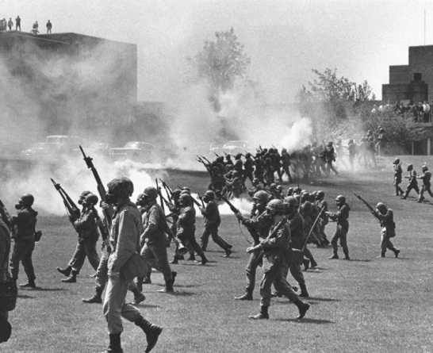
National Guardsmen at Kent State
Source: Used with permission from AP Photo.
The history of these enduring images is more complex. ^{[14]} Protests began on college campuses on April 30, 1970, when President Richard Nixon announced an invasion of Cambodia, expanding the Vietnam War. Protests were not always peaceful. In Kent, students smashed store windows on May 1, and Kent State’s ROTC building was burned down on May 2. Ohio’s governor mobilized the National Guard to defend the campus. On May 4, the Guard, badly outnumbered, sought to stop the rally. Other photos from May 4 show students taunting the Guard, fogs of tear gas, and volleys of empty tear-gas canisters and rocks thrown at soldiers. The picture of soldiers aiming their rifles may have been an early attempt to subdue the protest without shooting. The immediate response to the shootings did not blame the Guard. Nixon’s reaction was widely reprinted: “This should remind us all once again that when dissent turns to violence it invites tragedy.” ^{[15]} Polls showed most of the public blamed students for the deaths and backed the Guard’s actions. ^{[16]}
The enduring image, however, is of Mary Ann Vecchio. One reason is its emotional resonance: it resembles a Pietà sculpture of Mary grieving over the body of Jesus. Also, American politics after the invasion of Cambodia turned from engaging in to ending the Vietnam War—in part as a response to unrest that racked the country. And President Nixon’s law-and-order rhetoric lost support as revelations of illegal misdeeds surfaced in the Watergate scandal. By the fall of 1973, a majority in a Harris poll saw the shootings as “unjustified and repressive.” ^{[17]} As images of Kent State were winnowed down to the one picture of Mary Ann Vecchio over the body of Jeffrey Miller, the meaning of what happened at Kent State shifted from a tragic consequence of disorder to a vivid symbol of civil liberties denied.
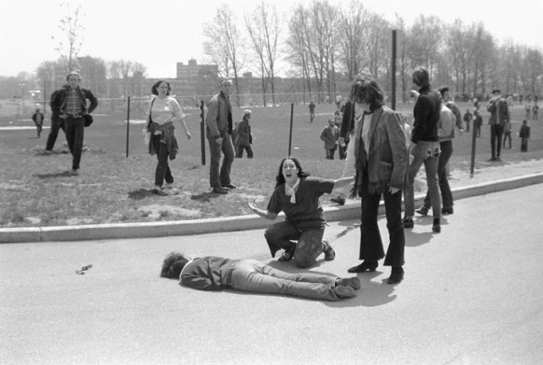
Mary Ann Vecchio Kneeling over the Body of Jeffrey Miller
Source: Used with permission from Getty Images.

KEY TAKEAWAYS
In this section we discussed the constitutional protections guaranteeing freedoms of religion, speech, the press, assembly, and petition. These important protections are far reaching but nonetheless subject to important exceptions.

EXERCISES
- What is the difference between the establishment and the free exercise clauses of the First Amendment? How do these clauses complement one another? How might they come into conflict?
- What kinds of speech are protected by the First Amendment? What factors determine whether speech is protected?
- Why might it be important for citizens of a democracy to have the right to assemble and to petition their government? In your opinion, what should the limits of these rights be?

[1] Lemon v. Kurtzman, 403 US 602 (1971).
[2] Respectively, Engel v. Vitale, 370 US 421 (1962); Abington School District v. Schempp, 374 US 203 (1963); Wallace v. Jaffree, 472 US 38 (1985); Lee v. Weisman, 507 US 577 (1992); and Santa Fe Independent School District v. Doe, 530 US 290 (2000).
[3] New York Times v. Sullivan, 376 US 254 (1964).
[4] United States v. O’Brien, 391 US 367 (1968); and Tinker v. Des Moines Independent Community School District, 393 US 503 (1969).
[5] New York Times v. Sullivan, 376 US 254 (1964).
[6] The key cases here are Roth v. United States, 354 US 476 (1957); Stanley v. Georgia, 394 US 557 (1969); and Miller v. California, 413 US 15 (1973).
[7] Respectively, Schenck v. United States, 249 US 47 (1919); Dennis v. United States, 341 US 494 (1951); and Brandenburg v. Ohio, 395 US 444 (1969).
[8] James B. Jacobs and Kimberly Potter, Hate Crimes: Criminal Law and Identity Politics (New York: Oxford University Press, 1998), 112–21.
[9] Near v. Minnesota, 283 US 697 (1931); and New York Times v. United States, 403 US 713 (1971).
[10] Herbert N. Foerstel, Freedom of Information and the Right to Know: The Origins and Applications of the Freedom of Information Act (Westport, CT: Greenwood Press, 1999).
[11] Red Lion Broadcasting Company v. Federal Communication Commission, 395 US 367 (1969) and Turner Broadcasting System, Inc. et al. v. Federal Communication Commission, 520 US 180 (1997).
[12] See Susan Zaeske, Signatures of Citizenship: Petitioning, Antislavery, and Women’s Political Identity (Chapel Hill: University of North Carolina Press, 2003), and Linda J. Lumsden, Rampant Women: Suffragists and the Right of Assembly (Knoxville: University of Tennessee Press, 1997).
[13] Sue Schuurman, “Kent State Killings Shock Nation: 28 Years Ago This Week,” Weekly Alibi, May 11, 1998, http://weeklywire.com/ww/05-11-98/alibi_skeleton.html. The leading historian of Kent State is J. Gregory Payne, who provides a valuable narrative at May4Archive.org, http://www.may4archive.org.
[14] Writings on Kent State, particularly in the immediate aftermath of the shooting, are highly politicized, with government commissions’ reports being dismissed as cover-ups of conspiracies. A balanced assessment of the literature is Thomas R. Hensley and Jerry M. Lewis, eds., Kent State and May 4th: A Social Science Perspective (Dubuque, IA: Kendall/Hunt, 1978).
[15] Quoted in Sue Schuurman, “Kent State Killings Shock Nation: 28 Years Ago This Week,”Weekly Alibi, May 11, 1998, http://weeklywire.com/ww/05-11-98/alibi_skeleton.html.
[16] See the Gallup poll from Newsweek, May 25, 1970, 30, cited in James J. Best, “Kent State: Answers and Questions,” in Kent State and May 4th: A Social Science Perspective, ed. Thomas R. Hensley and Jerry M. Lewis (Dubuque, IA: Kendall/Hunt, 1978), 25.
[17] New York Post, October 3, 1973, as reported in J. Gregory Payne, “Aftermath,” May4Archive.org, http://www.may4archive.org/aftermath.shtml.

4.3 Arms, Search and Seizure, Accusation, Punishment, Property, and Privacy

LEARNING OBJECTIVES
After reading this section, you should be able to answer the following questions:
- What is the Second Amendment?
- What constitutes an illegal search and seizure?
- What amendments protect the rights of the accused?
- What is eminent domain?
- What is the current state of abortion as a civil liberty?

The Right to Keep and Bear Arms
The Second Amendment reads, “A well-regulated militia being necessary to the security of a free state, the right to keep and bear arms shall not be infringed.” Is this a right of self-defense that is akin to the protection of one’s dwelling guaranteed by other amendments? ^{[1]} Or is it simply a basis for states to build militias, balancing off the standing army of the national government—in which case the gradual replacement of volunteer state militias by the National Guard rendered the Second Amendment obsolete? ^{[2]}
Most crime rates in the United States are similar to those of countries such as Canada or Australia. But the United States has a far higher rate of violent crime, in part because of the greater availability of firearms. A large majority of the public supports restrictions on the sale of firearms, but few policies have been enacted to do so. Although opponents of gun control are outnumbered, they are more likely than supporters to vote on this issue.
Policy debate on gun control usually occurs only after a dramatic, heavily covered news event like an assassination or a massacre at a school. One political scientist described the result as “furious politics, marginal policy.” ^{[3]} For example, after the killings of Martin Luther King Jr. and Robert Kennedy in 1968, Congress debated President Lyndon Johnson’s proposal for a federal system of firearm registration and licensing of gun owners but passed only limited, ineffective legislation. In 1994, dramatic fights over banning assault weapons and mandating a waiting period for gun purchases produced a law with huge loopholes when it failed to cover gun shows.
The “right to keep and bear arms” has been debated by the public and politicians more than by courts. But in June 2008, the Supreme Court, by a vote of 5–4, ruled that individuals have the right to bear arms. This decision, an interpretation of the Second Amendment, struck down the District of Columbia’s thirty-two-year-old law banning the possession of handguns. ^{[4]} In June 2010, the Court, again by a vote of 5–4, applied the ruling to cities and states by overturning Chicago’s ban on handguns. ^{[5]} The Court has not prohibited all legislation and limitation of guns, but such governmental actions would likely conflict with the Court’s interpretation of the Second Amendment.

Searches and Seizures
The Fourth Amendment prevents the government from conducting “unreasonable searches and seizures.” A reasonable search is conducted with a warrant issued by a judge and based on probable cause. What is “unreasonable” varies with how much privacy people can expect when they are being searched. Cars are less private than houses, so rules for searches of cars are less stringent. And government agencies can state reasons to compel persons not suspected of a crime to submit to searches and seizures. The goal of preventing airplanes from being hijacked authorizes mandatory searches of persons and their property before boarding aircraft and allows the confiscation of objects deemed dangerous.

Electronic Searches
New technologies complicate searches and seizures. In 1967, the Supreme Court ruled that the Fourth Amendment did not simply restrict physical entry: it “protects people, not places.” ^{[6]} The pivotal test is whether a person has “a legitimate expectation of privacy” regardless of the technological means used to search. Thus the Court has held that the use of heat-sensing devices able to find intensive marijuana farms inside closets requires a search warrant as much as would a physical entry to one’s house. ^{[7]}
New technologies can also intrude into formerly private domains hitherto free from the potentially prying eye of government. For example, e-mail passes through many portals en route to delivery, each of which may be available for search without the sender’s or receiver’s knowledge. E-mail and web searches are still available in shadowy form even after the hard drive has seemingly been erased, and they can be searched for key words or other patterns efficiently. Police and prosecutors now have new weapons at their disposal in tracking down possible criminal activity.
The massive computerization of information tempts the government even more. In May 2004, the Government Accountability Office (GAO) released a report on data mining. It documented 52 federal agencies conducting 122 projects to collect, analyze, and use identifiable information on US persons for national security and law enforcement purposes. These numbers, which omit classified projects, are probably low-ball estimates.

Electronic Eavesdropping
In 2006, newspapers leaked word of a secret executive order signed by President George W. Bush authorizing electronic eavesdropping on computerized and cell phone conversation without a warrant. ^{[8]} Bush claimed that the inherent powers of the president and Congress’s authorization of force to respond to the 9/11 attacks allowed him to initiate this policy. Members of Congress, unhappy that the program had been put into place without their knowledge, supported legislation obliging the president to seek warrants from a secret court.

The Exclusionary Rule
The Fourth Amendment’s exclusionary rule prevents evidence from an illegal search or seizure being introduced against a defendant in court. The Supreme Court adopted this rule for federal cases in 1914 and extended it to states in 1961.
Law enforcement officers have long bridled at the exclusionary rule and claim that “technicalities” allow guilty suspects to be set free. The Supreme Court has permitted the use in trial of seized evidence that would have been “inevitably discovered” even without an unconstitutional search—such as that “in plain view”—or which police officers acquired under a search warrant that they did not know was improperly issued. ^{[9]}

The Rights of the Accused
Collectively, the Fifth, Sixth and Seventh Amendments set forth procedural guarantees known as “rights of the accused,” which exist through the criminal process from accusation to trial to conviction.

Innocent until Proven Guilty
The central right of the accused is the presumption that anyone charged with a crime is innocent until proven guilty in court. This rule can be hard to preserve when an accused individual has been subjected to massive unfavorable media attention prior to or during a trial. For example, the police have perfected a technique known as the “perp walk” (for “perpetrator”), allowing television cameras to film the accused—often handcuffed and in prison garb—escorted by police. Such images, repeated over and over again in news broadcasts, can lead viewers to presume guilt rather than innocence.

“Taking the Fifth”
The Constitution’s Fifth Amendment gives people the right to refuse to answer questions from any entity of government if they claim such responses might lead to criminal prosecution. Claiming this right not to incriminate oneself is popularly called “taking the fifth.” Witnesses may be compelled to testify only if given immunity from prosecution. ^{[10]}
Such restrictions frustrate law enforcement officers, who find confessions among the best means to obtain a guilty verdict.
The right against self-incrimination originally meant only that individuals could not be forced to testify against themselves during their trials. In the 1920s, the Supreme Court threw out convictions for which evidence had been gained by torture or coercion and slowly expanded the right to cover all discussions with all law enforcement officials.
By 1966, the Court was weary of issuing case-by-case decisions about whether the police had gone too far in questioning suspects. In Miranda v. Arizona (384 US 436), the justices, having reviewed numerous police manuals, concluded that police often tried to create an atmosphere designed to intimidate or manipulate the accused into confessing. The justices ruled that law enforcement officials must “demonstrate the use of procedural safeguards” by ensuring that the accused is “adequately and effectively apprised of his rights.” The Miranda decision required a warning to be read to suspects prior to interrogation—this warning is known as Miranda rights—without which their statements could not be admitted as evidence in court. Suspects must be notified of the following: that they have the right to remain silent, that whatever they say can be used against them in court, that they have the right to be represented by a lawyer before and during questioning, that they have the right to have a lawyer provided by the court if they cannot afford one, and that they have the right to terminate questioning at any time.
Figure 4.2 Oliver North’s Swearing In at Congressional Hearing
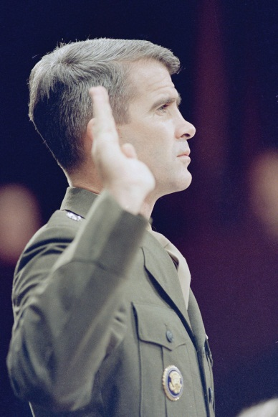
Congressional investigations that provide grants of immunity can complicate judicial proceedings. The conviction of Oliver North, a central figure in the arms-for-money Iran-Contra scandal of the 1980s, was overturned for that reason.
Source: Used with permission from AP Photo/J. Scott Applewhite.
These rights are familiar to anyone who has seen criminal detective movies or television shows.

Video Clip
http://www.youtube.com/watch?v=P0zgIzqgxFU

Infamous Dragnet “Blue Boy” LSD scene
Miranda rights were effectively introduced to the American public when the tough-guy detectives of the sixties television show Dragnet read them to suspects they were arresting.
But are they effective? Police officers view the reading of these rights as a mere technicality. They can get information by appealing to a suspect’s desire to tell his or her story and by acting as if they are on the suspect’s side. Even after suspects invoke Miranda rights, officers can try to change their minds or elicit what they term off-the-record information. Eighty percent of suspects voluntarily waive their rights; many confess. ^{[11]}

Trial Procedures
Over time, Supreme Court decisions have outlined processes for a suspect to be tried in court. The most important are the following:
- Individuals cannot be subject to double jeopardy; in other words, they cannot be tried again for a crime after being acquitted of it in an earlier trial. This restriction does not prevent someone acquitted in a criminal case from being sued in a civil case: actor-athlete O. J. Simpson, found not guilty of the murder of his ex-wife and her friend, was found in civil court to be responsible and financially liable for their deaths.
- Suspects must know and understand the charges and evidence against them; therefore, cases against those “incompetent to stand trial” for reasons of illness or insanity must be dismissed, and juvenile suspects cannot be tried as adults.
- The trial must be speedy, so that someone not yet proven guilty is not punished by lengthy incarceration before trial.
- Defendants for serious crimes (punishable by more than six months in prison or a $500 fine) and those in federal civil cases have a right to a trial by an “impartial jury” of their peers.
- Defendants have a right to face and confront witnesses against them.
- The accused has a right to a defense attorney. At first, this meant only that accused persons could pay for lawyers to represent them. But the 1932 case of seven young African American men sentenced in Scottsboro, Alabama, to die on a charge of raping two white women (a charge later found to be trumped-up) persuaded the Supreme Court otherwise. The justices ruled that these defendants—poor, illiterate, and charged with a capital offense—had to be represented by a public defender, a defense attorney employed and paid by the state.
This ruling gradually extended to all defendants in federal courts, then to felony defendants in state courts, and eventually to anyone facing any jail time. ^{[12]} But public defenders are underpaid and overworked. And their convicted clients can win on appeal only if they can show that public defenders made serious errors, depriving them of a fair trial. ^{[13]}
Moreover, most charges are resolved prior to trial when a defendant agrees to plead guilty to a lesser charge. They thereby avoid being charged with—and found guilty of—a more serious crime and receiving a more severe sentence, but they lose out on the many protections of trial procedures.

The War on Terror
Civil liberties are often impaired during international crises. Witness the “war on terrorism,” which is no exception. While the revelations in April 2004 of abuse and torture of Iraqi prisoners in the Abu Ghraib prison may be a matter more for international law than civil liberties, other rights of the accused were also in question after the terrorist attacks of 9/11.
In October 2001, Congress enacted the USA Patriot Act. Among other things, it authorized the attorney general to detain indefinitely a noncitizen when there are “reasonable grounds to believe” that the person is a threat to national security. Attorney General John Ashcroft praised these policies, correctly observing, “It is difficult for a person in jail or under detention to murder innocent people or to aid or abet in terrorism.” ^{[14]}
The Bush administration used these powers vigorously. Hundreds of resident aliens were detained without explanation in the fall of 2001, many in solitary confinement. When the Taliban government was overthrown in Afghanistan in late 2001, American forces captured some ten thousand soldiers and other Afghanis. Many of them were named “enemy combatants” (not “prisoners of war,” who would have greater protection under international law). Shackled and hooded, they were shipped to a military prison at the base at Guantánamo Bay. Some were subjected to abusive interrogation. The base was located on land the United States had leased from Cuba in perpetuity, and thus, according to the Bush administration, it was outside the jurisdiction of the federal judiciary. ^{[15]}
Many rights of the accused were directly challenged by these policies: the right to know charges against oneself, the right to counsel, the right to a speedy and public trial, the right to a jury of one’s peers, the right to confront adverse witnesses, and the ability to appeal decisions to a higher court.
In 2004, the Supreme Court upheld the president’s power as commander in chief to name persons as enemy combatants, to hold them indefinitely under Congress’s authorization of military force, and to fashion trial proceedings with less stringent standards of evidence. But that due process required that a citizen held in the United States as an enemy combatant be given a meaningful opportunity to contest the detention’s basis before a neutral decision maker. The Court also ruled that because the United States controlled Guantánamo, all detainees there had the habeas corpus right to go to federal court to challenge their detention. ^{[16]}.
In response, the Bush administration began keeping detainees in a camp in Bagram, Afghanistan, in the theater of war, where judges could not go. And Congress passed the Military Commissions Act of 2006, removing the federal courts’ jurisdiction to hear habeas corpus applications from detainees designated as enemy combatants. Then, in 2008, the Supreme Court, by a vote of 5–4, declared the Military Commissions Act unconstitutional, thereby giving back to enemy combatants their habeas corpus rights. ^{[17]}

Punishment of Convicted Criminals
The Eighth Amendment also gives rights to people convicted of a crime. It aims to make the punishment fit the crime and to prohibit “cruel and unusual punishment.” Policies affected by the Eighth Amendment include the length of prison sentences, prison conditions, and the death penalty.

Prisons
Through the 1970s, prisoners were rarely expected to serve out their full sentences. Parole or “time off for good behavior” gave incentives to cooperate and acquire skills needed to reenter society. But media stories about crimes committed by paroled ex-cons impelled “truth-in-sentencing” laws—mandatory minimums or fixed sentences for given crimes.
States began adopting “three-strikes-and-you’re-out” laws. These typically increase the sentence for a second felony conviction and require life in prison without parole for a third. These lengthy sentences often bear little connection to the gravity of the crimes committed.
Lengthy sentences and the fact that over three-fourths of those put in state or federal prison each year commit nonviolent crimes raise an Eighth Amendment question: does the punishment fit the crime? ^{[18]} In 2003 the Supreme Court decided that “three strikes” was not so “grossly disproportionate” as to violate restrictions on “cruel and unusual punishment.” ^{[19]}
The United States is the world leader in the proportion of its population that is incarcerated. When you include those on probation or parole, about 3.2 percent of adults live under the criminal justice system’s direct supervision. ^{[20]}
When prison policies are reexamined, it is less for civil liberties than for their costs. States badly needed to cut expenses when the economic depression that started in 2007 slashed their tax receipts. They instituted sentencing alternatives to prison for first-time offenders, those seeking early parole, and prisoner-release programs.
Prisoners may organize to pursue common interests, such as seeking decent conditions in prison. ^{[21]} Inspired by 1960s civil rights movements, they claimed a denial of basic rights. Their perspectives were bolstered by Hollywood films of the 1960s and 1970s, such as Birdman of Alcatraz, Cool Hand Luke, andOne Flew Over the Cuckoo’s Nest, that vividly depicted inhumane conditions of involuntary confinement. Some inmates taught themselves to become lawyers and sued the prisons. Starting in the 1960s, the Supreme Court recognized prisoners’ rights to bring suit and said the ban on “cruel and unusual punishment” included prison conditions. While harsh conditions may be part of a convict’s penalty, prisoners cannot be subjected to “unnecessary and wanton” pain by the “deliberate indifference” of authorities. ^{[22]}

The Death Penalty
The death penalty is now reserved for the most serious of crimes: murder and treason. In 1972, the Supreme Court threw out all state laws imposing the death penalty as a violation of due process being arbitrarily applied from one case to the next. In 1976, the Court allowed states to impose capital punishment as long as it is decided on by a jury following a strict process, weighing mitigating and aggravating circumstances to decide if death is the most appropriate punishment. ^{[23]} After 1976, thirty-eight states reinstated the death penalty, which by then was endorsed by a strong majority of the public.
The main objection to the death penalty today is that it cannot be applied dependably enough to meet the Bill of Rights’ standards for due process. Death sentences vary greatly based on the race of the convicted murderer and of the murder victim; blacks convicted of murdering a white person are far more likely to receive a death sentence than blacks convicted of murdering a black person (see Note 4.28 "Comparing Content").

Comparing Content
Victims and Capital Punishment
Victims are everywhere in the media. But who gets to play the part? For some investigative journalists, the answer is innocent death row inmates. Building on evidence dug up by journalism professor David Protess and his students at Northwestern University, reporters for the Chicago Tribunecompiled two devastating series about prisoners sentenced to die on faulty evidence—“Trial and Error” and “The Failure of the Death Penalty in Illinois.” The first story in the series began by listing accusations against prosecutors: “They have prosecuted black men, hiding evidence the real killers were white. They have prosecuted a wife, hiding evidence her husband committed suicide.…They do it to win. They do it because they won’t get punished.” ^{[24]}
Evidence of mistaken convictions led Illinois governor George Ryan to declare a moratorium on capital punishment and, just before leaving office in 2003, to commute all death penalties to life in prison without parole. Days later, Ryan went on Oprah. The show’s host, Oprah Winfrey, aired two episodes she termed “our show with the governor who emptied death row.” Before the broadcast, Winfrey videotaped interviews with surviving relatives of those whose murderers had been spared the death penalty. She confronted Ryan with this video testimony of survivors describing the gruesome crimes and their sense of betrayal.
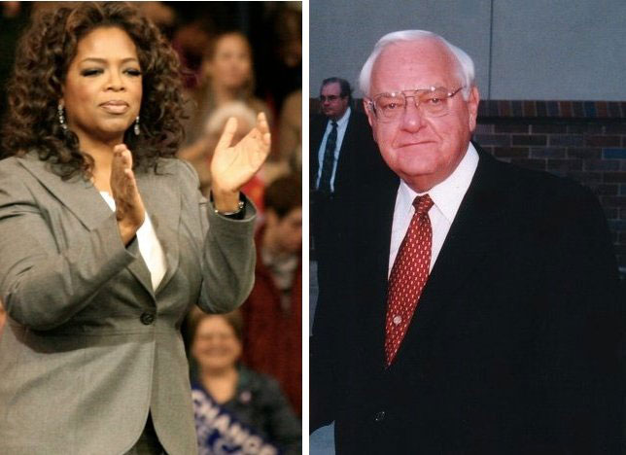
Oprah Winfrey and George Ryan
For investigative journalism, the victims are wrongfully convicted death row inmates, whose wrongful convictions justify a halt to the death penalty, so that the state does not put innocent people to death. This focus on the exoneration of the wrongfully convicted, sometimes by dramatic revelations of exculpatory DNA evidence, shifts the media’s frame away from the victims of crime to the victims of prosecution, and may thereby shift public opinion. But for the daytime talk show, the victims are survivors of violent crime who rely on the justice system to give them what Winfrey called “closure.” The future of capital punishment may depend on which frame wins.

Property Rights and Eminent Domain
The Fifth Amendment includes a takings clause: government must provide “just compensation” (usually market value) when it uses its power ofeminent domain to take property for public use, or if government action removes “all the purposes for which it was acquired.” ^{[25]}
Some civil liberty advocates propose expanding this right to limit government regulation. They echo Chief Justice Rehnquist, who wrote, “We see no reason why the Takings Clause of the Fifth Amendment, as much a part of the Bill of Rights as the First Amendment or Fourth Amendment, should be relegated to the status of a poor relation.” ^{[26]} Corporations and business associations have funded probusiness legal centers that argue that any regulation restricting a property’s value or use is a “taking” requiring compensation. This approach would throw out such land-use policies as zoning, rent control, wetland conservation laws, and regulations like the Endangered Species Act. ^{[27]}
The Supreme Court has resisted putting property rights front and center. The justices ruled in 2005 against a homeowner who contested the city’s plan to replace her economically depressed neighborhood with an office park, hotel, and conference center. They said that governments have broad discretion to take property for “public use” as long as it is put to a “public purpose,” including economic development, even when the land is transferred to other private owners. ^{[28]} In reaction, several states began to limit the uses of eminent domain.

Right to Privacy
A right to privacy is nowhere explicitly named in the Bill of Rights. However, some members of the Supreme Court recognized the right in a 1965 case. They overturned the conviction of executives of Connecticut’s Planned Parenthood for violating a state law that banned advising married couples about the use of birth control and prescribing contraceptives. One justice found privacy implicit in the First, Third, Fourth, and Fifth Amendments. Other justices found it in the Ninth Amendment’s reminder that the Bill of Rights does not exhaust the sum total of liberties. ^{[29]} Justice applied the right to the states through the due process clause of the Fourteenth Amendment.

Roe v. Wade and Abortion Rights
In this 1973 decision, the Supreme Court, invoking privacy, recognized a woman’s constitutional right to an abortion in the first three months of a pregnancy. ^{[30]} Whether to have an abortion was seen as a private decision between a woman and her doctor. Before and since then, a debate has raged between two sides calling themselves “pro-choice” and “pro-life”—a debate and a divide exaggerated by the news media’s preference for vivid conflicts.

Link
Oral Arguments in Roe v. Wade
Listen to oral arguments in Roe v. Wade athttp://www.oyez.org/cases/1970-1979/1971/1971_70_18/argument.
The Roe decision mobilized a pro-life movement. Members of Congress sought but failed to obtain the two-thirds majorities necessary for a constitutional amendment declaring that life begins with conception, thereby recognizing the fetus as a “person” able to receive the protection of the Bill of Rights. President Reagan, elected in 1980, also pushed to reverse Roe. States tried to test Roe’s boundaries. The Court initially rejected such efforts as requiring the written consent of the woman’s spouse or her parents, demanding that abortions be performed in a hospital, or enforcing twenty-four-hour waiting periods.
By the end of the 1980s—President Reagan having named new justices to the Supreme Court—the original majority for Roe had eroded. In 1989, the Court limited abortion rights by ruling that the state’s interest in the fetus begins at conception, not viability; states could now regulate abortions in the first trimester. ^{[31]}

Roe Reaffirmed
Figure 4.3 Roe v. Wade Anniversary
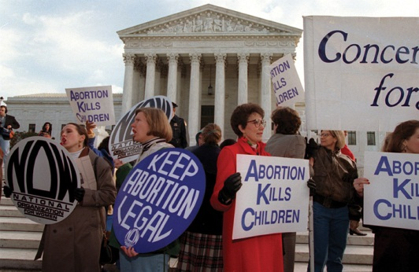
The justices of the Supreme Court presumably did not realize when they issued the Roe v. Wade decision on January 22, 1973, that its anniversary would be marked by demonstrations by opponents and counterdemonstrations of proponents in front of their building.
Source: Used with permission from AP Photo/Joe Marquette.
When pro-life president George H. W. Bush named David Souter and Clarence Thomas to replace retiring pro-choice justices William Brennan and Thurgood Marshall, Roe seemed doomed. In 1992, the justices considered a Pennsylvania law that required a married woman’s husband to be notified before she could have an abortion and a twenty-four-hour waiting period for a woman to be provided with information about risks and consequences of abortion. But Justice Anthony Kennedy, allying with Souter and Sandra Day O’Connor (a Reagan appointee), jointly wrote an opinion. They declined to overturn Roe’s central tenet that a woman had a right to an abortion prior to the ability of the fetus to live outside the womb. But they scrapped the trimester scheme of Roe and put in a new (if less clear) test of whether a law imposes an “undue burden” on a woman’s right to an abortion. The decision supported most of the restrictions Pennsylvania had placed on abortion. It fit public opinion that was against reversing Roe v. Wade but in support of conditions and exceptions. ^{[32]}

D&X or Partial-Birth Abortion?
With the Court’s reaffirmation of Roe, the pro-life movement was on the defensive—until it began focusing on an unusual abortion procedure known technically as “dilate and extract” (D&X). Giving it the unsettling term “partial-birth abortion” and recounting dramatic examples of its use late in a pregnancy, the pro-life side refocused the attention of the media on the fetus and away from the pro-choice emphasis on a woman’s right to decide (with her physician) on abortion without government interference.
In 2003, Congress passed—and President George W. Bush signed—a law banning partial-birth abortion. The law allowed an exception to save the lives of women but no exception for their health. It was the first time since Roe that federal law criminalized an abortion procedure. With President George W. Bush’s two appointees voting in the majority, the Supreme Court upheld the law by a vote of 5–4 in April 2007. ^{[33]}

KEY TAKEAWAYS
This section covered rights dealing with arms, search and seizure, the accused, punishment, property, and privacy. The Supreme Court has interpreted the Second Amendment as allowing people to bear arms. Freedom from unreasonable searches and seizures is complicated by the development of new technologies. Rights of the accused include the right to be considered innocent until proven guilty, protection against self-incrimination, the Miranda rights, and trial processes. Some policies initiated by the government’s war on terror have challenged these rights. The rights of convicted criminals apply to punishment, prison terms, and the death penalty. Property rights can conflict with the government’s power of eminent domain. Abortion is subject to Supreme Court decisions and political conflict.

EXERCISES
- What rationale does the Second Amendment give for protecting the right to bear arms? What are some different ways this rationale could be interpreted?
- How have new technologies made it difficult to determine what constitutes an unreasonable search and seizure? What information about you do you think the government should have access to?
- What are the arguments for and against the death penalty? On what grounds do some people argue that the death penalty infringes on the rights of the accused?
- Do you think people should have a basic right to privacy? In your opinion, does any part of the Bill of Rights seem to guarantee a right to privacy?

[1] Joyce Lee Malcolm, To Keep and Bear Arms: The Origins of an Anglo-American Right(Cambridge, MA: Harvard University Press, 1994).
[2] H. Richard Uviller and William G. Merkel, The Militia and the Right to Arms, Or, How the Second Amendment Fell Silent (Durham, NC: Duke University Press, 2002).
[3] Robert J. Spitzer, The Politics of Gun Control (Chatham, NJ: Chatham House, 1995), 168.
[4] District of Columbia v. Heller, 554 US 570 (2008).
[5] McDonald v. Chicago, 561 US ___, 130 S.Ct. 3020 (2010).
[6] Olmstead v. United States, 277 US 438 (1928) and Katz v. United States, 389 US 347 (1967).
[7] Kyllo v. US, 533 US 27 (2001).
[8] For revelations and details, see Eric Lichtblau, Bush’s Law: The Remaking of American Justice (New York: Pantheon, 2008).
[9] The cases that established the exclusionary rule are Weeks v. United States, 232 US 383 (1914) and Mapp v. Ohio, 367 US 643 (1961). See, more recently, Nix v. Williams, 467 US 431 (1984); United States v. Leon, 468 US 897 (1984); and Massachusetts v. Sheppard, 468 US 981 (1984).
[10] Quinn v. United States, 349 US 155 (1955); Emspak v. United States, 349 US 190 (1955) and Ullman v. United States, 350 US 422 (1956).
[11] Welsh S. White, Miranda’s Waning Protections: Police Interrogation Practices after Dickerson (Ann Arbor: University of Michigan Press, 2001), especially chap. 7.
[12] Johnson v. Zerbst, 304 US 458 (1938); Gideon v. Wainwright, 372 US 335 (1963) andArgersinger v. Hamlin, 407 US 25 (1972).
[13] United States v. Cronic, 466 US 648 (1984) and Strickland v. Washington, 466 US 668 (1984).
[14] Quoted in Matthew Purdy, “Bush’s New Rules to Fight Terror Transform the Legal Landscape,” New York Times, November 25, 2001, B4.
[15] For a detailed history of abuses in the war on terror, see Jane Mayer, The Dark Side: The Inside Story of How the War on Terror Turned into a War on American Ideals (New York: Doubleday, 2008); and for a critique of the trade-off between liberty and security see David Cole and Jules Lobel, Less Safe, Less Free: Why America Is Losing the War on Terror(New York: New Press, 2007).
[16] Hamdi v. Rumsfeld, 542 US 507 (2004) and Rasul et al. v. Bush, President of the United States, et al., 542 US 466 (2004).
[17] Boumediene et al. v. Bush, President of the United States, et al. (Nos. 06-1195 and 06-1196), 476 F. 3d 1981 (2008).
[18] Steven R. Donziger, ed., The Real War on Crime: The Report of the National Criminal Justice Commission (New York: Harper Collins, 1996), chap. 1.
[19] Ewing v. California, 538 US 11 (2003) and Lockyer v. Andrade, 538 US 63 (2003). The basis for “proportionality” as an Eighth Amendment test is Solem v. Helm, 462 US 277 (1983).
[20] Steven R. Donziger, ed., The Real War on Crime: The Report of the National Criminal Justice Commission (New York: Harper Collins, 1996), 34; Fox Butterfield, “U.S. ‘Correctional Population’ Hits New High,” New York Times, July 26, 2004, A10.
[21] Ronald Berkman, Opening the Gates: The Rise of the Prisoners’ Movement (Lexington, MA: D. C. Heath, 1979).
[22] Cooper v. Pate, 378 US 546 (1964); Estelle v. Gamble, 429 US 97 (1976); Wilson v. Seiter, 501 US 299 (1991) and Lewis v. Casey, 516 US 804 (1996).
[23] Furman v. Georgia, 408 US 238 (1972); Gregg v. Georgia, 428 US 153 (1976); Woodson v. North Carolina, 428 US 280 (1976).
[24] Ken Armstrong and Maurice Possley, “Trial and Error, Part 1: Verdict: Dishonor,”Chicago Tribune, January 10, 1999.
[25] This statement comes from Duquesne Light Company v. Barasch, 488 US 299 (1989).
[26] Dolan v. City of Tigard, 512 US 374 at 392 (1994).
[27] For an effective statement of this position, see Richard Epstein, Takings: Private Property and the Power of Eminent Domain (Cambridge, MA: Harvard University Press, 1985).
[28] Kelo v. New London, 545 US 469 (2005).
[29] Griswold v. Connecticut, 381 US 479 (1965).
[30] Roe v. Wade, 410 US 113 (1973).
[31] Webster v. Reproductive Health Services, 492 US 490 (1989).
[32] Planned Parenthood of Southeastern Pennsylvania v. Casey, 505 US 833 (1992).
[33] Gonzales v. Carhart and Gonzales v. Planned Parent Federation of America, 550 US 124 (2007).

4.4 Civil Liberties in the Information Age

LEARNING OBJECTIVES
After reading this section, you should be able to answer the following questions:
- Which civil liberty is vital to media operations and why?
- Why are civil liberties vulnerable to media frames?
- Why is the media’s depiction of civil liberties ambivalent?
“Liberty” is a word with special resonance in the United States. It is hailed in the Pledge of Allegiance. It is featured in the lyrics of patriotic songs. It is emblazoned on coins. The Liberty Bell and the Statue of Liberty are among the most central symbols of the promise of the United States. News and entertainment often pay homage to the value of civil liberties. Indeed, the media, like the American people as a whole, are strongly committed in principle to civil liberties, especially when presented as elements of the hallowed Bill of Rights. Yet, the media often slight, even undermine, specific civil liberties.

Media Interactions
Media personnel find civil liberties to be a vital topic because they hold fast to freedom of expression as a crucial protection to perform their jobs. Also, the frame of the virtuous individual standing up for beloved principles against the government is easily presentable as a defense of civil liberties.
The rights of the accused are the kernel of many a media story. For instance, dramas from the vantage point of a person wrongly accused by officials of a crime are perennial favorites in films and television. The television drama Perry Mason compiled 271 episodes from 1957 to 1966, and they are endlessly rerun. Each episode is similar: the brilliant lawyer Perry Mason defends his client in court against a rush to judgment by the district attorney and police and, in a climactic cross-examination, unveils the true guilty party.
Nowadays, the media feature crime control. Witness the television show Law and Order and its various spin-offs: these shows are presented from the perspectives of police and prosecutors, not civil liberties. Or consider crime in the news: its good-guys-versus-bad-guys dynamic makes it easy to tell and enables the news to crank out accounts of crime on a day-in-day-out (or hour-in-hour-out) basis. These stories are reported almost entirely from sources in police stations and courts. Crime-beat reporters call up police spokespersons every day and ask, “What have you got?” Police officers are happy to direct reporters to newsworthy events and quick, reliable information. By one estimate, newspapers report nine crime stories a day; local television news includes four a day. Because reporters rely so heavily on police for information, police misconduct, including violations of civil liberties, usually get scant attention. ^{[1]}
Similarly, war or other national security crises rarely invite critical media coverage, particularly in the early phases when the media act within asphere of consensus: a general agreement about the causes of and how to respond to a crisis. The media, already suspected by many of left-leaning bias, are sensitive to accusations of being unpatriotic and are attracted to the saga of the United States unified against its demonized enemies. As a result, the government’s voice is usually enhanced, and dissenters’ voices are muffled, making it easier for the government to advance restrictions on civil liberties in the name of national security.
In the first months after 9/11 officials and reporters began to ask if the failure to predict the terrorist attacks was occasioned by legal restrictions on cooperation between the Federal Bureau of Investigation (FBI) and the Central Intelligence Agency (CIA). These laws had been set in place to protect civil liberties and discourage the government from spying on its own citizens. Such concerns were eclipsed when the news media referred to legislation to lift those restrictions as “laws to make it easier for the FBI to gather information.”
The media are may be distracted away from civil liberties—and downplay their importance—for one other reason. Asserting civil liberties is often the way unpopular minorities struggle against being repressed or silenced in a majority-rule political system. But such outsiders have trouble getting their concerns into the news on their own terms, particularly if they are opposed to the government. They often have no choice except to make theatrical efforts to attract the news media’s appetite for dramatic conflict, such as demonstrating against or disrupting official events. This makes it hard for them to use the media to claim the civil liberty protections that are vital to their survival.

Media Consequences
The mass media’s choice of frames between law and order and civil liberties has powerful consequences. In one study, people were presented with different frames for a Ku Klux Klan march. When the news story framed the event as a threat to law and order, people gave high priority to the importance of order and low support for the application of civil liberties, the reverse of those who viewed a news story framing the march as an instance of freedom of expression.^{[2]}
Such ambivalence is not unique to the mass media. All the institutions, processes, and participants in American politics display a strong commitment to civil liberties alongside a willingness to submerge that commitment when other commitments (especially the maintenance of law and order) become more prominent—unless the issue is reframed, notably through media presentations, as one of civil liberties.
That said, the primary advocates and the main beneficiaries of civil liberties are not always—in fact, not often—the downtrodden and the underdog. As we have seen, powerful political forces use the leverage of civil liberties to win battles and gain yet more power. The freedoms of the Bill of Rights are not simply dusty statements of long-held principle. Nor are they simply obligations for government to protect the vulnerable. Instead, the words of the Bill of Rights aretools used in politics by all—and all kinds of—political players.

KEY TAKEAWAYS
In this section we saw that the media are ambivalent about civil liberties, much like the American public and the participants in American government, as their focus on civil liberties is in tension with at least equally strong concerns about crime and the need for law and order. American politics, powerfully buttressed by the media, is thus equivocal toward civil liberties, valued in principle but often submerged by other, seemingly more pressing, concerns.

EXERCISES
- How do the television programs and movies you have seen about the legal system treat the issue of civil liberties? Who are the heroes of these shows, and what are they fighting for?
- To what extent do you think there is a tradeoff between civil liberties and law and order? To what extent is it possible to protect individual rights and maintain civil order at the same time?

[1] See the ethnographic research of Steven M. Chermak in his book Victims in the News: Crime and the American News Media (Boulder, CO: Westview Press, 1995), especially chap. 2.
[2] Thomas E. Nelson, Rosalee A. Clawson, and Zoe M. Oxley, “Media Framing of a Civil Liberties Conflict and Its Effect on Tolerance,” American Political Science Review 91 (1997): 567–83; also George E. Marcus, John L. Sullivan, Elizabeth Theiss-Morse, and Sandra L. Wood, With Malice toward Some: How People Make Civil Liberties Judgments (New York: Cambridge University Press, 1995).

4.5 Recommended Reading
Amar, Akhil Reed. The Bill of Rights. New Haven, CT: Yale University Press, 1998. An ambitious, innovative vision of the Bill of Rights as a unified entity.
Cook, Timothy E., ed. Freeing the Presses: The First Amendment in Action. Baton Rouge: Louisiana State University Press, 2005. A collection of essays by scholars looking at freedom of the press in theory and practice.
Donziger, Steven R. The Real War on Crime: The Report of the National Criminal Justice Commission. New York: Harper Collins, 1996. A national commission’s eye-opening report on the looming disconnect between crime rates and punitive public policies.
Luker, Kristin. Abortion and the Politics of Motherhood. Berkeley: University of California Press, 1984. A discussion and analysis of pro-life and pro-choice politics.
Rapping, Elayne. Law and Justice as Seen on TV. New York: New York University Press, 2003. A thought-provoking analysis of the spate of “law and order” programming.
White, Welsh S. Miranda’s Waning Protections: Police Interrogation Practices after Dickerson. Ann Arbor: University of Michigan Press, 2001. A discerning account of the legacy of the Miranda case in theory and in practice.

4.6 Recommended Viewing
Bowling for Columbine (2002). Michael Moore’s quirky documentary on the United States’ “gun culture.”
Cool Hand Luke (1967). A convict (Paul Newman) becomes a hero to fellow inmates by resisting cruel prison authorities.
Dead Man Walking (1995). Film of Sister Helen Prejean’s memoir of her ethical, emotional, and spiritual conflicts in counseling a white-trash racist (Sean Penn) on death row.
The Farm (1998). Absorbing documentary of six inmates of the maximum-security Louisiana State Penitentiary at Angola.
Gideon’s Trumpet (1980). TV version of Anthony Lewis’s book about Clarence Gideon (Henry Fonda), the indigent who went to the Supreme Court to force the state to provide him with a lawyer.
Inherit the Wind (1960). A dramatization of the Scopes trial over teaching evolution in public schools.
Minority Report (2002). In a future world, where technology allows police to arrest people before they commit crimes, wrongly accused cop (Tom Cruise) fights to save his name.
School Prayer (1999). Riveting documentary about a Mississippi mother who sues her local school district to remove prayer and Bible classes—and about the outrage that ensues.
The Thin Blue Line (1988). Errol Morris’s film, combining documentary and fictional techniques, investigates the murder of a Dallas police officer and results in freeing an innocent man who had been convicted of the crime.

Chapter 5

Civil Rights

Preamble
The campaign for the Democratic party’s nomination for president in 2008 culminated in a contest between a mixed-race man and a white woman. Both candidates addressed their identities directly and with pride. Barack Obama gave a notable speech about race, saying that black anger and white resentments were grounded in legitimate concerns and that Americans must work together to move beyond their racial wounds. Conceding defeat in June, Hillary Clinton told her supporters, “Although we weren’t able to shatter that highest, hardest glass ceiling this time, it’s got about eighteen million cracks in it.”
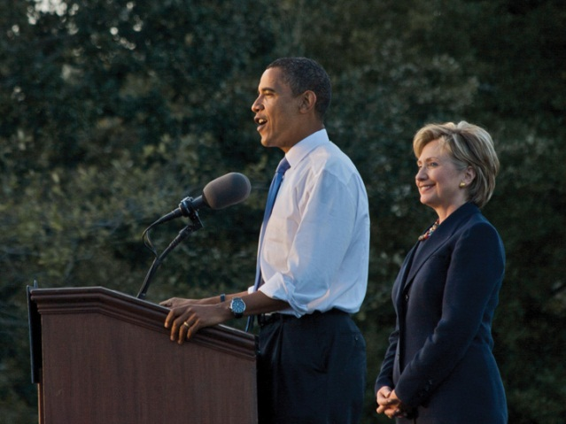
In 2008, a mixed-race man and a white woman make history as the leading contenders for the Democratic nomination for president.
Source: Photo courtesy of Nathan Forget,http://commons.wikimedia.org/wiki/File:Obama_Stump_Speech_-_cropped.jpg.
Reporters and commentators in the media identified how race and gender played out in the campaign and in the statements of the candidates and their associates, including the polarizing statements of figures such as Obama’s minister, Jeremiah Wright. At the same time, the media reported that the Democratic contest and Obama’s nomination symbolized how far civil rights have come in America from the dark days of segregation. This frame became dominant when Obama was elected president in November 2008.
Civil rights protect people against discrimination. They focus on equal access to society and to political activities such as voting. They are pursued bydisadvantaged groups who, because of a single characteristic, have historically been discriminated against. In this chapter, we consider race and ethnicity, gender, sexual orientation, and disability.
The history of civil rights was created, first and most influentially, by African Americans’ struggle for racial equality. Their strategies and policy victories became the model for all other disadvantaged groups. ^{[1]}

[1] John D. Skrentny, The Minority Rights Revolution (Cambridge, MA: Harvard University Press, 2002).

5.1 Civil War Amendments and African Americans

LEARNING OBJECTIVES
After reading this section, you should be able to answer the following questions:
- What are the Civil War amendments?
- What civil-rights challenges faced African Americans?
- What are de jure and de facto segregation?
- What did the US Supreme Court decide in Plessy v. Ferguson and Brown v. Board of Education?
- What are the Civil Rights and the Voting Rights Acts?
- What is affirmative action?

The Civil War Amendments
Equality did not enter the Constitution until the Civil War Amendments (the Thirteenth, Fourteenth, and Fifteenth) set forth the status and rights of former slaves.
In early 1865, with the Union’s triumph in the Civil War assured, Congress passed the Thirteenth Amendment. Quickly ratified by victorious Union states, it outlawed slavery and “involuntary servitude.” It authorized Congress to pass laws enforcing the amendment—giving it the power to eradicate not simply slavery but all “badges of servitude.” ^{[1]}
Abraham Lincoln, assassinated in 1865, was succeeded as president by Andrew Johnson, who pushed for a quick reunion of North and South. Republicans in Congress feared that the rights of newly freed slaves would be denied by a return to the old order. Distrusting Johnson, they decided protections had to be put into the Constitution. Congress enacted the Fourteenth Amendment in 1868 and made its ratification a condition for the Southern states’ reentry into the Union.
The Fourteenth Amendment contains three key clauses. First, anyone born in the United States is a US citizen, and anyone residing in a state is a citizen of that state. So it affirmed African Americans as US and state citizens.
Second, the amendment bars states from depriving anyone, whether a citizen or not, of “life, liberty, or property, without due process of law.” It thereby extended the Bill of Rights’ due process requirement on the federal government to the states.
Third, the amendment holds that a state may not “deny to any person within its jurisdiction the equal protection of the laws.” This equal protection clause is the Supreme Court’s major instrument for scrutinizing state regulations. It is at the heart of all civil rights. Though the clause was designed to restrict states, the Supreme Court has ruled that it applies to the federal government, too. ^{[2]}
The Fifteenth Amendment, ratified in 1870, bars federal and state governments from infringing on a citizen’s right to vote “on account of race, color, or previous condition of servitude.”
The Bill of Rights limited the powers of the federal government; the Civil War Amendments expanded them. These amendments created new powers for Congress and the states to support equality. They recognized for the first time a right to vote.
Political debate and conflict surround how, where, and when civil rights protections are applied. The complex US political system provides opportunities for disadvantaged groups to claim and obtain their civil rights. At the same time, the many divisions built into the Constitution by the separation of powers and federalism can be used to frustrate the achievement of civil rights.

African Americans
The status of African Americans continued to be a central issue of American politics after the Civil War.

Disenfranchisement and Segregation
The federal government retreated from the Civil War Amendments that protected the civil rights of African Americans. Most African Americans resided in the South, where almost all were disenfranchised and segregated by the end of the nineteenth century by Jim Crow laws that enforced segregation of public schools, accommodation, transportation, and other public places.

Link
Jim Crow Laws
“Jim Crow” was a derogatory term for African Americans, named after “Jump Jim Crow,” a parody of their singing and dancing as performed by a white actor in blackface.
Learn more about Jim Crow laws at http://www.pbs.org/wnet/jimcrow.
Enforcing the Fifteenth Amendment’s right to vote proved difficult and costly. Blacks voted in large numbers but faced violence from whites. Vigilante executions of blacks by mobs for alleged or imagined crimes reached new highs. In 1892 alone, 161 lynchings were documented, and many more surely occurred.
In 1894, Democrats took charge of the White House and both houses of Congress for the first time since the Civil War. They repealed all federal oversight of elections and delegated enforcement to the states. ^{[3]} Southern states quickly restricted African American voting. They required potential voters to take a literacy test or to interpret a section of the Constitution. Whites who failed an often easier test might still qualify to vote by virtue of a “grandfather clause,” which allowed those whose grandfathers had voted before the Civil War to register.
The Supreme Court also reduced the scope of the Civil War Amendments by nullifying federal laws banning discrimination. The Court ruled that the Fourteenth Amendment did not empower the federal government to act against private persons.
De jure segregation—the separation of races by the law—received the Supreme Court’s blessing in the 1896 case of Plessy v. Ferguson. A Louisiana law barred whites and blacks from sitting together on trains. A Louisiana equal rights group, seeking to challenge the law, recruited a light-skinned African American, Homer Plessy, to board a train car reserved for whites. Plessy was arrested. His lawyers claimed the law denied him equal protection. By a vote of 8–1, the justices ruled against Plessy, stating that these accommodations were acceptable because they were “separate but equal.” Racial segregation did not violate equal protection, provided both races were treated equally. ^{[4]}
Plessy v. Ferguson gave states the green light to segregate on the basis of race. “Separate but equal” was far from equal in practice. Whites rarely sought access to areas reserved for blacks, which were of inferior quality. Such segregation extended to all areas of social life, including entertainment media. Films with all-black or all-white casts were shot for separate movie houses for blacks and whites.

Mobilizing against Segregation
At the dawn of the twentieth century, African Americans, segregated by race and disenfranchised by law and violence, debated how to improve their lot. One approach accepted segregation and pursued self-help, vocational education, and individual economic advancement. Its spokesman, Booker T. Washington, head of Alabama’s Tuskegee Institute, wrote the best-selling memoir Up from Slavery(1901) and worked to build institutions for African Americans, such as colleges for blacks only. Sociologist W. E. B. Du Bois replied to Washington with his bookThe Soul of Black Folk (1903), which argued that blacks should protest and agitate for the vote and for civil rights.
Du Bois’s writings gained the attention of white and black Northern reformers who founded the National Association for the Advancement of Colored People (NAACP) in 1909. Du Bois served as director of publicity and research, investigating inequities, generating news, and going on speaking tours. ^{[5]}
The NAACP brought test cases to court that challenged segregationist practices. Its greatest successes came starting in the 1930s, in a legal strategy led by Thurgood Marshall, who would later be appointed to the Supreme Court. Marshall urged the courts to nullify programs that provided substandard facilities for blacks on the grounds that they were a violation of “separate but equal.” In a key 1937 victory, the Supreme Court ruled that, by providing a state law school for whites without doing the same for blacks, Missouri was denying equal protection. ^{[6]} Such triumphs did not threaten segregation but made Southern states take “separate but equal” more seriously, sometimes forcing them to give funds for black colleges, which became centers for political action.^{[7]}
During World War I, Northern factories recruited rural Southern black men for work, starting a “Great Migration” northward that peaked in the 1960s. In Northern cities, African Americans voted freely, had fewer restrictions on their civil rights, organized themselves effectively, and participated in politics. They began to elect black members of Congress, and built prosperous black newspapers. When the United States entered World War II, many African Americans were brought into the defense industries and the armed forces. Black soldiers who returned from fighting for their country engaged in more militant politics.
President Harry S. Truman saw black citizens as a sizable voting bloc. In 1946, he named an advisory commission to recommend civil rights policies. Amid his 1948 election campaign, Truman issued executive orders that adopted two of its suggestions: desegregating the armed forces and creating review boards in each cabinet department to monitor discrimination. With the crucial help of Northern black votes, Truman won in an upset.

The End of De Jure Segregation
In the 1940s, Supreme Court decisions on lawsuits brought by the NAACP and argued by Thurgood Marshall chipped away at “separate but equal.” In 1941, Arthur Mitchell, a black member of Congress from Chicago, was kicked out of a first-class sleeping car when his train entered Arkansas. The Court ruled that the Arkansas law enforcing segregation was unconstitutional. In 1944, the Court ruled that the Fifteenth Amendment barred Texas from running an all-white primary election. In 1948, it stopped enforcement of covenants that home buyers signed that said they would not resell their houses to blacks or Jews. ^{[8]}
Marshall decided to force the justices to address the issue of segregation directly. He brought suit against school facilities for blacks that were physically equal to those for whites. With the 1954 decision, Brown v. Board of Education, the Supreme Court overturned Plessy v. Ferguson and ruled unanimously that racial segregation in public education violated the Constitution. ^{[9]} (See Note 15.23 "Comparing Content" in Chapter 15 "The Courts".)
Only 6 percent of Southern schools had begun to desegregate by the end of the 1950s. In 1957, Arkansas Governor Orval Faubus, backed by white mobs, mobilized the National Guard to fight a federal court order to desegregate Little Rock’s public schools. President Eisenhower took charge of the Arkansas National Guard and called up US troops to enforce the order. ^{[10]} Television images of the nine Little Rock students attempting to enter Central High surrounded by troops and an angry mob brought the struggle for civil rights into American living rooms.

Link
Central High Conflicts
Learn more about the conflicts at Central High online athttp://www.nps.gov/nr/travel/civilrights/ak1.htm.

The African American Civil Rights Movement
Even before the Brown v. Board of Education decision, a mass movement of African Americans had emerged from black churches and black colleges. Such organizations provided networks for communicating with and organizing recruits. The black press in both the North and the South publicized the movement.
Daily newspapers in the South, which covered a white power structure and were aimed at white readers, all but ignored the African American civil rights movement. Southern reporters who covered the movement were threatened, and even harmed physically, by the Ku Klux Klan, a white supremacist group.^{[11]} Northern newspapers were slow to discover the movement, although the attention they eventually accorded civil rights protests would help the movement grow and expand.
The first mass action for civil rights took place in Baton Rouge, Louisiana, in 1953. African Americans led by a Baptist minister boycotted the city’s segregated public buses. Although African Americans provided about three-quarters of the ridership, they had to stand behind an often near-empty white section. A deal was struck: the city council saved the first two rows for whites but blacks could sit anywhere else, as long as they were not in front of whites.
Figure 5.1
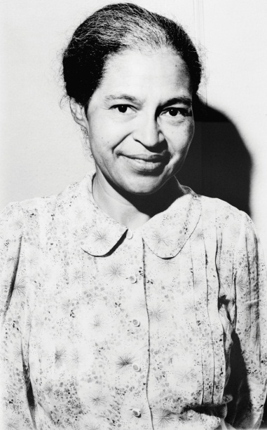
NAACP leaders sued the city and started a boycott led by a twenty-six-year-old Baptist preacher fresh out of divinity school—Martin Luther King Jr. The boycott lasted 381 days and ended only after the US Supreme Court had declared Montgomery’s segregated public transportation unconstitutional.
Source:http://en.wikipedia.org/wiki/File:Rosaparks_1964.jpg.
Another bus boycott took place in Montgomery, Alabama. Rosa Parks, a seamstress and an activist in the local NAACP, was arrested in December 1955 after refusing to give up her bus seat to a white man.

Enduring Images
Rosa Parks
Two enduring images of the African American civil rights movement are of Rosa Parks. In one, she is being arrested. In a later photograph taken forLook magazine, she is sitting on a city bus in front of a white passenger. Her refusal to give up her bus seat to a white person and move to the back of the bus touched off the massive Montgomery bus boycott that ended with a Supreme Court decision ordering the city to desegregate public transportation. The images endure because of the simple, moving tale of a lone individual affirming her dignity and equality by a simple act—sitting down.
What the images do not show is that Parks was a longstanding activist in local civil rights politics and was secretary of the Montgomery chapter of the NAACP. The photo of her arrest was not for her action on the bus, but for later activity in the boycott.
Parks was not the first African American woman to refuse to give up her seat in a bus. Claudette Colvin, a fifteen-year-old young woman active in the NAACP Youth Council, had refused to give up her bus seat a few months before. Colvin cried out as she was arrested, “this is my constitutional right.” NAACP leaders had hoped to draw attention to Colvin’s case, until they realized that she was foul-mouthed and unruly—the pregnant, unmarried Colvin was not the symbol of African American resistance the NAACP wished to portray. Parks, a diminutive, devout, soft-spoken, married woman, was ideal for favorable publicity. ^{[12]}
Civil rights activists receive most positive coverage when they are able to present themselves as noble, oppressed victims. The images of Parks, arrested and sitting at the front of the bus, have lasted and been widely reproduced. Other images of Parks as political activist and organizer, roles that are equally central to her life, have not.
King founded the Southern Christian Leadership Conference (SCLC) to lead black resistance, confirmed himself as the leading orator of the movement, and honed a strategy by which black victims of discrimination confronted repressive white power nonviolently. Rosa Parks’s example revealed how this “David-and-Goliath” story was well suited to getting the issue of civil rights into the news.
Students created the next wave of activism. In 1960, four freshmen at North Carolina A&T State University sat down at a dime-store, whites-only lunch counter in Greensboro and would not leave until they were served.
The students tipped off a local white photographer, who took a picture of them that gained national attention. The “Greensboro four” were arrested and jailed. Twenty-nine students sat at the lunch counter the next day, and hundreds more followed. After months of dwindling sales, Greensboro’s merchants agreed to desegregate. The sit-in was rapidly imitated across the South. ^{[13]} It inspired a new, younger, more confrontational organization—the Student Nonviolent Coordinating Committee (SNCC).
In 1961, white and black activists launched a Freedom Ride to travel together on buses from Washington, DC, to New Orleans in defiance of state laws. They did not make it. In Alabama, one bus was stopped, and its occupants were badly beaten. Another bus was set on fire, and the freedom riders barely escaped alive.
Dramatic, widely distributed photographs of these events forced President John F. Kennedy to order federal agencies to halt segregation and discrimination in interstate transportation. ^{[14]} Civil rights activists used depictions of white repression to win dramatic news coverage and generate public sympathy for their cause.
The SNCC organized the Freedom Summer of 1964, a campaign to register voters in Mississippi, the state with the largest percentage of blacks and the lowest rate of black voter registration. Massive resistance from whites resulted in violence, culminating in the murder of three civil rights workers—one black and two white. Murders of white civil rights activists generated more public outrage and received more news coverage than murders of black participants.
In 1963, King and the SCLC conducted an all-out campaign, including mass meetings, sit-ins, and boycotts of downtown stores in Birmingham, Alabama. Their attempts to march to city hall were violently suppressed by police. Marchers, including young children, were chased and attacked by police dogs and pummeled with water from fire hoses so powerful it tore off their clothes and removed bark from trees. Thousands were arrested.
These protests, and the official response, received saturation coverage in the news. After five weeks, Birmingham’s business leaders signed an agreement to desegregate stores and enhance black employment. ^{[15]} In a nationally televised address in June, President Kennedy proposed a far-reaching Civil Rights Act. Riding a surge of attention, King planned a national march on Washington. A quarter of a million people jammed around the Lincoln Memorial in August to hear speeches and songs, capped off by King’s “I Have a Dream” vision of racial reconciliation.

Link
Dr. Martin Luther King’s “I Have a Dream” Speech
Listen to King’s “I Have a Dream” speech online at http://mlk-kpp01.stanford.edu/index.php/encyclopedia/documentsentry/doc_august_28_1963_i_have_a_dream.

The 1964 Civil Rights Act and 1965 Voting Rights Act
After the assassination of President Kennedy in November 1963, the new president, Lyndon B. Johnson, asked Congress to pass the Civil Rights Act, which Kennedy had initiated. It became law after weeks of lobbying, concessions, deals, and filibusters by Southern senators.
Figure 5.2
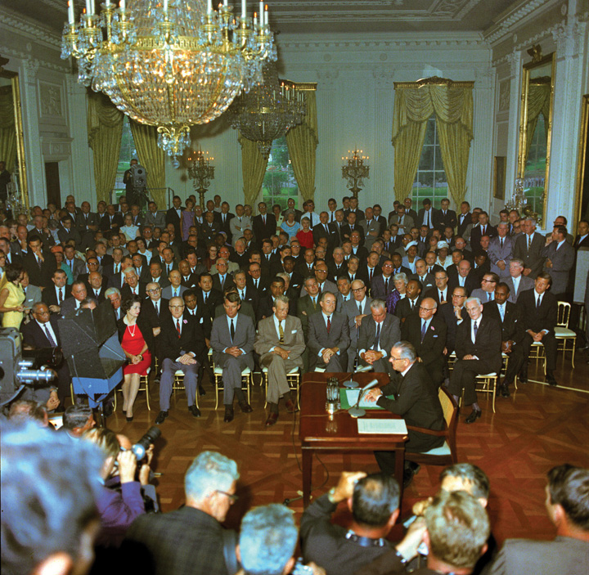
Landmark civil rights legislation was signed into law by a son of the Old South, Texan Lyndon B. Johnson, who pointedly invited the civil rights leader Martin Luther King Jr. to the White House for the ceremony.
Source:http://commons.wikimedia.org/wiki/File:LBJ_Civil_Rights_Act_crowd.jpg.
The Civil Rights Act forbids discrimination on the basis of “race, color, religion, or national origin” in public accommodations and employment. It set up the Equal Employment Opportunity Commission(EEOC) to implement the law.
With the passage of the Civil Rights Act, the movement turned from discrimination to the vote. Southern blacks trying to register to vote were required to answer impossible questions, such as “how many bubbles in a bar of soap?” Those who managed to register and then tried to vote might be beaten or fired from their jobs. King and the SCLC marched on Selma, Alabama, to peacefully push the goal of registering black citizens to vote. Such a simple message was ideal for transmission through the national news.
In March of 1965, King organized a march from Selma to the state capital, Montgomery. A column of six hundred marchers were confronted by fifty Alabama state troopers, some on horseback, and ordered to disperse. When they did not move, the troopers charged them and shot tear gas, brutally injuring one hundred of the demonstrators. Television footage of this “Bloody Sunday” was widely broadcast.
The upsurge in news coverage prompted membership and funding for civil rights organizations to soar. Public opinion polls revealed that civil rights was the nation’s most important problem. ^{[16]} Officials felt pressure to act. President Johnson gave a televised speech before Congress to propose the Voting Rights Act, stating, “It is all of us who must overcome the crippling legacy of bigotry and injustice.” He paused, then evoked the civil rights battle cry: “We shall overcome.” The act sailed through Congress. (See Johnson speak athttp://millercenter.org/scripps/archive/speeches/detail/3386.)
The Voting Rights Act of 1965 gave new powers to the federal government. The act outlawed literacy tests and required the states to prove to the justice department that any changes in voting practices would not abridge the right to vote. It authorized the federal government to use poll watchers and registration examiners to supervise state and local elections. It instantly removed barriers to black registration and voting. In Mississippi, the percentage of blacks registered to vote swelled from under 7 percent in 1964 to 60 percent in 1967.

From South to North
Victorious in the South, the African American civil rights movement turned north. Blacks and whites were separated by locality and attended different schools in both North and South. Separation of the races in the North was by practice more than by law; such de facto segregation proved tougher to address by legal efforts alone.
African Americans began rioting in Northern cities, and the rioting reached a peak in 1967. Many rioters saw their actions as protest or rebellion. Some of their violence targeted white-owned stores, which they looted, and police stations, which they set on fire. Scores of African Americans died after police and soldiers were brought in to restore order.
In part due to their perennial interest in vivid, dramatic conflict, the media shifted their focus from nobly suffering victims to fiery, demanding militants. The unity, discipline, and influence of the African American civil rights movement ebbed. King’s doctrine of nonviolent resistance was challenged by the rhetoric of the Black Muslim leader Malcolm X who advocated “any means necessary” to advance equality and promoted SNCC’s new motto, “Black Power.” In 1968, King was assassinated in Memphis, where he had gone to support the sanitation workers’ campaign for improved pay and working conditions.
Black militancy, amplified in the news, spawned a white backlash. Republican Richard Nixon was elected president in 1968 on a “law and order” platform that called for slowing down desegregation. The news prominently displayed the dramatic, sometimes violent, reaction by whites against the busing of black students to white schools in supposedly liberal Northern cities such as Boston. It did not miss the irony of massive demonstrations against the busing to desegregate the public schools of Boston, the city at the center of the opposition to slavery prior to the Civil War.
In 1974, the Supreme Court rejected a Detroit plan that required busing across school district lines. The judicial push for integration slowed. ^{[17]}

Affirmative Action
In recent years, the main mass-media focus on African American civil rights has been affirmative action: efforts made or enforced by government to achieve equality of opportunity by increasing the percentages of racial and ethnic minorities and women in higher education and the workplace.
Most members of racial and ethnic minorities support affirmative action; majorities of whites are opposed. Supporters tend to focus on remedying the effects of past discrimination; opponents respond that government should never discriminate on the basis of race. The media largely frame the issue as a question of one side winning and the other side losing. ^{[18]}
The Supreme Court first weighed in on affirmative action in 1978. Allan Bakke, a white applicant, was denied entrance to the medical school of the University of California, Davis. Bakke noted that his test scores were higher than other applicants admitted on a separate track for minorities. He sued, charging “reverse discrimination.” The Court concluded that UC Davis’s approach of separating white and minority applicants into two separate groups violated the principle of equal protection. School programs like Harvard’s, which considered race as one of many criteria, were permissible. ^{[19]}
A 2003 Supreme Court decision affirmed this position by voiding the undergraduate admission program at the University of Michigan that added points to a candidate’s application on the basis of race but upholding the graduate admission approach that considered race in a less quantitative way.
In 2007, the Supreme Court rejected the actions of the Seattle and Louisville school systems to promote racial integration by assigning students to particular schools in order to make the population of each school reflect the cities’ racial composition. This 5–4 decision by Chief Justice Roberts, leading the Court’s conservative majority, seemed to prohibit school systems from using race to classify and thus assign students. It did, however, allow the use of other (unspecified) race-conscious measures to combat racial segregation. ^{[20]}

Civil Rights Issues Persist
The legacy of slavery and segregation is evident in not only the higher rates of poverty, unemployment, and incarceration but also the lower life expectancy and educational test scores of African Americans compared to whites. Visitors to the website of the NAACP will find many subjects connected to race, such as police practices of racial profiling of suspects. But the NAACP also deals with issues that disproportionately affect African Americans and that some might think have “nothing to do with race.” These include a practice the NAACP labels “environmental racism,” whereby polluting factories are placed next to poor, largely African American neighborhoods.
The mass media tend to focus on incidents of overt discrimination rather than on damage caused by the poverty, poor education, and environmental hazards that disadvantaged groups often face. This media frame explains why television reporters, facing the devastation of New Orleans by Hurricane Katrina, were so thunderstruck by the overwhelming number of black faces among the victims. The topic of black urban poverty is simply not something the press routinely covers.

KEY TAKEAWAYS
Civil rights protect people against discrimination and focus on equal access to society and political life. In this section we have described the evolution and contents of the civil rights of African Americans. We started with the Civil War Amendments added to the Constitution to guarantee newly freed slaves’ legal status. We covered African Americans’ disenfranchisement and segregation, their mobilizing against segregation, the end of de jure segregation, and the civil rights movement. We described the 1964 Civil Rights Act and 1965 Voting Rights Act, and the issue of affirmative action. African Americans have had more success in combating segregation by law than fighting discrimination by practice. They have variously been helped and hindered by media coverage and depictions of their situation and struggles. Civil rights issues persist today.

EXERCISES
- What basic protections did the Civil War Amendments introduce? How would life in America be different if these amendments had never been passed?
- How were blacks denied the right to vote and equal protection even after the Civil War Amendments passed? When did that begin to change and why?
- How did civil rights protestors seek to bring discrimination to the public’s attention? Why do you think their strategy worked?
- To what extent do you think that the legacy of slavery and segregation is responsible for the inequalities that persist in America? How do you think the law should deal with those inequalities?

[1] Herman Belz, A New Birth of Freedom: The Republican Party and Freedmen’s Rights, 1861–1866, 2nd ed. (New York: Fordham University Press, 2000), chap. 7.
[2] Bolling v. Sharpe, 347 US 497 (1954). See also Adarand Constructors v. Peña, 515 US 200 (1995).
[3] William Gillette, Retreat from Reconstruction, 1869–1879 (Baton Rouge: Louisiana State University Press, 1979), chap. 2. Data on lynching are in Robert L. Zangrando, The NAACP’s Crusade Against Lynching, 1909–1950 (Philadelphia: Temple University Press, 1980), table 2.
[4] Plessy v. Ferguson, 163 US 537 (1896)
[5] Charles Flint Kellogg, NAACP: A History of the National Association for the Advancement of Colored People, vol. 1 (Baltimore: Johns Hopkins University Press, 1967).
[6] Missouri ex rel. Gaines v. Canada, 305 US 676 (1937). See Mark V. Tushnet, The NAACP’s Legal Strategy Against Segregated Education, 1925–1950 (Chapel Hill: University of North Carolina Press, 1987), chaps. 2–5.
[7] Doug McAdam, Political Process and the Development of Black Insurgency, 1930–1970, 2nd ed. (Chicago: University of Chicago Press, 1999), 100–103.
[8] Mitchell v. United States, 313 US 80 (1941); Smith v. Allwright, 321 US 649 (1944); Shelley v. Kraemer, 334 US 1 (1948).
[9] Brown v. Board of Education, 347 US 483 (1954).
[10] Harvard Sitkoff, The Struggle for Black Equality, 1954–1992, rev. ed. (New York: Hill and Wang, 1993), chap. 2.
[11] Gene Roberts and Hank Klibanoff, The Race Beat. (New York: Random House, 2006).
[12] Douglas Brinkley, Rosa Parks (New York: Viking Penguin, 2000), chap. 5.
[13] William H. Chafe, Civilities and Civil Rights: Greensboro, North Carolina, and the Black Struggle for Freedom (New York: Oxford University Press, 1980), chap. 3.
[14] David Niven, The Politics of Injustice: The Kennedys, the Freedom Rides, and the Electoral Consequences of a Moral Compromise (Knoxville: University of Tennessee Press, 2003).
[15] Glenn T. Eskew, But For Birmingham: The Local and National Movements in the Civil Rights Struggle (Chapel Hill: University of North Carolina Press, 1997).
[16] Tom W. Smith, “America’s Most Important Problem—A Trend Analysis, Public Opinion Quarterly 44, no. 2 (Summer 1980): 164–80.
[17] J. Harvie Wilkinson III, From Brown to Bakke: The Supreme Court and School Desegregation (New York: Oxford University Press, 1979), chaps. 8–9.
[18] Robert M. Entman and Andrew Rojecki, The Black Image in the White Mind: Media and Race in America (Chicago: University of Chicago Press, 2000).
[19] Regents of the University of California v. Bakke, 438 US 265 (1978).
[20] Parents Involved in Community Schools v. Seattle School District No. 1, 551 US 701 (2007).

5.2 Other Minorities, Women, Lesbians, Gay Men, and the Disabled

LEARNING OBJECTIVES
After reading this section, you should be able to answer the following questions:
- What civil rights challenges have Latinos, Asian Americans, and Native Americans faced?
- What is the Nineteenth Amendment?
- What is the Equal Rights Amendment?
- What is sexual harassment?
- What political and legal challenges do lesbians and gay men face?
- What is the Americans with Disabilities Act?
Policies protecting African Americans’ civil rights automatically extend to other racial and ethnic minorities. Most prominent of these groups are Latinos, Asian Americans, and Native Americans. They all have civil rights concerns of their own.

Latinos
Latinos have displaced African Americans as the largest minority group in the United States. They are disproportionately foreign-born, young, and poor. They can keep in touch with issues and their community through a burgeoning Spanish-language media. Daily newspapers and national television networks, such as Univisión, provide a mix of news and advocacy.
Politicians court Latinos as a growing bloc of voters. ^{[1]} As a result, Latinos have had some success in pursuing civil rights, such as the use of Spanish in voting and teaching. After Latino groups claimed that voting rights were at risk for citizens not literate in English, the Voting Rights Act was amended to require ballots to be available in a language other than English in election districts where that language was spoken by 5 percent or more of the electorate. And the Supreme Court has ruled that school districts violate the Civil Rights Act of 1964 when students are taught in a language that they do not understand. ^{[2]}
Latino success has not carried over to immigration. ^{[3]} Illegal immigrants pose vexing questions in terms of civil rights. If caught, should they be jailed and expelled? Should they be eligible to become citizens?
In 2006, Congressman Jim Sensenbrenner (R-WI) introduced legislation to change illegal immigration from a violation of civil law to a felony and to punish anyone who provided assistance to illegal immigrants, even church ministers. Hundreds of thousands rallied in cities across the country to voice their opposition. President George W. Bush pushed for a less punitive approach that would recognize illegal immigrants as “guest workers” but would still not allow them to become citizens.
Other politicians have proposed legislation. Mired in controversy, none of these proposals have become law. President Obama revisited one aspect of the subject in his 2011 State of the Union message:
Today, there are hundreds of thousands of students excelling in our schools who are not American citizens. Some are the children of undocumented workers, who had nothing to do with the actions of their parents. They grew up as Americans and pledge allegiance to our flag, and yet they live every day with the threat of deportation.…It makes no sense.
Now, I strongly believe that we should take on, once and for all, the issue of illegal immigration. I am prepared to work with Republicans and Democrats to protect our borders, enforce our laws, and address the millions of undocumented workers who are now living in the shadows. I know that debate will be difficult and take time. ^{[4]}

Link
The National Council of La Raza
To learn more about Latino civil rights, visit the National Council of La Raza online at http://www.nclr.org.

Asian Americans
Many landmark cases on racial discrimination going back to the nineteenth century stemmed from suits by Asian Americans. World War II brought more discrimination out of an unjustified, if not irrational, fear that some Japanese Americans might be loyal to Japan and thus commit acts of sabotage against the United States: the federal government imposed curfews on them. Then after President Roosevelt signed Executive Order 9066 on February 19, 1942, roughly 120,000 Japanese Americans (62 percent of them US citizens) were forcibly moved from their homes to distant, desolate relocation camps. Ruling toward the end of the war, the Supreme Court did not strike down the internment policy, but it did hold that classifying people by race is unconstitutional. ^{[5]}
Japanese Americans who had been interred in camps later pressed for redress. Congress eventually responded with the Civil Liberties Act of 1988, whereby the US government apologized to and compensated camp survivors. ^{[6]}

Link
Japanese Internment
To learn more about Japanese internment, visithttp://www.archives.gov/research/alic/reference/military/japanese-internment.html.
Figure 5.3
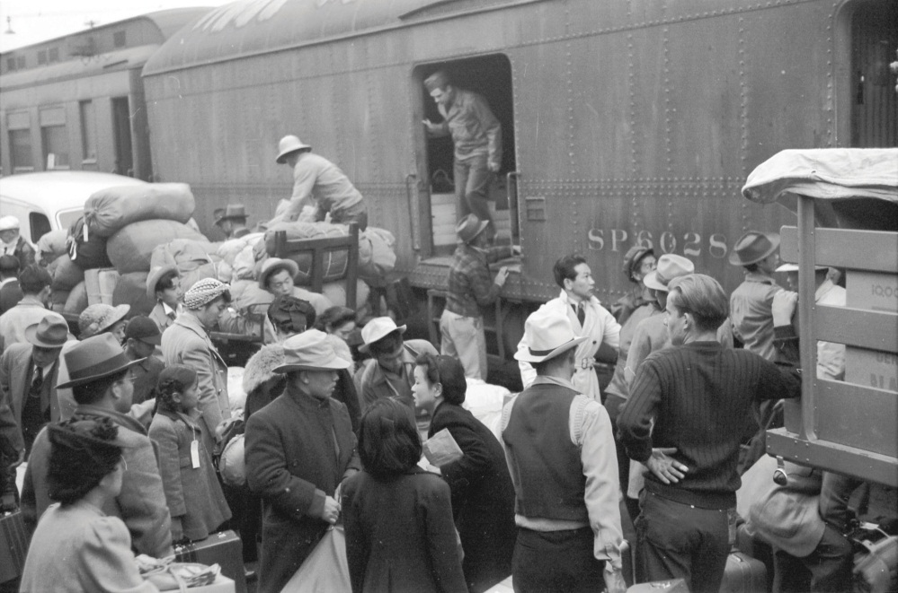
Japanese Americans being shipped to internment camps during World War II.
Source:http://commons.wikimedia.org/wiki/File:Internment.jpg.
Asian Americans have united against discrimination. During the Vietnam era, Asian American students opposing the war highlighted its impact on Asian populations. Instead of slogans such as “Bring the GIs home,” they chanted, “Stop killing our Asian brothers and sisters.”
These Asian American student groups—and the periodicals they spawned—provided the foundation for a unified Asian American identity and politics. ^{[7]}
A dazzling array of Asian American nationalities, religions, and cultures has emerged since 1965, after restrictions on immigration from Asia were removed. Yet vestiges of discrimination remain. For example, Asian Americans are paid less than their high education would warrant. ^{[8]} They point to mass-media stereotypes as contributing to such discrimination.

Native Americans
Native Americans represent many tribes with distinct languages, cultures, and traditions. Nowadays, they obtain protection against discrimination just as members of other racial and ethnic groups do. Specifically, the Indian Civil Rights Act (ICRA) of 1968 guaranteed them many civil rights, including equal protection under the law and due process; freedom of speech, press, and assembly; and protection from unreasonable search and seizure, self-incrimination, and double jeopardy.
Native Americans’ civil rights issues today center on tribal autonomy and self-government on Indian reservations. Thus some of the provisions of the Bill of Rights, such as the separation of church and state, do not apply to tribes. ^{[9]}Reservations may also legally discriminate in favor of hiring Native Americans.
For much of history, Native Americans residing outside of reservations were in a legal limbo, being neither members of self-governing tribal nations nor US citizens. For example, in 1881, John Elk, a Native American living in Omaha, claimed that he was denied equal protection of the laws when he was prevented from voting. The Supreme Court ruled that since he was “born to an Indian nation,” Elk was not a citizen and could not claim a right to vote. ^{[10]} Nowadays, Native Americans living on or outside reservations vote as any other citizens.

Link
The Native American Civil Rights Movement
For more on the Native American Civil Rights movement, visithttp://www.knowitall.org/roadtrip/cr-html/facts/timelines/na/index.cfm.

Women
Women constitute a majority of the population and of the electorate, but they have never spoken with a unified voice for civil rights, nor have they received the same degree of protection as racial and ethnic minorities.

The First Wave of Women’s Rights
In the American republic’s first years, the right to vote was reserved for property owners, most of whom were male. The expansion of the franchise to “universal white manhood suffrage” served only to lock in women’s disenfranchisement.
Women’s activism arose in the campaign to abolish slavery. Women abolitionists argued that the case against slavery could not be made as long as women did not have political rights as well. In 1848, women and men active in the antislavery movement, meeting in Seneca Falls, New York, adopted a Declaration of Sentiments. Emulating the Declaration of Independence, it argued that “all men and women are created equal” and catalogued “repeated injuries and usurpations on the part of man toward woman.” ^{[11]}

Link
The Seneca Falls Convention
To learn more about the Seneca Falls Convention, visithttp://www.npg.si.edu/col/seneca/senfalls1.htm.
After the Civil War, women abolitionists hoped to be rewarded with the vote, but women were not included in the Fifteenth Amendment. In disgust, Susan B. Anthony and Elizabeth Cady Stanton, two prominent and ardent abolitionists, launched an independent women’s movement. ^{[12]} Anthony drafted a constitutional amendment to guarantee women’s right to vote: “The right of citizens of the United States to vote shall not be denied or abridged by the United States or by any state on account of sex.” ^{[13]} Modeled on the Fifteenth Amendment, it was introduced in the Senate in 1878.
At first, the suffragists demurely petitioned and testified. By 1910, their patience was at an end. They campaigned against members of Congress and picketed the White House.
Figure 5.4
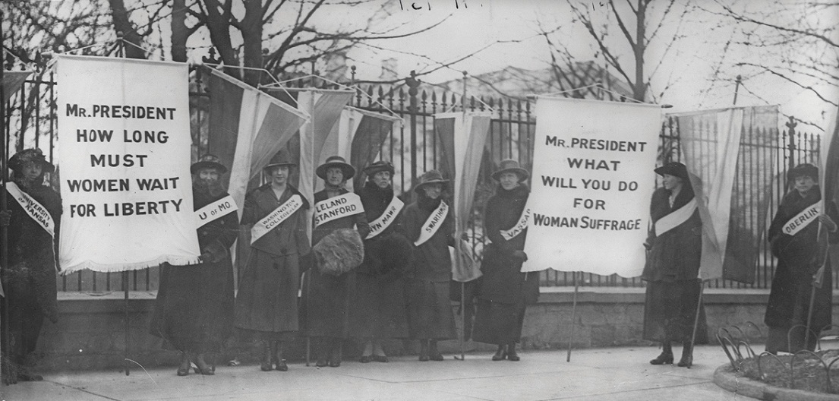
Women picketing in front of the White House embarrassed President Woodrow Wilson during World War I. They pointed out that his promise “to make the world safe for democracy” did not include extending the vote to women. Wilson changed his position to one of support for the Nineteenth Amendment.
Source:http://commons.wikimedia.org/wiki/File:Women_suffragists_picketing_in_front_of_the_White_house.jpg.
They went to jail and engaged in hunger strikes. Such efforts, widely publicized in the news, eventually paid off in 1920 when the Nineteenth Amendmentwas added to the Constitution. ^{[14]}

The Second Wave of Women’s Rights
When the vote won, the women’s movement lost its central focus. Women were split by a proposed Equal Rights Amendment (ERA) to the Constitution, mandating equal treatment of men and women under the law. It was proposed in 1923 by well-to-do Republican working professional women but was opposed by women Democrats in labor unions, who had won “specific bills for specific ills”—minimum wage and maximum hours laws for working women. Meanwhile, women constituted an increasing proportion of voters and made inroads in party activism and holding office. ^{[15]}

Link
The Equal Rights Amendment
Learn more about the Equal Rights Amendment athttp://www.now.org/issues/economic/eratext.html.
Then came an unexpected breakthrough: Conservative Southern House members, hoping to slow down passage of the 1964 Civil Rights Bill, offered what they deemed frivolous amendments—one of which expanded the act to protect women. Northern and Southern male legislators joined in derision and laughter. The small contingent of congresswomen berated their colleagues and allied with Southern conservatives to pass the amendment.
Thus the Civil Rights Act ended up also barring discrimination in employment on the basis of sex. However, the Equal Employment Opportunity Commission (EEOC), created to implement the act, decided that its resources were too limited to focus on anything but race.
In 1967, women activists reacted by forming the National Organization for Women (NOW), which became the basis for a revived women’s movement. NOW’s first president was Betty Friedan, a freelance writer for women’s magazines. Her 1963 best seller, The Feminine Mystique, showed that confining women to the domestic roles of wife and mother squelched opportunities for middle-class, educated women. ^{[16]} Women’s organizations adopted the slogan “the personal is political.” They pointed out that even when men and women in a couple worked outside the home equally, housework and child care fell more heavily on wives, creating a “second shift” limiting women’s opportunity for political activism.

Equality without the ERA
By 1970, Democrats and Republicans alike backed the ERA and women’s rights. One House member, Bella Abzug (D-NY), later exulted, “We put sex discrimination provisions into everything. There was no opposition. Who’d be against equal rights for women?” ^{[17]}
Such laws could be far reaching. Title IX of the Education Act Amendments of 1972, outlawing sex discrimination in federally funded educational programs, prompted little debate when it was enacted. Today it is controversial. Some charge that it pushes funds to women’s sports, endangering men’s sports. Defenders respond that all of women’s sports put together get less funding at universities than men’s sports, such as basketball or football. ^{[18]}
NOW and other organizations focused on the ERA. It passed by huge bipartisan margins in the House in 1970 and the Senate in 1972; thirty of the thirty-eight states necessary to ratify approved it almost immediately. However, opposition to the ERA, led and generated by conservative women, arose among the general public, including women. While women working outside the home generally favored the ERA to fight job discrimination, housewives feared that the ERA would remove protection for them, such as the legal presumptions that women were more eligible than men for alimony after a divorce. The public’s support of the ERA declined because of fears that it might allow military conscription of women and gay marriage. The political consensus crumbled, and in 1980, the Republican platform opposed ERA for the first time. ERA died in 1982 when the ratification process expired. ^{[19]}
Although women have made strides toward equality, they still fall behind on important measures. The United States is twenty-second among the thirty most developed nations in its proportion of women in Congress. The percentage of female state legislators and state elective officials is between 20 and 25 percent. The top twenty occupations of women are the same as they were fifty years ago: they work as secretaries, nurses, and grade school teachers and in other low-paid white-collar jobs.

Sexual Harassment
In 1980, the EEOC defined sexual harassment as unwelcome sexual advances or sexual conduct, verbal or physical, that interferes with a person’s performance or creates a hostile working environment. Such discrimination on the basis of sex is barred in the workplace by the Civil Rights Act of 1964 and in colleges and universities that receive federal funds by Title IX. In a series of decisions, the Supreme Court has ruled that employers are responsible for maintaining a harassment-free workplace. Some of the elements of a sexually hostile environment are lewd remarks and uninvited and offensive touching. ^{[20]}
Schools may be held legally liable if they have tolerated sexual harassment. ^{[21]}Therefore, they establish codes and definitions of what is and is not permissible. The College of William and Mary, for example, sees a power difference between students and teachers and prohibits any and all sexual contact between them. Others, like Williams College, seek to ensure that teachers opt out of any supervisory relationship with a student with whom they are sexually involved. The news often minimizes the impact of sexual harassment by shifting focus away from a public issue of systematic discrimination to the question of personal responsibility, turning the issue into a private “he said, she said” spat.^{[22]}

Lesbians and Gay Men
Gay people, lesbians and gay men, are at the forefront of controversial civil rights battles today. They have won civil rights in several areas but not in others. ^{[23]}
Gay people face unique obstacles in attaining civil rights. Unlike race or gender, sexual orientation may or may not be an “accident of birth” that merits constitutional protection. The gay rights movement is opposed by religious conservatives, who see homosexuality as a flawed behavior, not an innate characteristic. Moreover, gay people are not “born into” a visible community and identity into which they are socialized. A history of ostracism prompts many to conceal their identities. According to many surveys of gay people, they experience discrimination and violence, actual or threatened.
Election exit polls estimate that lesbians, gay men, and bisexuals make up 4 percent of the voting public. When candidates disagree on gay rights, gays vote by a three-to-one margin for the more progay of the two. ^{[24]} Some progay policies are politically powerful. For instance, the public overwhelmingly condemns discrimination against gay people in the workplace.

Gay Movements Emerge
The anti-Communist scare in the early 1950s spilled into worries about “sexual perverts” in government. Gay people faced harassment from city mayors and police departments pressured to “clean up” their cities of “vice.”
The first gay rights movement, the small, often secretive Mattachine Society, emerged to respond to these threats. Mattachine’s leaders argued that gay people, rather than adjust to society, should fight discrimination against them with collective identity and pride. Emulating the African American civil rights movement, they protested and confronted authorities. ^{[25]}
In June 1969, during a police raid at a gay bar in New York City’s Greenwich Village, the Stonewall Inn, customers fought back. Street protests and violent outbursts followed over several days and catalyzed a mass movement. The Stonewall riots were overlooked by network television and at best got only derisive coverage in the back pages of most newspapers. But discussion of the riot and the grievances of gay people blossomed in alternative newspapers such as The Village Voice and emerging weeklies serving gay urban enclaves. By the mid-1970s, a national newsmagazine, The Advocate, had been founded.
Figure 5.5
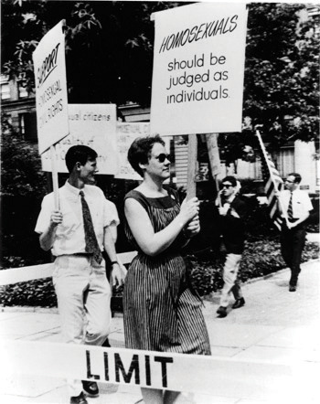
Lesbian and gay activists picked up a cue from the African American civil rights movement by picketing in front of the White House in 1965—in demure outfits—to protest government discrimination. Drawing on this new openness, media discussion in both news and entertainment grew dramatically from the 1950s through the 1960s.
Source: New York Public Library Manuscripts and Archives Division,http://commons.wikimedia.org/wiki/File:Barbara_Gittings_1965.jpg.
By the early 1980s, the gay movement boasted national organizations to gather information, lobby government officials, fund electoral campaigns, and bring test cases to courts. ^{[26]} The anniversary of the Stonewall riots is marked by “gay pride” marches and celebrations in cities across the country.

Political and Legal Efforts
The gay rights movement’s first political efforts were for laws to bar discrimination by sexual orientation in employment, the first of which were enacted in 1971. ^{[27]} President Bill Clinton issued an executive order in 1998 banning discrimination on the basis of sexual orientation in federal government employment outside the military. By 2003, nondiscrimination laws had been enacted in 40 percent of American cities and towns.
The first legal victory for lesbian and gay rights occurred in 1965: a federal district court held that the federal government could not disqualify a job candidate simply for being gay. ^{[28]} In 1996, the Supreme Court voided a 1992 Colorado ballot initiative that prevented the state from passing a law to ban discrimination on the basis of sexual orientation. The justices said the amendment was so sweeping that it could be explained only by “animus toward the class” of gay people—a denial of equal protection. ^{[29]}
In 2003, the Court rejected a Texas law banning same-sex sexual contact on the grounds that it denied equal protection of the law and the right to privacy. The decision overturned a 1986 ruling that had upheld a similar law in Georgia. ^{[30]}

The Military Ban
In 1992, presidential candidate Bill Clinton endorsed lifting the ban on gay people serving openly in the military. In a postelection press conference, Clinton said he would sign an executive order to do so. The news media, seeing a dramatic and clear-cut story, kept after this issue, which became the top concern of Clinton’s first days in office. The military and key members of Congress launched a public relations campaign against Clinton’s stand, highlighted by a media event at which legislators toured cramped submarines and asked sailors on board how they felt about serving with gay people. Clinton ultimately supported a compromise that was closer to a surrender—a “don’t ask, don’t tell” policy that has had the effect of substantially increasing the number of discharges from the military for homosexuality. ^{[31]}
Over years of discussion and debate, argument, and acrimony, opposition to the policy increased and support declined. President Obama urged repeal, as did his secretary of defense and leaders of the military. In December 2010, Congress passed and the president signed legislation repealing “don’t ask, don’t tell.” As the president put it in his 2011 State of the Union message, “Our troops come from every corner of this country—they are black, white, Latino, Asian, and Native American. They are Christian and Hindu, Jewish and Muslim. And yes, we know that some of them are gay. Starting this year, no American will be forbidden from serving the country they love because of who they love.” ^{[32]}

Same-Sex Marriage
Same-sex couples brought suits in state courts on the grounds that preventing them from marrying was sex discrimination barred by their state constitutions. In 1996, Hawaii’s state supreme court agreed. Many members of Congress, concerned that officials might be forced by the Constitution’s “full faith and credit” clause to recognize same-sex marriages from Hawaii, quickly passed a Defense of Marriage Act, which President Clinton signed. It defines marriage as the union of a man and a woman and denies same-sex couples federal benefits for married people. Many states followed suit, and Hawaii’s court decision was nullified when the state’s voters amended the state constitution before it could take effect.
In 2000, the highest state court in Vermont ruled that the state may not discriminate against same-sex couples and allowed the legislature to createcivil unions. These give same-sex couples “marriage lite” benefits such as inheritance rights. Going further, in 2003, Massachusetts’s highest state court allowed same-sex couples to legally wed. So did the California and Connecticut Supreme Courts in 2008.
Voters in thirty states, including California in 2008 (by 52 percent of the vote), passed amendments to their state constitutions banning same-sex marriage. President George W. Bush endorsed an amendment to the US Constitution restricting marriage and its benefits to opposite-sex couples. It received a majority of votes in the House, but not the two-thirds required.
In 2010, a federal judge in San Francisco struck down California’s voter-approved ban on same-sex marriage on the grounds that it discriminates against gay men and women. In 2011 New York allowed same-sex marriage. The legal battle is almost certain to be settled by the US Supreme Court.

People with Disabilities
People with disabilities have sought and gained civil rights protections. When society does not accommodate their differences, they view this as discrimination. They have clout because, by US Census estimates, over 19 percent of the population has some kind of disability.

From Rehabilitation to Rights
Early in the twentieth century, federal policy began seeking the integration of people with disabilities into society, starting with returning veterans of World War I. According to these policies, disabilities were viewed as medical problems; rehabilitation was stressed.
By the 1960s, Congress began shifting toward civil rights by enacting a law requiring new federal construction to be designed to allow entrance for people with disabilities. In 1972, Congress voted, without debate, that work and school programs receiving federal funds could not deny benefits to or discriminate against someone “solely by reason of his handicap.” ^{[33]} Civil servants in the Department of Health, Education and Welfare built on this language to create a principle of reasonable accommodation. In the workplace, this means that facilities must be made accessible (e.g., by means of wheelchair ramps), responsibilities restructured, or policies altered so that someone with disabilities can do a job. At schools, it entails extra time for tests and assignments for those with learning disabilities.
The Americans with Disabilities Act (ADA) passed Congress by a large margin and was signed into law in 1990 by President George H. W. Bush. The act moves away from the “medical model” by defining disability as including a physical or mental impairment that limits a “major life activity.” It gives the disabled a right of access to public building. It prohibits discrimination in employment against those who, given reasonable opportunity, could perform the essential functions of a job.
However, the courts interpreted the law and its definition of disability narrowly; for example, to exclude people with conditions that could be mitigated (e.g., by a hearing aid or artificial limb), controlled by medication, or were in remission.
In response, on September 29, 2008, President Bush signed legislation overturning the Supreme Court’s decisions. It expanded the definition of disability to cover more physical and mental impairments and made it easier for workers to prove discrimination.

Depictions of Disabilities
Disability activists fight to be respected and accepted as they are. They advocate for what they can do when society does not discriminate against them and adapts to their needs. This effort is frustrated by the typical media frame presenting disabilities as terrible medical burdens to conquer. The mass media tend to present disabled people either as pitiable, helpless victims requiring a cure or as what activists call “supercrips”: those courageously trying to “overcome” their handicaps ^{[34]} ().

Comparing Content
Christopher Reeve
In 1995, the actor Christopher Reeve suffered a devastating fall in a horseback-riding accident, which paralyzed him from the neck down and forced him to use a ventilator to breathe. Reeve—best known for playing the role of Superman in a series of movies—would not be deterred. He became a film director and found award-winning acting roles, such as a television remake of the classic Rear Window, in which the principal character has a broken leg.
Above all, Reeve resolved he would walk again. He began to campaign for a cure for spinal injuries, sponsoring television specials and raising money through a newly formed foundation. He gave countless speeches, including one to the Democratic National Convention in 2000. Reeve’s efforts won praise in the media, which monitored his landmarks, such as breathing without a ventilator. A Time magazine headline in September 2002 was typical: “Against All the Odds: Christopher Reeve, in a visit with TIME, tells how he is regaining control of his body, one finger at a time.”
Actor Christopher Reeve was adored by the news media—and politicians—for his committed fight to regain the use of his body after a horseback-riding accident.
Source:http://commons.wikimedia.org/wiki/File:Christopher_Reeve_MIT.jpg.
The media attention lavished on Reeve until his death in 2004 irked many people with disabilities. They saw the massive publicity he received as undermining their struggle for civil rights and equal treatment. In magazines aimed at serving people with disabilities, such as Ability Magazine and Ragged Edge, writers blasted Reeve for presenting himself as, in their words, “incomplete” or “decayed.” Chet Cooper, editor of Ability Magazine, confronted Reeve in a 1998 interview. Cooper began, “Promoting civil rights for people with disabilities would involve encouraging people to accept and respect people with disabilities just as they are…Their concept is ‘I don’t need to walk to be a whole human being. I am able to lead a fully functional life, independent of walking.’” Reeve answered, “We were not born to be living in wheelchairs. We were meant to be walking upright with all of our body systems fully functional and I’d like to have that back.” ^{[35]}

KEY TAKEAWAYS
In this section, we addressed the civil rights challenges facing Latinos, Asian Americans, and Native Americans, as well as women, lesbians and gays, and individuals with disabilities. Latinos have gained language but not immigration rights. After the horror of relocation inflicted on Japanese Americans, Asian Americans have obtained their rights, although vestiges of discrimination remain. Rights issues for Native Americans concern tribal autonomy and self-government. Women have gained less civil rights protection, in part because of policy disagreements among women and because of fear of undermining men’s and women’s traditional roles. Gay people have won protections against discrimination in states and localities and through the courts, but have been denied equality in marriage. People with disabilities have won civil rights protections through national legislative and executive action.

EXERCISES
- Are there differences between discriminating on the basis of race or ethnicity and discriminating on the basis of gender, sexual orientation, or disability? What might be some legitimate reasons for treating people differently?
- Would you favor the passage of an Equal Rights Amendment today? Are there contexts in which you think men and women should be treated differently?
- Do you feel you have faced discrimination? How do you think the type of discrimination you have faced should be addressed in the law?

[1] Benjamin Márquez, LULAC: The Evolution of a Mexican American Political Organization(Austin: University of Texas Press, 1993); David Rodríguez, Latino National Political Coalitions: Struggles and Challenges (New York: Routledge, 2002).
[2] Lau v. Nichols, 414 US 56 (1974).
[3] Rodolfo O. de la Garza et al., Latino Voices: Mexican, Puerto Rican, and Cuban Perspectives on American Politics (Boulder, CO: Westview Press, 1992).
[4] “State of the Union 2011: President Obama’s Full Speech,” ABC News, accessed February 3, 2011, http://abcnews.go.com/Politics/State_of_the_Union/state-of-the-union-2011-full-transcript/story?id=12759395&page=2
[5] Korematsu v. United States, 323 US 214 (1944).
[6] Leslie T. Hatamiya, Righting a Wrong: Japanese Americans and the Passage of the Civil Liberties Act of 1988 (Stanford, CA: Stanford University Press, 1993); Mitchell T. Maki, Harry H. L. Kitano, and S. Megan Berthold, Achieving the Impossible Dream: How Japanese Americans Obtained Redress (Urbana: University of Illinois Press, 1999).
[7] Yen Le Espiritu, Asian American Panethnicity: Bridging Institutions and Identities(Philadelphia: Temple University Press, 1992), chap. 2; Pei-Te Lien, The Making of Asian America Through Political Participation (Philadelphia: Temple University Press, 2001), chap. 5.
[8] Mia Tuan, Forever Foreigners or Honorary Whites. The Asian Experience Today (New Brunswick, NJ: Rutgers University Press, 1998).
[9] Talton v. Mayes, 163 US 376 (1896).
[10] Elk v. Wilkins, 112 US 94 (1884).
[11] Nancy Isenberg, Sex and Citizenship in Antebellum America (Chapel Hill: University of North Carolina Press, 1998); Susan Zaeske, Signatures of Citizenship: Petitioning, Antislavery, and Women’s Political Identity (Chapel Hill: University of North Carolina Press, 2003).
[12] Louise Michele Neuman, White Women’s Rights: The Racial Origins of Feminism in the United States (New York: Oxford University Press, 1999).
[13] Jean H. Baker, ed., Votes for Women: The Struggle for Suffrage Revisited (New York: Oxford University Press, 2002).
[14] Lee Ann Banaszak, Why Movements Succeed or Fail: Opportunity, Culture, and the Struggle for Woman Suffrage (Princeton, N.J.: Princeton University Press, 1996).
[15] Cynthia Ellen Harrison, On Account of Sex: The Politics of Women’s Issues, 1945–1968(Berkeley: University of California Press, 1988).
[16] On EEOC’s initial implementation, see Hugh Davis Graham, The Civil Rights Era: Origins and Development of National Policy (New York: Oxford University Press, 1990), chap. 8; on the founding of NOW, see Jo Freeman, The Politics of Women’s Liberation (New York: Longman, 1975).
[17] Quoted in Christina Wolbrecht, The Politics of Women’s Rights: Parties, Positions, and Change (Princeton, NJ: Princeton University Press, 2000), 35
[18] Joyce Gelb and Marian Lief Palley, Women and Public Policies: Reassessing Gender Politics, rev. ed. (Charlottesville: University Press of Virginia, 1998), chap.5.
[19] Jane S. Mansbridge, How We Lost the ERA (Chicago: University of Chicago Press, 1986).
[20] Meritor Savings Bank v. Vinson, 477 US 57 (1986); Harris v. Forklift Systems, Inc., 510 US 17 (1993); Burlington Industries, Inc., v. Ellerth, 524 US 742 (1998); Farragher v. City of Boca Raton, 524 US 775 (1998); Oncale v. Sundowner Offshore Services, Inc., 523 US 75 (1998).
[21] Davis v. Monroe County Board of Education, 526 US 629 (1999).
[22] Mary Douglas Vavrus, Postfeminist News: Political Women in Media Culture (Albany: State University of New York Press, 2002), chap. 2.
[23] Gary Mucciaroni, Same Sex, Different Politics: Success and Failure in the Struggle over Gay Rights (Chicago: University of Chicago Press, 2008); and Paul Brewer, Value War: Public Opinion and the Politics of Gay Rights (Lanham, MD: Rowman & Littlefield, 2008).
[24] Mark Hertzog, The Lavender Vote: Lesbians, Gay Men, and Bisexuals in American Electoral Politics (New York: New York University Press, 1996).
[25] John D’Emilio, Sexual Politics, Sexual Communities: The Making of a Homosexual Minority, 1940–1970 (Chicago: University of Chicago Press, 1983). On news coverage of the early movement, see Edward Alwood, Straight News: Gays, Lesbians, and the Media (New York: Columbia University Press, 1996).
[26] Craig A. Rimmerman, From Identity to Politics: The Lesbian and Gay Movements in the United States (Philadelphia: Temple University Press, 2002), chaps. 2 and 3.
[27] James W. Button, Barbara A. Rienzo, and Kenneth D. Wald, Private Lives, Public Conflicts: Battles Over Gay Rights in American Communities (Washington, DC: CQ Press, 1997).
[28] Scott v. Macy, 349 F. 2d 182 (1965).
[29] Romer v. Evans, 517 US 620 (1996) at 632.
[30] Lawrence v. Texas, 539 US 558 (2003) overturning Bowers v. Hardwick 478 US 186 (1986).
[31] Craig A. Rimmerman, ed., Gay Rights, Military Wrongs: Political Perspectives on Lesbians and Gays in the Military (New York: Garland Publishing, 1996).
[32] “State of the Union 2011: President Obama’s Full Speech,” ABC News, , accessed February 3, 2011, http://abcnews.go.com/Politics/State_of_the_Union/state-of-the-union-2011-full-transcript/story?id=12759395&page=4.
[33] Richard K. Scotch, From Good Will to Civil Rights: Transforming Federal Disability Policy, 2nd ed. (Philadelphia: Temple University Press, 2001), chap. 3.
[34] Charles A. Riley II, Disability and the Media: Prescriptions for Change (Hanover, NH: University Press of New England, 2005).
[35] Christopher Reeve and Fred Fay, “The Road I Have Taken: Christopher Reeve and the Cure,” interview by Chet Cooper, Ability Magazine, 1998,http://abilitymagazine.com/reeve_interview.

5.3 Civil Rights in the Information Age

LEARNING OBJECTIVES
After reading this section, you should be able to answer the following questions:
- How do media portrayals of civil rights activities vary?
- How and why do civil rights organizers exert pressure on media outlets?
- How are new media being used to serve the interests of civil rights groups and raise awareness of civil rights issues?
The media are a potential resource for disadvantaged groups subject to discrimination to try to energize their members, attract support (sway opinion, raise funds) from the public, and achieve their policy objectives.

Media Interactions
Generating positive media depictions can be a struggle for disadvantaged groups, but it has proved essential in their progress toward achieving their civil rights.

Stages of Interaction
Civil rights movements’ interactions with the media tend to move in stages. At first, fearing biased depictions, these groups try to stay out of the media or work defensively to limit negative coverage. Over time, activists become more sophisticated in dealing with the news media and more determined to use news attention as leverage. Their challenge is to find ways to “package” the discrimination they face every day into a compelling breaking story.
Demonstrations, marches, and protests are one way to respond, although they can quickly become “old news.” Some activists end up conducting larger and more militant protests in order to get covered, but this can be detrimental. After 1965, for example, the African American civil rights movement divided, as some participants embraced the confrontational, even inflammatory rhetoric of the “Black Power” movement. Coverage of militancy easily turns negative, so activists have learned to anticipate the needs of the news media and become more disciplined when they plan their activities. As a result, they may downplay controversial issues and stress less sweeping policy changes.
Members of disadvantaged groups are quick to see the media acting as agents ofdiscrimination, reinforcing derogatory stereotypes. ^{[1]} They therefore monitor media content and apply pressure on both news and entertainment media to influence how their members are portrayed. ^{[2]} They threaten boycotts of media companies and advertisers. One of the first endeavors of the National Association for the Advancement of Colored People (NAACP) was to protest against D. W. Griffith’s feature film Birth of a Nation (1913), which portrayed African Americans after the Civil War as stupid and venal and celebrated the Ku Klux Klan. Even if the controversy does not end in a withdrawal of the offensive material, it sensitizes media executives to the risks of potentially inflammatory programming.
Targets of public criticism may respond by reforming their depictions. Griffith himself was stung by the accusations of insensitivity. His next film, Intolerance(1916), is an eloquent epic combining multiple stories across the ages to plead for understanding between groups. More recently, director Jonathan Demme faced protests from lesbian and gay groups over his film Silence of the Lambs, whose villain was a seductive, murderous cross-dresser. In response, Demme’s next film, Philadelphia, featured Tom Hanks as a sympathetic gay man with AIDS who sues the law firm that fired him.

Supportive Media
Through old and new media, disadvantaged groups can reach out and mobilize among themselves in favor of civil rights.
Supportive media have long prospered in one old technology: newsprint. Newspapers aimed at black readers date back to Freedom’s Journal, a newspaper founded in 1827 in New York to rebut the racist claims of other newspapers. Today the black press, ranging from small local weeklies to glossy high-circulation national magazines like Ebony and Jet, continues the tradition. It provides news items that might otherwise go unnoticed in the mainstream media and also adds information and interpretation about ongoing stories explicitly taking the interests and viewpoints of African Americans into account.^{[3]}
The burgeoning number of foreign-language daily and weekly newspapers (many of them also online), which serve other racial and ethnic minorities, are among the few gaining readership today. Many are small, independent operations; others are offshoots of established newspapers such as El Nuevo Herald in Miami or Viet Mercury in San Jose. They often provide information and perspectives that challenge narrow or stereotypical coverage. Magazines such as Ms. enable women to address each other about political concerns.
News and entertainment cable channels serving disadvantaged groups include Oxygen for women, Black Entertainment Television for African Americans, and Logo for gay people. The small “indie” subsidiaries of Hollywood studios in 2005 produced two Oscar finalists with challenging content: Crash on race andBrokeback Mountain on sexual orientation.

Going Online
There are numerous resources online that can inform disadvantaged individuals and groups about their civil rights. Websites such as Civilrights.org, sponsored by the Leadership Conference on Civil Rights, provide up-to-date information about a wide range of issues, such as how homeowners with disabilities can protect their homes during an economic downturn. Rich resources recounting the struggles for civil rights throughout history are available online, including the Library of Congress’s Voices of Civil Rights, an online exhibition of thousands of documents, oral histories, photos, and news reports on the African American civil rights movement.
Disadvantaged groups use digital media to mobilize an often far-flung constituency and spark action for civil rights. They organize online communities on Facebook to share information and concerns. They use e-mail alerts and text messages to keep their supporters abreast of the latest developments and to call them to action when needed. They orchestrate blast e-mail messages and online petitions urging members of Congress to support their cause.

Media Consequences
The media sometimes sympathetically depict and amplify disadvantaged groups’ demands for civil rights, especially when they are voiced by individuals who ask only for equality of opportunity and to be judged on their own merits. Coverage is unfavorable when it frames the demands as undeserved or requiring special privileges or the issue as a conflict in which one side will win and the other lose. The media’s frame of interracial conflict increases racial divides on affirmative action. If affirmative action is presented in terms that are less stark than win-lose or either-or, whites’ views become more favorable. ^{[4]}
Civil rights issues often make the news in the form of dramatic, unexpected events. Two widely publicized hate crime murders from 1999 drew attention to these issues. James Byrd Jr., an African American, was chained to the back of a truck and dragged to his death in Jasper, Texas. Matthew Shepard, a gay University of Wyoming student was beaten, tied to a remote fence in Laramie, and left to die. These murders provoked massive attention to the threat of violence against African Americans and gay men.
Televised docudramas were made about both cases. The media’s constant images of the dusty back roads of Jasper and the buck-and-rail fence outside Laramie evoked images of the old South and the Wild West. These media depictions sparked debates about the persistence of discrimination. But they presented it is an isolated problem, and not one that concerns mainstream America.
The media can depict members of disadvantaged groups positively to the public. Given that most Americans are surrounded by and interact with people like themselves, such visibility can push toward understanding and tolerance. Perhaps the most notable example of this effect is the shift in the portrayals of gay people in the mass media. ^{[5]} Positive images appeared on television series, such as Will and Grace. Familiar, openly gay showbiz personalities appear on talk shows, including Ellen DeGeneres, who “came out of the closet” in real life and in playing her character in her situation comedy Ellen. She subsequently hosted a talk show of her own. Such depictions create a climate of tolerance in which gay people are more comfortable being open. As a result, more Americans report knowing someone who is gay, which in turn increases their support for equal treatment. ^{[6]}

Figure 5.6
Ellen DeGeneres’s character on her situation comedy Ellen came out of the closet, and so did DeGeneres herself, to huge media attention.
Source: Alan Light http://flickr.com/photos/alan-light/210467067

KEY TAKEAWAYS
In this section we showed that the media are a potential resource for disadvantaged groups to energize their members, sway public opinion, and achieve their policy objectives. Such groups may engage in behavior that attracts media attention; they may monitor and try to influence media coverage. Disadvantaged groups also benefit from their own media and through their use of digital media. Depictions in the mass media can be unfavorable—for example, when a group’s demands are framed as undeserved or requiring special privileges—or favorable, as in portrayals of gays on television entertainment shows.

EXERCISES
- What do you think makes people sympathetic to discrimination claims? What makes them more likely to dismiss them?
- How are people of the same race, gender, sexual orientation, or disability as you portrayed in the media? Do you think they are portrayed realistically?
- Do you support any civil rights groups? How do these groups use the media to bring attention to their cause?

Civic Education
Los Angeles High School Students Walkout
High school students in and around Los Angeles walked out of class on Friday, March 24 and Monday, March 27, 2006. They were protesting legislation passed by the House of Representatives to criminalize illegal immigration and any sort of aid to illegal immigrants. Through mass media coverage of the walkout they were able to raise their concerns in their own terms. ^{[7]}
As the example of the high school students shows, schools can be a fertile ground for civil rights activism. Civil rights are especially pertinent to institutions of higher learning. Public universities and colleges must be operated according to the Fourteenth Amendment’s demand that governments provide “equal protection of the law.” Private universities and colleges are subject to civil rights laws, since the vast majority of them receive federal funds.

[1] For an exhaustive catalog of stereotypes, see Stephanie Greco Larson, Media and Minorities (Lanham, MD: Rowman & Littlefield, 2005).
[2] Kathryn C. Montgomery, Target Prime Time: Advocacy Groups and the Struggle over Entertainment Television (New York: Oxford University Press, 1989).
[3] Susan Herbst, Politics at the Margin: Historical Studies of Public Expression Outside the Mainstream (New York: Cambridge University Press, 1994), chap. 3.
[4] Paul M. Sniderman and Thomas Piazza, The Scar of Race (Cambridge, MA: Belknap Press of Harvard University Press, 1993).
[5] Larry Gross, Up from Invisibility: Lesbians, Gay Men, and the Media in America (New York: Columbia University Press, 2001); Suzanna Danuta Walters, All the Rage: The Story of Gay Visibility in America (Chicago: University of Chicago Press, 2001).
[6] On the dynamics of public opinion, see Alan S. Yang, “The Polls—Trends: Attitudes Toward Homosexuality,” Public Opinion Quarterly 61, no. 3 (1997): 477–507; and From Wrongs to Rights, 1973–1999: Public Opinion on Gay and Lesbian Americans Moves Toward Equality (New York: Policy Institute, The National Gay and Lesbian Task Force, 2001).
[7] See Cynthia H. Cho and Anna Gorman, “Massive Student Walkout Spreads Across Southland,” Los Angeles Times, March 28, 2006, A1; Teresa Watanabe and Hector Becerra, “How DJs Put 500,000 Marchers in Motion,” Los Angeles Times, March 28, 2006, A10.

5.4 Recommended Reading
García, John A. Latino Politics in America: Community, Culture, and Interests. Lanham, MD: Rowman & Littlefield, 2003. A well-informed, inclusive account of Latino politics.
Larson, Stephanie Greco. Media and Minorities. Lanham, MD: Rowman & Littlefield, 2005. An exhaustive catalog of the many ways in which the media stereotype racial and ethnic minorities.
McClain, Paula D., and Joseph Stewart Jr. “Can We All Get Along?” Racial and Ethnic Minorities in American Politics, 5th ed. Boulder, CO: Westview Press, 2009. A valuable, comprehensive overview of racial and ethnic minorities.
Mucciaroni, Gary. Same Sex, Different Politics: Success and Failure in the Struggle over Gay Rights. Chicago: University of Chicago Press, 2008. Argues that obtaining gay rights depends on interactions between advocates, public opinion, and political institutions.
Roberts, Gene, and Hank Klibanoff. The Race Beat. New York: Random House, 2006. Media coverage of the civil rights movement.
Scotch, Richard K. From Good Will to Civil Rights: Transforming Federal Disability Policy, 2nd ed. Philadelphia: Temple University Press, 2001. A revealing case study of Congress’s pioneering steps on the issue of disability.
Wolbrecht, Christina. The Politics of Women’s Rights: Parties, Positions, and Change. Princeton, NJ: Princeton University Press, 2000. A comprehensive survey and analysis.

5.5 Recommended Viewing
The Birth of a Nation (1915). Director D. W. Griffith’s groundbreaking epic of the Civil War and its aftermath rewrites history in its glorification of the Ku Klux Klan.
Brokeback Mountain (2005). A pathbreaking Hollywood movie about the doomed romance of two male Wyoming ranch hands.
Do the Right Thing (1989). Director Spike Lee’s troubling take on racial and ethnic tensions in the city.
El Norte (1983). Director Gregory Nava’s pioneering drama of Guatemalans fleeing political repression to enter the United States as illegal immigrants.
Eyes on the Prize (1987). A compelling multipart documentary of the African American civil rights movement.
Freedom Riders (2010). Documentary about the black and white men and women who flouted Jim Crow laws and faced enraged mobs by sitting together on interstate buses and trains traveling across the South.
Iron Jawed Angels (2004). Recounts the struggle of the suffragists who fought for the passage of the Nineteenth Amendment.
The Laramie Project (2002). Director Moises Kaufman’s video adaptation of his play based on interviews with Wyomingites in the wake of the antigay murder of Matthew Shepard.
Mississippi Burning (1988). Loosely based on the FBI investigation, obstructed by bigotry and a conspiracy of violence, into the murder of three civil rights workers.
North Country (2005). The true story of the battle of a woman against sexual harassment in a Minnesota mining company.
Of Civil Wrongs and Rights: The Fred Korematsu Story (2000). Absorbing documentary on the battle for vindication of a Japanese American interned by the US government during World War II.
Outrage (2009). Kirby Dick’s documentary outs closeted politicians whose antigay records, it contends, contradict their homosexuality.
Stonewall Uprising (2010). Documentary recounting the 1969 “rebellion” by gays in New York city against police raids, that catalyzed the gay liberation movement.
The Times of Harvey Milk (1984). A moving documentary about one of the first openly gay elected officials in the United States, gunned down by a fellow city supervisor in 1978. Made into the Hollywood film Milk (2008), starring Sean Penn.
Two Towns of Jasper (2001). A documentary about the murder of James Byrd, in which blacks interview blacks and whites interview whites in the two racially separate communities within the town.

Chapter 6

Political Culture and Socialization

Preamble
Americans have strong positive feelings about the country’s flag. Government leaders and candidates giving speeches often are flanked by the Stars and Stripes; flags appear in ceremonies honoring police officers, firefighters, and military personnel; and American embassies, military bases, and ships abroad are depicted with flags flying. The flag is displayed prominently in television, print, and online advertisements for many different products; car showrooms are draped with flags; clothing manufacturers present models wearing the latest fashions against American flag backdrops; and flags appear in ads for food, furniture, toys, and electronic gadgets.
Immediately following the 9/11 terrorist attacks, there was a huge increase in the sale and display of the American flag. Nowhere was the trend more apparent than on television news broadcasts: news anchors wore American-flag lapel pins, and background visuals featured themes such as “America Fights Back,” wrapped in the flag’s color scheme of red, white, and blue.
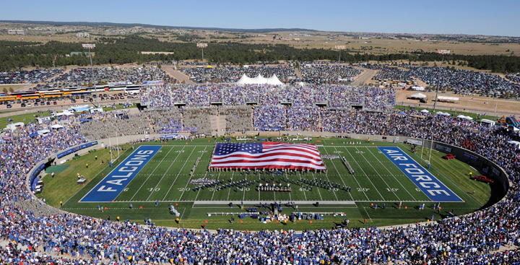
Prior to a football game in September 2010, cadets from the US Air Force Academy unfurl a large American flag in Falcon Stadium to commemorate the people who lost their lives in the 9/11 terrorist attacks.
Source: http://commons.wikimedia.org/wiki/File:BYU_at_Air_Force_2010-09-11.jpg.
The United States flag is the core icon of American political culture. Media representations associate the flag with the two dominant values of the American creed: democracy and capitalism. News media connect the flag with aspects of democratic political culture, including elections, institutions, and national pride. People have more positive reactions to politicians when they appear with the American flag. Advertisements send the message that to “buy American,” and thereby support the free-market economic system, is to be patriotic.
People gain an understanding and acceptance of the political culture of their nation through a process called political socialization. The term “political socialization” refers to the process by which people learn their roles as citizens and develop an understanding of government and politics. This chapter explores the ways in which knowledge about politics; the attitudes about government, political processes, and leaders; and citizens’ political behavior—all of which are elements of American political culture—are passed on from generation to generation.

6.1 Political Culture

LEARNING OBJECTIVES
After reading this section, you should be able to answer the following questions:
- What is a nation’s political culture, and why is it important?
- What are the characteristics of American political culture?
- What are the values and beliefs that are most ingrained in American citizens?
- What constitutes a political subculture, and why are subcultures important?
This section defines political culture and identifies the core qualities that distinguish American political culture, including the country’s traditions, folklore, and heroes. The values that Americans embrace, such as individualism and egalitarianism, will be examined as they relate to cultural ideals.

What Is Political Culture?
Political culture can be thought of as a nation’s political personality. It encompasses the deep-rooted, well-established political traits that are characteristic of a society. Political culture takes into account the attitudes, values, and beliefs that people in a society have about the political system, including standard assumptions about the way that government works. As political scientist W. Lance Bennett notes, the components of political culture can be difficult to analyze. “They are rather like the lenses in a pair of glasses: they are not the things we see when we look at the world; they are the things we see with.” ^{[1]} Political culture helps build community and facilitate communication because people share an understanding of how and why political events, actions, and experiences occur in their country.
Political culture includes formal rules as well as customs and traditions, sometimes referred to as “habits of the heart,” that are passed on generationally. People agree to abide by certain formal rules, such as the country’s constitution and codified laws. They also live by unstated rules: for example, the willingness in the United States to accept the outcomes of elections without resorting to violence. Political culture sets the boundaries of acceptable political behavior in a society. ^{[2]}
While the civic culture in the United States has remained relatively stable over time, shifts have occurred as a result of transforming experiences, such as war, economic crises, and other societal upheavals, that have reshaped attitudes and beliefs. ^{[3]} Key events, such as the Civil War, World War I, World War II, the Great Depression, the Vietnam War, the civil rights movement, and the terrorist attacks of 9/11 have influenced the political worldviews of American citizens, especially young people, whose political values and attitudes are less well established.

American Political Culture
Political culture consists of a variety of different elements. Some aspects of culture are abstract, such as political beliefs and values. Other elements are visible and readily identifiable, such as rituals, traditions, symbols, folklore, and heroes. These aspects of political culture can generate feelings of national pride that form a bond between people and their country. Political culture is not monolithic. It consists of diverse subcultures based on group characteristics such as race, ethnicity, and social circumstances, including living in a particular place or in a certain part of the country. We will now examine these aspects of political culture in the American context.

Beliefs
Beliefs are ideas that are considered to be true by a society. Founders of the American republic endorsed both equality, most notably in the Declaration of Independence, and liberty, most prominently in the Constitution. These political theories have become incorporated into the political culture of the United States in the central beliefs of egalitarianism and individualism.
Egalitarianism is the doctrine emphasizing the natural equality of humans, or at least the absence of a preexisting superiority of one set of humans above another. This core American belief is found in the preamble to the Declaration of Independence, which states that “all men are created equal” and that people are endowed with the unalienable rights to “life, liberty, and the pursuit of happiness.” Americans endorse the intrinsic equal worth of all people. Survey data consistently indicate that between 80 percent and 90 percent of Americans believe that it is essential to treat all people equally, regardless of race or ethnic background. ^{[4]}
The principle of individualism stresses the centrality and dignity of individual people. It privileges free action and people’s ability to take the initiative in making their own lives as well as those of others more prosperous and satisfying. In keeping with the Constitution’s preoccupation with liberty, Americans feel that children should be taught to believe that individuals can better themselves through self-reliance, hard work, and perseverance. ^{[5]}
The beliefs of egalitarianism and individualism are in tension with one another. For Americans today, this contradiction tends to be resolved by an expectation of equality of opportunity, the belief that each individual has the same chance to get ahead in society. Americans tend to feel that most people who want to get ahead can make it if they’re willing to work hard. ^{[6]} Americans are more likely to promote equal political rights, such as the Voting Rights Act’s stipulation of equal participation for all qualified voters, than economic equality, which would redistribute income from the wealthy to the poor. ^{[7]}

Values
Beliefs form the foundation for values, which represent a society’s shared convictions about what is just and good. Americans claim to be committed to the core values of individualism and egalitarianism. Yet there is sometimes a significant disconnect between what Americans are willing to uphold in principle and how they behave in practice. People may say that they support the Constitutional right to free speech but then balk when they are confronted with a political extremist or a racist speaking in public.
Core American political values are vested in what is often called theAmerican creed. The creed, which was composed by New York State Commissioner of Education Henry Sterling Chapin in 1918, refers to the belief that the United States is a government “by the people, for the people, whose just powers are derived from the consent of the governed.” The nation consists of sovereign states united as “a perfect Union” based on “the principles of freedom, equality, justice, and humanity.” American exceptionalism is the view that America’s exceptional development as a nation has contributed to its special place is the world. It is the conviction that the country’s vast frontier offered boundless and equal opportunities for individuals to achieve their goals. Americans feel strongly that their nation is destined to serve as an example to other countries. ^{[8]} They believe that the political and economic systems that have evolved in this country are perfectly suited in principle to permit both individualism and egalitarianism.
Consequently, the American creed also includes patriotism: the love of one’s country and respect for its symbols and principles. The events of 9/11 ignited Americans’ patriotic values, resulting in many public displays of support for the country, its democratic form of government, and authority figures in public-service jobs, such as police and firefighters. The press has scrutinized politicians for actions that are perceived to indicate a lack of patriotism, and the perception that a political leader is not patriotic can generate controversy. In the 2008 presidential election, a minor media frenzy developed over Democratic presidential candidate Barack Obama’s “patriotism problem.” The news media debated the significance of Obama’s not wearing a flag lapel pin on the campaign trail and his failure to place his hand over his heart during the playing of the national anthem.

Video Clip

http://s166.photobucket.com/albums/u90/snopesbinary/Politics/?action=view&current=abc_obama_anthem_071022a.flv

Barack Obama's Patriotism
A steak fry in Iowa during the 2008 Democratic presidential primary sparked a debate over candidate Barack Obama’s patriotism. Obama, standing with opponents Bill Richardson and Hillary Clinton, failed to place his hand over his heart during the playing of the national anthem. In the background is Ruth Harkin, wife of Senator Tom Harkin, who hosted the event.
Another core American value is political tolerance, the willingness to allow groups with whom one disagrees to exercise their constitutionally guaranteed freedoms, such as free speech. While many people strongly support the ideal of tolerance, they often are unwilling to extend political freedoms to groups they dislike. People acknowledge the constitutional right of racist groups, such as skinheads, to demonstrate in public, but will go to great lengths to prevent them from doing so. ^{[9]}
Democratic political values are among the cornerstones of the American creed. Americans believe in the rule of law: the idea that government is based on a body of law, agreed on by the governed, that is applied equally and justly. The Constitution is the foundation for the rule of law. The creed also encompasses the public’s high degree of respect for the American system of government and the structure of its political institutions.
Capitalist economic values are embraced by the American creed. Capitalist economic systems emphasize the need for a free-enterprise system that allows for open business competition, private ownership of property, and limited government intervention in business affairs. Underlying these capitalist values is the belief that, through hard work and perseverance, anyone can be financially successful. ^{[10]}
Figure 6.1
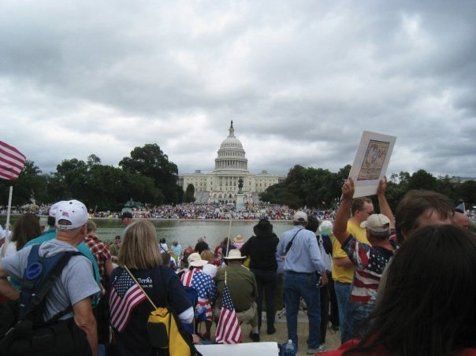
Tea Party supporters from across the country staged a “March on Washington” to demonstrate their opposition to government spending and to show their patriotism.
Source: http://commons.wikimedia.org/wiki/File:9.12_tea_party_in_DC.jpg.
The primacy of individualism may undercut the status quo in politics and economics. The emphasis on the lone, powerful person implies a distrust of collective action and of power structures such as big government, big business, or big labor. The public is leery of having too much power concentrated in the hands of a few large companies. The emergence of the Tea Party, a visible grassroots conservative movement that gained momentum during the 2010 midterm elections, illustrates how some Americans become mobilized in opposition to the “tax and spend” policies of big government. ^{[11]} While the Tea Party shunned the mainstream media because of their view that the press had a liberal bias, they received tremendous coverage of their rallies and conventions, as well as their candidates. Tea Party candidates relied heavily on social media, such as Facebook and Twitter, to get their anti–big government message out to the public.

Rituals, Traditions, and Symbols
Rituals, traditions, and symbols are highly visible aspects of political culture, and they are important characteristics of a nation’s identity. Rituals, such as singing the national anthem at sporting events and saluting the flag before the start of a school day, are ceremonial acts that are performed by the people of a nation. Some rituals have important symbolic and substantive purposes: Election Night follows a standard script that ends with the vanquished candidate congratulating the opponent on a well-fought battle and urging support and unity behind the victor. Whether they have supported a winning or losing candidate, voters feel better about the outcome as a result of this ritual. ^{[12]} The State of the Union address that the president makes to Congress every January is a ritual that, in the modern era, has become an opportunity for the president to set his policy agenda, to report on his administration’s accomplishments, and to establish public trust. A more recent addition to the ritual is the practice of having representatives from the president’s party and the opposition give formal, televised reactions to the address.
Figure 6.2
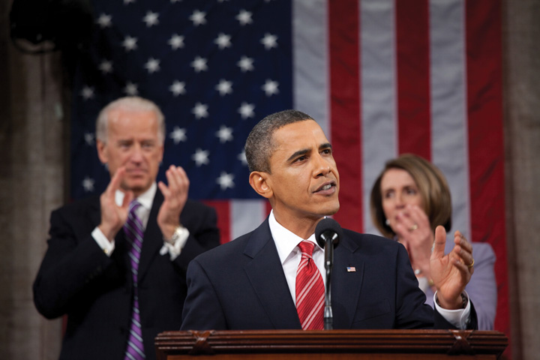
President Barack Obama gives the 2010 State of the Union address. The ritual calls for the president to be flanked by the Speaker of the House of Representatives (Nancy Pelosi) and the vice president (Joe Biden). Members of Congress and distinguished guests fill the House gallery.
Source:http://commons.wikimedia.org/wiki/File:2010_State_of_the_Union.jpg.
Political traditions are customs and festivities that are passed on from generation to generation, such as celebrating America’s founding on the Fourth of July with parades, picnics, and fireworks. Symbols are objects or emblems that stand for a nation. The flag is perhaps the most significant national symbol, especially as it can take on enhanced meaning when a country experiences difficult times. The bald eagle was officially adopted as the country’s emblem in 1787, as it is considered a symbol of America’s “supreme power and authority.”
Figure 6.3
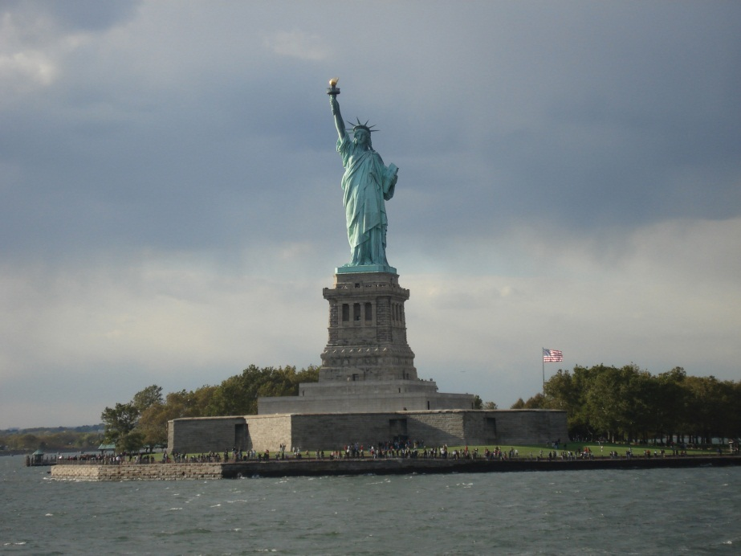
The Statue of Liberty stands in New York Harbor, an 1844 gift from France that is a symbol welcoming people from foreign lands to America’s shores.
Source: Photo courtesy of Severin St. Martin,http://www.flickr.com/photos/severinstmartin/55840746/.

Folklore
Political folklore, the legends and stories that are shared by a nation, constitutes another element of culture. Individualism and egalitarianism are central themes in American folklore that are used to reinforce the country’s values. The “rags-to-riches” narratives of novelists—the late-nineteenth-century writer Horatio Alger being the quintessential example—celebrate the possibilities of advancement through hard work.
Much American folklore has grown up around the early presidents and figures from the American Revolution. This folklore creates an image of men, and occasionally women, of character and strength. Most folklore contains elements of truth, but these stories are usually greatly exaggerated.

Figure 6.4
There are many folktales about young George Washington, including that he chopped down a cherry tree and threw a silver dollar across the Potomac River. These stories were popularized by engravings like this one by John C. Mccabe depicting Washington working as a land surveyor.
Source: Photo courtesy of the National Park Service Historical Handbook Series No. 26, frontispiece,http://commons.wikimedia.org/wiki/File:Young_George_Washington.jpg.
The first American president, George Washington, is the subject of folklore that has been passed on to school children for more than two hundred years. Young children learn about Washington’s impeccable honesty and, thereby, the importance of telling the truth, from the legend of the cherry tree. When asked by his father if he had chopped down a cherry tree with his new hatchet, Washington confessed to committing the deed by replying, “Father, I cannot tell a lie.” This event never happened and was fabricated by biographer Parson Mason Weems in the late 1700s. ^{[13]} Legend also has it that, as a boy, Washington threw a silver dollar across the Potomac River, a story meant to illustrate his tremendous physical strength. In fact, Washington was not a gifted athlete, and silver dollars did not exist when he was a youth. The origin of this folklore is an episode related by his step-grandson, who wrote that Washington had once thrown a piece of slate across a very narrow portion of the Rappahannock River in Virginia. ^{[14]}

Heroes
Heroes embody the human characteristics most prized by a country. A nation’s political culture is in part defined by its heroes who, in theory, embody the best of what that country has to offer. Traditionally, heroes are people who are admired for their strength of character, beneficence, courage, and leadership. People also can achieve hero status because of other factors, such as celebrity status, athletic excellence, and wealth.
Shifts in the people whom a nation identifies as heroes reflect changes in cultural values. Prior to the twentieth century, political figures were preeminent among American heroes. These included patriotic leaders, such as American-flag designer Betsy Ross; prominent presidents, such as Abraham Lincoln; and military leaders, such as Civil War General Stonewall Jackson, a leader of the Confederate army. People learned about these leaders from biographies, which provided information about the valiant actions and patriotic attitudes that contributed to their success.
Today American heroes are more likely to come from the ranks of prominent entertainment, sports, and business figures than from the world of politics. Popular culture became a powerful mechanism for elevating people to hero status beginning around the 1920s. As mass media, especially motion pictures, radio, and television, became an important part of American life, entertainment and sports personalities who received a great deal of publicity became heroes to many people who were awed by their celebrity. ^{[15]}
In the 1990s, business leaders, such as Microsoft’s Bill Gates and General Electric’s Jack Welch, were considered to be heroes by some Americans who sought to achieve material success. The tenure of business leaders as American heroes was short-lived, however, as media reports of the lavish lifestyles and widespread criminal misconduct of some corporation heads led people to become disillusioned. The incarceration of Wall Street investment advisor Bernard Madoff made international headlines as he was alleged to have defrauded investors of billions of dollars. ^{[16]}
Sports figures feature prominently among American heroes, especially during their prime. Cyclist Lance Armstrong is a hero to many Americans because of his unmatched accomplishment of winning seven consecutive Tour de France titles after beating cancer. However, heroes can face opposition from those who seek to discredit them: Armstrong, for example, has been accused of doping to win races, although he has never failed a drug test.

Figure 6.5
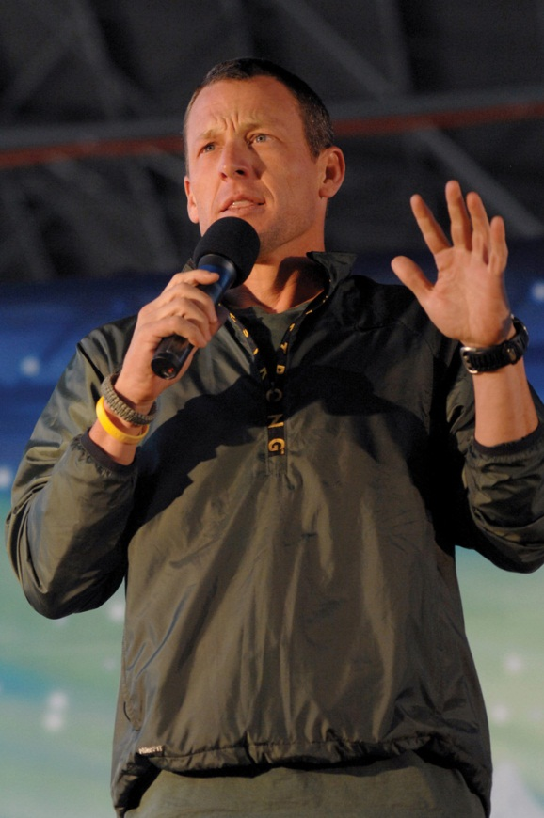
Cyclist Lance Armstrong is considered by many to be an American hero because of his athletic accomplishments and his fight against cancer. He also has been the subject of unrelenting media reports that attempt to deflate his hero status.
Source:http://commons.wikimedia.org/wiki/File:Lance_Armstrong_Aviano.jpg.
NBA basketball player Michael Jordan epitomizes the modern-day American hero. Jordan’s hero status is vested in his ability to bridge the world of sports and business with unmatched success. The media promoted Jordan’s hero image intensively, and he was marketed commercially by Nike, who produced his “Air Jordans” shoes. ^{[17]} His unauthorized 1999 film biography is titled Michael Jordan: An American Hero, and it focuses on how Jordan triumphed over obstacles, such as racial prejudice and personal insecurities, to become a role model on and off the basketball court. Young filmgoers watched Michael Jordan help Bugs Bunny defeat evil aliens in Space Jam. In the film Like Mike, pint-sized rapper Lil’ Bow Wow plays an orphan who finds a pair of Michael Jordan’s basketball shoes and is magically transformed into an NBA star. Lil’ Bow Wow’s story has a happy ending because he works hard and plays by the rules.
The 9/11 terrorist attacks prompted Americans to make heroes of ordinary people who performed in extraordinary ways in the face of adversity. Firefighters and police officers who gave their lives, recovered victims, and protected people from further threats were honored in numerous ceremonies. Also treated as heroes were the passengers of Flight 93 who attempted to overtake the terrorists who had hijacked their plane, which was believed to be headed for a target in Washington, DC. The plane crashed in a Pennsylvania field.

Subcultures
Political subcultures are distinct groups, associated with particular beliefs, values, and behavior patterns, that exist within the overall framework of the larger culture. They can develop around groups with distinct interests, such as those based on age, sex, race, ethnicity, social class, religion, and sexual preference. Subcultures also can be geographically based. Political scientist Daniel Elazar identified regional political subcultures, rooted in American immigrant settlement patterns, that influenced the way that government was constituted and practiced in different locations across the nation. The moral political subculture, which is present in New England and the Midwest, promotes the common good over individual values. The individual political subculture, which is evident in the middle Atlantic states and the West, is more concerned with private enterprise than societal interests. The traditional political subculture, which is found in the South, reflects a hierarchical societal structure in which social and familial ties are central to holding political power. ^{[18]}Political subcultures can also form around social and artistic groups and their associated lifestyles, such as the heavy metal and hip-hop music subcultures.

Media Frames
The Hip-Hop Subculture
A cohort of black Americans has been labeled the hip-hop generation by scholars and social observers. The hip-hop generation is a subculture of generation X (people born between 1965 and 1984) that identifies strongly with hip-hop music as a unifying force. Its heroes come from the ranks of prominent music artists, including Grandmaster Flash, Chuck D, Run DMC, Ice Cube, Sister Souljah, Nikki D, and Queen Latifah. While a small number of people who identify with this subculture advocate extreme politics, including violence against political leaders, the vast majority are peaceful, law-abiding citizens. ^{[19]}
The hip-hop subculture emerged in the early 1970s in New York City. Hip-hop music began with party-oriented themes, but by 1982 it was focusing heavily on political issues. Unlike the preceding civil rights generation—a black subculture of baby boomers (people born immediately after World War II) that concentrated on achieving equal rights—the hip-hop subculture does not have an overarching political agenda. The messages passed on to the subculture by the music are highly varied and often contradictory. Some lyrics express frustration about the poverty, lack of educational and employment opportunities, and high crime rates that plague segments of the black community. Other songs provide public service messages, such as those included on the Stop the Violence album featuring Public Enemy and MC Lyte, and Salt-N-Pepa’s “Let’s Talk about AIDS.” Music associated with the gangsta rap genre, which was the product of gang culture and street wars in South Central Los Angeles, promotes violence, especially against women and authority figures, such as the police. It is from these lyrics that the mass media derive their most prominent frames when they cover the hip-hop subculture. ^{[20]}
Media coverage of the hip-hop subculture focuses heavily on negative events and issues, while ignoring the socially constructive messages of many musicians. The subculture receives most of its media attention in response to the murder of prominent artists, such as Tupac Shakur and Notorious B.I.G., or the arrest of musicians for violating the law, usually for a weapons- or drug-related charge. A prominent news frame is how violence in the music’s lyrics translates into real-life violence. As hip-hop music became more popular with suburban white youth in the 1990s, the news media stepped up its warnings about the dangers of this subculture.
Media reports of the hip-hop subculture also coincide with the release of successful albums. Since 1998, hip-hop and rap have been the top-selling record formats. The dominant news frame is that the hip-hop subculture promotes selfish materialist values. This is illustrated by news reports about the cars, homes, jewelry, and other commodities purchased by successful musicians and their promoters. ^{[21]}
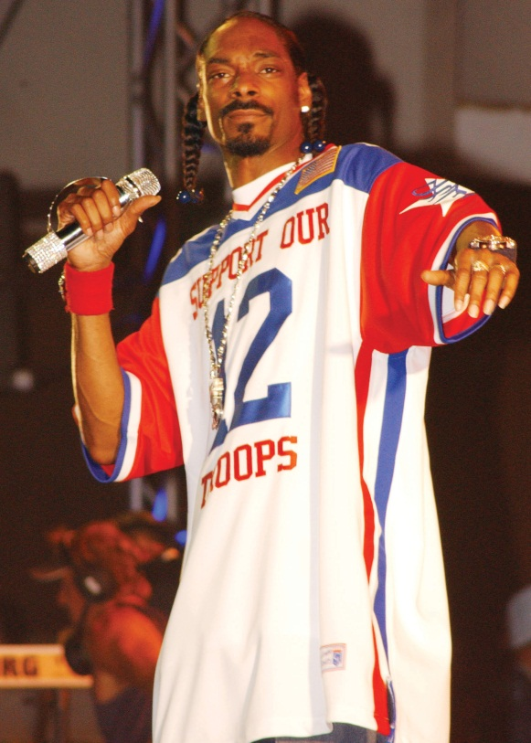
Media coverage of hip-hop tends to downplay the positive aspects of the subculture.
Source:http://commons.wikimedia.org/wiki/File:Snoop_Dogg_Hawaii.jpg.
Although the definition of political culture emphasizes unifying, collective understandings, in reality, cultures are multidimensional and often in conflict. When subcultural groups compete for societal resources, such as access to government funding for programs that will benefit them, cultural cleavages and clashes can result. As we will see in the section on multiculturalism, conflict between competing subcultures is an ever-present fact of American life.

Multiculturalism
One of the hallmarks of American culture is its racial and ethnic diversity. In the early twentieth century, the playwright Israel Zangwill coined the phrase “melting pot” to describe how immigrants from many different backgrounds came together in the United States. The melting pot metaphor assumed that over time the distinct habits, customs, and traditions associated with particular groups would disappear as people assimilated into the larger culture. A uniquely American culture would emerge that accommodated some elements of diverse immigrant cultures in a new context. ^{[22]} For example, American holiday celebrations incorporate traditions from other nations. Many common American words originate from other languages. Still, the melting pot concept fails to recognize that immigrant groups do not entirely abandon their distinct identities. Racial and ethnic groups maintain many of their basic characteristics, but at the same time, their cultural orientations change through marriage and interactions with others in society.
Over the past decade, there has been a trend toward greater acceptance of America’s cultural diversity. Multiculturalism celebrates the unique cultural heritage of racial and ethnic groups, some of whom seek to preserve their native languages and lifestyles. The United States is home to many people who were born in foreign countries and still maintain the cultural practices of their homelands.
Multiculturalism has been embraced by many Americans, and it has been promoted formally by institutions. Elementary and secondary schools have adopted curricula to foster understanding of cultural diversity by exposing students to the customs and traditions of racial and ethnic groups. As a result, young people today are more tolerant of diversity in society than any prior generation has been. Government agencies advocate tolerance for diversity by sponsoring Hispanic and Asian American/Pacific Islander heritage weeks. The US Postal Service has introduced stamps depicting prominent Americans from diverse backgrounds.
Figure 6.6
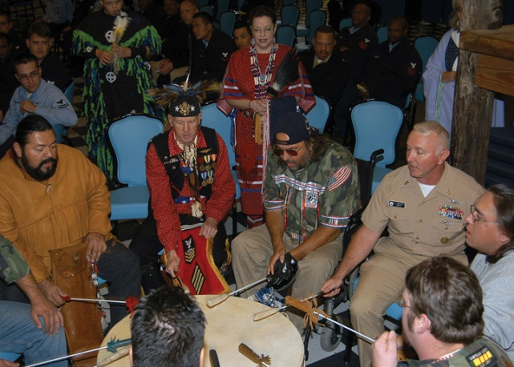
Americans celebrate their multicultural heritage by maintaining traditions associated with their homelands.
Source: http://commons.wikimedia.org/wiki/File:US_Navy_061121-N-6159N-001_USS_John_F ._Kennedy_%28CV_67%29_Command_Master _Chief,_Carl_L._Dassance_pounds_on_a_ceremonial _drum_during_the_Native_American_and_Alaskan_Heritage _celebration.jpg.
Despite these trends, America’s multiculturalism has been a source of societal tension. Support for the melting pot assumptions about racial and ethnic assimilation still exists. ^{[23]} Some Americans believe that too much effort and expense is directed at maintaining separate racial and ethnic practices, such as bilingual education. Conflict can arise when people feel that society has gone too far in accommodating multiculturalism in areas such as employment programs that encourage hiring people from varied racial and ethnic backgrounds. ^{[24]}

Enduring Images
The 9/11 Firefighters’ Statue
On 9/11 Thomas E. Franklin, a photographer for Bergen County, New Jersey’s Record, photographed three firefighters, Billy Eisengrein, George Johnson, and Dan McWilliams, raising a flag amid the smoldering rubble of the World Trade Center. Labeled by the press “the photo seen ‘round the world,” his image came to symbolize the strength, resilience, and heroism of Americans in the face of a direct attack on their homeland.
Developer Bruce Ratner commissioned a nineteen-foot-tall, $180,000 bronze statue based on the photograph to stand in front of the New York City Fire Department (FDNY) headquarters in Brooklyn. When the statue prototype was unveiled, it revealed that the faces of two of the three white firefighters who had originally raised the flag had been replaced with those of black and Hispanic firefighters. Ratner and the artist who designed the statue claimed that the modification of the original image represented an effort to promote America’s multicultural heritage and tolerance for diversity. The change had been authorized by the FDNY leadership. ^{[25]}
The modification of the famous photo raised the issue of whether it is valid to alter historical fact in order to promote a cultural value. A heated controversy broke out over the statue. Supporters of the change believed that the statue was designed to honor all firefighters, and that representing their diverse racial and ethnic backgrounds was warranted. Black and Hispanic firefighters were among the 343 who had lost their lives at the World Trade Center. Kevin James of the Vulcan Society, which represents black firefighters, defended the decision by stating, “The symbolism is far more important than representing the actual people. I think the artistic expression of diversity would supersede any concern over factual correctness.” ^{[26]}
Opponents claimed that since the statue was not meant to be a tribute to firefighters, but rather a depiction of an actual event, the representation needed to be historically accurate. They drew a parallel to the famous 1945 Associated Press photograph of six Marines raising the flag on Iwo Jima during World War II and the historically precise memorial that was erected in Arlington, Virginia. Opponents also felt that it was wrong to politicize the statue by making it part of a dialogue on race. The proposed statue promoted an image of diversity within the FDNY that did not mirror reality. Of the FDNY’s 11,495 firefighters, 2.7 percent are black and 3.2 percent are Latino, percentages well below the percentage these groups represent in the overall population.
Some people suggested a compromise—two statues. They proposed that the statue based on the Franklin photo should reflect historical reality; a second statue, celebrating multiculturalism, should be erected in front of another FDNY station and include depictions of rescue workers of diverse backgrounds at the World Trade Center site. Plans for any type of statue were abandoned as a result of the controversy.
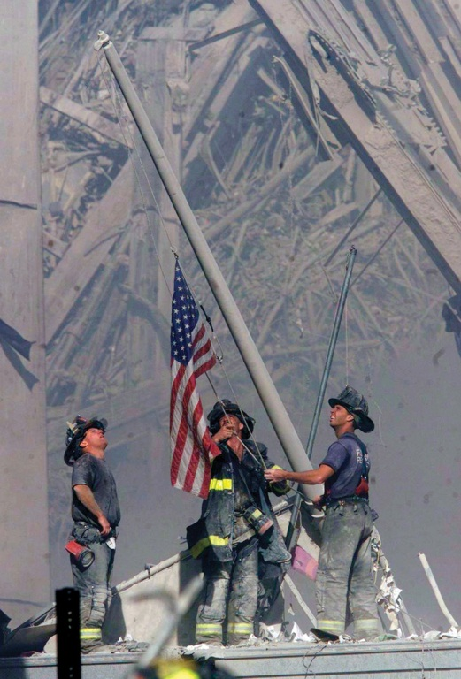
The iconic photograph of 9/11 firefighters raising a flag near the rubble of the World Trade Center plaza is immortalized in a US postage stamp. Thomas Franklin, the veteran reporter who took the photo, said that the image reminded him of the famous Associated Press image of Marines raising the American flag on Iwo Jima during World War II.
Source: Used with permission from Getty Images.

KEY TAKEAWAYS
Political culture is defined by the ideologies, values, beliefs, norms, customs, traditions, and heroes characteristic of a nation. People living in a particular political culture share views about the nature and operation of government. Political culture changes over time in response to dramatic events, such as war, economic collapse, or radical technological developments. The core American values of democracy and capitalism are vested in the American creed. American exceptionalism is the idea that the country has a special place in the world because of the circumstances surrounding its founding and the settling of a vast frontier.
Rituals, traditions, and symbols bond people to their culture and can stimulate national pride. Folklore consists of stories about a nation’s leaders and heroes; often embellished, these stories highlight the character traits that are desirable in a nation’s citizens. Heroes are important for defining a nation’s political culture.
America has numerous subcultures based on geographic region; demographic, personal, and social characteristics; religious affiliation, and artistic inclinations. America’s unique multicultural heritage is vested in the various racial and ethnic groups who have settled in the country, but conflicts can arise when subgroups compete for societal resources.

EXERCISES
- What do you think the American flag represents? Would it bother you to see someone burn an American flag? Why or why not?
- What distinction does the text make between beliefs and values? Are there things that you believe in principle should be done that you might be uncomfortable with in practice? What are they?
- Do you agree that America is uniquely suited to foster freedom and equality? Why or why not?
- What characteristics make you think of someone as particularly American? Does race or cultural background play a role in whether you think of a person as American?

[1] W. Lance Bennett, Public Opinion in American Politics (New York: Harcourt Brace Jovanovich, 1980), 368.
[2] Daniel J. Elazar, The American Mosaic (Boulder, CO: Westview Press, 1994).
[3] Ronald Inglehart, Culture Shift in Advanced Industrial Society (Princeton, NJ: Princeton University Press, 1990).
[4] James Davison Hunter and Carl Bowman, The State of Disunion (Charlottesville, VA: In Media Res Educational Foundation, 1996); Pew Research Center for the People and the Press, Values Survey (Washington, DC: Pew Research Center, March 2009).
[5] James Davison Hunter and Carl Bowman, The State of Disunion (Charlottesville, VA: In Media Res Educational Foundation, 1996).
[6] Pew Research Center for the People and the Press, Retro-Politics: The Political Typology(Washington, DC: Pew Research Center, November 11, 1999).
[7] Richard W. Wilson, “American Political Culture in Comparative Perspective,” Political Psychology, 18, no. 2 (1997): 483–502.
[8] James Davison Hunter and Carl Bowman, The State of Disunion (Charlottesville, VA: In Media Res Educational Foundation, 1996).
[9] John L. Sullivan, James Piereson, and George E. Marcus, Political Tolerance and American Democracy (Chicago: University of Chicago Press, 1982).
[10] Herbert McClosky and John Zaller, The American Ethos (Cambridge, MA: Harvard University Press, 1987).
[11] Pew Research Center for the People and the Press, Views of Business and Regulation Remain Unchanged (Washington, DC: Pew Research Center, February 21, 2001).
[12] Benjamin Ginsberg and Herbert Weissberg, “Elections and the Mobilization of Popular Support,” American Journal of Political Science 22, no.1 (1978): 31–55.
[13] George Washington’s Mount Vernon, “Is it true that George Washington chopped down a cherry tree when he was a boy?,” accessed February 3, 2011,http://www.mountvernon.org/knowledge/index.cfm/fuseaction/view/KnowledgeID/21.
[14] George Washington’s Mount Vernon, “Did George Washington really throw a silver dollar across the Potomac River?,” accessed February 3, 2011,http://www.mountvernon.org/knowledge/index.cfm/fuseaction/view/KnowledgeID/20.
[15] Fred I. Greenstein, Children and Politics (New Haven, CT: Yale University Press, 1969).
[16] Sandra Yin, “Shifting Careers,” American Demographics, 23, no. 12 (December 2001): 39–40.
[17] Pat Walters, “Michael Jordan: The New American Hero” (Charlottesville VA: The Crossroads Project, 1997).
[18] Daniel J. Elazar, American Federalism: A View From the States, 2nd ed. (New York: Thomas Y. Crowell, 1972).
[19] Bakari Kitwana, The Hip-Hop Generation (New York: Basic Civitas Books, 2002).
[20] Manning Marable, “The Politics of Hip-Hop,” The Urban Think Tank, 2 (2002).http://www.hartford-hwp.com/archives/45a/594.html.
[21] Autumn Lewis, “Vilification of Black Youth Culture by the Media” (master’s thesis, Georgetown University, 2003).
[22] Lawrence H. Fuchs, The American Kaleidoscope. (Middletown, CT: Wesleyan University Press, 1990).
[23] James Davidson Hunter and Carl Bowman, The State of Disunion (Charlottesville, VA: In Media Res Education Foundation, 1996).
[24] Pew Research Center for the People and the Press, Retro-Politics: The Political Typology(Washington, DC: Pew Research Center, November 11, 1999).
[25] Rod Dreher, “The Bravest Speak,” National Review Online, January 16, 2002.
[26] “Ground Zero Statue Criticized for ‘Political Correctness,’” CNN, January 12, 2002, http//www.cnn.com.

6.2 Political Socialization

LEARNING OBJECTIVES
After reading this section, you should be able to answer the following questions:
- How do people develop an understanding of their political culture?
- What is political socialization, and why is it important?
- What constitutes a political generation?
This section will define what is meant by political socialization and detail how the process of political socialization occurs in the United States. It will outline the stages of political learning across an individual’s life course. The agents that are responsible for political socialization, such as the family and the media, and the types of information and orientations they convey will be discussed. Group differences in political socialization will be examined. Finally, the section will address the ways that political generations develop through the political socialization process.

What Is Political Socialization?
People are inducted into the political culture of their nation through the political socialization process. ^{[1]} Most often older members of society teach younger members the rules and norms of political life. However, young people can and do actively promote their own political learning, and they can influence adults’ political behavior as well. ^{[2]}
Political scientists Gabriel Almond and James Coleman once observed that we “do not inherit our political behavior, attitudes, values, and knowledge through our genes.” ^{[3]} Instead, we come to understand our role and to “fit in” to our political culture through the political learning process. ^{[4]} Political learning is a broad concept that encompasses both the active and passive and the formal and informal ways in which people mature politically. ^{[5]} Individuals develop apolitical self, a sense of personal identification with the political world. Developing a political self begins when children start to feel that they are part of a political community. They acquire the knowledge, beliefs, and values that help them comprehend government and politics. ^{[6]} The sense of being an American, which includes feeling that one belongs to a unique nation in which people share a belief in democratic ideals, is conveyed through the political learning process.
Political socialization is a particular type of political learning whereby people develop the attitudes, values, beliefs, opinions, and behaviors that are conducive to becoming good citizens in their country. Socialization is largely a one-way process through which young people gain an understanding of the political world through their interaction with adults and the media. The process is represented by the following model: ^{[7]}
who (subjects) → learns what (political values, beliefs, attitudes, behaviors) → from whom (agents) → under what circumstances → with what effects.
Agents of socialization, which include parents, teachers, and the mass media, convey orientations to subjects, who are mostly passive. For example, parents who take an active role in politics and vote in every election often influence their children to do the same. Young people who see television coverage of their peers volunteering in the community may take cues from these depictions and engage in community service themselves. The circumstances under which political socialization can take place are almost limitless. Young people can be socialized to politics through dinner conversations with family members, watching television and movies, participating in a Facebook group, or texting with friends. The effects of these experiences are highly variable, as people can accept, reject, or ignore political messages.
People develop attitudes toward the political system through the socialization process. Political legitimacy is a belief in the integrity of the political system and processes, such as elections. People who believe strongly in the legitimacy of the political system have confidence that political institutions will be responsive to the wants and needs of citizens and that abuses of governmental power will be held in check. If political leaders engage in questionable behavior, there are mechanisms to hold them accountable. The presidential impeachment process and congressional ethics hearings are two such mechanisms.
Political efficacy refers to individuals’ perceptions about whether or not they can influence the political process. People who have a strong sense of political efficacy feel that they have the skills and resources to participate effectively in politics and that the government will be responsive to their efforts. Those who believe in the legitimacy of the political system and are highly efficacious are more likely to participate in politics and to take strong stands on public-policy issues. ^{[8]} Citizens who were frustrated about the poor state of the economy and who felt they could influence the political process identified with the Tea Party in the 2010 election and worked to elect candidates who promised to deal with their concerns.
Much political socialization in the United States passes on norms, customs, beliefs, and values supportive of democracy from one generation to the next. Americans are taught to respect the democratic and capitalist values imbedded in the American creed. Young people are socialized to respect authorities, such as parents, teachers, police officers, and fire fighters, and to obey laws.
The goal of this type of socialization is deliberately intended to ensure that the democratic political system survives even in times of political stress, such as economic crisis or war. ^{[9]} One indicator of a stable political system is that elections take place regularly following established procedures and that people recognize the outcomes as legitimate. ^{[10]} Most Americans quickly accepted George W. Bush as president when the 2000 election deadlock ended with the Supreme Court decision that stopped the recounting of disputed votes in Florida. The country did not experience violent protests after the decision was announced, but instead moved on with politics as usual. ^{[11]}

Video Clip
http://www.youtube.com/watch?v=PDMpAAM24Z8

2000 Presidential Election Bush vs. Gore
This citizen-produced video shows peaceful protestors outside of the Supreme Court as the case of Bush v. Gore was being considered to decide the outcome of the 2000 presidential election.
Some scholars argue that political socialization is akin to indoctrination, as it forces people to conform to the status quo and inhibits freedom and creativity.^{[12]} However, socialization is not always aimed at supporting democratic political orientations or institutions. Some groups socialize their members to values and attitudes that are wildly at odds with the status quo. The Latin Kings, one of the largest and oldest street gangs in the United States, has its own constitution and formal governing structure. Leaders socialize members to follow gang rules that emphasize an “all for one” mentality; this includes strict internal discipline that calls for physical assault against or death to members who violate the rules. It also calls for violent retribution against rival gang members for actions such as trafficking drugs in the Kings’s territory. The Kings have their own sign language, symbols (a five-point crown and tear drop), colors (black and gold), and holidays (January 6, “King’s Holy Day”) that bond members to the gang. ^{[13]}

Political Socialization over the Life Course
Political learning begins early in childhood and continues over a person’s lifetime. The development of a political self begins when children realize that they belong to a particular town and eventually that they are Americans. Awareness of politics as a distinct realm of experience begins to develop in the preschool years. ^{[14]}
Younger children tend to personalize government. The first political objects recognized by children are the president of the United States and the police officer. Children tend to idealize political figures, although young people today have a less positive view of political actors than in the past. This trend is partially a result of the media’s preoccupations with personal scandals surrounding politicians.
Young people often have warm feelings toward the political system. Children can develop patriotic values through school rituals, such as singing the “Star Spangled Banner” at the start of each day. As children mature, they become increasingly sophisticated in their perceptions about their place in the political world and their potential for involvement: they learn to relate abstract concepts that they read about in textbooks like this one to real-world actions, and they start to associate the requirements of democracy and majority rule with the need to vote when they reach the age of twenty-one.
Figure 6.7
Young people who participate in community service projects can develop a long-term commitment to volunteering and political participation.
© Thinkstock
People are the most politically impressionable during the period from their midteens through their midtwenties, when their views are not set and they are open to new experiences. College allows students to encounter people with diverse views and provides opportunities for political engagement. ^{[15]} Young people may join a cause because it hits close to home. After the media publicized the case of a student who committed suicide after his roommate allegedly posted highly personal videos of him on the Internet, students around the country became involved in antibullying initiatives. ^{[16]}
Significant events in adults’ lives can radically alter their political perspectives, especially as they take on new roles, such as worker, spouse, parent, homeowner, and retiree. ^{[17]} This type of transition is illustrated by 1960s student protestors against the Vietnam War. Protestors held views different from their peers; they were less trusting of government officials but more efficacious in that they believed they could change the political system. However, the political views of some of the most strident activists changed after they entered the job market and started families. Some became government officials, lawyers, and business executives—the very types of people they had opposed when they were younger. ^{[18]}

Figure 6.8
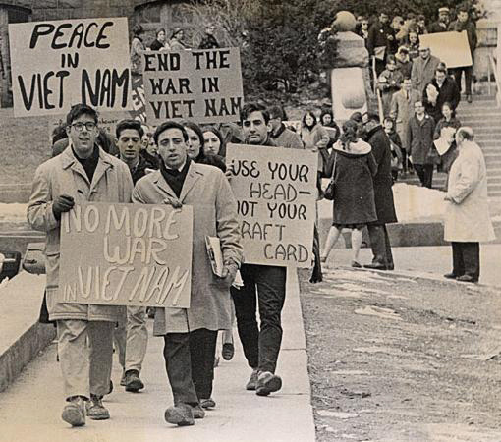
Student activists in the 1960s protested against US involvement in the Vietnam War. Some activists developed more favorable attitudes toward government as they matured, had families, and became homeowners.
Source: Photo courtesy of UW Digital Collectionshttp://commons.wikimedia.org/wiki/File:Student_Vietnam_War_protesters.JPG.
Even people who have been politically inactive their entire lives can become motivated to participate as senior citizens. They may find themselves in need of health care and other benefits, and they have more time for involvement. Organizations such as the Gray Panthers provide a pathway for senior citizens to get involved in politics. ^{[19]}

Agents of Political Socialization
People develop their political values, beliefs, and orientations through interactions with agents of socialization. Agents include parents, teachers, friends, coworkers, military colleagues, church associates, club members, sports-team competitors, and media. ^{[20]} The political socialization process in the United States is mostly haphazard, informal, and random. There is no standard set of practices for parents or teachers to follow when passing on the rites of politics to future generations. Instead, vague ideals—such as the textbook concept of the “model citizen,” who keeps politically informed, votes, and obeys the law—serve as unofficial guides for socializing agencies. ^{[21]}
Agents can convey knowledge and understanding of the political world and explain how it works. They can influence people’s attitudes about political actors and institutions. They also can show people how to get involved in politics and community work. No single agent is responsible for an individual’s entire political learning experience. That experience is the culmination of interactions with a variety of agents. Parents and teachers may work together to encourage students to take part in service learning projects. Agents also may come into conflict and provide vastly different messages.
We focus here on four agents that are important to the socialization process—the family, the school, the peer group, and the media. There are reasons why each of these agents is considered influential for political socialization; there are also factors that limit their effectiveness.

Family
Over forty years ago, pioneering political-socialization researcher Herbert Hyman proclaimed that “foremost among agencies of socialization into politics is the family.” ^{[22]} Hyman had good reason for making this assumption. The family has the primary responsibility for nurturing individuals and meeting basic needs, such as food and shelter, during their formative years. A hierarchical power structure exists within many families that stresses parental authority and obedience to the rules that parents establish. The strong emotional relationships that exist between family members may compel children to adopt behaviors and attitudes that will please their parents or, conversely, to rebel against them.
Parents can teach their children about government institutions, political leaders, and current issues, but this rarely happens. They can influence the development of political values and ideas, such as respect for political symbols or belief in a particular cause. The family as an agent of political socialization is most successful in passing on basic political identities, especially an affiliation with the Republican or Democratic Parties and liberal or conservative ideological leanings. ^{[23]}
Children can learn by example when parents act as role models. Young people who observe their parents reading the newspaper and following political news on television may adopt the habit of keeping informed. Adolescents who accompany parents when they attend public meetings, circulate petitions, or engage in other political activities stand a better chance of becoming politically engaged adults. ^{[24]} Children can sometimes socialize their parents to become active in politics; participants in the Kids Voting USA program have encouraged their parents to discuss campaign issues and take them to the polls on Election Day.
The home environment can either support or discourage young people’s involvement in political affairs. Children whose parents discuss politics frequently and encourage the expression of strong opinions, even if it means challenging others, are likely to become politically active adults. Young people raised in this type of family will often initiate political discussion and encourage parents to become involved. Alternatively, young people from homes where political conversations are rare, and airing controversial viewpoints is discouraged, tend to abstain from politics as adults. ^{[25]} Politics was a central focus of family life for the Kennedys, a family that has produced generations of activists, including President John F. Kennedy and Senator Ted Kennedy.
Figure 6.9
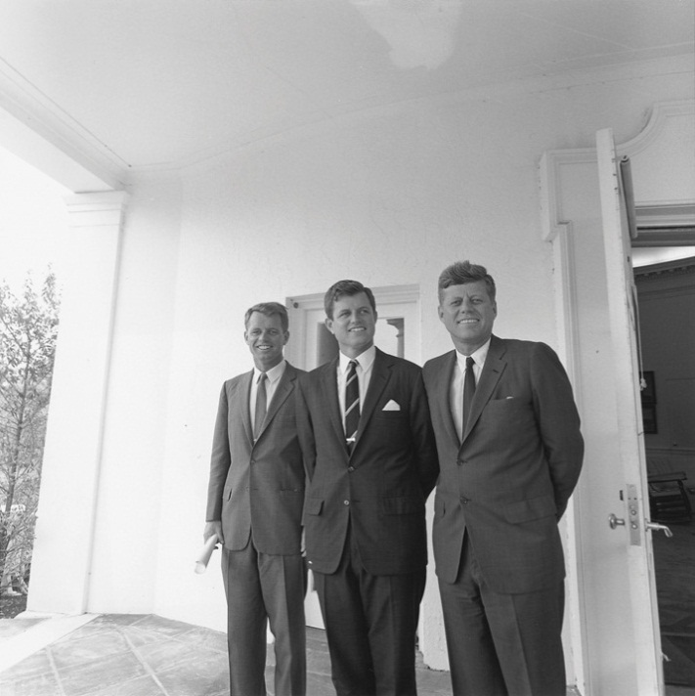
Members of the Kennedy family have been prominently involved in politics for over a century, illustrating how the desire to participate in politics is passed on generationally.
Source:http://commons.wikimedia.org/wiki/File:John_F._Kennedy_Inaugural_Ball,_20_January_1961.jpg.
There are limitations on the effectiveness of the family as an agent of political learning and socialization. Most families are not like the Kennedys. For many families, politics is not a priority, as they are more concerned with issues related to day-to-day life. Few parents serve as political role models for their children. Many activities, such as voting or attending town meetings, take place outside of the home. ^{[26]}

School
Some scholars consider the school, rather than the family, to be the most influential agent of political socialization. ^{[27]} Schools can stimulate political learning through formal classroom instruction via civics and history classes, the enactment of ceremonies and rituals such as the flag salute, and extracurricular activities such as student government. Respect for authorities is emphasized, as teachers have the ability to reward and punish students through grades.
The most important task of schools as agents of political socialization is the passing on of knowledge about the fundamentals of American government, such as constitutional principles and their implications for citizens’ engagement in politics. Students who master these fundamentals feel competent to participate politically. They are likely to develop the habit of following politics in the media and to become active in community affairs. ^{[28]}
The college classroom can be an environment for socializing young people to politics. Faculty and student exchanges can form, reinforce, or change evaluations of politics and government. A famous study of women students who attended Bennington College during the Great Depression of the 1930s illustrates how the college experience can create long-lasting political attitudes. The Bennington women came predominantly from wealthy families with conservative values. The faculty consisted of political progressives who supported the New Deal and other social programs. About one-third of the Bennington women adopted the progressive ideals of their teachers. Many of these women remained active in politics their entire lives. A number became leaders of the women’s rights movement. ^{[29]}
Figure 6.10
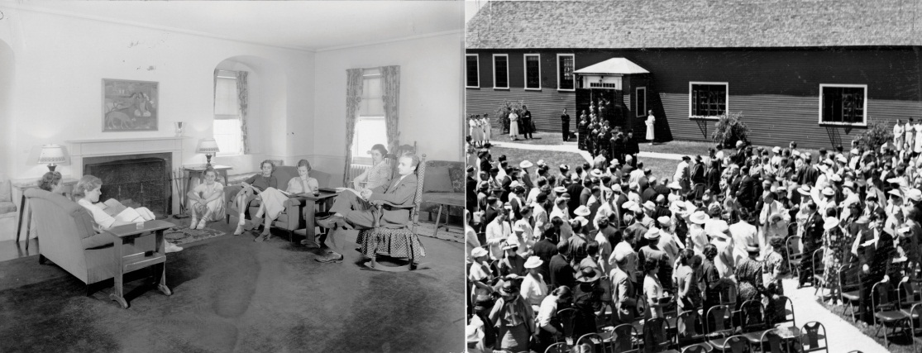
Women at Bennington College in the 1930s became active in community affairs as a result of their political socialization in college.
Source: Courtesy of Bennington College. Left photo by C.G. Scofield. Right photo by Rotzel.
While schools have great potential as agents of political socialization, they are not always successful in teaching even basic facts about government to students. Schools devote far less time to civics and history than to other subjects that are considered to be basic skills, such as reading and math. The average amount of classroom time spent on civics-related topics is less than forty-five minutes per week nationwide, although this figure varies widely based on the school. Students whose exposure to civics is exclusively through lectures and readings generally memorize facts about government for tests but do not remember them or make connections to real-world politics. The most effective civic education programs engage students in activities that prepare them for the real world of politics, such as mock elections and legislative hearings. ^{[30]}

Peer Group
Peers (a group of people who are linked by common interests, equal social position, and similar age) can be influential in the political socialization process. Young people desire approval and are likely to adopt the attitudes, viewpoints, and behavior patterns of groups to which they belong. Unlike the family and school, which are structured hierarchically with adults exercising authority, the peer group provides a forum for youth to interact with people who are at similar levels of maturity. Peers provide role models for people who are trying to fit in or become popular in a social setting. ^{[31]}
Peer-group influence begins when children reach school age and spend less time at home. Middle-childhood (elementary school) friendships are largely segregated by sex and age, as groups of boys and girls will engage in social activities such as eating together in the lunchroom or going to the mall. Such interactions reinforce sex-role distinctions, including those with political relevance, such as the perception that males are more suited to hold positions of authority. Peer relationships change later in childhood, adolescence, and young adulthood, when groups are more often based on athletic, social, academic, and job-related interests and abilities. ^{[32]}
The pressure to conform to group norms can have a powerful impact on young people’s political development if group members are engaged in activities directly related to politics, such as student government or working on a candidate’s campaign. Young people even will change their political viewpoints to conform to those held by the most vocal members of their peer group rather than face being ostracized. Still, individuals often gravitate toward groups that hold beliefs and values similar to their own in order to minimize conflict and reinforce their personal views. ^{[33]} As in the case of families, the influence of peer groups is mitigated by the fact that politics is not a high priority for most of them.

Media
As early as the 1930s, political scientist Charles Merriam observed that radio and film had tremendous power to educate: “Millions of persons are reached daily through these agencies, and are profoundly influenced by the material and interpretations presented in impressive form, incessantly, and in moments when they are open to suggestion.” ^{[34]} The capacity of mass media to socialize people to politics has grown massively as the number of media outlets has increased and as new technologies allow for more interactive media experiences. Most people’s political experiences occur vicariously through the media because they do not have personal access to government or politicians.
Since the advent of television, mass media have become prominent socialization agents. Young people’s exposure to mass media has increased markedly since the 1960s. Studies indicate that the typical American aged two to eighteen spends almost forty hours a week consuming mass media, which is roughly the equivalent of holding a full-time job. In one-third of homes, the television is on all day. Young people’s mass-media experiences often occur in isolation. They spend much of their time watching television, using a computer or cell phone, playing video games, or listening to music alone. Personal contact with family members, teachers, and friends has declined. More than 60 percent of people under the age of twenty have televisions in their bedrooms, which are multimedia sanctuaries. ^{[35]}
The use of more personalized forms of media, such as text messaging and participation in social networking sites, has expanded exponentially in recent years. Young people using these forms of media have greater control over their own political socialization: they can choose to follow politics through a Facebook group that consists largely of close friends and associates with similar viewpoints, or they may decide to avoid political material altogether. Young people, even those who have not reached voting age, can become involved in election campaigns by using social media to contribute their own commentary and videos online.
Media are rich sources of information about government, politics, and current affairs. People learn about politics through news presented on television, in newspapers and magazines, on radio programs, on Internet websites, and through social media. The press provides insights into the workings of government by showcasing political leaders in action, such as gavel-to-gavel coverage of Congress on C-SPAN. People can witness politicians in action, including on the campaign trail, through videos posted on YouTube and on online news sites such as CNN and MSNBC. Entertainment media, including television comedies and dramas, music, film, and video games also contain much political content. Television programs such as The West Wing and Law and Order offer viewers accounts of how government functions that, although fictionalized, can appear realistic. Media also establish linkages between leaders, institutions, and citizens. In contrast to typing and mailing a letter, it is easier than ever for people to contact leaders directly using e-mail and Facebook.
Some factors work against the media as agents of political socialization. Media are first and foremost profit-driven entities that are not mandated to be civic educators; they balance their public service imperative against the desire to make money. Moreover, unlike teachers, journalists do not have formal training in how to educate citizens about government and politics; as a result, the news often can be more sensational than informative.

Group Differences
Political learning and socialization experiences can differ vastly for people depending on the groups with which they associate, such as those based on gender and racial and ethnic background. Certain groups are socialized to a more active role in politics, while others are marginalized. Wealthier people may have more resources for participating in politics, such as money and connections, than poorer people.
Figure 6.11
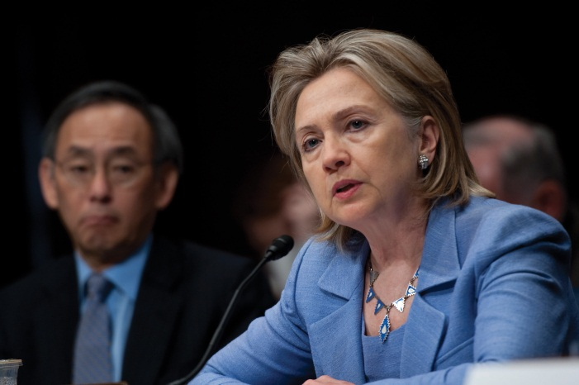
Secretary of State Hillary Clinton is one of an increasing number of women who has achieved a highly visible political leadership role.
Source:http://commons.wikimedia.org/wiki/File:Secretary_of_State_Hillary_Rodham_Clinton.jpg.
There are significant differences in the way that males and females are socialized to politics. Historically, men have occupied a more central position in American political culture than women. This tradition was institutionalized at the time of the founding, when women did not receive the right to vote in the Constitution. While strides have been made over the past century to achieve political equality between the sexes, differences in sex-role socialization still exist. Traits associated with political leadership, such as being powerful and showing authority, are more often associated with males than females. Girls have fewer opportunities to observe women taking political action, especially as few females hold the highly visible positions, such as member of Congress and cabinet secretary, that are covered by mass media. This is starting to change as women such as Madeleine Albright and now Hillary Clinton attract media attention in their roles as secretary of state or as Nancy Pelosi did as Speaker of the House of Representatives. Sarah Palin gained national attention as Republican John McCain’s vice presidential running mate in 2008, and she has become a visible and outspoken political figure in her own right. Despite these developments, women are still are socialized to supporting political roles, such as volunteering in political campaigns, rather than leading roles, such as holding higher-level elected office. The result is that fewer women than men seek careers in public office beyond the local level. ^{[36]}

Political Generations
A political generation is a group of individuals, similar in age, who share a general set of political socialization experiences leading to the development of shared political orientations that distinguish them from other age groups in society. People of a similar age tend to be exposed to shared historical, social, and political stimuli. A shared generational outlook develops when an age group experiences a decisive political event in its impressionable years—the period from late adolescence to early adulthood when people approach or attain voting age—and begins to think more seriously about politics. At the same time, younger people have less clearly defined political beliefs, which makes them more likely to be influenced by key societal events. ^{[37]}
The idea of American political generations dates back to the founding fathers. Thomas Jefferson believed that new generations would emerge in response to changing social and political conditions and that this would, in turn, influence public policy. Today people can be described as being part of the Depression Era/GI generation, the silent generation, the baby boom generation, generation X, and the millennial generation/generation Y. Depression Era/GIs, born between 1900 and 1924, were heavily influenced by World War I and the Great Depression. They tend to trust government to solve programs because they perceived that Franklin Delano Roosevelt’s New Deal programs helped the country recover from the Depression. The silent generation, born between 1922 and 1945, experienced World War II and the 1950s during their impressionable years. Like their predecessors, they believe that government can get things done, but they are less trusting of leaders. The Vietnam War and the civil rights and women’s rights movements left lasting impressions on the baby boomers, who were born between 1943 and 1960. The largest of the generations, this cohort protested against the government establishment in its youth and still distrusts government. Generation Xers, born between 1965 and 1980, came of age during a period without a major war or economic hardship. The seminal events they relate to are the explosion of the Challenger spacecraft and the Iran-Contra hearings. This generation developed a reputation for lacking both knowledge and interest in politics. ^{[38]} The political development of the millennials, those born between 1981 and 2000, is influenced by the terrorist attacks of 9/11 and its aftermath, as well as by the rise of digital technologies. This generation is more multicultural and has more tolerance for racial and ethnic difference than older cohorts. Sociologists William Strauss and Neil Howe have identified an emerging cohort born after 2000, which they label the homeland generation. This generation is influenced by omnipresent technology, the war on terror, and parents who seek to protect them from societal ills. ^{[39]}
Conflicts between generations have existed for centuries. Thomas Jefferson observed significant differences in the political worldviews of younger and older people in the early days of the republic. Younger government leaders were more willing to adapt to changing conditions and to experiment with new ideas than older officials. ^{[40]} Today generation Xers and the millennials have been portrayed as self-interested and lacking social responsibility by their elders from the baby boom generation. Generational conflicts of different periods have been depicted in landmark films including the 1950s-era Rebel without a Causeand the 1960s-era Easy Rider. Generation X has been portrayed in films such asSlacker, The Breakfast Club, and Reality Bites. Movies about the millennial generation include Easy A and The Social Network.

KEY TAKEAWAYS
Political socialization is the process by which people learn about their government and acquire the beliefs, attitudes, values, and behaviors associated with good citizenship. The political socialization process in the United States stresses the teaching of democratic and capitalist values. Agents, including parents, teachers, friends, coworkers, church associates, club members, sports teams, mass media, and popular culture, pass on political orientations.
Political socialization differs over the life course. Young children develop a basic sense of identification with a country. College students can form opinions based on their experiences working for a cause. Older people can become active because they see a need to influence public policy that will affect their lives. There are subgroup differences in political socialization. Certain groups, such citizens with higher levels of education and income, are socialized to take an active part in politics, while others are marginalized.
Political generations consist of individuals similar in age who develop a unique worldview as a result of living through particular political experiences. These key events include war and economic depression.

EXERCISES
- Do you believe you have the power to make an impact on the political process?
- What is the first political event you were aware of? What did you think about what was going on? Who influenced how you thought about it?
- How do members of your political generation feel about the government? How do your attitudes differ from those of your parents?

[1] Fred I. Greenstein, Children and Politics (New Haven, CT: Yale University Press, 1969).
[2] Michael McDevitt and Steven Chaffee, “From Top-Down to Trickle-Up Influence: Revisiting the Assumptions about the Family in Political Socialization,” Political Communication, November 2002, 281–301.
[3] Gabriel A. Almond and James S. Coleman, eds., The Politics of the Developing Areas(Princeton, NJ: Princeton University Press, 1960), 27.
[4] Pamela Johnston Conover, “Political Socialization: Where’s the Politics?” in Political Science: Looking to the Future, Volume III, Political Behavior, ed. William Crotty (Evanston, IL: Northwestern University Press, 1991), 125–152.
[5] Carole L. Hahn, Becoming Political (Albany: State University of New York Press, 1998).
[6] Richard E. Dawson and Kenneth Prewitt, Political Socialization (Boston: Little Brown and Company, 1969).
[7] Fred I. Greenstein, Children and Politics (New Haven, CT: Yale University Press, 1969).
[8] Stephen C. Craig, Malevolent Leaders (Boulder, CO: Westview, 1993).
[9] Jack Dennis, David Easton, and Sylvia Easton, Children in the Political System (New York: McGraw-Hill, 1969).
[10] Jack Dennis, David Easton, and Sylvia Easton, Children in the Political System (New York: McGraw-Hill, 1969).
[11] Pamela Johnston Conover, “Political Socialization: Where’s the Politics?” in Political Science: Looking to the Future, Volume III, Political Behavior, ed. William Crotty (Evanston, IL: Northwestern University Press, 1991), 125–152.
[12] Charles E. Lindblom, “Another Sate of Mind,” in Discipline and History, ed. James Farr and Raymond Seidelman (Ann Arbor: University of Michigan Press, 1993), 327–43.
[13] Felix Padilla, The Gang as American Enterprise (New Brunswick, NJ: Rutgers University Press, 1992).
[14] Jack Dennis, David Easton, and Sylvia Easton, Children in the Political System (New York: McGraw-Hill, 1969).
[15] Richard G. Niemi and Mary A. Hepburn, “The Rebirth of Political Socialization,”Perspectives on Political Science, 24 (1995): 7–16.
[16] Virginia Sapiro, The Political Integration of Women (Urbana: University of Illinois Press, 1983).
[17] Janie S. Steckenrider and Neal E. Cutler, “Aging and Adult Political Socialization,” inPolitical Learning in Adulthood, ed. Roberta S. Sigel (Chicago: University of Chicago Press, 1988), 56–88.
[18] Paul Lyons, Class of ‘66 (Philadelphia: Temple University Press, 1994).
[19] Anne Daugherty Miles, “A Multidimensional Approach to Distinguishing between the Most and Least Politically Engaged Senior Citizens, Using Socialization and Participation Variables” (PhD diss., Georgetown University, 1997).
[20] Richard E. Dawson and Kenneth Prewitt, Political Socialization (Boston: Little, Brown, 1969).
[21] Kenneth P. Langton, Political Socialization (New York: Oxford, 1969); Michael P. Riccards, The Making of American Citizenry (New York: Chandler Press, 1973).
[22] Herbert Hyman, Political Socialization (Glencoe, IL: Free Press, 1959), 69.
[23] Jack Dennis and Diana Owen, “The Partisanship Puzzle: Identification and Attitudes of Generation X,” in After the Boom, ed. Stephen C. Craig and Stephen Earl Bennet (Lanham, MD: Rowman & Littlefield, 1997), 43–62.
[24] Richard M. Merelman, Making Something of Ourselves (Berkeley: University of California Press, 1986).
[25] M. N. Saphir and Steven H. Chaffee, “Adolescents’ Contribution to Family Communication Patterns,” Human Communication Research 28, no. 1 (2002): 86–108.
[26] Richard M. Merelman, “The Family and Political Socialization: Toward a Theory of Exchange,” Journal of Politics, 42:461–86.
[27] Robert Hess and Judith Torney, The Development of Political Attitudes in Children(Chicago: Aldine, 1967).
[28] Norman H. Nie, Jane Junn, and Kenneth Stehlik-Barry, Education and Democratic Citizenship in America (Chicago: University of Chicago Press, 1996).
[29] Duane F. Alwin, Ronald L. Cohen, and Theodore M. Newcomb, Political Attitudes Over the Life Span (Madison: University of Wisconsin Press, 1991).
[30] Richard G. Niemi and Jane Junn, Civic Education (New Haven, CT: Yale University Press, 1998).
[31] Lawrence J. Walker, Karl H. Hennig, and Tobias Krettenauer, “Parent and Peer Contexts for Children’s Moral Reasoning Development,” Child Development 71, no. 4 (August 2000): 1033–48.
[32] Judith Rich Harris, “Where Is the Child’s Environment? A Group Socialization Theory of Development,” Psychological Review 102, no. 3 (1995): 458–89.
[33] Eric L. Dey, “Undergraduate Political Attitudes,” Journal of Higher Education, 68 (1997): 398–413.
[34] Charles Edward Merriam, The Making of Citizens (Chicago: University of Chicago Press, 1931), 160–61.
[35] Kaiser Family Foundation, The Media Family (Menlo Park, CA: Kaiser Family Foundation, 2006).
[36] Virginia Sapiro, Women in American Society (New York: Mayfair Publishing, 2002).
[37] Michael X. Delli Carpini, Stability and Change in American Politics (New York: New York University Press, 1986).
[38] William Strauss and Neil Howe, Generations (New York: William Morrow, 1992).
[39] William Strauss and Neil Howe, Millennials Rising (New York: Random House, 2000).
[40] Daniel J. Elazar, The Generational Rhythm of American Politics (Philadelphia: Temple University, Center for the Study of Federalism, 1976).

6.3 Political Culture and Socialization in the Information Age

LEARNING OBJECTIVES
After reading this section, you should be able to answer the following questions:
- How do people’s interactions with media contribute to their political socialization?
- How do media depict political socialization in the news and on entertainment channels?
New media are becoming important agents of political socialization because they host a great deal of political content and require the active engagement of users. Both news media and entertainment media provide depictions that influence political socialization, such as models of government leaders and citizen action.

Media Interactions
People’s interactions with media are increasingly important to the process of political socialization. The explosion in communication technologies has resulted in people communicating less via face-to-face interactions with family members and peers and more through technological intermediaries, such as the Internet, cell phones, and personal digital devices. Even teachers find it increasingly difficult to compete with the communications technologies that command their students’ attention.
The Internet is a potentially powerful agent of political socialization because of the vast amount of political information available online and the fact that people actively engage with online platforms. Not only do people get information about government from news sites and blogs, they can post responses to stories and debate others through discussion forums. They also can use online media to actively take part in political processes, such as election campaigns.
Young people, in particular, use the Internet to learn about and participate in politics, although older people are going online for politics at an increasing rate. Evidence suggests that young people are developing their political identities online as they learn about the differences between candidates and political parties and acquire information about issues and political events. They use social media to create collaborative online communities that organize for political causes, lobby government, and campaign for candidates. All of these activities contribute to the socialization of engaged citizens.

Media Depictions
Depictions of socialization and learning experiences abound in media. News and entertainment media are especially powerful as they provide depictions that embody the beliefs and values that make up American political culture. Core American values are crucial elements of a “good story,” as they resonate with the public. Both egalitarianism and individualism are celebrated in stories in which lone, ordinary people are able to defeat powerful economic and political forces aligned against them.

News Media
News media provide frequent depictions of political role models, including government leaders and citizens who are actively involved in community affairs. Politicians are often portrayed negatively, which can cause people to distrust leaders and lose faith in government. A prominent media frame portrays political leaders as constantly at odds and unable to reach civil agreement or compromise. This media frame is reinforced during elections when candidates attack their opponents unrelentingly in their stump speeches and ads.

Entertainment Media
Entertainment media provide depictions of core American values central to the political socialization process. Individualism is portrayed frequently in television dramas and comedies that tell stories of average citizens taking on the political and economic systems. Politicians can use entertainment media to convey an image of themselves embodying American values. Former Alaska governor Sarah Palin has cultivated an image of rugged individualism and self-reliance. She reinforced this image through the reality television program Sarah Palin’s Alaska.
Depictions can take the form of fictional dramas, such as Friday Night Lights’ portrayal of family life and the politics of sports in rural Texas, and sitcoms, or the offbeat view of parent-child relationships shown in Modern Family. Reality television programs such as Kate Plus 8 and Keeping Up with the Kardashiansoffer insights into family socialization that can invite commentary and criticism from viewers.
Children’s literature and movies feature many stoic, individualist characters. The classic film The Wizard of Oz (1939) has been called a tale of self-reliance. Dorothy, dropped from Kansas into Oz by a tornado, is advised that, to be able to return home, she should go to the Emerald City and appeal to the superior power, the Wizard of Oz. On the way there, she meets up with a Scarecrow desiring a brain, a Tin Man in search of a heart, and a Cowardly Lion in need of courage. The four meet a fearsome Wizard who orders them to bring back the broom of the Wicked Witch of the West. After a series of adventures, they return victorious to the Emerald City, only to find that the Wizard is nothing but a small man behind a curtain who has created an illusion of the “great and powerful Oz.” It turns out, he explains, that he was merely a lost itinerant balloonist who, upon descending from the clouds, was declared a Wizard by the credulous people. Dorothy and her friends learn that they each had the power they sought all along.
Teachers seeking to instill democratic and character values in their students have capitalized on the popularity of Harry Potter, the protagonist wizard in J. K. Rowling’s popular books. Harry has become a hero to children (and adults) who have read about his exploits. He embodies values of individualism and bravery tempered with humility. Young people can relate to Harry because in the world of the Muggles (those without magical powers), he is average and imperfect. Even among the wizards, he is not the smartest or the most talented. Yet he is able to handle extraordinary situations with bravery and skill. Harry’s heroism provides a civics lesson for readers because it illustrates the balance between the democratic values of individualism and egalitarianism. While Harry realizes that his magic powers give him the ability to distinguish himself, he chooses to include others—Hermione Granger, Ron and Ginny Weasley, and Neville Longbottom—as he fights against evil. Further, Harry does not seek public recognition for his acts of heroism. ^{[1]}
MTV’s series The Real World, which first aired in 1991, provides an intriguing look at the socialization experiences of groups of twentysomething strangers who live together for a year. The program provides insights into the effects of peers on the development of the housemates’ attitudes and behaviors. In the course of learning to adapt to new surroundings, live as a group, and find jobs, cast members deal with political issues. The San Francisco season attracted national media attention because it featured the house members grappling with the issue of HIV/AIDS when roommate Pedro, who worked as an AIDS educator and counselor, tested positive for the disease. Depictions related to subgroup relations and multiculturalism abound on The Real World. Cast members come from a variety of racial and ethnic backgrounds, which is a source of tension in the house. Almost every season involves a black male who stereotypically is alienated and confrontational. Most of the time, this character is shown talking about the societal injustices he suffers and picking fights with other house members. These confrontations force cast members to take sides and voice their opinions about race.

Media Consequences
Parents and educators express concerns that socialization of young people via mass media contributes to a citizenry that is alienated from politics and distrusts government. Many of the media messages young people receive about politics are negative. They spend little time discussing these messages with other people or discovering the ways in which they can actively engage the political world. Alternatively, young people today are exposed to much more political media content than any prior generation. This exposure can contribute to greater awareness of government and opportunities for civic action. Digital communication technologies offer people increased opportunities for taking part in politics via media, such as posting to a blog or participating in a “tweetup,” using the microblogging platform Twitter to inform people about a political event taking place online or offline.

Scandal Coverage
The influence of mass media on children’s attitudes toward leaders and government has become more negative over time, as media messages focus more on personal scandals and institutional dysfunction. For the most part, young children’s initial views of politics tend to be positive. Studies conducted in the 1960s showed that children idealized the president. They considered him a benevolent leader, someone who did good things for the country and would help a child personally. Even during the Watergate scandal of the 1970s, which involved a break-in at the Democratic National Committee headquarters and a cover-up by President Richard Nixon, children held strong, positive feelings about the office of the president. Children learned about President Nixon’s impeachment primarily from their parents and teachers, and not from the mass media. Media accounts focused on the political aspects of the Nixon impeachment, which went over the heads of most children. Many parents felt it was important to instill positive views of government in their children during this period of political upheaval.
The situation was much different in the 1990s when children learned about President Bill Clinton’s involvement with White House intern Monica Lewinsky, predominantly from nonstop, graphic television coverage that focused on Clinton’s personal life. Young children became disillusioned with President Clinton because they felt he had not told the truth. For the first time, children’s views of the sitting president, as well as their opinions about the institution of the presidency, were significantly more negative than those of their parents. Fewer children aspired to become president when they grew up. ^{[2]}

Hollywood and Washington
The Payne Fund studies of motion pictures and youth, conducted between 1929 and 1933, provide early evidence that film can be a powerful agent of socialization. The studies found that people developed attitudes toward racial and ethnic groups, war, and crime based on their exposure to popular films. Audience members who saw the controversial film Birth of a Nation believed that blacks in the post–Civil War era were uncivilized and dangerous. Children who watched their favorite movie stars, such as James Cagney and Humphrey Bogart, playing criminals on screen imitated their behavior patterns by acting up in school. ^{[3]}
Figure 6.12
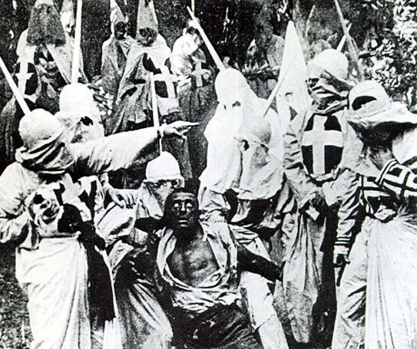
Early research indicated that film could be an influential agent of political socialization. Negative attitudes toward African Americans were transmitted to audiences through the film Birth of a Nation.
Source:http://commons.wikimedia.org/wiki/File:Birth-of-a-nation-klan-and-black-man.jpg.
Recognizing that film has the power to impart political messages to the public, officials in Washington have forged connections with the filmmaking community in Hollywood. The Hollywood-Washington connection dates back to the 1930s when President Herbert Hoover befriended MGM mogul Louis B. Mayer, whose studio produced many of the most popular films of the era. President Franklin D. Roosevelt realized that films could influence public perceptions of the Great Depression and the United States’ involvement in World War II. Roosevelt encouraged filmmakers to make movies with optimistic messages that would generate support for government action. The defeatist ending of director John Ford’s Oscar-winning film The Grapes of Wrath (1940), based on the John Steinbeck novel, was changed to depict the Joad family persevering despite terrible hardship, due to their inner strength. In addition to prowar documentaries such as Frank Capra’s Why We Fightseries, Roosevelt requested that studio heads make popular films in support of the war effort. Films such as Confessions of a Nazi Spy depicted Germany as a nation out to destroy the American Constitution and the Bill of Rights. Anti-German messages were delivered in popular series films such as Tarzan Triumphs (1943), in which Tarzan and Cheetah fight Nazis who parachute into their jungle paradise. ^{[4]}
Immediately following the 9/11 terrorist attacks, representatives of Hollywood’s major studios, television networks, trade organizations, and the creative community met with senior White House officials to discuss how the entertainment community could help in the war against terror by emphasizing that the 9/11 attacks were an affront to civilization. ^{[5]} Hollywood sought to define its political role while at the same time protecting its future at the box office. The first inclination was to feature comedy and fantasy fare that would be uplifting and noncontroversial. Films featuring terrorist themes—such as the Jennifer Lopez vehicle Tick Tock, which is about terrorists planting bombs in Los Angeles shopping malls, and Nose Bleed, a Jackie Chan movie about a window washer who discovers a plan to blow up the World Trade Center—were shelved. Images of the Twin Towers were removed from films set for release, such as Spiderman. However, video rentals of films featuring dramatic action and terrorist plots increased by 30 percent in the months directly following the attacks, which gave Hollywood an indication that the public would be receptive to more violent offerings. ^{[6]} War films with a patriotic theme, such as Behind Enemy Lines and The Last Castle, proved to be highly popular, and coincidentally, reinforced the messages suggested by the White House delegation.

KEY TAKEAWAYS
Mass media have become compelling agencies of political learning, as young people spend a tremendous amount of time being exposed to television, the Internet, video games, and other media rather than interacting with other people. Media messages about politics are often negative, which may lead young people to become alienated from the political process. Young people, in particular, may learn a good deal about politics from entertainment and popular media.

EXERCISES
- Are there any fictional characters who seem heroic to you? What qualities make him or her seem heroic?
- Where do you get most of your news about politics? Do you think that where you get your news might affect your views about politics? In what ways?

Civic Education
Young people often have difficulty seeing the relevance of civic education to their immediate lives. Programs tend to emphasize future participation such as voting in presidential elections, which is an activity that students cannot engage in until they reach the age of eighteen. However, innovative curriculum projects can stimulate students’ interest in elections through meaningful campaign-related activities.
Kids Voting USA is a program initiated in 1988 that allows grade school teachers to use a curriculum designed around an election campaign. Students become involved by researching issues and preparing position papers, constructing informational websites, writing articles for newspapers, and serving as reporters on local television stations. On Election Day, children accompany parents to the polls and cast ballots in a special election. Children who participate are often motivated to turn out at elections when they reach voting age. In addition, children’s participation in Kids Voting USA stimulates parents’ interest in the campaign and voter turnout. Young people initiate discussions at home that are associated with their school projects. This enthusiasm for elections continues for some families after the program’s completion, especially among families of lower socioeconomic status who previously had little incentive for participating in politics. ^{[7]}

[1] Jeffrey A. Becker, “Heroism and the Political Morality of Democracy in Harry Potter,” paper delivered at the Annual Meeting of the American Political Science Association, Boston, MA, August 29–September 1, 2002.
[2] Diana Owen and Jack Dennis, “Kids and the Presidency: Assessing Clinton’s Legacy,”The Public Perspective 10, no. 3 (April–May 1999): 41–44.
[3] Garth Jowett, Ian C. Jarvic, and Kathy H. Fuller, Children and the Movies (New York: Cambridge, 1996).
[4] Clayton R. Koppes and Gregory D. Black, Hollywood Goes to War (New York: Free Press, 1987).
[5] “Hollywood Considers Role in War Effort,” CNN, November 12, 2001,http://www.cnn.com.
[6] “Commercial Response to September 11,” NewsHour Online, October 24, 2001,http://www.pbs.org/newshour.
[7] Michael McDevitt and Steven H. Chaffee, “Second-Chance Political Socialization: ‘Trickle-Up’ Effects of Children on Parents,” in Engaging the Public, ed. Thomas J. Johnson, Carol E. Hays, and Scott P. Hays (Lanham, MD: Rowman & Littlefield, 1998), 57–66.

6.4 Recommended Reading
Calavita, Marco. Apprehending Politics. Albany: State University of New York Press, 2005. Looks at how the news media influences the political beliefs and behavior of generation X.
Campbell, David E. Why We Vote. Princeton, NJ: Princeton University Press, 2006. Examines the ways in which schools and communities socialize young people to politics.
Craig, Steven C., and Stephen Earl Bennet, eds. After the Boom. Lanham, MD: Rowman & Littlefield, 1997. Explores the socializing experiences and political orientations of generation X, people born between 1960 and 1980.
Delli Carpini, Michael X. Stability and Change in American Politics. New York: New York University Press, 1986. A study of the baby boom generation using a political socialization framework.
Elazar, Daniel J. The American Mosaic. Boulder, CO: Westview Press, 1994. Examines the geographical underpinnings of American political culture across generations.
Hunter, James Davison. Culture Wars. New York: Basic Books, 1991. Discusses how subgroups based on religious differences disagree on fundamental issues of American national identity.
Johnson, Thomas J., Carol E. Hays, and Scott P. Hays. Lanham, MD: Rowman & Littlefield, 1998. A collection of articles discussing how the mass media can contribute to the political socialization process and foster the development of democratic values and participation.
Kitwana, Bakari. The Hip-Hop Generation. New York: Basic Civitas Books, 2002. Discusses the socialization experiences of young black Americans who find their political voice in hip-hop music.
McClosky, Herbert, and John Zaller. The American Ethos. Cambridge, MA: Harvard University Press, 1984. Examines the nature of Americans’ commitment to democratic and capitalist values.
Niemi, Richard G., and Jane Junn. Civic Education. New Haven, CT: Yale University Press, 1998. Explores how schools succeed and fail in teaching civics.
Schmermund, Kathleen. Charles Gibson vs. Jon Stewart. New York: Lambert Academic Publishing, 2010. Compares political socialization of young people via traditional and fake news media.
Strauss, William, and Neil Howe. Generations. New York: William Morrow and Company, 1992. Provides an overview of American generations since the founding of America.
White, John Kenneth. The Values Divide. New York: Chatham House Publishers, 2003. An account of how changes in the demographic, racial, and ethnic makeup of the United States that have occurred since the 1950s have resulted in a fundamental shift in cultural values.
Youniss, James, and Miranda Yates. Community Service and Social Responsibility in Youth. Chicago: University of Chicago Press, 1997. A study of high school community service programs and how they work to promote future civic participation.

6.5 Recommended Viewing
42: Forty Two Up (1999). The sixth and final installment of Michael Apted’s unprecedented documentary film chronicling the lives of fourteen British men and women in seven-year intervals. The subjects represent a cross-section of British society, and their life stories depict a variety of socialization experiences and political orientations. This series of documentaries, beginning with Seven Up, is the only film depiction of socialization over the life course.
American Family (2002). A PBS dramatic series that examines the everyday lives of members of an extended Latino family.
American History X (1998). An examination of two brothers who are drawn into a neo-Nazi skinhead gang. The film examines family socialization as the initial source of one brother’s racism, which is reinforced in prison and in a gang.
An American Family (1973), American Family Revisited (1983), Lance Loud!: A Death in an American Family (2003). A television documentary series capturing the life and times of the Loud family; the series was one of the first forays into “reality TV” and became controversial as the family dealt publicly with many difficult life situations, including issues of sexual orientation and divorce.
The Breakfast Club (1985). This film explores diverse socialization experiences in the home, school, and peer group of several high school students forced to do detention together in the school library.
Dead End (1937). An examination of the problems, including cultural conflicts, faced by New York City residents as they live through their impressionable years during the Great Depression.
Easy Rider (1969). This portrayal of two young societal dropouts who ride motorcycles across the American southwest depicts various scenes of the late 1960s counterculture.
Rebel without a Cause (1955). James Dean portrays a troubled and misunderstood middle-class 1950s-era youth in this classic depiction of generational conflict.
River’s Edge (1987). A dark portrayal of 1980s youth culture based on a true story of friends who do not report the murder of a woman in their group by her boyfriend. The film deals with issues, such as family socialization in homes with absentee parents and peer-group influence. It was selected as the “Film That Mattered” for the 1980s by the LA International Film Festival.
Slacker (1991). This documentary-style film of twentysomethings living on the edge of society in Austin, Texas, contributed to the image of 1990s youth culture as aimless and bored.

Chapter 7

Public Opinion

Preamble
It has become a ritual for Americans to spend the evening of presidential elections gathered in front of their televisions, or more recently, their computer screens, to follow the voting returns as they are announced state by state. Election Night 2000 began like any other since the late 1960s, when the television networks began using exit polls of voters taken as they leave the polling place to predict the winner. Election Night coverage is driven by anchors making projections about which candidate will win each state’s electoral votes. Typically, news organizations have a good sense of who will be the next president of the United States based on exit polls by late afternoon, although they hold off on making a prediction until later in the evening. ^{[1]}
The 2000 presidential election was the closest in many decades. There was much uncertainty about whether Republican George W. Bush or Democrat Al Gore would emerge victorious. As Election Night unfolded, it became clear that the outcome would be decided by Florida’s twenty-five electoral votes. ^{[2]}
Network and cable news anchors discussed the closeness of the election and told the public to anticipate a long and interesting evening—a statement that proved prescient. By 8 p.m., exit polls indicated that Al Gore was leading the state of Florida, prompting television news organizations to speculate that Gore would be headed to the White House. CBS News anchor Dan Rather observed on air, “Now, remember, Florida is the state where Jeb Bush, the brother of George Bush, is the governor, and you can bet that Governor Bush will be madder than a rained-on rooster that his brother, the governor, wasn’t able to carry this state for him.” ^{[3]}
Three hours later, the networks began to rescind the call of Florida for Gore when it became evident that data from exit polls conflicted with actual returns from voting precincts. Network anchors reported that Florida’s electoral votes were still up for grabs until Fox News called Florida for Bush at 2:16 a.m.; ABC, CBS, and NBC quickly followed suit. With the media’s proclamation of Bush as the winner, Gore phoned Bush and conceded the election. Gore then departed from his hotel suite in Nashville to make his concession speech in front of his supporters. While Gore was en route, the press once again changed their position, stating that the election was too close to call. Gore returned to his hotel, as the media’s Election Night prediction of a Bush victory lasted all of ninety minutes.
Television news was not the only media source to prematurely call the election. Print newspapers, including the New York Post, the Miami Herald, and the San Francisco Chronicle, ran headlines declaring Bush the winner. The New York Times released 100,000 newspapers stating that Bush “appears to have won.” For an hour, the New York Times website proclaimed, “Bush Captures the White House.” ^{[4]}
The 2000 election was not decided on Election Night—November 7. Instead, a recount of the votes in Florida was undertaken in an attempt to determine the winner. The recount was halted by the US Supreme Court on December 12, 2000, and George W. Bush was sworn in as president on January 20, 2001.
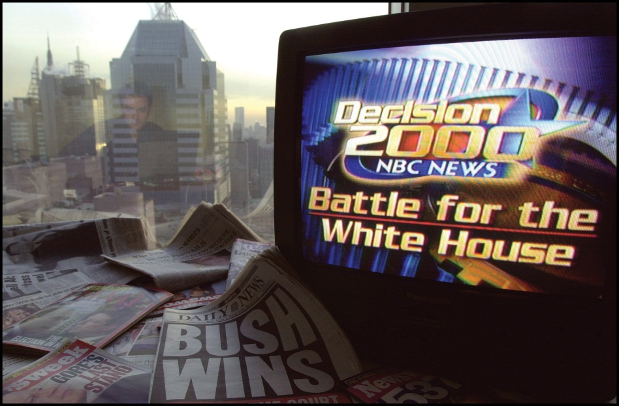
Exit polls misguide 2000 Election Night coverage. Misguided by exit poll data, television news organizations prematurely called the 2000 presidential election contest in favor of Al Gore first and then George W. Bush. The election was too close to call on election night and eventually was decided in favor of Bush.
Source: Used with permission from Getty Images.
The Election Night 2000 media debacle illustrates a number of points relevant to this chapter. Polling is an integral element of American politics. Polls shape the way that news organizations frame their stories and convey information to the public. In fact, many news organizations have in-house polling operations or collaborate with polling firms to have public opinion data constantly available. Poll results allow the media to convey information to the public in a concise and authoritative manner. Polls can provide guidance to decision makers about election outcomes and policy debates. However, poll results are not always accurate, as was the case with the exit polls in the 2000 presidential election, and they can misrepresent public sentiment. Therefore, it is important for people to be savvy consumers of opinion polls.

[1] Robert S. Erikson and Kent L. Tedin, American Public Opinion, 8th ed. (New York: Longman, 2011).
[2] James W. Ceaser and Andrew E. Busch, The Perfect Tie (Lanham, MD: Rowman & Littlefield, 2001).
[3] Dan Rather, CBS Evening News, Election Night Coverage, November 7, 2000, 8:15 p.m.
[4] Diana Owen, “Media Mayhem,” in Overtime!, ed. Larry J. Sabato (New York: Longman, 2002), 123–56.

7.1 What Is Public Opinion?

LEARNING OBJECTIVES
After reading this section, you should be able to answer the following questions:
- What is public opinion?
- What are the different interpretations of public opinion?
- How does an attitude differ from an opinion?
Public opinion is one of the most frequently evoked terms in American politics. At the most basic level, public opinion represents people’s collective preferences on matters related to government and politics. However, public opinion is a complex phenomenon, and scholars have developed a variety of interpretations of what public opinion means. One perspective holds that individual opinions matter; therefore, the opinions of the majority should be weighed more heavily than opinions of the minority when leaders make decisions. A contrasting view maintains that public opinion is controlled by organized groups, government leaders, and media elites. The opinions of those in positions of power or who have access to those in power carry the most weight.
Public opinion is often made concrete through questions asked on polls. Politicians routinely cite public opinion polls to justify their support of or opposition to public policies. Candidates use public opinion strategically to establish themselves as front-runners or underdogs in campaigns. Interest groups and political parties use public opinion polls to promote their causes. The mass media incorporate reports of public opinion into news story about government and politics.

Defining Public Opinion
What exactly is public opinion? Scholars do not agree on a single definition of public opinion. The concept means different things depending on how one defines “the public” and assumptions about whose opinion should or does count the most—individuals, groups, or elites.
Most simply, the public can be thought of as people who share something in common, such as a connection to a government and a society that is confronted by particular issues that form the bases of public policies. Not all people have the same connection to issues. Some people are part of the attentive publicwho pay close attention to government and politics in general. Other individuals are members of issue publics who focus on particular public policy debates, such as abortion or defense spending, and ignore others. ^{[1]} They may focus on a policy that has personal relevance; a health-care activist, for example, may have a close relative or friend who suffers from a prolonged medical problem. Some members of the public have little interest in politics or issues, and their interests may not be represented.
An opinion is the position—favorable, unfavorable, neutral, or undecided—people take on a particular issue, policy, action, or leader. Opinions are not facts; they are expressions of people’s feelings about a specific political object. Pollsters seeking people’s opinions often say to respondents as they administer a survey, “there are no right or wrong answers; it’s your thoughts that count.” Opinions are related to but not the same as attitudes, or persistent, general orientations toward people, groups, or institutions. Attitudes often shape opinions. For example, people who hold attitudes strongly in favor of racial equality support public policies designed to limit discrimination in housing and employment.
Public opinion can be defined most generically as the sum of many individual opinions. More specific notions of public opinion place greater weight on individual, majority, group, or elite opinion when considering policy decisions.

Equality of Individual Opinions
Public opinion can be viewed as the collection of individual opinions, where all opinions deserve equal treatment regardless of whether the individuals expressing them are knowledgeable about an issue or not. Thus, public opinion is the aggregation of preferences of people from all segments of society. The use of public opinion polls to gauge what people are thinking underlies this view. ^{[2]}By asking questions of a sample of people who are representative of the US population, pollsters contend they can assess the American public’s mood. ^{[3]}People who favor this perspective on public opinion believe that government officials should take into account both majority and minority views when making policy.

Majority Opinion
Another perspective maintains that public opinion is the opinion held by the most people on an issue. In a democracy, the opinions of the majority are the ones that should count the most and should guide government leaders’ decision making. The opinions of the minority are less important than those of the majority. This view of public opinion is consistent with the idea of popular election in that every citizen is entitled to an opinion—in essence a vote—on a particular issue, policy, or leader. In the end, the position that is taken by the most people—in other words, the position that receives the most votes—is the one that should be adopted by policymakers.
Rarely, if ever, does the public hold a single unified opinion. There is often significant disagreement in the public’s preferences, and clear majority opinions do not emerge. This situation poses a challenge for leaders looking to translate these preferences into policies. In 2005, Congress was wrestling with the issue of providing funding for stem cell research to seek new medical cures. Opinion polls indicated that a majority of the public (56 percent) favored stem cell research. However, views differed markedly among particular groups who formed important political constituencies for members. White evangelical Protestants opposed stem cell research (58 percent), arguing the need to protect human embryos, while mainline Protestants (69 percent) and Catholics supported research (63 percent). ^{[4]}

Public Debate among Groups
Some scholars contend that public opinion emerges from public debate among groups rather than from individual opinions. ^{[5]} Political parties, interest groups, trade associations, nonprofit organizations, trade unions, and corporations will articulate positions and front public discussion of issues in which they have a stake. Groups representing opposing viewpoints often find themselves in a position to define social problems. While individuals often find it difficult to make their views known and have them taken seriously, organized groups have the resources, such as lobbyists and funding to administer polls and pay for advertising, as well as the ability to attract the attention of policymakers and the mass media. Social media have made it easier for groups without significant resources to publicize their opinions by using Facebook groups and other platforms.
Groups work hard to frame issue debates to their advantage. They often will gauge public preferences and use this information when devising media tactics to gain support for their positions. ^{[6]} Opposing groups will present competing public opinion poll data in an effort to influence decision makers and the press. In 1997, the United States’ participation in a summit in Kyoto, Japan, where nations signed a climate-control treaty, sparked a barrage of media stories on the issue of global warming and the potential for deadly gasses to induce climate change. Most Americans believed then that global warming existed and that steps should be taken to combat the problem. ^{[7]} Groups such as the Environmental Defense Fund, Greenpeace, and the Sierra Club who favor government-imposed regulations on fossil-fuel companies and automobile manufacturers to curb pollution cited opinion poll data showing that over 70 percent of the public agreed with these actions. Organizations representing industry interests, such as the now-defunct Global Climate Coalition, used opinion polls indicating that the public was reluctant to sacrifice jobs or curb their personal energy use to stop global warming. ^{[8]} The debate in the media among competing groups influenced public opinion over the following decade. There was a massive shift in opinion, as only 52 percent believed that global warming was a problem in 2010. ^{[9]}
Figure 7.1 Group Opinions on Social Media
Social media facilitate people’s ability to express their opinions through groups, such as those related to environmental activism.
Source: http://twitter.com/#!/Greenversations.

Elite Opinion
Politicians, pollsters, policy specialists, activists, and journalists have assumed the position of opinion leaders who shape, create, and interpret public opinion. These political elites are devoted to following public affairs—it’s their job. ^{[10]}Noted journalist and social commentator Walter Lippmann observed that average people have neither the time nor the inclination to handle the impossible task of keeping up with the myriad issues that confront the nation. They do not have the opportunity to directly experience most political events and must rely on second-hand accounts conveyed by elites primarily through mass media. In Lippmann’s view, public opinion is best managed by specialists who have the knowledge and capabilities to promote policies. Thus, elite opinion, and not the views of average citizens, should count the most.
The mass media rely heavily on the opinions of government elites, especially when covering foreign policy and domestic issues, such as the economy and employment. The breadth of news coverage about foreign affairs is constrained to reflect the range of viewpoints expressed by officials such as members of Congress who are debating the issues. The voices of average Americans are much less prominent in news coverage. ^{[11]} As political scientist V. O. Key stated, “The voice of the people is but an echo.” ^{[12]}
Figure 7.2 Pundits Offer Opinions
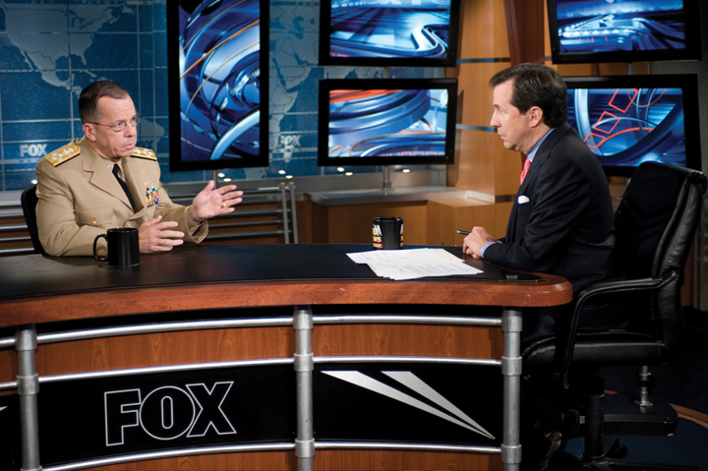
“Talking heads,” who provide elite opinions about issues, events, and leaders, populate cable news.
Source:http://commons.wikimedia.org/wiki/File:Admiral_Mike_Mullen_interview_on_Fox_News_Sunday.jpg.
Elite opinion is increasingly articulated by pundits who offer their opinion or commentary on political issues. College professors, business and labor leaders, lobbyists, public relations representatives, and pollsters are typical pundits who provide expert opinion. Some pundits represent distinctly partisan or ideological viewpoints and use public opinion data selectively to support these positions. Pundits can establish their credentials as experts on governmental affairs and politics through their frequent media appearances as “talking heads” on cable television programs such as CNN, MSNBC, and Fox News.

KEY TAKEAWAYS
Public opinion can be defined broadly as the collective views of people in a society. It is a complicated concept that takes into account the opinions of individual citizens, groups, and elites. Public opinion is publicized through the media, often by pundits who promulgate elite views.

EXERCISES
- Have you ever participated in an opinion poll? Did you feel that you were able to adequately convey your feelings about the issues you were asked about?
- What are the different ideas about what public opinion really is? What might the advantages of looking at public opinion in each of those different ways be?

[1] James A. Stimson, Public Opinion in America, 2nd ed. (Boulder, CO: Westview, 1999).
[2] Carroll J. Glynn, Susan Herbst, Garrett J. O’Keefe, and Robert Y. Shapiro, Public Opinion(Boulder, CO: Westview, 1999).
[3] Susan Herbst, Numbered Voices (Chicago: University of Chicago Press, 1993).
[4] Pew Research Center for the People & the Press, “More See Benefits of Stem Cell Research” (Washington, DC: Pew Research Center, May 23, 2005).
[5] Carroll J. Glynn, Susan Herbst, Garrett J. O’Keefe, and Robert Y. Shapiro, Public Opinion(Boulder, CO: Westview, 1999).
[6] Ken Kollman, Outside Lobbying (Princeton, NJ: Princeton University Press, 1999).
[7] Jon A. Krosnick, Penny S. Visser, and Allyson L. Holbrook, “American Opinion on Global Warming,” Resources no. 133 (Fall 1998): 5–9.
[8] Glynn R. Wilson, “Global Warming: Competing Ideas and Interest Groups,” Public Opinion Project, May 2, 1998, accessed June 19, 2005,http://www.southerner.net/fast/pocompet.html.
[9] Christopher R. Borick, Erick Lachapelle, and Barry G. Rabe, “Climate Compared: Public Opinion on Climate Change in the United States and Canada,” Issues in Governance Studies, no. 39, April 2011, accessed April 11, 2011,http://www.brookings.edu/~/media/Files/rc/papers/2011/04_climate_change_opinion/04_climate_change_opinion.pdf.
[10] John Zaller, The Nature and Origins of Mass Opinion (New York: Cambridge, 1992).
[11] W. Lance Bennett, Regina C. Lawrence, and Steven Livingston, When the Press Fails(Chicago, IL: University of Chicago Press, 2007).
[12] V. O. Key Jr., Public Opinion and American Democracy (New York: Alfred A. Knopf, 1961).

7.2 Democracy and Public Opinion

LEARNING OBJECTIVES
After reading this section, you should be able to answer the following questions:
- Why is public opinion important in a democracy?
- How does public opinion differ from public judgment?
- What is deliberative polling?
Political scientist Harold Lasswell once noted, “The open interplay of opinion and policy is the distinguishing mark of popular rule.” ^{[1]} Public opinion plays a number of important roles in a representative democracy. Leaders can take public opinion into account when making laws and formulating policy. Public opinion can act as a check on leadership, as the members of the public can express their dissatisfaction with politicians who refuse to take their opinions into account and vote them out of office.

Public Opinion and Public Policy
One purpose of public opinion in a democracy is to inform public policymaking. Opinion polls provide a mechanism for succinctly presenting the views of the mass public to government leaders who are making decisions that will affect society. Leaders often monitor the public pulse when making policy decisions, especially when they face an election campaign.
Perspectives about the relationship of public opinion to policymaking differ vastly. On the one hand, scholars and political practitioners believe that public policy should be guided by public opinion so that the will of the people is respected. Public opinion polls are essential to ensuring democratic governance. Political scientist Sidney Verba supports this view: “Surveys produce just what democracy is supposed to produce—equal representation of all citizens. The sample survey is rigorously egalitarian; it is designed so that each citizen has an equal chance to participate and an equal voice when participating.” ^{[2]} From this perspective, members of Congress, state legislators, and local officials should pay close attention to the public’s views when making laws.
Others disagree with the notion that leaders should pay close attention to public opinion when making decisions. They point out that many members of the public are uniformed about issues, and the opinions they record on polls are not carefully reasoned. Journalist and scholar Walter Lippmann noted that governing by popularity is not always best. Instead, public policy should be grounded in sound principles supported by experts; decision making should not simply be the result of popular will. This view is consistent with the belief that the country is being run by pollsters and their followers and not by leaders with integrity and principle. As an editorial in the Wall Street Journal lamented, “Spend too much time following polls and you simply forget how to lead, especially when it matters.” ^{[3]}
Some scholars take issue with Verba’s assessment of the egalitarian nature of polls in democracy and argue that minority opinion is not given sufficient weight. Certain people, such as individuals with few economic resources, have a difficult time getting their views recognized. Pollsters may not reach these people because they do not have regular telephone or Internet service, or they do not have the time or inclination to answer questionnaires.

Public Judgment
Public opinion, especially as measured by polls, is a quick take on the public pulse. It often does not require that members of the public have much knowledge about politicians, government, or policies; they merely must be willing to state whatever views pop into their heads. Public opinion polls often deal with issues and abstract ideas that people have not thought much about.
Public judgment, in contrast, is a special type of public opinion where people carefully consider the important issues of the day, contemplate the range of viewpoints, and weigh the consequences of policy prescriptions. Rather than stating positions off the top of their heads, public judgment requires people to be knowledgeable about an issue and debate the merits of policies before arriving at an informed opinion. For example, public opinion polls conducted by the Pew Research Center in 2011 indicate that the public favors tougher immigration laws and better enforcement of border security. However, when people exercise public judgment and consider the consequences of immigration policy, such as the moral issues related to the welfare of children of illegal immigrants, they support more generous policies. ^{[4]} Public judgment is not easily achieved, but it offers an important counterbalance to the domination of elite opinion in the policy sphere.

Deliberative Polling
Deliberative polling is a technique that provides members of the public with the opportunity to think carefully about issues and their relationship to public policy. It attempts to deal with the fact that many people know little about issues because they lack the time to acquire information. Deliberative polling was pioneered in 1988 and has been used around the world to gauge opinion. The Center for Deliberative Democracy at Stanford University applies and studies the use of deliberative polling.

Link
Deliberative Polling
Learn more about deliberative polling at http://cdd.stanford.edu/polls/.
Figure 7.3 Deliberative Polling
Deliberative polling brings people together to discuss issues in detail with policy experts so that they can develop informed choices.
Source: Photo courtesy of Bernard Pollack,http://www.flickr.com/photos/labor2008/2587616688/.
A random, representative sample of people is first polled about their positions on targeted issues. They are then brought together for a few days to discuss a particular issue in detail. The participants are provided with briefing materials, engage in a dialogue with experts on specific topics, and discuss their views in small groups led by trained moderators. The deliberations are shared with the general public through television broadcasts. The participants are polled again after they have deliberated to determine if their opinions have changed. Scholars believe that deliberative polls represent the opinions the public would hold on issues if they had the opportunity to exercise public judgment and carefully consider their options. After deliberating on an issue, members of the public frequently shift positions. ^{[5]} For example, people participating in a deliberative polling experiment in Texas shifted their views on the use of wind power from 54 percent to 84 percent in favor. As a result, political leaders heeded the views of Texas’s population, and the state went from last to first in the use of wind power. ^{[6]}
Political scientist James Fishkin, who pioneered deliberative polling, observes, “The Public is very smart if you give it a chance. If people think their voice actually matters, they’ll do the hard work, really study their briefing books, ask the experts smart questions and then make tough decisions.”

KEY TAKEAWAYS
Public opinion is important in a democracy, as it can guide policy decisions. There is disagreement about the extent to which political leaders should take the public’s views into account compared with the advice of experts. Many people do not have a good understanding about issues and related policies. Deliberative polling is an attempt to give people the opportunity to become more informed about issues and to contemplate policy options.

EXERCISES
- How much do you think politicians should take public opinion polls into account when making policy? When do you think they should disregard public opinion?
- What does deliberative polling attempt to measure? What are the advantages of deliberative polling?

[1] Harold D. Lasswell, Democracy through Public Opinion (Menasha, WI: George Banta Publishing Company, 1941), 15.
[2] As cited in Scott Keeter, “Public Opinion Polling and Its Problems,” in Political Polling in the Digital Age, ed. Kirby Goidel (Baton Rouge: Louisiana State University Press, 2011), 28.
[3] Kenneth F. Warren, In Defense of Public Opinion Polling (Boulder, CO: Westview Press, 2004), 6.
[4] Daniel Yankelovich, Coming to Public Judgment (Syracuse, NY: Syracuse University Press, 1991).
[5] James S. Fishkin, When the People Speak (New York: Oxford University Press, 2009).
[6] Joe Klein, “How Can a Democracy Solve Tough Problems?,” Time, September 2, 2010, accessed June 6, 2011,http://www.time.com/time/politics/article/0,8599,2015481,00.html.

7.3 Polling the Public

LEARNING OBJECTIVES
After reading this section, you should be able to answer the following questions:
- How have public opinion polls developed historically?
- What are the different types of public opinion polls?
Public opinion polling has a long history in the United States. Polls are ubiquitous in American political life. In 2007, there were nearly 5,500 polling organizations in the United States, an increase of over 1,500 organizations in ten years. ^{[1]} Every day the public is polled about topics ranging from their views about taxes and the federal budget, their opinions about the environment and global warming, and whether or not a principal has the right to prevent students from bringing their lunches to school.
Polls vary greatly in terms of their quality, content, and purpose. Reliable public opinion data are gathered by reputable commercial polling organizations, nonpartisan think tanks, academic institutions, government agencies, and news organizations. Misleading information about public opinion can result from quick polls that do not employ appropriate data-gathering techniques.

History of Opinion Polling
Public opinion polls date back to the early days of the American republic. From the outset, polls were linked closely with newspapers. The Harrisburg Pennsylvanian conducted the first informal “straw poll” in 1824 that incorrectly predicted Andrew Jackson as the winner over John Quincy Adams in the presidential election. ^{[2]} Early straw polls were administered haphazardly and without concern for drawing a proper sample, often right after people had cast their ballots in elections or even when they were checking into a hotel. They were notoriously inaccurate, yet they became a popular feature of newspapers and magazines, which treated poll data as a source of news much like today.
Straw polls were sponsored by publishers as a gimmick to attract readers who would fill out mail-in ballots that included subscription offers. Over eighty straw polls were conducted during the 1924 presidential election, six of which were national polls. Newspapers also conducted polls on pressing issues of the day, such as whether or not people favored Prohibition, the constitutional ban on alcohol. Coverage of these polls in print publications generated thousands of column inches. ^{[3]}
By the 1920s, market researchers had begun to use scientific polls that employed samples representative of the population to ascertain consumer product preferences. They used polls to discover everything from what kinds of magazine stories readers enjoyed most to what automobiles people preferred.^{[4]} Commercial pollsters applied market research techniques to determine what candidates voters favored, how satisfied the public was with the way the president was doing his job, and how people felt about the pressing issues of the day.
Despite these advances, magazines and newspapers continued to use unscientific straw polls, which were less expensive to administer and contributed to the profitability of the publication. The problems associated with straw polls came to a head in the 1936 presidential election when the Literary Digest, a popular magazine with a large circulation, incorrectly predicted the presidential election outcome, prompting the public to lose faith in polls. For a time after the Literary Digest debacle, newspapers shied away from highlighting polls in their coverage.

Enduring Image
The Literary Digest Poll
In polling, more subjects does not necessarily yield better results. This lesson was learned all too well by the Literary Digest in 1936. Founded in 1890, the Literary Digest was a venerable general interest magazine that catered to an educated, well-off clientele. In 1916, the magazine initiated a presidential election poll that became a popular feature. Subscribers mailed in sample ballots indicating their preference in the election. The poll correctly predicted that Woodrow Wilson would be the winner, and the magazine’s poll went on to successfully call the next four elections. Newspapers gave substantial coverage to the poll, which drove up the magazine’s readership. In 1932, James A. Farley, chairman of the Democratic National Committee, was widely quoted as saying, “Any sane person cannot escape the implication of such a gigantic sampling of popular opinion as is embraced in the Literary Digest straw vote.… It is a Poll fairly and correctly conducted.”
The magazine set out to launch its most ambitious poll ever in 1936. Over 10 million postcards were mailed to Literary Digest subscribers, people on automobile registration lists, and names in telephone directories, of which 2.4 million were returned. The Literary Digest issued its predictions in an article boasting that the figures represented the opinions of “more than one in every five voters polled in our country” scattered throughout the forty-eight states. The results indicated that Republican candidate Alfred Landon would defeat Franklin Roosevelt, receive 57 percent of the popular vote, and carry thirty-two states in the Electoral College. Roosevelt won by a landslide, commanding 61 percent of the popular vote and winning in all but two states.
While the magazine made no claims of infallibility, its methodology was heavily flawed. The sample was biased toward Republican-leaning voters who could afford telephone service, cars, and magazine subscriptions. The volunteers who tabulated the results were not carefully trained, which introduced additional error into the calculations. The backlash from the errant results was monumental. The Literary Digest went bankrupt, and the public’s faith in polls was shattered.
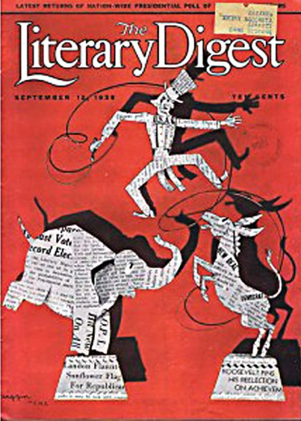
Literary Digest 1936 election issue. The 1936Literary Digest straw poll that incorrectly predicted that Alf Landon would defeat Franklin Roosevelt by almost 20 percentage points in the presidential election marked the end of the era of straw polls and the beginning of the use of scientific polls in reporting.
Source:http://www.fromgrandpasattic.com/presta_gpa/product.php?id_product=130.
Commercial pollsters using scientific techniques correctly predicted that Roosevelt would defeat Landon in the 1936 election. These pollsters conduct polls for clients for a profit. The Gallup Poll administered personal interviews with a quota sample of people who fit into particular demographic categories, such as sex and age groups. Gallup correctly predicted the winners of the 1940 and 1944 presidential contests. However, during the 1948 election, three major pollsters—Gallup, Roper, and Crossley all incorrectly predicted that Republican presidential candidate Thomas Dewey would defeat Democratic candidate Harry Truman. The quota sampling method used by these pollsters was problematic and was replaced by probability sampling, in which subjects are randomly selected to take part in a poll. ^{[5]}

Enduring Image
Dewey Defeats Truman
The 1948 presidential election did not start off well for Democratic candidate Harry S. Truman. As vice president, Truman was sworn in as president when Franklin Roosevelt died less than three months into his fourth term. Truman was forced to deal with a variety of controversial issues, including the decision to drop atomic bombs on Hiroshima and Nagasaki, which he believed would end World War II in the Pacific. Newspapers labeled Truman a “little man,” a tag that resonated with the public who contrasted him unfavorably to the larger-than-life Roosevelt.
The Democrats were highly factionalized when they met in Philadelphia for their national nominating convention. They attempted unsuccessfully to recruit popular war hero Dwight D. Eisenhower to be their candidate. When the convention adopted a strong civil rights platform, Southern delegations bolted and nominated their own candidate, Strom Thurmond of South Carolina. Liberals who disapproved of Truman’s policies formed the Progressive Party and nominated Henry Wallace of Iowa as their candidate. In the end, Truman became the nominee with Senator Alben Barkeley of Kentucky as his running mate. The pair was faced with an unenthusiastic constituency.
In contrast, the Republican Party united behind Thomas E. Dewey, the popular governor of New York. Dewey had been the Republicans’ candidate in the 1944 presidential campaign, and had come close to Roosevelt in the popular vote. California Governor Earl Warren, future chief justice of the Supreme Court, was the vice presidential candidate.
Pollsters and the press anticipated that Dewey would win by a landslide. On September 9, 1948, nearly two months prior to the election, noted pollster Elmo Roper declared that there would be no more Roper Polls predicting the outcome: “My whole inclination is to predict the election of Thomas E. Dewey by a heavy margin and devote my time and efforts to other things.”^{[6]}
Normally, incumbents such as President Truman run low-key campaigns, and challengers such as Governor Dewey work hard to win. Dewey campaigned like a front-runner, remaining aloof and dignified while avoiding discussions of controversial issues. Roles were reversed in the 1948 presidential campaign. Truman, realizing he had nothing to lose, launched an aggressive “Whistle Stop” campaign. Traveling in a special Pullman railroad car nicknamed the Ferdinand Magellan, after the explorer who circumnavigated the world, Truman covered 32,000 miles and gave 355 rousing speeches. At each stop, Truman would introduce his family to the crowd, answer questions, and shake hands. As he fought his way through the campaign, he acquired the slogan “Give ‘em hell, Harry!”
Even as Truman’s campaign picked up steam and polls showed the gap between the candidates was closing, the press refused to concede that he could win. Newsweek polled fifty political journalists a month before the campaign, and all of them stated that Dewey would win. Truman had the support of only 15 percent of the nation’s newspapers. ^{[7]} By Election Day, polls indicated that Truman might pull an upset, but journalists stuck to their story that Dewey would win by a landslide. Reports filtered in throughout Election Night that Truman was leading in the popular vote, but the press continued to report that he could not emerge victorious. TheChicago Tribune was so certain that Truman would lose, the headline of the early edition proclaimed “DEWEY DEFEATS TRUMAN.” The paper had already been delivered, and the Tribune dispatched employees to retrieve the papers from newsstands and homes, but many remained in the hands of readers. Traveling by train from his home state of Missouri to Washington, DC, Truman made a brief stop in St. Louis, where he was presented with one of the papers bearing the infamous headline. Truman held up the paper and quipped, “This is for the books.” ^{[8]}
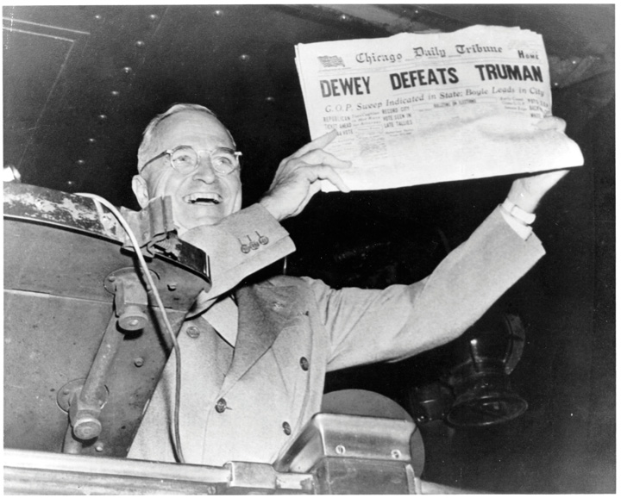
“DEWEY DEFEATS TRUMAN.” Truman’s victory, as immortalized in this enduring image, is one of the biggest comebacks in American elections.
Source: Photo courtesy of Dave Winer,http://www.flickr.com/photos/scriptingnews/2544447858/.
Survey research organizations associated with academic institutions emerged in the 1940s with the establishment of the National Opinion Research Center(NORC) at the University of Chicago and the Survey Research Center (SRC) at the University of Michigan. These organizations and others like them, such as theRoper Center at the University of Connecticut, field and archive detailed surveys that provide researchers with a wealth of data to use in studies to gain a deeper understanding of the public’s political attitudes and behavior. Nonpartisan survey research organizations, such as the Pew Research Center and the Field Poll in California, provide data to news organizations and academics. Commercial pollsters, including Gallup and IBOPE Zogby International, provide polling services to clients and also share their data with the press, scholars, and the public through their websites.

Types of Polls
The amount of polling data available today from commercial polling firms, academic survey research organizations, campaign organizations, trade associations, interest groups, media outlets, and online sources is almost overwhelming. There are great variations in the type and quality of polling data. A public opinion survey fielded by a reputable organization using proper social scientific techniques differs greatly from a quick poll consisting of one or two questions administered online to whoever is willing to take it.
Questionnaires used to measure public opinion include a variety of question types. Closed-ended questions provide respondents with a fixed number of options about a topic from which they can choose the one that best fits their position. A closed-ended question frequently asked to gauge people’s feelings about the direction in which the country is headed is “Generally speaking, would you say things in this country are heading in the right direction, or are they off on the wrong track?” Respondents must select one of the options: the right direction or the wrong track. Closed-ended questions are easier and less time-consuming to analyze, although they limit the respondent’s ability to express their opinions to the choices offered by the researcher. Open-ended questions do not provide fixed options but instead allow respondents to reply to a question in their own words. This type of question elicits more information from respondents and can be useful in gaining insight into sensitive topics. The drawbacks of open-ended questions are that people may not want to take the time to answer them and they are more time-consuming for pollsters to analyze. An open-ended question about the direction in which the country is headed would ask people to express their own views in response to the question “How do you think things are going in this country?”
Most polls provide snapshots of people’s opinions at a particular point in time. Other polls track opinions over time in order to determine if people’s views remain stable or change. In rare cases, studies have tracked the opinions of the same groups of people over years, even decades. The views of the women who attended Bennington College in the 1930s were tracked through the 1980s. The study revealed that the college experience changed some of the women’s attitudes and that the views acquired in college remained stable over time. ^{[9]}

Polls and Surveys
The terms “poll” and “survey” often are used interchangeably, yet there are distinctions between them. A public opinion poll is typically conducted by a commercial organization working for a profit. A poll generally consists of a short questionnaire administered over a brief period of time to a sample of between six hundred and fifteen hundred people. A survey most often is conducted by academic or government researchers. Surveys consist of longer questionnaires designed to examine the foundations and consequences of opinions in some detail. Researchers may administer the survey to thousands of subjects interviewed over an extended period of time. ^{[10]}
Scientific polls and surveys are considered to be the gold standard for measuring public opinion. They adhere to established procedures that help ensure the accuracy of their results, which includes using proper techniques for drawing a sample and designing questions. Scientific polls and surveys are administered to a sample of people who are representative of a larger population. The sample is drawn using probability sampling, meaning that each person in the population has a chance of being included in the sample. It is possible to get an accurate accounting of public opinion with a relatively small sample. A representative sample of twelve hundred people can accurately reflect the public opinion of the entire population of the United States. On the other hand, large samples that are not representative may not reflect public opinion accurately at all. Question wording is another important consideration when measuring public opinion. Questions need to be clearly stated, and they should not lead the respondent to choose one answer over another. A poorly worded question can be misunderstood by the respondent and ultimately can misrepresent the public’s viewpoints. Answer options that do not provide the public with clear alternatives also are problematic.

Poll: Give Obama a Grade on the State of the Union
A Fox News poll taken after the 2011 State of the Union Address does not provide clear options for respondents. ^{[11]} The answers are double-barreled because people can agree with one part of the answer but not the other. For option A, you may believe that President Obama gave a wonderful speech but not reconsider at least one item on his agenda. Similarly, for option B, you may agree that President Obama gave a good speech, but you may have changed your mind about his agenda.
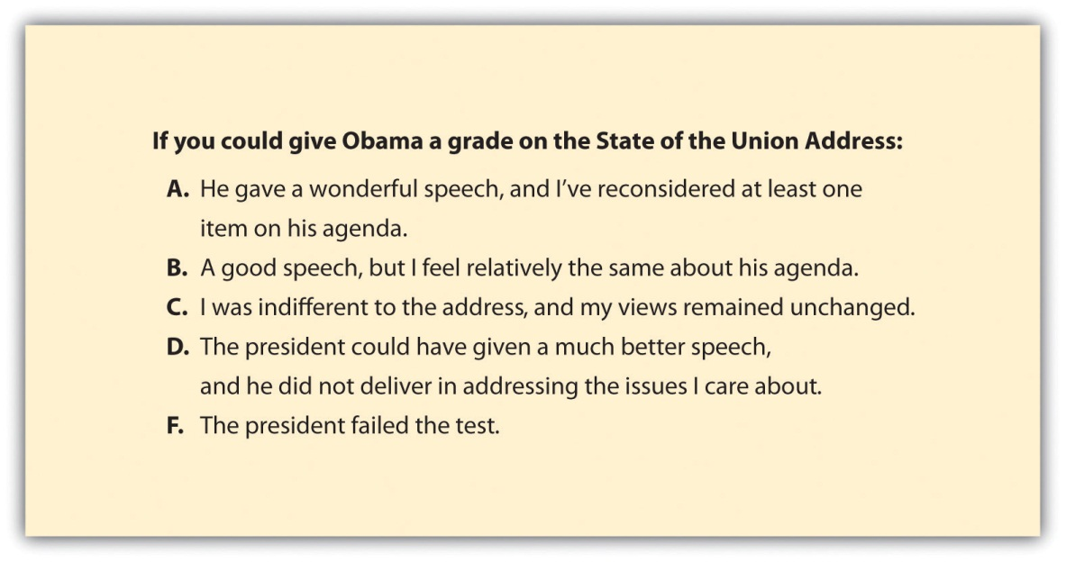
Survey Question Wording
Source: Adapted from http://foxnewsinsider.com/2011/01/26/poll-give-obama-a-grade-on-the-state-of-the-union/.
There are many ways in which polls and surveys can be administered, including through face-to-face interviews, telephone interviews, mail questionnaires, and online questionnaires. Each of these methods has pros and cons. Face-to-face interviews are advantageous for administering long, complicated surveys, yet they are costly and subjects may be reluctant to talk to a stranger about their opinions. Telephone interviews are relatively easy to administer, but getting a representative sample has become more difficult as many polling organizations rely on landline telephone directories to recruit respondents, and people increasingly are relying on cell phones. Young people are not well represented in landline polls. ^{[12]} Mail questionnaires are a low-cost method that allows subjects privacy when answering questions, which can yield more accurate results. However, mail surveys often suffer from low response rate, as people simply opt out because the questionnaire is self-administered. ^{[13]}
Online polls have become a more popular option in recent years as the majority of the public has access to the Internet. According to the Pew Internet and American Life Project, 79 percent of American adults were online in May 2010. Studies indicate that online polls are no less reliable than other forms of polling. They have the advantage of being cost-effective, and allowing respondents privacy when answering questions. Online polls also provide opportunities for innovation, such as getting reactions to video clips of campaign ads. The limitation of online polls is that it is more difficult to get a representative sample using the Internet than with some traditional methods, because not all of the public is online. Also, online surveys are self-administered, and people can drop out before they are completed, especially if the questionnaire is lengthy. ^{[14]}

Exit Polls
Exit polls are face-to-face interviews with voters taken as they leave the voting booth to determine their candidate preference in the election and their positions on issues. They are fielded in a small number of voting precincts with states with the goal of acquiring representative data. They are used to predict the outcomes of elections and to determine the characteristics of voters who supported particular candidates. Exit poll data can reveal, for example, who female, Latino, Republican voters favored in an election campaign.
Exit polls are a major component of the media’s Election Night coverage. Until 1992, each news network had its own in-house exit polling operation. To cut costs, an exit poll consortium, Voter News Service (VNS), was formed to provide data to all the major networks. VNS released the exit poll data that prompted the networks to prematurely declare the results of the 2000 presidential election, and the organization subsequently was disbanded. Exit poll data in the 2008 presidential election and 2010 midterm elections were provided to major television news organizations and the Associated Press by the National Election Exit Polls conducted by Edison Research.

Link
Exit Polling
Read more about exit polling athttp://www.edisonresearch.com/us_exit_polling.php.
News organizations use exit polls to declare a winner, sometimes when few of the actual returns from the voting precincts have been recorded. This practice has raised concerns, especially since the major television networks all rely on exit poll data from the same source—the National Election Exit Poll. While exit polls are often accurate, if the sample of voters is unrepresentative of the population, the survey questions are poorly written, or interviewers are not trained to properly administer the poll, the results can be wrong, as was the case in the 2000 presidential election.
Some scholars allege that media reports of exit polls can depress election turnout. When the media declare the winner in a presidential election on the basis of exit polls before the voting booths have closed across the country, people who have not yet voted may decide not turn out. Network television newscasts declared Ronald Reagan the winner of the 1980 presidential election on the basis of exit polls hours before the voting booths had closed on the West Coast. A controversy ensued around the allegation that West Coast voters were discouraged from casting a ballot because they felt their vote was irrelevant. The networks agreed voluntarily to refrain from declaring a winner in elections until after all the polls have closed nationwide—an agreement that has not always been followed.

Quick Polls
A quick poll usually consists of one or two questions that are posted to a website, blog, discussion board, social media platform, or podcast. Quick polls have become standard features of websites of news organizations, political leaders, issue advocacy groups, political parties, candidates, bloggers, and even average citizens. They can be distributed through website sidebars, e-mail links, Facebook postings, and Twitter feeds. There are many platforms available that make it easy for just about anyone to field a quick poll. Quick polls also can be administered through robo-polling—administering automated polls by phone using a recorded voice to ask the question and requiring respondents to answer by pressing the touch pad on their telephone. ^{[15]}
Quick polls do not conform to the established protocols for conducting scientific polls, and they generally are not reliable indicators of public opinion. They often use an unscientific convenience sample of people who may see the poll posted online or have the link sent to them through e-mail. Most respondents to quick polls are self-selected, and they may have a strong interest in the topic. Often it is possible for people to register their views more than once, which can bias the outcome of the poll. Quick polls may generate many responses, but the results can be wildly inaccurate. In addition, quick poll questions can be designed in a way that elicits a particular response that is then used to promote a particular position. For example, a quick poll might seek to find support for bike lanes in cities by stating, “Seven out of ten Americans favor designating bike lanes in major cities. Do you favor or oppose designating bike lanes in your city?”
Quick polls can be a fun way to generate interest in political affairs. People can express their views easily, and they often get immediate feedback about where they stand compared to others. The results of quick polls often are revealed in visually appealing graphics. Reporters and bloggers use the results of quick polls to generate story lines and supplement the text of their pieces. However, quick polls can be misused when the results are interpreted as if they truly reflect public opinion rather than the views of the people who chose to take them.
Figure 7.4 Quick Polls
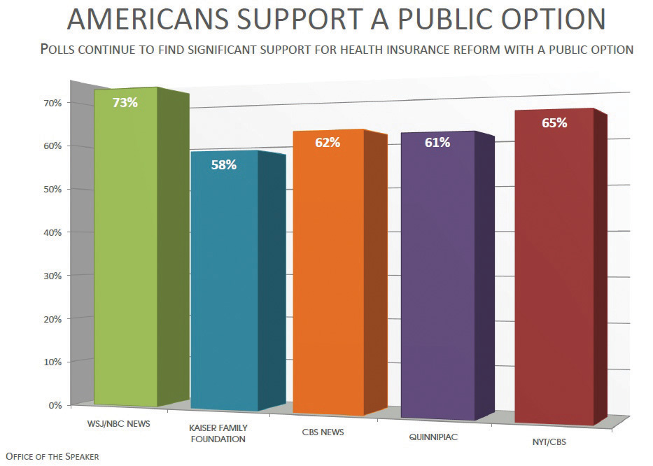
Quick polls provide snapshots of political opinion that are used by the media, interest groups, parties, and candidates.
Source: Photo courtesy of Leader Nancy Pelosi,http://www.flickr.com/photos/speakerpelosi/4012966154/.

Push Polls
A push poll is a marketing technique used by political campaigns and issue advocacy groups to influence the opinions of respondents. Despite their name, push polls are not legitimate public opinion polls. They are a form of advertising masquerading in the form of an opinion survey. No one collects or analyzes data from a push poll. However, push polls can influence vote choice in campaigns by incorporating negative attacks on a candidate into the questions asked or associating a candidate with a particular issue position which may or may not be accurate.
Push polls were used against Republican candidate John McCain during the 2000 presidential primary. Voters in South Carolina were asked questions like “Would you be more or less likely to vote for John McCain for president if you knew he had fathered an illegitimate black child?” Push polls were used to target Democratic candidate Barack Obama in the 2008 presidential campaign. Voters in Ohio received phone calls from Opinion Access Corporation asking if they would be more or less likely to vote for Barack Obama if they knew that he had voted to let convicted child sex offenders out early. ^{[16]} While these allegations were untrue or taken out of context, the information was spread to voters. Push polls have been outlawed in certain states and they have been condemned by the American Association of Public Opinion Researchers (AAPOR), the organization that upholds standards for polling and survey research.

Other Ways of Measuring Public Opinion
There are a variety of ways of measuring public opinion aside from polls. The different sides of an argument expressed in public debates or at a community meeting reflect public opinion. The positions taken in letters to the editor, blog and social media posts, and the comments in response to news stories and editorials are all indicators of public sentiment. The commentary that people post in response to news stories can provide a rich source of information about public opinion, especially when people take the issue seriously and are respectful when expressing their views. This commentary also can be careless and vitriolic, as people resort to personal attacks or post quick reactions to complex issues.
Focus groups have been used for over eighty years to ascertain people’s attitudes, beliefs, and opinions about politics within a group setting. A facilitator asks questions of a group of between eight and twelve people who can engage in a conversation about the topic. Focus groups not only are useful for gaining in-depth insights into what individuals think but also aid in understanding the group dynamics behind public opinion. Focus groups can reveal when people feel comfortable expressing their beliefs, when they will confront others about their views, when they will withdraw from a discussion, and when they are influenced by the opinions of others. ^{[17]} Focus groups have been used to allow college students to reveal their views about government and their role in a democratic polity. Talking with students in a group setting, researchers discovered that young people are more interested and engaged in politics than survey-based studies indicate, and that they are thinking creatively about ways to become involved, especially using social media. ^{[18]} Focus groups are used extensively in election campaigns to determine what voters are thinking about and which candidates they prefer.
Figure 7.5 Online Comments as Public Opinion
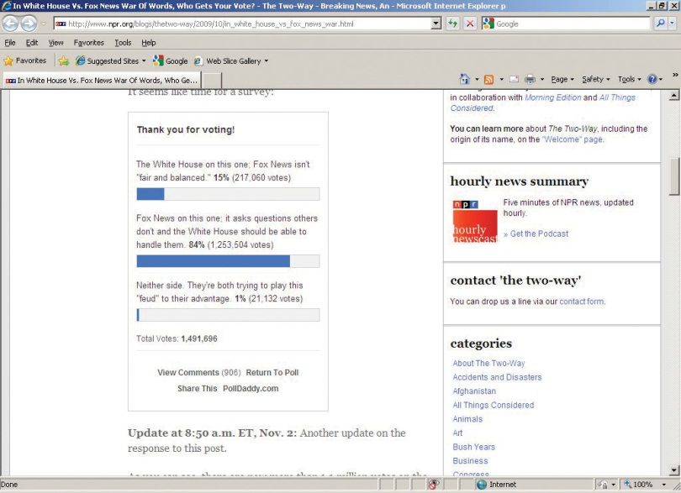
Online news stories provide comment sections where people can discuss issues and events. These comments are an expression of public opinion.
Source: http://www.flickr.com/photos/landoni/4081475385/.

KEY TAKEAWAYS
Public opinion polling dates back to the early days of the republic. The abundance of poll data measuring Americans’ opinions about government and politics available today is astounding. In this environment, it is important to differentiate between quality polling data generated through established scientific methods and unreliable information produced by quick polls.

EXERCISES
- Why did newspapers begin running straw polls? What incentive did newspapers have to ensure their polls were representative?
- How was the 1936 Literary Digest presidential poll flawed? Why did most journalists fail to predict Truman’s reelection in 1948?
- What is the purpose of push polling? Why is it generally considered to be dishonest or manipulative?

[1] Kirby Goidel, “Public Opinion Polling in a Digital Age: Meaning and Measurement,” inPolitical Polling in the Digital Age, ed. Kirby Goidel (Baton Rouge: Louisiana State University, 2011), 11–27.
[2] Robert S. Erikson and Kent L. Tedin, American Public Opinion, 8th ed. (New York: Longman, 2011).
[3] Robert S. Erikson and Ken L. Tedin, American Public Opinion, 8th ed. (New York: Longman, 2011).
[4] Kathleen Morgan Drowne, The 1920s (Westport, CT: Greenwood Press, 2004).
[5] Barbara A. Bardes and Robert W. Oldendick, Public Opinion: Measuring the American Mind (Belmont, CA: Wadsworth/Thompson Learning, 2006).
[6] Elmo Roper as quoted in David McCullough, Truman (New York: Simon & Schuster, 1992), 657.
[7] American Treasures of the Library of Congress, “Dewey Defeats Truman” (Washington, DC: Library of Congress, American Memory Collection, 2003).
[8] David McCullough, Truman (New York: Simon & Schuster, 1992).
[9] Duane F. Alwin, Ronald L. Cohen, and Theodore M. Newcomb, Political Attitudes over the Life Span: The Bennington Women after Fifty Years (Madison: University of Wisconsin Press, 1991).
[10] Michael W. Traugott and Paul J. Lavrakas, The Voter’s Guide to Election Polls, 2nd ed. (New York: Chatham House, 2000).
[11] “Fox News Poll: Give Obama a Grade on the State of the Union,” Fox News, January 26, 2011, accessed April 5, 2011, http://foxnewsinsider.com/2011/01/26/poll-give-obama-a-grade-on-the-state-of-the-union.
[12] Scott Keeter, “Public Opinion Polling and Its Problems,” in Political Polling in the Digital Age, ed. Kirby Goidel (Baton Rouge: Louisiana State University Press, 2011), 28–53.
[13] Michael W. Traugott and Paul J. Lavrakas, The Voter’s Guide to Election Polls, 2nd ed. (New York: Chatham House, 2000).
[14] Scott Keeter, “Public Opinion Polling and Its Problems,” in Political Polling in the Digital Age, ed. Kirby Goidel (Baton Rouge: Louisiana State University Press, 2011), 28–53.
[15] Mark Blumenthal, “The Case for Robo-Pollsters,” National Journal, September 14, 2009, accessed April 10, 2011, http://www.nationaljournal.com/njonline/the-case-for-robo-pollsters-20090914.
[16] Sam Stein, “Nasty Anti-Obama Push Poll Launched in Ohio,” Huffington Post, September 11, 2008, accessed June 6, 2011,http://www.huffingtonpost.com/2008/09/11/nasty-anti-obama-push-pol_n_125607.html.
[17] David W. Stewart, Prem N. Shamdasani, and Dennis W. Rook, Focus Groups: Theory and Practice, 2nd ed. (Thousand Oaks, CA: Sage Publications, 2007).
[18] Nicholas V. Longo and Ross P. Meyer, College Students and Politics: A Literature Review, Circle Working Paper 46 (College Park, MD: Center for Information and Research on Civic Learning and Engagement, May, 2006).

7.4 Public Opinion in the Information Age

LEARNING OBJECTIVES
After reading this section, you should be able to answer the following questions:
- How are public opinion polls depicted in the media?
- What are opinion leaders, and how do they influence the views of opinion followers?
- What is an echo chamber? What is the effect of echo chambers on democracy?
The media’s use of public opinion data has a long history. The press depends on polls as a source of information for its stories, and polling organizations need the media to publicize their results. For almost two centuries, the press has commissioned polls from professional organizations or sponsored their own in-house polling operations. Today, major news organizations join with well-established polling firms to measure public opinion. USA Today and CNN work with the Gallup organization to field opinion polls.
In the information age, the press’s use of opinion polls has flourished as it is easy and more cost-effective to collect opinion information. Digital polls are a quick way to get people to express their views and to exchange opinions with others. These polls can be taken online, on an electronic tablet, or on a cell phone. The potential for polls to not only measure public opinion but also influence opinion has increased.

Media Depictions
The results of public opinion polls are prominently depicted in all forms of media. News organizations regularly include poll results in their stories about political issues, events, and leaders. Poll results released by the press, candidate organizations, and political parties feature prominently during elections in news stories, commentary, and campaign media. Political websites and blogs offer quick polls where people can record their views on myriad topics instantaneously. These poll results are depicted as colorful sidebars that attract audiences’ attention. Poll results frequently run on the ticker on cable television news broadcasts and on media organization websites.
Poll results make headlines. They can be presented in the form of eye-catching visuals to highlight their prominence. The headline for the lead story about the federal budget deficit in the April 20, 2011, online version of the Washington Post proclaimed, “Poll finds little backing for debt remedies.” Directly beneath the headline was a colorful graph citing the public’s approval of the way President Obama (39 percent approval) was handling the federal budget deficit compared to Republicans in Congress (33 percent approval). The story discussed the results of a Washington Post-ABC News poll that indicated that most Americans want to keep government benefits, such as Medicare and Social Security, and would oppose plans to cut these programs to reduce the national debt. Almost three thousand people weighed in with their thoughts about this poll story within just a few hours of its posting. These comments represent another expression of public opinion. The poll story became the most popular piece on the Washington Post website for the day, and thousands of people recommended it to their friends on Facebook.
Pundits and experts who appear in the media make extensive use of poll results when making their case. They appear with charts and graphs depicting poll results to emphasize that the public shares their views. They use opinion polls to speak on behalf of the public, whether or not they are truly representing the views of the people.

Media Interactions
Elites and the mass public use public opinion polls in a variety of ways. Opinion leaders use poll results to convey information to others who rely on their guidance when making political decisions. Digital media have not only created more opportunities for the public to share their opinions but have also made it possible for average citizens to field their own polls and collect opinion data.

Opinion Leaders
An opinion leader is a broker who imparts information about politics and government to other people. Opinion leaders are attentive to media messages and pass on information in a simplified format to people who pay less attention to politics. The two-step flow model of communication posits that the media disseminate information that is received by opinion leaders, who interpret the information and pass it on to opinion followers, who are less interested in and informed about political affairs. Opinion leaders have the respect of opinion followers because of their status in a social group, their role as a political expert, or their celebrity. ^{[1]}

Figure 7.6 Two-Step Flow Model of Communication
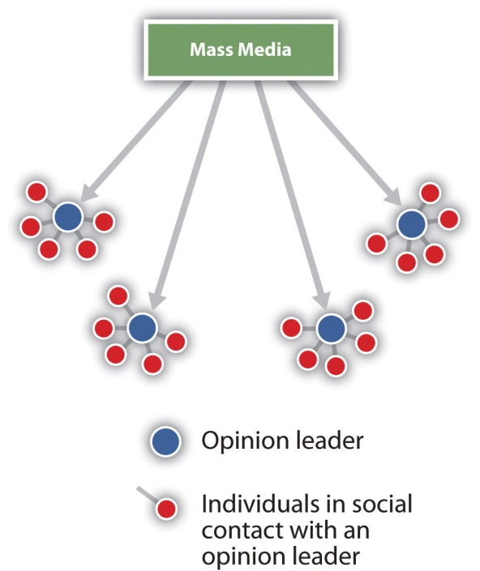
Source: Adapted from E. Katz and P. Lazarsfeld, Personal Influence, (New York, NY: The Free Press, 1955).
Figure 7.7 Celebrity Opinion Leaders
Celebrities can use their prominence in the media to promote causes and influence public opinion.
Source: Photo courtesy of Nando65,http://commons.wikimedia.org/wiki/File:George_Clooney_and_Fatma_Samoura.JPG.
Opinion leaders may be members of the public who are especially attentive to political matters. They follow the news religiously, pay attention to political leaders’ speeches, and even may participate in governmental affairs by attending meetings or holding office. People who are in the same social group will seek cues from opinion leaders who share their interests and who can simplify their voting decisions or provide them with shortcuts for taking positions on complicated issues. Pundits, political experts, and public officials can be opinion leaders when they are held in esteem by citizens. Media personalities, including television news anchors, talk show hosts, and prominent political bloggers, increasingly have taken on the role of opinion leaders, especially when they have ideological views similar to people who follow them. ^{[2]} Celebrities from the entertainment industry can become opinion leaders. Actor George Clooney has used his celebrity to bring attention to violence in the Sudan.

Digital Polls and Forums
The opportunities for the public to express their opinions through the media have skyrocketed in the information age. The interactive features of digital media make it easy for people to express their views and share their opinions with others. Quick polls can be incorporated into just about any news or political site, and they can be shared virally through social media and e-mail. Online forums allow people to post their views and react to the opinions of others.
Digital polls, which use Internet platforms and smartphones to administer questions to members of the public, have proliferated in the information age. These polls run the gamut from sophisticated survey instruments to one-question quick polls. Online polls are a standard feature of news websites, political party and candidate sites, interest group and trade association sites, blogs, social media sites, and Twitter feeds. The quality of online polls varies greatly as well. Online polls administered by reputable organizations to a representative sample of the public yield reliable results. Quick polls taken by a convenience sample of people who come across the poll and decide to take it are generally inaccurate.
Digital media have made it possible for members of the public to conduct their own informal polls to solicit opinions about government and politics. There are online platforms, such as YouPolls.com and SurveyMonkey.com, where average citizens, political activists, and bloggers can post a question and solicit answers from interested members of the public. People can post a video clip of a news item and gauge the public’s reaction. These informal poll results can be used to stimulate online discussions about issues, leaders, government institutions, and political events. Some of these citizen-initiated polls deal with serious debates facing the nation, such as taxes and immigration policy. Some opinion forums are designed more to entertain than to elicit serious opinions. Comedian Stephen Colbert hosts the Colbert Nation Forum on his website, where fans post often humorous statements and videos about current issues and events.

Live Polls
Live polls record people’s reactions to a speech, debate, or event in real time. The results of live polls are displayed below images of the event as it takes place, which allows viewers to see fluctuations in opinion over time. In January 2011, live polling was used to gauge the public’s opinion of President Obama’s State of the Union address as it was unfolding. The public was invited to participate in a nationwide poll gathering reactions to the address using their smartphones and iPads. Reactions from Democrats, Republicans, and independents were tracked and displayed on the bottom portion of the television screen on cable news channels. While the sample was not representative, hundreds of thousands of people took part. ^{[3]}
The satirical news source The Onion produced a parody of pundits adjusting their views in an attempt to please the public as they watch a live poll tracking the audience’s opinion about their discussion.

Video Clip

http://www.youtube.com/watch?v=uFpK_r-jEXg

In The Know: New Live Poll Lets Pundits Pander to Viewers in Real Time

Media Consequences
A major issue confronting opinion researchers is whether or not polls released in the media actually influence opinion. It may be the case that polls not only reflect opinion but also can change people views about candidates and issues. It is difficult to isolate poll effects, but there is some evidence to suggest that the media’s dissemination of poll results can influence personal opinions.

The Echo Chamber
Public judgment, informed opinions about issues, requires that people be open to diverse viewpoints and consider the outcomes when supporting policy positions. Some scholars believe that a democracy requires media that provide a place where citizens can gain a broad perspective on political issues and events. However, in the current high-choice media environment that offers literally hundreds of options for getting information, people increasingly are exposed solely to viewpoints consistent with their own beliefs.
The media landscape is populated by cable news programs, talk radio shows, online news sites, and blogs that represent extreme liberal and extreme conservative positions on issues. Many people who tune into these opinionated sources of information shield themselves from other perspectives, thus cutting off the potential to meaningfully debate policy options. Communication scholars Kathleen Hall Jamieson and Joseph Cappella label this phenomenon theecho chamber. They observe that some people attend to media that are essentially “self protected enclaves hospitable to their own beliefs.” ^{[4]} With more than three hundred cable channels alone to choose from, people gravitate toward niche media that often feature like-minded hosts. Fox News’s conservative talk show host Sean Hannity and MSNBC’s liberal host Rachel Maddow reach their followers on television, radio, and online. Blog readers visit sites that are in line with their views and avoid those that challenge their opinions.
Scholars have identified negative and positive consequences of the echo chamber effect. On one hand, selective exposure to ideological media may have deleterious effects on democratic discourse as people take extreme positions on issues and refuse to make compromises that are often necessary to achieve workable public policies. At the same time, people who come to feel strongly about their political beliefs are more likely to participate in politics. ^{[5]}

KEY TAKEAWAYS
The relationship between the media and public opinion has grown increasingly complicated. Poll results and opinion forums have proliferated in all forms of media. The vast number of political media sources has made it possible for people to expose themselves only to news and information that conforms to their personal ideological and partisan perspectives. The implications for democratic politics are both negative and positive.

EXERCISES
- In what sense is the relationship between the media and polling organizations mutually beneficial?
- What makes someone an opinion leader? What makes you personally pay attention to a public figure’s opinion?
- Why do some scholars argue that the current media environment has become like an echo chamber? Do you think you regularly consume any media that challenges your political views?

Civic Education
Increasing Issue Understanding
In the information age, a wealth of material about issues, as well as the stands Americans take on these issues, is available from the media, government agencies, and nonprofit organizations. Accessing and sorting through the often complicated and conflicting material on issues can be a daunting task, especially when not all available information is reliable or of high quality. Only a small segment of the population has the motivation or the opportunity to become informed about most issues, especially when the costs in terms of time and effort are high. As a result, there is a knowledge gap among the public about issues. Highly educated people from upper-income brackets have a greater command of issues and thus more influence on policies that effect society than people from lower socioeconomic backgrounds.
Creative civic education initiatives can help alleviate the knowledge gap on issues and assist people in developing informed opinions. Deliberative forums can help young people develop informed views on issues and even take action. Knowledgeable opinion leaders and subject-area experts can meet with people in classes, clubs and organizations, private homes, or online to share information about issues.
Forums have been held across the country on the topic of climate change, which is a highly contested issue with much conflicting evidence. Experts provide information followed by discussions that are facilitated by citizen participants. Effective forums have a clear focus, such as the effect of climate change on the local area. Specific examples can be provided in order to make the issue resonate with the participants. Communities of people who are interested in climate change can form offline and continue to interact online through discussion boards and social media. ^{[6]}

[1] Paul F. Lazarsfeld, Bernard R. Berelson, and Hazel Gaudet, The People’s Choice (New York: Duell, Sloan, and Pierce, 1944).
[2] Ronald S. Burt, “The Social Capital of Opinion Leaders,” Annals of the American Academy of Political and Social Science, November 1999, 1–22.
[3] David Baker, “Live-Polling the State of the Union,” Huffington Post, January 25, 2011, accessed May 20, 2011, http://www.fightsforjobs.com/2011/01/live-polling-the-state-of-the-union.
[4] Kathleen Hall Jamieson and Joseph N. Cappella, Echo Chamber (New York: Oxford University Press, 2008), 87.
[5] Natalie Jomini Stroud, Niche News (New York: Oxford University Press, 2011).
[6] Matthew C. Nisbet, “Civic Education about Climate Change: Opinion-Leaders, Communication Infrastructure, and Participatory Culture,” White Paper (Washington, DC: Climate Change Education Roundtable, National Academies, December 6, 2010).

7.5 Recommended Reading
Althaus, Scott L. 2003. Collective Preferences in Democratic Politics. New York: Cambridge University Press, 2003. A study examining the ways in which public opinion surveys influence democratic deliberation in ways that favor particular groups in society.
Asher, Herbert B. Polling and the Public: What Every Citizen Should Know, 7th ed. Washington, DC: CQ Press, 2007. A valuable guidebook providing insight into how polls are designed and reported.
Bennett, W. Lance, and David L. Paletz, eds. Taken By Storm: The Media, Public Opinion, and U.S. Foreign Policy in the Gulf War. Chicago: University of Chicago Press, 1994. A comprehensive study of public opinion, media, and foreign policy focusing on the Gulf War period.
Brooker, Russell, and Todd Schaefer. Public Opinion in the 21st Century. New York: Wadsworth, 2005. An introductory text examining the ways in which Americans make their opinions known to political leaders.
Donsbach, Wolfgang, and Michael W. Traugott. The Sage Handbook of Public Opinion Research. Thousand Oaks, CA: Sage Publications, 2008. A handbook covering topics in public opinion ranging from the development of public opinion research, methods for ascertaining opinion, and uses of public opinion data.
Erikson, Robert S., and Kent L. Tedin, American Public Opinion, 8th ed. New York: Longman, 2011. A text covering key topics in public opinion, including the history of polling, methodological issues, and the role of public opinion in a democracy.
Glynn, Carroll J., Susan Herbst, Garrett J. O’Keefe, and Robert Y. Shapiro, Public Opinion. Boulder, CO: Westview Press, 1999. A comprehensive overview of public opinion in scholarship and practice.
Goidel, Kirby, ed. Political Polling in the Digital Age. Baton Rouge: Louisiana State University Press, 2011. A collection of essays about the challenges of public opinion polling in the new media era.
Herbst, Susan, Numbered Voices. Chicago: University of Chicago Press, 1993. An insightful study of the development of consequences of public opinion polling that questions the extent to which polls truly represent the voices of the mass public.
Lippmann, Walter, Public Opinion. New York: Free Press, 1922. A classic work that explores the relationship between the press and public opinion, arguing that the media make events known to the public that they cannot directly experience, thereby influencing opinion.
Stroud, Natalie Jomini, Niche News. New York: Oxford University Press, 2011. A detailed exploration of Americans’ growing preference for highly partisan news sources and its implications.
Warren, Kenneth F., In Defense of Public Opinion Polling. Boulder, CO: Westview Press, 2003. An account of Americans’ love-hate relationship with polls, which includes a brief history of polling and a discussion of the use of polling in a democracy.
Zaller, John, The Nature and Origins of Mass Opinion. New York: Cambridge, 1992. A study examining the ways in which the public acquires information from elites and the mass media and translates it into opinions.

7.6 Recommended Viewing
Ask a Silly Question (1998). A respected Canadian journalist employs humor to raise important issues about the power of public opinion polls to shape policy.
Atomic Café (1982). A lively documentary consisting entirely of government materials that were used to influence public opinion about the atomic bomb during the Cold War.
Constructing Public Opinion (2001). A scholarly and engaging examination of the ways in which politicians and the media use polling data to construct public opinion.
Gentleman’s Agreement (1947). Originally titled Public Opinion, this Academy Award winner stars Gregory Peck as a reporter who pretends to be Jewish to uncover opinions about racial and religious prejudice.
Magic Town (1947). When the small Midwestern town of Grandview is found to replicate Gallup poll results for the entire nation, a pollster (Jimmy Stewart) uses the town to gauge public opinion, causing its citizens to change their behavior while shouldering this great responsibility.
North Carolina Voices (2005). A series of documentaries—“The State of Aging,” “Looking for Work,” and “Touched by War,”—that examines trends in public opinion about issues. The series incorporates historical footage, interviews, and public opinion polls.
Recount (2008). A chronicle of the recount of Florida votes as the results of the 2000 presidential election hang in the balance.
What America Needs: From Sea to Shining Sea (2003). Documentary filmmaker Mark Wojahn traveled the country by train, asked more than five hundred people from all walks of life the question “What do you think America needs?” and recorded a plethora of opinions.

Chapter 8

Participation, Voting, and Social Movements

Preamble
The night of the 2004 presidential election, the Associated Press (AP) released a story under the headline “2004 Not the Breakout Year for Youth Vote After All.” According to the story, “Fewer than one in 10 voters Tuesday were 18 to 24, about the same proportion of the electorate as in 2000.…A vigorous push on college campuses by both parties and national mobilization drives had raised expectations that 2004 would be the year of the youth vote.” ^{[1]} The AP story implied that young voters had not turned out in the large numbers that many observers had predicted. It cited early exit polls, which are notoriously unreliable, as the basis for its conclusion. The article was reprinted in many newspapers, and it formed the basis of numerous television, radio, and online reports.
The article, however, was incorrect. In fact, turnout among eighteen- to twenty-four-year-olds had risen significantly from 36 percent in the 2000 presidential election to 47 percent in 2004. ^{[2]} Youth-vote activists and scholars acted quickly to correct the inaccuracies through the media, but it was too late. This single article had a tremendous influence on opinion leaders and political operatives. Candidates, campaign consultants, and political party leaders cited the AP article as evidence that young voters are not a constituency that is worth targeting in elections. ^{[3]}
The AP story was the first to come out on the youth vote following the election, which gave it particular prominence. More importantly, the article reinforced existing stereotypes of young voters held by elites and journalists. It employed the standard “apathetic youth voter” frame that journalists have used for decades when covering young voters. This frame reflects conventional beliefs that young voters are less likely to turn out in campaigns than older voters.
The “apathetic youth voter” frame is so entrenched in political and journalistic lore that it is difficult to refute, even when evidence is to the contrary. The assumptions underlying this media frame were challenged again during the 2008 presidential campaign, as young people were a visible and active force in the election, and turnout increased from 2004. Still, postelection stories in 2008 perpetuated the myth of the “apathetic youth voter.” The Florida Sentinelproclaimed, “Young people are turning out in disproportionately low numbers.” Even the Daily Tar Heel, a college newspaper, reported, “The expected youth surge didn’t exactly pan out.”
The “apathetic youth voter” frame focuses on elections, but it typifies the media’s dominant image of the American public, which is portrayed as politically disengaged, alienated, disinterested, and uninformed. Media images of the general public’s political involvement are unflattering, but depictions of young people are worse. Mainstream media portray young people as irresponsible, self-centered, and lacking the motivation to become involved in government and politics.
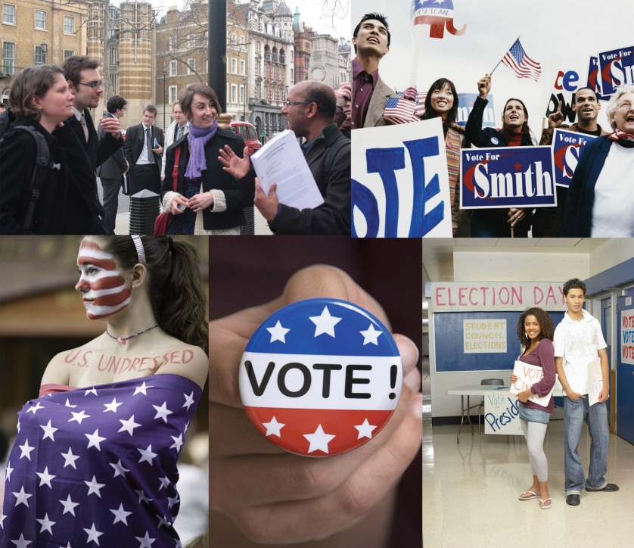
Young people participate in different ways. Media often depict young people as being disinterested in voting, but this portrayal does not reflect the fact that many young voters engage actively in elections.
© Thinkstock
Media representations of the public’s political disengagement contain elements of truth. Americans do not meet the ideal of involved and fully informed citizens that derives from the concept of the New England town meeting of the colonial period where the entire community took part in civic affairs. Media coverage focuses on the particular aspects of political participation that typically have low rates of civic engagement—especially political party work and campaign activity—or on the aspects that are expected to have higher rates of engagement, such as voting.
The public is more politically active and aware than much press coverage would suggest. Over 50 percent of adults have joined political organizations and more than 70 percent of young people have done community service. ^{[4]} Still, the “engaged public” remains a largely untold news story.
Americans participate in politics in many different ways, such as voting, contacting leaders, holding public office, and protesting. Social movementsthat mobilize large numbers of people on behalf of a cause are an important dimension of American political involvement. This chapter examines the origins, development, and influence of social movements. The media’s depiction of citizens’ political participation is complex and even contradictory.

[1] Siobahn McDonough, “2004 Not the Breakout Year for Youth Vote After All,” Associated Press, November 2, 2004.
[2] Center for Information & Research on Civic Learning and Engagement (CIRCLE), “Youth Voting,” http://www.civicyouth.org/?page_id=241#1.
[3] Diana Owen, Youth Voting and the Media (Washington, DC: George Washington University Graduate School of Political Management, 2006).
[4] Michael Schudson, The Good Citizen (New York: Free Press, 1998).

8.1 What Is Political Participation?

LEARNING OBJECTIVES
After reading this section, you should be able to answer the following questions:
- What are the ways in which Americans participate in politics?
- What factors influence voter turnout in elections?
- How do Americans participate in groups?
Americans have many options for taking part in politics, including voting, contacting public officials, campaigning, running for and holding office, protesting, and volunteering. Voting is the most prominent form of political participation. Voter registration and turnout is influenced by legal and structural factors, voter qualifications, the type of election, and voters’ enthusiasm about a particular campaign.

Types of Political Participation
Political participation is action that influences the distribution of social goods and values. ^{[1]} People can vote for representatives, who make policies that will determine how much they have to pay in taxes and who will benefit from social programs. They can take part in organizations that work to directly influence policies made by government officials. They can communicate their interests, preferences, and needs to government by engaging in public debate.^{[2]} Such political activities can support government officials, institutions, and policies, or aim to change them.
Far more people participate in politics by voting than by any other means. Yet there are many other ways to take part in politics that involve varying amounts of skill, time, and resources. People can work in an election campaign, contact public officials, circulate a petition, join a political organization, and donate money to a candidate or a cause. Serving on a local governing or school board, volunteering in the community, and running for office are forms of participation that require significant time and energy. Organizing a demonstration, protesting, and even rioting are other forms of participation. ^{[3]}
People also can take part in support activities, more passive forms of political involvement. They may attend concerts or participate in sporting events associated with causes, such as the “Race for the Cure” for breast cancer. These events are designed to raise money and awareness of societal problems, such as poverty and health care. However, most participants are not activists for these causes. Support activities can lead to active participation, as people learn about issues through these events and decide to become involved.
Figure 8.1
People take part in support activities on behalf of a cause, which can lead to greater involvement.
© Thinkstock
People also can engage in symbolic participation, routine or habitual acts that show support for the political system. People salute the flag and recite the pledge of allegiance at the beginning of a school day, and they sing the national anthem at sporting events. Symbolic acts are not always supportive of the political system. Some people may refuse to say the pledge of allegiance to express their dissatisfaction with government. Citizens can show their unhappiness with leadership choices by the symbolic act of not voting.

Voting
For many people, voting is the primary means of taking part in politics. A unique and special political act, voting allows for the views of more people to be represented than any other activity. Every citizen gets one vote that counts equally. Over 90 percent of Americans agree with the principle that citizens have a duty to vote. ^{[4]} Still, many people do not vote regularly.

Voter Qualifications
Registered voters meet eligibility requirements and have filed the necessary paperwork that permits them to vote in a given locality. In addition to the requirement that voters must be eighteen years of age, states can enforce residency requirements that mandate the number of years a person must live in a place before being eligible to vote. A large majority of people who have registered to vote participate in presidential elections.
The composition of the electorate has changed radically throughout American history. The pool of eligible voters has expanded from primarily white, male property owners at the founding to include black men after the Civil War, women after 1920, and eighteen- to twenty-year-olds after 1971. The eligible electorate in the 1800s, when voter turnout consistently exceeded 70 percent, was far different than the diverse pool of eligible voters today.

Barriers to Voting
Social, cultural, and economic factors can keep people from voting. Some barriers to voting are informal. The United States holds a large number of elections, and each is governed by specific rules and schedules. With so many elections, people can become overwhelmed, confused, or just plain tired of voting.
Other barriers are structural. Voter registration laws were implemented in the 1860s by states and big cities to ensure that only citizens who met legal requirements could vote. Residency requirements limited access to registration offices. Closing voting rosters weeks or months in advance of elections effectively disenfranchised voters. Over time, residency requirements were relaxed. Beginning in the 1980s, some states, including Maine, Minnesota, and Wisconsin, made it possible for people to register on Election Day. Turnout in states that have Election Day registration averages ten points higher than in the rest of the country. ^{[5]}
The United States is one of the few democracies that requires citizens to register themselves rather than having the government take responsibility for automatically registering them. Significant steps have been taken to make registration easier. In 1993, Congress passed theNational Voter Registration Act, also known as the “motor voter” law, allowing citizens to register at motor vehicle and social service offices. “Motor voter’s” success in increasing the ranks of registered voters differs by state depending on how well the program is publicized and executed.
Figure 8.2
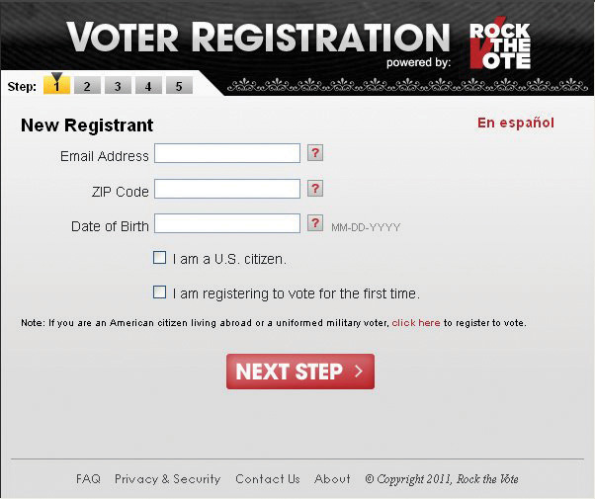
Organizations conducting voter registration drives register as many voters as government voter registration sites.
© Copyright 2011, Rock the Vote
Voter registration also has been assisted by online registration. In most cases, individuals must download the form, sign it, and mail it in. Rock the Vote (RTV), a nonpartisan youth mobilization organization, established the first online voter registration initiative in 1992 with official backing from the Congressional Internet Caucus. RTV registered over 2 million new voters in 1992, 80 percent of whom cast a ballot, and signed up over 2.5 million voters in 2008. ^{[6]} Following the 2008 election, RTV lobbied the Obama administration to institute fully automated online voter registration nationally.

Disenfranchisement of Felons
In all states except Maine, Vermont, and Massachusetts, inmates serving time for committing felonies lose their right to vote. At least ten states prohibit former felons from voting even after they have served their time. States argue that their legal authority to deny convicted felons voting rights derives from the Fourteenth Amendment, which stipulates that voting rights of individuals guilty of “participation in rebellion, or other crime” can be denied. This practice excludes almost 4 million people from the voting rolls. ^{[7]}
Opinions are divided on this issue. Some people believe that individuals who have committed a serious crime should be deprived of the privileges enjoyed by law-abiding people. Others contend that the integrity of the democratic process is at stake and that individuals should not be denied a fundamental right once they have served their time.

Turnout
Voter turnout depends on the type of election. A large number of elections are held in the United States every year, including local elections, elections for county and statewide offices, primaries, and general elections. Only a small number of people, generally under one-quarter of those eligible, participate in local, county, and state elections. Midterm elections, in which members of Congress run for office in nonpresidential-election years, normally draw about one-third of eligible voters. ^{[8]} Voter turnout in presidential elections is generally higher than for lower-level contests; usually more than half the eligible voters cast a ballot.
Much is made about low levels of voter turnout for presidential elections in the current era. However, there have not been great fluctuations in turnout since the institution of universal suffrage in 1920. Forty-nine percent of the voting-age public cast a ballot in the 1924 presidential contest, the same percentage as in 1996. Turnout in presidential elections in the 1960s was over 60 percent. More voters were mobilized during this period of political upheaval in which people focused on issues of race relations, social welfare, and the Vietnam War.^{[9]} Turnout was lower in the 1980s and 1990s, when the political climate was less tumultuous. There has been a steady increase in turnout since the 2000 presidential election, in which 51 percent of the voting-age public cast a ballot. Turnout was 55 percent in 2004 and 57 percent in 2008, when 132,618,580 people went to the polls. ^{[10]}
Turnout varies significantly across localities. Some regions have an established culture of political participation. Local elections in small towns in New England draw up to 80 percent of qualified voters. Over 70 percent of Minnesota voters cast ballots in the 2008 presidential election compared with 51 percent in Hawaii and West Virginia. ^{[11]}
Turnout figures can be skewed by undercounting the vote. This problem gained attention during the 2000 election. The contested vote in the Florida presidential race resulted in a recount in several counties. Ballots can be invalidated if they are not properly marked by voters or are not read by antiquated voting machines. Political scientists have determined that presidential election turnout is underestimated on average by 4 percent, which translates into hundreds of thousands of votes. ^{[12]}
Voters in midterm elections choose all the members of the US House of Representatives and one-third of the Senate, along with office holders at the state and local levels. Voter turnout levels have hovered around 40 percent in the past three midterm elections. Turnout for the 2010 midterm election was 41.6 percent, compared with 41.4 percent in 2006 and 40.5 percent in 2002.^{[13]} Young voters are less likely to turn out in midterm elections than older citizens. In 2010, only about 23 percent of eligible eighteen- to twenty-nine-year-olds cast a ballot. ^{[14]} The United States Election Project provides information about voter turnout in presidential campaigns.

Democratic Participation
People have many options for engaging in politics. People can act alone by writing letters to members of Congress or staging acts of civil disobedience. Some political activities, such as boycotts and protest movements, involve many people working together to attract the attention of public officials. Increasingly people are participating in politics via the media, especially the Internet.

Contacting Public Officials
Expressing opinions about leaders, issues, and policies has become one of the most prominent forms of political participation. The number of people contacting public officials at all levels of government has risen markedly over the past three decades. Seventeen percent of Americans contacted a public official in 1976. By 2008, 44 percent of the public had contacted their member of Congress about an issue or concern. ^{[15]} E-mail has made contacting public officials cheaper and easier than the traditional method of mailing a letter.

Figure 8.3
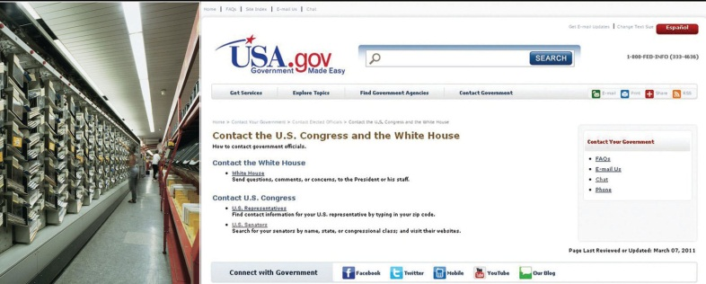
The directive to “write your member of Congress” is taken seriously by increasing numbers of citizens: legislators’ e-mail boxes are filled daily, and millions of letters are processed by the Capitol Hill post offices.
Source: © Thinkstock and http://www.congress.org/.
Students interning for public officials soon learn that answering constituent mail is one of the most time-consuming staff jobs. Every day, millions of people voice their opinions to members of Congress. The Senate alone receives an average of over four million e-mail messages per week and more than two hundred million e-mail messages per year. ^{[16]} Still, e-mail may not be the most effective way of getting a message across because office holders believe that an e-mail message takes less time, effort, and thought than a traditional letter. Leaders frequently are “spammed” with mass e-mails that are not from their constituents. Letters and phone calls almost always receive some kind of a response from members of Congress.

Contributing Money
Figure 8.4
Direct mail appeals by single-issue groups for contributions aimed especially at more affluent Americans are targeted methods of mobilizing people.
© Thinkstock
The number of people who give money to a candidate, party, or political organization has increased substantially since the 1960s. Over 25 percent of the public gave money to a cause and 17 percent contributed to a presidential candidate in 2008. ^{[17]} Direct mail and e-mail solicitations make fundraising easier, especially when donors can contribute through candidate and political-party websites. A positive side effect of fundraising campaigns is that people are made aware of candidates and issues through appeals for money.^{[18]}
Americans are more likely to make a financial contribution to a cause or a candidate than to donate their time. As one would expect, those with higher levels of education and income are the most likely to contribute. Those who give money are more likely to gain access to candidates when they are in office.

Campaign Activity
In addition to voting, people engage in a range of activities during campaigns. They work for political parties or candidates, organize campaign events, and discuss issues with family and friends. Generally, about 15 percent of Americans participate in these types of campaign activities in an election year. ^{[19]}
New media offer additional opportunities for people to engage in campaigns. People can blog or participate in discussion groups related to an election. They can create and post videos on behalf of or opposed to candidates. They can use social networking sites, like Facebook, to recruit supporters, enlist volunteers for campaign events, or encourage friends to donate money to a candidate.
Figure 8.5
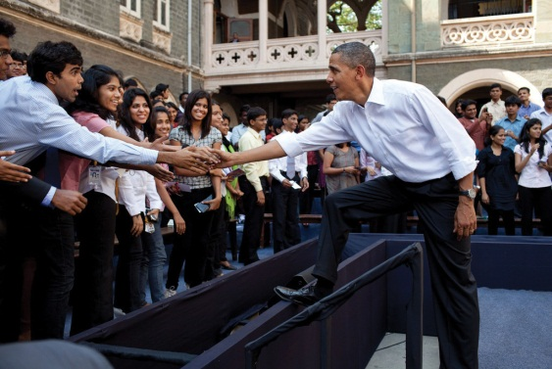
Participation in the 2008 presidential election was greater than usual, as people were motivated by the open race and the candidate choices.
Source: Photo courtesy of the White House Photo (Pete Souza),http://commons.wikimedia.org/wiki/File:Obama_greets_students_following_a_town_hall _meeting_at_St._Xavier_College.jpg.
The 2008 presidential election sparked high levels of public interest and engagement. The race was open, as there was no incumbent candidate, and voters felt they had an opportunity to make a difference. Democrat Barack Obama, the first African American to be nominated by a major party, generated enthusiasm, especially among young people. In addition to traditional forms of campaign activity, like attending campaign rallies and displaying yard signs, the Internet provided a gateway to involvement for 55 percent of Americans. ^{[20]}Young people, in particular, used social media, like Facebook, to organize online on behalf of candidates. Students advertised campus election events on social media sites, such as candidate rallies and voter registration drives, which drew large crowds.

Running for and Holding Public Office
Being a public official requires a great deal of dedication, time, energy, and money. About 3 percent of the adult population holds an elected or appointed public office. ^{[21]} Although the percentage of people running for and holding public office appears small, there are many opportunities to serve in government.
Potential candidates for public office must gather signatures on a petition before their names can appear on the ballot. Some people may be discouraged from running because the signature requirement seems daunting. For example, running for mayor of New York City requires 7,500 signatures and addresses on a petition. Once a candidate gets on the ballot, she must organize a campaign, solicit volunteers, raise funds, and garner press coverage.

Protest Activity
Protests involve unconventional, and sometimes unlawful, political actions that are undertaken in order to gain rewards from the political and economic system. Protest behavior can take many forms. People can engage in nonviolent acts of civil disobedience where they deliberately break a law that they consider to be unjust. ^{[22]} This tactic was used effectively during the 1960scivil rights movement when African Americans sat in whites-only sections of public busses. Other forms of protest behavior include marking public spaces with graffiti, demonstrating, and boycotting. Extreme forms of protest behavior include acts that cause harm, such as when environmental activists place spikes in trees that can seriously injure loggers, terrorist acts, like bombing a building, and civil war.

Figure 8.6 The Watts Riots
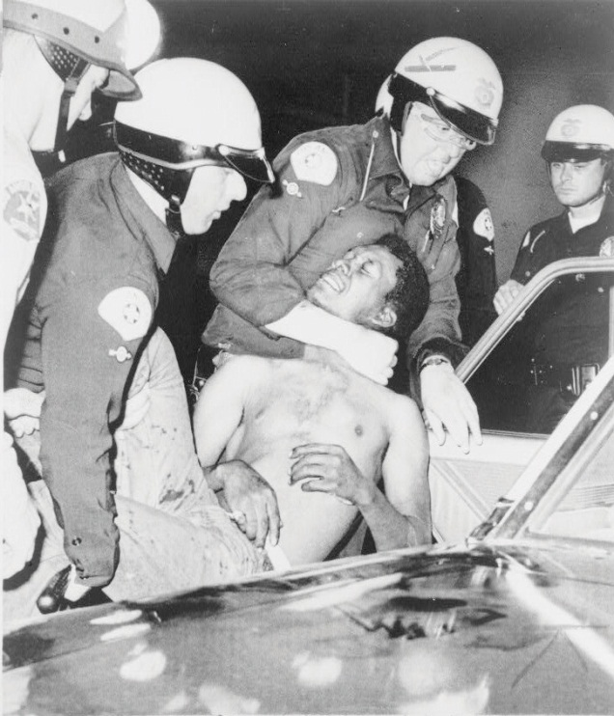
The Watts riots in 1965 were the first of a number of civil disturbances in American cities. Although its participants thought of them as political protests, the news media presentation rarely gave that point of view.
Source: Photo courtesy of New York World-Telegram,http://commons.wikimedia.org/wiki/File:Wattsriots-policearrest-loc.jpg.
Extreme discontent with a particular societal condition can lead to rioting. Riots are frequently spontaneous and are sparked by an incident that brings to a head deep-seated frustrations and emotions. Members of social movements may resort to rioting when they perceive that there are no conventional alternatives for getting their message across. Riots can result in destruction of property, looting, physical harm, and even death. Racial tensions sparked by a video of police beating Rodney King in 1991 and the subsequent acquittal of the officers at trial resulted in the worst riots ever experienced in Los Angeles.

Comparing Coverage
The Rodney King Video
In March 1991, KTLA News at Ten in Los Angeles interrupted programming to broadcast an eighty-one-second amateur videotape of several police officers savagely beating black motorist Rodney King as he stood next to his vehicle. A nineteen-second edit of the tape depicted the most brutal police actions and became one of the most heavily broadcast images in television news history. The original and the edited tape tell two different stories of the same event.
Viewing the entire tape, one would have seen a belligerent and violent Rodney King who was difficult for police to constrain. Not filmed at all was an intoxicated King driving erratically, leading police on an eight-mile, high-speed chase through crowded streets.
The edited video showing the beating of King told a different story of police brutality and was the basis of much controversy. Race relations in Los Angeles in 1991 were strained. The tape enraged blacks in Los Angeles who saw the police actions as being widespread within the Los Angeles Police Department and not an isolated incident.
Four white officers were tried in criminal court for the use of excessive force, and they were acquitted of all but one charge. Jurors were shown the entire tape, not just the famous nineteen-second clip. Soon after the verdict was announced, riots broke out. Demonstrators burned buildings and assaulted bystanders. Fifty-four people were killed and two thousand were wounded. Property damage was in the millions of dollars.
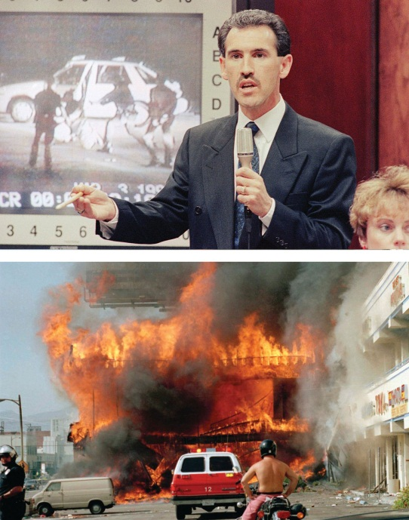
The video of the beating of Rodney King in Los Angeles in 1991 sparked riots.
Source: Used with permission from AP Photo/Mark J. Terill (top) and AP Photo/Nick Ut (bottom).

Link
CBS News Report on the Rodney King Incident
The CBS News report on the Rodney King incident included the following controversial video.
http://www.cbsnews.com/video/watch/?id=1344797n.

Video Clip

http://www.youtube.com/watch?v=tgiR04ey7-M

LA Riots of 1992: Rodney King Speaks
The following video is the CNN News Report on the Los Angeles Riots, including Rodney King’s appeal to stop the violence.
College students in the 1960s used demonstrations to voice their opposition to the Vietnam War. Today, students demonstrate to draw attention to causes. They make use of new communications technologies to organize protests by forming groups on the Internet. Online strategies have been used to organize demonstrations against the globalization policies of the World Trade Organization and the World Bank. Over two hundred websites were established to rally support for protests in Seattle, Washington; Washington, DC; Quebec City, Canada; and other locations. Protest participants received online instructions at the protest site about travel and housing, where to assemble, and how to behave if arrested. Extensive e-mail listservs keep protestors and sympathizers in contact between demonstrations. Twitter, a social messaging platform that allows people to provide short updates in real time, has been used to convey eyewitness reports of protests worldwide. Americans followed the riots surrounding the contested presidential election in Iran in 2009 on Twitter, as observers posted unfiltered, graphic details as the violent event unfolded.

Participation in Groups
About half the population takes part in national and community political affairs by joining an interest group, issue-based organization, civic organization, or political party. Organizations with the goal of promoting civic action on behalf of particular causes, or single-issue groups, have proliferated. These groups are as diverse as the People for the Ethical Treatment of Animals (PETA), which supports animal rights, the Concord Coalition, which seeks to protect Social Security benefits, and the Aryan Nation, which promotes white supremacy.
There are many ways to advocate for a cause. Members may engage in lobbying efforts and take part in demonstrations to publicize their concerns. They can post their views on blogs and energize their supporters using Facebook groups that provide information about how to get involved. Up to 70 percent of members of single-issue groups show their support solely by making monetary contributions. ^{[23]}

Volunteering
Even activities that on the surface do not seem to have much to do with politics can be a form of political participation. Many people take part in neighborhood, school, and religious associations. They act to benefit their communities without monetary compensation.
Maybe you coach a little league team, visit seniors at a nursing home, or work at a homeless shelter. If so, you are taking part in civil society, the community of individuals who volunteer and work cooperatively outside of formal governmental institutions. ^{[24]} Civil society depends on social networks, based on trust and goodwill, that form between friends and associates and allow them to work together to achieve common goals. Community activism is thriving among young people who realize the importance of service that directly assists others. Almost 70 percent of high school students and young adults aged eighteen to thirty report that they have been involved in community activities.^{[25]}

KEY TAKEAWAYS
There are many different ways that Americans can participate in politics, including voting, joining political parties, volunteering, contacting public officials, contributing money, working in campaigns, holding public office, protesting, and rioting. Voting is the most prevalent form of political participation, although many eligible voters do not turn out in elections. People can take part in social movements in which large groups of individuals with shared goals work together to influence government policies. New media provide novel opportunities for political participation, such as using Facebook to campaign for a candidate and Twitter to keep people abreast of a protest movement.

EXERCISES
- What are some of the ways you have participated in politics? What motivated you to get involved?
- What political causes do you care the most about? What do you think is the best way for you to advance those causes?
- Do you think people who have committed serious crimes should be allowed to vote? How do you think not letting them vote might affect what kind of policy is made?

[1] Steven J. Rosenstone and John Mark Hansen, Mobilization, Participation, and Democracy in America (New York: Macmillan, 1993), 4.
[2] Sidney Verba, Kay Lehman Schlozman, and Henry E. Brady, Voice and Equality: Civic Voluntarism in American Politics (Cambridge, MA: Harvard University Press, 1995).
[3] Lester W. Milbrath and M. L. Goel, Political Participation, 2nd ed. (Chicago: Rand McNally, 1977).
[4] William H. Flanigan and Nancy H. Zingale, Political Behavior of the American Electorate, 9th ed. (Washington, DC: CQ Press, 1999).
[5] Raymond E. Wolfinger and Steven J. Rosenstone, Who Votes? (New Haven, CT: Yale University Press, 1980).
[6] “The Campaign: Rockers and Rappers,” The Economist, June 20, 1993, 25.
[7] Human Rights Watch and the Sentencing Project, Losing the Vote: The Impact of Felony Disenfranchisement Laws (New York: Human Rights Watch, 2000).
[8] Steven J. Rosenstone and John Mark Hansen, Mobilization, Participation, and Democracy in America (New York: Macmillan Publishing Company, 1993), 1.
[9] Frances Fox Piven and Richard A. Cloward, Why Americans Still Don’t Vote (Boston: Beacon Press, 2000).
[10] Michael McDonald, “Voter Turnout,” United States Election Project,http://elections.gmu.edu/voter_turnout.htm.
[11] Michael McDonald, “Voter Turnout,” United States Election Project,http://elections.gmu.edu/voter_turnout.htm.
[12] William H. Flanigan and Nancy H. Zingale, Political Behavior of the American Electorate, 9th ed. (Washington, DC: CQ Press, 1999).
[13] Michael McDonald, “Voter Turnout,” United States Election Project,http://elections.gmu.edu/voter_turnout.htm.
[14] Center for Information & Research on Civic Learning and Engagement (CIRCLE), “Young Voters in the 2010 Elections,” http://www.civicyouth.org/wp-content/uploads/2010/11/2010-Exit-Poll-FS-Nov-17-Update.pdf.
[15] Congressional Management Foundation, Communicating with Congress: How the Internet Has Changed Citizen Engagement (Washington, DC: Congressional Management Foundation, 2008).
[16] Congressional Management Foundation, Communicating With Congress: How the Internet Has Changed Citizen Engagement (Washington, DC: Congressional Management Foundation, 2008).
[17] Pew Research Center for the People and the Press, “Pew Research Center for the People & the Press Re-Interview Poll, Nov, 2008,” Poll Database, http://people-press.org/questions/?qid=1720790&pid=51&ccid=51#top.
[18] Gary C. Jacobson, The Politics of Congressional Elections (New York: HarperCollins, 1997).
[19] Sidney Verba, Kay Lehman Schlozman, and Henry E. Brady, Voice and Equality: Civic Voluntarism in American Politics (Cambridge, MA: Harvard University Press, 1995), 70.
[20] Diana Owen, “The Campaign and the Media,” in The American Elections of 2008, ed. Janet M. Box-Steffensmeier and Steven E. Schier (Lanham, MD: Rowman & Littlefield, 2009), 9–32.
[21] Sidney Verba, Kay Lehman Schlozman, and Henry E. Brady, Voice and Equality: Civic Voluntarism in American Politics (Cambridge, MA: Harvard University Press, 1995), 51–52.
[22] Michael Lipsky, “Protest as a Political Resource,” American Political Science Review, December 1968, 1145.
[23] Robert D. Putnam, Bowling Alone: America’s Declining Social Capital (New York: Simon & Schuster, 2000).
[24] Don E. Eberly, America’s Promise: Civil Society and the Renewal of American Culture(Lanham, MD: Rowman & Littlefield, 1998).
[25] Peter D. Hart Research Associates, New Leadership for a New Century (Washington, DC: Public Allies, August 28, 1998).

8.2 Why People Participate

LEARNING OBJECTIVES
After reading this section, you should be able to answer the following questions:
- How do people become politically mobilized?
- How interested are Americans in taking part in politics?
People get involved in politics for a variety of reasons. They may be personally motivated because of an event that changed their lives. They may receive invitations to participate from friends, organizations, political parties, or a candidate’s campaign. A person’s socialization, life experience, and attitudes toward politics can influence participation. Some people have a strong sense of civic duty and a belief that they can influence government, which compels them to act. Barriers, such as legal obstacles, may preclude some people from engaging politically.

Mobilization Efforts
Most people do not wake up one morning and decide that they are going to engage in politics. They must be motivated to participate, often by people or organizations reaching out to them and asking them to get involved. Increasingly people received digital invitations to participate through Facebook groups formed by friends, e-mail solicitations from campaigns and interest groups, and podcasts from political organizations.
Traditionally, political parties helped mobilize people by recruiting volunteers for campaigns and other political events. Parties provided a training ground for candidates and leaders and rallied people around issues. Today, parties’ role in directly mobilizing people to participate in politics has diminished. People are more inclined to support a candidate who represents their interests than a political party. ^{[1]}
Interest groups and candidates’ campaigns can encourage people to take part in politics. They use marketing strategies to target potential activists based on demographic characteristics and political orientations. Organizations acquire lists of prospects from political parties and market research firms, and they use these lists to contact people by mail, telephone, and e-mail. ^{[2]} They canmicrotarget supporters based on specific characteristics, such as voters who are in their twenties, drink Starbucks coffee, enjoy Judd Apatow films, and work in the legal field.
Figure 8.7
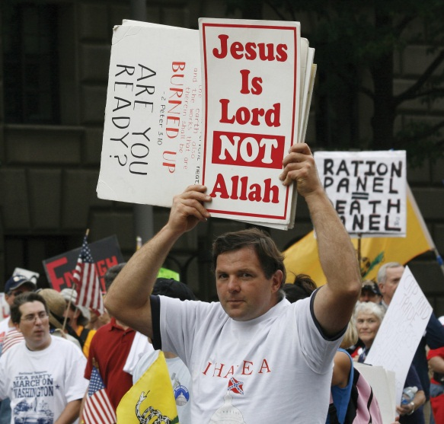
Religious convictions can influence people to participate in politics.
Source: Photo courtesy of dbkinghttp://commons.wikimedia.org/wiki/File:Christian_protester_-_Tea_Party_march.jpg.
Trade unions mobilize blue-collar workers, especially on behalf of the Democratic Party. Black churches are instrumental in organizing political action in the African American community, fundamentalist congregations provide a base for the Christian Right, and the Catholic Church helps mobilize the pro-life movement against abortion and anti–death-penalty activists.

Socialization and Life Experience
People can establish the habit of participating in politics through political socialization, the process by which people acquire their political beliefs, attitudes, and actions. Political experiences with families, schools, friendship groups, churches, community organizations, and mass media can motivate people to become lifelong political participants. If your parents are community activists there is a good chance that you also will be active at some point in your life. ^{[3]} People can be socialized to participation through civic education when they learn in school how democracy works and how they can take part. Students can gain experience by participating in extracurricular activities, student government, or community volunteer programs. These activities place young people in social and political networks with others who have a strong sense ofcivic duty, the belief that one has a responsibility to take part in community life.
People’s integration into their communities is strongly related to their level of political activity. Those who are mobile and have not established community roots find it more difficult to participate in politics because they are not part of a social network. It takes about three to five years to develop friendship networks, learn about the problems facing a community, and identify which people are the key players. ^{[4]}
Difficult life experiences can cause people to act who never thought they would become involved. President Bill Clinton pardoned Dorothy Gaines and Kemba Smith, who had received long mandatory prison sentences on drug charges with no hope of parole. They were not involved with drugs but had boyfriends who were dealers. It is a crime under federal law to associate with known drug dealers. Ms. Gaines lobbied for her freedom from her jail cell, working with civil rights organizations, and she drew media attention to her problem, including a widely read article in People magazine. Kemba Smith’s father, Gus, an accountant who had never been politically active, worked to secure his daughter’s release. A cover story in Ebony magazine rallied support for her case, and a film was made about her life. Since the pardons, Dorothy Gaines, her father, and Kemba Smith have continued to lobby for changes in the sentencing laws. Kemba Smith has established a foundation to educate young people about making proper decisions.

Link
Kemba Smith Foundation
Learn more about Kemba Smith’s foundation athttp://www.kembasmithfoundation.org.

Attitudinal Factors
People’s attitudes about government and politics can influence their decision to participate. People who have a strong sense of political efficacy, are interested in politics, and have a sense of civic duty are more likely to participate. Political efficacy is the belief that you personally can make a difference in governmental affairs. ^{[5]} During the 2008 presidential election, people who believed that their vote could make a difference were more likely to cast a ballot than those who felt that their vote didn’t matter.
Americans’ interest in politics had declined for about two decades beginning in the 1980s. Only about one-quarter of the public in 2000 expressed much interest in the presidential campaign, and there was even less interest in other aspects of politics. Only about 40 percent of citizens felt strongly that voting was an important civic duty. The 2008 presidential campaign bucked this trend: around 80 percent of the public expressed interest in the election and over 60 percent considered voting to be their civic duty. Americans are typically less interested in nonpresidential elections. Forty-three percent of the public claimed to be interested in the 2010 congressional midterm elections. ^{[6]}
Political interest has been bolstered by the ability of people to take part in politics and express their opinions more easily through digital media. People feel like they have a greater say in government and can reach out to leaders through e-mail and online discussion forums. Political leaders have established social media accounts on Facebook and Twitter in order to share information and to enable greater interaction with their constituents. “U.S. Politics on Facebook” provides a gateway to the pages of politicians, elected officials, and political campaigns.

Personal Gratification
The expectation that political participation will be rewarding can spark people to become active. Some people are motivated by the belief that they will be connected to powerful leaders and receive material benefits, such as a chance to further their careers or get help with a personal problem. Others embrace the opportunities to meet people and socialize while working together, or they are happy to do something good for the community. High schools and colleges throughout the nation have instituted community service programs to stimulate lifelong participation based on the personal gratification students experience when they realize that their efforts make a difference.
Figure 8.8
A majority of US high school students and many other young people participate in community service activities ranging from tutoring after school to cleaning up public spaces.
Source: Photo courtesy of US Navy Mass Communication Specialist 3rd Class Daniel Viramontes,http://commons.wikimedia.org/wiki/File:US_Navy_090804-N-7280V-398 _Sailors_paint_a_classroom_during_a _community_service_project.jpg.

KEY TAKEAWAYS
People often are motivated to participate in politics because they are targets of mobilization efforts by political parties and interest groups. They also can acquire the habit of participating politically through the process of political socialization or have a life experience that prompts them to act. Political attitudes such as civic duty and a sense of political efficacy can influence a person’s decision to participate. People may seek personal gratification through political action, as they enjoy working with others and helping their community. Legal factors such as voter registration requirements can impede participation.

EXERCISES
- Are you aware of interest groups’ and political campaigns’ efforts to mobilize you? What techniques do they use to try to reach people like you?
- Why do you think Americans have become less engaged in politics? Why do you think they were more engaged during the 2008 election?

[1] Jack Dennis and Diana Owen, “The Partisanship Puzzle,” in After the Boom: The Politics of Generation X, ed. Stephen C. Craig, and Stephen Earl Bennett (Lanham, MD: Rowman & Littlefield, 1997), 43–61.
[2] Steven E. Schier, By Invitation Only: The Rise of Exclusive Politics in the United States(Pittsburgh, PA: University of Pittsburgh Press, 2000).
[3] Richard M. Merelman, Making Something of Ourselves (Berkeley: University of California Press, 1984).
[4] M. Margaret Conway, Political Participation in the United States, 3rd ed. (Washington, DC: CQ Press, 2000).
[5] Sidney Verba and Norman H. Nie, Participation in America: Political Democracy and Social Equality (New York: Harper & Row, 1972).
[6] Pew Research Center for the People and the Press, “Pew Weekly News Interest Index Poll, Oct, 2010,” Poll Database, http://people-press.org/questions/?qid=1772828&pid=51&ccid=51#top: “Thinking about this year’s (2010) Congressional elections, would you say that you are interested in what’s happening in elections around the country?”

8.3 Who Participates and Who Does Not

LEARNING OBJECTIVES
After reading this section, you should be able to answer the following questions:
- What types of people are the most and the least likely to participate in American government and politics?
- What barriers to political participation are faced by some groups?
Meaningful and regular opportunities for all people to participate must be guaranteed by a democratic political system, whether or not everyone chooses to take part. But not all Americans take part in politics, nor are the opportunities for participation equal. Voters and political activists generally are older, more educated, and better off financially than the general population. These people have the best chance of having their views represented in government. Meanwhile, those who rely the most on government programs and policies, such as recipients of public assistance, often have fewer opportunities to participate and are less engaged.

Socioeconomic Status
Socioeconomic status (SES) is determined by people’s levels of education, income, and occupation. Wealthier and better educated people tend to vote more often, participate more in political activities, and donate more money to causes than poorer or less educated people. They also have greater access to the resources that facilitate political activity, including contacts with people in powerful positions. People’s occupations also are related to their participation, as people in managerial and professional positions are the most politically active, followed by craftspersons, service workers, and laborers. Many managers and professionals follow politics as part of their jobs. The unemployed are the least inclined to take part.
Education has the strongest impact on participation, as it provides people with background knowledge of how the political system works. Educated people develop the skills that allow them to follow and understand events through the mass media. They are likely to form opinions about political issues and engage in discussions. The political blogs with the most readers, such as Daily Kos and Huffington Post, are written and read by well-educated people. ^{[1]} Education prepares people to deal with the bureaucratic aspects of participation, such as registering to vote or organizing a petition drive. Eighty-three percent of people with graduate school education voted in the 2008 presidential election compared with 39 percent of those without a high school diploma. ^{[2]} The 2010 midterm elections were decided primarily by people with at least some college experience. Less than 5 percent of voters had no high school education, 16 percent were high school graduates, 29 percent had some college, and 50 percent were college graduates. ^{[3]}

Age
Political participation differs notably by age. People between the ages of thirty-five and sixty-five are the most politically active. At this stage in life, people are more likely than younger people to have established homes, hold steady jobs, and be settled into communities. Those with stable community roots often have strong incentives and greater resources for becoming involved in politics.
While younger people turn out in elections less often than older people, youth voting has been on the rise in presidential elections since 2004. Turnout among eighteen- to twenty-four-year-olds dropped from 50 percent in 1972, the first presidential election year after the voting age was lowered to eighteen, to 36 percent in 2000. Turnout among senior citizens, people sixty-five and older, increased to nearly 70 percent in that same time period. ^{[4]} Young voter turnout rose to 47 percent in 2004 and 51 percent in 2008, partly as a result of voter registration and mobilization efforts by groups like Rock the Vote. The youth vote contributed to the success of Democratic presidential candidate Barack Obama in 2008, as young volunteers provided countless hours of campaign support. ^{[5]} Information about young voters can be obtained from theCenter for Information & Research on Civic Learning and Engagement.
Figure 8.9
Young people have brought issues to the attention of public officials and worked effectively for positive change.
Source: Photo courtesy of the US Department of State,http://www.flickr.com/photos/statephotos/5085000843/.
People under the age of thirty are among the least involved in mainstream forms of participation. Young people often lack the money and time to participate. Still, many young people realize that participation matters. Reacting to problems they see in their hometowns, youth have formed groups to work for change. They have successfully lobbied government officials, spoken out at public meetings, and provided formal testimony at hearings. Young people have established safety policies in schools, protested against increases in college tuition rates, and prompted the creation of recreational facilities for biking, skateboarding, and ice hockey.

Gender
Political scientists and journalists often talk about the gender gap in participation, which assumes women lag behind men in their rates of political engagement. The gender gap is closing for some forms of participation, such as voting, but still exists for activities such as running for office.
Women turn out to vote more frequently than men. Since 1986, women have exceeded men’s turnout rate in presidential elections. Sixty-six percent of women cast a ballot in 2008 compared with 62 percent of men. Women have a strong sense of civic duty and believe that voting is a citizen’s obligation. The prominence in campaigns of issues of importance to women, such as abortion, education, and child welfare, also encourages women to vote. ^{[6]}
Since the 1990s, women have been as likely as men to contact members of congress, sign and circulate petitions, attend local political meetings, and donate their time to political causes. They take part in local and state political activities more than in the national realm, where most media attention is focused. However, women are somewhat less inclined than men to use new media, such as online news sites and blogs, for politics.
A significant gender gap in participation exists for running for and holding political office. While women make up more than half the population, they constitute far less than half of the elected officeholders, especially at the national level. A total of 274 women have served in Congress since 1917, when Jeannette Rankin (R-MT) was the first woman elected to Congress. A record number of women—over 270—ran in the congressional primaries in 2010, although many were not successful in their bids. There are 75 female House members in the 112th Congress, constituting 17 percent of the 435-member body, which is a historical high. Eighteen of the one hundred senators are women. ^{[7]}

Link
Women in Congress
The Women in Congress website of the Office of the Clerk of the US Capitol provides historical information and data on women members of Congress.

Figure 8.10
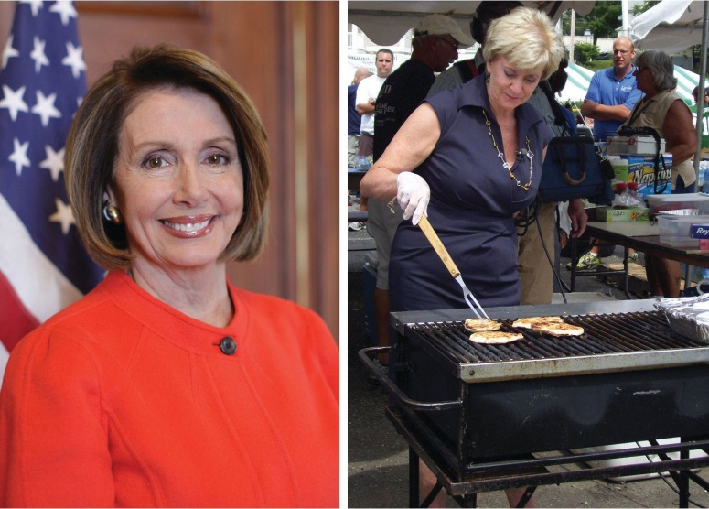
An increasing number of women are running for national office.
Source: Photo courtesy of the Office of the Speaker,http://commons.wikimedia.org/wiki/File:Speaker_Nancy_Pelosi.jpg andhttp://commons.wikimedia.org/wiki/File:Linda_McMahon_Grilling_--_Sgt._R.K._Blue.jpg.
There is little evidence today that female candidates have a harder time attracting fair news coverage, raising money, or getting votes than male candidates running as challengers or for open seats. In the 2010 midterm elections, some of the best-funded candidates were women. However, women candidates often face male incumbents, candidates already in office, who are difficult to defeat. ^{[8]}Motherhood becomes an issue for women who seek or hold public office. The 2008 Republican vice presidential candidate, Sarah Palin, faced scrutiny by the press and voters because she was the mother of five children, including a four-month-old baby with Down syndrome.

Race and Ethnicity
Participation differs among members of racial and ethnic groups. Specific patterns of participation are associated with blacks, Latinos, and Asian Americans and Pacific Islanders.

Blacks
Discriminatory practices kept black voter turnout low until after the passage of the Voting Rights Act of 1965. Poll taxes, fees that had to be paid before a citizen could register to vote, disenfranchised the poor, many of whom were black. Literacy tests, which required people to demonstrate their ability to read, write, and interpret documents prior to voting, were applied unfairly to blacks. The “white primary” restricted voting in Democratic primaries to whites in certain Southern states. The Southern Democratic party was so dominant that winning the primary was tantamount to election to office. Intimidation and violence by groups such as the Ku Klux Klan kept black voters from the polls. Eventually, civil rights protests and litigation resulted in the elimination of formal barriers to voting. Today, black citizens vote at least as often as white citizens who share the same socioeconomic status. Sixty-five percent of black voters turned out in the 2008 presidential election compared with 66 percent of white voters. Over 90 percent of black voters supported African American candidate Barack Obama. ^{[9]}
Black and white Americans are about equal in how much time and effort they devote to activities other than voting. However, they differ in the types of activities in which they engage. Whites are more likely to contact public officials and join political organizations. Black citizens are active in election campaigns and social movements.

Latinos
The Latino population in the United States is well established and has grown to over 47 million people from diverse countries of origin. Although they form a substantial political bloc, only 49 percent of eligible Latino voters turned out in the 2008 presidential election. Latinos tend to participate in other forms of political activity with less frequency than either white or black citizens. In 2010, however, three Latino candidates were elected to top offices, including two governors and one senator, for the first time in history. The Pew Hispanic Centerprovides information and data on Latino American politics.
Figure 8.11
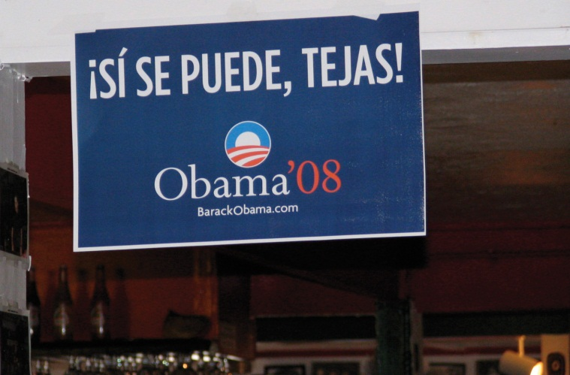
Candidates routinely aim campaign ads at the fast-growing Latino and Asian American populations.
Source: Photo courtesy of (Brian),http://commons.wikimedia.org/wiki/File:Si_se_puede,_Tejas_Obama.jpg.
Language is one barrier to Latino participation. Candidates recognize that Latinos constitute a large and growing voting bloc and have begun campaigning in Spanish. During the 2000 presidential election campaign, candidate George W. Bush ran nearly as many ads in Spanish as in English.^{[10]} The 2008 presidential candidates’ websites featured extensive Spanish-language content, as did the websites of a good number of congressional candidates in 2010.

Asian Americans and Pacific Islanders
According to the US Census, Asian Americans and Pacific Islanders are the fastest growing and most diverse ethnic group. Yet their rates of participation are lower than for other groups. In 2008, 48 percent of Asian Americans turned out to vote. ^{[11]} Cultural factors contribute to the lower levels of Asian American and Pacific Islander voting. Some are recent immigrants who still maintain strong ties to their ethnic culture. Asian Americans who have been victims of hate crimes or consider themselves to be part of a deprived group find their way to the polls in greater numbers. ^{[12]}

KEY TAKEAWAYS
Who participates in politics depends on a variety of factors, including socioeconomic status, age, gender, and race and ethnicity. Those with the most money, time, and skills are more likely to participate. Older people with higher education and income are the most likely to vote and take part in politics. People who have the least in society, and who are most in need of government assistance, are often the most poorly equipped to take action to improve their lot.

EXERCISES
- Which groups are the least likely to participate in politics? What are the obstacles to participation that these groups face?
- What effect do you think it has on politics that some groups participate more than others? What effect do you think it has that there are relatively few women in Congress?

[1] Matthew Hindman, The Myth of Digital Democracy (Princeton, NJ: Princeton University Press, 2008).
[2] Michael McDonald, “Current Population Survey Voting and Registration Supplement,”United States Election Project, http://elections.gmu.edu/CPS_2008.html.
[3] Ezra Klein, “Who Graduates, Who Votes and Who’s Unemployed—in the 2010 Midterm Elections,” washingtonpost.com, http://voices.washingtonpost.com/ezra-klein/2010/12/who_graduates_who_votes_and_wh.html.
[4] Project Vote-Smart, Democracy Inclusion Project, http://www.vote-smart.org/yip.
[5] Center for Information & Research on Civic Learning and Engagement (CIRCLE), “Youth Voting,” http://www.civicyouth.org/?page_id=241#1.
[6] Richard Seltzer, Jody Newman, Melissa Vorhees Leighton, Sex as a Political Variable(Boulder, CO: Lynne Reinner, 1997).
[7] Office of the Clerk, US Capitol, Women in Congress website,http://womenincongress.house.gov.
[8] R. Darcy, Susan Welch, and Janet Clark, Women, Elections, and Representation (Lincoln: University of Nebraska Press, 1994).
[9] Michael McDonald, “Current Population Survey Voting and Registration Supplement,”United States Election Project, http://elections.gmu.edu/CPS_2008.html.
[10] Rush Schriefer, Bush campaign media consultant, interview by Owen, May 22, 2001.
[11] Douglas R. Hess, “Analysis of the 2008 Current Population Survey (CPS) Voter and Registration Supplement,”http://www.projectvote.org/images/publications/Reports%20on%20the%20Electorate/Analysis%20of%20the%202008%20CPS%20Voting%20Supplement.pdf.
[12] The White House Commission on Asian Americans and Pacific Islanders, A People Looking Forward (Washington, DC: US Government, 2001).

8.4 Social Movements

LEARNING OBJECTIVES
After reading this section, you should be able to answer the following questions:
- What is a social movement?
- Why did the civil rights movement form, and how did it work toward its objectives?
- What were the goals of the women’s movement, and how were they achieved?
Thus far our discussion has focused primarily on how and why individuals decide to participate in politics by engaging in activities such as voting or running for office. There are times when groups of people who are concerned about a particular issue or idea join forces to demand government action. A social movement is formed when large numbers of people organize and mobilize to actively pursue common political objectives. ^{[1]}
A social movement has a formal and enduring organizational structure as well as recognized leaders. Movements begin with people who share concerns about long-standing societal problems and believe that their rights and interests are not being adequately represented. They can evolve from grassroots groups into national organizations and even become interest groups that lobby government officials. Social movements can last for months, years, or even decades. The farmworkers’ movement was founded in the 1960s by César E. Chávez and still exists today. Its national organization, the United Farm Workers, seeks congressional legislation to guarantee fair wages and treatment of undocumented workers. ^{[2]}
Movement participants assume that collective action, cooperative activities by groups in pursuit of a common goal, will be more effective in gaining the attention of media and government officials to instigate change than individuals acting on their own. Establishing a communications network to energize participants and mobilize them for action is a key component of a social movement. The digital media have become important organizing tools for social movements. They can use websites, Twitter feed, social media, text messages, and other platforms to publicize their cause, recruit members, fundraise, and organize events.

A Brief History of Social Movements
The United States has a long tradition of social movements that have sparked major changes in political processes and government policies. Theabolitionist movement of the mid-1800s sought to end slavery, an issue that contributed to the outbreak of the Civil War. The temperance movement, led by the Anti-Saloon League and the Women’s Christian Temperance Union, prompted Congress to pass the Eighteenth Amendment in 1919 prohibiting the sale or transportation of alcohol. Prohibition was repealed in 1935.

Figure 8.12
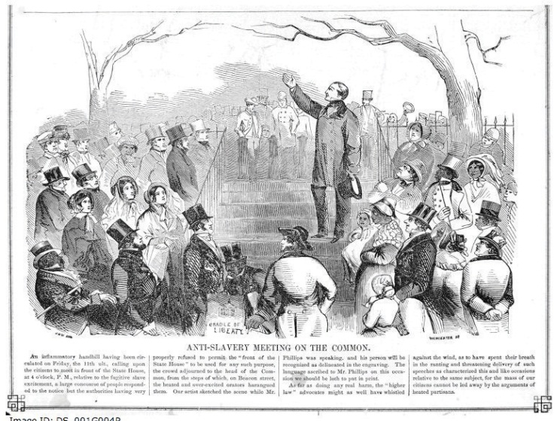
People, including many women, were involved in the abolitionist movement against slavery in the mid-1800s.
Source:http://commons.wikimedia.org/wiki/File:1851_Antislavery_BostonCommon_Gleason.png.
Guaranteeing the right to vote to all citizens has been the focus of some of the most important social movements. The Constitution at the time of the founding guaranteed suffrage only to white, male landowners. States placed restrictions on voting based on race, age, sex, religion, and even personal character. All states had dropped the requirement for land ownership by 1844, but constitutional restrictions based on race remained until 1870 and sex until 1920.

The Civil Rights Movement
The Fifteenth Amendment to the Constitution formally ended race-based limitations on voting in 1870. However, minority citizens were not truly enfranchised until the passage of theCivil Rights Act of 1964 and the Voting Rights Act of 1965. This legislation was the result of pressure on the government by the civil rights movement.
The civil rights movement emerged in the 1950s in reaction to discrimination against African Americans in Southern states. Segregationist policies placed restrictions on black citizens’ right to vote and violated their basic civil rights in other ways. African Americans were forced to use facilities separate from whites, such as restrooms and water fountains, and to sit at the back of public buses. Black students attended schools that were usually inferior to schools for whites.
United under the Southern Christian Leadership Conference, black churches formed one foundation of the civil rights movement. Dr. Martin Luther King Jr., one of the movement’s leaders, emphasized that nonviolent direct action would be used to expose racial injustices. Civil rights activists boycotted businesses that employed discriminatory practices. They engaged in acts of civil disobedience that disrupted established patterns of daily life. Blacks ate at white lunch counters, were arrested, and jailed. Southern blacks mounted large-scale voter registration drives. In the summer of 1963 alone, over fourteen hundred demonstrations and marches were staged to protest disenfranchisement and other forms of discrimination.
These tactics were designed to attract media attention that would help to galvanize the movement and force political leaders to take notice, and they worked. Politicians perceived that black voters were becoming powerful and listened to their demands. President John F. Kennedy agreed to sponsor legislation that would ensure black civil and voting rights, which Congress passed and President Lyndon Johnson signed into law after Kennedy’s assassination.

Enduring Image
“I Have a Dream”
One of the most enduring, indeed revered, images of the civil rights movement is of Dr. Martin Luther King Jr. addressing a crowd of more than 250,000 people on the Washington Mall from the steps of the Lincoln Memorial. King was joined by thousands of protesters from across the nation participating in the March on Washington for Jobs and Freedom in August 1963.
King delivered the stirring keynote speech extemporaneously. The backdrop of the Lincoln Memorial dramatized the fact that a century after the Emancipation Proclamation had been signed, freeing the slaves, blacks were still crippled by segregation and discrimination. King uttered the famous words, “I have a dream that one day this nation will rise up and live out the true meaning of its creed: ‘We hold these truths to be self-evident, that all men are created equal.’”
The speech was covered on television in its entirety and received widespread attention in newspapers and magazines. The image of King, arm extended and head held high, addressing the crowd marks a memorable moment in our nation’s history and has come to symbolize the civil rights movement and its leaders. It has been replicated in history books and popular films, like Forrest Gump.
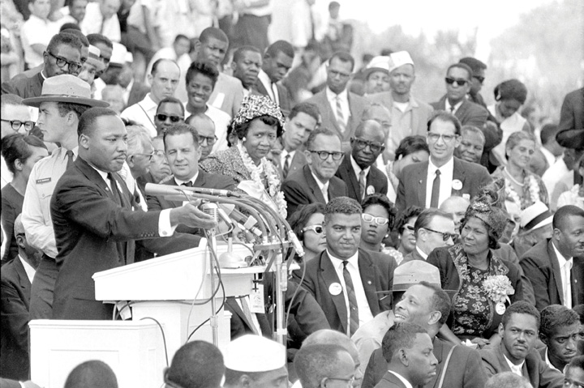
Dr. Martin Luther King Jr. giving the “I Have a Dream” speech. The image of Dr. Martin Luther King Jr. addressing the crowd on the National Mall endures as a symbol of the civil rights movement.
Source: Used with permission from AP Photo.

Video Clip

http://www.youtube.com/watch?v=smEqnnklfYs

Martin Luther King Jr. “I Have a Dream”
Video of the “I Have a Dream Speech” delivered by Dr. Martin Luther King Jr. in August 1963.

The Women’s Movement
Throughout much of American history, a woman was considered to be an extension of her husband and, as such, did not need her own vote. Women were not granted the constitutional right to vote until 1920, but they were politically involved. Women formed charitable institutions to fight poverty and were active in reform movements, such as protecting children working in factories and textile mills. They participated in abolitionist groups that formed in the 1830s to achieve suffrage for slaves. Lucretia Mott and Elizabeth Cady Stanton were denied voting rights as delegates to a worldwide antislavery convention in London. This event compelled them to organize the women’s movement in the United States with the primary goal of gaining the fundamental right to vote.
Women acquired organizing skills that were central to their movement from their involvement with other causes. They lobbied Congress and state legislatures, spoke passionately in public forums, held rallies, circulated petitions, and even went to jail for their beliefs. The Nineteenth Amendment, ratified in 1920, granted woman suffrage.
Figure 8.13Suffragettes Fighting for the Right to Vote
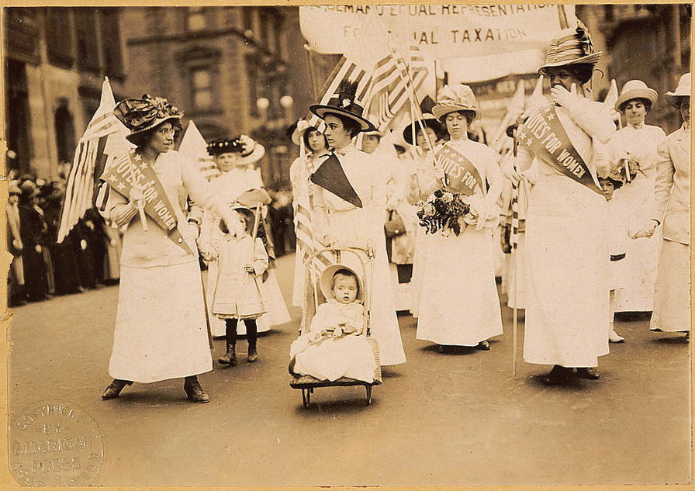
Women who had been active in the movement to abolish slavery had thought that demands for women’s equality would be next on the agenda. As it turned out, they had to pressure for another fifty years before the Nineteenth Amendment guaranteed the right of women to vote.
Source: Photo courtesy of the US Library of Congress,http://commons.wikimedia.org/wiki/File:Suffrage_parade-New_York_City-May_6_1912.jpg.
Even as women won the legal right to vote, barriers to their participation remained. States made registration difficult. Some women were discouraged from voting by their husbands and friends. ^{[3]} From the 1960s to the 1980s, the women’s movement was revitalized around the basic goals of achieving equal rights for women in politics, business, organized religion, and sports. Women fought for equal work for equal pay, for women to be ordained as clergy, and for girls to have the same opportunities to compete in school sports as boys. They were successful in achieving many of their goals. Congress passed the Women’s Educational Equity Act in 1974, which included Title IX, requiring schools to remove barriers to females’ full participation in sports.
Today, there is no longer a single mass women’s movement. Instead, there are many organizations working on a wide range of issues related to women, such as health care, social justice, and domestic violence. ^{[4]} They make use of digital communication to reach out to the public and to support one another. The National Organization for Women(NOW), which takes action on issues of women’s equality, provides information and opportunities for participation online. Through its website, “Take Back The Night” promotes action against domestic violence by providing an online guide to organizing events, making T-shirts and posters available, and offering access to legal assistance. ^{[5]}

A Society of Many Movements
Following in the footsteps of the civil rights movement and the women’s movement, other movements have formed in reaction to policies that disadvantage particular segments of society. The gay rights movement has succeeded in having policies enacted to fight discrimination in the workplace, increase access to medical benefits, and stop bullying in schools. Disabled Americans formed a movement that resulted in the passage of the Americans with Disabilities Act of 1990 guaranteeing that no individual will be excluded from the benefits of any program or activity receiving public funding because of a handicap.
Some social movements have become a force in the political mainstream. TheChristian Right emerged in the 1980s as groups of evangelical Protestants found common ground in shared ideological beliefs, including support for marriage and traditional two-parent families, a pro-life position on abortion, local control of education and home schooling, and the protection of young people from pornography. It has become aligned with the conservative wing of the Republican Party. ^{[6]}
Social movements can employ tactics to reverse the law or to challenge outcomes using extralegal, illegal, and even violent means. Antiabortion activists who seek legislation making abortions illegal have bombed clinics and attacked and even killed doctors who perform abortions. Self-described “ecoterrorists” have set fire to housing developments that they see as contributing to suburban sprawl.
Some movements invoke the Constitution as a justification for violent action against the government. The militia movement believes it must preserve the Constitution’s Second Amendment right to keep and bear arms. Members conduct regular drills in military dress during which they fire high-powered weapons. The movement uses an elaborate system of websites and independent radio stations to present their position and communicate with one another.

Social Movements and the Media
Social movements rely on media attention to gain public support, recruit members, and present their agendas to political leaders. The media can shape the public’s views about particular movements and the causes they represent. Movement leaders attempt to gain control over their message through interviews and staged events.
The press can influence a movement’s success or failure. The 1960s student movement provides an illustration. At first the student movement was virtually ignored by the media. As the Vietnam War escalated, students expressed their opposition through demonstrations and sit-ins on college campuses. Media coverage was abundant and favorable. News stories about student activists along with graphic televised images of the war helped attract new members to the antiwar effort. Press coverage became more negative as government officials who opposed the antiwar movement emerged and were featured in media reports. Negative coverage galvanized the movement, as supporters rallied to defend the cause. It also radicalized the movement, as members pursued more militant tactics to ensure coverage. The bombing of a building at the University of Wisconsin, which killed a graduate student, caused people to lose sympathy with the activists. Journalists grew tired of the story and portrayed the movement as factionalized into different groups with rival leaders. The student movement eventually fell apart. ^{[7]}
The Tea Party is a loosely organized grassroots political movement formed in February 2009, whose members advocate reduced government spending, lower taxes, and a strict interpretation of the US Constitution. The organization borrows its name from the Boston Tea Party, an incident in 1773 in which colonists protested against the British government tax on tea by throwing tea imported by ships into the Boston Harbor. The Tea Party lacks a clear leader or centralized organization and is composed of more than fourteen hundred localized groups. The media have made it possible for the Tea Party to gain national attention and develop a sizable following that contributed to Tea Party candidates’ winning elections in 2010. Major news outlets publicized Tea Party protests against taxes and health care reform, especially as their lively rallies and colorful front persons, including former Alaska governor Sarah Palin, made for good copy. The Tea Party Patriots website provides an online community organization for the movement.

KEY TAKEAWAYS
America has a long tradition of social movements wherein people work collectively for a cause. Movements have sought equal rights for women, members of racial and ethnic groups, and lesbian and gay citizens. They have worked to create better opportunities for people with disabilities and senior citizens. Social movements rely on collective action that brings individuals together to work toward a joint goal. The media are important for attracting attention to these efforts, which can increase participation in the movement and force political leaders to take notice.

EXERCISES
- What were the goals of the civil rights movement? How did civil rights activists work to achieve them?
- What were the original goals of the women’s movement? How has the women’s movement evolved since then?
- What are the most important social movements today? How are these different movements portrayed in the media?

[1] Jo Freeman and Victoria Johnson, eds., Waves of Protest (Lanham, MD: Rowman & Littlefield, 1999).
[2] United Farm Workers of America, “Action Alert! Urge Congress to Support UFW-Sponsored Bills Allowing an Undocumented Farm Worker to Earn Legalization,” 2001,http://www.ufw.org/gallowact.htm.
[3] M. Margaret Conway, Political Participation in the United States (Washington, DC: CQ Press, 1991), 98–107.
[4] Barbara Epstein, “What Happened to the Women’s Movement,” Monthly Review, April 2000, 1–13.
[5] “Take Back The Night” website http://www.takebackthenight.org.
[6] Christian Coalition of America, “Our Mission,” http://www.cc.org.
[7] Todd Gitlin, The Whole World Is Watching (Berkeley: University of California Press, 1980).

8.5 Participation, Voting, and Social Movements in the Information Age

LEARNING OBJECTIVES
After reading this section, you should be able to answer the following questions:
- In what ways can people participate through the media?
- What influence do the media have on political participation?
The media are central to political participation and mobilization. The public uses all forms of media to express opinions, contact leaders, and engage in politics. Journalists, pollsters, and political consultants create media depictions of peoples’ participation and inactivity. These depictions shape the public’s perceptions about political participation. Individuals may be prompted to engage in public affairs when they view media accounts of people like themselves taking part. The public can participate in politics through media, especially via the Internet and digital platforms.

Media Interactions
The interaction between media and political participation is complicated. Media can encourage or discourage participation by drawing attention to political leaders, events, and issues. New media, in particular, not only allow people to monitor politics but also provide them with options for active engagement.

Participation through Media
Americans rely on newspapers, television, radio, and online media to stay informed about politics. Media connect people to political events, such as election campaigns and rallies on the National Mall in Washington, DC, to which they may have limited direct, personal contact.
People also can actively take part in politics through media. Television and radio call-in talk shows and Internet chat rooms accommodate political discussion between the public, political activists, government leaders, and the press. Right-wing talk-show host Rush Limbaugh not only encourages his listeners to sound off on air but also urges them to contact government officials, circulate political newsletters in their towns, and hold rallies and bake sales to raise funds for conservative causes. Many television and radio call-in shows accommodate predominantly callers who agree with the host. Rush Limbaugh, Glenn Beck, and Sean Hannity host programs that appeal to conservative audiences. Fewer call-in programs are hosted by political liberals.
Televised town meetings allow the public to ask questions directly of politicians and journalists. In June 2009, ABC programmed a day of news about health care, culminating in a “town-hall meeting” with President Barack Obama titled “Prescription for America,” in which he took questions from concerned citizens. During election campaigns, televised presidential debates that allow voters, rather than journalists, to ask questions draw the largest audiences. People see others like themselves taking part in political life through media depictions, which can make them more likely to become engaged. In 2007, candidates running for the Democratic and Republican Party nominations participated in YouTube debates, in which citizens submitted their questions via video.

Link
The CNN YouTube Debates: The Democrats
The CNN/YouTube Democratic Debates, July 23, 2007.
http://www.youtube.com/democraticdebate

Link
The CNN YouTube Debates: The Republicans
The CNN/YouTube Republican Debates, November 28, 2007.
http://www.youtube.com/republicandebate

Media Events and Civic Action
Figure 8.14
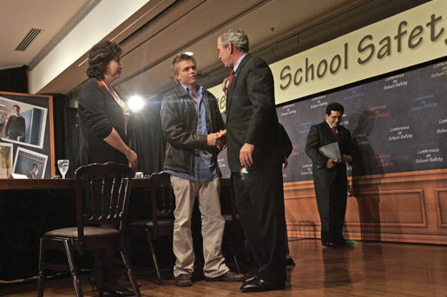
Students were mobilized to advocate for gun control and school safety after the 1999 shooting deaths at Columbine High School in Colorado and met with politicians, including President George W. Bush.
Source: Photo courtesy of the White House (Kimberlee Hewitt),http://commons.wikimedia.org/wiki/File:20061010-8_p101006kh-0240-515h.jpg.
Devastating events extensively reported in the media can spark people to organize and lobby for policy change. National media attention can prompt leaders to take activists seriously. Coverage of the 1999 shootings at Colorado’s Columbine High School, which left fifteen people dead, rallied support for tougher gun-control legislation. In the wake of the Columbine shootings, students from across the state formed SAFE—Sane Alternatives to the Firearms Epidemic. A ninety-person SAFE delegation traveled in August 1999 to Washington, DC, where they met with President Bill Clinton, Vice President Al Gore, and House Minority Leader Richard Gephardt (D-MO) who pledged support for the group’s position advocating tougher gun-control laws. In a made-for-media moment on the steps of Capitol Hill, the students grilled members of Congress who opposed tough gun-control legislation. ^{[1]}

e-Activism
New information technologies provide additional options for people who wish to take part in acts of civil disobedience and protest. Digital tools, such as websites, blogs, e-mail lists, and social network sites, can be used to organize people online. These tools can be used to spread information, recruit participants, and provide logistical information about events. People who are geographically dispersed can share stories and strategies that provide incentives for engagement.
Smart mobs are groups of people who are organized through networks facilitated by computers and smartphones. Smart mobs are more spontaneous, have less structure, and exist for a shorter time period than social movements. Antiglobalization and environmental activists protesting the World Trade Organization Ministerial Conference in Seattle in 1999 used smart mob tactics to coordinate their efforts.

Media Depictions
This chapter opened with an anecdote that illustrates a dominant theme of media coverage—that the public does not participate very much in politics, especially voting. While such depictions are not entirely inaccurate, the media’s emphasis on the disengaged public is misleading. Voter turnout in presidential elections has been on the rise. Americans are contacting public officials in record numbers, joining issue organizations, and participating in community service activities. Reporting that emphasizes the public’s disengagement can discourage people from taking part in politics. On the other hand, reports that highlight the ways that people participate can spark political interest and engagement.

Media Stereotypes and Political Participation
The media employ a number of stock frames in their stories about political participation. These frames generate stereotypes of the public’s participation that are at best partially accurate. Stereotypes assume that all members of the group share the same political orientations, but often this is not the case.

Figure 8.15
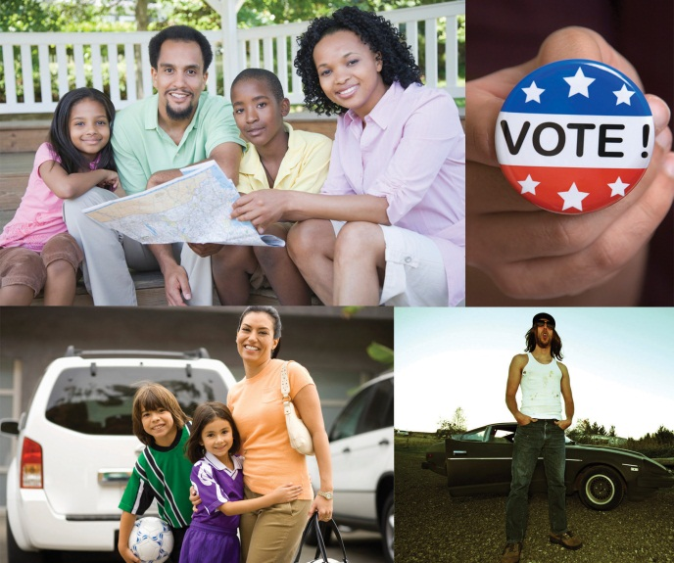
The news media often try to identify a swing voter group that will be key to an election campaign. Sometimes, their choices say more about the demographics of their audiences (or even of their reporters) than about the impact on the election.
The media use stereotypes in their campaign reporting to characterize groups of voters. Media attention focused on the “angry voter” for almost two decades beginning in the 1980s. At first, it was “angry white males” who emerged in response to political correctness. By the 1990s, the focus had shifted to “soccer moms” who were portrayed as being disgusted with politics. Yet studies showed that most white males and soccer moms were not upset about politics and that they did not vote as a bloc. During the 2008 campaign, the press highlighted McCain and Obama’s outreach to “NASCAR dads,” who were portrayed as a rowdy, beer guzzling crowd with lower levels of education and income than other voters. In fact, NASCAR fans’ socioeconomic status mirrors that of the general population, and they hail from all walks of life. ^{[2]}
Stereotyping has implications for political participation and policymaking. Stereotypes can form the basis of campaign and policy agendas. The media give the impression that the votes and opinions of “angry white males” who saw taxes and defense as priority issues, and “soccer moms” who were concerned about child care and education, count more than those of other people. As a result, candidates and political leaders may direct more of their attention toward this issue. Media stereotypes legitimate the ideas and causes of particular groups, while discounting those of others. ^{[3]}

Media Consequences
Scholars disagree about the effects of mass media on political participation. Some argue that the media serve the public by providing information that stimulates political interest, furthers information gathering, and encourages participation. The result is a “virtuous circle” that promotes political engagement. ^{[4]} During the 2008 presidential election, the media stimulated public interest with its campaign coverage that incorporated voters’ voices through innovated new media, such as blogs and amateur video reports. Others contend that the media’s scandal-ridden and negative coverage of government and politics creates a “spiral of cynicism” by generating public distrust, discouraging interest, eroding attention to the news, and ultimately hindering participation. ^{[5]} Public opinion about government fell in the wake of the nonstop coverage of President Bill Clinton’s affair with White House intern Monica Lewinsky. Neither of these perspectives alone tells the full story, as both positive and negative media effects can result depending on coverage.
The media, in some instances, may have no effect on participation. People may not pay attention to political media or take media messages seriously. They assess politics on the basis of their own personal experiences or those of their families and friends. The decision to participate is related to their membership in groups and social networks, being contacted by a political party or interest group, or a sense of civic duty and efficacy. Thus some individuals’ participation or inaction is influenced by their personal realities rather than mediated realities.
Some scholars contend that the media create a situation wherein passive monitoring of politics substitutes for real action. ^{[6]} People spend time watching television instead of participating in community activities, such as holding local office or volunteering at a homeless shelter. Political scientist Robert Putnam argues that television may be making the United States a nation of watchers rather than doers who are more likely to “bowl alone” than to work with others. ^{[7]}

KEY TAKEAWAYS
The media offer opportunities for political participation. People can engage using the Internet to express their opinions, share information, organize political events, support candidates, and encourage others to get involved.
The media’s relationship to political participation is complex. The press can stimulate or depress political activity, or it may have no effect on it. Media stereotypes of groups and their political participation can influence the amount of attention these groups get from political leaders. While some of the traditional institutions that mobilize people, such as political parties, have become less of a force, the mass media’s potential to have an impact on political action has grown.

EXERCISES
- How do people use the media to get involved in politics and make their opinions heard? What opportunities do new media create for people to become involved?
- In your opinion, is the way the media covers politics more likely to encourage people to become involved in politics or more likely to turn them off from politics? Why do you think that is?

Civic Education and Participation
A New Generation of Civil Rights Activists
The historic election of an African American president, Barack Obama, has energized a new generation of civil rights activists. Young people have become active in organizations whose membership was aging and their ranks dwindling. They have sought to keep the momentum of the election alive by organizing around issues, taking part in community affairs, and seeking positions in government and public affairs.
The National Association for the Advancement of Colored People (NAACP) was founded in 1909 and is the nation’s largest grassroots civil rights organization. The average age of NAACP members is fifty-five years old. The NAACP sought to revitalize its mission and membership on the coattails of the Obama election by ramping up its youth movement. The organization has seen a rise in the number of chapters on college campuses throughout the country. Young people also have activated more than six hundred “youth units” to carry out a campaign to increase college access and affordability.
Demar Lamont Roberts, a recent graduate of South Carolina State University in his twenties, became active in the NAACP to experience “the camaraderie, seeing civil rights persons that have come before me and paved the way for me.” He attended the 2009 NAACP national convention in Las Vegas so that he could interact with young people like himself who are passionate about social justice issues. He joined the leadership of the NAACP National Youth Work Committee, which is mobilizing around voting rights and other issues. Roberts used the social messaging platform Twitter to keep friends and associates informed about the convention. The NAACP website provides information about the organization’s history, current news, and ways to become involved.
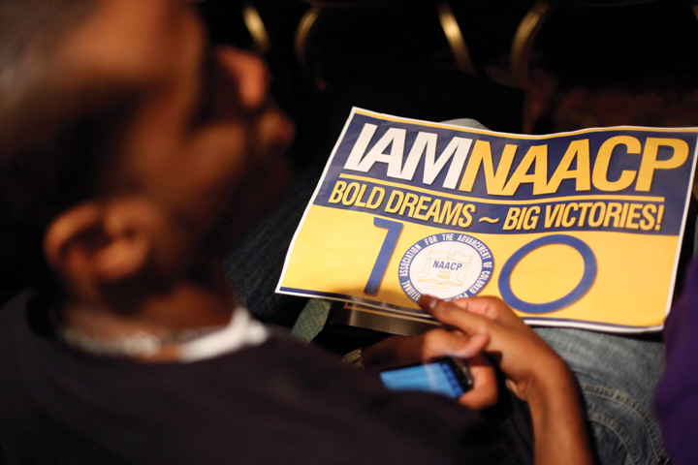
The 2009 NAACP convention offered young people the opportunity to learn about issues related to civil rights.
Source: Used with permission from AP Photo/Seth Wenig.

[1] Michael Grunwald, “At Capitol, Young Friends and Foe of Gun Control Test Each Other,Washington Post, July 19, 1999, A10.
[2] Liz Clarke, One Helluva Ride (New York: Villard, 2008).
[3] Barbara L. Poole and Melinda A. Mueller, “Alienation and the ‘Soccer Mom’: A Media Creation or a New Trend in Voting Behavior,” in Engaging the Public, ed. Thomas J. Johnson, Carol E. Hays, and Scott P. Hays (Boulder, CO: Rowman & Littlefield, 1998), 29–40; Susan J. Carroll, “The Disempowerment of the Gender Gap: Soccer Moms and the 1996 Elections,”PS Online, March, 1999, http://www.apsanet.org.
[4] Pippa Norris, A Virtuous Circle: Political Communications in Postindustrial Societies (New York: Cambridge University Press, 2003).
[5] Joseph Cappella and Kathleen Hall Jamieson, Spiral of Cynicism: The Press and the Public Good (New York: Oxford University Press, 1997).
[6] Roderick P. Hart, Seducing America: How Television Charms the Modern Voter (New York: Oxford University Press, 1994).
[7] Robert Putnam, Bowling Alone: America’s Declining Social Capital (New York: Simon & Schuster, 2000).

8.6 Recommended Reading
Conway, M. Margaret. Political Participation in the United States, 3rd ed. Washington, DC: CQ Press, 2000. An overview of trends in political participation.
Foot, Kirsten A, and Steven M. Schneider. Web Campaigning. Cambridge, MA: MIT Press, 2006. An examination of the evolution of the use of the Internet in election campaigns.
Frantzich, Stephen E. Citizen Democracy. Lanham, MD: Rowman & Littlefield, 1999. A series of compelling stories of how average people have made a difference through political participation.
Freeman, Jo, and Victoria Johnson, eds. Waves of Protest. Lanham, MD: Rowman & Littlefield, 1999. A collection of articles on a variety of protest movements, including AIDS activism, the fight for the rights of the disabled, and the women’s movement of the 1990s.
Hindman, Matthew. The Myth of Digital Democracy. Princeton, NJ: Princeton University Press, 2008. Hindman discusses the common contention that the Internet has made political participation more accessible to the general public and finds instead that online politics is dominated by a new, technologically savvy elite.
Jacobs, Lawrence R., Fay Lomax Cook, and Michael X. Delli Carpini. Talking Together: Public Deliberation and Political Participation in America. Chicago: University of Chicago Press, 2009. The authors examine how and why citizens engage in political conversations that can contribute to political participation.
Johnson, Thomas J., Carol E. Hays, and Scott P. Hays, eds. Engaging the Public. Lanham, MD: Rowman & Littlefield, 1998. Scholars and journalists discuss ways in which government and the mass media can stimulate political activity.
Piven, Frances Fox, and Richard A. Cloward. Why Americans Still Don’t Vote. Boston: Beacon Press, 2000. Discusses historical trends in voter turnout, and provides explanations for nonvoting.
Schier, Stephen E. By Invitation Only: The Rise of Exclusive Politics in the United States. Pittsburgh, PA: University of Pittsburgh Press, 2000. Contends that American political participation falls short of democratic ideals because political parties, interest groups, and campaigns target small exclusive segments of the population with their activation strategies. The importance of money for successful mobilization efforts is emphasized.
Schudson, Michael. The Good Citizen. New York: Free Press, 1998. Schudson provides a historical overview of civic participation in the United States, including a discussion of the part played by mass media at each stage of development.
Skocpol, Theda, and Morris P. Fiorina, eds. Civic Engagement in American Democracy. Washington, DC: Brookings, 1999. A collection of essays that attempts to sort out the reasons for and implications of Americans’ disappointing levels of political participation.

8.7 Recommended Viewing
Election (1999). A dark comedy, starring Reese Witherspoon and Matthew Broderick, about a high school election that goes awry.
Eyes on the Prize (1988). An award-winning documentary about the civil rights movement.
Forrest Gump (1994). Tom Hanks stars in this film about a simple man who witnesses historical events between the 1950s and the 1980s, including social movements and protests.
Seeing Red (1984). A documentary film about the political dedication, activities, lives, and fates of American communists.
This Is What Democracy Looks Like (1999). A documentary covering the World Trade Organization (WTO) protests in 1999.
Unfinished Symphony (2001). A documentary film that focuses on a three-day protest march in 1971 tracing the path of Paul Revere’s 1775 ride by newly returned veterans of the Vietnam War, including a young John Kerry, who became a US Senator.
The War at Home (1980). This documentary film chronicles the evolution of the Vietnam protest movement focusing on the college town of Madison, Wisconsin in 1969.

Chapter 9

Interest Groups

Preamble
The media often depict interest group lobbyists negatively in the news and in entertainment. One particular episode of The Simpsons provides an extreme example. Lisa Simpson writes an essay titled “The Roots of Democracy” that wins her a trip to Washington, DC, to compete for the best essay on patriotism award. She writes, “When America was born on that hot July day in 1776, the trees in Springfield Forest were tiny saplings…and as they were nourished by Mother Earth, so too did our fledgling nation find strength in the simple ideals of equality and justice.”
In Senator Bob Arnold’s office a lobbyist proposes to raze the Springfield National Forest. Arnold responds, “Well, Jerry, you’re a whale of a lobbyist, and I’d like to give you a logging permit, I would. But this isn’t like burying toxic waste. People are going to notice those trees are gone.” The lobbyist offers a bribe, which Arnold accepts.
Lisa sees it happen and tears up her essay. She sits on the steps of the Capitol and envisions politicians as cats scratching each other’s backs and lobbyists as pigs feeding from a trough. Called to the microphone at the “Patriots of Tomorrow” awards banquet, Lisa reads her revised essay, now titled “Cesspool on the Potomac.” A whirlwind of reform-minded zeal follows. Congressman Arnold is caught accepting a bribe to allow oil drilling on Mount Rushmore and is arrested and removed from office. Lisa does not win the essay contest. ^{[1]}
Congressman Arnold is corrupt, but the cartoon’s unpunished instrument of corruption is the lobbyist.

[1] Matt Groening, James L. Brooks, Sam Simon, and George Meyer, “Mr. Lisa Goes to Washington,” The Simpsons, Season 3, Episode 2, originally aired September 26, 1991. This episode is loosely based on the movie Mr. Smith Goes to Washington.

9.1 The Interest Group System

LEARNING OBJECTIVES
After reading this section, you should be able to answer the following questions:
- What are interest groups?
- What are the main types of interest groups?
- What are the most important elements of interest groups?
- What incentives encourage interest group membership?
- How do interest groups recruit members?
- How do the media portray unions and union activity?
- How do interest groups influence elections?
Interest groups are intermediaries linking people to government, and lobbyists work for them. These groups make demands on government and try to influence public policies in their favor. Their most important difference from political parties is that they do not seek elective office. Interest groups can be single entities, join associations, and have individual members. The University of Texas at Austin is an educational institution. Its main purposes are teaching and research. Like other educational institutions, it is an interest group when it tries to influence government policies. These policies include government funding for facilities and student grants, loans, and work study. It may also try to influence laws and court decisions applying to research, admissions, gender equality in intercollegiate sports, and student records. It may ask members of Congress to earmark funds for some of its projects, thereby bypassing the normal competition with other universities for funds based on merit. ^{[1]}
Figure 9.1 University of Texas Logo (“Disciplina Praesidium Civitatis,” translated as “The cultivated mind is the guardian genius of democracy”)
Devoted to education (and sports), universities try to influence government policies that affect their interests.
Source:http://www.flickr.com/photos/ostraconlist/5261743505/.
Single entities often join forces in associations. Associations represent their interests and make demands on government on their behalf. The University of Texas belongs to the Association of American Universities. General Electric (GE) belongs to over eighty trade associations, each representing a different industry such as mining, aerospace, and home appliances. ^{[2]}
Many interest groups have individuals as members. People join labor unions and professional organizations (e.g., associations for lawyers or political scientists) that claim to represent their interests.

Types of Interest Groups
Interest groups can be divided into five types: economic, societal, ideological, public interest, and governmental.

Economic Interest Groups
The major economic interest groups represent businesses, labor unions, and professions. Business interest groups consist of industries, corporations, and trade associations. Unions usually represent individual trades, such as the International Brotherhood of Teamsters. Most unions belong to an association, the American Federation of Labor-Congress of Industrial Organizations (AFL-CIO).
Economic interest groups represent every aspect of our economy, including agriculture, the arts, automobiles, banking, beverages, construction, defense, education, energy, finance, food, health, housing, insurance, law, media, medicine, pharmaceuticals, sports, telecommunications, transportation, travel, and utilities. These groups cover from head (i.e., the Headwear Institute of America) to toe (i.e., the American Podiatric Medical Association) and from soup (i.e., the Campbell Soup Company) to nuts (i.e., the Peanut Butter and Nut Processors Association). ^{[3]}

Societal Interest Groups
Societal interest groups focus on interests based on people’s characteristics, such as age, gender, race, and ethnicity, as well as religion and sexual preference. The National Association for the Advancement of Colored People(NAACP) is one of the oldest societal interest groups in the United States.

Ideological Interest Groups
Ideological interest groups promote a reactionary, conservative, liberal, or radical political philosophy through research and advocacy. Interest groups that take stands on such controversial issues as abortion and gun control are considered ideological, although some might argue that they are actually public interest groups.

Public Interest Groups
Public interest groups work for widely accepted concepts of the common good, such as the family, human rights, and consumers. Although their goals are usually popular, some of their specific positions (e.g., environmental groups opposing offshore drilling for oil) may be controversial and challenged.

Government Interest Groups
Government interest groups consist of local, state, and foreign governments. They seek to influence the relevant policies and expenditures of the federal government.

Life Stages of Interest Groups
Interest groups commonly experience a life cycle of creation (or birth), growth and change (or evolution), and sometimes death.

Creation
As the United States has become more complex with new technologies, products, services, businesses, and professions, the US government has become more involved in the economy and society. People with common interests organize to solicit support and solutions to their problems from government. Policies enacted in response to the efforts of these groups affect other people, who then form groups to seek government intervention for themselves. These groups may give rise to additional groups. ^{[4]}
Some interest groups are created in reaction to an event or a perceived grievance. The National Right to Life Committee (NRLC) was founded in 1973 in response to the US Supreme Court’s Roe v. Wade decision earlier that year legalizing abortion. However, groups may form long after the reasons for establishing them are obvious. The NAACP was not founded until 1909 even though segregation of and discrimination against black people had existed for many years.

Link
Oral Arguments in Roe v. Wade
Listen to oral arguments in the Roe v. Wade athttp://www.oyez.org/cases/1970-1979/1971/1971_70_18/arguments.
Interest group entrepreneurs usually are important in the creation of groups. Often they are responding to events in their lives. After a drunk driver killed one of her daughters, Candy Lightner founded Mothers Against Drunk Driving (MADD) in 1980. She thereby identified latent interests: people who could be grouped together and organized to pursue what she made them realize was a shared goal, punishing and getting drunk drivers off the road. She was helped by widespread media coverage that brought public attention to her loss and cause.

Evolution and Demise
Interest groups can change over time. The National Rifle Association (NRA) started out as a sports organization in the late nineteenth century dedicated to improving its members’ marksmanship. It became an advocate for law and order in the 1960s, until its official support for the 1968 Gun Control Act brought dissension in its ranks. Since the election of new leaders in 1977, the NRA has focused on the Second Amendment right to bear arms, opposing legislation restricting the sale or distribution of guns and ammunition. ^{[5]}
Interest groups can also die. They may run out of funds. Their issues may lose popularity or become irrelevant. Slavery no longer exists in the United States and thus neither does the American Anti-Slavery Society.

How Interest Groups Are Organized
Interest groups have leaders and staff. They control the group, decide its policy objectives, and recruit and represent members.

Leaders and Staff
Leaders and top staff usually run the interest group. They do so because they command its resources and information flow and have the experience and expertise to deal with public policies that are often complex and technical. Almost a century ago, Robert Michels identified this control by an organization’s leaders and staff and called it “the iron law of oligarchy.” ^{[6]}
This oligarchy, or rule by the few, applies to single-entity interest groups and to most associations. Their leaders are appointed or elected and select the staff. Even in many membership organizations, the people who belong do not elect the leaders and have little input when the leaders decide policy objectives. ^{[7]} Their participation is limited to sending in dues, expressing opinions and, if membership is voluntary, leaving when dissatisfied.

Voluntary Membership
People join membership interest groups voluntarily or because they have no choice.
When membership is voluntary, interest groups must recruit and try to retain members. Members help fund the group’s activities, legitimize its objectives, and add credibility with the media.
Some people may not realize or accept that they have shared interests with others on a particular issue. For example, many young adults download music from the Internet, but few of them have joined the Future of Music Coalition, which is developing ways to do this legally. Others may be unwilling to court conflict by joining a group representing oppressed minorities or espousing controversial or unpopular views even when they agree with the group’s views.^{[8]}
People do not need to join an interest group voluntarily when they can benefit from its activities without becoming a member. This is the problem of collective goods. Laws successfully lobbied for by environmental organizations that lead to cleaner air and water benefit members and nonmembers alike. However, the latter get a free ride. ^{[9]}
There are three types of incentives that, alone or in combination, may overcome this free-rider problem. A purposive incentive leads people voluntarily to join and contribute money to a group because they want to help the group achieve its goals. Membership in the American Civil Liberties Union (ACLU) increased by one hundred thousand in the eighteen months following the 9/11 attacks as the group raised concerns that the government’s antiterrorism campaign was harming civil liberties. ^{[10]} In addition, people may join groups, such as the Union of Concerned Scientists, because of a solidary incentive. The motivation to join the group stems from the pleasure of interacting with like-minded individuals and the gratification of publicly expressing one’s beliefs.
People may also join groups to obtain material incentives available only to members. AARP, formerly the American Association of Retired Persons, has around thirty-five million members. It obtains this huge number by charging a nominal annual membership fee and offering such material incentives as health insurance and reduced prices for prescription drugs. The group’s magazine is sent to members and includes tax advice, travel and vacation information, and discounts.

Recruitment
One way interest groups recruit members is through media coverage. The appealingly named Center for Science in the Public Interest (CSPI) is a consumer organization that focuses on food and nutrition issues, produces quality research, and has media savvy. It is a valuable source of expertise and information for journalists. The frequent and favorable news coverage it receives brings the group and its activities to the public’s attention and encourages people to support and join it.
News coverage of an interest group does not always have to be favorable to attract members. Oftentimes, stories about the NRA in major newspapers are negative. Presenting this negative coverage as bias and hostility against and attacks on gun owners, the group’s leaders transform it into purposive and solidary incentives. They use e-mail “to power membership mobilization, fund raising, single-issue voting and the other actions-in-solidarity that contribute to [their] success.” ^{[11]}
Groups also make personalized appeals to recruit members and solicit financial contributions. Names of people who might be sympathetic to a group are obtained by purchasing mailing lists from magazines, other groups, and political parties. Recruitment letters and e-mails often feature scare statements, such as a claim that Social Security is in jeopardy.
Interest groups recruit members, publicize their activities, and pursue their policy objectives through the new media. The Save Our Environment Action Center consists of twenty national environmental groups pooling their databases of supporters and establishing a website. Through this network, people can receive informational newsletters via e-mail, sign petitions, and contact their representatives.

Required Membership
Employment in most automobile plants requires that workers are members of the International Union, United Automobile, Aerospace and Agricultural Implement Workers of America (UAW). Workers fought to establish unions to improve their wages, working conditions, and job opportunities. One way of achieving these objectives was to require all workers at a plant to be union members. But union membership has plummeted as the United States has moved from a manufacturing to a service economy and employers have effectively discouraged unionization. Many jobs do not have unions for workers to join whether they want to or not. Today only about 12 percent of workers belong to a union compared to a high of 35.5 percent in 1945. Only 7 percent of private sector workers belong to a union. A majority of union members now work for the government.

Media Depictions of Unions
One reason for the decline of unions is their mainly negative portrayal in the mass media. ^{[12]} There are hardly any labor-beat reporters in the news media, so union officials are infrequently used as sources and are consequently unable to frame union news to their advantage.
Strikes are the union action most often shown in the news. These are usually framed not as legitimate collective tactics to improve wages and working conditions, but as hurting or inconveniencing consumers by disrupting services (e.g., suspending classes in elementary and high schools) and causing the cancellation of events (e.g., professional sporting games). ^{[13]}
Unions are rare in movies. Norma Rae (1979), Matewan (1987), and the documentary Harlan County, USA (1977), favorably portray workers’ struggles to organize and strike for better working conditions, wages, and security, against exploiting employers. But in the classic union film, the Academy Award–winning On the Waterfront (1954), the union is corrupt, violent, and linked to organized crime; the union leaders exploit members to enrich themselves.

Representation
Groups claim to represent the interests of their members or constituents, but these interests may conflict. In an extensive study, Dara Z. Strolovitch found that civil rights organizations prioritized the interests of their middle-class members over the interests of the poor and working class. For example, they pushed for affirmative action rather than welfare and antipoverty policies. ^{[14]}
A problem for AARP is that, aside from being fifty or over, its members may have little in common. In 1988, AARP supported legislation setting up a catastrophic health insurance plan in Medicare to provide insurance for elderly people faced with huge medical bills for major illnesses. After the plan went into effect, many seniors objected to the increase in their Medicare premiums and an annual surtax of as high as $800. Their complaints were widely covered in the media. Congress repealed the program the next year.
Even when members share a group’s general goals they may reject some of its policy proposals or tactics. In 2009, Apple quit the US Chamber of Commerce because the chamber opposed global-warming legislation.

Interest Groups and Elections
Interest groups become involved in elections to influence policymakers. They may contribute funds, make independent expenditures, advocate issues, and mobilize voters. Wealthy groups help pay for the presidential nominating conventions and the presidential inauguration. They give funds to political parties because “by helping party leaders retain or regain control of the House or Senate, policymaking rewards…follow.” ^{[15]}

Endorsing Candidates
Interest groups may endorse candidates for office and, if they have the resources, mobilize members and sympathizers to work and vote for them. President Bill Clinton blamed the NRA for Al Gore losing the 2000 presidential election because it influenced voters in several states, including Arkansas, West Virginia, and Gore’s home state of Tennessee. Had any of these states gone for Gore, he would have won the election.
Interest groups can promote candidates through television and radio advertisements. During the 2004 presidential election, the NRA ran a thirty-minute infomercial in battleground states favoring President George W. Bush and calling his opponent “the most anti-gun presidential nominee in United States history.” In 2008, the NRA issued ads endorsing Republican presidential candidate John McCain and his running mate, Sarah Palin.
Endorsements do carry risks. If the endorsed candidate loses, the unendorsed winner is likely to be unsympathetic to the group. Thus relatively few interest groups endorse presidential candidates and most endorsements are based on ideology.

Funding Candidates
Made possible by the 1971 Federal Election Campaign Act (FECA),political action committees (PACs) are a means for organizations, including interest groups, to raise funds and contribute to candidates in federal elections. Approximately one-third of the funds received by candidates for the House of Representatives and one-fifth of funds for Senate candidates come from PACs. The details of election funding are discussed further in Chapter 11 "Campaigns and Elections".
However, in January 2010 the Supreme Court ruled that the government cannot ban political spending by corporations in candidate elections. The court majority justified the decision on the grounds of the First Amendment’s free speech clause. The dissenters argued that allowing unlimited spending by corporations on political advertising would corrupt democracy. ^{[16]}
Many interest groups value candidates’ power above their ideology or voting record. Most PAC funds, especially from corporations, go to incumbents. Chairs and members of congressional committees and subcommittees who make policies relevant to the group are particularly favored. The case of Enron, although extreme, graphically reveals such funding. Of the 248 members of Congress on committees that investigated the 2002 accounting scandals and collapse of the giant corporation, 212 had received campaign contributions from Enron or its accounting firm, Arthur Andersen. ^{[17]}
Some interest groups do fund candidates on the basis of ideology and policy preference. Ideological and public interest groups base support on candidates’ views even if their defeat is likely. Pro-life organizations mainly support Republicans; pro-choice organizations mainly support Democrats.
The interest group–candidate relationship is a two-way street. Many candidates actively solicit support from interest groups on the basis of an existing or the promise of a future relationship. Candidates obtain some of the funds necessary for their campaigns from interest groups; the groups who give them money get the opportunity to make their case to sympathetic legislators. A businessman defending his company’s PAC is quoted as saying, “Talking to politicians is fine, but with a little money they hear you better.” ^{[18]}
Much better. The Center for Responsive Politics shows correlations between campaign contributions and congressional voting. After the House of Representatives voted 220–215 in 2003 to pass the Medicare drug bill, the organization reported that “lawmakers who voted to approve the legislation have raised an average of roughly twice as much since 1999 from individuals and PACs associated with health insurers, HMOs [Health Maintenance Organizations] and pharmaceutical manufacturers as those who voted against the bill.” ^{[19]}

KEY TAKEAWAYS
Interest groups are diverse in membership and purpose. They are created, may evolve in composition and goals, and sometimes die out. Interest group entrepreneurs may be integral to the creation of interest groups. Different types of incentives encourage interest group membership, and organizations use various methods to recruit new members. The media are particularly critical of labor unions. Interest groups try to influence elections in order to advance their policy objectives.

EXERCISES
- Why do you think some interest groups have a bad reputation? What social purpose do interest groups serve?
- Do you support any interest groups? What made you decide to support them?
- What are the different ways interest groups can influence policies? Do you think interest groups should be allowed to contribute as much as they want to political campaigns?

[1] James D. Savage, Funding Science in America: Congress, Universities, and the Politics of the Academic Pork Barrel (New York: Cambridge University Press, 1999); and Jeffrey Brainard and J. J. Hermes, “Colleges’ Earmarks Grow, Amid Criticism,” Chronicle of Higher Education, March 28, 2008.
[2] Kay Lehman Schlozman and John T. Tierney, Organized Interests and American Democracy (New York: Harper & Row, 1986), 72–73.
[3] Jeffrey H. Birnbaum, The Lobbyists: How Influence Peddlers Work Their Way in Washington (New York: Times Books, 1993), 36.
[4] This is known as disturbance theory. It was developed by David B. Truman in The Governmental Process: Political Interests and Public Opinion, 2nd ed. (New York: Alfred A. Knopf, 1971), chap. 4; and it was amplified by Robert H. Salisbury in “An Exchange Theory of Interest Groups,” Midwest Journal of Political Science 13 (1969): 1–32.
[5] Scott H. Ainsworth, Analyzing Interest Groups: Group Influence on People and Policies(New York: W. W. Norton, 2002), 87–88.
[6] Robert Michels, Political Parties: A Sociological Study of the Oligarchical Tendencies of Modern Democracy (New York: Dover Publications, 1959; first published 1915 by Free Press).
[7] Scott H. Ainsworth, Analyzing Interest Groups: Group Influence on People and Policies(New York: W. W. Norton, 2002), 114–15.
[8] Scott Sigmund Gartner and Gary M. Segura, “Appearances Can Be Deceiving: Self Selection, Social Group Identification, and Political Mobilization,” Rationality and Society9 (1977): 132–33.
[9] See Mancur Olson Jr., The Logic of Collective Action: Public Goods and the Theory of Groups (Cambridge, MA: Harvard University Press, 1965).
[10] Eric Lichtblau, “F.B.I. Leader Wins a Few at Meeting of A.C.L.U.,” New York Times, June 14, 2003, accessed March 23, 2011, http://www.nytimes.com/2003/06/14/us/fbi-leader-wins-a-few-at-meeting-of-aclu.html?ref=ericlichtblau.
[11] Brian Anse Patrick, The National Rifle Association and the Media: The Motivating Force of Negative Coverage (New York: Peter Lang, 2002), 9.
[12] William J. Puette, Through Jaundiced Eyes: How the Media View Organized Labor(Ithaca, NY: ILR Press, 1992).
[13] For an exception, see Deepa Kumar, Outside The Box: Corporate Media, Globalization, and the UPS Strike (Urbana: University of Illinois Press, 2007).
[14] Affirmative Advocacy: Race, Class, and Gender in Interest Group Politics (Chicago: University of Chicago Press, 2007).
[15] Michael M. Franz, Choices and Changes: Interest Groups in the Electoral Process(Philadelphia, PA: Temple University Press, 2008), 7.
[16] The case is Citizens United v. Federal Election Commission, No. 08–205. See also Adam Liptak, “Justices, 5-4, Reject Corporate Spending Limit,” New York Times, January 21, 2010, accessed March 23, 2011,http://www.nytimes.com/2010/01/22/us/politics/22scotus.html.
[17] Don Van Natta Jr., “Enron’s Collapse: Campaign Finance; Enron or Andersen Made Donations to Almost All Their Congressional Investigators,” New York Times, January 25, 2002, accessed March 23, 2011, http://www.nytimes.com/2002/01/25/business/enron-s-collapse-campaign-finance-enron-andersen-made-donations-almost-all- their.html.
[18] Mark Green, “Political PAC-Man,” New Republic 187, no. 24 (December 13, 1982): 18.
[19] Center for Responsive Politics, “Money and Medicare: Campaign Contributions Correlate with Vote,” OpenSecrets Blog, November 24, 2003,http://www.opensecrets.org/capital_eye/inside.php?ID=113.

9.3 Interest Groups and the Political System

LEARNING OBJECTIVES
After reading this section, you should be able to answer the following questions:
- What factors determine an interest group’s success?
- What are the levels of influence that interest groups can possess in their relations with policymakers?
- What is pluralism?
- What are the strengths and weaknesses of business interest groups?
In the book The Israel Lobby and U.S. Foreign Policy, John J. Mearsheimer and Stephen M. Walt argue that the activities of interest groups, notably theAmerican Israel Public Affairs Committee, are one reason why, since World War II, the United States has provided more direct economic and military support to Israel than any other ally and pursues a policy of preserving and enhancing Israel’s security. ^{[1]} This raises the question of why interest groups succeed or fail to achieve their policy objectives.

Why Interest Groups Are (or Are Not) Successful
The main factors determining an interest group’s effectiveness are its assets, objectives, alliances, the visibility of its involvement in policy decisions, and its responses to political change and crises, plus, of course, the media’s depiction of it.

Assets
Successful interest groups have prestige, respected leadership, political skills, and ample finances. The Business Roundtable, composed of the chief executives of the two hundred leading corporations, has them all and thus has access to and influence on policymakers. Monetary assets allow groups to contribute to political campaigns through their political action committees (PACs).
The status and distribution of an interest group’s members also contribute to its success. Automobile dealers are influential and live, as do their employees, in congressional districts across the country. After President Barack Obama proposed putting automobile loans under the oversight of a new federal consumer authority aimed at protecting borrowers from abusive lender, the dealers’ lobbying arm, the National Automobile Dealers Association, organized opposition, including trips to Washington for some of the eighteen thousand dealers to meet and plead their case with their legislators. ^{[2]} Congress exempted auto dealers from the regulation.

Objectives
The ease or difficulty of achieving a group’s goals can determine its success. Preventing legislation from being enacted is usually easier than passing it. In a comprehensive study of interest group activities during the last two years of the Clinton administration and the first two years of the George W. Bush administration, researchers found that although some advocates succeed eventually in changing policy, “[t]he vast bulk of lobbying in Washington has to do not with the creation of new programs, but rather with the adjustment of existing programs or with the maintenance of programs just as they are.” ^{[3]}
Moreover, legislation enacted over the opposition of powerful interest groups, tends to be watered down. Or the political costs of its passage are so heavy that its proponents in the presidential administration and Congress are discouraged from challenging the groups again.

Alliances
Interest groups sometimes cooperate with other groups to help them achieve a policy objective they could not accomplish alone. A coalition expands resources, broadens expertise, and adds to the credibility of the policy objectives. Alliances are often of natural allies such as the National Restaurant Association, the American Nursery and Landscape Association, and theNational Council of Agricultural Employers, who united to oppose restrictions on immigration and penalties on businesses that employ illegal immigrants. But they can be made up of strange bedfellows, as when the American Civil Liberties Union (ACLU) and the National Rifle Association (NRA) allied to oppose the US Department of Justice putting raw, unsubstantiated data into a national computer network. For the ACLU, it was a violation of people’s right to privacy; for the NRA, it was a move toward denying people the right to bear arms. ^{[4]}

Visibility of Policy Involvement
Interest groups are often most successful when their activities are unreported by the media, unscrutinized by most policymakers, and hidden from the public. Opposition to a group’s activities is difficult when they are not visible. As one lobbyist observed, “A lobby is like a night flower, it thrives in the dark and dies in the sun.” ^{[5]}
In what are called iron triangles, or subgovernments, policy on a subject is often made by a relatively few people from Congress, the bureaucracy, and interest groups. A classic iron triangle has been veterans’ affairs policy. Members of Congress chairing the relevant committees and subcommittees and their aides, key agency administrators from the US Department of Veterans Affairs, and representatives from interest groups such as the American Legion and the Veterans of Foreign Wars (VFW) have interacted and dominated policymaking. ^{[6]} This policymaking has taken place with low visibility and very little opposition to the benefits provided for veterans. In general, the news media pay little attention to iron triangles in the absence of conflict and controversy, and interest groups are likely to achieve many of their objectives.

Political Change and Crises
Whether interest groups defend what they have or go on the offense to gain new benefits often depends on who is in control of the government. Some interest groups’ goals are supported or opposed far more by one political party than another. A new president or a change in party control of Congress usually benefits some groups while putting others at a disadvantage. The Republican takeover of the House of Representatives in the 2010 election put a brake on new regulation of business by Congress, reduced funds for regulators to hire staff and enforce regulation, and limited investigations of industry practices.
Crises, especially ones extensively depicted by the media, often involve politicians and interest groups trying to achieve or prevent policy changes. Looking to exploit the horrific BP (British Petroleum) oil spill of 2010 in the Gulf of Mexico (which was widely covered in the media and replete with images of the oil-infested waters and oil-coated beaches and wildlife), environmentalists and their congressional allies worked for “measures to extend bans on new offshore drilling, strengthen safety and environmental safeguards, and raise to $10 billion or more the cap on civil liability for an oil producer in a spill.” ^{[7]}Opposing them were the oil and gas industry, which, according to the Center for Responsive Politics, spent $174.8 million on lobbying in 2009, and its allies in Congress from such oil states as Texas and Louisiana.

Relations between Interest Groups and Policymakers
When viewed overall, there is a hierarchy in the influence of relations between interest groups and policymakers. ^{[8]}
- At the top, the interest group makes policy. This is uncommon.
- More common, the group maintains close political relations with policymakers.
- The group has an unchallengeable veto status over some governmental decisions, for example, over a presidential appointment.
- The group receives some attention from policymakers but mainly has a pressure relationship with them.
- The group has only a potential reprisal relationship with policymakers; it can threaten to oppose a member of Congress at the next election.
- At the bottom of the ladder, rejected by policymakers, the group is left to agitate and resist; its public demonstrations usually signify its inability to achieve its objectives by less visible means.
The relationships between interest groups and policymakers vary depending on the administration in power. Energy companies had a close political support and referral relationship with the George W. Bush administration but primarily a pressure relationship with the Obama administration. Relationships also vary by subject. For example, a Democratic president’s choice to head the US Department of Labor may have to be acceptable to the American Federation of Labor and Congress of Industrial Organizations (AFL-CIO), but the union organization has little influence over other cabinet appointments.

Who Benefits from Interest Groups?
In Federalist No. 10, James Madison warns of the dangers of factions: “[A] number of citizens, whether amounting to a majority or minority of the whole, who are united and actuated by some common impulse of passion, or of interest, adverse to the rights of other citizens, or to the permanent and aggregate interests of the community.” ^{[9]} Madison believed that factions were inevitable, because their causes were “sown in the nature of man.” ^{[10]}
Madison’s factions are not exactly today’s interest groups. Indeed, interest groups, by representing diverse segments of society, offset one of Madison’s concerns—the domination of the majority. Nonetheless, his warning raises important questions about the effects of interest groups.

Pluralism: Competition among Groups
Briefly stated, pluralism is the theory that competition among interest groups produces compromise and balance among competing policy preferences. For pluralists, the abundance of interest groups, the competition between them, and their representation of interests in society are inherent in American democracy. Bargaining between groups and ever-changing group alliances achieve a desirable dispersion of power or at least an acceptable balancing of the various interests in society. ^{[11]}
Pluralists acknowledge that some groups might dominate areas where their interests are paramount. But they believe two factors rectify this situation. Inoverlapping membership, people belonging to several interest groups encourage negotiation and compromise. And underrepresented people will in time establish groups to assert their interests.

The Advantage of Business
An argument against pluralism is that business has an advantage over other segments of society, particularly the poor and the working class. These Americans lack the disposable income and political skills to organize. The issues that concern them are often absent from the policy agenda. ^{[12]} Business sponsors political advertisements, gives campaign contributions through PACs, donates to political parties, hires law and public relations firms, and funds research advocacy groups promoting free-market economics. A corporation can deploy multiple lobbyists and obtain access to various policymakers by joining several trade groups, belonging to business associations such as the US Chamber of Commerce, and using its CEO and other personnel from headquarters to lobby. ^{[13]}
Business and trade associations make up approximately 70 percent of the organizations with representation in Washington, DC. ^{[14]} Add interest groups representing professionals, and they account for approximately 85 percent of total spending on lobbying. ^{[15]}
Quite often a policy appears only to affect specific corporations or industries and therefore does not receive much media or public attention. ^{[16]} The Walt Disney Company’s copyright on Mickey Mouse was due to expire in 2003 and those on Pluto, Goofy, and Donald Duck would expire soon after. In 2000, after lobbying and well-placed campaign contributions by Disney, Congress extended all copyrights for twenty more years. ^{[17]}
Business is not monolithic. Interests conflict between and among industries, individual corporations, and organizations representing professionals. Large businesses can have different objectives than small businesses. The interests of manufacturers, distributors, and retailers can clash. Moreover, even when business is united, its demands are not necessarily gratified immediately and absolutely, especially when the issue is visible and the demands provoke opposition.

Negative Depictions of Business
The media often depict business interest groups negatively, which can limit the groups’ influence. Witness, for example, stories about the dubious dealings and bankruptcy of corporations such as Enron, the trials of corporate leaders who have pillaged their companies, and the huge salaries and bonuses paid in financial and related business sectors.
Corporations and their executives are commonly the villains in popular films including RoboCop (1987), Wall Street (1987), The Naked Gun 2 and ½: The Smell of Fear (1991), and the documentaries of Michael Moore, particularlyRoger and Me (1989). Television news stories oftentimes portray the big business sector as buying access and favors with lavish campaign contributions and other indulgences, wielding undue influence on the policy process, and pursuing its interests at the expense of the national interest. ^{[18]} Newspapers similarly frame business interest groups and their lobbyists as involved in dubious activities and exercising power for private greed. Typical is the New York Times’ headline: “Vague Law and Hard Lobbying Add Up to Billions for Big Oil.” ^{[19]}
These stories could frame business interest groups more positively. They could point out that business lobbyists favor essential and deserving objectives, present information and valid arguments to policymakers, and make their proposals in a political arena (i.e., Congress) in competition with other groups. However, the negative view of business is incarnated in the enduring image of the chairman of the seven leading tobacco companies testifying before Congress (Note 9.27 "Enduring Image").

Enduring Image
Big Tobacco Testifies Before Congress
On April 14, 1994, the chief executives of the leading tobacco companies stood up, raised their right hands, and swore before members of the subcommittee on Health and the Environment of the House of Representatives’ Committee on Energy and Commerce that nicotine was not addictive. The photograph of this moment, prominently featured in the US and foreign media, has become an enduring image of business executives who place the interests and profits of their corporations above the public interest even if it requires them to engage in self-deception, defy common sense about the dangers of their products, and give deceptive testimony under oath.
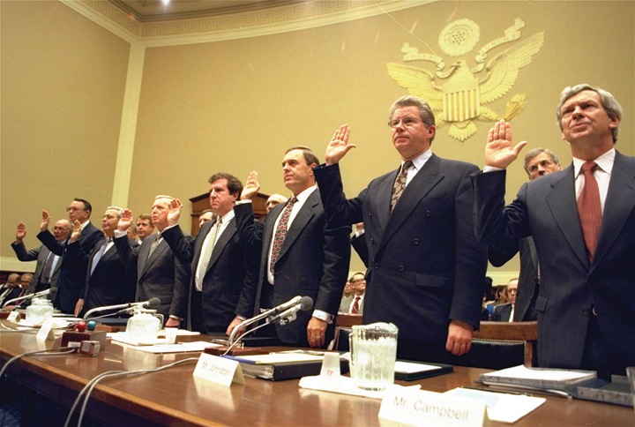
The chairmen of the seven leading tobacco companies swear that nicotine is not addictive.
Source: Used with permission from AP Photo/John Duricka.
Had one sat through the several hours of hearings, watched them on television, or read the transcript, the executives would have come across as less defiant and more reasonable. They agreed to give Congress unpublished research documents, acknowledged that cigarettes may cause various health problems including cancer and heart disease, and admitted that they would prefer that their children not smoke. ^{[20]} But the photo and its brief explanatory caption, not the complicated hearings, are the enduring image.
Why does this image of venal, almost criminal, tobacco executives endure? Simply put, television news’ continuing coverage of the litigation by state attorneys general against the tobacco companies required vivid video to illustrate and dramatize an otherwise bland story. What better choice than the footage of the seven tobacco executives? Thus the image circulated over and over again on the nightly news and is widely available on the Internet years later.

KEY TAKEAWAYS
Numerous factors determine the success or failure of interest groups in achieving their policy objectives. These include their assets, objectives, alliances, visibility of their involvement in policy decisions, responses to political change and crises, and depictions in the media. Relatedly, there is a hierarchy of interest groups’ relations with policymakers. Pluralists regard interest groups as essential to American democracy; critics, however, believe that business interest groups are too dominant. Business interest groups have several advantages enabling them to achieve their policy objectives but also several disadvantages, including negative media depictions.

EXERCISES
- What makes an interest group effective? What do you think are the most effective interest groups in the United States?
- Why might interest groups be more effective when their activities are not widely known? Why might publicity make lobbying less effective?
- What advantages do business interest groups have in influencing politics? What factors limit the effectiveness of business interest lobbying?

[1] John J. Mearsheimer and Stephen M. Walt, The Israel Lobby and U.S. Foreign Policy (New York: Farrar, Straus & Giroux, 2007). See also the critique by Robert C. Lieberman, “The ‘Israel Lobby’ and American Politics,” Perspectives on Politics 7, no. 2 (June 2009): 235–57; the rebuttal by John J. Mearsheimer and Stephen M. Walt, “The Blind and the Elephant in the Room: Robert Lieberman and the Israel Lobby,” Perspectives on Politics 7, no. 2 (June 2009): 259–73; and the rejoinder by Robert Lieberman, “Rejoinder to Mearsheimer and Walt,” Perspectives on Politics 7, no. 2 (June 2009): 275–81.
[2] Eric Lichtblau, “Auto Dealers Campaign to Fend Off Regulation,” New York Times, May 16, 2010, accessed March 23, 2011,http://www.nytimes.com/2010/05/17/business/17dealers.html.
[3] Frank R. Baumgartner, Jeffrey M. Berry, Marje Hojnacki, David C. Kimball, and Beth L. Leech, Lobbying and Policy Change: Who Wins, Who Loses, and Why (Chicago: University of Chicago Press, 2009), 240. See also R. Kenneth Godwin and Barry J. Seldon, “What Corporations Really Want from Government: The Public Provision of Private Goods,” inInterest Group Politics, 6th ed., ed. Allan J. Cigler and Burdett A. Loomis (Washington, DC: CQ Press, 2002), 205–224.
[4] Jeffrey M. Berry, and Clyde Wilcox, The Interest Group Society, 3rd. ed. (New York: Longman, 2008), 188–190.
[5] Jeffrey Goldberg, “Real Insiders,” New Yorker, July 4, 2005, accessed March 23, 2011,http://www.newyorker.com/archive/2005/07/04/050704fa_fact.
[6] J. Leiper Freeman, The Political Process: Bureau-Legislative Committee Relations, rev. ed. (New York: Random House, 1965).
[7] Eric Lichtblau and Jad Mouaward, “Oil Companies Weigh Strategies to Fend Off Tougher Regulations,” New York Times, June 2, 2010, accessed March 23, 2011,http://www.nytimes.com/2010/06/03/us/03lobby.html.
[8] These categories come from Samuel J. Eldersveld, “American Interest Groups,” inInterest Groups on Four Continents, ed. Henry W. Ehrmann (Pittsburgh, PA: University of Pittsburgh Press, 1958), 187.
[9] James Madison, “Federalist #10,” in Clinton Rossiter, ed., The Federalist Papers (New York: New American Library, 1961), 78; see also Library of Congress, THOMAS, “Federalist No. 10,” accessed April 4, 2011, http://thomas.loc.gov/home/histdox/fed_10.html.
[10] James Madison, “Federalist #10,” in The Federalist Papers, ed. Clinton Rossiter (New York: New American Library, 1961), 79.
[11] See Robert A. Dahl, A Preface to Democratic Theory (Chicago: University of Chicago Press, 1956); also Arthur F. Bentley, The Process of Government: A Study of Social Pressures(Chicago: University of Chicago Press, 1908); and William P. Browne, Groups, Interests, and U.S. Public Policy (Washington, DC: Georgetown University Press, 1998).
[12] Frank R. Baumgartner, Jeffrey M. Berry, Marje Hojnacki, David C. Kimball, and Beth L. Leech, Lobbying and Policy Change: Who Wins, Who Loses, and Why (Chicago: University of Chicago Press, 2009), 254–55.
[13] Jeffrey M. Berry, and Clyde Wilcox, The Interest Group Society, 3rd. ed. (New York: Longman, 2008), 221.
[14] Kay Lehman Schlozman and John T. Tierney, Organized Interests and American Democracy (New York: Harper & Row, 1986), 67.
[15] Frank R. Baumgartner and Beth L. Leech, “Interest Niches and Policy Bandwagons: Patterns of Interest Group Involvement in National Politics,” Journal of Politics 63, no. 4 (November 2001): 1197. The figure is for 1996.
[16] Mark A. Smith, American Business and Political Power: Public Opinion, Elections, and Democracy (Chicago: University of Chicago Press, 2000).
[17] James Surowiecki, “Righting Copywrongs,” New Yorker, January 21, 2002, accessed March 23, 2011,http://www.newyorker.com/archive/2002/01/21/020121ta_talk_surowiecki.
[18] Lucig H. Danielian and Benjamin Page, “The Heavenly Chorus: Interest Group Voices on TV News,” American Journal of Political Science 38, no. 4 (November 1994): 1056.
[19] Edmund L. Andrews, “Vague Law and Hard Lobbying Add Up to Billions for Big Oil,”New York Times, March 27, 2006, accessed March 23, 2011,http://www.nytimes.com/2006/03/27/business/27royalties.html.
[20] For an account of the hearing, see Philip J. Hilts, “Tobacco Chiefs Say Cigarettes Aren’t Addictive,” New York Times, April 15, 1994, accessed on March 23, 2011,http://www.nytimes.com/1994/04/15/us/tobacco-chiefs-say-cigarettes- aren-t-addictive.html.

9.4 Interest Groups in the Information Age

LEARNING OBJECTIVES
After reading this section, you should be able to answer the following questions:
- How do interest groups interact with the media?
- How do the media depict interest groups?
- What are the consequences of these depictions?

Media Interactions
Many business interest groups try not to interact with the news media at all. They avoid media attention, particularly when it is likely to be negative. They prefer to pursue their policy preferences out of the media’s and the public’s sight and scrutiny.

Public Relations
Other interest groups have the need or the resources to strive for a favorable image and promote themselves and their policy preferences. One way is through advertising. They place advertisements on the television networks’ evening news shows in policymakers’ constituencies, such as Washington, DC, and New York, where opinion leaders will see them and in prominent newspapers, such as the New York Times, Washington Post, and Wall Street Journal. Even media outlets with tiny audiences may be suitable for advertisements. The Lockheed Martin Corporation has advertised in the policy-oriented National Journal in order to reach Washington insiders and policymakers.
Some interest groups engage in public relations campaigns. Walmart paid $10 million annually in order to counter lobbying groups that were funded by two unions. These unions were critical of the retail giant’s low wages, inadequate health care, and discrimination against women. The public relations campaign promoted the company’s positive activities and responded to criticisms. ^{[1]}
Public relations is not confined to American interest groups. Approximately 160 foreign governments have US public relations consultants or lobbyists representing them in communicating with the US media, policymakers, and the public. The firms instruct their clients on how to deal with the media, arrange meetings for them with journalists, set up editorial briefings, pitch stories to reporters and editors, and try to create newsworthy events. These tactics usually succeed in increasing and improving the countries’ news coverage and images. ^{[2]}
Occasionally, the media expose this public relations activity. The New York Times revealed that, in part because fifteen of the nineteen terrorists involved with the attacks on 9/11 were Saudi Arabian, the Saudi “government has spent millions of dollars on well-connected lobbyists and national television advertisements since 9-11 in a drive to improve its image among Americans.” ^{[3]}

Advocacy Campaigns
A few interest groups engage in advocacy campaigns through the media. A notable example took place during the 1994 attempt by the Clinton administration to change the US health-care system. Some $60 million was spent on advertising, with opponents outspending supporters two to one.
The Health Insurance Association of America (now named America’s Health Insurance Plans), representing small to medium-sized insurance companies, waged the most effective public campaign. Under the appealing name of the Coalition for Health Insurance Choices, it spent around $14 million creating and showing television ads in which a woman (Louise) and her spouse (Harry) critically comment on alleged defects in the president’s health-care proposal. “Having choices we don’t like is no choice at all,” says Louise in one ad. No direct reference was made to the health insurance industry behind the ad.
The ads were aimed at members of Congress and thus aired mostly in Washington, DC, and on CNN. They attracted news coverage, which amplified awareness about, attributed influence to, and enhanced their effects. This attention increased even more when the Clintons made a parody version of the ad. By framing the administration’s proposal in terms of high cost and big government, the ads contributed to its defeat in Congress. It would not be until 2010 that reform of health care would be achieved, as discussed in Chapter 16 "Policymaking and Domestic Policies".

Attracting Media Attention
Most interest groups do not engage in advocacy campaigns. Indeed, they lack sufficient funds to advertise at all. Yet coverage in the news media is essential, especially for many public interest groups, if they are to recruit members, raise funds, improve their access to policymakers, and obtain public support for their objectives. ^{[4]} So they hold news conferences, issue press releases, release research studies, give interviews to journalists, and try to have their spokespeople appear on talk radio and television public affairs shows. Their problem is that there are far more groups seeking news coverage than the media can or do accommodate.
Interest groups deploy several techniques to attract media coverage. Among them are the catchy phrase, the telling statistic, the scorecard, and the poll. Charlton Heston embodied the catchy phrase. While he was president and spokesperson of the National Rifle Association (NRA), he held up a musket during its annual meeting and told members that the only way he would give up his gun is when they pry it “from my cold dead hands.”
Figure 9.2 Charlton Heston
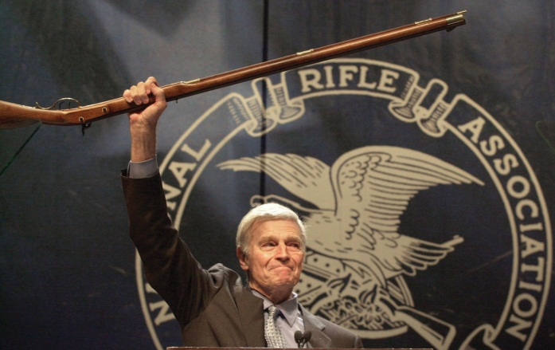
As its president, this hero of some of Hollywood’s greatest epics brought the NRA even more prominence, especially when he uttered his defiant phrase.
Source: Used with permission from AP Photo/Ric Feld.
This media-attention-getting phrase became his trademark, which he repeated with other guns at subsequent conventions. They were the last words he uttered before he officially stepped down from the NRA’s presidency in 2003.
Another technique is the telling statistic. A report titled City Slickers: How Farm Subsidy Checks End Up in Big Cities from the Environmental Working Group achieved widespread and prominent publicity when it revealed that $1.2 million per year in agricultural subsidies was going to people living in the 90210 zip code, which is, as most Americans know from the television show of the same name, urban and affluent Beverly Hills. ^{[5]} Because farm subsidies are traditionally justified as preserving and protecting family farms, the report persuasively reframed the issue as government subsidies of wealthy corporate farm interests. ^{[6]}

Link
The City Slickers Report
Read City Slickers: How Farm Subsidy Checks End Up in Big Cities in its entirety at http://www.ewg.org/reports/slickers.
Some interest groups issue scorecards that enable journalists easily to report how policymakers have voted on issues of concern to the group’s members and the public. The League of Conservation Voters has released a list to the press during election years of the “Dirty Dozen” members of Congress with the supposedly worst records on the environment. The legislators targeted are usually in close races and some 60 percent of them have been defeated.
Interest groups also pay for or conduct public opinion polls, sometimes with questions that frame the issue to push the public toward their point of view. During the California water shortage of 2001, the California Farm Bureaureleased a poll showing that 71 percent of those polled believed “that the federal government has a financial responsibility to help keep California’s farmers in agriculture production.” The actual question asked about “California family farmers” (the word “family” encouraged a positive response), the phrase “financial responsibility” is quite vague, and the 71 percent figure was achieved by adding the 44 percent “definite yes” response to the 27 percent “probably yes” response. ^{[7]}

Disproportionate Coverage
Most news coverage of societal and public interest groups goes only to a few. According to an article by Lucig H. Danielian and Benjamin Page, “The media seize upon a few prominent individuals or groups to speak for broad sets of interests.” ^{[8]}
Witness a study of 244 interest groups in fourteen major newspapers, two news magazines, and the top three television networks. ^{[9]} The single most-covered group in each of four policy areas received around 40 percent of all the coverage in that area. These were the Sierra Club on the environment, theCouncil on Foreign Relations on national security and foreign policy, theAmerican Civil Liberties Union (ACLU) for civil rights, and the Christian Coalition of America on broad matters of public policy. The figure reaches approximately 68 percent when the number of groups is raised to twelve (5 percent of the total number) to include the National Association for the Advancement of Colored People (NAACP), Greenpeace, and a few others. In contrast, 34 percent of the interest groups did not appear in a single story.
The larger a group’s budget, the more likely it is to be covered. These groups have staff to communicate with the media, hold regular press conferences, provide the press with dependable information, stage events with dramatic visuals and symbolism, and make news by suing the government. They also are covered because reporters return repeatedly to sources that are familiar to them and their audiences.
Most news organizations are not inclined to incur the expense of investigating interest groups’ organization and claims of accomplishments. Nor are they able to obtain easy access to the groups’ records. For ten years, the Christian Coalition was the most prominent interest group of the religious right. Journalists took the claims of its leaders at face value. Only later did former national leaders who had left the group reveal to the press that the number of members had been inflated. ^{[10]}

Media Consequences
Media depictions matter. Favorable coverage of public interest groups seeking to protect the environment and consumers has helped get their issues on the policy agenda and some of their proposals enacted. ^{[11]} The breast cancer lobby is far more successful at shaping media coverage and thus influencing public opinion and determining public policy (including government funding) than the prostate cancer lobby, even though the diseases have almost identical morbidity and mortality rates. ^{[12]}
Disproportionate coverage of a few societal and public interest groups enhances their importance and the impression that each one represents a policy area. Instead, there is often a spectrum of interest groups across areas. Sparse or nonexistent coverage of these interest groups means that the media do not bring their demands, activities, and policy perspectives to the attention of policymakers and the public.
Unfavorable media depictions of labor unions reinforce their negative stereotypes. This coverage reduces public support for unions’ organizing efforts and discourages people from voluntarily joining unions. It discredits striking as a desirable or even appropriate way for unions to achieve their objectives.
Media coverage of business interest groups conveys their power. It limits this power by framing it as excessive and adverse to the public interest and by exposing some of it as greed and exploitation. This coverage affects public opinion. Of the people polled about “the power of different groups in influencing government policy, politicians, and policymakers in Washington” and which groups had “too much” influence, 86 percent selected “big companies,” 83 percent chose “political action committees which give money to political candidates,” and 71 percent picked “political lobbyists.” ^{[13]} Overwhelmingly, people have the impression that government is run by a few big interests. ^{[14]} In November 2005, 90 percent of respondents to a Harris poll (up from 83 percent the previous year) said big companies had too much influence on government.
No wonder interest groups become issues in elections. Each party accuses the other of being beholden to “special interests” and of unsavory relationships with lobbyists. The media pursue stories about interest group contributions and of lobbyists holding prominent staff positions in candidates’ campaigns. Democratic presidential candidate Barack Obama refused in the 2008 presidential election to accept contributions from registered lobbyists andpolitical action committees (PACs). Republican nominee John McCain established a conflict-of-interest policy that resulted in the resignation or dismissal of several members of his campaign staff who were registered as lobbyists.

KEY TAKEAWAYS
Interest groups use a variety of techniques to interact with the news media and obtain favorable coverage. These include advertising, public relations, and advocacy. Despite the vast number of interest groups in existence, the news media tend to cover the activities of only a few leading organizations. Media depictions of interest groups can have a significant impact on public opinion about them and support for or opposition to their policy preferences. The media often depict big business groups negatively, while they usually portray other groups such as environmental organizations more positively. The overall effect of the media’s depictions of interest groups is to give people the impression that government is run by a few big interests.

EXERCISES
- Why do you think some interest groups avoid media exposure? Why do others try to use the media to achieve their objectives?
- Which interest groups do you view negatively? Which do you view positively? What do you think made you view those groups that way?

Civic Education
SAVE
Forming an interest group and keeping it going takes a strong commitment, but many young people have done just that. They recognize that there is power in numbers and that having a group of people unite behind a cause can be more effective than acting alone. Enterprising young people have established interest groups representing a wide range of causes and issues.
An example of a youth-focused interest group is the Student Association for Voter Empowerment (SAVE), a national organization of college students whose mission is to promote civic education in order to increase voter participation and help young people navigate the public policy process and interact with government. In addition to voter advocacy, SAVE lobbies government officials to pass legislation promoting jobs, health insurance, and college financial aid for young people. SAVE was founded by Kenyon College graduates Matthew Segal and Anna Salzberg and has over ten thousand members on campuses in fifteen states. The organization makes use of online media to facilitate its operations. Students wishing to start a chapter of SAVE on their campus can access on online tool kit with directions for creating a constitution, building an organization, and becoming active. The organization provides information about key issues, advertises its activities, including conferences and outreach projects, facilitates communication among its members, and fundraises through itswebsite. Group leaders also publish a blog on the Huffington Post. SAVE was instrumental in getting the House of Representatives to introduce the bipartisan Student Voter Opportunity to Encourage Registration (VOTER) Act of 2008, which requires colleges to take measures to register students to vote.

[1] Jeffrey Goldberg, “Selling Wal-Mart,” New Yorker, April 2, 2007, accessed March 23, 2011, http://www.newyorker.com/reporting/2007/04/02/070402fa_fact_goldberg.
[2] Jarol B. Manheim, Strategic Public Diplomacy and American Foreign Policy (New York: Oxford University Press, 1994); also Jarol B. Manheim and Robert B. Albritton, “Changing National Images: International Public Relations and Media Agenda Setting,” American Political Science Review 78, no. 3 (September 1984): 641–57; and Pat Choate, Agents of Influence: How Japan’s Lobbyists in the United States Manipulate America’s Political and Economic System (New York: Knopf, 1990).
[3] Christopher Marquis, “Worried Saudis Pay Millions to Improve Image in the U.S.,” New York Times, August 29, 2002, accessed March 23, 2011,http://www.nytimes.com/2002/08/29/world/worried-saudis-pay-millions-to-improve-image-in-the-us.html.
[4] Kay Lehman Schlozman and John T. Tierney, Organized Interests and American Democracy (New York: Harper & Row, 1986), chap. 10; also Ken Kollman, Outside Lobbying: Public Opinion & Interest Group Strategies (Princeton, NJ: Princeton University Press, 1998).
[5] Ken Cook, Clark Williams, Andrew Art, and Chris Campbell, City Slickers: How Farm Subsidy Checks End Up in Big Cities, March 1995, accessed April 4, 2011,http://www.ewg.org/reports/slickers.
[6] Jeffrey M. Berry and Clyde Wilcox, The Interest Group Society, 3rd. ed. (New York: Longman, 2008), 235–36.
[7] California Farm Bureau Federation, “Farm leader calls for Federal action on farm crisis,” May 8, 2001.
[8] Lucig H. Danielian and Benjamin Page, “The Heavenly Chorus: Interest Group Voices on TV News,” American Journal of Political Science 38, no. 4 (November 1994): 1069.
[9] A. Trevor Thrall, “The Myth of the Outside Strategy: Mass Media News Coverage of Interest Groups,” Political Communication 23, no. 4 (2006): 407–20.
[10] Laurie Goodstein, “Debt and Leadership Turmoil Sap Christian Coalition’s Political Strengths,” International Herald Tribune, August 3, 1999, 3.
[11] Jeffrey M. Berry, The New Liberalism: The Rising Power of Citizen Groups (Washington, DC: Brookings Institution Press, 2000).
[12] Karen M. Kedrowski and Marilyn Stine Sarow, Cancer Activism: Gender, Media, and Public Policy (Urbana: University of Illinois Press, 2007).
[13] The Harris Poll, April 26–May 5, 2001.
[14] 1995 poll cited in Jeffrey M. Berry and Clyde Wilcox, The Interest Group Society, 3rd. ed. (New York: Longman, 2008), 19.

9.5 Recommended Reading
Ainsworth, Scott H. Analyzing Interest Groups: Group Influence on People and Policies. New York: W. W. Norton, 2002. An analysis of interest groups and their activities using a theoretical approach.
Baumgartner, Frank R., Jeffrey M. Berry, Marie Hojnacki, David C. Kimball, and Beth L. Leech. Lobbying and Policy Change: Who Wins, Who Loses, and Why. Chicago: University of Chicago Press, 2009. An account showing that because the entrenched Washington system favors the status quo, 60 percent of lobbying campaigns fail to change policy.
Berry, Jeffrey M., and Clyde Wilcox. The Interest Group Society. New York: Longman, 2008. A leading text providing basic information about most aspects of interest groups.
Cigler, Allan J., and Burdett A. Loomis, eds. Interest Group Politics, 7th ed. Washington, DC: CQ Press, 2006. An informative and wide-ranging collection of research on interest groups in American politics.
Dahl, Robert A. A Preface to Democratic Theory. Chicago: University of Chicago Press, 1956. The leading statement of the pluralist position and the democratic role of interest groups.
Olson, Mancur, Jr. The Logic of Collective Action: Public Goods and the Theory of Groups. Cambridge, MA: Harvard University Press, 1965. An influential study using an economic approach to groups’ organization, membership, and effectiveness.
Schattschneider, Elmer E. The Semi-Sovereign People. New York: Holt, Rinehart, and Winston, 1960. A powerful critique of pluralism and American democracy.
Schlozman, Kay Lehman, and John T. Tierney. Organized Interests and American Democracy. New York: Harper & Row, 1986. A comprehensive account of Washington-based interest groups in the early 1980s.
Truman, David B. The Governmental Process: Political Interests and Public Opinion, 2nd ed. New York: Alfred A. Knopf, 1971 (originally published 1951). This book revived the study of interest groups as central to US politics and raised many subjects, concepts, and questions that are still important.

9.6 Recommended Viewing
Casino Jack and the United States of Money (2010). Droll documentary about Jack Abramoff, his confederates, and his victims.
Citizen Ruth (1996). A satire in which a delinquent, pregnant girl (Laura Dern) is exploited and then exploits the pro-life and pro-choice movements battling over her.
Harlan County, U.S.A. (1977). Powerful documentary about the strike of Kentucky mine workers against a mining company.
The Naked Gun 2 and ½: The Smell of Fear (1991). In one of the plots, oil, coal, and nuclear interests kidnap and replace the president’s proenvironment energy policy appointee.
Norma Rae (1979). Southern mill worker becomes an independent woman as she protests working conditions and strives to organize a union.
On the Waterfront (1954). Marlon Brando is memorable as a man who accepts then fights against union corruption.
The People and the Power Game: The Lobbies (1996). A television program that analyzes the relationship between members of Congress and the lobbyists who seek to influence them.
Roger & Me (1989). A docucomedy in which Michael Moore pursues General Motors’ president to show him how the closing of automobile plants and firing of workers affected Flint, Michigan.
Thank You for Smoking (2005). Comedy about the tribulations and triumphs of a public relations operative for big tobacco.

Chapter 10

Political Parties

Preamble
A favorite pastime of political journalists is periodically assessing the state of political parties, usually in conjunction with national elections. Journalists are rarely optimistic or complimentary when describing parties’ present status or forecasting their future. However, history has shown that the Democratic and Republican parties are amazingly enduring institutions, even when the mass media have sold them short.
Reporters routinely take stock of the parties, and their prognosis is typically bleak and filled with foreboding. In 2003, New York Times political reporter Adam Clymer took stock of the Democratic and Republican parties in a series of front-page articles. “With the Congress thinly divided along partisan lines, another presidential election taking shape, and the rules of campaign finance in limbo, the two national political parties are at crucial turning points,” he wrote. Clymer described a revitalized Republican Party that was looking forward to an era of political dominance after having had “one foot in the grave” for more than twenty years since the Watergate scandal in 1974. His prognosis for the Democratic Party was more pessimistic. Clymer quoted a Democratic Party leader as saying, “God knows we need help” and another who observed that his party had “run out of gas.” ^{[1]} He argued that the Democrats lacked a unified message or a clear leader, and quoted a party activist: “Our party has so many disparate points of influence that we can never focus enough to achieve our programs.” ^{[2]}
In hindsight, Clymer’s predictions are not entirely accurate, especially after the victory of Democratic president Barack Obama in 2008, and illustrate the pitfalls of speculating about the future of political parties. However, his observations raise important ideas about American parties. Political parties are enduring and adaptive institutions whose organization and functions change in response to different political and historical circumstances. ^{[3]} The two major American political parties, the Republicans and the Democrats, each have gone through periods of popularity, decline, and resurgence.
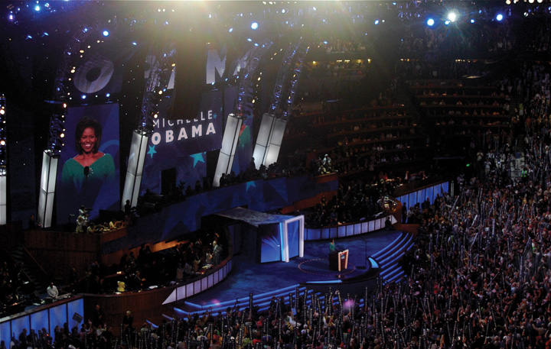
Michelle Obama addresses delegates. Political parties are important mechanisms for citizen involvement at the grassroots level.
Source: Photo courtesy of http://commons.wikimedia.org/wiki/File:Michelle_Obama_DNC_2008.jpg.
The Democratic and Republican parties have dominated for over 150 years because of their ability to adapt to changing political and cultural circumstances. In the early decades of the republic, when voting rights were limited to male landowners, parties formed around charismatic leaders such as Thomas Jefferson and John Adams. When voting rights were extended, parties changed to accommodate the public. As immigrants came to the United States and settled in urban areas, party machines emerged and socialized the immigrants to politics.
Parties also have adapted to changes in the media environment. When radio and television were new technologies, parties incorporated them into their strategies for reaching voters, including through advertising. More recently, the Republican and Democratic parties have advanced their use of the Internet and digital media for campaigning, fundraising, and issue advocacy.

[1] Adam Clymer, “Buoyed by Resurgence, G.O.P. Strives for an Era of Dominance,” New York Times, May 25, 2003, accessed March 23, 2011,http://query.nytimes.com/gst/fullpage.html?res=950CE1D91531F936A15756C0A9659C8B63&pagewanted=all.
[2] Adam Clymer, “Democrats Seek a Stronger Focus, and Money” New York Times, May 26, 2003, accessed March 23, 2011, http://www.nytimes.com/2003/05/26/us/democrats-seek-a-stronger-focus-and-money.html.
[3] Leon D. Epstein, Political Parties in the American Mold (Madison: University of Wisconsin Press, 1986).

10.1 History of American Political Parties

LEARNING OBJECTIVES
After reading this section, you should be able to answer the following questions:
- What is a political party?
- What were James Madison’s fears about political factions?
- How did American political parties develop?
- How did political machines function?
Political parties are enduring organizations under whose labels candidates seek and hold elective offices. ^{[1]} Parties develop and implement rules governing elections. They help organize government leadership. ^{[2]} Political parties have been likened to public utilities, such as water and power companies, because they provide vital services for a democracy.
The endurance and adaptability of American political parties is best understood by examining their colorful historical development. Parties evolved from factions in the eighteenth century to political machines in the nineteenth century. In the twentieth century, parties underwent waves of reform that some argue initiated a period of decline. The renewed parties of today are service-oriented organizations dispensing assistance and resources to candidates and politicians. ^{[3]}

Link
The Development of Political Parties
A timeline of the development of political parties can be accessed athttp://www.edgate.com/elections/inactive/the_parties.

Fear of Faction
The founders of the Constitution were fearful of the rise of factions, groups in society that organize to advance a political agenda. They designed a government of checks and balances that would prevent any one group from becoming too influential. James Madison famously warned in Federalist No. 10 of the “mischiefs of faction,” particularly a large majority that could seize control of government. ^{[4]} The suspicion of parties persisted among political leaders for more than a half century after the founding. President James Monroe opined in 1822, “Surely our government may go on and prosper without the existence of parties. I have always considered their existence as the curse of the country.” ^{[5]}
Figure 10.1
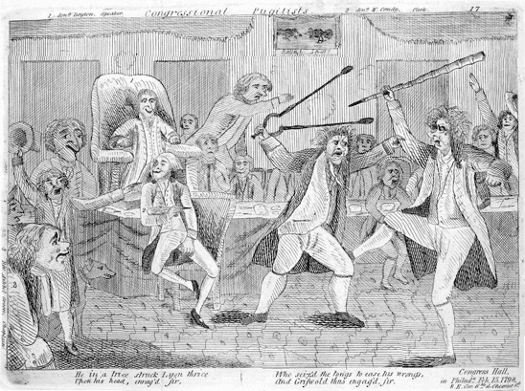
Newspaper cartoons depicted conflicts that arose between the Federalists and Republicans, who sought to control government.
Source:http://www.vermonthistory.org/freedom_and_unity/new_frontier/images/cartoon.gif.
Despite the ambiguous feelings expressed by the founders, the first modern political party, the Federalists, appeared in the United States in 1789, more than three decades before parties developed in Great Britain and other western nations. ^{[6]} Since 1798, the United States has only experienced one brief period without national parties, from 1816 to 1827, when infighting following the War of 1812 tore apart the Federalists and the Republicans. ^{[7]}

Parties as Factions
The first American party system had its origins in the period following the Revolutionary War. Despite Madison’s warning in Federalist No. 10, the first parties began as political factions. Upon taking office in 1789, President George Washington sought to create an “enlightened administration” devoid of political parties. ^{[8]} He appointed two political adversaries to his cabinet, Alexander Hamilton as treasury secretary and Thomas Jefferson as secretary of state, hoping that the two great minds could work together in the national interest. Washington’s vision of a government without parties, however, was short-lived.
Hamilton and Jefferson differed radically in their approaches to rectifying the economic crisis that threatened the new nation. ^{[9]} Hamilton proposed a series of measures, including a controversial tax on whiskey and the establishment of a national bank. He aimed to have the federal government assume the entire burden of the debts incurred by the states during the Revolutionary War. Jefferson, a Virginian who sided with local farmers, fought this proposition. He believed that moneyed business interests in the New England states stood to benefit from Hamilton’s plan. Hamilton assembled a group of powerful supporters to promote his plan, a group that eventually became the Federalist Party. ^{[10]}

The Federalists and the Republicans
The Federalist Party originated at the national level but soon extended to the states, counties, and towns. Hamilton used business and military connections to build the party at the grassroots level, primarily in the Northeast. Because voting rights had been expanded during the Revolutionary War, the Federalists sought to attract voters to their party. They used their newfound organization for propagandizing and campaigning for candidates. They established several big-city newspapers to promote their cause, including the Gazette of the United States, the Columbian Centinel, and the American Minerva, which were supplemented by broadsheets in smaller locales. This partisan press initiated one of the key functions of political parties—articulating positions on issues and influencing public opinion. ^{[11]}
Figure 10.2 The Whiskey Rebellion
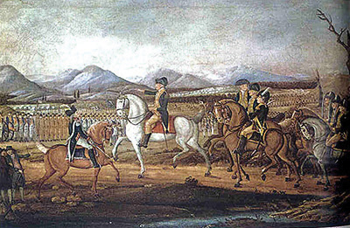
Farmers protested against a tax on whiskey imposed by the federal government. President George Washington established the power of the federal government to suppress rebellions by sending the militia to stop the uprising in western Pennsylvania. Washington himself led the troops to establish his presidential authority.
Source:http://commons.wikimedia.org/wiki/File:WhiskeyRebellion.jpg.
Disillusioned with Washington’s administration, especially its foreign policy, Jefferson left the cabinet in 1794. Jefferson urged his friend James Madison to take on Hamilton in the press, stating, “For God’s sake, my Dear Sir, take up your pen, select your most striking heresies, and cut him to pieces in the face of the public.” ^{[12]} Madison did just that under the pen name of Helvidius. His writings helped fuel an anti-Federalist opposition movement, which provided the foundation for the Republican Party. This early Republican Party differs from the present-day party of the same name. Opposition newspapers, the National Gazette and the Aurora, communicated the Republicans’ views and actions, and inspired local groups and leaders to align themselves with the emerging party. ^{[13]} TheWhiskey Rebellion in 1794, staged by farmers angered by Hamilton’s tax on whiskey, reignited the founders’ fears that violent factions could overthrow the government. ^{[14]}

First Parties in a Presidential Election
Political parties were first evident in presidential elections in 1796, when Federalist John Adams was barely victorious over Republican Thomas Jefferson. During the election of 1800, Republican and Federalist members of Congress met formally to nominate presidential candidates, a practice that was a precursor to the nominating conventions used today. As the head of state and leader of the Republicans, Jefferson established the American tradition of political parties as grassroots organizations that band together smaller groups representing various interests, run slates of candidates for office, and present issue platforms. ^{[15]}
The early Federalist and Republican parties consisted largely of political officeholders. The Federalists not only lacked a mass membership base but also were unable to expand their reach beyond the monied classes. As a result, the Federalists ceased to be a force after the 1816 presidential election, when they received few votes. The Republican Party, bolstered by successful presidential candidates Thomas Jefferson, James Madison, and James Monroe, was the sole surviving national party by 1820. Infighting soon caused the Republicans to cleave into warring factions: the National Republicans and the Democratic-Republicans. ^{[16]}

Establishment of a Party System
A true political party system with two durable institutions associated with specific ideological positions and plans for running the government did not begin to develop until 1828. The Democratic-Republicans, which became the Democratic Party, elected their presidential candidate, Andrew Jackson. The Whig Party, an offshoot of the National Republicans, formed in opposition to the Democrats in 1834. ^{[17]}
The era of Jacksonian Democracy, which lasted until the outbreak of the Civil War, featured the rise of mass-based party politics. Both parties initiated the practice of grassroots campaigning, including door-to-door canvassing of voters and party-sponsored picnics and rallies. Citizens voted in record numbers, with turnouts as high as 96 percent in some states. ^{[18]} Campaign buttons publically displaying partisan affiliation came into vogue. Thespoils system, also known as patronage, where voters’ party loyalty was rewarded with jobs and favors dispensed by party elites, originated during this era.
The two-party system consisting of the Democrats and Republicans was in place by 1860. The Whig Party had disintegrated as a result of internal conflicts over patronage and disputes over the issue of slavery. The Democratic Party, while divided over slavery, remained basically intact. ^{[19]} The Republican Party was formed in 1854 during a gathering of former Whigs, disillusioned Democrats, and members of the Free-Soil Party, a minor antislavery party. The Republicans came to prominence with the election of Abraham Lincoln.
Figure 10.3 Thomas Nast Cartoon of the Republican Elephant
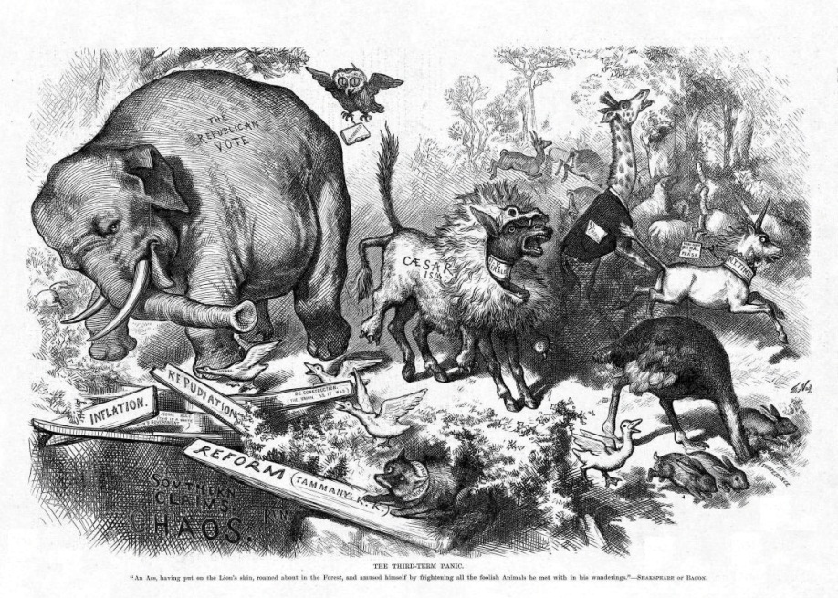
The donkey and the elephant have been symbols of the two major parties since cartoonist Thomas Nast popularized these images in the 1860s.
Source: Photo courtesy of Harper’s Weekly,http://commons.wikimedia.org/wiki/File:NastRepublicanElephant.jpg.

Parties as Machines
Parties were especially powerful in the post–Civil War period through the Great Depression, when more than 15 million people immigrated to the United States from Europe, many of whom resided in urban areas. Party machines, cohesive, authoritarian command structures headed by bosses who exacted loyalty and services from underlings in return for jobs and favors, dominated political life in cities. Machines helped immigrants obtain jobs, learn the laws of the land, gain citizenship, and take part in politics.
Machine politics was not based on ideology, but on loyalty and group identity. The Curley machine in Boston was made up largely of Irish constituents who sought to elect their own. ^{[20]} Machines also brought different groups together. The tradition of parties as ideologically ambiguous umbrella organizations stems from Chicago-style machines that were run by the Daley family. The Chicago machine was described as a “hydra-headed monster” that “encompasses elements of every major political, economic, racial, ethnic, governmental, and paramilitary power group in the city.” ^{[21]} The idea of a “balanced ticket” consisting of representatives of different groups developed during the machine-politics era. ^{[22]}
Because party machines controlled the government, they were able to sponsor public works programs, such as roads, sewers, and construction projects, as well as social welfare initiatives, which endeared them to their followers. The ability of party bosses to organize voters made them a force to be reckoned with, even as their tactics were questionable and corruption was rampant. ^{[23]} Bosses such as William Tweed in New York were larger-than-life figures who used their powerful positions for personal gain. Tammany Hall boss George Washington Plunkitt describes what he called “honest graft”:
My party’s in power in the city, and its goin’ to undertake a lot of public improvements. Well, I’m tipped off, say, that they’re going to lay out a new park at a certain place. I see my opportunity and I take it. I go to that place and I buy up all the land I can in the neighborhood. Then the board of this or that makes the plan public, and there is a rush to get my land, which nobody cared particular for before. Ain’t it perfectly honest to charge a good price and make a profit on my investment and foresight? Of course, it is. Well, that’s honest graft.^{[24]}

Enduring Image
Boss Tweed Meets His Match
The lasting image of the political party boss as a corrupt and greedy fat cat was the product of a relentless campaign by American political cartoonist Thomas Nast in Harper’s Weekly from 1868 to 1871. Nast’s target was William “Boss” Tweed, leader of the New York Tammany Hall party machine, who controlled the local Democratic Party for nearly a decade.
Nast established the political cartoon as a powerful force in shaping public opinion and the press as a mechanism for “throwing the rascals” out of government. His cartoons ingrained themselves in American memories because they were among the rare printed images available to a wide audience in a period when photographs had not yet appeared in newspapers or magazines, and when literacy rates were much lower than today. Nast’s skill at capturing political messages in pictures presented a legacy not just for today’s cartoonists but for photographers and television journalists. His skill also led to the undoing of Boss Tweed.
Tweed and his gang of New York City politicians gained control of the local Democratic Party by utilizing the Society of Tammany (Tammany Hall), a fraternal organization, as a base. Through an extensive system of patronage whereby the city’s growing Irish immigrant population was assured employment in return for votes, the Tweed Ring was able to influence the outcome of elections and profit personally from contracts with the city. Tweed controlled all New York state and city Democratic Party nominations from 1860 to 1870. He used illegal means to force the election of a governor, a mayor, and the speaker of the assembly.
The New York Times, Harper’s Weekly, reform groups, and disgruntled Democrats campaigned vigorously against Tweed and his cronies in editorials and opinion pieces, but none was as successful as Nast’s cartoons in conveying the corrupt and greedy nature of the regime. Tweed reacted to Nast’s cartoon, “Who Stole the People’s Money,” by demanding of his supporters, “Stop them damned pictures. I don’t care what the papers write about me. My constituents can’t read. But, damn it, they can see pictures.”^{[25]}
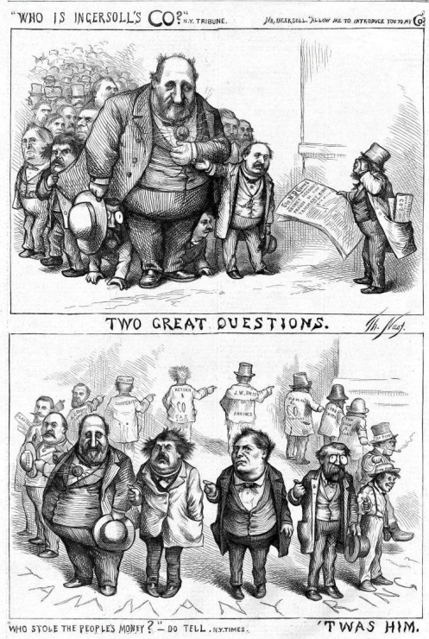
“Who Stole the People’s Money.” Thomas Nast’s cartoon, “Who Stole the People’s Money,” implicating the Tweed Ring appeared in Harper’s Weekly on August 19, 1871.
Source: Photo courtesy of Harper’s Weekly,http://www.harpweek.com/09cartoon/BrowseByDateCartoon-Large.asp?Month=August&Date=19.
The Tweed Ring was voted out in 1871, and Tweed was ultimately jailed for corruption. He escaped and was arrested in Spain by a customs official who didn’t read English, but who recognized him from the Harper’s Weeklypolitical cartoons. He died in jail in New York.

Parties Reformed
Not everyone benefited from political machines. There were some problems that machines either could not or would not deal with. Industrialization and the rise of corporate giants created great disparities in wealth. Dangerous working conditions existed in urban factories and rural coal mines. Farmers faced falling prices for their products. Reformers blamed these conditions on party corruption and inefficiency. They alleged that party bosses were diverting funds that should be used to improve social conditions into their own pockets and keeping their incompetent friends in positions of power.

The Progressive Era
The mugwumps, reformers who declared their independence from political parties, banded together in the 1880s and provided the foundation for theProgressive Movement. The Progressives initiated reforms that lessened the parties’ hold over the electoral system. Voters had been required to cast color-coded ballots provided by the parties, which meant that their vote choice was not confidential. The Progressives succeeded by 1896 in having most states implement the secret ballot. The secret ballot is issued by the state and lists all parties and candidates. This system allows people to split their ticket when voting rather than requiring them to vote the party line. The Progressives also hoped to lessen machines’ control over the candidate selection process. They advocated a system of direct primary elections in which the public could participate rather than caucuses, or meetings of party elites. The direct primary had been instituted in only a small number of states, such as Wisconsin, by the early years of the twentieth century. The widespread use of direct primaries to select presidential candidates did not occur until the 1970s.
The Progressives sought to end party machine dominance by eliminating the patronage system. Instead, employment would be awarded on the basis of qualifications rather than party loyalty. The merit system, now called thecivil service, was instituted in 1883 with the passage of the Pendleton Act. The merit system wounded political machines, although it did not eliminate them.^{[26]}
Progressive reformers ran for president under party labels. Former president Theodore Roosevelt split from the Republicans and ran as the Bull Moose Party candidate in 1912, and Robert LaFollette ran as the Progressive Party candidate in 1924. Republican William Howard Taft defeated Roosevelt, and LaFollette lost to Republican Calvin Coolidge.
Figure 10.4 Progressive Reformers Political Cartoon
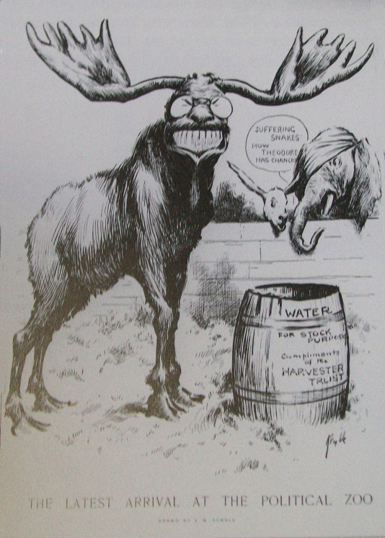
The Progressive Reformers’ goal of more open and representative parties resonate today.
Source: Photo courtesy of E W Kemble,http://commons.wikimedia.org/wiki/File:Theodore_Roosevelt_Progressive_Party_Cartoon,_1912_copy.jpg.

New Deal and Cold War Eras
Democratic President Franklin Delano Roosevelt’s New Deal program for leading the United States out of the Great Depression in the 1930s had dramatic effects on political parties. The New Deal placed the federal government in the pivotal role of ensuring the economic welfare of citizens. Both major political parties recognized the importance of being close to the power center of government and established national headquarters in Washington, DC.
An era of executive-centered government also began in the 1930s, as the power of the president was expanded. Roosevelt became the symbolic leader of the Democratic Party. ^{[27]} Locating parties’ control centers in the national capital eventually weakened them organizationally, as the basis of their support was at the local grassroots level. National party leaders began to lose touch with their local affiliates and constituents. Executive-centered government weakened parties’ ability to control the policy agenda. ^{[28]}
The Cold War period that began in the late 1940s was marked by concerns over the United States’ relations with Communist countries, especially the Soviet Union. Following in the footsteps of the extremely popular president Franklin Roosevelt, presidential candidates began to advertise their independence from parties and emphasized their own issue agendas even as they ran for office under the Democratic and Republican labels. Presidents, such as Dwight D. Eisenhower, Ronald Reagan, and George H. W. Bush, won elections based on personal, rather than partisan, appeals. ^{[29]}

Candidate-Centered Politics
Political parties instituted a series of reforms beginning in the late 1960s amid concerns that party elites were not responsive to the public and operated secretively in so-called smoke-filled rooms. The Democrats were the first to act, forming the McGovern-Fraser Commission to revamp the presidential nominating system. The commission’s reforms, adopted in 1972, allowed more average voters to serve as delegates to thenational party nominating convention, where the presidential candidate is chosen. The result was that many state Democratic parties switched from caucuses, where convention delegates are selected primarily by party leaders, to primary elections, which make it easier for the public to take part. The Republican Party soon followed with its own reforms that resulted in states adopting primaries. ^{[30]}
Figure 10.5 Jimmy Carter Campaigning in the 1980 Presidential Campaign
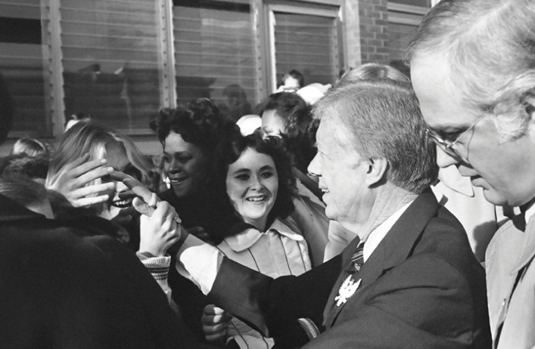
Democrat Jimmy Carter, a little-known Georgia governor and party outsider, was one of the first presidential candidates to run a successful campaign by appealing to voters directly through the media. After Carter’s victory, candidate-centered presidential campaigns became the norm.
Source: Used with permission from AP Photo/Wilson.
The unintended consequence of reform was to diminish the influence of political parties in the electoral process and to promote the candidate-centered politics that exists today. Candidates build personal campaign organizations rather than rely on party support. The media have contributed to the rise of candidate-centered politics. Candidates can appeal directly to the public through television rather than working their way through the party apparatus when running for election. ^{[31]} Candidates use social media, such as Facebook and Twitter, to connect with voters. Campaign professionals and media consultants assume many of the responsibilities previously held by parties, such as developing election strategies and getting voters to the polls.

KEY TAKEAWAYS
Political parties are enduring organizations that run candidates for office. American parties developed quickly in the early years of the republic despite concerns about factions expressed by the founders. A true, enduring party system developed in 1828. The two-party system of Democrats and Republicans was in place before the election of President Abraham Lincoln in 1860.
Party machines became powerful in the period following the Civil War when an influx of immigrants brought new constituents to the country. The Progressive Movement initiated reforms that fundamentally changed party operations. Party organizations were weakened during the period of executive-centered government that began during the New Deal.
Reforms of the party nominating system resulted in the rise of candidate-centered politics beginning in the 1970s. The media contributes to candidate-centered politics by allowing candidates to take their message to the public directly without the intervention of parties.

EXERCISES
- What did James Madison mean by “the mischiefs of faction?” What is a faction? What are the dangers of factions in politics?
- What role do political parties play in the US political system? What are the advantages and disadvantages of the party system?
- How do contemporary political parties differ from parties during the era of machine politics? Why did they begin to change?

[1] Leon D. Epstein, Political Parties in the American Mold (Madison: University of Wisconsin Press, 1986), 3.
[2] V. O. Key Jr., Politics, Parties, & Pressure Groups, 5th ed. (New York: Thomas Y. Crowell Company, 1964).
[3] John H. Aldrich, Why Parties? The Origin and Transformation of Party Politics in America(Chicago: University of Chicago Press, 1995); Samuel J. Eldersveld and Hanes Walton Jr.,Political Parties in American Society, 2nd ed. (Boston: Bedford/St. Martin’s, 2000).
[4] Publius (James Madison), “The Federalist No. 10,” in The Federalist, ed. Robert Scigliano (New York: The Modern Library Classics, 2001), 53–61.
[5] Richard Hofstadter, The Idea of a Party System (Berkeley: University of California Press, 1969), 200.
[6] William Nisbet Chambers and Walter Dean Burnham, The American Party Systems (New York, Oxford University Press, 1975).
[7] William Nisbet Chambers, Political Parties in a New Nation (New York: Oxford University Press, 1963).
[8] John Kenneth White and Daniel M. Shea, New Party Politics (Boston: Bedford/St. Martin’s, 2000).
[9] Joseph Charles, The Origins of the American Party System (New York: Harper & Row, 1956).
[10] Richard Hofstadter, The Idea of a Party System (Berkeley: University of California Press, 1969).
[11] See William Nisbet Chambers, Political Parties in a New Nation (New York: Oxford University Press, 1963).
[12] William Nisbet Chambers, Political Parties in a New Nation (New York: Oxford University Press, 1963), 58.
[13] See William Nisbet Chambers, Political Parties in a New Nation (New York: Oxford University Press, 1963).
[14] Michael Schudson, The Good Citizen (New York: Free Press, 1998).
[15] John Kenneth White and Daniel M. Shea, New Party Politics (Boston: Bedford/St. Martin’s, 2000).
[16] Ronald P. Formisano, “Federalists and Republicans: Parties, Yes—System, No,” in The Evolution of the American Electoral Systems, ed. Paul Kleppner, Walter Dean Burnham, Ronald P. Formisano, Samuel P. Hays, Richard Jensen, and William G. Shade (Westport, CT: Greenwood Press, 1981), 37–76.
[17] Michael F. Holt, The Rise and Fall of the American Whig Party (New York: Oxford University Press, 2003).
[18] Michael F. Holt, The Rise and Fall of the American Whig Party (New York: Oxford University Press, 2003).
[19] Michael F. Holt, The Rise and Fall of the American Whig Party (New York: Oxford University Press, 2003).
[20] John Kenneth White and Daniel M. Shea, New Party Politics (Boston: Bedford/St. Martin’s, 2000).
[21] Milton Rakove, Don’t Make No Waves, Don’t Back No Losers: An Insider’s Analysis of the Daley Machine (Bloomington: Indiana University Press, 1975), 3.
[22] Gerald M. Pomper, Passions and Interests (Lawrence: University Press of Kansas, 1992).
[23] A. James Riechley, The Life of the Parties (New York: Free Press, 1992).
[24] William L. Riordon, Plunkitt of Tammany Hall (St. James, NY: Brandywine Press, 1994), 3.
[25] Jonathan Kandall, “Boss,” Smithsonian Magazine, February 2002, accessed March 23, 2011, http://www.smithsonianmag.com/people-places/boss.html.
[26] Charles Merriam and Harold F. Gosnell, The American Party System (New York: MacMillan, 1922).
[27] A. James Riechley, The Life of the Parties (New York: Free Press, 1992).
[28] John Kenneth White and Daniel M. Shea, New Party Politics (Boston: Bedford/St. Martin’s, 2000).
[29] James W. Caeser, Presidential Selection (Princeton, NJ: Princeton University Press, 1979).
[30] William Crotty, American Parties in Decline (Boston: Little, Brown, 1984).
[31] Diana Owen, Media Messages in American Presidential Elections (Westport, CT: Greenwood Press, 1991).

10.2 Political Parties Today

LEARNING OBJECTIVES
After reading this section, you should be able to answer the following questions:
- What are the characteristics of modern-day American political parties?
- What are political party platforms?
Political parties play an important role in politics today. Whereas observers like the Washington Post’s David Broder could write a book in 1972 with the title The Party’s Over, such eulogies were premature. Compared to the 1970s, party organizations today are larger, farther reaching, and better financed. Relations among party officials in Washington and the states have improved dramatically. Voters are still more likely to cast their votes along partisan lines than independently.
American political parties have a number of distinctive characteristics. The two major political parties have been dominant for a long period of time. The parties are permeable, meaning that people are able to join or leave the party ranks freely. The two major parties are ideologically ambiguous in that they are umbrella organizations that can accommodate people representing a broad spectrum of interests.

Two-Party Domination
A two-party system is one in which nearly all elected offices are held by candidates associated with the two parties that are able to garner the vast majority of votes. The Republican Party and the Democratic Party are the major parties that have monopolized American politics since the early 1850s. ^{[1]} A major party runs candidates for local, state, and federal offices in a majority of states and holds one of the two largest blocs of seats in the US Congress. ^{[2]}
Many people consider the two-party system as a uniquely American phenomenon. Some scholars argue that this acceptance of the two-party norm is a result of Americans’ aversion to radical politics and their desire to maintain a stable democratic political system. ^{[3]} Having too many parties can destabilize the system by confusing voters and allowing parties who take extreme ideological positions to become prominent in government, much like Madison feared at the founding.

Ideological Ambiguity
Rather than assuming strong, polarizing ideological alignments, the two major parties represent the core values of American culture that favor centrist positions inherent in the liberal tradition of liberty, democracy, and equal opportunity. ^{[4]} These values appeal to the majority of Americans, and political parties can advocate them without losing followers.
Former Democratic Speaker of the House Thomas P. “Tip” O’Neill was fond of saying, “In any other country, the Democratic Party would be five parties.” ^{[5]}O’Neill was referring to the fact that the Democratic Party has no clear ideological identity and instead accommodates interests from across the liberal-conservative spectrum. Groups who both favor and oppose gun control can find a home in the Democratic Party. The Democratic Party is loosely associated with a liberal attitude toward politics, which proposes that government should take a more active role in regulating the economy, provide a social safety net, and ensure equality in society through programs like affirmative action.
Similar things have been said about the Republican Party, ^{[6]} although the Republicans have a more unified message than the Democrats. The Republican agenda favors capitalism and limited government intervention in people’s lives. The Republican Party’s base includes fewer disparate groups than the Democratic base. The Republican Party is associated with a conservative outlook that advocates limited government intervention in society and a free-market economic system.

Party Platforms
Rather than developing distinct ideological positions, parties developpolicy platforms. Policy platforms are plans outlining party positions on issues and the actions leaders will take to implement them if elected. ^{[7]} Parties frequently assume middle-of-the-road positions or waffle on issues to avoid alienating potential supporters. ^{[8]} For example, party platforms may oppose abortion—except in cases of rape or incest. ^{[9]}
Some scholars contend that American parties have become more ideologically distinct over the last three decades. Party leaders are expressing polarized opinions on issues, especially at the national level. These differences can be seen in the highly partisan debate over the health-care system. Democrats in Congress support government involvement in the health-care system and worked to pass the Patient Protection and Affordable Care Act endorsed by President Obama in 2010. Republicans sought to repeal the act in 2011, arguing that it would cost people their jobs.

Permeability
Political parties in the United States are porous, decentralized institutions that can be joined readily by people who choose to adopt the party label, usually Democrat or Republican. ^{[10]} American parties are notmass membership organizations that require people to pay dues if they want to belong, which is the case in many European democracies. Instead, party membership is very loosely defined often by state laws that are highly variable. In some states, citizens declare a party affiliation when registering to vote. People also can join a state or local party organization, or work for a candidate associated with a particular party.
Parties are umbrella organizations that accommodate labor and business federations, interest groups, racial and ethnic constituencies, and religious organizations. Traditionally, the Democratic Party has been home to labor unions, and the Republican Party has accommodated business interests, although these relationships are not set in stone.
The fact that groups seeking to achieve similar political goals are found in both parties is evidence of their permeability. Pro-choice and antiabortion forces exist within the two major parties, although the Democratic Party is far more accommodating to the pro-choice position while the Republican Party is overwhelmingly pro-life. The WISH List is a group supporting pro-choice Republican candidates. The Democratic counterpart supporting pro-choice women candidates is Emily’s List. Democrats for Life of America and Republican National Coalition for Life represent antiabortion constituencies.
Parties compete for the allegiances of the same groups in an effort to increase their bases of support. As the Latino population has swelled to over 35 million people, the Democratic and Republican parties have stepped up their efforts to attract Latino voters and organizations. Both parties have produced Spanish-language television ads and websites, tailored their messages about health care and education to appeal to this group, and recruited Latino candidates. ^{[11]} The parties also have increased their appeals to Asian American voters.

KEY TAKEAWAYS
Political parties today are experiencing a period of renewal. They have strengthened their organizations, improved their fundraising techniques, and enhanced the services they offer to candidates and officeholders.
American parties have three major characteristics. Two parties, the Republicans and the Democrats, have dominated for over 150 years. These major parties are ideologically ambiguous in that they take middle-of-the-road rather than extreme positions on issues. Parties are permeable institutions that allow people and groups to move easily in and out of their ranks. Rather than having strong ideological predispositions, American parties devise broad platforms to outline their stances on issues.

EXERCISES
- How does the two-party system differ from other party systems? What are the advantages of a two-party system? What are its disadvantages?
- What do you think explains the enduring appeal of the two major parties? How are they able to adapt to the changing ideas of the electorate?

[1] William Nisbet Chambers and Walter Dean Burnham, eds., The American Party Systems(New York: Oxford University Press, 1975).
[2] Steven J. Rosenstone, Roy L. Behr, and Edward H. Lazarus, Third Parties in America, 2nd ed. (Princeton, NJ: Princeton University Press, 2000), 9.
[3] Clinton Rossiter, Parties and Politics in America (Ithaca, NY: Cornell University Press, 1960).
[4] John Gerring, Party Ideologies in America, 1828–1996 (New York: Cambridge, 1998).
[5] Adam Clymer, “Buoyed by Resurgence, G.O.P. Strives for an Era of Dominance,” New York Times, May 25, 2003, accessed March 23, 2011,http://query.nytimes.com/gst/fullpage.html?res=950CE1D91531F936A15756C0A9659C8B63&pagewanted=all.
[6] Gerald M. Pomper, Passions and Interests (Lawrence: University Press of Kansas, 1992).
[7] Leon D. Epstein, Political Parties in the American Mold (Madison: University of Wisconsin Press, 1986); Gerald M. Pomper, Passions and Interests (Lawrence: University Press of Kansas, 1992).
[8] Anthony Downs, An Economic Theory of Democracy (New York: Harper, 1957).
[9] John C. Green and Paul S. Herrnson, eds., Responsible Partisanship? (Lawrence: University Press of Kansas, 2002).
[10] Leon D. Epstein, Political Parties in the American Mold (Madison: University of Wisconsin Press, 1986).
[11] Susan Milligan, “Midterms May Hinge on Votes of Latinos: Both Major Parties Tailoring Messages to Growing Minority,” Boston Globe, October 31, 2002.

10.3 Party Organization

LEARNING OBJECTIVES
After reading this section, you should be able to answer the following questions:
- What is the organizational structure of American political parties?
- How do national party organizations differ from state and local party organizations?
- What functions do political parties perform?
The organizational structure of political parties consists of the machinery, procedures, and rituals party leaders and professionals employ so that parties operate effectively in the electoral and governing processes. ^{[1]} Party organizations establish connections between leaders and followers so that they can build and maintain a base of supportive voters they can count on during elections. Parties maintain permanent offices to assist their constituencies. They engage in party-building activities, including voter registration and get-out-the-vote drives. They provide candidate support, such as collecting polling data and running ads. ^{[2]}
Party organizations take many forms. National and state parties are large and complex organizations. They have permanent headquarters, chairpersons, boards of directors, and full-time employees with specialized responsibilities. They maintain lists of officers and members, operate under established bylaws and rules, and hold scheduled meetings and conventions. Local parties range from highly active, well-organized, professional structures to haphazard, amateur operations. ^{[3]}

National Parties
National party committees today are the power centers of the Republican and Democratic parties. They are the ultimate authority in the parties’ organizational hierarchy. The Democratic National Committee (DNC) and theRepublican National Committee (RNC) are located in Washington, DC. The DNC and RNC chairs are the leaders of the party organization and are visible representatives of the parties in the press.
National organizations are responsible for putting on the nominating conventions where presidential candidates are selected every four years. Nominating conventions provide an opportunity to rally the troops and reward the party faithful by having them participate as delegates. They also provide an opportunity for parties to showcase their leaders and policies in front of a national television audience.
National parties adapted to the era of candidate-centered politics by becoming service-oriented organizations, providing resources for candidates and officeholders. They stepped up their fundraising activities, expanded their staffs, and established stronger linkages with state, local, and candidate campaign organizations. The DNC and the RNC have established multimedia strategies that include traditional mass media appeals through press releases and staged events. They also get their message out using sophisticated websites, Facebook pages, Twitter feeds, and YouTube channels. Party websites are a one-stop shop for information about candidates and officeholders, issue positions, and voting logistics. They also provide a gateway for people to become involved in politics by providing information about volunteer activities and offering opportunities to contribute to the party.

Legislative Campaign Committees
Legislative campaign committees finance and manage legislative elections. Members of Congress officially oversee the committee staffs. The National Republican Congressional Committee, National Republican Senatorial Committee, Democratic Congressional Campaign Committee, and theDemocratic Senatorial Campaign Committee help candidates for the House and Senate meet the demands of modern campaigning. They provide survey research to determine voters’ candidate preferences and stands on issues. They recruit volunteers and raise funds for campaigns. These committees organize media appeals to promote the party’s leaders and agenda through television advertising, press briefings, direct mail, e-mail solicitations, and social media.^{[4]}

State Parties
State party organizations operate in vastly different environments because of the political culture of individual states. There is fierce competition between parties in some states, while other states lean more favorably toward one party. Party competition, however, exists in every state. According to Gallup, the two parties were competitive in a majority of states in 2011. Only fourteen states were solidly Democratic and five states were solidly Republican. ^{[5]}
Party and election laws vary greatly among states. In Maryland, voters must register and declare their party identification twenty-nine days before a primary election in order to participate. In Massachusetts, independents can register with a party to vote in that party’s primary on Election Day. In Wisconsin, party preference is part of the secret ballot.
Like their national counterparts, state parties provide candidates with services, such as volunteer recruitment and polling. They offer citizens access to government leaders and information about issues. State parties have become multimillion-dollar organizations, most of which own their headquarters, employ full-time staffs, and have operating budgets of over a half-million dollars. State legislative campaign committees assist in campaigns by dispensing funds to candidates. ^{[6]}

Local Parties
Local party organizations exist at the legislative district, county, city, ward, and precinct levels. Some local parties are extremely vital, providing the link between average people and parties. In addition to fulfilling the basic election functions, they sponsor public affairs programs, provide services to senior citizens and young people, and organize community events. Some local parties are less active because many community-level positions, like town council seats, are nonpartisan.

KEY TAKEAWAYS
Party organization refers to the officials, activists, and members who set up the administration, make the rules, and carry out the collective goals and activities of the party. The Democratic and Republican national party committees are the central authorities for the two major American parties. Party organizations at the state and local level are influenced by the political environment in which they are situated.

EXERCISES
- What kinds of services do contemporary parties provide? Why does it make sense for them to provide these kinds of services?
- How do national, state, and local party organizations differ from one another? What are the main functions of each level of party organization?

[1] V. O. Key Jr., Politics, Parties, & Pressure Groups, 5th ed. (New York: Thomas Y. Crowell Company, 1964).
[2] Samuel J. Eldersveld, and Hanes Walton Jr., Political Parties in American Society, 2nd ed. (Boston: Bedford/St. Martin’s, 2000).
[3] Stephen E. Frantzich, Political Parties in the Technological Age (New York: Longman, 1989).
[4] John Kenneth White and Daniel M. Shea, New Party Politics (Boston: Bedford/St. Martin’s, 2000).
[5] Jeffrey M. Jones, “Number of Solidly Democratic States Cut in Half from ‘08 to ‘10,”Gallup, February 21, 2011, accessed March 26, 2011,http://www.gallup.com/poll/146234/Number-Solidly-Democratic-States-Cut-Half.aspx?utm_source= tagrss&utm_medium=rss&utm_campaign=syndication&utm_term= State%20Politics.
[6] Sarah M. Morehouse and Malcolm E. Jewell, “State Parties: Independent Partners in the Money Relationship,” in The State of the Parties, ed. John C. Green and Rick Farmer (Lanham, MD: Rowman & Littlefield), 151–68.

10.4 Party in Government

LEARNING OBJECTIVES
After reading this section, you should be able to answer the following questions:
- What constitutes the party in government?
- How do presidents use their position as symbolic leader of their political party?
- What are legislative parties?
- What is divided government, and what challenges does it pose for presidential leadership?
The party in government constitutes the organized partisans who serve in office, such as members of the Democratic and Republican parties in Congress. Parties provide an organizational structure for leaders in office, develop policy agendas, and ensure that majority and minority party opinions are voiced. The party in government seeks to represent its supporters, achieve policy objectives, and enhance the prospects for reelection. It is the center of democratic action. Party coalitions of many officeholders can be more powerful mechanisms for voicing opinions than individual leaders acting on their own. Coalitions from opposing parties spar openly by taking different positions on issues. ^{[1]}

Presidential Leadership
The president is the official and symbolic leader of his party. Presidents can use this position to rally members of Congress to push their agendas as President Franklin Roosevelt did to get his New Deal programs passed quickly with the help of congressional Democrats. President Ronald Reagan mobilized congressional Republicans to enact the so-called Reagan revolution of conservative policies, such as cutting taxes and increasing defense spending. Other presidents prefer to adopt a policy of triangulation, where they work both sides of the congressional aisle. ^{[2]} President Barack Obama successfully encouraged Democrats and Republicans in Congress to pass a bill extending tax cuts to citizens.
Figure 10.6 Organizing for America
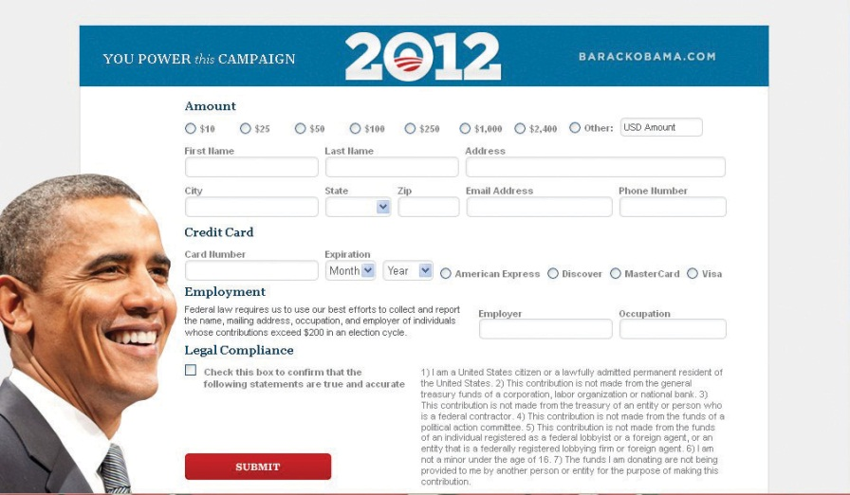
President Barack Obama’s campaign organization, Organizing for America, continued to raise funds through its website following the 2008 election in anticipation of his reelection bid in 2012.
Source: http://www.barackobama.com/index.php.
Since the 1990s, presidents have assumed a major responsibility for party fundraising. President Bill Clinton made fundraising a priority for the Democratic Party. He was the headliner at major events that drew big crowds and raised millions of dollars. President George W. Bush became the top fundraiser for the Republican Party, raising a record $84 million in six months en route to achieving a $170 million goal by the 2004 presidential election. ^{[3]}During his campaign for the presidency, Barack Obama raised over $600 million mostly through online appeals. Once in office, President Obama continued to raise funds for Democratic Party candidates through appearances at dinners and events as well as through his campaign organization’s website, Organizing for America. ^{[4]}

Legislative Parties
Legislative parties are the internal party organizations within each house of Congress. The Speaker of the House and the Senate Majority Leader, the highest ranking leaders in Congress, are members of the majority party. They work closely with the majority leader, whip, chair of the policy committee, and chair of campaign committee in each body. The House and Senate minority leaders head a similar cast on the opposite side of the partisan fence. The Democratic Caucus and the Republican Conference, consisting of all members elected from a party, are the internal party organizations within each house of Congress. They oversee committee assignments and encourage party discipline by asking members to vote along party lines.
Party discipline can be difficult to enforce given the diversity of constituency interests and personalities in Congress. The extent to which party members are willing to vote in a block varies over time. Party unity in congressional voting rose from 40 percent in the early 1970s to 90 percent or more since 2000.

Link
Congressional Voting Patterns
Congressional Quarterly, a Washington, DC–based publisher, has analyzed the voting patterns of members of Congress since 1953 and presents them in an interactive graphic.
http://boagworld.com/blogImages/Obama-20090122-133646.jpg
Members of the same party in Congress are more similar ideologically in recent years than in the past. The Democratic Party in Congress contains few conservatives compared to the period before 1980, when conservative southern Democrats often disagreed with the liberal and moderate members of their party. Republicans in Congress today are more united in taking conservative positions than in the past. ^{[5]}
Legislative parties like those in Congress are found in forty-nine of the fifty state legislatures. Nebraska, which has a nonpartisan, unicameral legislature, is the exception.

Divided Government
The American system of separation of powers and checks and balances devised by the framers presents some obstacles to elected officials using their party connections to wield power. Divided government, which occurs when the chief executive is of a different party from the majority in the legislature, is a common occurrence in American government. Divided government can get in the way of cooperative policymaking. Presidential vetoes of legislation passed by Congress can be more frequent during periods of divided government. ^{[6]}
President Clinton faced the challenges of divided government beginning in 1994, when the Republicans took control of the House and Senate. Clinton did not use the veto power once when his Democratic Party controlled Congress between 1993 and 1994. After the Democrats lost fifty-two seats in Congress to Republicans as a result of the 1994 midterm elections, President Clinton used the veto to block legislation his party opposed, including tax bills that were central to the Republican Party’s platform. From 1995 to 2000, he vetoed thirty-six bills. ^{[7]} Democratic President Barack Obama was faced with divided government in 2010 when the Republican Party won the majority in the House of Representatives while the Democrats held the Senate by a small margin. Obama used the State of the Union address to call for the parties to work together on key issues, especially health care and the economy. ^{[8]}

KEY TAKEAWAYS
The party in government constitutes the organized partisans who serve in office, such as members of the Democratic and Republican parties in Congress. The president is the symbolic leader of his political party and can use this position to urge party members to achieve policy goals. Legislative parties seek to impose discipline on party members in Congress, which is not always easily accomplished because members represent vastly different constituencies with particular needs. Divided government—periods when the president is of a different party from the majority in Congress—can create challenges for presidents seeking to enact their policy agendas.

EXERCISES
- What role does the president play in party politics? What role do legislative parties play?
- What might the advantages and disadvantages of divided government be? Would you prefer the executive and legislative branches be controlled by the same party or by different parties?

[1] Samuel J. Eldersveld and Hanes Walton Jr., Political Parties in American Society, 2nd ed. (Boston: Bedford/St. Martin’s, 2000).
[2] John Kenneth White and Daniel M. Shea, New Party Politics (Boston: Bedford/St. Martin’s, 2000).
[3] “Bush Campaign Has Raised Nearly $84 Million Since Last Spring,” Washington Post, October 14, 2003.
[4] Jose Antonio Vargas, “Obama Raised Half a Billion Online,” Washington Post, November 20, 2008, accessed March 26, 2011,http://voices.washingtonpost.com/44/2008/11/obama-raised-half-a-billion-on.html.
[5] Larry Schwab, “The Unprecedented Senate: Political Parties in the Senate after the 2000 Election,” in The State of the Parties, ed. John C. Green and Rick Farmer (Lanham, MD: Rowman & Littlefield), 241–53.
[6] Gary W. Cox and Samuel Kernell, The Politics of Divided Government (Boulder, CO: Westview Press, 1991).
[7] Samuel B. Hoff, “Evaluating the Clinton Veto Record 1993–2001,” unpublished paper, Delaware State University, 2003.
[8] Mike Dorning, “Obama Ushers in Era of Divided Government with Appeal for Unity, Progress,” Bloomberg, January 26, 2011, accessed March 26, 2011,http://www.bloomberg.com/news/2011-01-26/obama-ushers-in-era-of-divided- government-with-appeal-for-unity-progress.html.

10.5 Party Identification

LEARNING OBJECTIVES
After reading this section, you should be able to answer the following questions:
- How do Americans affiliate with a political party?
- What are partisan coalitions?
- What happens during a partisan realignment or dealignment?
People who identify with a political party either declare their allegiance by joining the party or show their support through regular party-line voting at the polls. People can easily switch their party affiliation or distance themselves from parties entirely. However, people who do not declare a partisan affiliation when they register to vote lose the opportunity to participate in primary election campaigns in many states.

Partisan Identification
A person’s partisan identification is defined as a long-term attachment to a particular party. ^{[1]} Americans are not required to formally join party organizations as is the case in other democracies. Instead people self-identify as Republicans, Democrats, or members of minor parties. They also can declare themselves independent and not aligned with any political party. ^{[2]}
Since the 1960s there has been a gradual decline in identification with political parties and a rise in the number of independents. In 2000, more people identified as independents (40 percent of the voting population) than affiliated with either the Democratic (34 percent) or Republican (24 percent) parties for the first time in history. ^{[3]} The proportion of people registering as independents increased 57 percent between 1990 and 1998, while those registering as Democrats declined by 14 percent and as Republicans by 5 percent. In 2011, 31 percent of the population identified as Democrats, 29 percent as Republican, and 38 percent as independents. ^{[4]}

Link
Trends in Party Identification
Trends in party identification from 1932 to the present have been compiled by the Pew Research Center in this interactive graph found at http://people-press.org/party-identification-trend.
As voter identification with political parties has declined, so has dedication to the two-party system. According to a national survey, citizens have more trust in product brands, such as Nike, Levis, Honda, and Clorox, than in the Democrats and Republicans. ^{[5]} Since the 1980s, Americans have become skeptical about the two major parties’ ability to represent the public interest and to handle major issues facing the country, such as crime, the environment, and saving Social Security. At the same time, support for third parties, like the Tea Party, has increased over the last decade. ^{[6]} Still, the two-party system continues to dominate the political process as a viable multiparty alternative has not emerged.

Party Coalitions
Party coalitions consist of groups that have long-term allegiances to a particular political party. Regions of the country establish loyalties to a specific party as a result of the party’s handling of a war, a major social problem, or an economic crisis. Social, economic, ethnic, and racial groups also become aligned with particular parties. Catholics and labor union members in the Northeast form a part of the Democratic coalition. White fundamentalist Protestants are a component of the Republican coalition. ^{[7]} Parties count on coalition members to vote for them consistently in elections.
A major, enduring shift in coalition loyalties that results in a change in the balance of power between the two major parties is called a realignment. ^{[8]}Realignments can be sparked by critical elections, where a minority party wins and becomes the majority party in government following an election, and remains dominant for an extended period of time. American parties realign about once every thirty or forty years. A critical election in 1932 brought the Democrats and President Franklin Roosevelt to power after a period of Republican domination dating from the 1890s. This New Deal coalition was based on an alliance of white Southerners and liberal Northerners who benefited from the social welfare policies of the Democratic administration during the Great Depression. The election of Ronald Reagan in 1980 marked the beginning of a realignment favoring the Republicans. In this coalition, white Southerners moved away from the Democratic Party as they favored the more conservative values espoused by the Republicans. ^{[9]}
Partisan dealignment occurs when party loyalty declines and voters base their decisions on short-term, election-specific factors, such as the leadership qualities of a candidate. ^{[10]} The inclination of people to identify as independents rather than as partisans is evidence that a dealignment is occurring. ^{[11]} A partisan dealignment may be occurring today, as more people are identifying as independents and more voters select their candidates on the basis of personal traits, such as honesty. Mass media can contribute to partisan realignment by focusing attention on candidates’ personalities and scandals, which are short-term factors that can influence vote choice.

KEY TAKEAWAYS
People indicate their identification with a political party either by declaring their allegiance to a particular party or by regularly supporting that party at the polls. Societal groups that gravitate toward particular political parties can form partisan coalitions. These coalitions can shift during critical elections, which result in a minority party becoming the majority party in government.

EXERCISES
- Do you consider yourself either a Republican or a Democrat? What makes you identify with one party rather than the other?
- Why do parties go through realignment? How does realignment allow parties to adapt to a changing electorate?

[1] Angus Campbell, Philip E. Converse, Warren E. Miller, and Donald E. Stokes, The American Voter (New York: John Wiley and Sons, 1960).
[2] Donald Green, Bradley Palmquist, and Eric Schickler, Partisan Hearts and Minds (New Haven, CT: Yale University Press, 2002).
[3] Data computed using the American National Election Studies,http://www.electionstudies.org. Two percent of the sample consider themselves “apolitical.”
[4] Jeffrey M. Jones, “Democratic Party ID Drops in 2010, Tying 22-Year Low,” Gallup, January 5, 2011, accessed March 26, 2011,http://www.gallup.com/poll/145463/democratic-party-drops-2010-tying-year-low.aspx.
[5] Patricia Winters Lauro, “According to a Survey, the Democratic and Republican Parties Have Brand-Name Problems,” New York Times, November 17, 2000.
[6] Diana Owen and Jack Dennis, “Antipartyism in the USA and Support for Ross Perot,”European Journal of Political Research 29: 383–400.
[7] Paul Allen Beck, “A Tale of Two Electorates: The Changing American Party Coalitions, 1952–2000,” in The State of the Parties, 4th ed., ed. John C. Green and Rick Farmer (Lanham, MD: Rowman & Littlefield, 2003), 38–53.
[8] V. O. Key Jr., “A Theory of Critical Elections,” Journal of Politics 21: 198–210.
[9] Walter Dean Burnham, “Realignment Lives: The 1994 Earthquake and Its Implications,” in The Clinton Presidency: First Appraisals, ed. Colin Campbell and Bert A. Rockman (Chatham, NJ: Chatham House, 1996), 363–95.
[10] Walter Dean Burnham, Critical Elections and the Mainsprings of American Politics (New York: Norton, 1970).
[11] Paul Allen Beck, “A Tale of Two Electorates: The Changing American Party Coalitions, 1952–2000,” in The State of the Parties, 4th ed., ed. John C. Green and Rick Farmer (Lanham, MD: Rowman & Littlefield, 2003), 38–53.

10.6 Minor Parties

LEARNING OBJECTIVES
After reading this section, you should be able to answer the following questions:
- What is a minor party, also known as a third party?
- What are the types of minor parties in American politics?
- What difficulties do minor parties face in winning elections?
A minor party, or third party, is an organization that is not affiliated with the two major American parties—the Democrats or Republicans. Minor parties run candidates in a limited number of elections and they do not receive large pluralities of votes. They arise when the two major parties fail to represent citizens’ demands or provide the opportunity to express opposition to existing policies. Citizens often form a minor party by uniting behind a leader who represents their interests.

Functions of Minor Parties
Minor parties raise issues that the Democrats and Republicans ignore because of their tendency to take middle-of-the road positions. As a result, minor parties can be catalysts for change. ^{[1]} The Progressive Party backed the women’s suffrage movement in the early twentieth century, which led to the passage of the Nineteenth Amendment. Child labor laws, the direct election of US senators, federal farm aid, and unemployment insurance are policies enacted as a result of third-party initiatives. ^{[2]}
More recently, the Tea Party has raised issues related to the national debate, government bailouts to failing industries, and the health care system overhaul. The Tea Party is a conservative-leaning grassroots political movement that emerged in 2009 when the Young Americans for Liberty in the state of New York organized a protest against state government “tax and spend” policies. The Tea Party–themed protest recalled events in 1773, when colonists dumped tea into Boston Harbor to demonstrate their opposition to paying a mandatory tax on tea to the British government. Subsequent Tea Party protests took place in states across the country. Tea Party supporters participated in national protests in Washington, DC, which drew thousands of supporters.

Video Clip

http://www.youtube.com/watch?v=zp-Jw-5Kx8k

CNBC’s Rick Santelli’s Chicago Tea Party
The national protests were prompted by a video of a rant by CNBC editor Rick Santelli opposing government subsidies of mortgages that went viral after being posted on the Drudge Report.
Santelli called for a “Chicago Tea Party” protest, which ignited the movement. The Tea Party’s efforts were publicized through new media, including websites such as Tea Party Patriots, Facebook pages, blogs, and Twitter feeds.
Minor parties can invigorate voter interest by promoting a unique or flamboyant candidate and by focusing attention on a contentious issue. ^{[3]} Voter turnout increased in the 1992 presidential contest for the first time in over two decades in part because of minor-party candidate Ross Perot. ^{[4]} Perot, a wealthy businessman, was a candidate for president in 1992 for the minor party, United We Stand America, receiving nearly twenty million votes. He ran again in 1996 as a member of the Reform Party and earned nearly eight million votes. ^{[5]}Perot supporters were united in their distrust of professional politicians and opposition to government funding of social welfare programs.
Figure 10.7 Ross Perot and Ralph Nader Campaigning
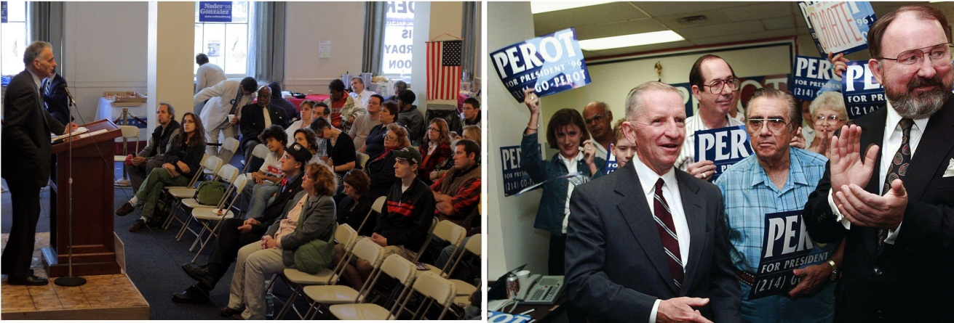
Minor-party candidates Ross Perot and Ralph Nader did not come close to winning the presidency, but they did bring media attention to issues during the elections in which they ran.
Source: Photo (left) used with permission from AP/Eric Gay. Photo (right) courtesy of Sage Ross,http://commons.wikimedia.org/wiki/File:Ralph_Nader_and_crowd,_October_4,_2008.jpg.
Minor party candidates can be spoilers in elections by taking away enough votes from a major party candidate to influence the outcome without winning. Minor parties collectively have captured over 5 percent of the popular vote in every presidential election since 1840, although individual minor parties may win only a small percentage of votes. ^{[6]}Green Party candidate Ralph Nader was considered by some analysts to be a spoiler in the 2000 presidential campaign by taking votes away from Democratic contender Al Gore in Florida. George W. Bush received 2,912,790 votes in Florida compared to Al Gore’s 2,912,253 votes. ^{[7]} If 540 of Nader’s 96,837 votes had gone to Gore, Gore might have ended up in the White House. ^{[8]}

Types of Minor Parties
Minor parties can be classified as enduring, single-issue, candidate-centered, and fusion parties.

Enduring Minor Parties
Some minor parties have existed for a long time and resemble major parties in that they run candidates for local, state, and national offices. They differ from major parties because they are less successful in getting their candidates elected. ^{[9]}
The Libertarian Party, founded in 1971, is an enduring minor party, which is a type of minor party that has existed for a long time and regularly fields candidates for president and state legislatures. The Libertarians are unable to compete with the two major parties because they lack a strong organizational foundation and the financial resources to run effective campaigns. The party also holds an extreme ideological position, which can alienate voters. Libertarians take personal freedoms to the extreme and oppose government intervention in the lives of individuals, support the right to own and bear arms without restriction, and endorse a free and competitive economic market. ^{[10]}

Single-Issue Minor Parties
Sometimes called ideological parties, single-issue minor parties exist to promote a particular policy agenda. The Green Party is a product of the environmental movement of the 1980s. It advocates environmental issues, such as mandatory recycling and strong regulations on toxic waste. ^{[11]}

Candidate-Centered Minor Parties
Candidate-centered minor parties form around candidates who are able to rally support based on their own charisma or message. Former World Wrestling Federation star Jesse “The Body” Ventura was elected governor of Minnesota in 1998 under the Independence Party label, an offshoot of the Reform Party. The plainspoken, media savvy Ventura made the need for an alternative to two-party domination a core theme of his campaign: “It’s high time for a third party. Let’s look at Washington. I’m embarrassed. We’ve got a lot of problems that the government should be dealing with, but instead, for the next nine months, the focus of this nation will be on despicable behavior by career politicians. If this isn’t the right time for a third party, then when?” ^{[12]}

Fusion Minor Parties
Fusion minor parties, also known as alliance parties, are enduring or single-issue minor parties that engage in the practice of cross endorsement, backing candidates who appear on a ballot under more than one party label. Fusion parties routinely endorse candidates who have been nominated by the two major parties and support their causes. Cross endorsement allows minor parties to contribute to the election of a major-party candidate and thus gain access to officeholders. In addition to giving a major-party candidate an additional ballot position, fusion parties provide funding and volunteers.
Only eight states permit the practice of cross endorsement. The most active fusion parties are in New York. The Liberal Party and the Democratic Party cross endorsed Mario Cuomo in the 1990 New York governor’s race, leading him to defeat his Republican Party and Conservative Party opponents handily. The Conservative Party and the Republican Party cross endorsed George Pataki in the 2000 governor’s race, leading him to victory. ^{[13]} During the 2010 midterm elections, the Tea Party cross endorsed several successful candidates running in the primary under the Republican Party label, upsetting mainstream Republican candidates. Some of the Tea Party–endorsed candidates, such as US Senate candidate Rand Paul in Kentucky, went on to win the general election.

Comparing Content
The Tea Party
There has been almost as much discussion about media coverage of the Tea Party as there has been about the organization’s issue positions, candidate endorsements, and protest activities. Tea Party activists, such as former Alaska governor and Republican vice presidential candidate Sarah Palin, have lambasted the traditional news media for being tied to special interests and irrelevant for average Americans. Instead, Tea Party leaders have embraced social media, preferring to communicate with their supporters through Facebook and Twitter.
Early Tea Party protests against government economic policies received little mainstream press attention. Media coverage increased as the Tea Party staged rowdy protests against government health care reform, and public interest in the movement grew. Stories by major news organizations focused on the evolution of the Tea Party, its positions on issues, its membership, and its most vocal spokespersons. Tea Party rallies garnered extensive attention from mainstream media as well as political bloggers. The Tea Party received the lion’s share of media coverage on election night in 2010, as the mainstream press framed the election results in terms of public dissatisfaction with the political status quo as evidenced by victories by Tea Party–backed candidates. ^{[14]}
Coverage of the Tea Party differs widely by media outlet. CNN reports of a Tea Party protest in Chicago featured on-site reporters aggressively interviewing average citizens who were participating in the event, challenging them to defend the Tea Party’s positions on issues. CNN and network news outlets reported that members of Congress had accused Tea Party protestors of anti-Obama racism based on racially charged statements and signs held by some protestors. Fox News, on the other hand, assumed the role of Tea Party cheerleader. Fox analyst Tobin Smith took the stage at a Tea Party rally in Washington, DC, and encouraged the protestors. Reporting live from a Boston Tea Party protest, Fox Business anchor Cody Willard encouraged people to join the movement, stating, “Guys, when are we going to wake up and start fighting the fascism that seems to be permeating this country?” ^{[15]}
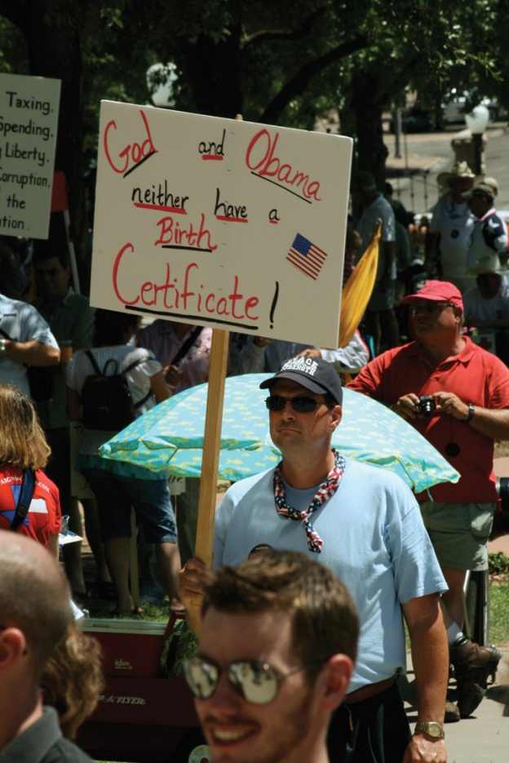
Tea Party signs at a rally. Media coverage of Tea Party rallies focused on racially charged signs prompting the movement’s leaders to decry the mainstream press.
Source: Photo courtesy of Bonzo McGrue,http://commons.wikimedia.org/wiki/File:BirthCertificate.jpg.
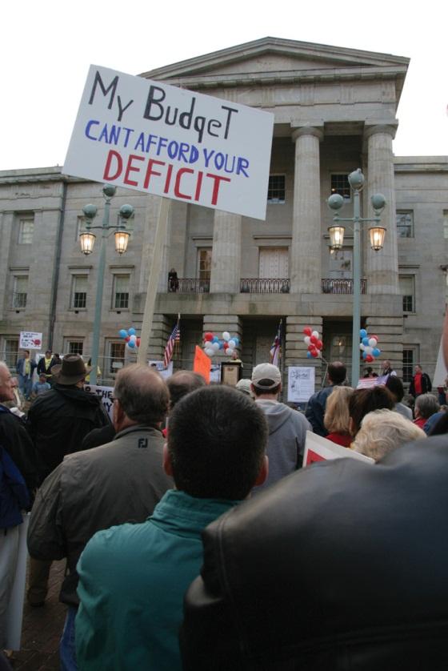
Signs oppose the press. The majority of Tea Party signs at rallies state issue positions without racially charged messages.
Source: Photo courtesy of Ivy Dawned,http://www.flickr.com/photos/ivydawned/3446727838/.
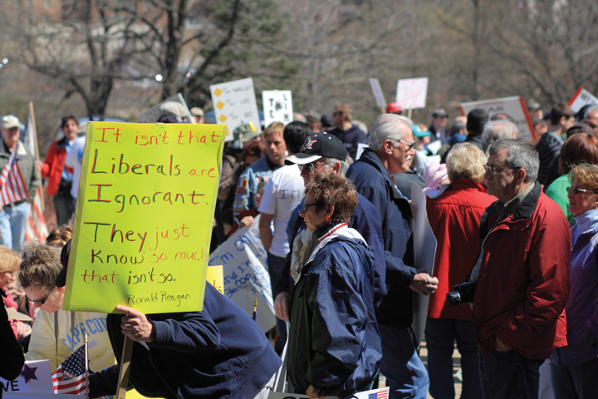
Rally Signs Depict Issue Positions
Source: Photo courtesy of Sage Ross,http://www.flickr.com/photos/ragesoss/3445951311/.
Studies of mainstream press coverage of the Tea Party also vary markedly depending on the source. A 2010 report by the conservative Media Research Center found that the press first ignored and then disparaged the Tea Party. The report alleged that ABC, CBS, NBC, and CNN framed the Tea Party as a fringe or extreme racist movement. ^{[16]} Conversely, a 2010 survey conducted by the mainstream newspaper the Washington Postfound that 67 percent of local Tea Party organizers felt that traditional news media coverage of their groups was fair, compared to 23 percent who considered it to be unfair. Local organizers also believed that news coverage improved over time as reporters interviewed Tea Party activists and supporters and gained firsthand knowledge of the group and its goals. ^{[17]}Both reports were debated widely in the press.

Challenges Facing Minor Parties
A minor-party candidate has never been elected president. In the past five decades, minor parties have held few seats in Congress or high-level state offices. Few minor party candidates have won against major-party candidates for governor, state representative, or county commissioner in the past two decades. Minor-party candidates have better luck in the approximately 65,000 nonpartisan contests for city and town offices and school boards in which no party labels appear on the ballot. Hundreds of these positions have been filled by minor-party representatives. ^{[18]}
A majority of the public favors having viable minor-party alternatives in elections. ^{[19]} Why, then, are minor parties unable to be a more formidable presence in American politics?

Winner-Take-All Elections
One major reason for two-party dominance in the United States is the prominence of the single-member district plurality system of elections,^{[20]} also known as winner-take-all elections. Only the highest vote getter in a district in federal and most state legislative elections gains a seat in office. Candidates who have a realistic chance of winning under such a system are almost always associated with the Democratic and Republican parties, which have a strong following among voters and necessary resources, such as funding and volunteers to work in campaigns.
In contrast, proportional representation (PR) systems, such as those used in most European democracies, allow multiple parties to flourish. PR systems employ larger, multimember districts where five or more members of a legislature may be selected in a single election district. Seats are distributed according to the proportion of the vote won by particular political parties. For example, in a district comprising ten seats, if the Democratic Party got 50 percent of the vote, it would be awarded five seats; if the Republican Party earned 30 percent of the vote, it would gain three seats; and if the Green Party earned 20 percent of the vote, it would be granted two seats. ^{[21]} PR was used for a short time in New York City council elections in the 1940s but was abandoned after several communists and other minor-party candidates threatened the Democratic Party’s stronghold. ^{[22]}

Legal Obstacles
Minor parties are hindered by laws that limit their ability to compete with major parties. Democrats and Republicans in office have created procedures and requirements that make it difficult for minor parties to be listed on ballots in many states. In Montana, Oklahoma, and several other states, a candidate must obtain the signatures of least 5 percent of registered voters to appear on the ballot. A presidential candidate must collect over one million signatures to be listed on the ballot in every state. This is an insurmountable barrier for most minor parties that lack established organizations in many states. ^{[23]}
Campaign finance laws work against minor parties. The 1974 Federal Election Campaign Act and its amendments provide for public financing of presidential campaigns. Rarely has a minor-party candidate been able to qualify for federal campaign funds as the party’s candidates must receive 5 percent or more of the popular vote in the general election. Similar barriers hinder state-level minor-party candidates from receiving public funding for taxpayer-financed campaigns, although some states, such as Connecticut, are debating plans to rectify this situation.

Lack of Resources
The financial disadvantage of minor parties impedes their ability to amass resources that are vital to mounting a serious challenge to the two major parties. They lack funds to establish and equip permanent headquarters. They cannot hire staff and experienced consultants to conduct polls, gather political intelligence, court the press, generate new media outreach, or manage campaigns. ^{[24]}

Lack of Media Coverage
Minor parties rarely receive significant media coverage except when they field a dynamic or outlandish candidate, such as Jesse Ventura, or when they are associated with a movement that taps into public concerns, such as the Tea Party. The dominant horserace frame employed by the media focuses on who is ahead and behind in an election and usually tags minor-party candidates as losers early in the process. Media treat minor parties as distractions and their candidates as novelty acts that divert attention from the main two-party attractions.
Minor parties often are unable to air televised campaign ads because they lack funds. Even in the digital era, television advertising is an essential part of campaigns because it allows candidates to control their own message and reach large numbers of voters. Minor-party candidates have difficulty gaining publicity and gaining recognition among voters when they cannot advertise.
Minor-party candidates routinely are excluded from televised debates in which major-party candidates participate. ^{[25]} By being allowed to participate in the 1992 presidential debates, Reform Party candidate Ross Perot achieved national visibility and symbolic equality with incumbent president George W. Bush and Democratic candidate Bill Clinton.

Video Clip

http://www.youtube.com/watch?v=Rkgx1C_S6ls

Giant Sucking Sound: Ross Perot 1992 Presidential Debate
Perot received significant press coverage from his debate performance.
Figure 10.8 Ross Perot Participating in the 1992 Presidential Debate
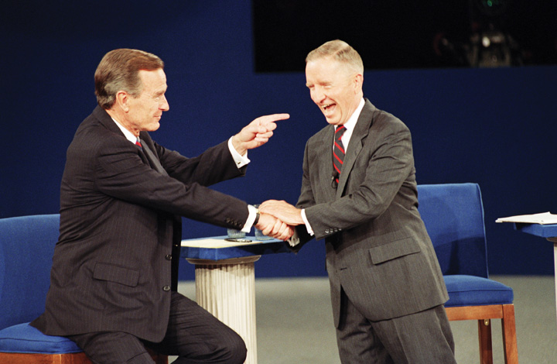
Minor-party candidates rarely have the opportunity to participate in televised presidential debates. An exception was Reform Party candidate Ross Perot, whose campaign was bolstered by his inclusion in the 1992 presidential debate with Republican George W. Bush and Democrat Bill Clinton.
Source: Used with permission from AP Photo/Greg Gibson.
These benefits were denied Ralph Nader when he was excluded from the presidential debates in 2000 because the Commission on Presidential Debates ruled that Nader did not have enough voter support to warrant inclusion.

Absorption by Major Parties
When a minor-party movement gains momentum, the Republican and Democratic parties move quickly to absorb the minor party by offering enticements to their members, such as support for policies that are favored by the minor party. Major-party candidates appeal to minor-party supporters by arguing that votes for minor-party candidates are wasted. ^{[26]}Major parties are often successful in attracting minor-party voters because major parties are permeable and ambiguous ideologically. ^{[27]}
After the Democrats in Congress were instrumental in passing the Voting Rights Act in 1964, the Republican Party absorbed the southern Dixiecrats, a Democratic Party faction opposed to the legislation. The two major parties tried to attract Ross Perot’s Reform Party supporters after his 1992 presidential bid, with the Republican Party succeeding in attracting the lion’s share of votes. The Republican Party’s position against big government appealed to Perot supporters. ^{[28]} Even though the Tea Party gravitates toward the Republican Party, Republicans have not universally accepted it.

KEY TAKEAWAYS
Minor parties offer an alternative to the dominant Republican and Democratic parties, but they have difficulty surviving. They arise to challenge the two major parties when people feel that their interests are not being met. There are four major types of minor parties: enduring, single-issue, candidate-centered, and fusion parties. Minor parties have difficulty winning high-level office but are able to fill seats at the county and local level. There are numerous challenges faced by minor parties in American politics, including winner-take-all elections, legal obstacles, lack of resources, and limited media coverage.

EXERCISES
- When do minor parties tend to arise? How can minor parties have an impact on national politics if they cannot usually compete in national elections?
- What minor parties are you familiar with? How are minor parties generally portrayed in the media?
- What makes it difficult for minor parties to win state and local elections?

[1] Daniel A. Mazmanian, Third Parties in Presidential Elections (Washington, DC: Brookings Institution, 1974).
[2] Micah L. Sifry, Spoiling for a Fight (New York: Routledge, 2003).
[3] Daniel A. Mazmanian, Third Parties in Presidential Elections (Washington, DC: Brookings Institution, 1974).
[4] Diana Owen and Jack Dennis, “Antipartyism in the USA and Support for Ross Perot,”European Journal of Political Research 29 (1996): 383–400.
[5] John C. Green and William Binning, “Surviving Perot: The Origins and Future of the Reform Party,” in Multiparty Politics in America, ed. Paul S. Herrnson and John C. Green (Lanham, MD: Rowman & Littlefield, 1997), 87–102.
[6] Steven J. Rosenstone, Roy L. Behr, and Edward H. Lazarus, Third Parties in America, 2nd ed. (Princeton, NJ: Princeton University Press, 2000).
[7] Committee for the Study of the American Electorate, “Votes Cast for Presidential Candidates,” accessed March 26, 2011,http://www.fairvote.org/turnout/prrevote2000.htm.
[8] Micah L. Sifry, Spoiling for a Fight (New York: Routledge, 2003).
[9] Steven J. Rosenstone, Roy L. Behr, and Edward H. Lazarus, Third Parties in America, 2nd ed. (Princeton, NJ: Princeton University Press, 2000).
[10] Terry Savage, “The Libertarian Party: A Pragmatic Approach to Party Building,” inMultiparty Politics in America, ed. Paul S. Herrnson and John C. Green (Lanham, MD: Rowman & Littlefield, 1997), 141–45.
[11] Greg Jan, “The Green Party: Global Politics at the Grassroots,” in Multiparty Politics in America, ed. Paul S. Herrnson and John C. Green (Lanham, MD: Rowman & Littlefield, 1997), 153–57.
[12] Micah L. Sifry, Spoiling for a Fight (New York: Routledge, 2003).
[13] J. David Gillespie, Politics at the Periphery (Columbia: University of South Carolina Press, 1993).
[14] Brian Stelter, “In News Coverage, Tea Party and Its ‘New Personalities’ Hold the Spotlight,” New York Times, November 3, 2010.
[15] Tony Rogers, “Both Fox News and CNN Made Mistakes in Tea Party Protest Coverage,” About.com Journalism, accessed March 26, 2011,http://journalism.about.com/od/ethicsprofessionalism/a/teaparty.htm.
[16] Rich Noyes, “TV’s Tea Party Travesty,” Media Research Center, April 15, 2010, accessed March 26, 2011,http://www.mrc.org/specialreports/uploads/teapartytravesty.pdf.
[17] Amy Gardner, “Tea Party Groups Say Media Have Been Fair, Survey Finds,” Washington Post, October 26, 2010, accessed March 26, 2011, http://www.washingtonpost.com/wp-dyn/content/article/2010/10/26/AR2010102602796.html.
[18] Micah L. Sifry, Spoiling for a Fight (New York: Routledge, 2003), 45.
[19] Micah L. Sifry, Spoiling for a Fight (New York: Routledge, 2003), 45.
[20] Maurice Duverger, Party Politics and Pressure Groups (New York: Thomas Y. Crowell, 1972).
[21] Douglas J. Amy, Real Choices/New Voices (New York: Columbia University Press, 1993).
[22] Clinton Rossiter, Parties and Politics in America (Ithaca, NY: Cornell University Press, 1960).
[23] Steven J. Rosenstone, Roy L. Behr, and Edward H. Lazarus, Third Parties in America, 2nd ed. (Princeton, NJ: Princeton University Press, 2000).
[24] Steven J. Rosenstone, Roy L. Behr, and Edward H. Lazarus, Third Parties in America, 2nd ed. (Princeton, NJ: Princeton University Press, 2000).
[25] Steven J. Rosenstone, Roy L. Behr, and Edward H. Lazarus, Third Parties in America, 2nd ed. (Princeton, NJ: Princeton University Press, 2000).
[26] Clinton Rossiter, Parties and Politics in America (Ithaca, NY: Cornell University Press, 1960).
[27] J. David Gillespie, Politics at the Periphery (Columbia: University of South Carolina Press, 1993).
[28] Ronald B. Rapoport and Walter J. Stone, “Ross Perot Is Alive and Well and Living in the Republican Party: Major Party Co-optation of the Perot Movement and the Reform Party,” in The State of the Parties, 2nd ed., ed. John C. Green and Rick Farmer (Lanham, MD: Rowman & Littlefield, 2003), 337–53.

10.7 Political Parties in the Information Age

LEARNING OBJECTIVES
After reading this section, you should be able to answer the following questions:
- How do political parties publicize their leaders, candidates, and causes?
- How do the media depict political parties?
- In what ways has the relationship of the media and political parties changed over time?
Political parties thrive when they are able to manage the media and effectively promote their candidates, leaders, and causes. Their goal is to use the media to publicize policy positions, activities, and leaders. Party organizations launch media blitzes and provide technical communications assistance to campaigns and government officials so that they can attract media attention. They also use media to inform and mobilize their loyalists. Media depictions tend to be dramatic, emphasizing infighting among party members as well as conflicts between different parties.

Media Interactions
Political parties are obsessed with keeping their names and representatives in the public eye. Publicity gives the impression that the party is active and influential. A party with a strong media presence can attract volunteers and financial contributors. Parties use a variety of tactics in their efforts to control the media agenda and get their message out to the public and to journalists. They employ many of the same tactics as interest groups, such as holding news conferences, issuing press releases, giving interviews to journalists, and appearing on television and radio talk shows. Democratic and Republican officials provide competing commentary about issues. Party leaders participate in “spin sessions” to get their views heard. Parties engage in aggressive advertising campaigns. Finally, they maintain significant web and digital media presences to reach their supporters and to court the press.

Partisan Spin
Political parties seek to influence political debate on a daily basis by confronting the opposition in the media. They engage in spin, the practice of providing an interpretation of events or issues that favors their side. High-profile partisans make the rounds of political talk programs such as Meet the Press, and news shows and give interviews to print journalists to spin their views. Partisan spin doctors routinely appear on television immediately following candidate debates or major speeches to interpret what has been said and to recast any misstatements. ^{[1]} Spin doctors can be elected leaders, party officials, or interest group leaders. In 2011, Republican Congressman Paul Ryan and Washington Governor Gary Locke provide opposing commentary on the State of the Union address by President Barack Obama. Minnesota Congresswoman Michele Bachmann gave the Tea Party spin on the address via webcast.
Specific media outlets are associated with spin doctors who favor a specific party. Conservative talk radio host Rush Limbaugh favors the Republican Party and draws a large audience. Liberal talk show hosts such as MSNBC’s Rachel Maddow tend to support Democrats. The Fox News Network hosts spin doctors such as Bill O’Reilly, who calls his program a “no-spin zone” despite its constant promotion of Republican and conservative causes.

Advertising
Political advertising is a way for parties to disseminate messages without having them filtered by journalists. Parties engaged extensively in issue advocacy, advertising campaigns that focus on legislative policies. They also develop ads supportive of their candidates and leaders and critical of the opposition. Online video is a cost-effective alternative to television advertising, although many more people are reached through TV ads than via online ads.

Link
The Democratic and Republican parties feature online ads on their YouTube channels, which makes them readily available to supporters as well as journalists.
Next to You: The Ihle Family
http://www.youtube.com/user/DemocraticVideo
RNC Launches YouTube Contest
http://www.youtube.com/user/rnc

Websites
Party websites offer a vast amount of information to average citizens, political activists, and journalists who take the initiative to visit them. Websites provide an effective mechanism for communicating information to citizens and can lessen the administrative burden on party organizations. They reach a large number of people instantaneously and have become more effective mechanisms for raising funds than the earlier method of direct mail. The sites include general political information, such as facts about American democracy and party history. Press releases, platforms, and position papers give the lowdown on issues and candidates. Party sites also host discussion boards and blogs where party elites, including candidates, interact with rank-and-file members. ^{[2]}Websites hype symbols that create a sense of identity as well as a party brand. The technical delivery of this content is an important aspect of outreach, so developing e-mail lists of party members, especially visitors to the website, is a priority.
Figure 10.9Democratic Party’s New Logo and Slogan
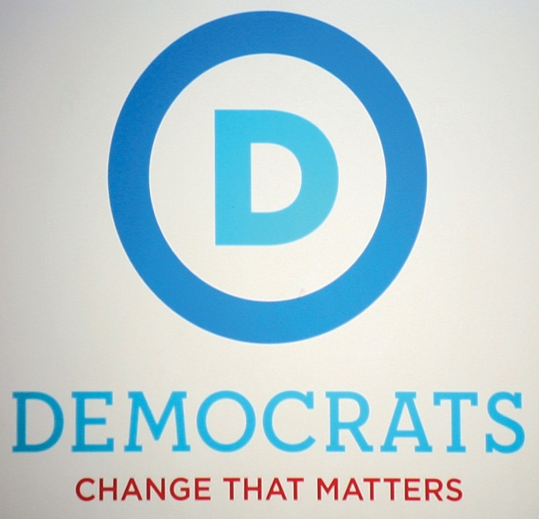
The Democratic Party uses its website to promote its logo and Obama-era slogan, “Democrats: Change that Matters.”
Source: Photo courtesy of Cliff,http://www.flickr.com/photos/nostri-imago/4994523865/.
Figure 10.10 Rebulican Party’s Logo
The Republican Party logo features the historic elephant icon that has represented the party since the 1860s.
Source: Used with permission from Getty Images.
The Democratic Party’s and Republican Party’s websites have become sophisticated. In addition to the sites’ content, visitors are offered the opportunity to connect with the party through Facebook, Twitter, YouTube, Flickr, and other social media. Some of the material on Democratic and Republican websites consists of negative, at times vicious, attacks on the opposing party. In 2011, the Republican Party used its website to gain momentum for its quest to win the White House in 2012. Clicking on the link to the Republican National Committee site led directly to page featuring a negative ad against the Obama administration and the opportunity to “Help Fight Back” by donating money. The Democratic National Committee website, which represents the party of the sitting president, focuses heavily on the accomplishments of the Obama administration.

Media Depictions of Political Parties
In depicting political parties, the media highlight conflicts between the two major parties and divisions within each party. The press also focuses on the strategies parties employ in their pursuit of political power.

Partisan Conflict
Parties as adversaries is an accurate characterization of one of their primary functions, representing opposing viewpoints and providing platforms for debate. The modern party has been called “a fighting organization.” ^{[3]} Indeed, parties actively promote this image. Reporters consulting party websites and reading partisan blogs get their fill of negative hyperbole about the opposition.
The press coverage can exaggerate the conflicts between parties by employing sports and war metaphors. Parties often are described as attacking, battling, fighting, jousting, beating, and pummeling one another. This type of media coverage becomes a problem when parties genuinely try to work together while the press continues to frame their relations in conflict terms. When the Republican congressional leadership held a meeting at the White House in 1995 and agreed to work with Democratic President Bill Clinton on public policy, Republican House Speaker Newt Gingrich told reporters that the meeting was “great.” When the press immediately speculated about when the cordial relations would break down, Gingrich reacted by dressing down reporters: “[Y]ou just heard the leaders of the Republican Party say that the Democratic President today had a wonderful meeting on behalf of America; we’re trying to work together. Couldn’t you try for twenty-four hours to have a positive, optimistic message as though it might work?” ^{[4]}

Party Strategies
Media depictions often focus on the strategies parties use to win elections and control government. The press is obsessed with how the Republicans and Democrats manage their messages to attract or lose supporters.
One strategy typically portrayed by mass media is that parties routinely compromise the public good to achieve self-interested goals. The Democratic Party is continually criticized for catering to organized labor, Hollywood liberals such as Barbara Streisand and Alec Baldwin, and feminists. The Republican Party is chided for favoring conservatives and corporate interests. The press argues that both parties support these privileged groups because they make large financial donations to party organizations and campaigns.
Media depictions suggest that parties fail to live up to campaign promises about policies they will enact if their candidates are elected. A recurring media theme during President Obama’s presidency is that Obama has not represented his party’s interests, such as on the issue of tax cuts. However, press coverage is not consistent with research demonstrating that party leaders keep campaign promises at least two-thirds of the time. ^{[5]}

Media Consequences
Political parties have had to adapt to a dynamic mass media environment that at times has weakened their position in the political process. The introduction of television in the 1950s allowed candidates and government officials to circumvent parties and take their appeals directly to the public. An example is Nixon’s “Checkers” speech. Richard Nixon, who was running on a ticket headed by Republican presidential candidate General Dwight D. Eisenhower, had been accused of taking money from campaign supporters. The Republican Party was unhappy with Nixon and considered dropping him from the ticket. To save his political career, Nixon went on television to make his case to the American people by detailing his personal finances and denying any wrongdoing. With his wife, Pat, by his side, Nixon declared that there was one gift from supporters he would not return, a dog named Checkers that had become a beloved family pet. The tactic worked as the public bought into Nixon’s impassioned television appeal. Eisenhower and Nixon went on to win the election.

Video Clip

http://www.youtube.com/watch?v=S4UEv_jjPL0

Nixon’s “Checkers Speech”
A defining moment was the “Checkers” speech delivered by vice presidential candidate Richard Nixon on September 23, 1952.
By the 1980s, party elites had less influence on public opinion than media elites, especially journalists. ^{[6]} The press had assumed parties’ responsibility for recruiting candidates, organizing the issue agenda, and informing and mobilizing voters. ^{[7]} Journalists controlled the amount of publicity parties and candidates received, which contributes to their recognition among voters.
Consultants work directly with candidates to develop media strategies, often leaving parties out of the loop. In his bid for the 2004 Democratic presidential nomination, former governor of Vermont Howard Dean worked with consultants to develop an innovative campaign strategy centered on using the Internet to build a base of online supporters through sites including Meetup.com and MoveOn.org, and to raise funds. The Democratic Party expressed concerns about Dean’s tactics because he ignored the traditional bases of the party’s support, such as environmental activists and other liberal interest groups. ^{[8]}Dean was successful in raising funds on the Internet but was unable to secure the presidential nomination.
Parties responded in the 1990s by developing media strategies to enhance their proficiency as service providers to candidates, officeholders, and voters. They engaged in aggressive fundraising schemes so that they could afford to hire the services of consultants and purchase expensive advertising time on television and space in print publications. Parties have facilities where politicians do on-air television and radio interviews and tape messages for local media markets. They invest heavily in advertising during and between election cycles.
Today, major parties are at the forefront of innovation with communications technology as they seek ways of making the Internet and digital media more effective and exciting for party members. These media efforts have been paying off. Seventy-seven percent of the public believes that political parties are important to them for providing political information. ^{[9]} Party advertisements can influence the opinions of up to 4 percent of voters, enough to sway an election, although this does not happen in every contest. ^{[10]}

KEY TAKEAWAYS
Political parties have a double-edged relationship with the media. On the one hand, the press is important for political parties because it publicizes the activities and positions of party organizations, leaders, and candidates, which can build a base of support. On the other hand, media coverage of parties emphasizes conflict and the failure of parties to make good on promises they make about policies. Thus parties are continually revising their strategies as they attempt to garner as much positive coverage and publicity as possible.
Parties need to manage the media and attract sufficient attention to remain viable in the public eye and inform and mobilize their constituents. They interact with journalists by engaging in spin, producing and airing advertisements, hosting websites, and populating social media. Media depictions highlight the conflicts between parties and the strategies they employ to attract voters. Parties have adapted to a changing media environment by developing in-house media facilities to allow candidates and officeholders to communicate with constituents.

EXERCISES
- Why is publicity important to political parties? What are the different strategies parties employ to stay in the public eye and get their messages across?
- Why does media coverage of political parties tend to exaggerate the conflicts between them? What incentive do the media have to portray politics as conflictual?

Civic Education
Youth Engagement in Political Parties
Political parties provide a gateway to involvement in public affairs. Parties offer opportunities for taking part in political campaigns, advocating on behalf of a policy issue, and even running for office. The experience of involvement with a political party can help people hone their organizational skills, develop as public speakers, and learn how to use media for outreach.
Young people traditionally have been somewhat resistant to participation in political parties. They often feel that political parties are targeted more toward older citizens. Yet active party organizations aimed at young people exist at the national, state, and local levels. The College Democrats andCollege Republicans have national organizations with local affiliates on campuses. These organizations are integral to the parties’ voter registration and campaign efforts. They host conferences to give young people a voice in the party. They provide training in campaign techniques, including the use of social media, that instructs young people in reaching out to their peers so that they can make a difference in elections.
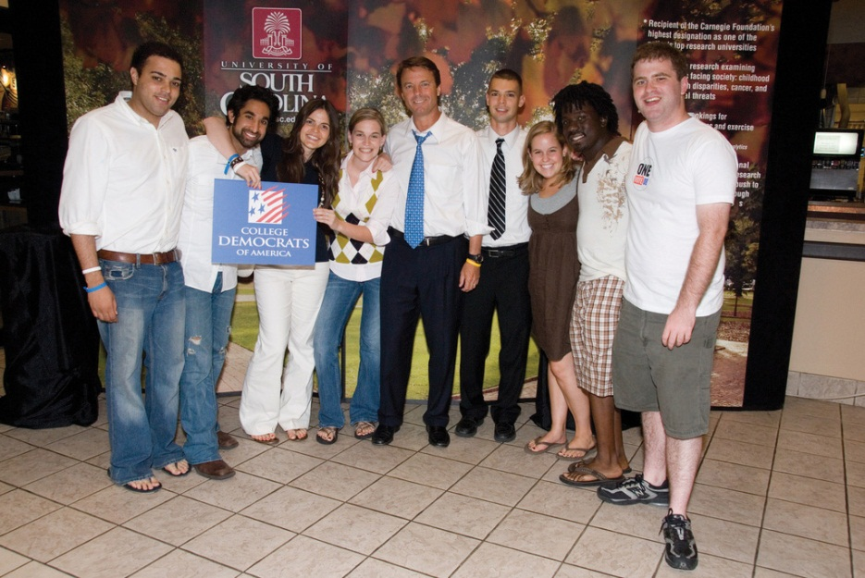
College democrats.College party organizations offer a wide range of opportunities for getting involved in government and politics.
Source: Photo courtesy of John Edwards 2008,http://www.flickr.com/photos/forallofus/1254455614/.

[1] Stephen Bates, The Future of Presidential Debates (Boston: Joan Shorenstein Barone Center on the Press, Politics and Public Policy, 1993).
[2] Rachael Gibson and Stephen Ward, “A Proposed Methodology for Studying the Function and Effectiveness of Party and Candidate Web Sites,” Social Science Computer Review 18: 301–19.
[3] Robert Michels, Political Parties, ed. Seymour Martin Lipset (1915; New York: Collier Books, 1962), 78.
[4] Joseph N. Cappella and Kathleen Hall Jamieson, Spiral of Cynicism (New York: Oxford University Press, 1997).
[5] Joseph N. Cappella and Kathleen Hall Jamieson, Spiral of Cynicism (New York: Oxford University Press, 1997).
[6] Nelson Polsby, The Consequences of Party Reform (New York: Oxford University Press, 1983).
[7] Thomas E. Patterson, Out of Order (New York: Knopf, 1994).
[8] Thomas B. Edsall, “Dean Sparks Debate on His Potential to Remold Party,” Washington Post, October 20, 2003.
[9] James A. Thurber, Erin O’Brien, and David A. Dulio, “Where Do Voters Get Their Political Information,” Campaigns and Elections, April, 2001, 9.
[10] Will Lester, “About $1B Spent on Televised Midterm Ads,” Associated Press, December 5, 2002.

10.8 Recommended Reading
Bibby, John, and Sandy Maisel. Two Parties or More? The American Party System. Boulder, CO: Westview Press, 2002. An exploration of the strengths, weaknesses, and functions of minor parties in a two-party dominant system.
Brewer, Mark, and Jeffrey Stonecash. Dynamics of American Political Parties. New York: Cambridge University Press, 2009. A historical account of the evolution of American political parties.
Chambers, William Nisbet, and Walter Dean Burnham. The American Party Systems, 2nd ed. New York: Oxford University Press, 1975. An excellent collection of essays discussing the historical stages of development of the political party system.
Epstein, Leon D. Political Parties in the American Mold. Madison: University of Wisconsin Press, 1986. An impressive investigation into political parties’ ability to adapt to changing political, social, economic, and technological conditions.
Gibson, Rachel, Paul Nixon, and Stephen Ward, eds. Political Parties and the Internet: Net Gain? London: Routledge, 2003. A timely collection of articles assessing the positive and negative implications of political parties and the Internet.
Green, Donald, Bradley Palmquist, Eric Schickler, and Giordano Bruno. Partisan Hearts and Minds. New Haven, CT: Yale University Press, 2002. A comprehensive study of the party in the electorate that argues for the enduring centrality of partisanship as a political cue for many Americans.
Johnson, Dennis W. No Place for Amateurs. New York: Routledge, 2001. Argues that political consultants, pollsters, media experts, political action committees, fund raisers, and debate coaches have take on the functions of political parties, diminishing parties’ significance in the political process.
Key, V. O., Jr. Politics, Parties, & Pressure Groups, 5th ed. New York: Thomas Y. Crowell, 1964. The classic treatise on political parties covering their history and development, structure, and function.
Lepore, Jill. The Whites of Their Eyes. Princeton, NJ: Princeton University Press, 2010. An examination of the Tea Party in historical context.
Maisel, L. Sandy, and Jeffrey M. Berry. The Oxford Handbook of American Political Parties and Interest Groups. New York: Oxford University Press, 2010. A comprehensive handbook defining terms related to political parties and interest groups.
Riechley, A. James. The Life of the Parties. New York: Free Press, 1992. A lively, detailed account of the history of American parties from the founding to the present day.
Riordon, William L. Plunkitt of Tammany Hall. St. James, NY: Brandywine Press, 1994. Political wisdom dispatched by a New York party boss in the 1800s.
Sifry, Micah L. Spoiling for a Fight. New York: Routledge, 2003. A survey of contemporary third parties, including case studies of Ross Perot and Jesse Ventura of the Reform Party and Ralph Nader of the Green Party.
White, John Kenneth, and Daniel M. Shea. New Party Politics. Boston: Bedford/St. Martin’s, 2000. An account of the influence of new communications technologies, including the Internet, on American political parties.

10.9 Recommended Viewing
Advise and Consent (1962). This political thriller depicts hardcore partisan politics when a president seeks Senate confirmation of a candidate for secretary of state in the Cold War era.
America’s Political Parties: The Democratic Party, 1960–1992 (1992). Documentary beginning with the swearing in of President John F. Kennedy and following developments in the Democratic Party through the years of reform to the election of President Bill Clinton.
America’s Political Parties: The Republican Party, 1960–1992 (1992). Documentary tracing the evolution of the Republican Party and its various constituent groups from the candidacy of conservative Barry Goldwater through the Nixon, Reagan, and first Bush presidencies.
Daley: The Last Boss (1995). Award-winning documentary of mayor of Chicago Richard J. Daley, who reigned from 1955 to 1976 and was considered to be the last of the big-city bosses affiliated with the Democratic machine.
Gangs of New York (2002). Director Martin Scorsese’s depiction of the Five Points section of New York during the reign of Boss Tweed.
Head of State (2003). Chris Rock stars as a Washington, DC, alderman who is recruited to run for president by party leaders who want to gain support from minority groups.
Perot: The Rise and Fall of a Presidential Contender (1992). A CNN-produced film that explores the third-party presidential bid of millionaire businessman Ross Perot in 1992; the film includes compelling interviews and news footage.
Power, Politics and Latinos (1992). A documentary focusing on efforts by Latinos to promote political awareness and participation in the United States; the film includes an examination of the development of the La Raza Unida party.
The Last Hurrah (1958). The last stand of a venerable political boss in a northeastern city is explored in this classic film based loosely on the last race run by famous Boston mayor James Michael Curley.
The People and the Power Game—the Elected: The Presidency and Congress(1996). Author Hedrick Smith’s production focuses on the difficulties faced by President Bill Clinton and the Democrats in enacting their policy agenda after the Republican takeover of the House of Representatives in 1995.
Tea Party: The Documentary Film (2010). A pro–Tea Party film investigating the grassroots bases of Tea Party support.
A Third Choice (1996). A documentary exploring minor parties over the course of over two hundred years.
The Time of the Lincolns (2001). A documentary based on biographies of Abraham and Mary Todd Lincoln that spends significant time exploring the evolution of the political party system from 1836 to 1864.

Chapter 11

Campaigns and Elections

Preamble
It has become commonplace for reality programs to hold elections. TheAmerican Idol winner is chosen in an elimination contest by receiving the most votes from viewers who, just like voters in regular elections, make decisions based on any number of reasons: voice, song selections, looks, gender, race, even hometown. True, in American Idol, people vote as often as they want by telephone and text message. On Dancing with the Stars, a voting controversy was set off when Bristol Palin survived poor performances and unfavorable ratings from the judges because partisan supporters of her mother, former Republican Alaska governor Sarah Palin, allegedly stuffed the electronic ballot box. Multiple voting, although illegal, has not been unknown in American elections; and distance voting may be a way of the future, freeing voters from traveling to the polling booth.
Americans are accustomed to voting to choose everything from reality-program winners to government officeholders.
Source: Used with permission from AP Photo/Chris Pizzello.
It is no surprise that the winner of an entertainment contest would be chosen by the voting public because elections are the heart and voting is the voice of American democracy. Elections legitimize the winners and the political system. They enable Americans to influence the decisions of their elected leaders.

11.1 Election Campaigns

LEARNING OBJECTIVES
After reading this section, you should be able to answer the following questions:
- How are American election campaigns organized?
- How are campaigns funded? What are the regulations that guide campaign fundraising and spending?
- What strategies do candidates use when pursuing elected office?
This section covers campaign organization, funding, and strategy. Getting elected often requires defeating opponents from the same political party in aprimary election in order to become that party’s nominee. One party’s nominee must defeat the candidates from other parties in thegeneral election. Election campaigns require organization, funding, and strategy. Legal guidelines, especially for campaign finance, influence the environment within which elections take place.

Campaign Organization
It takes the coordinated effort of a staff to run a successful campaign for office. The staff is headed by the campaign manager who oversees personnel, allocates expenditures, and develops strategy. The political director deals with other politicians, interest groups, and organizations supporting the candidate. The finance director helps the candidate raise funds directly and through a finance committee. The research director is responsible for information supporting the candidate’s position on issues and for research on the opponents’ statements, voting record, and behavior, including any vulnerabilities that can be attacked.
The press secretary promotes the candidate to the news media and at the same time works to deflect negative publicity. This entails briefing journalists, issuing press releases, responding to reporters’ questions and requests, and meeting informally with journalists. As online media have proliferated, the campaign press secretary’s job has become more complicated, as it entails managing the information that is disseminated on news websites, such as blogs like the Huffington Post, and social media, such as Facebook. Campaigns also have consultants responsible for media strategy, specialists on political advertising, and speech writers.
Figure 11.1 Voter Poll
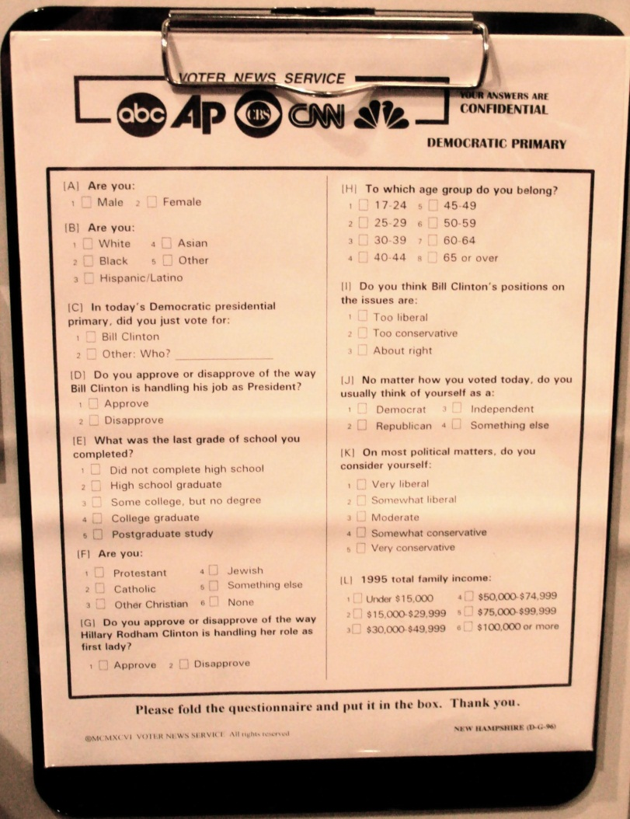
Outside the polls, some voters answer questions on exit polls that are used in media reports.
Source: Photo courtesy of RadioFan,http://en.wikipedia.org/wiki/File:Voter_poll.jpg.
Pollsters are essential because campaigning without polls is like “flying without the benefit of radar.” ^{[1]}Polls conducted by campaigns, not to be confused with the media’s polls, can identify the types of people who support or oppose the candidate and those who are undecided. They can reveal what people know and feel about the candidates, the issues that concern them, and the most effective appeals to win their votes. Tracking polls measure shifts in public opinion, sometimes daily, in response to news stories and events. They test the effectiveness of the campaign’s messages, including candidates’ advertisements.

Figure 11.2 People Taking Part in a Campaign Focus Group
Campaigns convene focus groups consisting of voters who share their views about candidates and the election in order to guide strategic decisions.
© Thinkstock
Relatedly, focus groups bring together a few people representative of the general public or of particular groups, such as undecided voters, to find out their reactions to such things as the candidate’s stump speech delivered at campaign rallies, debate performance, and campaign ads.

Funding Campaigns
“Money is the mother’s milk of politics,” observed the longtime and powerful California politician Jesse Unruh. The cost of organizing and running campaigns has risen precipitously. The 2008 presidential and congressional elections cost $5.3 billion dollars, a 25 percent increase over 2004. ^{[2]} Around 60 percent of this money goes for media costs, especially television advertising. The Campaign Finance Institute has a wealth of information about funding of American election campaigns.

Limiting Contributions and Expenditures
In an episode of The Simpsons, Homer’s boss tells him, “Do you realize how much it costs to run for office? More than any honest man could afford.” ^{[3]}Spurred by media criticisms and embarrassed by news stories of fund-raising scandals, Congress periodically passes, and the president signs, laws to regulate money in federal elections.
The Federal Election Campaign Act (FECA) of 1971, amended in 1974, limited the amount of money that individuals, political parties, and political groups could contribute to campaigns and provided guidelines for how campaign funds could be spent. The FECA also provided a system of public financing for presidential campaigns. It required that campaigns report their financial information to a newly established enforcement institution, theFederal Elections Commission (FEC), which would make it public.
Opponents challenged the constitutionality of these laws in the federal courts, arguing that they restrict political expression. ^{[4]} In the 1976 case of Buckley v. Valeo, the Supreme Court upheld the limits on contributions and the reporting requirement but overturned all limits on campaign spending except for candidates who accept public funding for presidential election campaigns. ^{[5]}The Supreme Court argued that campaign spending was the equivalent of free speech, so it should not be constrained.
This situation lasted for around twenty years. “Hard money” that was contributed directly to campaigns was regulated through the FECA. However, campaign advisors were able to exploit the fact that “soft money” given to the political parties for get-out-the-vote drives, party-building activities, and issue advertising was not subject to contribution limits. Soft money could be spent for political advertising as long as the ads did not ask viewers to vote for or against specific candidates. Nonparty organizations, such as interest groups, also could run issue ads as long as they were independent of candidate campaigns. The Democratic and Republican parties raised more than $262 million in soft money in 1996, much of which was spent on advertising that came close to violating the law. ^{[6]}

Figure 11.3 Republican National Committee Ad Featuring Presidential Candidate Bob Dole
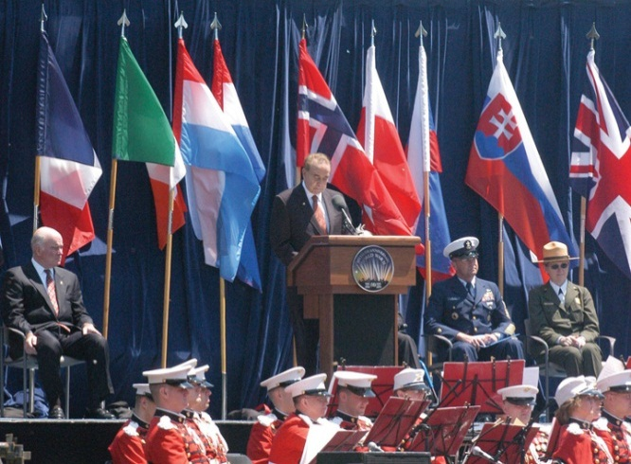
The Republican National Committee used “soft money” to produce an ad that devoted fifty-six seconds to presidential candidate Bob Dole’s biography and only four seconds to issues. Similarly, the Democratic National Committee used “soft money” on ads that promoted candidate Bill Clinton. These ads pushed the limits of campaign finance laws, prompting a call for reform.
Source: Photo courtesy of the US Department of Defense by Samantha Quigley,http://commons.wikimedia.org/wiki/File:Bob_Dole_VE_Day_60th_Anniversery.jpg.
Congress responded with the Bipartisan Campaign Reform Act (BCRA) of 2002, better known by the names of its sponsoring senators as McCain-Feingold. It banned soft-money contributions by political committees and prohibited corporations and labor unions from advocating for or against a candidate via broadcast, cable, or satellite prior to presidential primaries and the general election. A constitutional challenge to the law was mounted by Senate Majority Whip Mitch McConnell, who believed that the ban on advertising violated First Amendment free-speech rights. The law was upheld by a vote of 5–4 by the Supreme Court. ^{[7]} This decision was overruled in 2010 when the Supreme Court ruled that restricting independent spending by corporations in elections violated free speech. ^{[8]} The case concerned the rights of Citizens United, a conservative political group, to run a caustic ninety-minute film, Hillary: The Movie, on cable television to challenge Democratic candidate Hillary Rodham Clinton as she ran in the 2008 primary election campaign. The 5–4 decision divided the Supreme Court, as justices weighed the interests of large corporations against the Constitutional guarantee of free speech. ^{[9]}

Video Clip

http://www.youtube.com/watch?v=BOYcM1z5fTs

Hillary: The Movie Trailer
YouTube trailer for Hillary: The Movie.
In April 2011 comedic news anchor Stephen Colbert announced his intention to form a “super PAC” to expose loopholes in the campaign finance laws that allow corporations to form political actions committees, which can spend unlimited amounts of money in elections on advertising. Colbert testified in front of the FEC and was granted permission to form his PAC, which would be funded by Viacom, the media corporation that owns Comedy Central, which hosts The Colbert Report. The decision sparked concern that media organizations would be free to spend unlimited amounts of money in campaigns; however, the FEC’s decision imposed the strict limitation that Colbert could only show the ads on his program. Colbert announced the FEC’s decision to allow him to form a PAC to raise and spend funds in the 2012 election in this video:http://www.colbertnation.com/the-colbert-report-videos/391146/june-30-2011/colbert-super-pac---i-can-haz-super-pac-.

Sources of Funding
There are six main sources of funding for federal elections. These sources include individuals, political action committees, public funding, candidates’ contributions to their own campaigns, political party committees, and advocacy organizations or “527 committees.” Individuals contribute the most to election campaigns. Individual donations amounted to $1,330,861,724 ^{[10]} for the 2008 presidential election cycle. People can give up to $2,300 to candidates for each primary, runoff, and general election; $28,500 annually to national political parties and $10,000 to each state party; $2,300 to a legal compliance fund; and as much as they want to a political action committee (PAC) and advocacy organizations. PACs were developed by business and labor to fund candidates. Politicians have also created PACs. They can give up to $5,000 per candidate per election. In 2008, they gave the second-largest amount: $5,221,500.
Presidential candidates can opt for public funding of their election campaigns. The funds come from an income tax check-off, where people can check a box to contribute $3 to a public funding account. To qualify for public funding, candidates must have raised $100,000 in amounts of $250 or less, with at least $5,000 from each of twenty states. The first $250 of every individual contribution is matched with public funds starting January 1 of the election year. However, candidates who take public funds must adhere to spending limits.
Figure 11.4 Presidential Candidate John McCain on the Campaign Trail in 2008
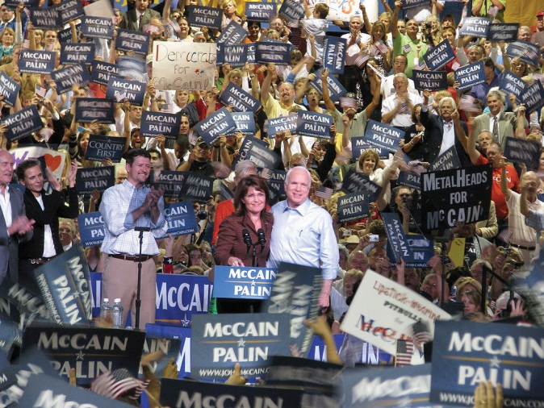
In 2008, Republican candidate John McCain criticized his Democratic opponent, Barack Obama, for failing to use public financing for his presidential bid, as he had promised. McCain felt disadvantaged by taking public funds because the law limits the amount of money he could raise and spend, while Obama was not subject to these restrictions.
Source: Photo courtesy of Matthew Reichbach,http://commons.wikimedia.org/wiki/File:Sarah_Palin_and_John_McCain_in_Albuquerque.jpg.
Party committees at the national, state, and local level, as well as the parties’ Senate and House campaign committees, can give a Senate candidate a total of $35,000 for the primary and then general election and $5,000 to each House candidate. There is no limit on how much of their own money candidates can spend on their campaigns. Neither John McCain nor Barack Obama used personal funds for their own campaigns in 2008. Self-financed presidential candidates do not receive public funds.
Known as “527 committees” after the Internal Revenue Service regulation authorizing them, advocacy groups, such as the pro-Democratic MoveOn.org and the pro-Republican Progress for America, can receive and spend unlimited amounts of money in federal elections as long as they do not coordinate with the candidates or parties they support and do not advocate the election or defeat of a candidate. They spent approximately $400 million in all races in the 2008 election cycle. In the wake of the Supreme Court decision supporting the rights of Citizens United to air Hillary: The Movie, spending by independent committees grew tremendously. The 527 committees spent $280 million in 2010, an increase of 130 percent from 2008. ^{[11]}

Campaign Strategy
Most campaigns have a strategy to win an election by raising funds, recruiting volunteers, and gaining votes. Campaign strategies take into account voters’ party identification, the candidate’s image, and issues. Candidates carry out their strategy through retail politics and the media.
In retail politics, also known as field operations, candidates engage in person-to-person campaigning. They speak at rallies, visit voters in their homes, and put in appearances at schools, religious institutions, and senior-citizen centers. They greet workers outside factories and in eateries and hold town-hall meetings. The campaign distributes posters, lawn signs, T-shirts, baseball caps, and buttons.
If the campaign has sufficient funds, retail politics involves microtargeting, using computers and mathematical models to identify people’s vote preferences on the bases of the magazines they read, credit card purchases, and the cars they own. ^{[12]} This information is used to woo undecided voters and ensure that supporters are registered and cast their ballot. Microtargeting has become more common and efficient in the information age.

Party Identification
Candidates have a base of support, usually from people who are registered with and consistently vote for the candidate’s party. For a candidate whose party has a majority of the people registered to vote in an electoral district, all it takes to win the election is getting enough of them out to vote. This may be easier said than done.
Party identification seldom decides elections alone, although it is a strong predictor of a person’s vote choice. A candidate’s image and her position on issues are also important, particularly when independents and undecided voters hold the balance. It does not apply in a primary when all the candidates are of the same party.

Candidate Image
Candidate image consists of the background, experiences, and personal qualities of people running for elected office. Campaigns strive to present an image of their candidate that fits the public’s expectations of the office sought, especially in comparison with the opponent, who is portrayed as less qualified. Voters expect the president to have leadership skills and to be principled, decisive, and honest. Other qualities, such as military service and compassion, may be deemed by the public and the media to be important as well.
Figure 11.5 George W. Bush and Al Gore in the 2000 Presidential Election
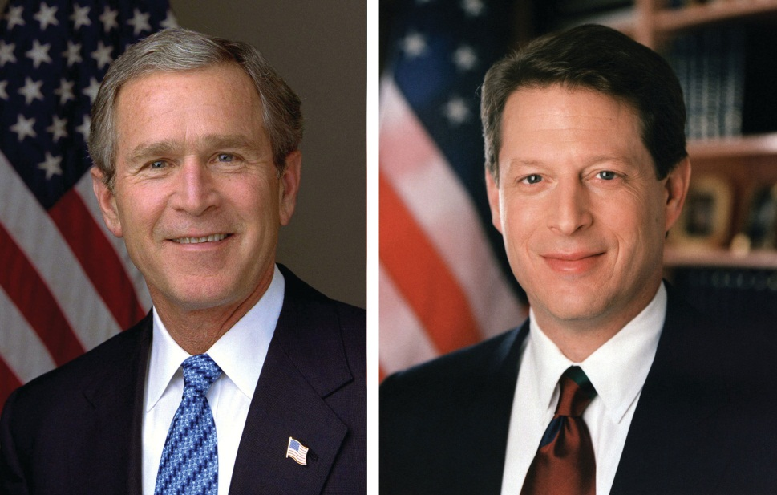
The media’s depictions of presidential candidates Republican George W. Bush and Democrat Al Gore during the 2000 presidential election influenced public perceptions. Bush was depicted as being unintelligent by news organizations that compiled lists of his gaffes and malapropisms. Gore was construed as being dishonest for allegedly claiming that he invented the Internet.
Source: Photo (left) courtesy of the White House by Eric Draper,http://commons.wikimedia.org/wiki/File:George-W-Bush.jpeg. Photo (right) courtesy of the World Resources Institute Staff,http://commons.wikimedia.org/wiki/File:Al_Gore.jpg.
Images are not entirely malleable. Age, gender, race, and military service cannot be changed willy-nilly. But they can be manipulated by selective accounting and shrewd presentation of the facts. Images are easiest to create early in a campaign when many people may not know much about a candidate. Which of a candidate’s possible images the public accepts often depends on the media’s depictions.

Issues
Issues, subjects, and public-policy positions on matters of concern are central to campaigns. Candidates take positions on issues that are designed to increase their chances of election. Issues raised during campaigns are often based on voters’ concerns that are identified by polls. The media can make issues a prominent part of the election agenda, which can work for or against a candidate.
Many candidates have past records indicating their stands on issues, leaving them little choice about how to manage some issues. Incumbents claim credit for their accomplishments. Challengers blame the incumbent for the country’s problems. Moreover, each party is associated with certain issues. Democrats are seen as the party to protect social security, improve the economy by creating jobs, increase the minimum wage, and expand health care coverage. Republicans are viewed as the party to strengthen national defense, cut taxes, and be tough on crime.
Wedge issues are issues that cut across party lines. A candidate can increase her vote by splitting off some of the people who usually support the other party and its candidates. ^{[13]} Republicans have employed affirmative action as a wedge issue in order to siphon off from the Democrat’s base working-class white men who oppose it. Democrats have used abortion rights to appeal to some conservative Republican women.

Staying on Message
Implementing strategy effectively requires staying on message. Candidates are like barkers at a fairground, each promoting his or her own show. At every opportunity they repeat their message, which is sometimes abbreviated into a slogan. In 1992 the main message of Bill Clinton’s presidential campaign was “It’s the economy, stupid,” which was aimed at blaming President George H. W. Bush for the country’s economic problems. Barack Obama’s campaign slogan in 2008, “Change we can believe in,” was a fresh take on a familiar call for change in American politics.

Figure 11.6 Barack Obama’s Campaign Slogan
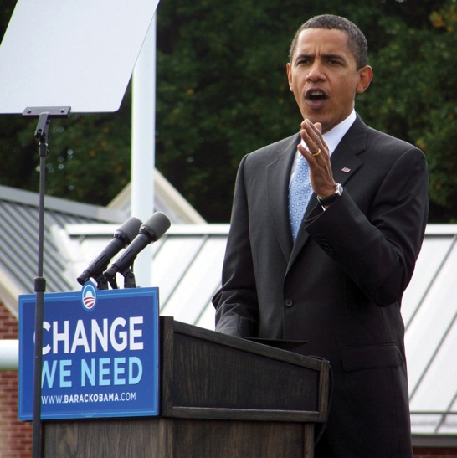
Presidential candidate Barack Obama reinforced his campaign slogan, “Change we can believe in,” during his campaign trail appearances in 2008.
Source: Photo courtesy of Bbsrock,http://commons.wikimedia.org/wiki/File:ObamaAbingtonPA.JPG.
Staying on message is not easy. Campaigns constantly have to react to unexpected events and to the other side’s statements and actions—all in a twenty-four-hour news cycle. They usually respond rapidly to new subjects and issues, deflecting, reframing, or exploiting them.

KEY TAKEAWAYS
Elections are crucial in a representative democracy like the United States. They enable people to choose their leaders and thereby influence public policy. They endow elected officials with legitimacy. There are two main types of elections: primary and general elections. Candidates from the same political party contest for the party’s nomination in primary elections. Candidates from different parties run in the general election, which decides who will take office.
Campaign finance is an integral element of American elections. Individuals, PACs, public funds, political parties, candidates themselves, and 527 committees fund campaigns. Campaign finance laws have shaped the way that candidates raise and spend money in elections, especially presidential candidates who accept public funding.
Candidates engage in retail politics by meeting with voters on the campaign trail. Campaigns employ strategies that take into account party identification, candidate image, issues, and message cohesion.

EXERCISES
- How do you think the fact that it takes so much money to run for political office affects what politicians do in office? Why might we want to limit the role money plays in politics?
- Do you think it makes sense to treat money spent on campaign advertising as a form free speech? How is campaign spending like other forms of self-expression? How is it different?
- What do you think the most important factors in choosing leaders should be? How effective do you think political campaigning is in influencing your opinion?

[1] Paul S. Herrnson, Congressional Elections: Campaigning at Home and in Washington, 5th ed. (Washington, DC: CQ Press, 2007), 75.
[2] Brody Mullins, “Cost of 2008 Election Cycle: $5.3 Billion,” Wall Street Journal, October 23, 2008.
[3] “Two Cars in Every Garage, Three Eyes on Every Fish,” The Simpsons, November 1990.
[4] See Bradley A. Smith, Unfree Speech: The Folly of Campaign Finance Reform (Princeton, NJ: Princeton University Press, 2001); and John Samples, The Fallacy of Campaign Finance Reform (Chicago: University of Chicago Press, 2006).
[5] Buckley v. Valeo, 424 US 1 (1976).
[6] Dan Froomkin, “Special Report: Campaign Finance: Overview Part 4, Soft Money—A Look at the Loopholes,” Washington Post, September 4, 1998.
[7] McConnell v. Federal Election Commission, 540 US 93 (2003).
[8] Citizens United v. Federal Election Commission, 130 S.Ct. 876 (2010).
[9] Adam Liptak, “Justices 5–4, Reject Corporate Spending Limit,” New York Times, January 21, 2010.
[10] Campaign finance data for the 2008 campaign are available at the Federal Election Commission, “Presidential Campaign Finance: Contributions to All Candidates by State,”http://www.fec.gov/DisclosureSearch/mapApp.do.
[11] Campaign Finance Institute, “Non-Party Spending Doubled in 2010 But Did Not Dictate the Results” press release, November 5, 2010.
[12] Leslie Wayne, “Democrats Take Page from Their Rival’s Playbook,” New York Times, October 31, 2008.
[13] D. Sunshine Hillygus and Todd G. Shields, The Persuadable Voter: Wedge Issues in Presidential Campaigns (Princeton, NJ: Princeton University Press, 2008).

11.2 Media and Election Campaigns

LEARNING OBJECTIVES
After reading this section, you should be able to answer the following questions:
- How do candidates present and use political advertising in their campaigns?
- How do candidates manage campaign debates? How do media influence debates?
- What is the nature of campaign media coverage? How do campaigns attempt to influence election coverage?
Campaigns want to influence media coverage in their candidate’s favor. They seek to dominate the election agenda, frame and prime issues, and have the media transmit their message of the day. The proliferation and diversity of modes of communication makes this complicated. Campaigns attempt to control their political advertisements and influence debates. They try to set the news-media agenda, but the relationship is uncertain at best. ^{[1]}

Political Advertisements
Television and radio advertisements are essential elements of election campaigns. ^{[2]} Ads capitalize on people’s beliefs and values. They are often designed to arouse emotions, such as anxiety and fear, hope and enthusiasm. ^{[3]}They attract attention with dramatic visuals, sounds, and slogans. They sometimes exaggerate, even distort, information.
Candidate advertising in the information age has become more complex as campaigns seek to disseminate their ads through multiple platforms. Candidates release ads on candidate and political-party websites and on video-sharing platforms, such as YouTube and Hulu. Ads also are posted or linked on news sites and blogs.

Ad Formats
Ads come in many formats, but even now when glitzy techniques are available, the talking head, in which the candidate speaks directly to the audience, is common. Other formats are testimonials from people enthusiastically supporting the candidate and documentary ads utilizing footage of the candidate campaigning. Ads that utilize a “self-incrimination” of the opponent can be devastating. In 1992, the Clinton campaign ran an effective ad juxtaposing President George H. W. Bush’s positive comments about the economy with data showing its decline.
Ads can use a panoply of visual and sound techniques. Distance (tight close-ups can be unflattering), angles (camera shots that look up make an individual seem more powerful), movement (slow motion suggests criminality), editing (people looking at a candidate with adoration or disgust)—all these techniques influence viewers’ reactions. Color also influences perceptions: blue reassures, red threatens. Candidates often are shown in flattering color while the opponent is depicted in sinister black and white. Morphing, electronically changing and blending photographs and other visuals, can identify candidates with unpopular figures, such as Adolf Hitler.

Attack Ads
Attack ads denounce elements of the opponent’s record, image, and issue positions. ^{[4]} They have been criticized as “the crack cocaine of politics” and for being demeaning and misleading. They also have been praised as “political multivitamins,” providing voters with pertinent and substantial evidence-backed information about policies they would otherwise not encounter. Attack ads can allow voters to contrast candidate’s qualifications and issue stance. ^{[5]}They can mark memorable moments in campaigns, such as the “Daisy Ad” attacking Republican presidential candidate Senator Barry Goldwater in 1964.
Attack ads employ a number of techniques to convey their points. They can point out “flip-flops,” exposing apparent contradictions in the opponent’s voting record and public statements. They can chastise the opponent for “not being on the job” and missing votes. Ads can convey “guilt by association,” linking the opponent to unpopular individuals and organizations. Candidates can attempt to refute attack ads with denials, explanations, rebuttals, and apologies. However, many attack ads are effective in generating negative impressions of candidates. Rebuttals tend to repeat the original charge and prolong the ad’s visibility. ^{[6]}The Wisconsin Advertising Project provides information and research about candidate, political-party, and interest-group advertising.

Enduring Image
The Daisy Ad
The Daisy ad, an enduring attack ad, was designed for the 1964 election campaign of Democratic president Lyndon Johnson. It exploited the fear that Johnson’s Republican opponent, Senator Barry M. Goldwater of Arizona, was willing to use nuclear weapons.
The ad shows a little girl plucking the petals from a daisy as she counts down out of order from ten. A doomsday-sounding male voice takes over the countdown. At zero, there is a nuclear explosion, and the girl’s face turns into a mushroom cloud that fills the screen.
Over the roar of the cloud, President Johnson intones, “These are the stakes. To make a world in which all of God’s children can live, or to go into the dark.” The word stakes, with its suggestion of being burnt at the stake, fits the Johnson campaign slogan, which ends the ad: “Vote for President Johnson on November 3. The stakes are too high for you to stay home.”
The ad, which only ran once on television, never mentions Goldwater’s name. It was not necessary. People were soon informed by the news media that it referred to him. Outraged Republican leaders unintentionally publicized the ad, which only was aired once by the Johnson campaign. The news media replayed the ad, increasing its visibility and the negative effect it had on the Goldwater candidacy.
View the ad in its entirety athttp://www.livingroomcandidate.org/commercials/1964/peace-little-girl-daisy.

Video Clip

http://www.youtube.com/watch?v=AtYpnGZr6TA

The Daisy Ad
The classic attack ad from President Lyndon Johnson’s 1964 campaign in which it is implied that Republican challenger Senator Barry Goldwater, whose name is never mentioned, is prepared to use nuclear weapons. The Daisy ad ran only once on television, but it gained tremendous notoriety through media coverage that proved detrimental to Goldwater.

Link
Political Advertising Archives
The Living Room Candidate at http://www.livingroomcandidate.org is a rich archive of campaign advertising dating back to the 1952 presidential election.
The Wisconsin Advertising Project at http://wiscadproject.wisc.eduprovides data and research on ads in addition to copies of historic ads.

Ad Watches
Some newspapers, a few television stations, and websites, such as FactCheck.org, analyze ads and point out their inaccuracies. These ad watchesmay limit the deceptiveness of ads in an election. But they may boomerang by showing the ads to people who might not otherwise have seen them.
Toward the end of a campaign, ad checks have trouble standing out amid the clutter of so many ads for so many candidates. People also can ignore them, skip over them with remotes, and delete them with a keyboard stroke.

Link
Ensuring Accuracy
FactCheck.org is a project of the Annenberg Public Policy Center, which checks ads and news stories for inaccuracies on a continuing basis.
Learn more about FactCheck.org at http://www.FactCheck.org.

Debates
Debates between candidates running for office have become a campaign ritual. They allow voters to assess how candidates respond to questions and think on their feet. Debates also provide an opportunity for voters to directly compare candidates’ stands on issues. While television is the most popular medium, voters can tune into debates via a wide range of platforms, including radio and Internet sites. YouTube debates have been held where candidates answer questions that are submitted on video by average citizens.
Candidates seek to influence their debates by negotiating with the sponsoring organization and their opponents. ^{[7]} They negotiate over who will participate, the number and timing of debates, the subjects that will be addressed, and who will be the moderators and questioners. No detail is left out, including whether questions can be followed-up, the type of audience involvement, the length of answers, the height of the podia behind which the candidates will stand, whether and how much the candidates can move about the stage, and whether the camera can cut away from the speaker to an opponent.
Figure 11.7 The Televised Kennedy-Nixon Debate
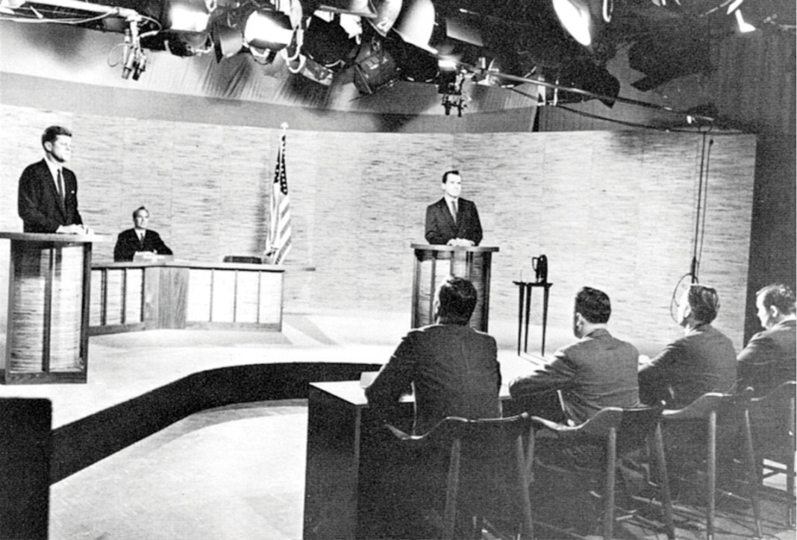
Vice President Richard Nixon, confident about his debating skills, underestimated the importance of appearance. He was wan and sweating in contrast to his assured opponent, Senator John F. Kennedy, during the first televised debate of the 1960 presidential election.
Source: Photo courtesy of the National Parks Service,http://commons.wikimedia.org/wiki/File:Kennedy_Nixon_Debat_%281960%29.jpg.
In the first-ever televised presidential debate, the Kennedy-Nixon debate in 1960, the camera cut away to show Vice President Richard Nixon, who was recovering from the flu and wearing heavy pancake makeup, sweating while his opponent, Senator John F. Kennedy (D-MA), coolly answered questions. Viewers who saw the debate on television declared Kennedy the debate winner. However, people who listened to the debate on radio were turned off by Kennedy’s heavy Boston accent and felt that Nixon had won the debate.

Link
1960 Kennedy-Nixon Debate (Part I) (1960)
Watch video of the Kennedy-Nixon Debate, 1960 athttp://www.archive.org/details/1960_kennedy-nixon_1.
Candidates are coached for debates. They prepare answers to anticipated questions that can be designed to catch them off guard, which might result in a gaffe. They memorize words and phrases from their campaign strategists that have been tested in focus groups and polls. They try to project leadership, appear likeable and sincere, stay on message, emphasize issues that favor them, be critical of, but not nasty toward, their opponent, and avoid gaffes.

Video Clip

http://www.youtube.com/watch?v=7ffbFvKlWqE

Clinton vs. Bush in 1992 Debate
President Bush checks his watch during a presidential debate in 1992.
Figure 11.8 George H. W. Bush at a 1992 Town Hall Debate
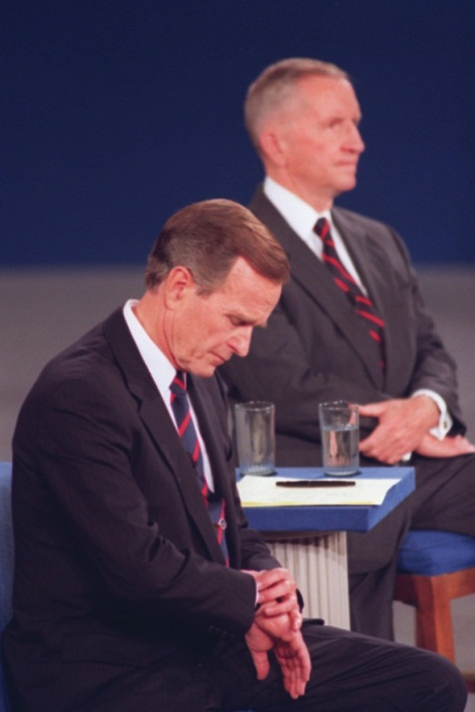
Small things can loom large in a debate: President Bush checking his watch was seen by some reporters and viewers as his lack of interest in the debate, a hope that it would soon end, and a sign of his struggling candidacy in 1992.
Source: Used with permission from AP Photo/stf/Ron Edmonds.
The campaigns spin the media before and after the debates. Predebate, they lower expectations about the debating skill of the candidate and raise them for the opponent. Campaign supporters try to convince journalists that their candidate won the debate. This spin is essential because journalists’ judgments, more than the substance of the debate, influence public opinion. ^{[8]} Journalists and pundits, in their instant analysis and polls of viewers, frame debates in terms of who won or lost. They focus on “defining moments,” identifying memorable lines and gaffes. In his debate with Jimmy Carter in 1976, President Gerald Ford, trying to make a statement about the spirit of the East Europeans, said that the Soviet Union did not dominate Eastern Europe. Although people watching the debate registered little reaction, reporters picked up on this apparent blunder and hounded Ford for days. Public opinion swung from seeing the debate as essentially a tie to seeing it as a crippling loss for Ford.

News Media
The speed of the twenty-four-hour news cycle and the range of media outlets make it difficult for campaigns to control what the news media report. Still, they try to stick to one message each day, embellishing it with sound bites to appeal to the attending reporters. They stage events and photo opportunities, or photo ops, with carefully selected locations, backdrops, and crowds. Staging can backfire. To show that he was strong on defense, Democratic presidential candidate Michael Dukakis appeared in a tank during the 1988 campaign. The press reported that his helmet made him look like the comic book character Snoopy.
Figure 11.9 Michael Dukakis in a Tank during the 1988 Presidential Election
Democratic presidential candidate Michael Dukakis’s campaign advisors felt that depicting him in a tank would prove that he was not weak on defense. Provoking mockery from the press corps, cartoonists, and late-night comedians, the photo op had the reverse effect.
Source: Used with permission from AP Photo/Michael E. Samojeden.
Reporters and editors have the final say over the subjects and frames of campaign news. Bill Clinton’s campaign manager, James Carville, described the power of the news media as “staggering” and said that his staff dubbed them “The Beast.” ^{[9]}
Horse race coverage focuses on which candidate is leading and which is trailing based on their standing in the polls, and it dominates campaign news. Coverage also focuses heavily on the campaign process and strategies, including the actions, decisions, and conflicts of the candidate’s staff. The press highlights candidates’ attacks on one another, as well as conflicts, controversies, blunders, and gaffes. Scandal, such as misconduct in office and illegal drug use, sometimes brought to reporters’ attention by a candidate’s opponents and spread on the Internet’s rumor mills, is a news staple. ^{[10]}
Coverage of policy issues in the news is slight, even in presidential elections. Candidates focus on only a few policy positions, which they repeat throughout the campaign. Journalists have little reason to report them frequently. Besides, policies lack the excitement and drama of the horse race.

KEY TAKEAWAYS
Candidates attempt to control their image, establish their campaign theme, and set the issue agenda through their campaign advertising. They design ads that will appeal to their supporters and reach out to undecided voters. Negative ads are prevalent in campaigns, as they can be effective in creating negative views of opponents and allowing voters to compare candidates.
Debates allow voters to assess candidates one-on-one. Candidates seek to control debates by negotiating the logistics and engaging in intense preparation. Media engage in postdebate assessments of the candidates’ performances.
News media focus heavily on the horse race and strategy elements of campaigns, especially who’s ahead and who’s behind in the polls. Candidate’s messages are conveyed in short sound bites. Journalists pay more attention to a candidate’s image, gaffes, and scandals than to issues.

EXERCISES
- What kind of political ads are you personally most likely to see? Do you think you are more likely to be influenced by direct mailers, television and radio ads, or online ads?
- How do you think having televised debates changes how people evaluate political candidates? Does actually seeing candidates debate help people evaluate their qualifications for office?
- Why do you think candidates try to stick with just one message every day? What do you think the advantage of “staying on message” is?

[1] For an award-winning study of media in the 1992 presidential election, see Marion R. Just, Ann N. Crigler, Dean E. Alger, Timothy E. Cook, Montague Kern, and Darrell M. West,Crosstalk: Citizens, Candidates, and the Media in a Presidential Campaign (Chicago: University of Chicago Press, 1996).
[2] See Edwin Diamond and Stephen Bates, The Spot (Cambridge, MA: MIT Press, 1992); and Kathleen Hall Jamieson, Packaging the Presidency, 3rd ed. (New York: Oxford University Press, 1996).
[3] Ted Brader, Campaigning for Hearts and Minds (Chicago: University of Chicago Press, 2006).
[4] For a discussion of how candidates go negative as circumstances warrant or allow, see Emmett H. Buell Jr. and Lee Sigelman, Attack Politics: Negativity in Presidential Campaigns since 1960 (Lawrence: University Press of Kansas, 2008).
[5] See Michael M. Franz, Paul B. Freedman, Kenneth M. Goldstein, and Travis N. Ridout,Campaign Advertising and American Democracy (Philadelphia, PA: Temple University Press, 2008); and John G. Geer, In Defense of Negativity: Attack Ads in Presidential Campaigns(Chicago: University of Chicago Press, 2006). “Multivitamin” quote is from Michael M. Franz, Paul B. Freedman, Kenneth M. Goldstein, and Travis N. Ridout, Campaign Advertising and American Democracy (Philadelphia: Temple University Press, 2008), 143 and “crack” quote by Senator Tom Daschle is from John G. Geer, In Defense of Negativity: Attack Ads in Presidential Campaigns (Chicago: University of Chicago Press, 2006), 1.
[6] Michael Pfau and Henry C. Kenski, Attack Politics (New York: Praeger, 1990), 53.
[7] On debates, see Alan Schroeder, Presidential Debates: Fifty Years of High-Risk TV, 2nd ed. (New York: Columbia University Press, 2008); and Newton N. Minow and Craig L. LaMay,Inside the Presidential Debates: Their Improbable Past and Promising Future (Chicago: University of Chicago Press, 2008).
[8] Diana Owen, “The Debate Challenge,” in Presidential Campaign Discourse, ed. Kathleen E. Kendall (Albany: State University of New York Press, 1995), 135–55.
[9] Mary Matalin and James Carville, with Peter Knobler, All’s Fair: Love, War, and Running for President (New York: Random House, 1994), 185.
[10] See Stephen J. Farnsworth and S. Robert Lichter, The Nightly News Nightmare: Television’s Coverage of U.S. Presidential Elections, 1988–2004, 2nd ed. (Lanham, MD: Rowman & Littlefield, 2007) for an analysis and denunciation of the television news networks’ coverage of presidential elections.

11.3 Presidential Elections

LEARNING OBJECTIVES
After reading this section, you should be able to answer the following questions:
- How are political party nominees for president selected?
- What is the purpose of presidential nominating conventions?
- What is the Electoral College, and how does it work?
The presidential election gets the most prominent American campaign. It lasts the longest and receives far more attention from the media than any other election. The Constitution requires the president to be a natural-born US citizen, at least thirty-five years old when taking office, and a resident of the United States for at least fourteen years. It imposed no limits on the number of presidential terms, but the first president, George Washington, established a precedent by leaving office after two terms. This stood until President Franklin D. Roosevelt won a third term in 1940 and a fourth in 1944. Congress then proposed, and the states ratified, the Twenty-Second Amendment to the Constitution, which limited the president’s term of office to two terms.

Caucuses and Primaries
Becoming a political party’s presidential nominee requires obtaining a majority of the delegates at the party’s national nominating convention. Delegates are party regulars, both average citizens who are active in party organizations and officeholders, who attend the national nominating conventions and choose the presidential nominee. The parties allocate convention delegates to the states, the District of Columbia, and to US foreign territories based mainly on their total populations and past records of electing the party’s candidates. The Republican and Democratic nominating conventions are the most important, as third-party candidates rarely are serious contenders in presidential elections.
Most candidates begin building a campaign organization, raising money, soliciting support, and courting the media months, even years, before the first vote is cast. Soon after the president is inaugurated, the press begins speculating about who might run in the next presidential election. Potential candidates test the waters to see if their campaign is viable and if they have a chance to make a serious bid for the presidency.
Delegates to the party nominating conventions are selected through caucusesand primaries. Some states hold caucuses, often lengthy meetings of the party faithful who choose delegates to the party’s nominating convention. The first delegates are selected in the Iowa caucuses in January. Most convention delegates are chosen in primary elections in states. Delegates are allocated proportionally to the candidates who receive the most votes in the state. New Hampshire holds the first primary in January, ten months before the general election. More and more states front-load primaries—hold them early in the process—to increase their influence on the presidential nomination. Candidates and the media focus on the early primaries because winning them gives a campaign momentum.
The Democrats also have super delegates who attend their nominating convention. Super delegates are party luminaries, members of the National Committee, governors, and members of Congress. At the 2008 Democratic convention they made up approximately 18 percent of the delegates.

The National Party Conventions
The Democratic and Republican parties hold theirnational nominating conventions toward the end of the summer of every presidential election year to formally select the presidential and vice presidential candidates. The party of the incumbent president holds its convention last. Conventions are designed to inspire, unify, and mobilize the party faithful as well as to encourage people who are undecided, independent, or supporting the other party to vote for its candidates. ^{[1]} Conventions also approve the party’s platform containing its policy positions, proposals, and promises.
Selecting the party’s nominees for president and vice president is potentially the most important and exciting function of national conventions. But today, conventions are coronations as the results are already determined by the caucuses and primaries. The last presidential candidate not victorious on the first ballot was Democrat Adlai Stevenson in 1952. The last nominee who almost lacked enough delegates to win on the first ballot was President Gerald Ford at the 1976 Republican National Convention.
Presidential candidates choose the vice presidential candidate, who is approved by the convention. The vice presidential candidate is selected based on a number of criteria. He or she might have experience that compliments that of the presidential nominee, such as being an expert on foreign affairs while the presidential nominee concentrates on domestic issues. The vice presidential nominee might balance the ticket ideologically or come from a battleground state with many electoral votes. The choice for a vice presidential candidate can sometimes be met with dissent from party members.
Figure 11.10 John McCain and Barack Obama Accepting Their Nominations
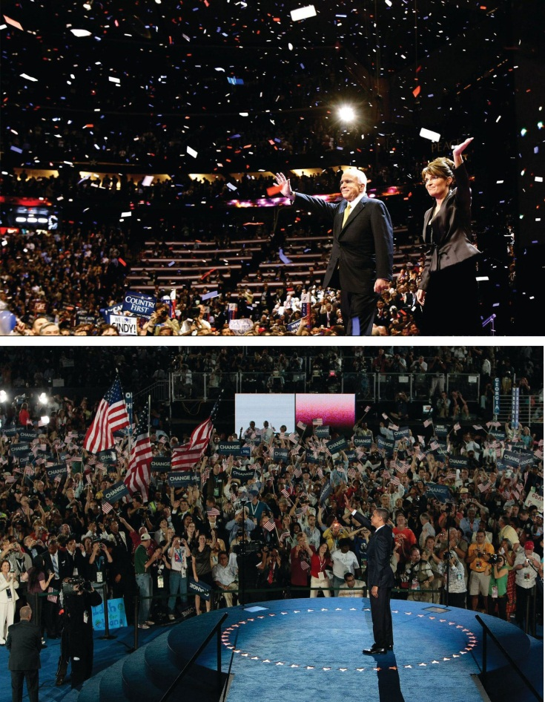
Republican John McCain and his running mate, former Alaska governor Sarah Palin, and Democrat Barack Obama and his running mate, former Delaware senator Joe Biden, accept their party’s nominations for president in 2008 to great fanfare.
Source: Used with permission from Getty Images.
Modern-day conventions are carefully orchestrated by the parties to display the candidates at their best and to demonstrate enthusiasm for the nominee. The media provide gavel-to-gavel coverage of conventions and replay highlights. As a result, candidates receive a postconvention “bounce” as their standing in the polls goes up temporarily just as the general election begins.

The Electoral College
The president and vice president are chosen by the Electoral College as specified in the Constitution. Voters do not directly elect the president but choose electors—representatives from their state who meet in December to select the president and vice president. To win the presidency, a candidate must obtain a majority of the electors, at least 270 out of the 538 total. The statewide winner-take-all by state system obliges them to put much of their time and money into swing states where the contest is close. Except for Maine and Nebraska, states operate under a winner-take-all system: the candidate with the most votes cast in the state, even if fewer than a majority, receives all its electoral votes.

Link
Electoral College Information
The US National Archives and Records Administration has a resource for the Electoral College at http://www.archives.gov/federal-register/electoral-college.
It is possible to win the election without winning the popular vote, as George W. Bush did in 2000 with about half a million fewer votes than Democrat Al Gore. The Electoral College decision depended on who won the popular vote in Florida, where voting was contested due to problems with ballots and voting machines. The voting in Florida was so close that the almost two hundred thousand ballots thrown out far exceeded Bush’s margin of victory of a few hundred votes.

KEY TAKEAWAYS
Presidential elections involve caucuses, primaries, the national party convention, the general election, and the Electoral College. Presidential hopefuls vie to be their party’s nominee by collecting delegates through state caucuses and primaries. Delegates attend their party’s national nominating convention to select the presidential nominee. The presidential candidate selects his vice presidential running mate who is approved at the convention. Voters in the general election select electors to the Electoral College who select the president and vice president. It is possible for a candidate to win the popular vote and lose the general election.

EXERCISES
- What is the difference between a caucus and a primary? Why might caucuses and primaries produce different results?
- What is the purpose of national party conventions, if presidential nominees are no longer really chosen at them?
- How does the Electoral College system differ from a system in which voters choose the president directly?

[1] Costas Panagopoulos, ed., Rewiring Politics: Presidential Nominating Conventions in the Media Age (Baton Rouge: Louisiana State University Press, 2007).

11.4 George W. Bush Reelected in 2004

LEARNING OBJECTIVES
After reading this section, you should be able to answer the following questions:
- What were the key issues in the 2004 presidential election?
- How did the media depict the candidates during the campaign?
Republican president George W. Bush ran for reelection against Democratic candidate Senator John Kerry (MA) and won. The campaign hinged on the candidates’ performance in battleground states where the race was close. Terrorism and the war in Iraq were key campaign issues.

The Nominating Campaign

Figure 11.11 Howard Dean Speaking at a DNC Event
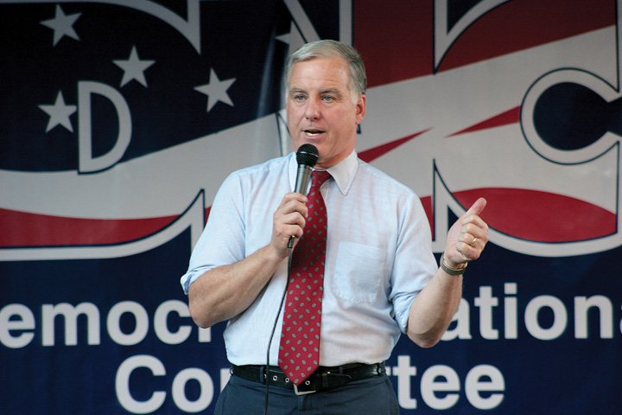
The candidacy of Governor Howard Dean, who was vying for the Democratic presidential nomination in 2004, was derailed after a video of the scream he let out when addressing his supporters at the Iowa caucuses ignited an unfavorable media blitz.
Source: Photo courtesy of Matt Wright,http://commons.wikimedia.org/wiki/File:HowardDeanDNC.jpg.
In 2003, Governor Howard Dean (VT) was the Democratic presidential candidate most vociferously opposing the Iraq War. His stance and forceful rhetoric gave his campaign unprecedented success in obtaining funds and volunteers through the web. ^{[1]} This accomplishment surprised the news media, generated reams of favorable coverage for him, helped him to raise funds, and transformed him from a marginal candidate to the front runner—all before a single vote was cast. But in the Iowa caucus, Governor Dean came in third behind Senators John Kerry of Massachusetts and John Edwards of North Carolina. That night, shouting over the din of his supporters, he committed to continuing his campaign and then let out a loud scream. The networks and cable news replayed the visual and shout, now described as “the scream heard around the political world,” hundreds of times, but without the loud audience noise over which he was attempting to be heard. He seemed a bit unbalanced and certainly not presidential. Parodies of “the scream” proliferated online.

Video Clip

http://www.youtube.com/watch?v=D5FzCeV0ZFc

Howard Dean’s Scream
The media endlessly replayed Democrat Howard Dean’s scream after the Iowa caucuses in 2004.
After the Iowa caucuses the news media reported that Senator Kerry was likely to be nominated. Dean received less coverage than before, most of it negative. His support shrank by 50 percent in the polls, while Kerry’s popularity in the polls grew. Kerry won New Hampshire and other primaries, locking up the nomination on Super Tuesday, March 2.
The theme of the Democratic convention and John Kerry’s acceptance speech centered on Kerry’s status as a Vietnam war hero with the strength and determination to be president, commander in chief, and to wage the war on terrorism. Missing from the convention were a vision and program for the future of the country. There were few attacks on President George W. Bush or his record. For these reasons, Kerry did not experience much of a postconvention bounce.
The Republicans renominated the incumbents, President George W. Bush and Vice President Dick Cheney, who were unchallenged in their party’s caucuses and primaries. Their convention was held in New York City around the anniversary of the 9/11 terrorist attack on the World Trade Center and within staging distance of the ground zero site. The convention portrayed President Bush as a strong and decisive leader. Convention speakers attacked Kerry as weak, a waffler, and unqualified to be president. In his acceptance speech, President Bush laid out programs and policies he would pursue if reelected, which included security and defense in order to ensure that America “is safer.” In polls, his postconvention bounce ranged from 4 to 11 percent.
The Iraq War was an issue that posed problems for both candidates. For Bush, it was the continued insurgency against the US occupation and the failure to find weapons of mass destruction. He tried to finesse this by equating the war in Iraq with the war on terrorism. Kerry offered few alternatives to existing policy. He compounded his problem by saying in a speech at Marshall University about his vote for funding the war, “I actually did vote for the $87 billion before I voted against it.” This statement, at best confusing, at worst contradictory, was a major news story the next day and was pounced on by the Bush camp.
The Republicans had a wedge issue in same-sex marriage. For many months this subject had been prominent in the news. Eleven states had propositions on their ballots amending their constitutions to limit marriage to one man and one woman. An ad supporting this position used the sound of wedding bells to remind people that the amendment would protect traditional marriage. The issue primed people’s vote when evaluating the presidential candidates, attracting some Democratic voters to choose the Republican candidate. Nine of the eleven states went for President Bush.

The General Election
Campaigning focused on eighteen battleground states that either candidate could win, a number reduced as Election Day neared to Florida, Iowa, Ohio, and Wisconsin. ^{[2]} Candidates used their ads strategically in these states. Bush’s ads were more memorable and effective than Kerry’s. One “documents” Kerry’s supposed flip-flops by editing scenes of the senator wind surfing so that he goes one way then another to the accompaniment of Strauss’s “Blue Danube” waltz, while the voice-over states his different (contradictory) positions. The ad ends with this voice-over: “John Kerry: Whichever way the wind blows.”

Figure 11.12 John Kerry Windsurfing in Nantucket
The image of Democratic candidate John Kerry windsurfing off Nantucket, Massachusetts, was featured in an ad by his opponent, Republican George W. Bush, as well as in major news stories and blog posts.
Source: Used with permission from AP Photo/Gerald Herbert.
The most damaging ads attacking Kerry were made by Swift Boat Veterans for Truth. As a 527 organization, they relieved the Bush campaign of any responsibility for the ads and from having to justify or defend them. The first Swift Boat ad opens with Kerry’s running mate, Senator John Edwards (NC), saying that the best way to understand Kerry is to “spend three minutes with the men who served with him.” The ad spliced together short interviews with veterans who accused Kerry of lying about his Vietnam War record and betraying his comrades by later opposing the war. The ad appeared in only a few states, but its incendiary charges dominated election-news coverage where the ad was shown repeatedly. Senator Kerry’s campaign waited two weeks before showing an ad responding to the accusations. In that time, the attack stuck, casting doubts about Kerry’s heroism, integrity, and fitness to lead the fight against terrorism.
Kerry revived his election prospects through his performance in televised presidential debates. Polls showed that Kerry won the first debate, as he appeared presidential and seemed to be more certain than his opponent in answering the questions. However, President Bush improved in the two subsequent debates. People do not necessarily equate winning a debate with deserving their vote.
In 2004, the news media overwhelmingly emphasized the horse race. Only 18 percent of the stories on network news discussed candidates’ stands on policy issues, their qualifications, or previous records. ^{[3]} Two events given prominent media coverage benefited the president: Chechen terrorists killed teachers and children in a school-hostage massacre in Beslan, Russia, and Osama bin Laden released a videotaped statement the weekend before the election. These events made the Republicans’ issue of the terrorism threat resonate with voters.
President Bush won the Electoral College 286 to 252. He gained 50.7 percent of the popular vote compared to 48.3 percent for John Kerry. Bush held all the states he had won in 2000 except for New Hampshire, and he picked up Iowa and New Mexico. The key state was Ohio with twenty electoral votes, which President Bush won with 51 percent of the vote.

Link
Party Voting in Presidential Elections by State
Maps depicting presidential-election voting by party from 1960 to 2008, produced by Robert Vanderbei, of Princeton University can be found athttp://www.princeton.edu/~rvdb/JAVA/election2004.

KEY TAKEAWAYS
Republican president George W. Bush was reelected in the 2004 presidential election against Democratic candidate John Kerry. Media coverage focused on the horse race between the candidates, especially in battleground states where the race was tight. Kerry faced opposition from a 527 organization, Swift Boat Veterans for Truth, which ran ads that cast aspersions on Kerry’s service in the Vietnam War.

EXERCISES
- How did the issue of the Iraq War pose problems for George Bush in 2004? In what ways did he manage to turn the issue to his advantage?
- How did John Kerry try to present himself in the 2004 presidential campaign? How did he end up coming across in the media?

[1] Zephyr Teachout and Thomas Streeter, eds., Mousepads, Shoe Leather, and Hope(Boulder, CO: Paradigm, 2008).
[2] For the campaign from the consultants’ perspectives, see Kathleen Hall Jamieson, ed.,Electing the President, 2004: The Insider’s View (Philadelphia: University of Pennsylvania Press, 2005).
[3] Content analysis provided by Media Tenor.

11.5 Barack Obama Elected in 2008

LEARNING OBJECTIVES
After reading this section, you should be able to answer the following questions:
- In what ways did the 2008 election campaign stand out from other American presidential elections?
- What were the key issues in the 2008 campaign?
- What part did media play in the election?
The year 2008 marked the first time since 1952 that no incumbent president or incumbent vice president was a candidate in the presidential election. Media speculation about the possible Democratic and Republican nominees started earlier than ever before. The field of candidates seeking the nomination for both parties was large. Senator John McCain became the Republican nominee, and Senator Barack Obama clinched the Democratic nomination. The 2008 election witnessed unprecedented use of social media, such as Facebook, and video-sharing media, like YouTube, by candidates, journalists, and voters.

The Nominating Campaign
Eleven men competed for the Republican nomination. The leading candidates were former Massachusetts governor Mitt Romney, former New York mayor Rudolph Giuliani, former Arkansas governor Mike Huckabee, and Senator John McCain of Arizona. McCain had been written off by pundits the previous summer when his campaign was in disarray and out of money. He placed fourth in the Iowa caucuses but continued to campaign, winning the New Hampshire and South Carolina primaries. Both Giuliani and Romney withdrew after disappointing primary performances, leaving Huckabee to run against McCain. The Arizona senator swept the four primaries on March 5, giving him a majority of the total number of delegates for the nomination.
Senator McCain surprised pundits and politicians by choosing little-known Alaska governor Sarah Palin as his vice presidential candidate. During the primaries, the senator had been attacked by conservative talk-radio host Rush Limbaugh and other right-wing commentators as being too liberal. Putting Palin on the ticket aimed to placate conservatives and appeal to women.
Eight men and one woman competed for the Democratic nomination. Bias against women seeking elective office by party elites, fund-raisers, the media, and voters has greatly diminished, but obstacles remain for women aspiring to be president. Women face gender stereotyping that calls into question their ability to lead the country, and they must overcome the fact that the president has always been male. ^{[1]} Hillary Clinton sought to overcome these odds. She had name recognition and fund-raising prowess from her eight years as First Lady and her election as senator from New York. Her most formidable challenger was Barack Obama, a first-term senator from Illinois and an African American (more accurately, he is of mixed race, from a Kenyan father and white American mother). The Democratic primary was a landmark contest between the first female candidate and first African American candidate to make a serious bid for the presidency.
The campaign for the Democratic nomination was hotly contested. Hillary Clinton’s campaign made several strategic mistakes and lacked a coherent message. Obama ran the more effective campaign and was able to make his call for “change” resonate with voters. Both campaigns had sophisticated websites that not only included the usual biographical and issue information but also featured videos, ads, and interactive features that allowed users to participate in the campaign by donating, volunteering, posting messages and videos, and recruiting supporters. The Obama campaign also made extensive use of microtargeting, designing specialized messages delivered through e-mail andpodcasts that appealed to particular voters, such as young professionals who frequent Starbucks and use Blackberries to communicate.
Clinton lost to Obama in the first contest, the Iowa caucus. She recovered by winning the New Hampshire primary. On Super Tuesday, a date when a large number of states hold their primaries, Clinton won nine of twenty-two primaries, including California, New York, and New Jersey. Obama won the other thirteen and subsequently went on to take twelve straight caucus and primary states. Clinton won primaries in Texas, Ohio, and Pennsylvania, while Obama gained North Carolina and Indiana and picked up most of the delegates in the remaining caucus states. Clinton stayed in the race until June 7, 2008, when she withdrew and endorsed him. With 2,118 delegates needed to win the nomination, she had 1,923, and he had 2,154. Obama also had the support of 463 of the nonelected super delegates compared to 257 who backed Clinton. As his running mate, Obama chose longtime Delaware senator Joseph Biden, who possessed the Washington and foreign-policy experience he lacked.

Images and Issues
Media images of the candidates varied widely. On the one hand, Barack Obama was portrayed positively as an American success story. Abandoned by his father when he was two, he was raised by a single mother who struggled financially, he worked his way through law school, and he was elected to the United States Senate. Alternately, he was depicted as a black man with a strange name and as an elitist with a Harvard law degree and radical ideas. Depictions of John McCain also were greatly at odds. McCain was shown to be an experienced leader, wise in the ways of national security, and as a maverick not wedded to Republican orthodoxy. On the other hand, he was portrayed as a tired, old Washington politician and as a conventional conservative averse to change.
The Democrats were able to capitalize on campaign issues that worked against the Republicans, the party of the incumbent president, George W. Bush, whose popularity was low. The fading economy took precedence over terrorism. The Iraq war was increasingly seen as a mistake to be ended. Obama denounced the Bush administration and attacked his opponent, stating, “I am not going to be Bush but McCain will.” He promised to respond to the problems of energy, education, and health care. He stated that taxes would be raised, but only for the wealthy.

The General Election
One of the hallmarks of the Obama campaign was its superior use of new media. His website was more sophisticated that McCain’s, despite the fact that McCain was one of the first candidates to use the Internet for fundraising when he had previously sought the Republican presidential nomination in 2000. His website included “My Neighborhood” profiles of voters in the same zip code; “Take Action Now” e-mail alerts; and “National Voter Protection Center,” a space for reporting voting irregularities. ^{[2]} The Obama campaign had its own media channel, where viewers could tune in to campaign events. The campaign used digital tools to develop an e-mail list and collect millions of cell phone numbers of potential voters. The campaign also harvested cell phone numbers of millions of potential voters.
Obama opted out of the public financing system and raised nearly $750 million. McCain took public financing and received $84 million to spend from his party convention to Election Day. Obama outspent McCain in battleground states by more than four to one. Obama had funds to air a half-hour prime-time “infomercial” on network and cable television just before the election.
During the campaign, uncertainty about Sarah Palin’s qualifications for the vice presidency were raised. Her performance in the vice presidential debate showed weaknesses in her command of foreign-policy issues. In addition, the news media reported that the Republican National Committee had spent $150,000 at upscale department stores for her campaign wardrobe. Palin was further undermined by Tina Fey’s imitations of her on “Saturday Night Live,” which became popular online videos that were downloaded millions of times.
Figure 11.13 Tina Fey as Sarah Palin
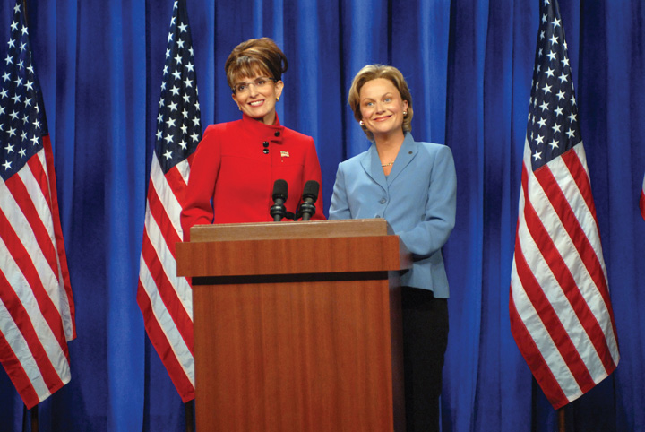
Comedian Tina Fey’s parody of Republican vice presidential candidate Sarah Palin was the subject of much media discussion. Almost 25 percent of voters attributed to Palin statements that Fey had fabricated, including, “I can see Russia from my house.”
Source: Used with permission from Dana Edelson/NBC/NBCU Photo Bank via AP Images.

Link
Governor Palin Cold Open
The real Sarah Palin appeared on “Saturday Night Live” alongside Tina Fey, who parodied her throughout the campaign.
Watch the opening skit at http://www.nbc.com/saturday-night-live/video/gov-palin- cold-open/773761.
About 62 percent of the public turned out to vote in the 2008 presidential election. Barack Obama obtained 53 percent of the popular vote and 365 Electoral College votes, including 112 from nine states that had gone for Bush in 2004. John McCain received 46 percent of the popular vote and 173 electoral votes.

Link
2008 Presidential Election and Exit Poll Results
The results of the 2008 general election are available athttp://www.cnn.com/ELECTION/2008/results/president.

KEY TAKEAWAYS
Senator Barack Obama was the first African American elected to the position of US president. He faced a strong challenge for the Democratic nomination from Senator Hillary Rodham Clinton and won the general election against Republican senator John McCain. Social media were used to inform and mobilize voters in the election.

EXERCISES
- In what ways to you think it might be harder for a woman or an African American man to win the presidency than it would be for a white man? Are there ways in which being a woman or an African American might be an advantage?
- What were the key issues in the 2008 campaign? Why did they present problems for a Republican candidate?
- How did the Obama campaign use the media to mobilize voters in a way that was different than the way previous campaigns had?

[1] Lori Cox Han and Caroline Heldman, eds., Rethinking Madam President: Are We Ready for a Woman in the White House? (Boulder, CO: Lynne Rienner Publishes, 2007); also Jennifer Lawless and Richard L. Fox, It Takes a Candidate: Why Women Don’t Run for Office(New York: Cambridge University Press, 2005).
[2] Matthew R. Kerbel, Netroots (Boulder, CO: Paradigm Press, 2009).

11.6 Congressional and Other Elections

LEARNING OBJECTIVES
After reading this section, you should be able to answer the following questions:
- What are the differences between House and Senate elections?
- What is the significance of midterm elections?
- What is gerrymandering, and how can it influence the outcomes of campaigns?
- What are ballot measures?
Every two years the entire House of Representatives and one-third of the Senate face election. Congressional elections command far less attention from the media and voters than do presidential campaigns. However, their outcomes can determine the partisan composition of Congress, which can influence the course of public policy for decades to come. Americans can have a direct say in state policy proposals, laws, and constitutional amendments through ballot measures. They also can remove an elected official from office through a recall election.

Congressional Elections
Congressional elections, in which all 435 House seats and one-third of Senate seats are contested, take place every two years, including years when there is a presidential election. Midterm elections occur in years when there is no presidential contest. Frequently, midterm elections are treated as referenda on the performance of the sitting president and can determine the balance of power in Congress. National issues, such as the economy and unemployment, can become prominent factors in midterm campaigns.
Since 1926, the president’s party has lost an average of thirty seats in the House and four seats in the Senate during midterm elections. The 2010 midterm election resulted in a sixty-three-seat swing and a shift in power in the House of Representatives. The Democrats lost control, as their membership dropped from 256 to 193 members, and the Republicans gained the majority, moving from 179 to 242 members. The Democrats, with fifty-three seats, maintained control of the Senate, although they lost six seats to the Republicans, who have forty-six seats. One seat is held by an Independent. ^{[1]}

Link
Party Voting in Congressional Elections by State
Maps depicting congressional election results from 2010 and earlier can be found at Politico.com and WashingtonPost.com.
Go to http://www.politico.com/2010/maps andhttp://www.washingtonpost.com/wp-srv/special/politics/election-results-2010.
Figure 11.14 Rand Paul at His Victory Celebration in 2010
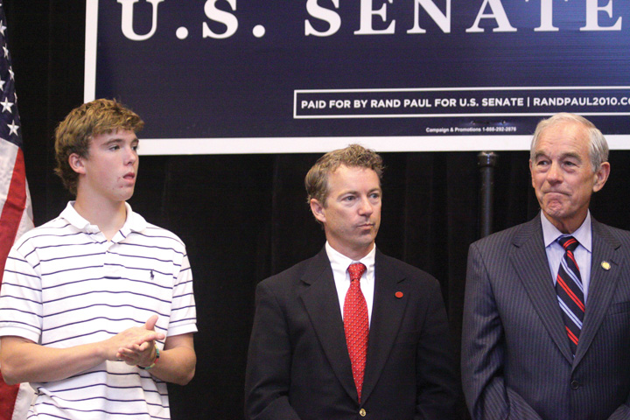
Republican Rand Paul, an ophthalmologist, won the Senate race in Kentucky against Democrat Jack Conway, the state’s attorney general, with the backing of the Tea Party.
Source: Photo courtesy of Gage Skidmore,http://commons.wikimedia.org/wiki/File:Will,_Rand_%26_Ron_Paul.jpg.
Local and regional media are in the best position to cover congressional elections, and they can set the agenda for national media. Typically, there is less media coverage of midterm elections compared with presidential campaigns. The 2010 midterm election received more coverage than usual, as voters expressed frustration with incumbent president Barack Obama’s performance in office. TheTea Party—a grassroots, conservative-leaning movement that opposed the government’s taxing and spending policies—staged protests that brought media attention to the election. Some Tea Party–backed candidates garnered significant national press attention.

The Senate
There are one hundred senators in the US Congress, two elected from each state, who serve six-year terms. One-third of Senate seats are up for election every two years. Senators are constitutionally required to be at least thirty years old and to have been a US citizen for at least nine years when they take office.
Many Senate elections are competitive in both the primary and the general election. Having been in office for six or more years, incumbents have records, controversial votes, and may have upset some of their constituents. Their opponents may have name recognition, ample funding, and run an effective campaign using the new media and political advertising. Especially when the election is close, challengers receive almost as much visibility as incumbents. They are able to publicize their images, get some of their issues on the campaign agenda, and have attention paid to their attacks on their opponent.
Senate races in the 2010 midterm election were hotly contested. The majority of incumbents won, but many faced tough competition. Thirteen Democratic incumbents ran for reelection and three lost, while all eleven Republican incumbents seeking reelection won. Candidates spent record amounts of money contesting in Senate campaigns. Sharron Angle, who won the Nevada Republican Senate nomination with the backing of the grassroots Tea Party movement, spent ninety-seven dollars per vote in the general election, which she lost to Democrat Harry Reid, the majority leader of the Senate, who spent sixty-nine dollars per vote. ^{[2]}

The House of Representatives
There are 435 voting members of the House of Representatives elected in separate districts within states for two-year terms. Candidates must be at least twenty-five years old and need to have been a citizen for at least seven years.
Members of the House who are seeking reelection in districts designed to favor their party have an advantage. They usually have better organized campaigns, greater name recognition, far more funds, and more support from interest groups than their opponents. Since 1954, 93 percent of House incumbents have been elected. This rate dropped slightly in 2010, as 87 percent of incumbents were reelected, which is the lowest percentage since 1964. ^{[3]}
The media contribute to this incumbency advantage. Challengers often lack the funds to air political ads. News coverage of House elections favors incumbents. Local television coverage pays little attention to even to the most competitive House elections. ^{[4]} Indeed, four thousand local television newscasts, in eleven major markets during the four weeks before the 2004 election, gave eight times as much air time to car crashes and other accidents than to House campaigns. ^{[5]} The use of social media, such as Facebook and Twitter, can benefit challengers, especially if their messages are picked up by the mainstream press. However, many voters get most of the campaign information from television. Debates can sometimes improve a challenger’s chances if they are televised and widely seen. But nearly 70 percent of debates held by House candidates are not televised. ^{[6]}

Redistricting
Each state is awarded a number of seats in the House of Representatives based on its population as determined by the national census, which is taken every ten years as required by the Constitution. If the census reveals shifts in the size of the population within districts, state legislators redraw the district lines to equalize the number of people within each district.
Figure 11.15 Gerrymander (Gerry-Mander)
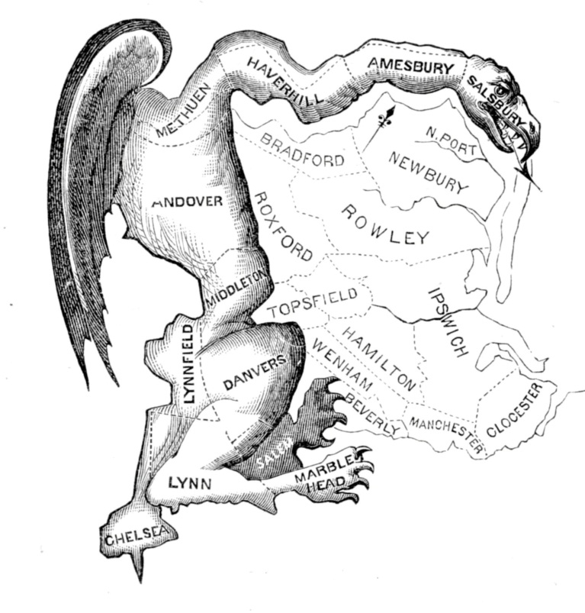
In 1812, Massachusetts governor Elbridge Gerry pushed through electoral redistricting that ensured his Republican party’s majority in the township of Marblehead would outweigh the Federal majority in eleven other townships. Artist Elkanah Tisdale drew a cartoon map of the salamander-shaped district for the Boston Gazette and coined the term “Gerry-mander” (now “gerrymander”) that became a staple of political language. The visual and the term are therefore both media creations.
Source: http://commons.wikimedia.org/wiki/File:The_Gerry-Mander.png.
Redistricting is often a highly partisan and contentious activity because it can change the number of House seats each party wins in a state. The party in control of the state legislature can design districts so as to protect its incumbents and increase its House seats. The party in power can obtain more seats by having small but usually safe majorities in several districts and cramming large numbers of the other party’s voters into just a few districts. This is achieved through a gerrymander, drawing congressional district lines to give one party the advantage in electing its candidates to the House of Representatives. ^{[7]} Incumbents in gerrymandered districts are usually reelected.

Comparing Content
Candidates in Fiction and Documentary Films
There are two types of film about candidates: Hollywood fiction seen by millions of people and documentaries seen by far fewer. ^{[8]} In Hollywood films the candidates are glamorous and charismatic. They run for high office, usually the presidency or Senate. The focus is on their character. Either they are cynical and hypocritical from the start (the presidential candidate played by John Travolta in Primary Colors, 1998), or they become cynical and compromise their ideals and principles over the course of their campaigns (the senatorial candidate played by Robert Redford inThe Candidate, 1972), or they are disillusioned career politicians trying but failing to change a corrupt campaign process (Warren Beatty as the senator up for reelection in Bulworth, 1998). Their campaign consultants use whatever tactics and techniques will win the election. The candidates have an adversarial relationship with the news media.
Documentaries offer a wider range of candidates and circumstances. The Perfect Candidate (1996) covers Republican Oliver North’s 1994 senatorial campaign in Virginia from the perspective of the candidate, his campaign manager, and a Washington Post reporter. The subject of Taking on the Kennedys (1996) is a Republican doctor running against Senator Edward Kennedy’s son Patrick for an open House of Representatives’ seat in Rhode Island. In I’m a Candidate (2001), two young men, one a black Republican in Georgia and the other a white Democrat in Cincinnati, challenge incumbent members of the House.
The candidates in the documentaries are idealists, even a bit naive. They have principles and policy preferences. Campaigning is an all-consuming activity requiring perseverance and the sacrifice of personal life. Money is crucial for their campaigns, and they spend a lot of time trying to raise it. They engage in retail politics: shaking hands, meeting people, visiting senior-citizen centers, and marching in parades. They struggle to break through to an indifferent electorate; yet, even after they have campaigned for several months, many people remain unaware of them. They are vulnerable to the news media, which defines and depicts them.
Hollywood movies and documentaries convey the drama and conflict of elections, the demands on the candidates, and the strategies required to have a chance of winning. But for the lived experience of a political campaign, watch the documentaries.

Ballot Measures
Many states offer people the opportunity to vote on ballot measures on proposed laws, ordinances, or constitutional amendments. Two types of ballot measures are the initiative and the referendum. In the 2010 midterm election, a total of 160 questions were considered on ballots in 37 states. Another type of ballot measure is the recall election, whereby voters can remove an elected official from office.

The Referendum
In a referendum, the state legislature refers a proposal to citizens who vote to either approve or reject the measure. In every state except Delaware, amendments to the state’s constitution passed by the legislature go on the ballot automatically. ^{[9]} State legislatures put other measures on the ballot to let voters make a choice or to avoid deciding a controversial issue. Referenda also can work as an end run around decisions made by a state governor.

The Initiative
The initiative is similar to the referendum except that voters propose and pass laws and present them to the state legislature. Citizens also can propose an amendment to the state constitution. In some states, the legislature can adopt the proposal outright. In most cases, registered voters can place a proposal on the ballot, sometimes with a counterproposal from the state legislature. If the initiative wins a majority of the votes in an election, it goes into effect.
In recent years, initiatives have been passed to cap property taxes, curtail illegal immigration, and allow medicinal marijuana and euthanasia. California had sixteen initiatives on the ballot in 2004, including a proposal to spend $3 billion for research on human embryonic stem cells, which passed with 59 percent of the vote. In six states, citizens’ groups put on the ballot for a vote to an amendment to the state constitution that recognized marriage as between one man and one woman. In 2010, initiatives related to fiscal policy and taxes were most prevalent. The proposals differed vastly from lowering property taxes in Indiana to overturning a tax on soda in Washington. ^{[10]}

Link
State Ballot Measures in the 2010 Elections
Voters in states considered over 160 ballot initiatives in the 2010 midterm elections, which are described on Stateline’s website athttp://www.stateline.org/live/details/story?contentId=479649.
The initiative was originally designed to combat powerful interests such as those controlling the railroads in the nineteenth century. ^{[11]} Today, initiatives are sometimes a way for wealthy individuals or interest groups to put policies into effect while bypassing the state legislature. Consulting firms specializing in initiative campaigns are paid to collect the signatures required to put a measure on the ballot. ^{[12]}
Critics attack initiatives for congesting ballots and confusing voters, and for their sometimes deceptive titles and descriptions. “Keep California Green” was the slogan for a proposition to keep taxes low on private golf courses. However, research shows that “the initiative has a significant impact on state and local government and in doing so pushes policy in the direction a majority of people say they want to go.” ^{[13]}

The Recall
Originally intended to root out corruption among elected officials, the recallallows voters to remove public officials from office through a direct election. A recall is initiated when a designated number of voters sign a petition requesting a special election. Fourteen state constitutions provide for recall elections for state officials, and many localities have provisions for the recall of lower-level elected officials.
Figure 11.16 Governor Arnold Schwarzenegger
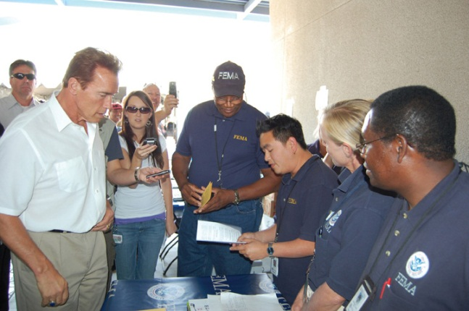
Movie action hero Arnold Schwarzenegger is elected governor of California in the recall election of 2003. This is a stellar example of how prominence in the entertainment media can be translated into visibility in the news media and victory in politics.
Source: Photo courtesy of the Federal Emergency Management Agency,http://commons.wikimedia.org/wiki/File:FEMA_-_33305_-_Community_Relations_workers _in_California.jpg.
Until 2003, only one governor, North Dakota’s Lynn J. Frazier in 1921, had been successfully recalled. In 2003, a California Republican congressmen initiated and mainly funded the recall of California’s Democratic governor Gray Davis for his alleged policy failings. Spurred by conservative talk-radio hosts, websites run by Republican operatives, disenchanted Democrats, and antitax organizations, and coordinated by e-mail, more than 900,000 eligible voters signed the petition to put the recall on the ballot. The ballot asked voters two questions: if the governor should be removed from office and who they would select from a list of candidates to replace him if the governor were recalled. The voters selected Republican Arnold Schwarzenegger to replace Governor Davis.

KEY TAKEAWAYS
Congressional candidates run for either the Senate or the House of Representatives. There are no limits on the number of terms a member of Congress can serve. Senators are elected in states and Representatives in congressional districts in states. Congressional districts are based on the US census and are reconfigured periodically. Elections for the Senate tend to be more competitive than for the House, where incumbent officeholders have an advantage.
Ballot measures, consisting of the initiative and the referendum, are mechanisms that allow voters to have a more direct say in state laws, government proposals, and constitutional amendments. In certain states, voters can remove elected officials from office through a recall election.

EXERCISES
- Why do you think the president’s party tends to lose seats in Congress in midterm elections? Why might holding the presidency be a disadvantage in elections?
- What advantages do incumbents have in running for office? What advantages do challengers have?
- What are the advantages of using ballot measures to let people vote on legislative issues directly, rather than letting elected representatives decide them? What might be the disadvantages of using ballot measures?

[1] Post Politics, “Election 2010: Live Results,” Washington Post, December 28, 2010,http://www.washingtonpost.com/wp-srv/special/politics/election-results-2010.
[2] T. W. Famam, “Angle, McMahon Led Way Spending $97 Per Vote—and Lost,”Washington Post, November 9, 2010.
[3] Benjamin Knoll, “Incumbent Losses in the 2010 Midterms,” Information Knoll, November 4, 2010, http://informationknoll.wordpress.com/2010/11/04/incumbent-losses-in-the-2010-midterms.
[4] Darrell M. West and L. Sandy Maisel, “Conclusion: Discourse and Beyond,” in Running on Empty? Political Discourse in Congressional Elections (Lanham, MD: Rowman & Littlefield, 2004), 237.
[5] “Local TV News Largely Ignores Local Political Races, New Lear Study Finds,” Lear Center Local News Archive, USC Annenberg School for Communication, February 15, 2005,http://www.localnewsarchive.org/pdf/LCLNARelease2005.pdf.
[6] Committee for the Study of the American Electorate, press release, May 16, 2001.
[7] Mark S. Monmonier, Bushmanders and Bullwinkles: How Politicians Manipulate Electronic Maps and Census Data to Win Elections (Chicago: University of Chicago Press, 2001).
[8] Relevant is Bradley Hunt, “On the Campaign Trail: Depictions of Political Campaigns in Films,” paper submitted to Paletz’s “Politics and Media” seminar, April 16, 2001.
[9] Matthew Mendelsohn and Andrew Parkin, eds., Referendum Democracy: Citizens, Elites and Deliberation in Referendum Campaigns (New York: Palgrave, 2001).
[10] Pamela M. Prah, “Guide to State Ballot Measures for 2010,” Stateline.org, November 12, 2010, http://www.stateline.org/live/details/story?contentId=479649.
[11] For its history and an evaluation of the arguments for and against the initiative, see Joseph F. Zimmerman, The Initiative: Citizen Law-Making (Westport, CT: Praeger, 1999).
[12] For criticisms of the initiative see Richard J. Ellis, Democratic Delusions: The Initiative Process in America (Lawrence: University Press of Kansas, 2002).
[13] John G. Matsusaka, For the Many or the Few (Chicago: University of Chicago Press, 2004), xi.

11.7 Campaigns and Elections in the Information Age

LEARNING OBJECTIVES
After reading this section, you should be able to answer the following questions:
- How do campaigns use new media?
- How has social media created new opportunities for campaign engagement?
- How are candidates depicted in campaigns?
Candidates in the information age not only have to manage traditional news media, such as newspaper and television news coverage; they also must contend with an ever-increasing number of new media platforms. New media enable candidates, voters, and journalists to engage in elections in novel ways. Entertainment media provide candidates with the opportunity to present their human side to voters. Candidates can attempt to exert control over political commentary, but they are not always successful.

Media Interactions
Campaigns use new media, such as websites, e-mail, text messages, social networking sites, Twitter, and blogs, in three overlapping ways. ^{[1]} New media can be used to inform voters about the candidate, including her biography, speeches and press releases, policy record, issue positions, endorsements, and attacks on the opponent. Candidates also can employ new media to get people involved in the election. New media can be used to recruit supporters and volunteers, raise funds, register voters, and get people to the polls on Election Day. ^{[2]} Finally, new media can connect voters by enabling people to exchange information on behalf of the campaign, promote the candidate to others, and interact with others who share their views. In the 2010 midterm election, voters participated in meetups and tweetups, offline meetings that were organized through social media, such as Twitter feeds.

Social Media
The importance of social media in elections has grown in recent election campaigns. Candidates regularly establish Facebook pages to communicate with supporters, especially younger voters. In 2010, 74 percent of House candidates and 81 percent of Senate candidates with the most Facebook friends won their elections.
People use digital media to participate in new ways, often outside the context of campaign organizations. Facebook, Delicious, LiveJournal, Foursquare, Twitter, and Tumblr are used for political expression and networking. These platforms are versatile, and allow users to post their support for a candidate, link to outside content, such as a candidate’s website, share photos and videos, express opinions, and share comments. In 2008, 5.4 million people used the “I voted” button on Facebook to let their friends know that they had taken part in the election. More than 12 million people clicked on this button in the 2010 midterm campaign.
The mainstream media have incorporated social media into their election coverage. News organization websites feature social media applications, such as Facebook links. In 2010, the Washington Post sponsored a promoted trend, #Election, on the Twitter.com homepage to allow users to view election coverage. The New York Times and CNN analyzed voter tweets as part of their campaign reporting.

Video Sharing
Campaigns make use of video-sharing platforms in order to make their ads, speeches, and appearances available to voters and journalists. Videos are posted on candidate and political-party websites as well as on public video-sharing platforms, such as YouTube and Hulu. Online videos have become a popular source of information for voters. In 2008, videos produced by the Obama campaign were accessed 37 million times during the primary. ^{[3]}
People posted campaign videos on YouTube that were circulated virally through e-mail messages, blog posts, and Facebook messages. While most videos posted by voters were selections from media broadcasts, such as debates, and clips of live events, such as candidate rallies, some original user-generated videos attracted extensive mainstream press coverage.
“Vote Different” was first aired in March 2007 and featured a mashup of Hillary Clinton speeches with an Apple commercial that depicted Clinton in the fearful role of “Big Brother.” The video was the creation of a producer with tenuous ties to the Obama campaign, who had placed the ad on YouTube without authorization. This video was viewed millions of times and generated thousands of comments. It sparked a tidal wave of user-produced campaign videos.

Video Clip

http://www.youtube.com/watch?v=6h3G-lMZxjo

Vote Different
“Vote Different” was a user-produced video attacking Hillary Clinton that aired during the 2008 presidential primary campaign.
Comedic videos are popular with voters and can garner mainstream media publicity. Perhaps the most popular video of the 2008 campaign was “Obama Girl…Cause I got a crush on Obama.” The video, which first aired in November 2007, starred aspiring actress-model Amber Lee Ettinger wearing a bikini and lip-synching a song about her love for Obama. “Obama Girl” prompted copycat videos for other candidates, including the “Fabulous McCain Girl,” who turns into the Incredible Hulk as she defends her candidate.

Video Clip
http://www.youtube.com/watch?v=wKsoXHYICqU

Best of Obama Girl: Crush on Obama
“Obama Girl” video from the 2008 presidential campaign.

Video Clip
http://www.youtube.com/watch?v=x3dy6myWxg8

Incredible McCain Girl—Hulk Spoof
“Fabulous McCain Girl” video from the 2008 presidential campaign.
Another prominent video featured a mashup of clips from Barack Obama’s concession speech after he failed to win the New Hampshire primary, along with clips of actors and musicians stating, “Yes, We Can,” a line from Obama’s speech. The video, produced by Will.i.am of the rock group Black Eyed Peas, was posted on dipdive.com and YouTube. The video received over 16 million views during the campaign and helped to mobilize voters after Obama’s New Hampshire primary defeat.

Video Clip
http://www.youtube.com/watch?v=jjXyqcx-mYY

Yes We Can—Barack Obama Music Video
“Yes, We Can” video from the 2008 presidential election.

Media Depictions
Media depictions of candidates often focus on candidates’ personalities, personal lives, flaws, and faults. For this reason, candidates seek to convey a positive personal image through entertainment media. Presidential candidates are as likely to grace the cover of the entertainment weekly People magazine as they are to be depicted on the front of newsmagazines, such as Time andNewsweek.

Link
John McCain and His Family on the Cover of People
The only photo of John McCain with his entire family appeared in Peoplemagazine, which was given an exclusive to photograph the family during the Republican National Convention.
View the image athttp://www.people.com/people/article/0,,20224638,00.html

Entertainment Media
Candidates and their spouses participate in popular culture and go on entertainment shows to display their human touch, identify with ordinary folk, and connect with members of an audience that is otherwise hard to reach. Their ability to influence the contents of these shows varies.
Easiest are shows with hosts such as Oprah and Larry King because they usually ask softball questions easy to anticipate and answer. Oprah endorsed Obama for president, and his slogan “Yes we can” evoked her theme of helping people help themselves.
Candidates go on late-night talk shows, engaging in conversation with hosts Jay Leno and David Letterman. They also appear on Saturday Night Live and participate in its sketch comedy. They are interviewed by Jon Stewart on The Daily Show, which is popular with young voters.
In these appearances they try to come across as people rather than politicians, and by jesting with the hosts, they dissipate the negative effects of the jokes previously made about them. Some of these interchanges may be less spontaneous and more controlled by the candidates than it appears. According to Jay Leno, “Plenty of times when politicians are here, we write jokes for them. We try to make it comfortable.” ^{[4]}

Commentary
Campaigns have some influence over the contents of the cable television shows that generate commentary through the legions of candidates’ representatives and party strategists ushered in and out of the studios. However, they often are granted insufficient time to make their cases, which can result in argument and conflict rather than constructive discussion.
Campaigns’ influence with commentators also varies. These editorialists, columnists, and pundits are paid to have opinions and express them. Some of them are open to argument and persuasion. Others—such as staunch conservatives Rush Limbaugh on radio and Sean Hannity and Bill O’Reilly on Fox TV, and liberal Rachel Maddow on MSNBC—are impervious to the efforts of candidates and campaign media advisors they disagree with to change their minds. They are more inclined to transmit the message of the day or talking points (perspectives and arguments) of a candidate with whom they agree and promote.

Media Consequences
The election media environment is fast paced and saturated with information. The Internet enables campaigns to send journalists a barrage of e-mails containing endorsements, policy pronouncements, negative information about the opponent, and instant responses to news stories. Campaigns can post ads and videos of candidates for journalists to use in their reports. The new media make available reams of election-related content—an endless swirl of poll data, commentary, speculation on sites such as RealClearPolitics.com, Politico.com, and HuffingtonPost.com. Partisan argument abounds on blogs such as Daily Kos and Instapundit, providing insights, passion, humor, and rambling screeds.
The electoral environment, with its plethora of traditional and new media sources, can overwhelm voters with information. Despite this abundance, voters are not well informed about issues, which take a backseat to the horse race in campaign reporting.
Journalists check the accuracy of candidates’ statements, compare past votes and positions with current assertions, and analyze political advertisements. The media themselves are watched, checked, and corrected by sites like campaigndesk.org, mediamatters.org, and daily-howler.com. Yet, it is challenging for reporters to fact-check carefully and meet the demands of the twenty-four-hour news cycle. Bloggers and other commentators who are not schooled in journalistic practices and ethics can disseminate information without checking its veracity. As a result, voters increasingly encounter misleading information during elections. Forty-two percent of voters believed that Barack Obama was not born in the United States, a fallacy that was widely circulated in all types of media. ^{[5]}
Candidates must be more guarded than ever. Any careless or provocative comment can be caught on camera and immediately distributed around the world. Incidents from the past, preserved on tape, can haunt candidates. A media feeding frenzy developed around Delaware Republican Senate candidate Christine O’Donnell, who was backed by the Tea Party, as a result of statements that she had made on “Politically Incorrect” with Bill Maher in 1999 that she had “dabbled in witchcraft” when she was in high school. The clip was circulated through social media and made national news. O’Donnell lost the election.

Figure 11.17 Christine O’Donnell Campaigning in 2010
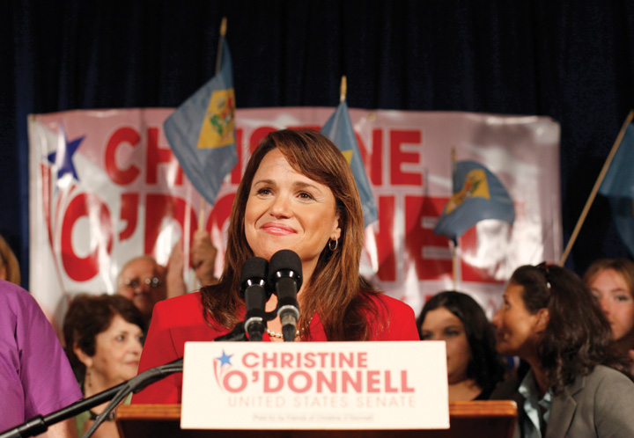
Delaware Republican Senate candidate Christine O’Donnell made headlines when a ten-year-old video clip in which she professed dabbling in witchcraft surfaced during the 2010 election.
Source: Used with permission from AP Photo/Rob Carr.

KEY TAKEAWAYS
The campaign media environment in the information age is complex and fast paced. Candidates, voters, and journalists must contend with a wide array of old and new media platforms. While traditional media primarily serve to inform voters, new media also involve voters in campaigns and help them to interact with others. Candidates’ appearances in entertainment media as well as discussions on commentary programs can influence voters’ perceptions. Today, candidates face intensive scrutiny not only from journalists but also from average people who report their actions using new media.

EXERCISES
- What social media platforms do you use? How does the way people use social media differ from the way they use newspapers and broadcast media?
- How do candidates use the media to control their image? If you could give advice to candidates trying to improve their image, what would it be?

Civic Education
Young People Taking Part in Campaigns and Elections
One of the primary goals of American civic education is to prepare young people to take part in election campaigns. Traditionally, this involves studying the democratic principles underlying elections, learning how the electoral process works, registering to vote and locating a polling place, and acquiring the basic skills necessary to follow campaigns through mainstream media. All of these things are fundamental precursors to exercising the right to vote.
In the current era, civic education also needs to take into account the new ways that people are engaging in elections. The next generation of voters should be schooled in how social media and other digital tools can be used in campaigns. Young people have been effective in developing new media election applications. They have innovated with established formats, such as campaign websites and blogs, to produce content that is more appealing to younger voters. Online versions of college newspapers have featured first-person accounts of campaign events using streaming video and interviews with candidates from dorm rooms. Young people were among the first to use Facebook, YouTube, and Twitter for campaign participation. As the number of platforms continues to evolve, such as microblogging sites like Tumblr, young voters will surely be among the first to develop them for campaign use.
Young people are ahead of the curve in using new media, compelling candidates to catch up. While candidates have incorporated social media into their campaigns, they have not always made good use of these platforms. Young citizens can be essential to campaign organizations in getting candidates up to speed with new media.

Link
Rock the Vote
The Rock the Vote website offers a gateway to participation in elections. It includes a feature “Democracy Class” that provides interactive lesson plans for teaching about civics and the voting process, including new media use.
Learn more about Rock the Vote’s mission at http://www.rockthevote.org.

[1] Adapted from Kirsten A. Foot and Steven M. Schneider, Web Campaigning (Cambridge, MA: The MIT Press, 2006).
[2] Bruce Bimber and Richard Davis, Campaigning Online: The Internet in U.S. Elections (New York: Oxford University Press, 2003).
[3] Ron Brownstein, “The First 21st Century Campaign,” National Journal, April 26, 2008, 26–32.
[4] Marshall Sella, “The Stiff Guy vs. the Dumb Guy,” New York Times Magazine, September 24, 2000, 75.
[5] Clay Ramsay, Steven Kull, and Evan Lewis, “Misinformation and the 2010 Election: A Study of the U.S. Electorate,” WorldPublicOpinion.org, Program on International Policy Attitudes, University of Maryland, College Park, MD, December 10, 2010.http://www.worldpublicopinion.org/pipa/pdf/dec10/Misinformation_ Dec10_rpt.pdf.

11.8 Recommended Reading
Bartels, Larry, and Lynn Vavreck, eds. Campaign Reform. Ann Arbor: University of Michigan Press, 2000. Thoughtful proposals to reform all aspects of the campaign process.
Box-Steffensmeier, Janet M., and Steven E. Schier, eds. The American Elections of 2008. Lanham, MD: Rowman & Littlefield, 2009.
Cornog, Evan (text), and Richard Whelan (illustrations selected and captioned),Hats in the Ring: An Illustrated History of American Presidential Campaigns. New York: Random House, 2000. Instructive summaries accompanied by well-chosen illustrations of presidential campaigns.
Foot, Kirsten A., and Steven M. Schneider. Web Campaigning. Cambridge, MA: MIT Press, 2006. A study of web practices based on numerous sites.
Hart, Roderick P. Campaign Talk: Why Elections Are Good for Us. Princeton, NJ: Princeton University Press, 2000. An unusual appraisal of election campaigns as a means to sustain democracy through the dialogue among candidates, the media, and the public.
Hollihan, Thomas A. Uncivil Wars: Political Campaigns in a Media Age, 2nd ed. Boston: Bedford/St. Martins, 2009. A text covering all aspects of the campaign process.
Jacobson, Gary C. The Politics of Congressional Elections, 5th ed. New York: Longman, 2001. A comprehensive and systematic text.
Just, Marion R., Ann N. Crigler, Dean E. Alger, Timothy E. Cook, Montague Kern, and Darrell M. West. Crosstalk: Citizens, Candidates, and the Media in a Presidential Campaign. Chicago: University of Chicago Press, 1996. Award-winning, comprehensive study of the interactions of candidates, the public, and all forms of media in the 1992 presidential election.
Schroeder, Alan. Presidential Debates: Fifty Years of High-Risk TV, 2nd ed. New York: Columbia University Press, 2008. An exhaustive survey of and discussion of all aspects of debates.
West, Darrell M. Air Wars: Television Advertising In Election Campaigns 1952–2004, 4th ed. Washington, DC: CQ Press, 2005. A major study of the contents and effects of political advertising.

11.9 Recommended Viewing
The Best Man (1964). Film version of Gore Vidal’s mordant portrayal of the candidates’ machinations at a convention to become their party’s presidential nominee.
Bob Roberts (1992). A fake documentary about a folksinging conservative candidate (Tim Robbins) that shows elections reduced by the media to easy entertainment.
Boogie Man: The Lee Atwater Story (2008). A documentary chronicling the career of the Republican mastermind of contemporary slash-and-burn election campaigns.
The Candidate (1972). The classic “authentic” campaign movie in which a candidate (Robert Redford) increasingly compromises his ideals as he is seduced by the prospects of victory.
Journeys with George (2001). A network television producer’s droll video diary of herself and the press covering George W. Bush’s 2000 presidential campaign.
The Last Hurrah (1958). In John Ford’s film, a machine-politics, big-city mayor (Spencer Tracy) seeks reelection at a time when television media image making is taking over campaigns.
Medium Cool (1969). Radical in content and form: the clashes between police and demonstrators at the 1968 Democratic national convention as seen from the perspective of a news cameraman.
Primary (1960). The first documentary on a campaign focuses on candidates Senators John F. Kennedy and Hubert H. Humphrey in Wisconsin’s 1960 presidential primary.
Unprecedented: The 2000 US Presidential Election (2003). A corrosive documentary about the contest between Governor George W. Bush and Vice President Al Gore for Florida.
The War Room (1993). A riveting documentary about the people, particularly James Carville, running Bill Clinton’s 1992 presidential campaign.

Chapter 12

Congress

Preamble
On July 30, 2010, Congressman Anthony Weiner, a Democrat from Brooklyn, New York, made an impassioned plea on the House floor blasting Republican members who were blocking a bill allocating $7 billion to monitor the health of first responders to the 9/11 attacks on the World Trade Center. He begged members to vote their conscience and to do what is right rather than to adhere to party lines. He refused to yield the floor when he was called out of order, shouting and gesticulating to emphasize his point.
Weiner’s angry and emotional two-minute outburst might well have gone the way of most congressional speechmaking, and been ignored by the press and the public. Few speeches, especially those made by little-known congressmen, receive media coverage other than on the Cable Satellite Public Affairs Network (C-SPAN), which routinely reports congressional proceedings. Instead, videos of Weiner’s remarks were posted on YouTube and other websites and quickly went viral. Within forty-eight hours, the YouTube video had been viewed over half a million times. The speech caught the attention of news producers and received coverage on morning and evening national network newscasts, cable news, radio, newspapers, and online publications. The YouTube video sparked numerous remixes, including one where Weiner is featured singing his rant to a dance tune.

Video Clip

http://www.youtube.com/watch?v=_O_GRkMZJn4

Raw Video: NY Rep Weiner’s Anti-GOP Rant
Congressman Anthony Weiner (D-NY) captured media attention with an emotional speech on the floor of the House of Representatives; the speech sparked a YouTube video that went viral.

Video Clip
http://www.youtube.com/watch?v=EzDbh8YF1is

Anthony Weiner Sings His Rant
Weiner’s speech brings to light a number of points about Congress and the media. Congress receives significantly less media attention than the president. Yet members rely on the media to publicize their actions, rally support for their positions, and run for reelection. It takes extraordinary efforts and publicity-seeking strategies for even prominent members to get press attention. In the current era, these strategies include making use of digital media, such as Twitter feeds and YouTube videos, to drive media coverage. Political leaders must be responsible in their use of digital media, as Weiner learned the hard way. In May 2011, the media reported that Weiner had sent inappropriate photos of himself via Twitter to women who were not his wife. The resulting scandal forced his resignation.
The media’s relationship with Congress maintains the distinction between the national institution of Congress and its locally elected members. Congress as an institution commands national media attention, while members of Congress are covered extensively in their local press. ^{[1]} The fact that Weiner’s speech dealing with an issue of particular concern to his constituents in New York gained national media attention was atypical. It was made possible because his rant conformed to the dramatic expectations of modern-day political media.
Congress is a national institution composed of locally elected politicians who represent distinct constituencies. Members rely on the support of voters in their home districts to keep their job in Congress. Members of Congress must work together to consider policy issues and make laws. Yet getting one hundred senators and 435 members of the House of Representatives to work collectively is a gargantuan task. The cumbersome legislative procedure outlined by the Constitution favors inaction. Members seeking to represent the interests of people back home can come into conflict with prevailing sentiments in Washington, creating obstacles to lawmaking.
The institution of Congress is slow to change. A large body with an intricate organizational structure, Congress operates under a complex system of rules and traditions (e.g., the filibuster in the Senate), some of which are byzantine. Congress adapts to innovations, including developments in communications media (e.g., television and the Internet), at a snail’s pace.
This chapter begins with discussions of the powers of Congress and the institution’s bicameral structure. It examines the party and leadership organizations as well as committees and their work. This chapter details the legislative process—how a bill becomes law—as well as the process of establishing the nation’s budget. It also covers the characteristics of members of Congress, their job description, and their staffs. Finally, Congress’s interactions with the media in the information age are investigated. The Center on Congressat Indiana University is a good source of information about Congress, including its relationship with the media.

[1] Wendy J. Schiller, Partners and Rivals (Princeton, NJ: Princeton University Press, 2000).

12.1 The Powers of Congress

LEARNING OBJECTIVES
After reading this section, you should be able to answer the following questions:
- What are the powers of Congress as enumerated in the US Constitution?
- What powers are reserved specifically for the House of Representatives, and what powers are held by the Senate alone?
- What is the Constitution’s elastic clause, and how is it used to expand the powers of Congress?
The institution of Congress is responsible for carrying out the legislative duties of the federal government. The powers of Congress are enumerated inArticle I of the Constitution. The founders established Congress in Article I, Section 1, which states, “All legislative Powers herein granted shall be vested in a Congress of the United States, which shall consist of a Senate and House of Representatives.” By instituting Congress in the first article of the Constitution the founders asserted their belief that the legislative branch should be the chief policymaking body. They preferred a government with power vested in the legislature, which they considered most representative of the people, rather than one where the executive was preeminent. They associated the executive branch with the British monarchy, which they had fought against in the Revolutionary War, so they relegated the presidency to the second article of the Constitution. As James Madison wrote in Federalist No. 51, “In a republican government, the legislative authority necessarily predominates.” ^{[1]}

Constitutional Powers
Congress was granted tremendous political power by the founders. These powers are listed primarily in Article I, Section 8, of the Constitution, which states that Congress has broad discretion to “provide for the common defense and general welfare of the United States.” To achieve this end, Congress has the authority to make and implement laws.
The Constitution lists a number of specific powers entrusted to Congress. These include responsibility for the nation’s budget and commerce, such as the power to lay and collect taxes, to pay the debts, to regulate commerce with foreign nations and among the states, to coin money, and to establish post offices. Congress is assigned the power to declare war and to raise an army and navy. Congress has the right to propose amendments to the Constitution and to create new states.

Figure 12.1 Constitutional Powers of Congress
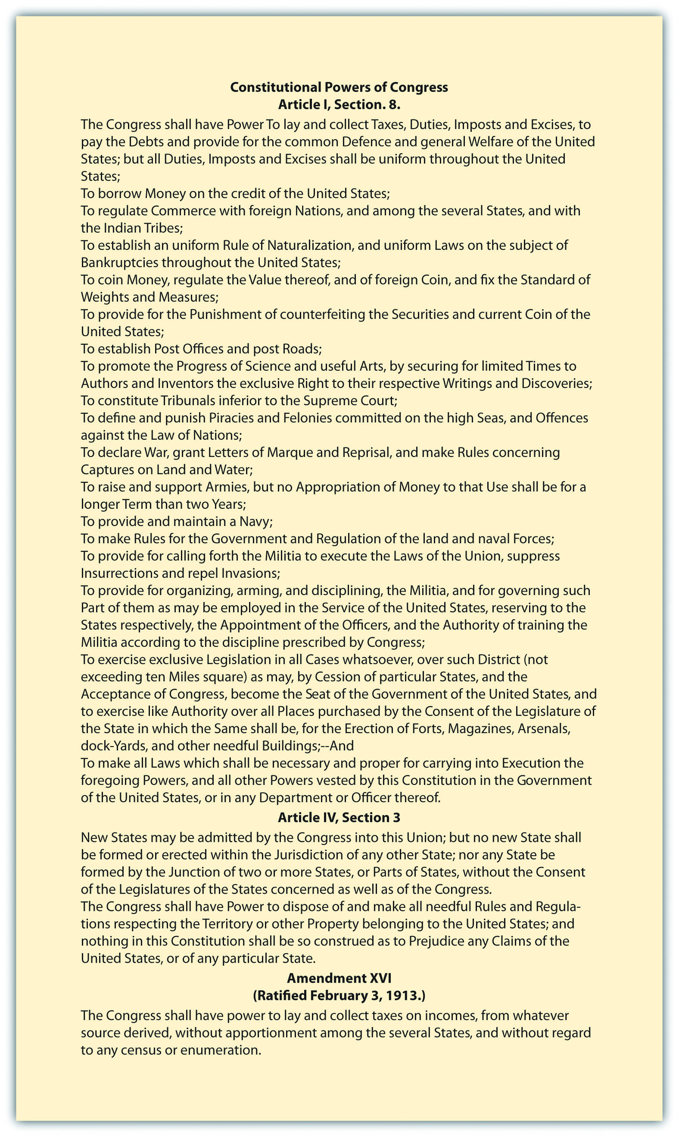
Certain powers are granted specifically to the House, such as the power to initiate all tax and spending bills. While the Senate cannot propose such bills, it can accept, reject, or amend them. The Senate has certain authority not vested in the House. High-level presidential nominees, such as cabinet officers, Supreme Court justices, and ambassadors, must gain Senate approval. The Senate also must concur in treaties with foreign countries.
The final paragraph of Article I, Section 8, grants to Congress the power “to make all laws which shall be necessary and proper for carrying into execution the foregoing powers.” This provision is known as the elastic clause because it is used to expand the powers of Congress, especially when national laws come into conflict with state laws. Legislation making it a federal crime to transport a kidnapped person across state lines was justified on the basis that the elastic clause allowed Congress to apply its power to regulate commerce in this situation. The reach of congressional power is explored on the website of theUniversity of Missouri–Kansas City Law School.

KEY TAKEAWAYS
Article I of the Constitution establishes Congress as the legislative branch of government with broad powers to provide for the “common defense and general welfare of the United States,” along with specific powers in important areas of domestic and foreign affairs. Certain powers, such as the ability to initiate taxing and spending bills, rest exclusively with the House of Representatives. Other powers, including the approval of presidential appointments, lie solely with the Senate. The powers of Congress have been extended through the elastic clause of the Constitution, which states that Congress can make all laws that are “necessary and proper” for carrying out its duties.

EXERCISES
- What are the advantages of making Congress the chief policymaking body? What might the disadvantages be?
- What are the limits of congressional power? How do the powers of the House and Senate differ?

[1] Clinton Rossiter, ed., “Federalist 51,” in The Federalist, Alexander Hamilton, James Madison, and John Jay (New York: Mentor, 1961), 322.

12.2 A Bicameral Legislative Branch

LEARNING OBJECTIVES
After reading this section, you should be able to answer the following questions:
- What is a bicameral legislative structure, and why was it established in Congress?
- What are the different characteristics of the House and Senate?
The bicameral structure of the US Congress was established by the founders to minimize the possibility of any one governmental body becoming too powerful. The House was meant to be the most democratic of the national institutions, as its members are subject to reelection every two years. The Senate was designed by the framers as an elite body that would act as a check on the House. The two bodies differ in terms of characteristics and norms as well as in the way they operate.

Bicameral Legislative Structure
The founders established Congress as a bicameral legislature as a check against tyranny. They feared having any one governmental body become too strong. This bicameral system distributes power within two houses that check and balance one another rather than concentrating authority in a single body. The House of Representatives is the larger body with membership based on each state’s population. The Senate is the smaller body with each state having two delegates. With one hundred members, the Senate is a more intimate, less formal legislative body than the House, which has 435 members elected from districts that are roughly the same size in population.
Members of Congress must reside in the district or state that elects them, although the Constitution does not specify for how long. Residency can become a campaign issue, as it did when former first lady and current secretary of state, Hillary Rodham Clinton, ran for a Senate seat from New York soon after leaving the White House, despite having never lived in the state. She was successful despite having to fend off criticism that as a carpetbagger she was not suited to represent New York’s interests in Congress. The term “carpetbagger” refers to a politician who runs for office from an area where he or she has lived for only a short time and has few community ties. It derives from a derogatory term coined after the Civil War referring to Northerners who went south to profit from the Reconstruction, carrying “carpet bags” for luggage.
Members of Congress are elected locally to serve nationally. All aspects of members’ jobs, whether it be making laws or providing service to people in their home districts, are influenced by this dual concern with representing local constituencies while dealing with national policy.

The Electoral Connection
The Constitution anticipated that the House would be more attentive to the people than the Senate. The House is designed to be the most democratic institutional body in the US government because each member represents a particular district within a state rather than the entire state, which is the case for the Senate. House members stand for election every two years to ensure that they keep in close touch with the opinions and interests of the people they represent or face defeat at the polls. There are no limits on the number of terms a member can serve. Consequently, many members are constantly campaigning to keep their seats in office.
Figure 12.2
Members of Congress engage in a permanent campaign for reelection that begins the minute they take office.
Source: Source: Photo courtesy of IowaPolitics.com,http://www.flickr.com/photos/iowapolitics/4984484879/in/photostream/.
Congress establishes the number of House members by enacting legislation. In 1787, there were 65 members, and the founders anticipated that House members would never represent more than 30,000 people. In 1910, the current number of 435 representatives was reached. The number of people represented by a single member has increased from 210,583 in 1910 to 646,947 in 2000 and 710,767 in 2010. The US Census Bureau calculates these apportionment figures, which can be viewed on an interactive map on its website. This number of people per congressional district is projected to top 900,000 in 2050. ^{[1]} Some observers question if the democratic character of the House will be compromised if constituencies grow even larger, while others oppose enlarging an institution that is already difficult to manage.
House members are elected in districts whose lines are drawn by state legislatures after the census, which takes place every ten years. States can gain or lose representatives if there are population shifts. Redistricting can be controversial as legislators seek to draw district lines that advantage their own political parties. In 2003, the process of redrawing congressional district lines in Texas attracted national media attention. Democratic state legislators twice fled to neighboring states to prevent a vote on a redistricting plan that they felt favored Republicans. The media depicted the fugitive Democratic legislators hanging out on the balcony of a cheap hotel in New Mexico as the infuriated Republicans threatened to call out the Texas Rangers to forcibly return them to the state. The media attention did not stop the redistricting plan. ^{[2]} This strategy of lawmakers fleeing to another state to stop the legislative process was used in Wisconsin in 2011, when Democratic senators left the state to prevent having a quorum to pass a budget bill supported by the Republican governor that would cut workers’ benefits in order to improve the state budget.
Figure 12.3
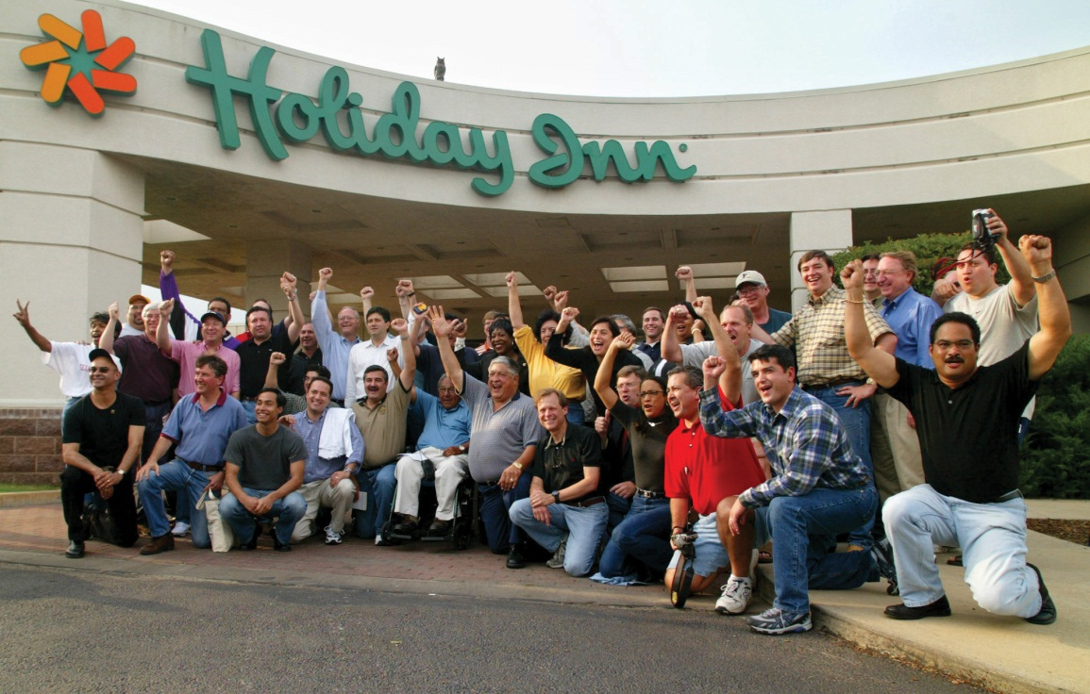
Democratic members of the Texas state assembly garnered national press attention by fleeing to a neighboring state to avoid having to vote on a redistricting plan they felt would give seats to Republicans.
Source: Used with permission from AP Photo/Sue Ogrocki.
The framers felt that the Senate should be constituted as an elite body that would act as a check on the House, the branch closest to the mass public. Senators serve six-year terms of office, and like the House, there are no limits on the number of terms they can serve. Senators, in theory, should have more time than House members to think about something besides reelection. However, as the cost of elections has grown and Senate elections have become more competitive, fundraising has become a constant concern for many senators. ^{[3]} The founders’ expectations that the House would be close to the people and the Senate would be more distant have not been realized. House members often hold safe seats and do not face serious challenges to reelection, so they often hold office for years.
House members are chosen in districts whose boundaries can cut across media markets and other political jurisdictions, such as county or city lines. Some parts of Maryland and Virginia receive most of their news from the District of Columbia, and their House members are given limited coverage. As a result, it can be difficult for local television news to cover House members and their reelection challengers. Senators, having won statewide races, receive more attention. Their opponents also are likely to receive significant media coverage, which often makes for hotly contested elections.

House and Senate Comparisons
The House and Senate are institutions that have decidedly different characters. Because of its large size and more frequent turnover in membership, the House is an impersonal institution. House members may not recognize their colleagues, and some have staff members assigned as “spotters,” who whisper names into their ears to avoid embarrassment. The House operates under formal rules. It is hierarchical, and seniority is important. Members serve for a long time before they become leaders. Senior members have more influence over decision making than their junior colleagues.
The Senate does not rely as heavily on hierarchy as the House. It is less rule-bound and operates more loosely and unpredictably than the House, especially as it requires unanimous consent for any bill to be taken up. This means that a lone senator has the power to stop legislative action, a power that House members do not possess. Senators serve long terms and get to know their colleagues. Seniority is less meaningful, as junior senators have considerable power to make decisions along with their senior colleagues. The smaller size of the chamber allows members to pursue a fast track to leadership and increased public visibility early in their careers.
The differences between the House and Senate are reflected in their respective chambers. The House meets in the largest parliamentary room in the world. Members do not have assigned seats and take any available place on padded benches. Few members spend time in the chamber other than when they are speaking or voting. The Senate chamber is smaller and more ornate. Senators are assigned desks and chairs, many of which have been held by distinguished members. Since the introduction of television to the Senate chamber in 1986, senior senators have taken back-row seats, which provide favorable camera angles against a flattering blue backdrop and have space for displaying charts and graphs.
The distinctions between the chambers extend to their ability to attract media coverage. The Senate routinely garners greater press attention than the House because it is easier for journalists to cover the smaller chamber and establish long-term relationships with its members. The hierarchical structure of the House makes it easy for leaders to become national media headliners, while other members must compete for attention. ^{[4]} The proliferation of digital media outlets has made it somewhat easier for media-savvy members to get their message out through websites, blogs, Twitter feeds, and online videos.

KEY TAKEAWAYS
The framers provided for a bicameral legislative branch with equal representation in the Senate and proportional representation based on state population in the House. The two bodies differ in a number of important ways that influence the way that they operate. The House is a more formal institution, where hierarchy and seniority are important factors. The Senate, as a smaller, more intimate body, is less bound by formal rules than the House. Senators typically garner more media attention than House members because they serve statewide constituencies and serve longer terms of office.

EXERCISES
- How is the design of the House intended to make its members particularly responsive to their constituents?
- What makes the House and Senate differ in character? How do the media portray the two bodies?

[1] Roger H. Davidson and Walter J. Oleszek, Congress and Its Members, 8th ed. (Washington, DC: CQ Press, 2002), 27.
[2] “Texas District Fight Goes to Court,” CBSNews.com, October 15, 2003, accessed February 15, 2011, cbsnews.com/stories/2003/10/09/politics/main577340.shtml.
[3] Quoted in Roger H. Davidson and Walter J. Oleszek, Congress and Its Members, 8th ed. (Washington, DC: CQ Press, 2002), 25.
[4] Patrick J. Sellers, “Winning Media Coverage in the U.S. Congress,” in U.S. Senate Exceptionalism, ed. Bruce I. Oppenheimer (Columbus, OH: Ohio State University Press, 2002), 132–53.

12.3 Parties in Congress

LEARNING OBJECTIVES
After reading this section, you should be able to answer the following questions:
- How are political parties in Congress organized?
- What role do political party organizations play in Congress?
- How do factional organizations function in Congress?
Maintaining order in an institution consisting of hundreds of individuals with often competing agendas is about as easy as herding cats. Political parties and the House and Senate leadership help members work together to perform their duties effectively. The Constitution says little about how Congress should be organized. Most of the functions of parties and congressional leaders have developed as members have sought to shape the institution over time.

Party Organization
Political parties provide Congress with organizational structure and discipline. The Democratic and Republican parties are a robust presence in Congress. Almost all members of Congress are either Republicans or Democrats. Party organizations have permanent offices and staffs on the Hill. Parties facilitate lawmaking and are the basis for the most stable coalitions in Congress. They unite individuals who share ideological orientations and policy goals and help them work together to pass legislation. Congressional campaign committees help party members get elected to Congress.
Formal party organizations consist of caucuses and committees. Themajority party controls the top leadership positions. The minority partyforms an organized opposition to the majority party.

Party Caucuses
All members of the House and Senate belonging to a political party form that party’s caucus or conference. Caucuses elect leaders, approve committee assignments, and appoint task forces to study specific issues. They provide a forum for debating policies and developing strategies for passing legislation. Party staffers serve members by supplying reports on pending legislation and assisting them with media relations by producing radio and television interviews, webcasts, and podcasts in studios on Capitol Hill.
Caucuses promote party loyalty by granting rewards to members, such as prestige committee assignments. For this reason, few members switch parties, with only twenty-seven instances in the Senate and fewer than ninety in the House since the 1880s. ^{[1]} In May 2001, Senator Jim Jeffords (I-VT) left the Republican Conference and became an Independent. His defection caused the Republicans to lose their majority position in the Senate. Jeffords was appointed to a committee chair by the Democratic Party, but his prestige was short-lived. When the Republicans became the majority party after winning additional seats in the 2002 election, Jeffords lost his chair. Senator Arlen Specter of Pennsylvania, a Republican senator since 1980, became a Democrat in 2009 due to his support of an economic stimulus package that was opposed by Republicans. Specter faced a difficult reelection bid as a Democrat in 2010 and lost to Joe Sestak in the primary, ending over four decades in Congress. ^{[2]}
In the aftermath of the 2010 midterm elections, party switching in the House became an issue when Congress was considering major taxing, spending, and health-care bills. Democratic House member Parker Griffith switched to the Republican Party as votes on these issues were pending, causing great distress within the House Democratic caucus.

Party Committees
The two major parties have established party committees that perform specific tasks. In the House, steering committees consisting of party leaders recommend members to serve on legislative committees. Each party’s House and Senate policy committee conducts research and advises members about legislative proposals. The campaign committees raise funds, conduct election research, organize volunteers, and develop campaign publicity to promote the election of party members to Congress. House Democrats’ Organization, Study, and Review Committee recommends changes in party organization and rules.

Party Voting
Congressional parties promote party voting on bills. Party votes occur when a majority of members of one party votes against a majority of members of the opposing party on major legislation. ^{[3]} The percentage of party votes over the past twenty years has averaged around 50 percent, which is high considering that many votes are routine and nondivisive and therefore do not precipitate a party vote. In recent Congresses, 70 percent to 80 percent of members have voted consistently with their party. ^{[4]}

Link
Party Votes
The Washington Post has compiled an interactive database of party votes in the US Congress from the 102nd Congress to the present athttp://projects.washingtonpost.com/congress/112/senate/members/#.
Political parties’ influence on members’ decisions and actions has been on the rise since the 1970s, especially in the House. One explanation for this increase in partisanship is that members come from districts where constituents are strongly affiliated with the Democratic or Republican Party. ^{[5]} Another explanation is that reforms instituted when Republicans took control of the House in 1994 have given more power to congressional leaders to handle procedural matters. When policy preferences among majority party members are consistent, members will delegate responsibility to the Speaker of the House and committee chairs to advance the party’s legislative program. ^{[6]} Some scholars argue that this results in the majority party promoting policy goals that are closer to the ideals of the leadership than those of rank-and-file members and the general public. ^{[7]}
The tension between the institution of Congress and individual members is evident in party voting. The primary source of conflict within party ranks stems from members’ disagreement with a party’s policy position because it deviates from their commitment to the voters back home. Party voting usually declines in election years, as members are less willing to face criticism in their districts for supporting unpopular positions.
Media reports on Congress commonly emphasize conflicts between the Republican and Democratic parties. The partisan conflict frame is prevalent when high-profile legislative issues are being debated. Journalists find it easier to focus on partisan dynamics, which are a legitimate part of the story, than to cover the often complicated details of the legislation itself.
Media coverage of the congressional debate over health care in recent years illustrates the use of the conflict frame, which often excludes coverage of the substance of policy issues. The media focused heavily on the strategies employed by President Barack Obama and Democratic members of Congress on the one hand and Republican members on the other to advance their positions on health care. Lawmakers on each side of the debate conducted extensive research and issued reports detailing the policy issues involved, yet news organizations focused primarily on fights between members and parties. According to the Pew Research Center, over 70 percent of the public felt that news organizations provided only fair or poor coverage of the details of various health-care proposals and their effect on people despite the health-care debate dominating the news agenda. ^{[8]}
Members have very different legislative experiences depending on whether or not their party is in power. Majority party members profit frompork barrel spending on projects that benefit their districts. Earmarks are legislative provisions that provide funding for pork barrel projects. Pork barrel projects include federally funded parks, community centers, theaters, military bases, and building projects that benefit particular areas. These projects can help members curry favor with their constituents and help their reelection prospects. However, opponents of pork barrel spending argue that these projects should be funded by state and local budgets in the places they benefit rather than the federal treasury. A proposal calling for a moratorium on earmarks in the 112th Congress was introduced by the Republican leadership in the House. ^{[9]}

Factions and Policy Groups
Outside of parties, like-minded members can form factions or specialized coalitions to promote a particular agenda. Some factions are long-standing groups with pronounced ideological leanings. They form coalitions to support or oppose legislation. ^{[10]} Some factions are based on members’ identification with a group. These include the Congressional Black Caucus and the Congressional Hispanic Caucus.
In addition to the major party caucuses of the Democrats and Republicans, there also are caucuses representing offshoots of the major parties. The Tea Party caucus consists of Republicans who gained office with the backing of the Tea Party grassroots movement. While more than forty Tea Party–backed candidates were elected to the House during the 2010 midterm contests, only around a dozen, or less than 10 percent of Republican members, joined the Tea Party caucus for the 112th Congress. ^{[11]}
Figure 12.4
Congressional causes can form around surprising issues. The Congressional Soccer Caucus encourages legislation, activities, and events that promote soccer, including improvement of fields and use of soccer for building communities.
© Thinkstock
Policy groups (factions) also unite members interested in a particular policy area and include both Republicans and Democrats. The Congressional Wine Caucus consists of 250 House and Senate members who share a concern with the wine industry’s cultural and financial significance. In addition to sponsoring wine seminars and tastings, and legislative briefings, the Wine Caucus holds fundraisers for charities.

KEY TAKEAWAYS
Political parties are central to the organizational structure of Congress. Parties provide a measure of discipline that helps the House and Senate to function more efficiently. Members who switch parties often lose the benefits of seniority, such as committee chair positions, and face an uncertain future when they seek reelection.

EXERCISES
- What is a caucus? What are some of the different caucuses in Congress?
- How do political parties help organize Congress? Why does media coverage tend to focus on party conflicts?

[1] Steven S. Smith, Jason Roberts, and Ryan Vander Wielen, The American Congress, 3rd ed. (New York: Houghton Mifflin Company, 2003).
[2] Paul Kane, “Arlen Specter’s Party Switch Haunts Him in Primary Campaign,”Washington Post, May 12, 2010, accessed February 12, 2011,http://www.washingtonpost.com/wp-dyn/content/article/2010/05/11/AR2010051105084.html.
[3] Keith T. Poole and Howard Rosenthal, Congress: A Political-Economic History of Roll Call Voting (New York: Oxford, 2000).
[4] Gary W. Cox and Matthew D. McCubbins, Legislative Leviathan (Berkeley: University of California Press, 1993).
[5] Keith Krehbiel, Pivotal Politics (Chicago: University of Chicago Press, 1998).
[6] David W. Rohde, Parties and Leaders in the Postreform House (Chicago: University of Chicago Press, 1991); Nicol C. Rae and Colton C. Campbell, eds., New Majority or Old Minority? (Lanham, MD: Rowman & Littlefield, 1999).
[7] John H. Aldrich, David W. Rohde, and Michael W. Tofias, “One D Is Not Enough: Measuring Conditional Party Government, 1887–2002,” Paper presented at the History of Congress Conference, Stanford University, Palo Alto, CA, April 9–10, 2004, accessed January 29, 2011, http://www.duke.edu/nmwt/papers/ART3.pdf.
[8] Pew Research Center for the People & the Press, “Many Faulty Media Coverage of Health Care Debate,” August 6, 2009, accessed June 6, 2011, http://people-press.org/report/533/many-fault-media-coverage-of-health-care.
[9] “Tea Party’s First Legislative Victory: McConnell Backs Earmark Ban,” Newsweek, November 15, 2010, accessed December 16, 2010, http://www.newsweek.com/blogs/the-gaggle/2010/11/15/tea-party-s-first-legislative-victory- mcconnell-backs-earmark-ban.html.
[10] Steven S. Smith, Jason Roberts, and Ryan Vander Wielen, The American Congress, 3rd ed. (New York: Houghton Mifflin Company, 2003).
[11] David M. Herszenhorn, “Senate Tea Party Caucus Holds First Meeting,” New York Times, January 27, 2011, accessed February 18, 2011,http://thecaucus.blogs.nytimes.com/2011/01/27/senate-tea-party-caucus- holds-first-meeting.

12.4 House Leadership

LEARNING OBJECTIVES
After reading this section, you should be able to answer the following questions:
- What criteria do House members use when selecting their leadership?
- What roles do the Speaker, floor leaders, and whips play in the House?
The House leadership consists of the Speaker, floor leaders, and whips. Committee chairs also are part of the House leadership, and they will be discussed in Section 12.6 "Committees", which is about committees. The rules of the House give extensive power to leaders to direct the legislative process.

Leadership Criteria
House members consider a number of factors when choosing leaders. A member’s personal reputation, interactions with other members, legislative skills, expertise, experience, length of service, and knowledge of the institution are taken into account. Members tend to choose leaders who are in the ideological mainstream of their party and represent diverse regions of the country. The positions that a member has held in Congress, such as service on important committees, are evaluated. Fundraising ability, media prowess, and communications skills are increasingly important criteria for leadership. The ability to forge winning coalitions and the connections that a member has to leaders in the Senate or the executive branch are factored into the decision. ^{[1]}
Holding a congressional leadership position is challenging, especially as most members think of themselves as leaders rather than followers. Revolts can occur when members feel leaders are wielding too much power or promoting personal agendas at the expense of institutional goals. At times, a leader’s style or personality may rub members the wrong way and contribute to their being ousted from office. ^{[2]}

Speaker of the House
The Speaker of the House is at the top of the leadership hierarchy. The Speaker is second in succession to the presidency and is the only officer of the House mentioned specifically in the Constitution. The Speaker’s official duties include referring bills to committees, appointing members to select and conference committees, counting and announcing all votes on legislation, and signing all bills passed by the House. He rarely participates in floor debates or votes on bills. The Speaker also is the leader of his or her political party in the House. In this capacity, the Speaker oversees the party’s committee assignments, sets the agenda of activities in the House, and bestows rewards on faithful party members, such as committee leadership positions. ^{[3]}
In addition to these formal responsibilities, the Speaker has significant power to control the legislative agenda in the House. The Rules Committee, through which all bills must pass, functions as an arm of the Speaker. The Speaker appoints members of the Rules Committee who can be relied on to do his or her bidding. He or she exercises control over which bills make it to the floor for consideration and the procedures that will be followed during debate. Special rules, such as setting limits on amendments or establishing complex time allocations for debate, can influence the contents of a bill and help or hinder its passage. ^{[4]}
Speakers’ personal styles have influenced the evolution of the position. Speaker Joe Cannon (R-IL) became the most powerful Speaker of the House by using strong-arm tactics to control members of both parties. “Czar” Cannon’s style so angered his colleagues that he was forced to step down as chairman of the Rules Committee during the St. Patrick’s Day Revolt of 1910, which stripped him of his ability to control appointments and legislation. The position lost prestige and power until Speaker Sam Rayburn (D-TX) took office in 1940. Rayburn was able to use his popularity and political acumen to reestablish the Speakership as a powerful position. ^{[5]}
Figure 12.5
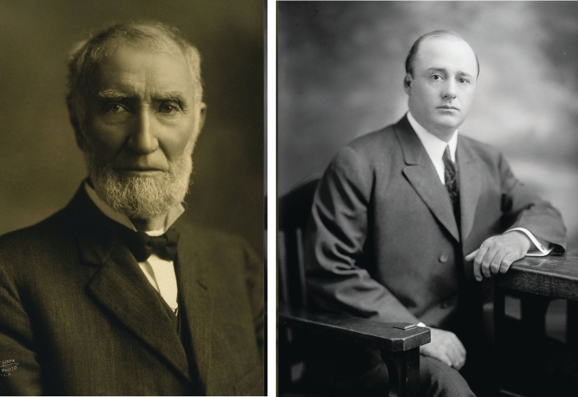
Strong Speakers of the House, such as Joe Cannon (left) and Sam Rayburn (right), were able to exert influence over other members. Strong speakers are no longer prominent in the House.
Source: Photo (left) courtesy of Hartsook Photo,http://en.wikipedia.org/wiki/File:JGCannon.jpg. Photo (right) courtesy of and Harris & Ewing, Inc.,http://commons.wikimedia.org/wiki/File:Sam_Rayburn3.jpg.
A Speaker’s personal style can influence the amount of media coverage the position commands. The Speaker can become the public face of the House by appearing frequently in the press. A charismatic speaker can rival the president in grabbing media attention and setting the nation’s issue agenda. On April 7, 1995, Speaker Newt Gingrich (R-GA) made an unprecedented prime-time television “State of the Congress” address on CBS indicating that the House has passed the Contract With America, a plan that proposed extensive changes to the social welfare system and tax policy. Despite the fact that the Contract with America died in the Senate, Gingrich became a “multimedia Whirling Dervish of books, writings, lectures, tapes, and television, spewing out ideas.” ^{[6]} He was a constant presence on the television and radio talk show circuit, which kept attention focused on his party’s issue platform. This strategy worked at the outset, as the Republicans were able to push through some of their proposals. Gingrich’s aggressive personal style and media blitz eventually backfired by alienating members of both parties. This experience illustrates that the media can have a boomerang effect—publicity can make a political leader and just as quickly can bring him down.
In contrast, Speaker Dennis Hastert (R-IL), who took office in 1999, exhibited an accommodating leadership style and was considered a “nice guy” by most members. He worked behind the scenes to build coalitions and achieve his policy initiatives. After the election of President George W. Bush, Hastert coordinated a communications strategy with the executive branch to promote a Republican policy agenda. He shared the media spotlight, which other members appreciated. His cooperative approach was effective in getting important budget legislation passed. ^{[7]}

Figure 12.6
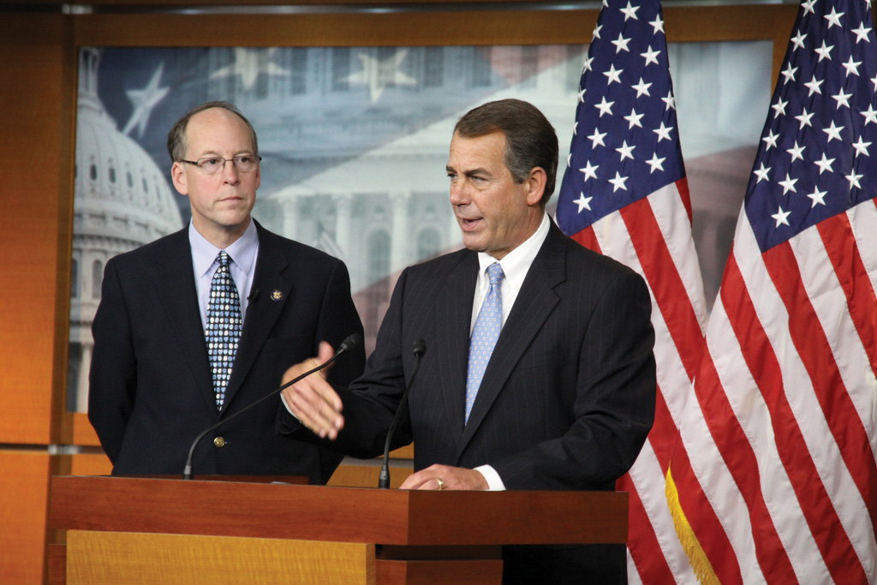
Republican John Boehner of Ohio became Speaker of the House after the Republicans took control following the 2010 elections. He replaced Democrat Nancy Pelosi, the first woman Speaker.
Source: Photo courtesy of the House GOP Leader,http://www.flickr.com/photos/gopleader/4331119670/.
Speaker Nancy Pelosi (D-CA) was the first woman Speaker of the House, serving from 2006 to 2010. Media coverage of Pelosi frequently included references to her gender, clothing, emotions, and personal style. Pelosi’s choice of Armani suits was much noted in the press following her selection. Syndicated New York Times columnist Maureen Dowd wrote a piece on November 6, 2006, titled “Squeaker of the House.” Dowd alleged that Pelosi’s first act after becoming Speaker was to “throw like a girl” and that she was “making her first move based on relationships and past slights rather than strategy.” “Squeaker of the House” became a moniker that stuck with Pelosi throughout her tenure as Speaker and was the subject of a YouTube parody. Pelosi was replaced by Rep. John Boehner (R-OH) when the Republicans took control of the House following the 2010 midterm elections.

Floor Leaders
The Republicans and Democrats elect floor leaders who coordinate legislative initiatives and serve as the chief spokespersons for their parties on the House floor. These positions are held by experienced legislators who have earned the respect of their colleagues. Floor leaders actively work at attracting media coverage to promote their party’s agenda. The leadership offices all have their own press secretaries.
The House majority leader is second to the Speaker in the majority party hierarchy. Working with the Speaker, he is responsible for setting the annual legislative agenda, scheduling legislation for consideration, and coordinating committee activity. He operates behind the scenes to ensure that the party gets the votes it needs to pass legislation. He consults with members and urges them to support the majority party and works with congressional leaders and the president, when the two are of the same party, to build coalitions. The majority leader monitors the floor carefully when bills are debated to keep his party members abreast of any key developments. ^{[8]}
Figure 12.7
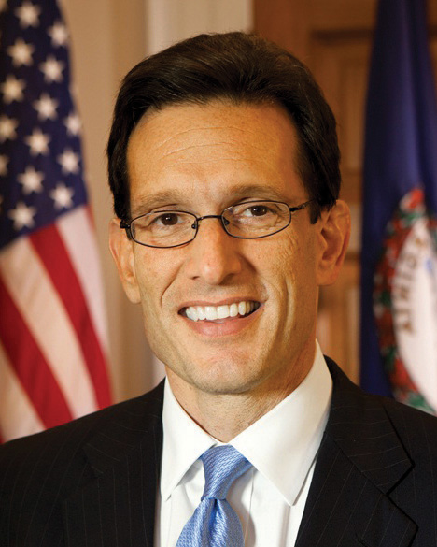
Rep. Eric Cantor (R-VA) became House Majority Leader following the 2010 midterm elections. Cantor’s web page features multiple means of reaching out to citizens, including links to Facebook and a TwitterBuzz feed.
Source: Photo courtesy of the US Congress,http://commons.wikimedia.org/wiki/File:Eric_Cantor,_official _portrait,_112th_Congress.jpg.

Link
House Majority Leader
See Eric Cantor’s web page at http://majorityleader.house.gov/.
The House minority leader is the party with the fewest members’ nominee for Speaker. She is the head of her party in the House and receives significant media coverage. She articulates the minority party’s policies and rallies members to court the media and publicly take on the policies of the majority party. She devises tactics that will place the minority party in the best position for influencing legislation by developing alternatives to legislative proposals supported by the majority. During periods of divided government, when the president is a member of the minority party, the minority leader serves as the president’s chief spokesperson in the House. ^{[9]}
Figure 12.8
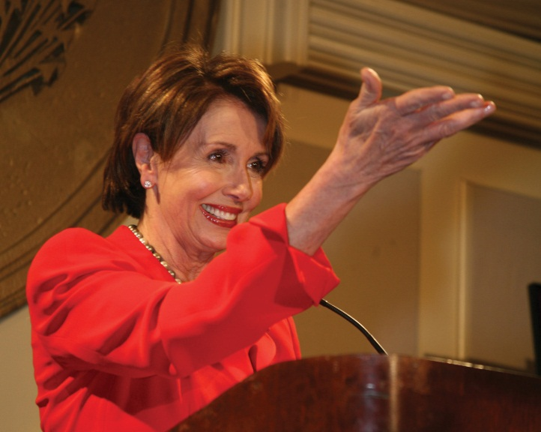
Rep. Nancy Pelosi (D-CA) became House Minority Leader after she was replaced as Speaker of the House by Republican Rep. John Boehner (R-OH) following the 2010 midterm elections. Pelosi’s website does not mention her status as minority leader.
Source: http://commons.wikimedia.org/wiki/File:Nancy_Pelosi_0009_3.jpg.

Whips
Members of Congress from the Republican and Democratic parties elect whips who are responsible for encouraging party loyalty and discipline in the House. Aided by extensive networks of deputies and assistants, whips make sure that the lines of communication between leaders and members remain open. In 2002, whip Steny Hoyer (D-MD) greatly expanded his organization to include forty senior whips and thirty assistant whips to enforce a “strategy of inclusion,” which gives more members the opportunity to work closely with party leaders and become vested in party decisions. This strategy made more party leaders with expertise available to the press in the hopes of increasing coverage of the Democratic Party’s positions. Whips keep track of members’ voting intentions on key bills and try persuade wayward members to toe the party line. ^{[10]}

KEY TAKEAWAYS
An extensive leadership structure provides an organizational framework that helps House members work effectively if not efficiently. At the top of the leadership hierarchy is the Speaker of the House, who is the body’s presiding officer. Majority and minority leaders help set their party’s agenda on issues. The whips encourage party unity on House votes.

EXERCISES
- What is the House Rules Committee? What makes it important to controlling what legislation gets through the House?
- How do the roles of Speaker of the House and majority leader differ? What do party whips do?

[1] Robert L. Peabody, Leadership in Congress (Boston: Little, Brown, 1976).
[2] Joseph Cooper and David W. Brady, “Institutional Context and Leadership Style: The House from Cannon to Rayburn,” American Political Science Review 75, no. 2 (June 1981): 411–25.
[3] Thomas P. Carr, “Party Leaders in the House: Election, Duties, and Responsibilities,”CRS Report for Congress, October 5, 2001, order code RS20881.
[4] Nicol C. Rae and Colton C. Campbell, eds. New Majority or Old Minority? (Lanham, MD: Rowman & Littlefield, 1999).
[5] Ronald M. Peters, Jr., The American Speakership (Baltimore: Johns Hopkins University Press, 1997).
[6] Dan Balz and Ronald Brownstein, Storming the Gates (Boston: Little Brown, 1996), 143.
[7] Roger H. Davidson and Walter J. Oleszek, Congress and Its Members, 8th ed. (Washington, DC: CQ Press, 2002).
[8] Richard C. Sachs, “Leadership in the U.S. House of Representatives,” CRS Report for Congress, September 19, 1996, order code 96-784GOV.
[9] Thomas P. Carr, “Party Leaders in the House: Election, Duties, and Responsibilities,”CRS Report for Congress, October 5, 2001, order code RS20881.
[10] Roger H. Davidson and Walter J. Oleszek, Congress and Its Members, 8th ed. (Washington, DC: CQ Press, 2002).

12.5 Senate Leadership

LEARNING OBJECTIVES
After reading this section, you should be able to answer the following questions:
- Who makes up the Senate leadership?
- What roles do the presiding officer, floor leaders, and whips play in the Senate?
The Senate leadership structure is similar to that in the House. The smaller chamber lacks the extensive formal rules of the House and thus requires its leaders to use their political and personal relations skills to move legislation through the institution.

Presiding Officer
The presiding officer convenes floor action in the Senate. Unlike the Speaker of the House, the Senate’s presiding officer is not the most visible or powerful member. The Senate majority leader has this distinction.
The Constitution designates the vice president as president of the Senate, although he rarely presides and can vote only to break a tie. Republican senators made sure that Vice President Dick Cheney was on hand for close votes during the 107th Congress, when the number of Democrats and Republican Senators was nearly equal.
In the absence of the vice president, the Constitution provides for thepresident pro tempore to preside. The president pro tempore is the second-highest ranking member of the Senate behind the vice president. By convention, the president pro tempore is the majority party senator with the longest continuous service. The president pro tempore shares presiding officer duties with a handful of junior senators from both parties, who take half-hour shifts in the position.

Floor Leaders
The Senate majority leader, who is elected by the majority party, is the most influential member of the Senate. He is responsible for managing the business of the Senate by setting the schedule and overseeing floor activity. He is entitled to the right of first recognition, whereby the presiding officer allows him to speak on the floor before other senators. This right gives him a strategic advantage when trying to pass or defeat legislation, as he can seek to limit debate and amendments.
Figure 12.9
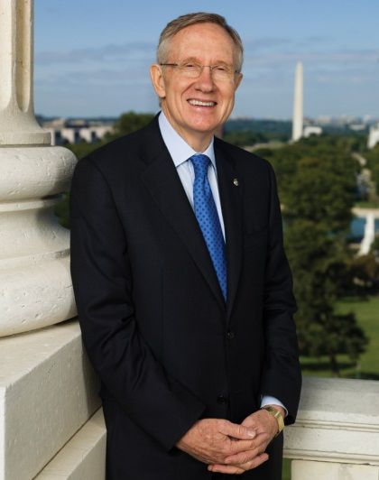
Senator Harry Reid, a Democrat from Nevada, is the Senate majority leader.
Source: Photo courtesy of the US Congress,http://commons.wikimedia.org/wiki/File:Harry_Reid_official_portrait_2009.jpg.
The Senate minority leader is the head of the opposing party. He works closely with the majority leader on scheduling. He confers regularly with members of his party to develop tactics for promoting their interests in the Senate.
Figure 12.10
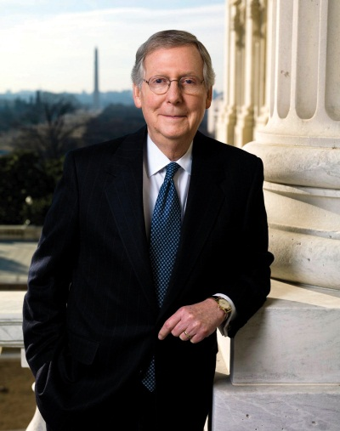
Senator Mitch McConnell, a Republican from Kentucky, is the Senate minority leader.
Source: Photo courtesy of the US Senate,http://commons.wikimedia.org/wiki/File:Sen_Mitch_McConnell_official.jpg.

Whips
Senate whips (assistant floor leaders) are referred to as assistant floor leaders, as they fill in when the majority and minority leaders are absent from the floor. Like their House counterparts, Senate whips are charged with devising a party strategy for passing legislation, keeping their party unified on votes, and building coalitions. The Senate whip network is not as extensive as its House counterpart. The greater intimacy of relationships in the Senate makes it easier for floor leaders to know how members will vote without relying on whip counts.

KEY TAKEAWAYS
The Senate leadership consists of the presiding officer, majority leader, minority leader, and whips. Unlike in the House, where the Speaker wields considerable power, the presiding officer is not the most visible member of the Senate and can only vote in case of a tie. The majority and minority leaders work together to schedule and manage Senate business. Whips are less important in the Senate than in the House because the closer personal relationships that develop in the smaller body make it easier to know how members will vote without a formal whip count.

EXERCISES
- What formal power does the vice president wield in the Senate? Who presides over the Senate when the vice president is absent?
- What is the right of first recognition? How does it give the Senate majority leader an advantage in legislative battles?

12.6 Committees

LEARNING OBJECTIVES
After reading this section, you should be able to answer the following questions:
- What criteria do members use when seeking congressional committee assignments?
- What are the prestige committees in the House and Senate?
- What is the function of investigative committees?
In 1885, Woodrow Wilson famously observed, “Congress in session is Congress on public exhibition, whilst Congress in its committee-rooms is Congress at work.” ^{[1]} This statement is no less true today. Committees are the lifeblood of Congress. They develop legislation, oversee executive agencies and programs, and conduct investigations.
There are different types of committees that are responsible for particular aspects of congressional work. Standing committees are permanent legislative committees. Select committees are special committees that are formed to deal with a particular issue or policy. Special committees can investigate problems and issue reports. Joint committees are composed of members of the House and Senate and handle matters that require joint jurisdiction, such as the Postal Service and the Government Printing Office.Subcommittees handle specialized aspects of legislation and policy.

Committee Assignments
Members seek assignments to committees considering the overlapping goals of getting reelected, influencing policy, and wielding power and influence. They can promote the interests of their constituencies through committee service and at the same time help their chances at reelection. Members from rural districts desire appointments to the Agriculture Committee where they can best influence farm policy. Those most interested in foreign policy seek appointment to committees such as the House Foreign Relations and Senate International Affairs Committees, where they can become embroiled in the pressing issues of the day. Power or prestige committee assignments in the House include Appropriations, Budget, Commerce, Rules, and Ways and Means. The most powerful committees in the Senate are Appropriations, Armed Services, Commerce, Finance, and Foreign Relations.

Link
House and Senate Committees
A list and description of House and Senate committees can be found athttp://www.govtrack.us/congress/committee.xpd andhttp://www.contactingthecongress.org/cgi-bin/committee_list.cgi?site=ctc.
Table 12.1 Congressional Committees
House Committees | Senate Committees
- Agriculture  - Appropriations  - Armed Services  - Budget  - Education and the Workforce  - Energy and Commerce  - Financial Services  - Foreign Affairs  - Homeland Security  - Administration  - Judiciary  - Natural Resources  - Oversight and Government Reform  - Rules  - Science, Space, and Technology  - Small Business  - Transportation and Infrastructure  - Veterans’ Affairs  - Ways and Means  - Permanent Select Committee on Intelligence  - Permanent Select Committee on Energy Independence and Global Warming | - Agriculture, Nutrition, and Forestry  - Appropriations  - Armed Services  - Banking, Housing, and Urban Affairs  - Budget  - Commerce, Science, and Transportation  - Energy and Natural Resources  - Environment and Public Works  - Finance  - Foreign Relations  - Health Education, Labor, and Pensions  - Homeland Security and Governmental Affairs  - Indian Affairs  - Judiciary  - Rules and Administration  - Small Business and Entrepreneurship  - Veterans’ Affairs  - Select Committee on Ethics  - Select Committee on Intelligence  - Special Committee on Aging  - Caucus on International Narcotics Control
Joint Committees
- Commission on Security and Cooperation in Europe
- Library
- Printing
- Taxation
- Economic Committee
Most House members end up getting assigned to at least one committee that they request. In the House, committee assignments can be a ticket to visibility and influence. Committees provide House members with a platform for attracting media attention as journalists will seek them out as policy specialists. Senate committee assignments are not as strongly linked to press visibility as virtually every senator is appointed to at least one powerful committee. The average senator serves on eleven committees and subcommittees, while the average House member serves on five.
Figure 12.11
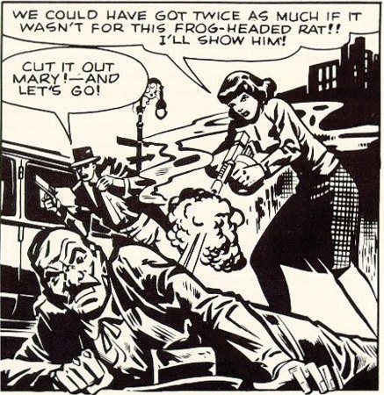
In the 1950s, Senator Estes Kefauver used controversial comics like “Frisco Mary” to generate press attention for his hearings on juvenile delinquency. This practice of using powerful exhibits to attract media attention to issues continues today.
Source:http://www.crimeboss.com/history03-1.html.
Service on powerful subcommittees can provide a platform for attracting media attention. In 1955, the Senate Subcommittee on Juvenile Delinquency staged three days of hearings in New York City as part of its investigation into allegations brought by Senator Estes Kefauver (D-TN), a subcommittee member, that violent comic books could turn children into criminals. The press-friendly hearings featured controversial speakers and slides of comic strips depicting a machine gun–toting woman character named “Frisco Mary” blowing away law enforcement officials without remorse that were circulated widely in the media. Kefauver anticipated that the press generated by these hearings would help him gain publicity for a bid to get on the 1956 Democratic presidential ticket. He lost the presidential nomination battle but ended up the vice presidential candidate for the losing side. ^{[2]}

Committee Work
Committees are powerful gatekeepers. They decide the fate of bills by determining which ones will move forward and be considered by the full House and Senate. Committee members have tremendous influence over the drafting and rewriting of legislation. They have access to experts and information, which gives them an advantage when debating bills on the floor. ^{[3]}
Committee chairs are especially influential, as they are able to employ tactics that can make or break bills. Powerful chairs master the committee’s subject matter, get to know committee members well, and form coalitions to back their positions. Chairs can reward cooperative members and punish those who oppose them by granting or withholding favors, such as supporting pork barrel legislation that will benefit a member’s district. ^{[4]}
Most committee work receives limited media coverage. Investigative hearings are the exception, as they can provide opportunities for high drama.

Committee Investigations
Conducting investigations is one of the most public activities in which congressional committees engage. During the Progressive Era of the 1890s through 1920s, members could gain the attention of muckraking journalistsby holding investigative hearings to expose corruption in business and government. The first of these was the 1913 “Pujo hearings,” in which Rep. Arsene Pujo (D-LA) headed a probe of Wall Street financiers. High-profile investigations in the 1920s included an inquiry into the mismanagement of the Teapot Dome oil reserves. During the Great Depression of the 1930s, Congress conducted an investigation of the stock market, targeting Wall Street once again. Newspapers were willing to devote much front-page ink to these hearings, as reports on the hearings increased newspaper readership. In 1950, Senator Kefauver held hearings investigating organized crime that drew 30 million television viewers at a time when the medium was new to American homes. ^{[5]}
The Senate convened a special committee to investigate the Watergate burglaries and cover-up in 1973. The burglars had been directed by President Richard Nixon’s reelection committee to break into and wiretap the Democratic National Committee headquarters at the Watergate building complex. TheWatergate hearings became a national television event as 319 hours of the hearings were broadcast and watched by 85 percent of American households. Gavel-to-gavel coverage of the hearings was broadcast on National Public Radio. The senators who conducted the investigation, especially Chairman Sam Ervin (D-NC) and Senator Howard Baker (R-TN), became household names. The hearings resulted in the conviction of several of President Nixon’s aides for obstruction of justice and ultimately led to Nixon’s resignation. ^{[6]}
Figure 12.12
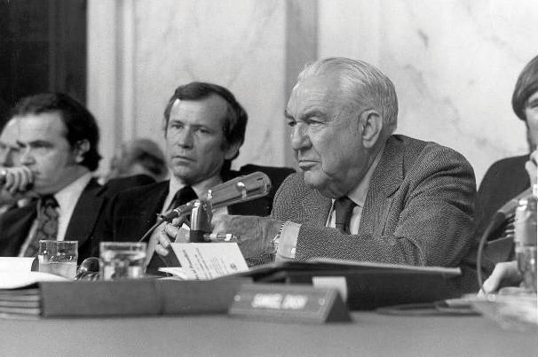
The Senate Watergate hearings in 1973 were a major television and radio event that brought Congress to the attention of the entire nation. Film clips of highlights from the Watergate hearings are available on the Watergate Files website of the Gerald R. Ford Library & Museum.
Source: Photo courtesy of the US Senate,http://commons.wikimedia.org/wiki/File:ThompsonWatergate.jpg.
In 2002, the House Financial Services Committee held thirteen hearings to uncover how Enron Corporation was able to swindle investors and drive up electricity rates in California while its executives lived the high life. Prior to the hearings, which made “Enron” a household word, there was little press coverage of Enron’s questionable operating procedures.

Video Clip
http://www.youtube.com/watch?v=hPqH3DrWEEU

Enron’s Skilling Answers Markey at Hearing; Eyes Roll
A clip of the Enron hearings before the House illustrates how Congress exercises its investigative power.

Enduring Image
The House Un-American Activities Committee and Hollywood
Following World War II, chilly relations existed between the United States and the Communist Soviet Union, a nation that had emerged as a strong power and had exploded an atomic bomb. ^{[7]} The House Un-American Activities Committee (HUAC), which was established in 1939 to investigate subversive activities, decided to look into allegations that Communists were threatening to overthrow American democracy using force and violence. People in government, the labor movement, and the motion picture industry were accused of being communists. Especially sensational were hearings where Hollywood actors, directors, and writers were called before the HUAC. It was not uncommon for people in Hollywood to have joined the Communist Party during the Great Depression of the 1930s, although many were inactive at the time of the hearings. HUAC alleged that film “was the principle medium through which Communists have sought to inject their propaganda.” ^{[8]}
Those accused of being communists, nicknamed “reds,” were called before the HUAC. They were subject to intense questioning by members of Congress and the committee’s counsel. In 1947, HUAC held hearings to investigate the influence of Communists in Hollywood. The “Hollywood Ten,” a group of nine screenwriters, including Ring Lardner, Jr. and Dalton Trumbo, and director Edward Dmytryk, were paraded before the committee. Members of Congress shouted to the witnesses, “Are you now or have you ever been a member of the Communist Party?” They were commanded to provide the names of people they knew to be Communists or face incarceration. Some of the Hollywood Ten responded aggressively to the committee, not answering questions and making statements asserting their First Amendment right to free expression. Blinding flashbulbs provided a constant backdrop to the hearings, as photographers documented images of dramatic face-offs between committee members and the witnesses. Images of the hearings were disseminated widely in front-page photos in newspapers and magazines and on television.
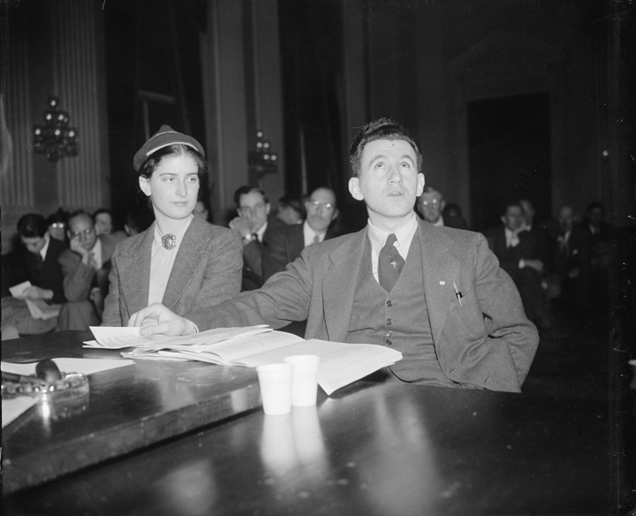
The HUAC hearings immortalized the dramatic image of the congressional investigation featuring direct confrontations between committee members and witnesses.
Source: Photo courtesy of the Harris and Ewing Collection,http://commons.wikimedia.org/wiki/File:Agnes_Reynolds_and_Joseph_P_Lash_1939.jpg.
The Hollywood Ten refused to cooperate with HUAC, were cited for contempt of Congress, and sent to prison. ^{[9]} They were blacklisted by the leaders of the film industry, along with two hundred other admitted or suspected communists, and were unable to work in the motion picture industry. Pressured by personal and financial ruin, Edward Dmytryk eventually gave in to HUAC’s demands.
Commercial films have perpetuated the dramatic image of congressional hearings made popular by the HUAC investigations. Films released around the time of the hearings tended to justify the actions the HUAC, includingBig Jim McClain (1952) and On the Waterfront (1954). The few films made later are more critical. Woody Allen plays a small-time bookie who fronts for blacklisted writers in The Front (1976), a film depicting the personal toll exacted by the HUAC and blacklisting. In Guilty by Suspicion (1991), Robert DeNiro’s character refuses to name names and jeopardizes his career as a director. One of the Hollywood Ten (2000), graphically depicts film director Herbert Biberman’s experience in front of the HUAC before he is jailed for not cooperating.

KEY TAKEAWAYS
Much of the important work in Congress is accomplished through committees. The fate of legislation—which bills will make it to the floor of the House and Senate—is determined in committees. Members seek committee assignments considering their desire to influence policy, exert influence, and get reelected. Most committee work receives little, if any, media coverage. Investigative committees are the exception when they are covering hearings on high-profile matters.

EXERCISES
- What is the role of congressional committees? What determines which committees members of Congress seek to be on?
- What are generally considered to be the most powerful and prestigious committees in Congress? What do you think makes those committees so influential?

[1] Woodrow Wilson, Congressional Government (New York: Houghton Mifflin, 1885), 69.
[2] Amy Kiste Nyberg, Seal of Approval (Oxford: University of Mississippi Press, 1998).
[3] Kenneth A. Shepsle and Barry R. Weingast, “The Institutional Foundations of Committee Power,” American Political Science Review 81: 85–104.
[4] Richard Fenno, Congressmen in Committees (Boston: Little, Brown, 1973).
[5] David R. Mayhew, America’s Congress (New Haven, CT: Yale University Press, 2000).
[6] Ronald Gray, Congressional Television: A Legislative History (Westport, CT: Greenwood Press, 1984).
[7] Ernest Giglio, Here’s Looking at You (New York: Peter Lang, 2000).
[8] Phillip L. Gianos, Politics and Politicians in American Film (Westport, CT: Praeger, 1998), 65.
[9] Larry Ceplair, “The Hollywood Blacklist,” in The Political Companion to American Film, ed. Gary Crowdus (Chicago: Lakeview Press, 1994), 193–99.

12.7 The Legislative Process

LEARNING OBJECTIVES
After reading this section, you should be able to answer the following questions:
- How does a bill become law?
- How do members of Congress develop and draft legislation?
- How does the congressional budget process work?
The primary responsibility of Congress is making laws. Lawmaking is no easy task. Political scientists have characterized Congress as “a procedural obstacle course that favors opponents of legislation and hinders proponents.” ^{[1]} It often takes years before a bill is passed. Only a small number of bills that are introduced, formally proposed by members of the House and Senate, become law. On average, close to eleven thousand bills are introduced in the House and Senate during a two-year legislative session and fewer than four hundred become laws. ^{[2]}
The process of making laws involves complex written rules and procedures, some of which date back to 1797, when Vice President Thomas Jefferson prepared a rule book to help him carry out his responsibilities as president of the Senate. Jefferson’s Manual was adopted by the House and remains the authoritative statement of rules except where it has been superseded by provisions passed by members. In addition, there are fifteen volumes of parliamentary procedures and supplementary manuals of notes specifying current rules that pertain to lawmaking in the House. Similar reams of codes exist in the Senate. ^{[3]}

Making Laws
The textbook legislative process begins when a member of the House or Senate introduces a bill, which then is referred to appropriate committees within each body. Committees decide whether or not a bill is recommended for floor action, where it will be debated and voted on. The House and Senate must pass identical versions of a bill before it can be sent to the president to be signed into law.

Figure 12.13 How a Bill Becomes a Law
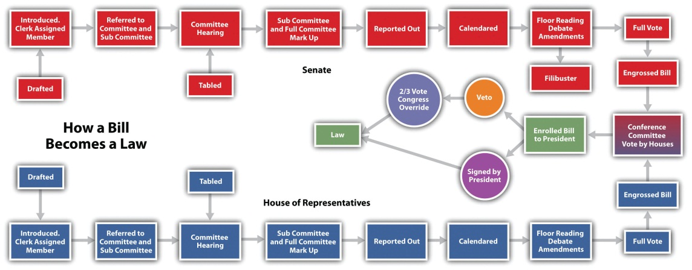
Source: Adapted from http://www.cybertelecom.org/images/howlaw.gif.
Few bills are passed via the organized, step-by-step, textbook process. Since the 1970s, “unorthodox lawmaking” has become the norm. Most bills wend their way through a circuitous path filled with political and procedural roadblocks. ^{[4]}Individual members, especially those seeking reelection, weigh in on bills, resulting in an often contentious atmosphere for lawmaking.

Developing Legislation
Members develop ideas for legislation from myriad sources. Most often, proposals stem from campaign promises and issues germane to members’ districts brought to their attention by constituents and lobbying groups. ^{[5]}Senator Warren Magnuson (D-WA) initiated a spate of legislation that led to the establishment of the Consumer Product Safety Commission in the 1970s after being shown an X ray of shrapnel embedded in a constituent’s skull resulting from an accident involving a power lawn mower. ^{[6]} Political parties may encourage members to develop legislative initiatives that support their agendas. Members may see a need to revise or repeal an existing law. They also can be motivated by personal experiences. The late Senator Strom Thurmond (R-SC), in an action that contradicted his fierce opposition to government regulation, sponsored a bill requiring warnings about the dangers of alcohol in all advertising after his daughter was killed by a drunk driver. ^{[7]} National emergencies can prompt members to take action. Congress enacted the Homeland Security Act of 2002 in the aftermath of the 9/11 terrorist attacks on America. This act created the Department of Homeland Security, a new government agency for emergency preparedness.
Legislation can originate as a result of executive communication, a message or letter from the president, a cabinet member, or an agency head to the Speaker of the House or president of the Senate recommending that Congress address a policy or budgetary issue. These requests often follow the president’s State of the Union address. Presidents also can make their agendas known to Congress by making speeches that are publicized through the media. Executive communications are referred to appropriate congressional committees, which decide whether or not to act on them. The president uses an executive communication to submit his proposed budget to the House Committee on Appropriations, which uses it as a basis for drafting federal funding legislation.^{[8]}
Every year, the docket—the schedule outlining Congress’s workload—accommodates a significant amount of legislation that is required to keep existing programs and services going. Most required legislation takes the form ofauthorization bills, which establish a suggested level of funding for a program, and appropriations bills, which actually provide the money for a department or agency to run the program. ^{[9]}

Drafting Legislation
If it is to have much chance of becoming law, a bill must be drafted into a proposal that will generate support in Congress as well as among the public, interest groups, and the executive branch. Bills are drafted by members with the assistance of their staffs and experts in the House and Senate legislative counsel offices.
A bill’s language can be instrumental in generating media publicity and subsequently support for or opposition to it. The title can position the bill in the public debate, as it captures the ideas and images proponents wish to convey. Megan’s Law, which requires communities to publicize the whereabouts of convicted sex offenders, is named after Megan Kanka, a New Jersey girl who was murdered by a sex offender after his release from prison. Politically charged shorthand often is used to characterize bills. The health-care reform legislation passed by Congress and signed into law by President Barack Obama in 2010 has been labeled “Obamacare” by opponents seeking to repeal the legislation.

Introducing Legislation
Members from either the House or Senate can introduce legislation. The member who introduces a bill is its sponsor. Other members can sign on as cosponsors, or supporters, of the bill. Having a large number of cosponsors or having congressional leaders sign onto a bill can boost its chances of success.
Bills are the most typical form of legislation. They can originate in either the House or Senate, with the exception of bills for raising revenue, which must be initiated in the House. ^{[10]} The same bill must pass through all the formal procedural hurdles in the House and Senate before it can be sent to the president to be signed into law.
Figure 12.14
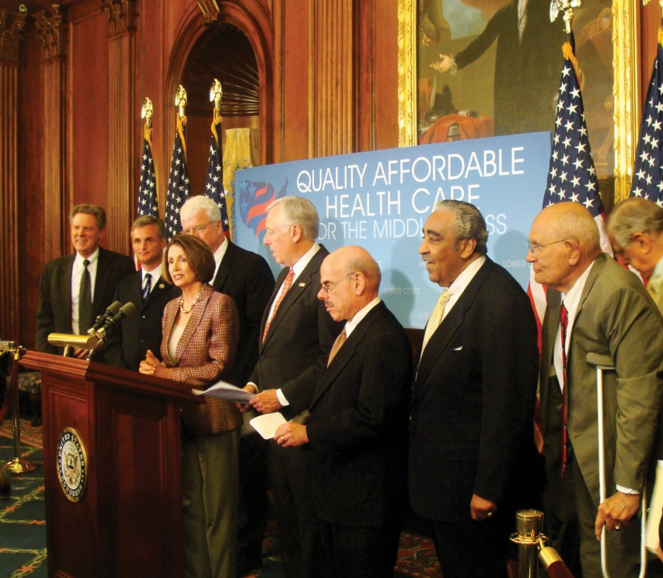
Members of the House or Senate introduce bills and open the floor to debate.
Source: Photo courtesy of Leader Nancy Pelosi,http://www.flickr.com/photos/speakerpelosi/3721370691/.

Committee Consideration
After a bill is introduced, it is referred to the standing committee having jurisdiction over its subject matter, such as energy or homeland security, by the presiding officers in each chamber. Having a bill referred to a friendly committee is a key to its potential for success. In the House, but not the Senate, a bill may be considered by more than one committee. ^{[11]} Committees in both chambers frequently pass a bill on to a subcommittee that deals with a specialized area of policy contained in the legislation. As more people work on a bill, the less likely it is they will reach consensus and that the bill will move beyond the committee stage. ^{[12]}

Figure 12.15
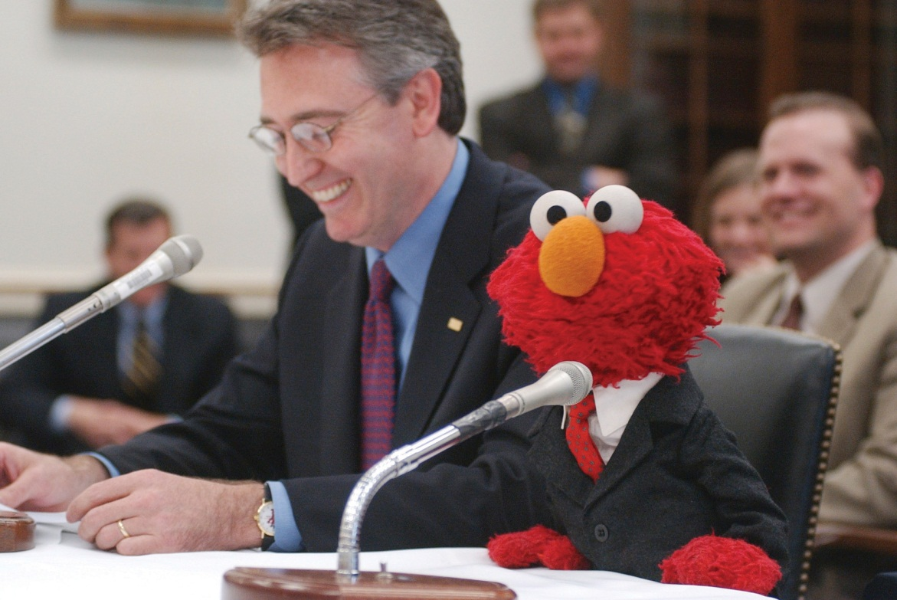
Sesame Street’s Elmo testified in front of the House Education Appropriations Subcommittee in 2002 in support of funding for school music programs.
Source: Used with permission from Getty Images.
Committees sometimes request input about a bill from government departments and agencies and hold public hearings where expert witnesses testify. When members seek media coverage of committee hearings, they sometimes will bring in celebrities as witnesses. In 2010, comedian Stephen Colbert testified in front of the House Judiciary Committee in order to bring attention to immigration reform and treatment of farm workers. The performance received mixed reviews from both members of Congress and political commentators.
The full committee votes to determine if the bill will be reported, meaning it will be sent to the floor for debate. If the vote is successful, the committee holds a mark-up session to revise the bill. The committee prepares a report documenting why it supports the bill. The report is sent to the whole chamber, and the bill is placed on the calendar to await floor debate.
In the House, bills must go the Rules Committee before reaching the floor. The Rules Committee assigns a bill a rule that sets the procedures under which the bill will be considered on the floor. The rule establishes the parameters of debate and specifies if amendments, proposed changes to the bill, will be permitted or not. A bill can become stalled if the Rules Committee does not assign it a rule at all or in a timely manner. Rules must be approved by a majority of the members of the House before floor action can begin. There is no Rules Committee in the Senate, where the process of bringing a bill to the floor is simpler and less formal. The Senate majority leader makes a motion to proceed with floor debate.
Figure 12.16
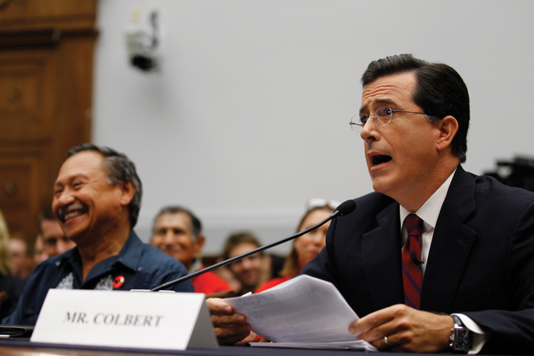
Stephen Colbert’s highly publicized testimony before Congress on behalf of immigration reform was both praised and criticized.
Source: Used with permission from AP Photo/Alex Brandon.

Floor Action
Once a bill reaches the House or Senate floor, it is debated, amended, and voted on. Many of the bills that make it to the floor are minor bills—noncontroversial measures that have symbolic value, such as naming a post office. ^{[13]} Floor consideration of most minor bills is brief, and they are approved by voice vote. Major bills focusing on divisive issues, such as budgetary proposals, health care, and national security, will prompt lengthy debate and amendment proposals before coming to a vote. A bill dies if either chamber fails to pass it.
In the House, bills are considered by the full House meeting in the chamber, which is referred to as the Committee of the Whole. The Speaker of the House chooses a chairperson to oversee floor action. Speakers for and against the bill have an equal amount of time. A general debate of the bill is followed by debate of amendments. A quorum of 218 members is required for a vote on the bill. Yeas and nays are recorded using a computerized system.
Senate floor action is less structured and more unpredictable than the House procedure. Senators are free to speak as long as they like. The filibuster can be used by skillful senators to defeat a bill by “talking it to death.” To avoid lengthy and unproductive floor sessions, the Senate can employunanimous consent agreements, negotiated agreements that set time limitations on debate. ^{[14]} Debate also can be restricted if three-fifths of the senators vote to invoke cloture, a motion to limit consideration of a bill. Getting sixty senators to agree to close debate is not easy, especially on controversial issues. Senators vote on the bill using a traditional call of the roll, with each voice vote recorded manually.

Conference Committee
If House and Senate versions of a bill are not the same, aconference committee is formed to work out the differences. Conference committees consist of members of both houses. In 1934, Senator George Norris (R-NE) characterized conference committees as the “third house of Congress” because of the power they wield in the legislative process. ^{[15]} They are the last places in which big changes in legislation can be made. Major changes in the provisions and language of bills are negotiated in conference committees. Up to 80 percent of important bills during a session of Congress end up in conference committees. ^{[16]}
During conference committee negotiations, conferees meet informally with party leaders and members who have an interest in the bill. Representatives of the executive branch work with conferees to devise a final bill that the president will be likely to sign. Once an agreement has been reached, the conference committee issues a report that must be passed by the House and Senate before the bill moves forward to be signed into law by the president. ^{[17]}

Presidential Approval

Figure 12.17
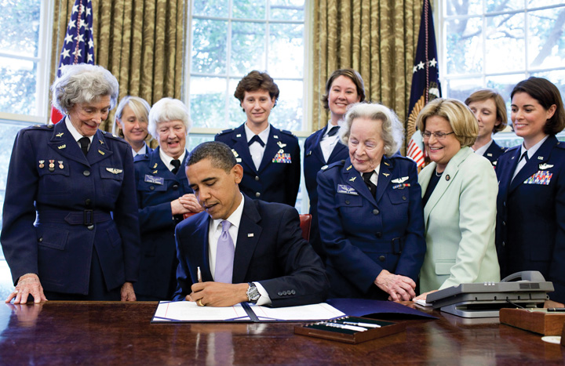
After passing through both houses of Congress, a bill does not become a law until it is signed by the president.
Source: Photo courtesy of Pete Souza,http://commons.wikimedia.org/wiki/File:WASP_Congressional_Gold_Medal.jpg.
A bill becomes law when it is signed by the president. A president can veto, or reject, a bill by sending it back to Congress with a memorandum indicating his objections. Congress can override a veto with a two-thirds vote in each chamber, enabling the bill to become a law over the president’s objections. ^{[18]}

The Budget Process
One of the most arduous tasks faced by Congress is passing legislation authorizing the nation’s annual budget. House and Senate members, their staffs, and congressional committees in conjunction with the president and the executive branch are responsible for preparing the budget. The president submits a detailed budget proposal to Congress, which serves as a starting point. The House and Senate Budget Committees hold hearings on the budget to get advice about how funds should be spent.
The nonpartisan Congressional Budget Office (CBO) with a staff of over 230 economists and policy analysts, provides expert budgetary advice to Congress. It reviews the president’s budget plan, projects the actual costs of budget items, and develops options for changes in taxing and spending. CBO staffers prepare detailed reports on the budget and testify before Congress. ^{[19]}
A two-step authorization and appropriations process is required to establish and fund specific programs within the guidelines set by the annual budget. Congress must first pass laws authorizing or recommending that federal programs receive funding at a particular level. The appropriations process, where funds are actually allocated to programs for spending, is the second step. The House Appropriations Committee initiates all bills to fund programs, and its counterpart in the Senate must approve funding bills. The budget resolution that ultimately passes the House and Senate Budget Committees is usually markedly different from the president’s budget proposal.
The budget process rarely goes smoothly. The process can stall, as was the case in 2011 when the inability of Congress to reach an agreement on the budget threatened to result in a government shutdown. Media coverage highlighting partisan bickering over what to fund and what to cut from the budget added to the drama surrounding the budget process.

C-SPAN
Members of the public can follow congressional action live on television. After much debate, televised coverage of floor proceedings via the Cable Satellite Public Affairs Network (C-SPAN) was established in the House in 1979 and in the Senate in 1986. C-SPAN transmits gavel-to-gavel coverage of floor action. It covers committee hearings and broadcasts educational panels and events.
C-SPAN affirmed Congress as a media-conscious institution. ^{[20]} A top Rules Committee staffer explained that Congress had tired of losing the battle with the president for media attention: “President Richard Nixon was dominating the airwaves with defenses of his Vietnam War policies, while Congressional opponents were not being given equal access by the networks.” ^{[21]}
C-SPAN’s cameras show Congress at its best and worst, at its most dramatic and most mundane. They showcase members’ elegant floor speeches and capture them joking and looking bored during hearings. C-SPAN is monitored continuously in most congressional offices and is a source of information and images for other mass media.
C-SPAN has expanded its operation beyond cable television and provides extensive radio and online coverage of Congress, the White House, and national politics. In addition to live streams of television and radio feeds from Capitol Hill, the C-SPAN website includes news stories, opinion pieces, history, educational materials, and event coverage.

Link
C-SPAN’s Channel on YouTube
People can follow C-SPAN via Twitter, Facebook, and Foursquare. C-SPAN has its own YouTube channel that hosts an extensive political video library.
http://www.youtube.com/user/CSPAN

Link
C-SPAN Bus
The C-SPAN bus travels the country, providing information about public affairs to communities and gathering local stories that they publicize online.
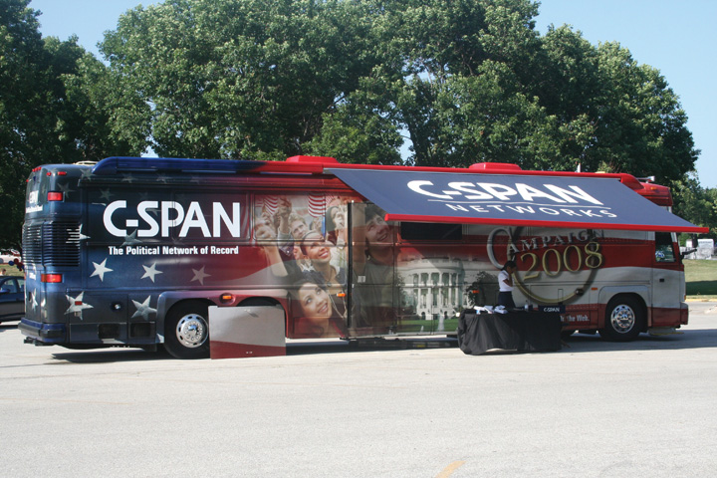
C-SPAN has expanded beyond its original television coverage of Congress to provide information about government and politics through a range of media.
Source: Photo courtesy of IowaPolitics.com,http://www.flickr.com/photos/iowapolitics/1094329886/.

KEY TAKEAWAYS
Making laws is a complex process guided by volumes of rules and influenced by politics. While many bills are proposed each congressional session, few make it all the way through the process to be signed by the president and made law. Congress is responsible for passing legislation enacting the nation’s annual budget, which is frequently a difficult task. The activities of Congress are reported by C-SPAN, which began as a cable network providing gavel-to-gavel coverage of floor proceedings and has expanded to become an extensive resource for information about government and politics.

EXERCISES
- Who can introduce legislation? What are the various different stages at which bills face votes as they move through Congress?
- What are the two steps of the budget process? Which committee has the power to initiate funding bills?

[1] “Structure and Powers of Congress,” in Congress A to Z, ed. David R. Tarr and Ann O’Connor, 4th ed. (Washington, DC: CQ Press), 428.
[2] John V. Sullivan, How Our Laws Are Made, research report (Washington, DC: Thomas Online, 2008), accessed May 21, 2011,http://thomas.loc.gov/home/lawsmade.bysec/foreword.html.
[3] Charles W. Johnson, How Our Laws Are Made (Washington, DC: US Government Printing Office, January 31, 2000).
[4] Barbara Sinclair, Unorthodox Lawmaking (Washington, DC: Congressional Quarterly Press, 1997).
[5] John V. Sullivan, How Our Laws Are Made, research report (Washington, DC: Thomas Online, 2008), accessed May 21, 2011,http://thomas.loc.gov/home/lawsmade.bysec/foreword.html.
[6] Eric Redman, The Dance of Legislation (Seattle, WA: University of Washington Press, 2001).
[7] Roger H. Davidson and Walter J. Oleszek, Congress and Its Members, 8th ed. (Washington, DC: CQ Press, 2002).
[8] Charles W. Johnson, How Our Laws Are Made (Washington, DC: US Government Printing Office, January 31, 2000).
[9] Lawrence D. Longley and Walter J. Oleszek, Bicameral Politics (New Haven, CT: Yale University Press, 1989).
[10] John V. Sullivan, How Our Laws Are Made, research report (Washington, DC: Thomas Online, 2008), accessed May 21, 2011,http://thomas.loc.gov/home/lawsmade.bysec/foreword.html.
[11] John V. Sullivan, How Our Laws Are Made, research report (Washington, DC: Thomas Online, 2008), accessed May 21, 2011,http://thomas.loc.gov/home/lawsmade.bysec/foreword.html.
[12] Barbara Sinclair, Unorthodox Lawmaking (Washington, DC: Congressional Quarterly Press, 1997).
[13] Brent Kendall, “Capitol Hill’s Odd Bills,” The American Observer, April 17, 2002.
[14] Roger H. Davidson and Walter J. Oleszek, Congress and Its Members, 8th ed. (Washington, DC: CQ Press, 2002).
[15] David J. Vogler, The Third House (Evanston, IL: Northwestern University Press, 1971).
[16] Stephen D. Van Beek, Post-Passage Politics (Pittsburgh, PA: University of Pittsburgh Press, 1995).
[17] Lawrence D. Longley and Walter J. Oleszek, Bicameral Politics (New Haven, CT: Yale University Press, 1989), 6.
[18] Roger H. Davidson and Walter J. Oleszek, Congress and Its Members, 8th ed. (Washington, DC: CQ Press, 2002).
[19] “CBO’s Role in the Budget Office” (Washington, DC: Congressional Budget Office, 2005), accessed February 16, 2011,http://www.cbo.gov/visitorsgallery/budgetprocess.shtml.
[20] Timothy E. Cook, Making Laws & Making News (Washington, DC: Brookings, 1989).
[21] Walter J. Oleszek, “The Internet and Congressional Decisionmaking,” report prepared for the Chairman of the House Rules Committee, September 19, 2001.

12.8 Members of Congress

LEARNING OBJECTIVES
After reading this section, you should be able to answer the following questions:
- What kinds of people are elected to Congress?
- How do members make news and generate publicity for themselves?
- What jobs are performed by congressional staff members?
Members of Congress are local politicians serving in a national institution. They spend their days moving between two worlds—their home districts and Washington. While many come from the ranks of the social and economic elite, to be successful they must be true to their local roots.
Figure 12.18
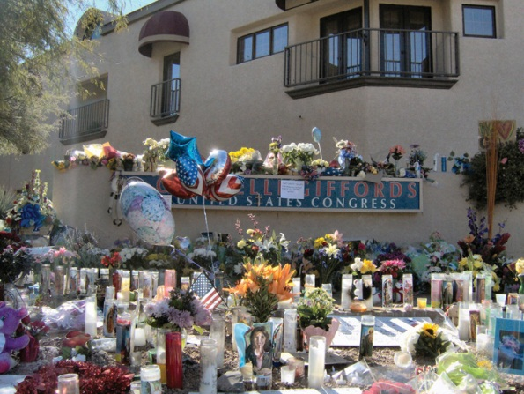
Congresswoman Gabrielle Giffords (D-AZ) was shot outside a grocery store where she was holding a “Congress on Your Corner” event to meet personally with constituents in her district in 2011. Six people were killed, including a nine-year-old girl, in the incident, which raised issues about the safety of members of Congress.
Source: Photo courtesy of Wayno Guerrini,http://commons.wikimedia.org/wiki/File:Memorial_in_front_of_office_of_Gabrielle_Giffords.jpg.
Members tailor the job to their personalities, interests, objectives, and constituent needs. ^{[1]} They engage in activities that better their chances for reelection. This strategy works, as the reelection rate for incumbents is over 90 percent. ^{[2]} They promote themselves and reach out to constituents by participating in events and public forums in their home districts. More recently, outreach has come to include using social media to connect with the public. Members of Congress take positions on issues that will be received favorably. They claim success for legislative activity that helps the district—and voters believe them. ^{[3]} Successful members excel atconstituent service, helping people in the district deal with problems and negotiate the government bureaucracy.

Profile of Members
The vast majority of members of Congress are white males from middle- to upper-income groups. A majority are baby boomers, born between 1946 and 1964. The 111th Congress—which coincided with the administration of President Barack Obama, one of the nation’s youngest presidents, who took office at age forty-seven—was the oldest in history. In the 112th Congress, the average age of House members is fifty-seven and the average of senators is sixty-two. Most have a college education, and many have advanced degrees. ^{[4]}

Gender and Race
Since the 1980s, more women and members of diverse ethnic and racial groups have been elected, but they still are massively underrepresented. Ninety-one of the seats in the 112th Congress, or 16 percent, were held by women. These included seventy-four women in the House and seventeen in the Senate. A record number of forty-four African Americans served in the House, but there were none in the Senate. There were twenty-eight Hispanics in Congress—twenty-six in the House and two in the Senate. Thirteen Asian Americans and Pacific Islanders and a single Native American were members of Congress.
Women and minority group representation in Congress can make a difference in the types of policy issues that are debated. Women members are more likely to focus on issues related to health care, poverty, and education. They have brought media attention to domestic violence and child custody. Members of minority groups raise issues pertinent to their constituents, such as special cancer risks experienced by Hispanics. The small number of women and minorities serving can hinder their ability to get legislation passed. ^{[5]}

Wealth
Members of Congress are a wealthy group. More than half of all members in 2009 were millionaires. More than fifty had net worths of over $10 million. ^{[6]}Members earn a salary of $174,000; leaders are compensated slightly more. ^{[7]}While this may seem like a lot of money, most members must maintain residences in Washington, DC, and their districts and must pay for trips back home. Some members take tremendous pay cuts to serve in Congress. Senator Maria Cantwell (D-WA) amassed a fortune of over $40 million as an executive for a Seattle software company before being elected in 2000. ^{[8]}

Occupations
For many members, serving in Congress is a career. Members of the House serve an average of nine years, or almost five terms. Senators average nearly eleven years, or almost two terms. Almost 75 percent of members seek reelection each cycle. ^{[9]} Members leave office because they seek more lucrative careers, such as in lobbying offices, or because they are ready to retire or are defeated.
Many members come from backgrounds other than politics, such as medicine, and bring experience from these fields to the lawmaking process. Business, law, and public service have been the dominant professions of members of Congress for decades. ^{[10]} Members who have come from nontraditional occupations include an astronaut, a magician, a musician, a professional baseball player, and a major league football player. Members also come from media backgrounds, including television reporters and an occasional sportscaster. Previous legislative experience is a useful qualification for members. Many were congressional staffers or state legislators in earlier careers. ^{[11]}

Members Making News
Because disseminating information and generating publicity are keys to governing, gaining reelection, and moving careers forward, many members of Congress hungrily seek media attention. They use publicity to rally public opinion behind their legislative proposals and to keep constituents abreast of their accomplishments. Media attention is especially important when constituents are deciding whether to retain or replace their member during elections or scandals. ^{[12]}
Members of Congress toe a thin line in their relations with the media. While garnering press attention and staying in the public eye may be a useful strategy, grabbing too much of the media spotlight can backfire, earning members a reputation for being more “show horse” than “work horse” and raising the ire of their colleagues.
Attracting national media attention is easier said than done for most members.^{[13]} Members engage a variety of promotional tactics to court the press. They distribute press releases and hold press conferences. They use the Capitol’s studio facilities to tape television and radio clips that are distributed to journalists via the Internet. Rank-and-file members can increase their visibility by participating in events with prominent leaders. They can stage events or hold joint press conferences and photo ops.

Testimony
Senator Chuck Schumer Meets the Press
One member of Congress who continually flirts with being overexposed in the media is Senator Charles “Chuck” Schumer (D-NY). Known as the consummate “show horse,” Schumer has been in public life and the media spotlight since being elected to the New York State Assembly at the age of twenty-three and then to the House of Representatives at twenty-nine. He became a US Senator in 1998 and has declared himself to be a “senator for life,” who does not have presidential aspirations. This claim gives him greater liberty to speak his mind in a manner that appeals to his New York constituency without worrying about pleasing a national audience. Schumer comes from modest means—his family owned a small pest extermination business—and has relied heavily on unpaid publicity to ensure his Senate seat. Over the years, the prolifically outspoken Schumer has earned a reputation for being one of the most notorious media hounds on Capitol Hill as well as one of the hardest working senators.
Schumer hails from Brooklyn, to which he attributes his affinity for speaking his mind. “That’s one of the benefits of being a Brooklynite. You’re a straight shooter with people, and people are back with you. And sometimes you offend people.” ^{[14]} While his Brooklynese may offend some, it generates headlines and plays well in New York, where he easily wins reelection campaigns.
Schumer’s communications staff is one of the busiest on Capitol Hill. Numerous press releases on a variety of issues affecting his home state and national policy might be issued in a single day. On the same day he announced legislation that would reverse plans to require passports at the Canadian border, called for the suspension of President Bush’s advisor Karl Rove’s security clearance for allegedly revealing the identity of CIA operative Valerie Plame, and publicized a list of twenty-five questions that should be asked of a Supreme Court nominee. This aggressive press strategy prompted his opponent in the 2004 election to pledge that he would “plant 25 trees to replace the trees killed last year to print Chuck Schumer’s press releases.” ^{[15]}
Schumer’s penchant for the media has made him the punch line for numerous jokes by fellow members of Congress. Former senator Bob Dole coined one of Capitol Hill’s favorite quips, “The most dangerous place in Washington is between Chuck Schumer and a microphone.” ^{[16]}
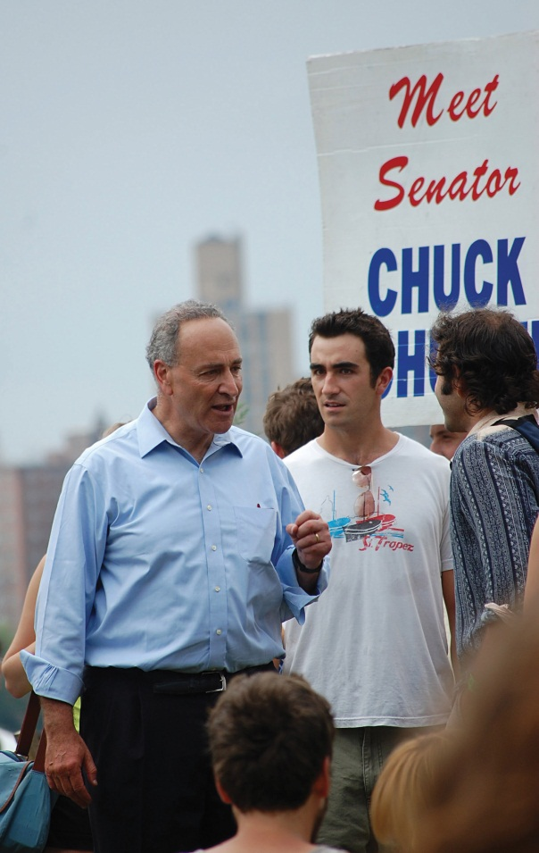
Senator Chuck Schumer is a high-profile member of Congress who regularly courts the media.
Source: Photo courtesy of Zoe,http://www.flickr.com/photos/_lovenothing/3851657362/.
Members of Congress use new media strategies to inform the public, court the media, and gain publicity. All members have websites that publicize their activities and achievements. Some members make their views know through blog posts, including in online publications like TheHill.com and theHuffington Post. More than 300 members of Congress use Twitter to post brief announcements ranging from alerts about pending legislation to shout-outs to constituents who are celebrating anniversaries to Bible verses.

Congressional Staff
Members have personal staffs to help them manage their work load. They also work with committee staff who specialize in particular policy areas. Most Hill staffers are young, white, male, and ambitious. Most members maintain a staff in their home districts to handle constituent service.
Congressional staff has grown substantially since the 1970s as the number of policy issues and bills considered by Congress increased. Today, House personal staffs consist of an average of fourteen people. Senate staffs range in size from thirteen to seventy-one and average about thirty-four people. ^{[17]} As a result of staff expansion, each member has become the head of an enterprise—an organization of subordinates who form their own community that reflects the personality and strengths of the member. ^{[18]}
Congressional staffers have specialized responsibilities. Some staffers have administrative responsibilities, such as running the office and handling the member’s schedule. Others are responsible for assisting members with policy matters. Personal staffers work in conjunction with committee staffers to research and prepare legislation. They write speeches and position papers. Some act as brokers for members, negotiating support for bills and dealing with lobbyists. Staff influence over the legislative process can be significant, as staffers become experts on policies and take the lead on issues behind the scenes. ^{[19]}
Some staff members focus on constituent service. They spend a tremendous amount of time carefully crafting answers to the mountains of correspondence from constituents that arrives every day via snail mail, e-mail, fax, and phone. People write to express their views on legislation, to seek information about policies, and to express their pleasure or dissatisfaction about a member’s actions. They also contact members to ask for help with personal matters, such as immigration issues, or to alert members of potential public health menaces, such as faulty wiring in a large apartment building in the district.
Members of Congress resisted using e-mail to communicate until recent years. Members were not assigned e-mail addresses until 1995. Despite the daunting flood of messages, e-mail has helped congressional offices communicate with constituents efficiently. While the franking privilege, members’ ability to post mail without cost, is still important, e-mail has reduced the significance of this perk.
All members of Congress have press secretaries to coordinate their interactions with the media. They bring a journalistic perspective to congressional offices, acting as consultants in devising media strategies. In recent years, the press secretary’s job has expanded to include using social media to publicize the member’s actions and positions. A press secretary for a publicity-seeking member who faces tough reelection bids constantly courts the media, making personal contacts, writing press releases, staging photo ops and events, and helping the member prepare video and audio interviews. The press secretary constantly updates the member’s Facebook and Twitter messages and YouTube videos. A press secretary for a member in a secure seat who prefers a low-key media presence concentrates on maintaining contact with constituents through newsletters and the member’s website.

KEY TAKEAWAYS
In recent years, the membership of Congress has become increasingly diverse, as more women and minority group members have been elected. Still, the dominant profile of the member of Congress is an older, white male. In addition to their constitutional duties, members of Congress engage in a host of other activities, many of which are related to getting reelected. Members strive to maintain close connections with their constituents while serving in Washington. They seek to publicize their activities through the mainstream press as well as social media. Congressional staffers aid members in keeping abreast of policy issues, performing constituent service, and dealing with the press.

EXERCISES
- Who represents you in Congress? How do they compare with the typical member of Congress?
- How can members of Congress attract media attention? What are the dangers of trying too hard for media attention?

[1] Richard Fenno, Home Style (New York: Longman Classics, 2003)
[2] Gary Jacobson, The Politics of Congressional Elections, 5th ed. (Boston: Allyn and Bacon, 2002).
[3] Alan I. Abramowitz, “Name Familiarity, Reputation, and the Incumbency Effect in a Congressional Election,” Western Political Quarterly 28 (September 1975): 668–84; Morris P. Fiorina, Congress: Keystone of the Washington Establishment (New Haven, CT: Yale, 1977); David R. Mayhew, Congress: The Electoral Connection (New Haven, CT: Yale University Press, 1974).
[4] Jennifer E. Manning, “Membership of the 112th Congress: A Profile,” CRS Report for Congress (Washington, DC: Congressional Research Service, March 1, 2011).
[5] Michele L. Swers, The Difference Women Make (Chicago: University of Chicago Press, 2002).
[6] Albert Bozzo, “Members of U.S. Congress Get Richer Despite Sour Economy,” CNBC, November 17, 2010, accessed December 12, 2010,http://www.cnbc.com/id/40233691/Members_of_US_Congress_Get_Richer_Despite_Sour_Economy.
[7] Ida Brudnick and Eric Peterson, Congressional Pay and Perks (Alexandria, VA: TheCapitolNet.com), 2010.
[8] Amy Keller, “The Roll Call 50 Richest,” Roll Call, September 8, 2003.
[9] Gary Jacobson, The Politics of Congressional Elections, 5th ed. (Boston: Allyn and Bacon, 2002).
[10] David T. Canon, Actors, Athletes, and Astronauts (Chicago: University of Chicago Press, 1990).
[11] Mildred L. Amer, “Membership of the 108th Congress: A Profile,” CRS Report for Congress, May, 2003.
[12] R. Douglas Arnold, Congress, the Press, and Political Accountability (Princeton, NJ: Princeton University Press, 2004).
[13] Timothy E. Cook, Making Laws & Making News (Washington, DC: Brookings, 1989).
[14] Mark Leibovich, “The Senator Has the Floor,” Washington Post, August 15, 2005: C01.
[15] Mark Leibovich, “The Senator Has the Floor,” Washington Post, August 15, 2005: C01.
[16] Miranda, Manuel, “Behind Schumer’s Ill Humor,” The Wall Street Journal, August 3, 2005, Editorial Page.
[17] Roger H. Davidson and Walter J. Oleszek, Congress and Its Members, 8th ed. (Washington, DC: CQ Press, 2002).
[18] Robert H. Salisbury and Kenneth A. Shepsle, “U.S. Congressman as Enterprise,”Legislative Studies Quarterly 6, no. 4 (November 1981): 559–76.
[19] Susan Webb Hammond, “Recent Research on Legislative Staffs,” Legislative Studies Quarterly 21, no. 4 (November 1996): 543–76.

12.9 Congress in the Information Age

LEARNING OBJECTIVES
After reading this section, you should be able to answer the following questions:
- How has Congress’s relationship to the media differed from that of the president?
- How do members communicate with their constituents and the press?
- How are members depicted by news media and popular media?
- What are the effects of media coverage of Congress on public perceptions of the institution?
Congressional media relations in the information age are as complex as the 535 members of the House and Senate are unique. The size, convoluted organization, and many rules governing Congress do not make for a media-friendly institution. The media environment has become more complicated to negotiate, as members must contend with both traditional news media and new media, which provide a two-way flow of information between legislators and their constituents.

Media Interactions
When asked by a Time magazine reporter to identify the most underplayed story of our times, former news anchor Walter Cronkite replied, “Congress. This is where our laws are made, where our laws are debated, and we don’t cover Congress the way it ought to be.” ^{[1]}
Cronkite’s observation speaks to the changing relations between the national press and Congress over time. For the first century of the republic, Congress and its members were far more visible in newspapers than presidents, who felt it was beneath the dignity of the office to speak on public issues. Debates on Capitol Hill were widely reprinted in partisan papers. The profit-minded penny press of the 1830s found Washington news attractive but often focused on members’ personal escapades, which raised the ire and suspicion of congressmen. Congress adopted the practice of reviewing reporters’ credentials, granting them permission to sit in the drafty public gallery on a case-by-case basis. When the Capitol was rebuilt in the 1850s, the construction included press galleries, separate areas to which reporters were automatically admitted on the recommendation of their editors.
By the 1920s, the president made most of the news; Congress was relegated to a distant second place, and the Supreme Court received the least press. ^{[2]} The modern relationship between the media and Congress took shape in the 1970s, when Washington Post reporters Bob Woodward and Carl Bernstein broke the story about the break-in at the Democratic National Committee headquarters at the behest of the Nixon White House to uncover Democrats’ campaign strategies. Hundreds of reporters were sent to Washington to cover the Watergate scandal, and many stayed after discovering that the town was ripe with stories. The Watergate scandal prompted Congress to pass sunshine laws, which opened most hearings to the public and the press. Many members welcomed the opportunity offered by the invigorated Washington press corps to promote themselves to their constituents.

Congress versus the President
There are a number of reasons why the president is the newsmaker-in-chief while Congress remains in his shadow. The president is a media magnet because he is a single individual at the hub of the executive branch. It is more difficult for reporters to cover Capitol Hill. Congress has many potential newsmakers and story lines that take journalists time and energy to track down. Congress also has been resistant to new communications technologies that might elevate its profile but at the same time subject members to greater public criticism. Radio journalists were not admitted to the press gallery until 1939. Television cameras filmed the opening session of the House in 1947; they would not be allowed back for almost thirty-five years. The institution did not begin to embrace the Internet until 1995, when websites for the House and Senate were established but used by only a handful of members. Only recently have members begun to embrace social media.

Congress Online
The tradition-bound Congress embraced the Internet slowly. Political scientist Stephen Frantzich describes the situation: “One can almost hear the crunch of metal as one ancient institution and one new technology collide. For all the promises of cyberdemocracy and enhanced political linkages, in some ways the interface of Congress and the Internet is a match made in Hell. Divorce is not possible, but tensions are inevitable.” ^{[3]}
Members were reluctant to change the way they conducted business and were wary of receiving a barrage of e-mail messages that would create more work for their overtaxed staffs. This attitude changed as members used the Internet to get elected, staff members became tech savvy, and constituents became Internet users. Today, all members communicate through online media, although some members are more sophisticated in their digital communication strategies than others.
Websites are an important resource for members’ public relations efforts. They provide a platform for publicizing members’ views and accomplishments that can be readily accessed by reporters. Members use websites to present their image to the public without journalistic filters. Websites can promote grassroots support for members through tools, such as printable brochures and buttons. Websites have improved constituent service. They are “virtual offices” open twenty-four hours a day, providing information and opportunities for interaction. Members can solicit opinions from constituents quickly through online polls, message boards, and social media. ^{[4]}
The websites for the House, Senate, and committees provide the public with a wealth of information about hearings and legislative action. The complete text of bills, the Congressional Record, which provides transcripts of floor debate, committee action, and institutional history, is available through the THOMAS website.

Media Depictions
Media depictions of Congress are a mixed bag. National news coverage focuses on the institution of Congress and tends to highlight conflict and partisan bickering. Local news covers individual members and is more positive. Depictions of Congress in television and film often exaggerate stereotypes, such as the corrupt senator or the crusading House representative.

News Coverage
The distinction between the institution of Congress and individual members is evident in media coverage. There are distinct differences in the tone, content, and scope of news reports on Congress in the national compared to local press. National news reports focus more on the institution than individual members. Stories emphasize the investigative side of reporting in that they seek the “smoking gun,” a problem, or a scandal. Reports convey the impression that Congress is populated by power brokers who are in the pocket of political insiders such as interest groups; reports often portray members of Congress as being ignorant of public concerns.
Local media coverage focuses on members more than the institution. Journalists value the access they have to members when they come home to their districts. Few local media organizations have Washington bureaus, so they rely heavily on press releases, wire feeds, canned video, members’ websites, blogs, and social media. Members spend much more time courting the local press than national media. The local press serves as an intermediary between members and their constituents by focusing on the congressional stories most relevant to the district.
Local stories generally are more positive than national news reports. Journalists even may become unofficial cheerleaders for members. This does not mean that members never receive bad press from local news sources. During reelection bids, especially, local journalists emphasize their watchdog role, and reporting can become more critical of members. ^{[5]}
When the media uncover evidence of a member of Congress misbehaving, the result is frenzied scandal coverage. In 2001, the press revealed that Rep. Gary Condit (D-CA) had been having an affair with Chandra Levy, an intern who had disappeared and whose remains were later found in Washington, DC. Representative Condit was dogged by journalists from both respectable and tabloid organizations, whose stories implied that he had something to do with Levy’s fate. Representative Condit lost his reelection bid. The story was headline news for months until the 9/11 terrorist attacks put it on the back burner. In 2011, a jury convicted another man in Levy’s murder.

Congress on Television and in Film
Congress has been the subject of numerous television programs and movies. Like media coverage in general, television and film treatment of Congress pales in comparison to that of the presidency.
There has been a stream of television sitcoms and dramas set in Congress, most of which have been short-lived. Programs exaggerate images of the institution that are predicated in reality. Others reinforce unflattering stereotypes of members as criminals or buffoons. ^{[6]} The television version of Congress is even more of a male bastion than the institution itself. Women primarily serve as support staff or love interests of male members. Mister Sterling, the congressional counterpart to The West Wing that survived one season, is typical. It featured an idealistic but all-too-serious young congressman who uses his intelligence to outsmart his older, white, male colleagues. Women members on the show were few, and none held leadership positions. Sterling used talk radio, which is dominated by male hosts and listeners, as his primary means of communicating to the public. ^{[7]} Another quickly cancelled program wasWomen of the House, in which a scatterbrained Southern belle inherits the Senate seat of her deceased fifth husband and schemes her way through her congressional duties.
Congress has been depicted in more than a dozen feature films since the 1930s, far fewer than the more than one hundred films that have focused on the presidency. Many of them overdramatize legislative processes and committee actions and oversimplify the workings of the institution. Floor action and committee hearings are ridden with conflict and full of surprises. In reality, floor action almost invariably proceeds by the rules with great decorum. The work of congressional committees is deliberate and complicated. On film, members of Congress are often pitted against one another. In fact, members rarely engage in direct confrontation. ^{[8]}
In Legally Blonde 2: Red, White & Blonde (2003), pink-clad Harvard Law School graduate Elle Woods goes to Washington with the aim of passing an animal rights bill to save the mother of her pet Chihuahua, Bruiser. To promote “Bruiser’s Bill,” Elle barges into a congressional hearing, interrupting the proceedings in a way that, in real life, would have guaranteed her an escort out by security. Instead, she gains enough support to get the bill passed. A clip of Mr. Smith Goes to Washington (1939) is cleverly inserted into the film to position it in the tradition of films in which the young, idealistic underdog takes on the corrupt lifelong politician.
Films depict members of Congress as politically and morally flawed. Blinded by ambition, they compromise their beliefs and values to achieve position and power. ^{[9]} In The Seduction of Joe Tynan (1979), a well-intentioned senator has an extramarital affair, even as he considers but ultimately resists caving in to powerful members to advance his career.

Media Consequences
The media can influence the behavior of members of Congress, the public’s perception of the institution, and constituents’ feelings about their members.

Legislative Behavior
Perspectives on the influence on the news media on Congress’ legislative activities differ. Some scholars contend that because the media do not cover much of what goes on in Congress, members are largely able to do their jobs without interference. Members with high public visibility can get into trouble as they are subject to scrutiny and criticism. Therefore, members who pursueinsider strategies—working behind the scenes to forge coalitions—can avoid press interference. ^{[10]}
Another perspective argues that the media have dramatically changed Congress by promoting outsider strategies for governing. To be successful, members must court media publicity rather than forge congressional relationships that are essential for building consensus. The result is that legislative actions can be held up as members seek to influence public opinion. ^{[11]}
A third, more realistic perspective posits that both the insider and outsider strategies are essential for lawmaking. It is important for members to publicize their views via the media in order to rally public opinion and at the same time work to build cooperation within the institution. ^{[12]}

Public Trust
Public confidence in Congress has declined over the past three decades. Congress has the lowest approval ratings of the three national institutions. In 2010, Congress received its lowest approval rating in the history of the Gallup poll, with 83 percent of the public disapproving of the way the institution is handling its job.

Link
Congressional Approval over Time
A graph and explanation of congressional approval over time is available on the Gallup website at http://www.gallup.com/poll/145238/congress-job-approval-rating-worst-gallup-history.aspx.
Scholars offer competing views about whether or not the media contribute to this trend of declining approval of Congress. Some suggest that the image of an institution characterized by conflict and deal making that pervades media coverage has a negative impact on public perceptions. Most Americans abhor the squabbling between members and acrimonious interactions between Congress and the presidency that they see in the media. They feel that congressional leaders have lost touch with average people and that the institution is dominated by special interests. ^{[13]} Other researchers disagree and believe that evidence of a direct connection between media coverage and declining public opinion about Congress is lacking. People’s low opinion of Congress is based on the public’s holding the institution accountable for negative societal conditions, such as a bad economy. ^{[14]}

National versus Local Coverage
The more critical national coverage of the institution compared to the more favorable local press accorded to members may account for differences in public opinion. People dislike the institution even as they hold favorable views of their own congressmen. Citizens claim to be unhappy with the “pork barrel” politics of the institution but are pleased when the media report that their own member has brought home the bacon. ^{[15]}

Figure 12.19
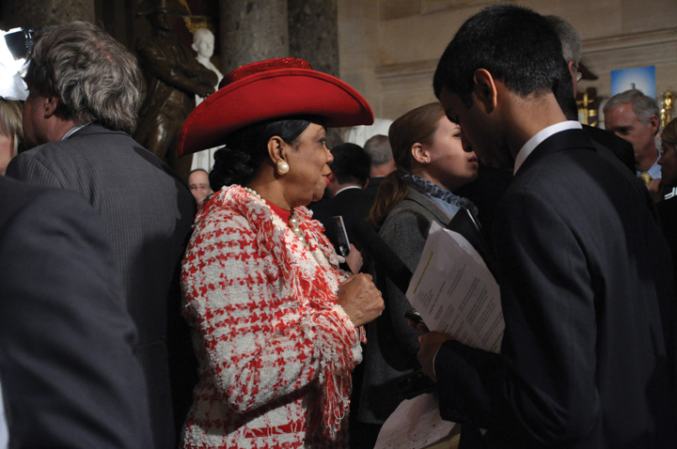
The close connection that many members of Congress have with constituents in their home districts is reflected in positive media coverage.
Source: Photo courtesy of Medill DC,http://www.flickr.com/photos/medilldc/5389481016/.
There may be a connection between positive local coverage of members and the large number of incumbents who win reelection. The public does not think that most members of the House should be reelected but are more supportive of returning their own member to Congress. ^{[16]}

Internet Effects
Online communication has influenced how citizens view Congress. On the one hand, Congress’s online presence fosters positive attitudes toward the institution and its members. Congressional websites have been successful in facilitating the flow of information to the public. People feel that members’ websites convey a sense of accountability and transparency when they report voting records, rationales for policy decisions, schedules, and issue information. Websites create trust, as people feel that members are not “hiding something.” ^{[17]}
At the same time, blogs, discussion boards, and video-sharing sites have placed Congress and its members under a microscope. While mainstream media coverage of Congress is less prevalent than it is for the presidency, bloggers generate a continual barrage of commentary and criticism of congressional action, often taking aim at particular members. Citizens armed with cell phones and flip cameras can capture a member at her or his worst moment, post an embarrassing photo or video online, and have it go viral within a short period of time. These negative depictions can play into the unpopular view of Congress that citizens frequently hold and contribute to declining trust in the institution.

KEY TAKEAWAYS
Congress historically has been slow to adapt to new media technologies such as radio, television, and the Internet. More recently, members have integrated new media into their communications strategies. Members use websites, social media, and e-mail to communicate efficiently with constituents.
Media reports may have a negative influence on the public’s perceptions of the institution and a favorable impact on feelings about individual members. Online media, including blogs and video-sharing sites, place the institution and its members under increased scrutiny.

EXERCISES
- What makes Congress difficult for the media to cover? What do the media tend to focus on when covering Congress?
- How do the insider and outsider strategies for having influence in Congress differ in the way they use the media?
- Why do you think public approval of Congress has declined? To what extent are Congress’s low approval ratings a result of the way media cover the institution?

Congress and Civic Education
Testifying before Congress is not just for celebrities and policy wonks. Average citizens can make a powerful case for a cause in front of congressional committees, an act that is frequently covered by the press. Young people have testified on behalf of research for illnesses (e.g., diabetes and cancer), educational reform, credit card company practices, and a variety of other issues.
Vicky Flamand was a young single mother in Florida working a double shift and attending college part time. With an annual income of $13,500, she relied on government-subsidized child-care benefits to keep her tenuous lifestyle going. When the benefits expired, she reapplied, only to be turned down because the county had run out of funds. A hard worker who did not want to go on welfare, she bombarded public officials, including members of Congress, with letters and e-mails describing her plight and those of more than forty-six thousand families who were denied child care in Florida alone. As a result, she was asked to testify in front of the Senate Finance Committee in support of the Child Care and Development Block Grant, which funds transitional child-care benefits. She worked with the Children’s Defense Fund to prepare her testimony.
Flamand felt that the senators were attentive to her testimony and sympathetic to her story. She had a powerful ally in Senator Christopher Dodd (D-CT), a cosponsor of the bill, who mentioned her testimony in his official statement at the Senate Finance Committee hearing. “I was a little person who could put a face on a problem that was hurting many, many families,” Flamand said. “Testifying before Congress gave me confidence that I had the power to make a difference. You must make an effort to be heard. Someone, somewhere, will listen and hear you.” Flamand’s child-care benefits were restored, and she enrolled full time in college with the goal of attending law school.
Meeting face-to-face with political leaders is one of the best ways to present your concerns about a policy and to learn about how legislative institutions work. Despite their rigorous schedules, arranging for members or former members of Congress and their staffs to speak at your school or club is not as hard as it may seem. Members of Congress and their staffs often welcome the chance to meet with young people in their districts.
Internships with members of Congress are an excellent way to get a real sense of how government works. There are many congressional internship opportunities available both in members’ personal offices on Capitol Hill and in state district offices and with congressional committees. Interns have a range of duties, including answering constituent mail, researching issues, preparing press releases, and helping with constituent service. They also do their fair share of grunt work—making photocopies, answering the phones, and running errands. Committee internships tend to offer greater opportunity for research and issue-related work than those in personal offices.

[1] “10 Questions for Walter Cronkite,” Time, November 3, 2003, 8.
[2] Timothy E. Cook, Making Laws & Making News (Washington, DC: Brookings, 1989).
[3] Stephen E. Frantzich, “RepresNETation: Congress and the Internet,” paper presented at the American University Center on Congress and the Presidency conference on “Congress, the Internet, and Deliberative Democracy,” May 4, 2001.
[4] Congress Online Project, Nine Benefits of a Good Website, research report (Washington, DC: George Washington University, 2003).
[5] Danielle Vinson, Local Media Coverage of Congress and Its Members (Cresskill, NJ: Hampton Press, 2002).
[6] Tracey L. Gladstone-Sovell, “Criminals and Buffoons: The Portrayal of Elected Officials on Entertainment Television,” in It’s Show Time!, ed. David A. Schultz (New York: Peter Lang, 2000), 119–32.
[7] Garrett Epps, “Sterling Character,” The American Prospect, January 17, 2003.
[8] David L. Paletz and Daniel Lapinski, “Movies on Congress,” in The Encyclopedia of the United States Congress, ed. Donald C. Bacon, Roger H. Davidson, and Morton Keller (New York: Simon and Schuster, 1995).
[9] Gary Crowdus, “Politicians in the American Cinema,” The Political Companion to American Film (Chicago: Lakeview Press, 1994), 322–30.
[10] Stephen Hess, The Ultimate Insiders (Washington, DC: Brookings, 1986).
[11] Todd Gitlin, Media Unlimited (New York: Metropolitan Books, 2002).
[12] Timothy E. Cook, Governing with the News (Chicago: University of Chicago Press, 1998).
[13] John Hibbing and Elizabeth Theiss-Morse, Congress as Public Enemy (New York: Cambridge, 1995).
[14] Pippa Norris, “The News Media and Democracy,” in Political Communication Transformed, ed. John Bartle and Dylan Griffiths (Basingstoke: Palgrave Macmillan, 2001), 163–80.
[15] John Hibbing and Elizabeth Theiss-Morse, Congress as Public Enemy (New York: Cambridge, 1995).
[16] CNN/USA Today/Gallup Poll, October 10–12, 2003,http://pollingreport.com/cong2004.htm.
[17] Congress Online Project, Nine Benefits of a Good Website, research report (Washington, DC: George Washington University, 2003).

12.10 Recommended Reading
Arnold, R. Douglas. Congress, the Press, and Political Accountability. Princeton, NJ: Princeton University Press, 2004. A comprehensive account of national and local media coverage of congress and its influence on citizens.
Bader, John B. Taking the Initiative. Washington, DC: Georgetown University Press, 1999. Study of leadership agendas and the “Contract with America” during the era when Newt Gingrich was Speaker of the House.
Baker, Ross K. House and Senate, 3rd ed. New York: W. W. Norton, 2001. A comprehensive comparison of the two houses of Congress that relies on hundreds of interviews with members and their staffs, journalists, and lobbyists.
Casey, Chris. The Hill on the Net. Boston: AP Professional, 1996. An overview of Congress and the Internet covering the background history, uses, and challenges faced when legislative offices go online.
Cook, Timothy E. Making Laws & Making News. Washington, DC: The Brookings Institution, 1989. An exploration of the interactive relationship between the press and the House of Representatives that illustrates how media strategies influence lawmaking.
Davidson, Roger H., and Walter J. Oleszek. Congress and Its Members, 12th ed. Washington, DC: CQ Press, 2009. A comprehensive guide covering the formal and informal aspects of the institution of Congress and its members.
Fenno, Richard F., Jr. Home Style. New York: Longman, 2003. A landmark ethnographic study of members of Congress and their relationship to their constituents.
Jacobson, Gary C. The Politics of Congressional Elections, 7th ed. New York: Longman, 2007. Examines the connection between legislating and running for reelection.
Kedrowski, Karen M. Media Entrepreneurs and the Media Enterprise in the U.S. Congress. Cresskill, NJ: Hampton Press, 1996. Examines the growing trend of members of Congress who are proficient at courting media attention as well as legislating effectively.
Mayer, Kenneth R., and David T. Canon. The Dysfunctional Congress? Boulder, CO: Westview Press, 1999. A study of the dilemma faced by members of Congress who need to satisfy both the needs of the institution and their interests of their constituents.
Mayhew, David. Congress: The Electoral Connection. New Haven, CT: Yale University Press, 1971. Classic study arguing that members make policy decisions with the single-minded goal of getting reelected.
Rhode, David W. Parties and Leaders in the Postreform House. Chicago: University of Chicago Press, 1991. Argues that majority party control of the legislative agenda has increased since the 1970s.
Richie, Donald A. The U.S. Congress: A Very Short Introduction. New York: Oxford University Press, 2010. A good overview of the institution of Congress and how it works.
Sellers, Patrick. Cycles of Spin. New York: Cambridge University Press, 2009. Discusses the communication strategies of members of Congress.
Sinclair, Barbara. Unorthodox Lawmaking, 3rd ed. Washington, DC: CQ Press, 2007. An accounting of changes in the legislative process that deviate from the textbook notion of how a bill becomes a law.
Vinson, Danielle C. Local Media Coverage of Congress and Its Members. Cresskill, NJ: Hampton Press, 2002. A study of patterns in local media coverage of Congress focusing on the amount and substance of coverage.

12.11 Recommended Viewing
Advise and Consent (1962). This political thriller depicts hardcore partisan politics when a president seeks Senate confirmation of a candidate for secretary of state in the Cold War era.
Big Jim McClain (1952). A film starring John Wayne that celebrates the House Un-American Activities Committee.
Born Yesterday (1950). A journalist uncovers corruption when a wealthy businessman attempts to buy influence in Congress.
Committee on Un-American Activities (1962). The first film made by a private citizen to question the legitimacy of a governmental agency, this documentary views the congressional investigation into alleged members of the Communist Party from the perspective of an average person seeking to understand the proceedings.
The Congress: History and Promise of Executive Government (1988). A Ken Burns documentary that examines the history and functions of Congress as well as some of the colorful characters who have been members.
The Distinguished Gentleman (1992). This Eddie Murphy comedy provides some insights into the ways in which interest groups and their associated political action committees interact with Congress.
The Front (1976). Woody Allen stars as a small-time bookie who lends his name to blacklisted entertainment industry writers in this landmark film whose credits include six Hollywood artists blacklisted in the 1950s.
Guilty by Suspicion (1991). A prominent film director (Robert De Niro) is falsely accused of being a communist and must appear before a congressional committee in the first major Hollywood film to portray the 1950s House Un-American Activities Committee hearings.
H.R. 6161: An Act of Congress (1979). An award-winning documentary about the conception, committee action, and passage of an amendment to the Clean Air Act featuring an unprecedented look at the behind-the-scenes workings of Congress.
I’m Just a Bill (1973). A popular “Schoolhouse Rock!” cartoon featuring an animated bill named Bill who goes through the steps of becoming law, which are recounted in a catchy song.
Legally Blonde 2: Red, White & Blonde (2003). A comedy following the escapades of a debutante-turned-lawyer who fights for animal rights on Capitol Hill, which provides a somewhat accurate view of office politics on congressional staffs.
A Member of the Hollywood Ten (1999). Documents the life of director Herbert Biberman during the period of the HUAC hearings.
Mr. Smith Goes to Washington (1939). Jimmy Stewart stars in this Frank Capra classic about an idealistic small-town youth-group leader who is appointed to the Senate, where he fights against political bosses.
On the Waterfront (1954). A film by director Elia Kazan, who cooperated with the HUAC, in which the protagonist testifies in front of a state investigative committee to expose corrupt union practices.
Taxes Behind Closed Doors (1986). An examination of the relationship between lobbyists and members of Congress, depicting strategy sessions and meetings as real estate interests fight a major tax bill.
The Seduction of Joe Tynan (1979). A drama focusing on the political dilemma faced by a young, liberal senator who holds a deciding vote in a US Supreme Court confirmation hearing.
That Delicate Balance 1—The President versus Congress: Executive Privilege and Delegation of Powers (1984). This documentary examines the extent to which the executive branch is bound by limitations imposed by Congress.
True Colors (1991). Two law school graduates take divergent political paths, as one becomes an aide to an influential senator and is involved in political maneuvering while the other works for the Justice Department prosecuting criminals in government.

Chapter 13

The Presidency

Preamble
On May 21, 2009, President Obama gave a speech explaining and justifying his decision to close the Guantánamo Bay detention center (prison). The facility had been established in 2002 by the Bush administration to hold detainees from the war in Afghanistan and later Iraq. President Obama spoke at the National Archives, in front of portraits of the founding fathers, pages of the Constitution open at his side. He thereby identified himself and his decision with the founding fathers, the treasured Constitution, and the rule of law.
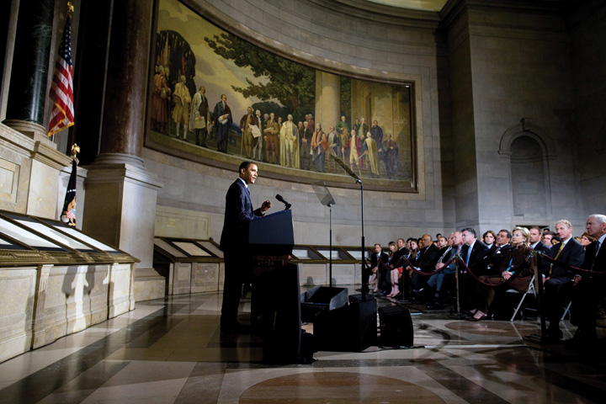
Presidents can connect their policy proposals to revered American forebears and documents, but this does not guarantee success.
Source: Photo courtesy of the White House (Pete Souza),http://www.flickr.com/photos/whitehouse/3583575606/.
Yet, years later, the prison remained open. The president had failed to offer a practical alternative or present one to Congress. Lawmakers had proved unwilling to approve funds to close it. The Republican National Committee had conducted a television advertising campaign implying that terrorists were going to be dumped onto the US mainland, presenting a major terrorist threat.

Video Clip

http://www.youtube.com/watch?v=ic6Sh3zjUF0

President Obama: Our Security, Our Values

13.1 The Powers of the Presidency

LEARNING OBJECTIVES
After reading this section, you should be able to answer the following questions:
- How is the presidency personalized?
- What powers does the Constitution grant to the president?
- How can Congress and the judiciary limit the president’s powers?
- How is the presidency organized?
- What is the bureaucratizing of the presidency?
The presidency is seen as the heart of the political system. It is personalized in the president as advocate of the national interest, chief agenda-setter, and chief legislator. ^{[1]} Scholars evaluate presidents according to such abilities as “public communication,” “organizational capacity,” “political skill,” “policy vision,” and “cognitive skill.” ^{[2]} The media too personalize the office and push the ideal of the bold, decisive, active, public-minded president who altruistically governs the country. ^{[3]}
Two big summer movie hits, Independence Day (1996) and Air Force One(1997) are typical: ex-soldier presidents use physical rather than legal powers against (respectively) aliens and Russian terrorists. The president’s tie comes off and heroism comes out, aided by fighter planes and machine guns. The television hit series The West Wing recycled, with a bit more realism, the image of a patriarchal president boldly putting principle ahead of expedience. ^{[4]}
Figure 13.1
Whether swaggering protagonists of hit moviesIndependence Day and Air Force One in the 1990s or more down-to-earth heroes of the hit television series The West Wing, presidents are commonly portrayed in the media as bold, decisive, and principled.
Source: Photo courtesy of US Navy Chief Journalist Daniel Ross,http://commons.wikimedia.org/wiki/File:Martinsheennavy.jpg.
Presidents are even presented as redeemers. ^{[5]}There are exceptions: presidents depicted as “sleazeballs” or “simpletons.” ^{[6]}

Enduring Image
Mount Rushmore
Carved into the granite rock of South Dakota’s Mount Rushmore, seven thousand feet above sea level, are the faces of Presidents George Washington, Thomas Jefferson, Abraham Lincoln, and Theodore Roosevelt. Sculpted between 1927 and 1941, this awe-inspiring monument achieved even greater worldwide celebrity as the setting for the hero and heroine to overcome the bad guys at the climax of Alfred Hitchcock’s classic and ever-popular film North by Northwest (1959).
This national monument did not start out devoted to American presidents. It was initially proposed to acknowledge regional heroes: General Custer, Buffalo Bill, the explorers Lewis and Clark. The sculptor, Gutzon Borglum, successfully argued that “a nation’s memorial should…have a serenity, a nobility, a power that reflects the gods who inspired them and suggests the gods they have become.” ^{[7]}
The Mount Rushmore monument is an enduring image of the American presidency by celebrating the greatness of four American presidents. The successors to Washington, Jefferson, Lincoln, and Roosevelt do their part by trying to associate themselves with the office’s magnificence and project an image of consensus rather than conflict, sometimes by giving speeches at the monument itself. A George W. Bush event placed the presidential podium at such an angle that the television camera could not help but put the incumbent in the same frame as his glorious predecessors.
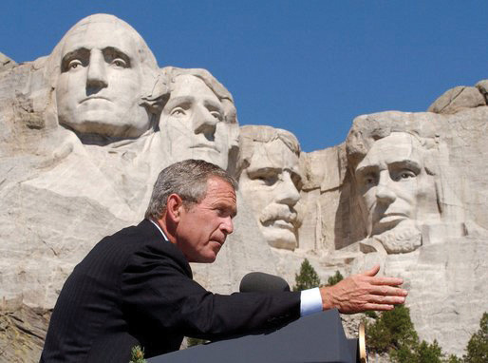
George W. Bush Speaking in Front of Mt. Rushmore
Source: Photo courtesy of the Executive Office of the President of the United States,http://commons.wikimedia.org/wiki/File:Bush_at_Mount_Rushmore.jpg.
The enduring image of Mount Rushmore highlights and exaggerates the importance of presidents as the decision makers in the American political system. It elevates the president over the presidency, the occupant over the office. All depends on the greatness of the individual president—which means that the enduring image often contrasts the divinity of past presidents against the fallibility of the current incumbent.
News depictions of the White House also focus on the person of the president. They portray a “single executive image” with visibility no other political participant can boast. Presidents usually get positive coverage during crises foreign or domestic. The news media depict them speaking for and symbolically embodying the nation: giving a State of the Union address, welcoming foreign leaders, traveling abroad, representing the United States at an international conference. Ceremonial events produce laudatory coverage even during intense political controversy.
The media are fascinated with the personality and style of individual presidents. They attempt to pin them down. Sometimes, the analyses are contradictory. In one best-selling book, Bob Woodward depicted President George W. Bush as, in the words of reviewer Michiko Kakutani, “a judicious, resolute leader…firmly in control of the ship of state.” In a subsequent book, Woodward described Bush as “passive, impatient, sophomoric and intellectual incurious…given to an almost religious certainty that makes him disinclined to rethink or re-evaluate decisions.” ^{[8]}
This media focus tells only part of the story. ^{[9]} The president’s independence and ability to act are constrained in several ways, most notably by the Constitution.

The Presidency in the Constitution
Article II of the Constitution outlines the office of president. Specific powers are few; almost all are exercised in conjunction with other branches of the federal government.
Table 13.1 Bases for Presidential Powers in the Constitution
Article I, Section 7, Paragraph 2 | Veto
 | Pocket veto
Article II, Section 1, Paragraph 1 | “The Executive Power shall be vested in a President…”
Article II, Section 1, Paragraph 7 | Specific presidential oath of office stated explicitly (as is not the case with other offices)
Article II, Section 2, Paragraph 1 | Commander in chief of armed forces and state militias
Article II, Section 2, Paragraph 1 | Can require opinions of departmental secretaries
Article II, Section 2, Paragraph 1 | Reprieves and pardons for offences against the United States
Article II, Section 2, Paragraph 2 | Make treaties
 | appoint ambassadors, executive officers, judges
Article II, Section 2, Paragraph 3 | Recess appointments
Article II, Section 3 | State of the Union message and recommendation of legislative measures to Congress
 | Convene special sessions of Congress
 | Receive ambassadors and other ministers
 | “He shall take Care that the Laws be faithfully executed”
Presidents exercise only one power that cannot be limited by other branches: the pardon. So controversial decisions like President Gerald Ford’s pardon of his predecessor Richard Nixon for “crimes he committed or may have committed” or President Jimmy Carter’s blanket amnesty to all who avoided the draft during the Vietnam War could not have been overturned.
Presidents have more powers and responsibilities in foreign and defense policy than in domestic affairs. They are the commanders in chief of the armed forces; they decide how (and increasingly when) to wage war. Presidents have the power to make treaties to be approved by the Senate; the president is America’s chief diplomat. As head of state, the president speaks for the nation to other world leaders and receives ambassadors.

Link
The Constituion
Read the entire Constituion athttp://www.archives.gov/exhibits/charters/constitution_transcript.html.
The Constitution directs presidents to be part of the legislative process. In the annual State of the Union address, presidents point out problems and recommend legislation to Congress. Presidents can convene special sessions of Congress, possibly to “jump-start” discussion of their proposals. Presidents can veto a bill passed by Congress, returning it with written objections. Congress can then override the veto. Finally, the Constitution instructs presidents to be in charge of the executive branch. Along with naming judges, presidents appoint ambassadors and executive officers. These appointments require Senate confirmation. If Congress is not in session, presidents can make temporary appointments known as recess appointments without Senate confirmation, good until the end of the next session of Congress.
The Constitution’s phrase “he shall take Care that the Laws be faithfully executed” gives the president the job to oversee the implementation of laws. Thus presidents are empowered to issue executive orders to interpret and carry out legislation. They supervise other officers of the executive branch and can require them to justify their actions.

Congressional Limitations on Presidential Power
Almost all presidential powers rely on what Congress does (or does not do). Presidential executive orders implement the law but Congress can overrule such orders by changing the law. And many presidential powers aredelegated powers that Congress has accorded presidents to exercise on its behalf—and that it can cut back or rescind.
Congress can challenge presidential powers single-handedly. One way is to amend the Constitution. The Twenty-Second Amendment was enacted in the wake of the only president to serve more than two terms, the powerful Franklin D. Roosevelt (FDR). Presidents now may serve no more than two terms. The last presidents to serve eight years, Ronald Reagan, Bill Clinton, and George W. Bush, quickly became “lame ducks” after their reelection and lost momentum toward the ends of their second terms, when attention switched to contests over their successors.
Impeachment gives Congress “sole power” to remove presidents (among others) from office. ^{[10]} It works in two stages. The House decides whether or not to accuse the president of wrongdoing. If a simple majority in the House votes to impeach the president, the Senate acts as jury, House members are prosecutors, and the chief justice presides. A two-thirds vote by the Senate is necessary for conviction, the punishment for which is removal and disqualification from office.
Prior to the 1970s, presidential impeachment was deemed the founders’ “rusted blunderbuss that will probably never be taken in hand again.” ^{[11]} Only one president (Andrew Johnson in 1868) had been impeached—over policy disagreements with Congress on the Reconstruction of the South after the Civil War. Johnson avoided removal by a single senator’s vote.

Links
Presidential Impeachment
Read about the impeachment trial of President Johnson athttp://www.senate.gov/artandhistory/history/minute/The_Senate_Votes_on_a_Presidential_Impeachment.htm.
Read about the impeachment trial of President Clinton athttp://www.lib.auburn.edu/madd/docs/impeach.html.
Since the 1970s, the blunderbuss has been dusted off. A bipartisan majority of the House Judiciary Committee recommended the impeachment of President Nixon in 1974. Nixon surely would have been impeached and convicted had he not resigned first. President Clinton was impeached by the House in 1998, though acquitted by the Senate in 1999, for perjury and obstruction of justice in the Monica Lewinsky scandal.
Figure 13.2
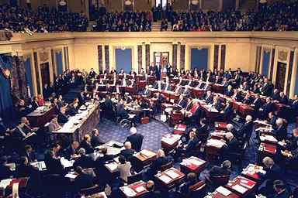
Bill Clinton was only the second US president to be impeached for “high crimes and misdemeanors” and stand trial in the Senate. Not surprisingly, in this day of huge media attention to court proceedings, the presidential impeachment trial was covered live by television and became endless fodder for twenty-four-hour-news channels. Chief Justice William Rehnquist presided over the trial. The House “managers” (i.e., prosecutors) of the case are on the left, the president’s lawyers on the right.
Source: http://en.wikipedia.org/wiki/File:Senate_in_session.jpg.
Much of the public finds impeachment a standard part of the political system. For example, a June 2005 Zogby poll found that 42 percent of the public agreed with the statement “If President Bush did not tell the truth about his reasons for going to war with Iraq, Congress should consider holding him accountable through impeachment.” ^{[12]}
Impeachment can be a threat to presidents who chafe at congressional opposition or restrictions. All three impeached presidents had been accused by members of Congress of abuse of power well before allegations of law-breaking. Impeachment is handy because it refers only vaguely to official misconduct: “treason, bribery, or other high crimes and misdemeanors.”
From Congress’s perspective, impeachment can work. Nixon resigned because he knew he would be removed from office. Even presidential acquittals help Congress out. Impeachment forced Johnson to pledge good behavior and thus “succeeded in its primary goal: to safeguard Reconstruction from presidential obstruction.” ^{[13]} Clinton had to go out of his way to assuage congressional Democrats, who had been far from content with a number of his initiatives; by the time the impeachment trial was concluded, the president was an all-but-lame duck.

Judicial Limitations on Presidential Power
Presidents claim inherent powers not explicitly stated but that are intrinsic to the office or implied by the language of the Constitution. They rely on three key phrases. First, in contrast to Article I’s detailed powers of Congress, Article II states that “The Executive Power shall be vested in a President.” Second, the presidential oath of office is spelled out, implying a special guardianship of the Constitution. Third, the job of ensuring that “the Laws be faithfully executed” can denote a duty to protect the country and political system as a whole.
Ultimately, the Supreme Court can and does rule on whether presidents have inherent powers. Its rulings have both expanded and limited presidential power. For instance, the justices concluded in 1936 that the president, the embodiment of the United States outside its borders, can act on its behalf in foreign policy.
But the court usually looks to congressional action (or inaction) to define when a president can invoke inherent powers. In 1952, President Harry Truman claimed inherent emergency powers during the Korean War. Facing a steel strike he said would interrupt defense production, Truman ordered his secretary of commerce to seize the major steel mills and keep production going. The Supreme Court rejected this move: “the President’s power, if any, to issue the order must stem either from an act of Congress or from the Constitution itself.”^{[14]}

The Vice Presidency
Only two positions in the presidency are elected: the president and vice president. With ratification of the Twenty-Fifth Amendment in 1967, a vacancy in the latter office may be filled by the president, who appoints a vice president subject to majority votes in both the House and the Senate. This process was used twice in the 1970s. Vice President Spiro Agnew resigned amid allegations of corruption; President Nixon named House Minority Leader Gerald Ford to the post. When Nixon resigned during the Watergate scandal, Ford became president—the only person to hold the office without an election—and named former New York Governor Nelson Rockefeller vice president.
The vice president’s sole duties in the Constitution are to preside over the Senate and cast tie-breaking votes, and to be ready to assume the presidency in the event of a vacancy or disability. Eight of the forty-three presidents had been vice presidents who succeeded a dead president (four times from assassinations). Otherwise, vice presidents have few official tasks. The first vice president, John Adams, told the Senate, “I am Vice President. In this I am nothing, but I may be everything.” More earthily, FDR’s first vice president, John Nance Garner, called the office “not worth a bucket of warm piss.”
In recent years, vice presidents are more publicly visible and have taken on more tasks and responsibilities. Ford and Rockefeller began this trend in the 1970s, demanding enhanced day-to-day responsibilities and staff as conditions for taking the job. Vice presidents now have a West Wing office, are given prominent assignments, and receive distinct funds for a staff under their control parallel to the president’s staff. ^{[15]}
Arguably the most powerful occupant of the office ever was Dick Cheney. This former doctoral candidate in political science (at the University of Wisconsin) had been a White House chief of staff, member of Congress, and cabinet secretary. He possessed an unrivaled knowledge of the power relations within government and of how to accumulate and exercise power. As George W. Bush’s vice president, he had access to every cabinet and subcabinet meeting he wanted to attend, chaired the board charged with reviewing the budget, took on important issues (security, energy, economy), ran task forces, was involved in nominations and appointments, and lobbied Congress. ^{[16]}

Organizing the Presidency
The presidency is organized around two offices. They enhance but also constrain the president’s power.

The Executive Office of the President
The Executive Office of the President (EOP) is an umbrella organization encompassing all presidential staff agencies. Most offices in the EOP, such as the Office of the Vice President, the National Security Council, and the Office of Management and Budget, are established by law; some positions require Senate confirmation.

Link
The EOP
Learn about the EOP at http://www.whitehouse.gov/administration/eop.
Inside the EOP is the White House Office (WHO). It contains the president’s personal staff of assistants and advisors; most are exempt from Congress’s purview. Though presidents have a free hand with the personnel and structure of the WHO, its organization has been the same for decades. Starting with Nixon in 1969, each president has named a chief of staff to head and supervise the White House staff, a press secretary to interact with the news media, and a director of communication to oversee the White House message. The national security advisor is well placed to become the most powerful architect of foreign policy, rivaling or surpassing the secretary of state. New offices, such as President Bush’s creation of an office for faith-based initiatives, are rare; such positions get placed on top of or alongside old arrangements.
Even activities of a highly informal role such as the first lady, the president’s spouse, are standardized. It is no longer enough for them to host White House social events. They are brought out to travel and campaign. They are presidents’ intimate confidantes, have staffers of their own, and advocate popular policies (e.g., Lady Bird Johnson’s highway beautification, Nancy Reagan’s antidrug crusade, and Barbara Bush’s literacy programs). Hillary Rodham Clinton faced controversy as first lady by defying expectations of being above the policy fray; she was appointed by her husband to head the task force to draft a legislative bill for a national health-care system. Clinton’s successor, Laura Bush, returned the first ladyship to a more social, less policy-minded role. Michelle Obama’s cause is healthy eating. She has gone beyond advocacy to having Walmart lower prices on the fruit and vegetables it sells and reducing the amount of fat, sugar, and salt in its foods.

Bureaucratizing the Presidency
The media and the public expect presidents to put their marks on the office and on history. But “the institution makes presidents as much if not more than presidents make the institution.” ^{[17]}
The presidency became a complex institution starting with FDR, who was elected to four terms during the Great Depression and World War II. Prior to FDR, presidents’ staffs were small. As presidents took on responsibilities and jobs, often at Congress’s initiative, the presidency grew and expanded.
Not only is the presidency bigger since FDR, but the division of labor within an administration is far more complex. Fiction and nonfiction media depict generalist staffers reporting to the president, who makes the real decisions. But the WHO is now a miniature bureaucracy. The WHO’s first staff in 1939 consisted of eight generalists: three secretaries to the president, three administrative assistants, a personal secretary, an executive clerk. Since the 1980s, the WHO has consisted of around eighty staffers; almost all either have a substantive specialty (e.g., national security, women’s initiatives, environment, health policy) or emphasize specific activities (e.g., White House legal counsel, director of press advance, public liaison, legislative liaison, chief speechwriter, director of scheduling). The White House Office adds another organization for presidents to direct—or lose track of.
The large staff in the White House, and the Old Executive Office Building next door, is no guarantee of a president’s power. These staffers “make a great many decisions themselves, acting in the name of the president. In fact, the majority of White House decisions—all but the most crucial—are made by presidential assistants.” ^{[18]}
Most of these labor in anonymity unless they make impolitic remarks. For example, two of President Bush’s otherwise obscure chief economic advisors got into hot water, one for (accurately) predicting that the cost of war in Iraq might top $200 billion, another for praising the outsourcing of jobs. ^{[19]} Relatively few White House staffers—the chief of staff, the national security advisor, the press secretary—become household names in the news, and even they are quick to be quoted saying, “as the president has said” or “the president decided.” But often what presidents say or do is what staffers told or wrote for them to say or do (seeNote 13.13 "Comparing Content").

Comparing Content
Days in the Life of the White House
On April 25, 2001, President George W. Bush was celebrating his first one hundred days in office. He sought to avoid the misstep of his father who ignored the media frame of the first one hundred days as the make-or-break period for a presidency and who thus seemed confused and aimless.
As part of this campaign, Bush invited Stephen Crowley, a New York Timesphotographer, to follow him and present, as Crowley wrote in his accompanying text, “an unusual behind-the-scenes view of how he conducts business.” ^{[20]} Naturally, the photos implied that the White House revolves completely around the president. At 6:45 a.m., “the White House came to life”—when a light came on in the president’s upstairs residence. The sole task shown for Bush’s personal assistant was peering through a peephole to monitor the president’s national security briefing. Crowley wrote “the workday ended 15 hours after it began,” after meetings, interviews, a stadium speech, and a fund-raiser.
We get a different understanding of how the White House works from following not the president but some other denizen of the West Wing around for a day or so. That is what filmmaker Theodore Bogosian did: he shadowed Clinton’s then press secretary Joe Lockhart for a few days in mid-2000 with a high-definition television camera. In the revealing one-hour video, The Press Secretary, activities of the White House are shown to revolve around Lockhart as much as Crowley’s photographic essay showed they did around Bush. Even with the hands-on Bill Clinton, the video raises questions about who works for whom. Lockhart is shown devising taglines, even policy with his associates in the press office. He instructs the president what to say as much as the other way around. He confides to the camera he is nervous about letting Clinton speak off-the-cuff.
Of course, the White House does not revolve around the person of the press secretary. Neither does it revolve entirely around the person of the president. Both are lone individuals out of many who collectively make up the institution known as the presidency.

KEY TAKEAWAYS
The entertainment and news media personalize the presidency, depicting the president as the dynamic center of the political system. The Constitution foresaw the presidency as an energetic office with one person in charge. Yet the Constitution gave the office and its incumbent few powers, most of which can be countered by other branches of government. The presidency is bureaucratically organized and includes agencies, offices, and staff. They are often beyond a president’s direct control.

EXERCISES
- How do the media personalize the presidency?
- How can the president check the power of Congress? How can Congress limit the influence of the president?
- How is the executive branch organized? How is the way the executive branch operates different from the way it is portrayed in the media?

[1] Jeffrey K. Tulis, The Rhetorical Presidency (Princeton, NJ: Princeton University Press, 1988).
[2] Fred I. Greenstein, The Presidential Difference: Leadership Style from FDR to Barack Obama, 3rd ed. (Princeton, NJ: Princeton University Press, 2009).
[3] For presidential depictions in the media, see Jeff Smith, The Presidents We Imagine(Madison: University of Wisconsin Press, 2009).
[4] Trevor Parry-Giles and Shawn J. Parry-Giles, The Prime-Time Presidency: The West Wingand U.S. Nationalism (Champaign: University of Illinois Press, 2006).
[5] Mark Sachleben and Kevan M. Yenerall, Seeing the Bigger Picture: Understanding Politics through Film and Television (New York: Peter Lang, 2004), chap. 4; and for a detailed survey, see Jeff Smith, The Presidents We Imagine (Madison: University of Wisconsin Press, 2009).
[6] Stephanie Greco Larson, “Political Cynicism and Its Contradictions in the Public, News, and Entertainment,” in It’s Show Time! Media, Politics, and Popular Culture, ed. David A. Schultz (New York: Peter Lang, 2000), 101–116.
[7] Cited in Robert J. Dean, Living Granite (New York: Viking Press, 1949), 18.
[8] Michiko Kakutani, “A Portrait of the President as the Victim of His Own Certitude,” review of State of Denial: Bush at War, Part III, by Bob Woodward, New York Times, September 30, 2006, A15; the earlier book is Bush at War (New York: Simon & Schuster, 2002).
[9] On the contrast of “single executive image” and the “plural executive reality,” see Lyn Ragsdale, Presidential Politics (Boston: Houghton Mifflin Harcourt, 1993).
[10] The language in the Constitution comes from Article I, Section 2, Clause 5, and Article I, Section 3, Clause 7. This section draws from Michael Les Benedict, The Impeachment and Trial of Andrew Johnson (New York: Norton, 1973); John R. Labowitz, Presidential Impeachment (New Haven, CT: Yale University Press, 1978); and Michael J. Gerhardt, The Federal Impeachment Process: A Constitutional and Historical Analysis, 2nd ed. (Chicago: University of Chicago Press, 2000).
[11] The early twentieth-century political scientist Henry Jones Ford quoted in John R. Labowitz, Presidential Impeachment (New Haven, CT: Yale University Press, 1978), 91.
[12] Polling Report, http://www.pollingreport.com/bush.htm, accessed July 7, 2005.
[13] Michael Les Benedict, The Impeachment and Trial of Andrew Johnson (New York: Norton, 1973), 139.
[14] Respectively, United States v. Curtiss-Wright Export Corp, 299 US 304 (1936); Youngstown Sheet & Tube Company v. Sawyer, 343 US 579 (1952).
[15] Paul C. Light, Vice-Presidential Power: Advice and Influence in the White House(Baltimore: Johns Hopkins University Press, 1984).
[16] Barton Gellman and Jo Becker, “Angler: The Cheney Vice Presidency,” Washington Post, June 24, 2007, A1.
[17] Lyn Ragsdale and John J. Theis III, “The Institutionalization of the American Presidency, 1924–92,” American Journal of Political Science 41, no. 4 (October 1997): 1280–1318 at 1316. See also John P. Burke, The Institutional Presidency, 2nd ed. (Baltimore: Johns Hopkins University Press, 2000).
[18] John H. Kessel, Presidents, the Presidency, and the Political Environment (Washington, DC: CQ Press, 2001), 2.
[19] Edmund L. Andrews, “Economics Adviser Learns the Principles of Politics,” New York Times, February 26, 2004, C4.
[20] Stephen Crowley, “And on the 96th Day…,” New York Times, April 29, 2001, Week in Review, 3.

13.2 How Presidents Get Things Done

LEARNING OBJECTIVES
After reading this section, you should be able to answer the following questions:
- How does the president try to set the agenda for the political system, especially Congress?
- What challenges does the president face in achieving his agenda?
- What are the strengths and weaknesses of the presidential veto?
- Can and do presidents lead Congress?
- What are the president’s powers as chief executive?
- Why do presidents give so many speeches?
- How do presidents seek public approval?
The political system was designed by the framers to be infrequently innovative, to act with neither efficiency nor dispatch. Authority is decentralized. Political parties are usually in conflict. Interests are diverse.^{[1]}
Yet, as we have explained, presidents face high expectations for action. Adding to these expectations is the soaring rhetoric of their election campaigns. For example, candidate Obama promised to deal with the problems of the economy, unemployment, housing, health care, Iraq, Afghanistan, and much more.
As we have also explained, presidents do not invariably or even often have the power to meet these expectations. Consider the economy. Because the government and media report the inflation and unemployment rates and the number of new jobs created (or not created), the public is consistently reminded of these measures when judging the president’s handling of the economy. And certainly the president does claim credit when the economy is doing well. Yet the president has far less control over the economy and these economic indicators than the media convey and many people believe.
A president’s opportunities to influence public policies depend in part on the preceding administration and the political circumstances under which the new president takes office. ^{[2]} Presidents often face intractable issues, encounter unpredictable events, have to make complex policy decisions, and are beset by scandals (policy, financial, sexual).
Once in office, reality sinks in. Interviewing President Obama on The Daily Show, Jon Stewart wondered whether the president’s campaign slogan of “Yes we can” should be changed to “Yes we can, given certain conditions.” President Obama replied “I think I would say ‘yes we can, but…it’s not going to happen overnight.’” ^{[3]}
So how do presidents get things done? Presidential powers and prerogatives do offer opportunities for leadership.

Link
Between 1940 and 1973, six American presidents from both political parties secretly recorded just less than five thousand hours of their meetings and telephone conversations.
Check out http://millercenter.org/academic/presidentialrecordings.
Presidents indicate what issues should garner most attention and action; they help set the policy agenda. They lobby Congress to pass their programs, often by campaign-like swings around the country. Their position as head of their political party enables them to keep or gain allies (and win reelection). Inside the executive branch, presidents make policies by well-publicized appointments and executive orders. They use their ceremonial position as head of state to get into the news and gain public approval, making it easier to persuade others to follow their lead.

Agenda-Setter for the Political System
Presidents try to set the political agenda. They call attention to issues and solutions, using constitutional powers such as calling Congress into session, recommending bills, and informing its members about the state of the union, as well as giving speeches and making news. ^{[4]}

Figure 13.3
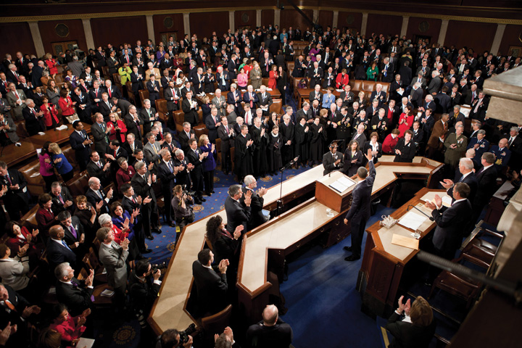
The president’s constitutional responsibility to inform Congress on “the state of the union” has been elevated into a performance, nationally broadcast on all major networks and before a joint session on Capitol Hill, that summarizes the key items on his policy agenda.
Source: Photo courtesy of the Executive Office of the President of the United States (Chuck Kennedy),http://commons.wikimedia.org/wiki/File:Obama_waves_State_of_the_Union_2011.jpg.
Congress does not always defer to and sometimes spurns the president’s agenda. Its members serve smaller, more distinct constituencies for different terms. When presidents hail from the same party as the majority of Congress members, they have more influence to ensure that their ideas receive serious attention on Capitol Hill. So presidents work hard to keep or increase the number of members of their party in Congress: raising funds for the party (and their own campaign), campaigning for candidates, and throwing weight (and money) in a primary election behind the strongest or their preferred candidate. Presidential coattails—where members of Congress are carried to victory by the winning presidential candidates—are increasingly short. Most legislators win by larger margins in their district than does the president. In the elections midway through the president’s term, the president’s party generally loses seats in Congress. In 2010, despite President Obama’s efforts, the Republicans gained a whopping sixty-three seats and took control of the House of Representatives.
Since presidents usually have less party support in Congress in the second halves of their terms, they most often expect that Congress will be more amenable to their initiatives in their first two years. But even then, divided government, where one party controls the presidency and another party controls one or both chambers of Congress, has been common over the last fifty years. For presidents, the prospect of both a friendly House and Senate has become the exception.
Even when the White House and Congress are controlled by the same party, as with President Obama and the 2009 and 2010 Congress, presidents do not monopolize the legislative agenda. Congressional leaders, especially of the opposing party, push other issues—if only to pressure or embarrass the president. Members of Congress have made campaign promises they want to keep despite the president’s policy preferences. Interest groups with pet projects crowd in.
Nonetheless, presidents are better placed than any other individual to influence the legislative process. In particular, their high prominence in the news means that they have a powerful impact on what issues will—and will not—be considered in the political system as a whole.
What about the contents of “the president’s agenda”? The president is but one player among many shaping it. The transition from election to inauguration is just over two months (Bush had less time because of the disputed 2000 Florida vote). Presidents are preoccupied first with naming a cabinet and White House staff. To build an agenda, presidents “borrow, steal, co-opt, redraft, rename, and modify any proposal that fits their policy goals.” ^{[5]} Ideas largely come from fellow partisans outside the White House. Bills already introduced in Congress or programs proposed by the bureaucracy are handy. They have received discussion, study, and compromise that have built support. And presidents have more success getting borrowed legislation through Congress than policy proposals devised inside the White House. ^{[6]}
Crises and unexpected events affect presidents’ agenda choices. Issues pursue presidents, especially through questions and stories of White House reporters, as much as presidents pursue issues. A hugely destructive hurricane on the Gulf Coast propels issues of emergency management, poverty, and reconstruction onto the policy agenda whether a president wants them there or not.
Finally, many agenda items cannot be avoided. Presidents are charged by Congress with proposing an annual budget. Raw budget numbers represent serious policy choices. And there are ever more agenda items that never seem to get solved (e.g., energy, among many others).

Chief Lobbyist in Congress
After suggesting what Congress should do, presidents try to persuade legislators to follow through. But without a formal role, presidents are outsiders to the legislative process. They cannot introduce bills in Congress and must rely on members to do so.

Legislative Liaison
Presidents aim at legislative accomplishments by negotiating with legislators directly or through their legislative liaison officers: White House staffers assigned to deal with Congress who provide a conduit from president to Congress and back again. These staffers convey presidential preferences and pressure members of Congress; they also pass along members’ concerns to the White House. They count votes, line up coalitions, and suggest times for presidents to rally fellow party members. And they try to cut deals.
Legislative liaison focuses less on twisting arms than on maintaining “an era of good feelings” with Congress. Some favors are large: supporting an appropriation that benefits members’ constituencies; traveling to members’ home turf to help them raise funds for reelection; and appointing members’ cronies to high office. Others are small: inviting them up to the White House, where they can talk with reporters; sending them autographed photos or extra tickets for White House tours; and allowing them to announce grants. Presidents hope the cordiality will encourage legislators to return the favor when necessary. ^{[7]}
Such good feelings are tough to maintain when presidents and the opposition party espouse conflicting policies, especially when that party has a majority in one or both chambers of Congress or both sides adopt take-it-or-leave-it stances.

The Veto
When Congress sends a bill to the White House, a president can return it with objections. ^{[8]} This veto—Latin for “I forbid”—heightens the stakes. Congress can get its way only if it overrides the veto with two-thirds majorities in each chamber. Presidents who use the veto can block almost any bill they dislike; only around 4 percent of all vetoes have ever been successfully overridden. ^{[9]} The threat of a veto can be enough to get Congress to enact legislation that presidents prefer.
The veto does have drawbacks for presidents:
- Vetoes alienate members of Congress who worked hard crafting a bill. So vetoes are most used as a last resort. After the 1974 elections, Republican President Ford faced an overwhelmingly Democratic Congress. A Ford legislative liaison officer recalled, “We never deliberately sat down and made the decision that we would veto sixty bills in two years.…It was the only alternative.” ^{[10]}
- The veto is a blunt instrument. It is useless if Congress does not act on legislation in the first place. In his 1993 speech proposing health-care reform, President Clinton waved a pen and vowed to veto any bill that did not provide universal coverage. Such a threat meant nothing when Congress did not pass any reform. And unlike governors of most states, presidents lack a line-item veto, which allows a chief executive to reject parts of a bill. Congress sought to give the president this power in the late 1990s, but the Supreme Court declared the law unconstitutional. ^{[11]} Presidents must take or leave bills in their totality.
- Congress can turn the veto against presidents. For example, it can pass a popular bill—especially in an election year—and dare the president to reject it. President Clinton faced such “veto bait” from the Republican Congress when he was up for reelection in 1996. The Defense of Marriage Act, which would have restricted federal recognition of marriage to opposite-sex couples, was deeply distasteful to lesbians and gay men (a key Democratic constituency) but strongly backed in public opinion polls. A Clinton veto could bring blame for killing the bill or provoke a humiliating override. Signing it ran the risk of infuriating lesbian and gay voters. Clinton ultimately signed the legislation—in the middle of the night with no cameras present.
- Veto threats can backfire. After the Democrats took over the Senate in mid-2001, they moved the “patients’ bill of rights” authorizing lawsuits against health maintenance organizations to the top of the Senate agenda. President Bush said he would veto the bill unless it incorporated strict limits on rights to sue and low caps on damages won in lawsuits. Such a visible threat encouraged a public perception that Bush was opposed to any patients’ bill of rights, or even to patients’ rights at all. ^{[12]} Veto threats thus can be ineffective or create political damage (or, as in this case, both).
Savvy presidents use “vetoes not only to block legislation but to shape it.…Vetoes are not fatal bullets but bargaining ploys.” ^{[13]} Veto threats and vetoing ceremonies become key to presidential communications in the news, which welcomes the story of Capitol Hill-versus-White House disputes, particularly under divided government. In 1996, President Clinton faced a tough welfare reform bill from a Republican Congress whose leaders dared him to veto the bill so they could claim he broke his 1992 promise to “end welfare as we know it.” Clinton vetoed the first bill; Republicans reduced the cuts but kept tough provisions denying benefits to children born to welfare recipients. Clinton vetoed this second version; Republicans shrank the cuts again and reduced the impact on children. Finally, Clinton signed the bill—and ran ads during his reelection campaign proclaiming how he had “ended welfare as we know it.”

Signing Statements
In a signing statement, the president claims the right to ignore or refuse to enforce laws, parts of laws, or provisions of appropriations bills even though Congress has enacted them and he has signed them into law. This practice was uncommon until developed during President Ronald Reagan’s second term. It escalated under President George W. Bush, who rarely exercised the veto but instead issued almost 1,200 signing statements in eight years—about twice as many as all his predecessors combined. As one example, he rejected the requirement that he report to Congress on how he had provided safeguards against political interference in federally funded research. He justified his statements on the “inherent” power of the commander in chief and on a hitherto obscure doctrine called the unitary executive, which holds that the executive branch can overrule Congress and the courts on the basis of the president’s interpretation of the Constitution.
President Obama ordered executive officials to consult with the attorney general before relying on any of President Bush’s signing statements to bypass a law. Yet he initially issued some signing statements himself. Then, to avoid clashing with Congress, he refrained from doing so. He did claim that the executive branch could bypass what he deemed to be unconstitutional restraints on executive power. But he did not invoke the unitary executive theory. ^{[14]}

Presidential Scorecards in Congress
How often do presidents get their way on Capitol Hill? On congressional roll call votes, Congress goes along with about three-fourths of presidential recommendations; the success rate is highest earlier in the term. ^{[15]} Even on controversial, important legislation for which they expressed a preference well in advance of congressional action, presidents still do well. Congress seldom ignores presidential agenda items entirely. One study estimates that over half of presidential recommendations are substantially reflected in legislative action. ^{[16]}
Can and do presidents lead Congress, then? Not quite. Most presidential success is determined by Congress’s partisan and ideological makeup. Divided government and party polarization on Capitol Hill have made Congress more willing to disagree with the president. So recent presidents are less successful even while being choosier about bills to endorse. Eisenhower, Kennedy, and Johnson staked out positions on well over half of congressional roll call votes. Their successors have taken positions on fewer than one-fourth of them—especially when their party did not control Congress. “Presidents, wary of an increasingly independent-minded congressional membership, have come to actively support legislation only when it is of particular importance to them, in an attempt to minimize defeat.” ^{[17]}

Chief Executive
As chief executive, the president can move first and quickly, daring others to respond. Presidents like both the feeling of power and favorable news stories of them acting decisively. Though Congress and courts can respond, they often react slowly; many if not most presidential actions are never challenged. ^{[18]} Such direct presidential action is based in several powers: to appoint officials, to issue executive orders, to “take care that the laws be faithfully executed,” and to wage war.

Appointment Powers
Presidents both hire and (with the exception of regulatory commissions) fire executive officers. They also appoint ambassadors, the members of independent agencies, and the judiciary. ^{[19]}
The months between election and inauguration are consumed by the need to rapidly assemble a cabinet, a group that reports to and advises the president, made up of the heads of the fourteen executive departments and whatever other positions the president accords cabinet-level rank. Finding “the right person for the job” is but one criterion. Cabinet appointees overwhelmingly hail from the president’s party; choosing fellow partisans rewards the winning coalition and helps achieve policy. ^{[20]} Presidents also try to create a team that, in Clinton’s phrase, “looks like America.” In 1953, President Dwight Eisenhower was stung by the news media’s joke that his first cabinet—all male, all white—consisted of “nine millionaires and a plumber” (the latter was a union official, a short-lived labor secretary). By contrast, George W. Bush’s and Barack Obama’s cabinets had a generous complement of persons of color and women—and at least one member of the other party.
These presidential appointees must be confirmed by the Senate. If the Senate rarely votes down a nominee on the floor, it no longer rubber-stamps scandal-free nominees. A nominee may be stopped in a committee. About one out of every twenty key nominations is never confirmed, usually when a committee does not schedule it for a vote. ^{[21]}
Confirmation hearings are opportunities for senators to quiz nominees about pet projects of interest to their states, to elicit pledges to testify or provide information, and to extract promises of policy actions. ^{[22]} To win confirmation, cabinet officers pledge to be responsive and accountable to Congress. Subcabinet officials and federal judges, lacking the prominence of cabinet and Supreme Court nominees, are even more belatedly nominated and more slowly confirmed. Even senators in the president’s party routinely block nominees to protest poor treatment or win concessions.
As a result, presidents have to wait a long time before their appointees take office. Five months into President George W. Bush’s first term, one study showed that of the 494 cabinet and subcabinet positions to fill, under half had received nominations; under one-fourth had been confirmed. ^{[23]} One scholar observed, “In America today, you can get a master’s degree, build a house, bicycle across country, or make a baby in less time than it takes to put the average appointee on the job.” ^{[24]} With presidential appointments unfilled, initiatives are delayed and day-to-day running of the departments is left by default to career civil servants.
No wonder presidents can, and increasingly do, install an acting appointee or use their power to make recess appointments. ^{[25]} But such unilateral action can produce a backlash. In 2004, two nominees for federal court had been held up by Democratic senators; when Congress was out of session for a week, President Bush named them to judgeships in recess appointments. Furious Democrats threatened to filibuster or otherwise block all Bush’s judicial nominees. Bush had no choice but to make a deal that he would not make any more judicial recess appointments for the rest of the year. ^{[26]}

Executive Orders
Presidents make policies by executive orders. ^{[27]} This power comes from the constitutional mandate that they “take care that the laws be faithfully executed.”
Executive orders are directives to administrators in the executive branch on how to implement legislation. Courts treat them as equivalent to laws. Dramatic events have resulted from executive orders. Some famous executive orders include Lincoln’s Emancipation Proclamation, Franklin D. Roosevelt’s closing the banks to avoid runs on deposits and his authorizing internment of Japanese Americans during World War II, Truman’s desegregation of the armed forces, Kennedy’s establishment of the Peace Corps, and Nixon’s creation of the Environmental Protection Agency. More typically, executive orders reorganize the executive branch and impose restrictions or directives on what bureaucrats may or may not do. The attraction of executive orders was captured by one aide to President Clinton: “Stroke of the pen. Law of the land. Kind of cool.” ^{[28]} Related ways for presidents to try to get things done are by memoranda to cabinet officers, proclamations authorized by legislation, and (usually secret) national security directives. ^{[29]}
Executive orders are imperfect for presidents; they can be easily overturned. One president can do something “with the stroke of a pen”; the next can easily undo it. President Reagan’s executive order withholding American aid to international population control agencies that provide abortion counseling was rescinded by an executive order by President Clinton in 1993, then reinstated by another executive order by President Bush in 2001—and rescinded once more by President Obama in 2009. Moreover, since executive orders are supposed to be a mere execution of what Congress has already decided, they can be superseded by congressional action.

War Powers
Opportunities to act on behalf of the entire nation in international affairs are irresistible to presidents. Presidents almost always gravitate toward foreign policy as their terms progress. Domestic policy wonk Bill Clinton metamorphosed into a foreign policy enthusiast from 1993 to 2001. Even prior to 9/11 the notoriously untraveled George W. Bush was undergoing the same transformation. President Obama has been just as if not more involved in foreign policy than his predecessors.
Congress—as long as it is consulted—is less inclined to challenge presidential initiatives in foreign policy than in domestic policy. This idea that the president has greater autonomy in foreign than domestic policy is known as the “Two Presidencies Thesis.” ^{[30]}
War powers provide another key avenue for presidents to act unilaterally. After the 9/11 attacks, President Bush’s Office of Legal Counsel to the US Department of Justice argued that as commander in chief President Bush could do what was necessary to protect the American people. ^{[31]}
Since World War II, presidents have never asked Congress for (or received) a declaration of war. Instead, they rely on open-ended congressional authorizations to use force (such as for wars in Vietnam and “against terrorism”), United Nations resolutions (wars in Korea and the Persian Gulf), North American Treaty Organization (NATO) actions (peacekeeping operations and war in the former Yugoslavia), and orchestrated requests from tiny international organizations like the Organization of Eastern Caribbean States (invasion of Grenada). Sometimes, presidents amass all these: in his last press conference before the start of the invasion of Iraq in 2003, President Bush invoked the congressional authorization of force, UN resolutions, and the inherent power of the president to protect the United States derived from his oath of office.
Congress can react against undeclared wars by cutting funds for military interventions. Such efforts are time consuming and not in place until long after the initial incursion. But congressional action, or its threat, did prevent military intervention in Southeast Asia during the collapse of South Vietnam in 1975 and sped up the withdrawal of American troops from Lebanon in the mid-1980s and Somalia in 1993. ^{[32]}
Congress’s most concerted effort to restrict presidential war powers, theWar Powers Act, which passed over President Nixon’s veto in 1973, may have backfired. It established that presidents must consult with Congress prior to a foreign commitment of troops, must report to Congress within forty-eight hours of the introduction of armed forces, and must withdraw such troops after sixty days if Congress does not approve. All presidents denounce this legislation. But it gives them the right to commit troops for sixty days with little more than requirements to consult and report—conditions presidents often feel free to ignore. And the presidential prerogative under the War Powers Act to commit troops on a short-term basis means that Congress often reacts after the fact. Since Vietnam, the act has done little to prevent presidents from unilaterally launching invasions. ^{[33]}
President Obama did not seek Congressional authorization before ordering the US military to join attacks on the Libyan air defenses and government forces in March 2011. After the bombing campaign started, Obama sent Congress a letter contending that as commander in chief he had constitutional authority for the attacks. The White House lawyers distinguished between this limited military operation and a war.

Presidents and the People
Public approval helps the president assure agreement, attract support, and discourage opposition. Presidents with high popularity win more victories in Congress on high-priority bills. ^{[34]} But obtaining public approval can be complicated. Presidents face contradictory expectations, even demands, from the public: to be an ordinary person yet display heroic qualities, to be nonpolitical yet excel (unobtrusively) at the politics required to get things done, to be a visionary leader yet respond to public opinion. ^{[35]}

Public Approval
For over fifty years, pollsters have asked survey respondents, “Do you approve or disapprove of the way that the president is handling his job?” Over time there has been variation from one president to the next, but the general pattern is unmistakable. ^{[36]} Approval starts out fairly high (near the percentage of the popular vote), increases slightly during the honeymoon, fades over the term, and then levels off. Presidents differ largely in the rate at which their approval rating declines. President Kennedy’s support eroded only slightly, as opposed to the devastating drops experienced by Ford and Carter. Presidents in their first terms are well aware that, if they fall below 50 percent, they are in danger of losing reelection or of losing allies in Congress in the midterm elections.
Events during a president’s term—and how the news media frame them—drive approval ratings up or down. Depictions of economic hard times, drawn-out military engagements (e.g., Korea, Vietnam, and Iraq), unpopular decisions (e.g., Ford’s pardon of Nixon), and other bad news drag approval ratings lower. The main upward push comes from quick international interventions, as for President Obama after the killing of Osama bin Laden in 2011, or successfully addressing national emergencies, which boost a president’s approval for several months. Under such conditions, official Washington speaks more in one voice than usual, the media drop their criticism as a result, and presidents depict themselves as embodiments of a united America. The successful war against Iraq in 1991 pushed approval ratings for the elder Bush to 90 percent, exceeded only by the ratings of his son after 9/11. It may be beside the point whether the president’s decision was smart or a blunder. Kennedy’s press secretary, Pierre Salinger, later recalled how the president’s approval ratings actually climbed after Kennedy backed a failed invasion by Cuban exiles at the Bay of Pigs: “He called me into his office and he said, ‘Did you see that Gallup poll today?’ I said, ‘Yes.’ He said, ‘Do you think I have to continue doing stupid things like that to remain popular with the American people?’” ^{[37]}
But as a crisis subsides, so too do official unity, tributes in the press, and the president’s lofty approval ratings. Short-term effects wane over the course of time. Bush’s huge boost from 9/11 lasted well into early 2003; he got a smaller, shorter lift from the invasion of Iraq in April 2003 and another from the capture of Saddam Hussein in December before dropping to levels perilously near, then below, 50 percent. Narrowly reelected in 2008, Bush saw his approval sink to new lows (around 30 percent) over the course of his second term.

Polls
Naturally and inevitably, presidents employ pollsters to measure public opinion. Poll data can influence presidents’ behavior, the calculation and presentation of their decisions and policies, and their rhetoric. ^{[38]}
After the devastating loss of Congress to the Republicans midway through his first term, President Clinton hired public relations consultant Dick Morris to find widely popular issues on which he could take a stand. Morris used a “60 percent rule”: if six out of ten Americans were in favor of something, Clinton had to be too. Thus the Clinton White House crafted and adopted some policies knowing that they had broad popular support, such as balancing the budget and “reforming” welfare.
Even when public opinion data have no effects on a presidential decision, they can still be used to ascertain the best way to justify the policy or to find out how to present (i.e., spin) unpopular policies so that they become more acceptable to the public. Polls can identify the words and phrases that best sell policies to people. President George W. Bush referred to “school choice” instead of “school voucher programs,” to the “death tax” instead of “inheritance taxes,” and to “wealth-generating private accounts” rather than “the privatization of Social Security.” He presented reducing taxes for wealthy Americans as a “jobs” package. ^{[39]}
Polls can even be used to adjust a president’s personal behavior. After a poll showed that some people did not believe that President Obama was a Christian, he attended services, with photographers in tow, at a prominent church in Washington, DC.

Speechmaker-in-Chief
Presidents speak for various reasons: to represent the country, address issues, promote policies, and seek legislative accomplishments; to raise funds for their campaign, their party, and its candidates; and to berate the opposition. They also speak to control the executive branch by publicizing their thematic focus, ushering along appointments, and issuing executive orders. ^{[40]} They aim their speeches at those physically present and, often, at the far larger audience reached through the media.
In their speeches, presidents celebrate, express national emotion, educate, advocate, persuade, and attack. Their speeches vary in importance, subject, and venue. They give major ones, such as the inauguration and State of the Union. They memorialize events such as 9/11 and speak at the site of tragedies (as President Obama did on January 12, 2011, in Tucson, Arizona, after the shootings of Rep. Gabrielle Giffords and bystanders by a crazed gunman). They give commencement addresses. They speak at party rallies. And they make numerous routine remarks and brief statements.

Video Clip

http://www.youtube.com/watch?v=ztbJmXQDIGA

Watch President Obama’s Full Speech at Tucson Memorial
Presidents are more or less engaged in composing and editing their speeches. For speeches that articulate policies, the contents will usually be considered in advance by the people in the relevant executive branch departments and agencies who make suggestions and try to resolve or meld conflicting views, for example, on foreign policy by the State and Defense departments, the CIA, and National Security Council. It will be up to the president, to buy in on, modify, or reject themes, arguments, and language.
The president’s speechwriters are involved in the organization and contents of the speech. ^{[41]} They contribute memorable phrases, jokes, applause lines, transitions, repetition, rhythm, emphases, and places to pause. They write for ease of delivery, the cadence of the president’s voice, mannerisms of expression, idioms, pace, and timing.
In search of friendly audiences, congenial news media and vivid backdrops, presidents often travel outside Washington to give their speeches. ^{[42]} In his first one hundred days in office in 2001, George W. Bush visited twenty-six states to give speeches; this was a new record even though he refused to spend a night anywhere other than in his own beds at the White House, at Camp David (the presidential retreat), or on his Texas ranch. ^{[43]}
Memorable settings may be chosen as backdrops for speeches, but they can backfire. On May 1, 2003, President Bush emerged in a flight suit from a plane just landed on the aircraft carrier USS Abraham Lincoln and spoke in front of a huge banner that proclaimed “Mission Accomplished,” implying the end of major combat operations in Iraq. The banner was positioned for the television cameras to ensure that the open sea, not San Diego, appeared in the background. The slogan may have originated with the ship’s commander or sailors, but the Bush people designed and placed it perfectly for the cameras and choreographed the scene.
Figure 13.4
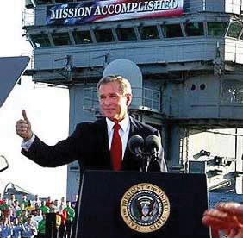
As violence in Iraq continued and worsened, the banner would be framed by critics of the war as a publicity stunt, a symbol of the administration’s arrogance and failure.
Source:http://en.wikipedia.org/wiki/File:Bush_mission_accomplished.jpg.
Speechmaking can entail going public: presidents give a major address to promote public approval of their decisions, to advance their policy objectives and solutions in Congress and the bureaucracy, or to defend themselves against accusations of illegality and immorality. Going public is “a strategic adaptation to the information age.” ^{[44]}
According to a study of presidents’ television addresses, they fail to increase public approval of the president and rarely increase public support for the policy action the president advocates. ^{[45]} There can, however, be arally phenomenon. The president’s approval rating rises during periods of international tension and likely use of American force. Even at a time of policy failure, the president can frame the issue and lead public opinion. Crisis news coverage likely supports the president.
Moreover, nowadays, presidents, while still going public—that is, appealing to national audiences—increasingly go local: they take a targeted approach to influencing public opinion. They go for audiences who might be persuadable, such as their party base and interest groups, and to strategically chosen locations. ^{[46]}

KEY TAKEAWAYS
The president gets things done as an agenda-setter and the chief lobbyist and via his veto power and signing statements. To what extent he can lead Congress depends on its party composition and ideological makeup. As the chief executive, the president gets things done through the appointment powers, executive orders, and war powers. The president seeks power and public approval through speeches and by heeding public response to polls.

EXERCISES
- What tools does the president have to set the political agenda? What determines what’s on the president’s own agenda?
- How do presidents use their veto power? What are the disadvantages of vetoing or threatening to veto legislation?
- How does the president’s position as chief executive allow him to act quickly and decisively? What powers does the president have to respond to events directly?
- What factors affect the president’s public approval ratings? What can presidents do to increase their approval ratings?

[1] George C. Edwards III, The Strategic President: Persuasion and Opportunity in Presidential Leadership (Princeton, NJ: Princeton University Press, 2009).
[2] Stephen Skowronek, Presidential Leadership in Political Time (Lawrence: University Press of Kansas, 2008).
[3] Sheryl Gay Stolberg, “Hope and Change as Promised, Just Not Overnight,”New York Times, October 28, 2010, A18.
[4] Donna R. Hoffman and Alison D. Howard, Addressing the State of the Union(Boulder, CO: Lynne Rienner Publishers, 2006).
[5] Paul C. Light, The President’s Agenda: Domestic Policy Choice from Kennedy to Clinton, 3rd ed. (Baltimore: Johns Hopkins University Press, 1999), 89.
[6] Andrew Rudalevige, Managing the President’s Program: Presidential Leadership and Legislative Policy Formulation (Princeton, NJ: Princeton University Press, 2002).
[7] This section relies on Kenneth Collier, Between the Branches: The White House Office of Legislative Affairs (Pittsburgh: University of Pittsburgh Press, 1997).
[8] This section relies most on Charles M. Cameron, Veto Bargaining: Presidents and the Politics of Negative Power (New York: Cambridge University Press, 2000); see also Robert J. Spitzer, The Presidential Veto: Touchstone of the American Presidency (Albany: State University of New York Press, 1988).
[9] See Harold W. Stanley and Richard G. Niemi, Vital Statistics on American Politics, 1999–2000 (Washington, DC: CQ Press, 1998), table 6-9.
[10] Quoted in Paul C. Light, The President’s Agenda: Domestic Policy Choice from Kennedy to Clinton, 3rd ed. (Baltimore: Johns Hopkins University Press, 1999), 112.
[11] Clinton v. City of New York, 524 US 427 (1998).
[12] Frank Bruni, “Bush Strikes a Positive Tone on a Patients’ Bill of Rights,” New York Times, July 10, 2001, A12.
[13] Charles M. Cameron, Veto Bargaining: Presidents and the Politics of Negative Power (New York: Cambridge University Press, 2000), 171.
[14] Charlie Savage, “Obama’s Embrace of a Bush Tactic Riles Congress,” New York Times, August 9, 2009, A1; and Charlie Savage, “Obama Takes a New Route to Opposing Parts of Laws,” New York Times, January 9, 2010, A9.
[15] George C. Edwards III, At the Margins: Presidential Leadership of Congress(New Haven, CT: Yale University Press, 1989); Jon R. Bond and Richard Fleisher,The President in the Legislative Arena (Chicago: University of Chicago Press, 1990); and Mark A. Peterson, Legislating Together: The White House and Capitol Hill from Eisenhower to Reagan (Cambridge, MA: Harvard University Press, 1990). For overall legislative productivity, the classic starting point is David R. Mayhew’sDivided We Govern: Party Control, Lawmaking, and Investigations, 1946–1990(New Haven, CT: Yale University Press, 1991).
[16] Mark A. Peterson, Legislating Together: The White House and Capitol Hill from Eisenhower to Reagan (Cambridge, MA: Harvard University Press, 1990); and Andrew Rudalevige, Managing the President’s Program: Presidential Leadership and Legislative Policy Formulation (Princeton, NJ: Princeton University Press, 2002), 136.
[17] Lyn Ragsdale, Vital Statistics on the Presidency, 3rd ed. (Washington, DC: CQ Press, 2008), 360. See also Steven A. Shull and Thomas C. Shaw, Explaining Congressional-Presidential Relations: A Multiple Perspective Approach (Albany: State University of New York Press, 1999), chap. 4.
[18] Terry M. Moe, “The Presidency and the Bureaucracy: The Presidential Advantage,” in The Presidency and the Political System, 6th ed., ed. Michael Nelson (Washington, DC: CQ Press, 2000), 443–74; and William G. Howell, Power without Persuasion: The Politics of Direct Presidential Action (Princeton, NJ: Princeton University Press, 2003).
[19] See David E. Lewis, The Politics of Presidential Appointments: Political Control and Bureaucratic Performance (Princeton, NJ: Princeton University Press, 2008); and G. Calvin Mackenzie, ed., Innocent until Nominated: The Breakdown of the Presidential Appointments Process, ed. G. Calvin Mackenzie (Washington, DC: Brookings Institution Press, 2001).
[20] Jeffrey E. Cohen, The Politics of the U.S. Cabinet: Representation in the Executive Branch, 1789–1984 (Pittsburgh, PA: University of Pittsburgh Press, 1988).
[21] Glen S. Kurtz, Richard Fleisher, and Jon R. Bond, “From Abe Fortas to Zoë Baird: Why Some Presidential Nominations Fail in the Senate,” American Political Science Review 92 (December 1998): 871–81.
[22] G. Calvin Mackenzie, The Politics of Presidential Appointments (New York: Free Press, 1981), especially chap. 7.
[23] James Dao, “In Protest, Republican Senators Hold Up Defense Confirmations,” New York Times, May 10, 2001, A20; and Crystal Nix Hines, “Lag in Appointments Strains the Cabinet,” New York Times, June 14, 2001, A20.
[24] G. Calvin Mackenzie, “The State of the Presidential Appointments Process,” in Innocent Until Nominated: The Breakdown of the Presidential Appointments Process, ed. G. Calvin Mackenzie (Washington, DC: Brookings Institution Press, 2001), 1–49 at 40–41.
[25] G. Calvin Mackenzie, “The State of the Presidential Appointments Process,” in Innocent Until Nominated: The Breakdown of the Presidential Appointments Process (Washington, DC: Brookings Institution Press, 2001), 35.
[26] Neil A. Lewis, “Deal Ends Impasse over Judicial Nominees,” New York Times, May 19, 2004, A1.
[27] Kenneth R. Mayer, With the Stroke of a Pen: Executive Orders and Presidential Power (Princeton, NJ: Princeton University Press, 2001).
[28] Paul Begala, quoted in James Bennet, “True to Form, Clinton Shifts Energies Back to U.S. Focus,” New York Times, July 5, 1998, 10.
[29] Phillip J. Cooper, By Order of the President: The Use and Abuse of Executive Direct Action (Lawrence: University Press of Kansas, 2002).
[30] See Barbara Hinckley, Less than Meets the Eye: Foreign Policy Making and the Myth of the Assertive Congress (Chicago: University of Chicago Press, 1994). Such deference seems largely limited to presidents’ own initiatives. See Richard Fleisher, Jon R. Bond, Glen S. Krutz, and Stephen Hanna, “The Demise of the Two Presidencies,” American Politics Quarterly 28 (2000): 3–25; and Andrew Rudalevige, Managing the President’s Program: Presidential Leadership and Legislative Policy Formulation (Princeton, NJ: Princeton University Press, 2002),148–49.
[31] John Yoo, The Powers of War and Peace: The Constitution and Foreign Affairs after 9/11 (Chicago: University of Chicago Press, 2005).
[32] William G. Howell and Jon C. Pevehouse, While Dangers Gather: Congressional Checks on Presidential War Powers (Princeton, NJ: Princeton University Press, 2007).
[33] Louis Fisher, Presidential War Power (Lawrence: University of Kansas Press, 1995); Barbara Hinckley, Less than Meets the Eye: Foreign Policy Making and the Myth of the Assertive Congress (Chicago: University of Chicago Press, 1994), chap. 4.
[34] Brandice Canes-Wrone, Who Leads Whom? Presidents, Policy, and the Public(Chicago: University of Chicago Press, 2006).
[35] Thomas E. Cronin and Michael A. Genovese, The Paradoxes of the American Presidency, 3rd ed. (New York: Oxford University Press, 2009).
[36] James A. Stimson, “Public Support for American Presidents: A Cyclical Model,” Public Opinion Quarterly 40 (1976): 1–21; Samuel Kernell, “Explaining Presidential Popularity,” American Political Science Review 72 (1978): 506–22; and Richard A. Brody, Assessing the President: The Media, Elite Opinion, and Public Support (Stanford, CA: Stanford University Press, 1991).
[37] Quoted in Daniel C. Hallin, ed., The Presidency, the Press and the People (La Jolla: University of California, San Diego, 1992), 21.
[38] Lawrence Jacobs and Robert Shapiro, Politicians Don’t Pander (Chicago: University of Chicago Press, 2000).
[39] Joshua Green, “The Other War Room,” Washington Monthly 34, no. 4 (April 2002): 11–16; and Ben Fritz, Bryan Keefer, and Brendan Nyhan, All the President’s Spin: George W. Bush, the Media, and the Truth (New York: Touchstone, 2004).
[40] See Michael Baruch Grossman and Martha Joynt Kumar, Portraying the President: The White House and the News Media (Baltimore: Johns Hopkins University Press, 1980); and John Anthony Maltese, Spin Control: The White House Office of Communications and the Management of Presidential News(Chapel Hill: University of North Carolina Press, 1992).
[41] This discussion is based on Robert Schlesinger, White House Ghosts: Presidents and Their Speechwriters (New York: Simon & Schuster, 2008).
[42] Roderick Hart, The Sound of Leadership: Presidential Communication in the Modern Age (Chicago: University of Chicago Press, 1986); Barbara Hinckley, The Symbolic Presidency (New York: Routledge, 1991); and Gregory L. Hager and Terry Sullivan, “President-Centered and Presidency-Centered Explanations of Presidential Public Activity,” American Journal of Political Science 38 (November 1994): 1079–1103.
[43] David E. Sanger and Marc Lacey, “In Early Battles, Bush Learns Need for Compromises,” New York Times, April 29, 2001, A1.
[44] Samuel Kernell, Going Public: New Strategies of Presidential Leadership, 4th ed. (Washington, DC: CQ Press, 2007), 2; and Stephen J. Farnsworth, Spinner in Chief: How Presidents Sell Their Policies and Themselves (Boulder, CO: Paradigm Publishers, 2009).
[45] George C. Edwards III, On Deaf Ears: The Limits of the Bully Pulpit (New Haven, CT: Yale University Press, 2003), 241.
[46] Jeffrey E. Cohen, Going Local: Presidential Leadership in the Post-Broadcast Age (New York: Cambridge University Press, 2010).

13.3 The Presidency in the Information Age

LEARNING OBJECTIVES
After reading this section, you should be able to answer the following questions:
- What are the basic purposes of the White House communications operation?
- How do presidents interact with the media?
- How does the White House press corps interact with the president?
- What challenges did President Obama face from the media, and how did he deal with them?
- What are the consequences of media coverage for the presidency?
The White House communications operation has four basic purposes.
- Advocating. Promoting the president’s policies and goals.
- Explaining. Providing information, details, answering questions.
- Defending. Responding to criticism, unanticipated events, cleaning up after mistakes, and challenging unfair news stories.
- Coordinating. Bringing together White House units, governmental agencies (bureaucracies), allies in Congress, and outside supporters (interest groups) to publicize and promote presidential actions. ^{[1]}
How is the White House organized to go about achieving these purposes?

Media Interactions: White House Press Operations
Presidents decide whether, when, where, at what length, and under what conditions they will talk to reporters. Most presidential interactions with the media are highly restricted and stage-managed.

Press Conferences
In the best-known form of press conference, the president appears alone, usually before television cameras, to answer questions on the record from the assembled reporters who can ask anything on their minds for a given period of time (usually up to an hour). Presidents generally hold such press conferences when they need to respond to important issues or mounting criticism—or if they have been accused of avoiding direct questions from the press.
Press conferences allow presidents to dominate the news, pay obeisance to or at least acknowledge the importance of a free press, galvanize supporters, and try to placate opponents. Presidents, as much as reporters, control press conferences. They make opening statements. They choose who asks questions—at his first press conference President Obama recognized the presence of the new media by taking a question from a writer for the influential online-only news outlet the Huffington Post. They can recover from a tough question by finding someone to toss them a softball. Follow-up questions are not guaranteed. Presidents can run out the clock, blather on in evasive or convoluted language, and refuse to take or answer questions on a subject. ^{[2]}

Figure 13.5
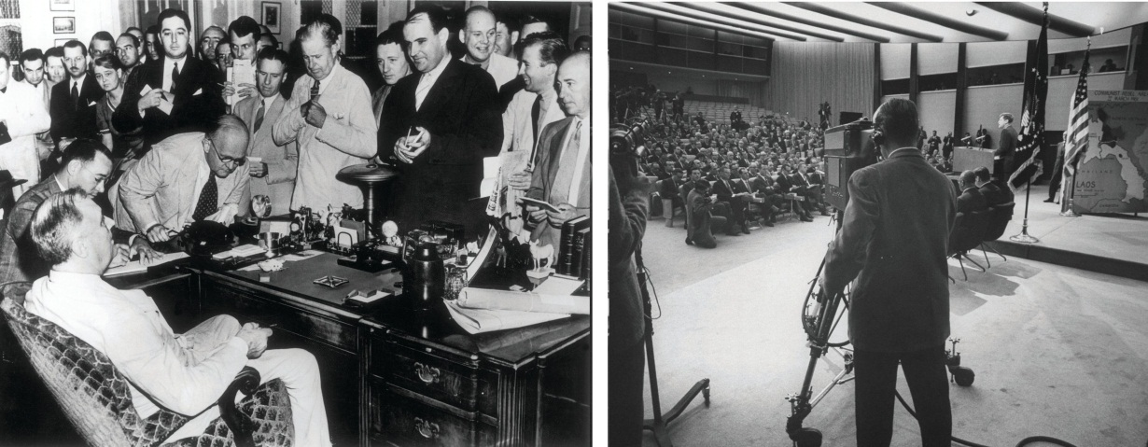
The presidential press conference evolved from Franklin D. Roosevelt’s informal, off-the-record bull session in the Oval Office to a full-fledged staged event when President Kennedy invited television cameras to broadcast the conference live.
Source: Used with permission from Getty Images.
Nonetheless, press conferences have risks for presidents. Since reporters’ questions have become more challenging over time, presidents shy away from press conferences more and more. ^{[3]}Increasingly, they rely on joint press conferences, most often with foreign leaders. Such press conferences add questioners from another press corps, limit the number of questions to a handful, and reduce the amount of time for the president to answer questions.
Presidents favor ever more controlled interactions with reporters. Most typically, they make a brief statement or give a speech without answering questions, or pose in a photo opportunity, where they are seen but not heard. Controversial announcements may be made in writing so that television news has no damaging footage to air. “It is a rare day when the president is not seen by reporters. But it is also a rare day when his appearance is not a scripted one. The White House goal is to have the president publicly available, but to do so with his having as little vulnerability to error as the staff can fashion.” ^{[4]}

Press Secretary
The most visible member of a White House publicity apparatus—and the key person for reporters—is the presidential press secretary. ^{[5]} The press secretary is “responsible for creating and disseminating the official record of the president’s statements, announcements, reactions, and explanations.” ^{[6]} The press secretary has three constituencies with different expectations of him: “the president, White House staff, reporters and their news organizations.” ^{[7]}

Link
White House Press Briefings
Search the archives of press briefings athttp://www.whitehouse.gov/briefing-room/press-briefings.
In every presidency starting with Ronald Reagan’s, press secretaries begin their day with meetings with the central coordinator of policy and message, the White House chief of staff, and other senior staffers to study overnight news developments (a news summary is circulated each day to senior staff), forecast where stories are going, and review the president’s schedule. Press secretaries next prepare for their first interaction with reporters, the morning’s daily, less formal discussion known as the gaggle.^{[8]} Cameras are not allowed into the gaggle. Reporters use tape recorders only to gather information, not for sound bites.
The press secretary begins the gaggle by reviewing the president’s schedule before entering into a fast-moving question-and-answer session. The gaggle benefits reporters: it provides responses to overnight news, gives guidance for the workday ahead, reveals the line the White House is pushing and allows them to lobby for access to the president. The gaggle helps press secretaries too by enabling them to float ideas and slogans and, by hearing what’s on reporters’ minds, prepare for the afternoon briefing.
The press secretary leads this more official 12:30 p.m. briefing, which is as close as anything to a daily enunciation of White House policy. Here, cameras are allowed; the briefing is broadcast live on cable television if news is brewing. The session is transcribed and disseminated (electronically and on paper) to reporters at the White House and beyond. The press secretary spends the hours between the gaggle and the briefing looking for answers to questions raised (or anticipated) and checking with other spokespersons elsewhere in the administration, such as at the Departments of State and Defense.
Figure 13.6
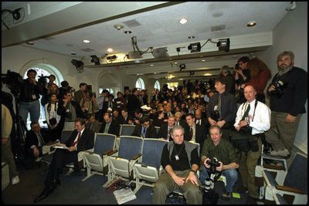
The daily White House press briefing is a central event of the day for both reporters and press secretaries.
Source: Photo courtesy of the White House (Tina Hager),http://georgewbush-whitehouse.archives.gov/history/photoessays/pressbriefingroom/02-js.html.
Briefings do not always benefit the White House. The presence of television cameras sometimes pushes reporters to be—or act—tough and combative for viewers. Reporters try to throw the press secretary off balance or to elicit a juicy or embarrassing admission. Briefings offer reporters a rare chance to quiz officials on matters the White House would prefer not to discuss. Press secretaries are often unresponsive to reporters’ questions, stonewall, and repeat set phrases. During a single briefing when he was peppered by questions about President George W. Bush’s National Guard service, press secretary Scott McClellan dutifully uttered the phrase “The president met all his responsibilities” some thirty-eight times.

Office of Communications
The press secretary on the front line is not always the key public relations strategist. Richard Nixon was the first president to craft long-range communication strategies. A bevy of public relations veterans defined a White House priority or storyline, coordinated who said what, and planned public schedules of administration officials. They brought local reporters from outside Washington to the capital. The aim was to emphasize a single White House position, woo softer local news, and silence contrary messages in the administration.
Such tasks were given to the newly establishedOffice of Communications—retained by all subsequent presidents. Directors of communications rarely interact with reporters on a regular basis; their job is to stress the big picture. Even when Nixon’s first successors, Gerald Ford and Jimmy Carter, pledged open and free interactions with reporters, they found they had to reopen the Office of Communications for central control of the all-important message.
Another lasting innovation of the Nixon presidency is the line of the day. Specific topics and storylines are repeated throughout the administration as the focus for all discussion on that day. Presidents use the Office of Communications to centralize a marketing strategy on issues. They are often open about this. In 2002, White House Chief of Staff Andrew Card said the Bush administration waited until after Labor Day to lobby Congress to authorize war against Iraq because, in his words, “From a marketing point of view…you don’t introduce new products in August.” ^{[9]}

“Manipulation by Inundation”
The public must be reached through the news media. Reagan’s election took such efforts to new heights. Like Nixon, Reagan downgraded the news conference in favor of stage-managed appearances. A press officer who worked for both presidents noted a crucial distinction. The Nixon administration was restrictive, but he said, “The Reagan White House came to the totally opposite conclusion that the media will take what we feed them. They’ve got to write their story every day.…Hand them a well-packaged, premasticated story in the format they want, they’ll go away. The phrase is ‘manipulation by inundation.’” ^{[10]}
Reagan’s lesson has been learned by subsequent presidents and media advisors. Presidents rarely have to “freeze out” given reporters (when officials do not return their calls). Staff do sometimes cajole and berate reporters, but frontal assaults against the press usually only occur in clear cases of journalistic bungling.
More typically, presidents and their staffs try to manage the news. Presidents cultivate reporters, columnists, and pundits: they host lunches, dine with them, and hold off-the-record sessions. The staff members anticipate what reporters will ask in briefings and prepare the president accordingly. They design events to meet news values of drama, color, and terseness. And they provide a wealth of daily, even hourly, information and images.

The End Run around White House Reporters
Inundation is not sufficient. George W. Bush was typical of all presidents when he groused in 2003 to a regional reporter, “There’s a sense that people in America aren’t getting the truth. I’m mindful of the filter through which some news travels, and sometimes you have to go over the heads of the filter and speak directly to the people.” ^{[11]}
All new presidents try novel strategies to do an end run around what they always perceive to be a biased press. President Franklin D. Roosevelt relished behind-the-scenes Oval Office conferences to woo Democratic-leaning reporters (and bypass Republican-leaning editorial pages).
President Richard Nixon shunned press conferences and sought other ways to get his messages out, such as through star-struck local news. President Bill Clinton instituted cozy miniconferences with other world leaders and brought in local television weather reporters for a confab on global warming. Nowadays, the White House deals directly with the regional and local press, special-interest media, and ethnic news organizations.

Media Interactions: The White House Press Corps
Presidents head the state, government, and their political party. So almost anything they do or that happens to them is newsworthy. ^{[12]} They are the sole political figures whose activities are followed around the clock. Presidents fit news values perfectly. The ongoing saga of a familiar hero engaged in myriad controversies and conflicts, international and domestic, is far simpler to explain and present than complex scenarios of coalition-building in Congress.
About seventeen hundred reporters are granted White House press passes. But the key members of the White House press corps are the few dozen regulars assigned to go there day in and day out and who spend their work days there. “A White House press pass provides merely the privilege to wait—wait for a briefing; wait to see the president; wait until a press conference is called; wait to see the press secretary; wait to see senior officials; wait to have phone calls returned. There may be propinquity to power, but there is little control over when and how the news is gathered.”^{[13]}
The regulars make up an intimate society with its own culture, norms, manners, friendship networks, and modes of interaction. The White House layout reinforces this in-group mentality. The briefing room, where press secretaries and reporters meet daily, is a claustrophobic, cluttered space with forty-eight scuffed and battered seats. Beyond the dais at one end, reporters can wander down the hall to buttonhole press officers, though they cannot go much farther (the Oval Office, just fifty feet away, is inaccessible). Hallways leading to two floors of press rooms are in the back; the rooms are crammed with desks and broadcasting equipment for the use of reporters. Along the corridor are bins that contain press releases, official statements, and daily schedules (which are also available electronically). Outside, on a once graveled-over and now paved section of the lawn named “Pebble Beach,” rows of television cameras await television reporters.

Figure 13.7
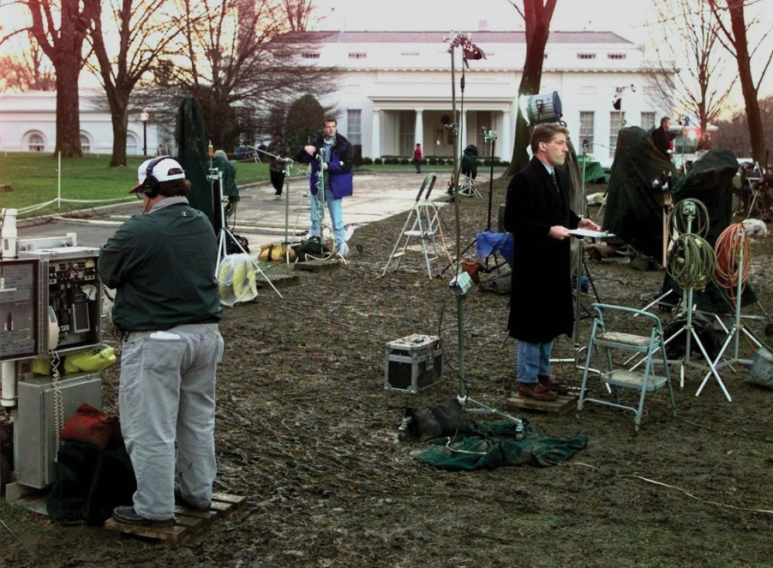
The White House accommodates television reporters to allow them to do their “stand-ups” with the august background of the White House portico. This area can become packed with reporters when big stories are developing.
Source: Used with permission from AP Photo/Joe Marquette.
Rather than foster enterprise, the White House herds reporters together, gives them all the same information, and breeds anxiety by leading them to believe they may be missing the big story everyone else is chasing.

Media Interactions: Negotiating News at the White House
Reporters submit to the conditions established by presidents and their staffers in receiving information. But they are less docile when they actually assemble that information in White House news.

Cooperation and Conflict
The relationship between the White House and its press corps is ongoing. The “village” feel to the newsbeat includes presidents and their staffers. But while this day-to-day continuity favors cooperation, the divergent interests and notions of the White House and reporters makes for a constant tension. Reporters do not like appearing as “mouthpieces” for presidents. They embrace the notion of acting as watchdogs and seek ways to present an independent and critical account whenever possible in their White House stories.
What reporters consider news and what presidents consider news are often at odds. Presidents love to speak at length, be alone at center stage, favor nuance if not ambiguity, and focus on questions of policy. Reporters like terse sound bites, dramatic conflict, clear-cut comments, and a new installment on how the president is doing politically.

Assembling the Story
Reagan’s first White House spokesperson, Larry Speakes, had a plaque on his desk that read: “You don’t tell us how to stage the news, and we won’t tell you how to cover it.” Though he was being playful, Speakes revealed how the White House and the press corps each control one part of the news.
The White House controls whether, when, how, and where White House officials will meet reporters and what information to release. Pictures and video of the president are packaged along with slogans that make a visual case regardless of the angle the reporter advances. Clinton’s aides affixed captions to the presidential podium during ceremonies to underscore the theme they wished to communicate. George W. Bush’s assistants went one better, crafting twenty different canvasses that could be placed behind him, each emblazoned with a motto of the day, such as “Protecting the Homeland” or “Corporate Responsibility.” Dan Bartlett, then Bush’s director of communication, defended such branding: “The message should be seen and read and understood on TV. It’s a good reinforcement.” ^{[14]}
But reporters take the raw material provided by presidential news operations and craft it into a coherent and dramatic story. In a typical television news story, the president’s words and images make up a tiny fraction of the allotted time. Television reporters add old video, interview critics in Congress, cite poll numbers, and give their own interpretations. Even on cable television news, which often airs presidential remarks live during the day, reporters and commentators will hash over and contest the White House “angle.” Presidential statements have a different effect once placed into the news media’s sometimes dramatically divergent context.
The dilemma for presidents, as Clinton’s press secretary Mike McCurry noted, is that “ninety percent of what happens at the White House is pure boredom.” ^{[15]} Reporters need drama. If presidents do not fit the heroic roles of “decisive problem solver” and “representative of the nation,” they can be slotted into a less positive frame. Politics will displace policy; criticism and conflict overwhelm praise and unity. Even in presidents’ supposed “honeymoon” periods, critical coverage is not unknown. Presidents are, then, in the unenviable position of needing the news and being routinely in its spotlight without being able consistently to control the images of themselves and their policies in that news.

President Obama and the Media
During his first term in office, President Obama could claim several significant accomplishments. They included health-care reform, an economic stimulus program, financial regulation, educational innovations, consumer protections, the withdrawal of combat troops from Iraq, banning torture of prisoners in US custody, ratification of a new strategic arms reduction treaty with Russia, and repeal of the “Don’t ask, don’t tell” law.
These accomplishments, except for the killing of Osama bin Laden, were not as widely recognized as they could have been. One reason was, as the president told a reporter, “we probably spent much more time trying to get the policy right than trying to get the politics right.…And I think anybody who’s occupied this office has to remember that success is determined by an intersection in policy and politics and that you can’t be neglecting of marketing and P.R. and public opinion.” ^{[16]} His media operation was accused of being reactive instead of proactive in responding to reporters and of lacking the skill to promote and the language to sell the president, his policies, and his party.
Compounding this neglect, the media environment imposed four challenges to any attempts by President Obama to communicate effectively with the American public.
First, presidents’ prime-time addresses, even when carried by all networks, reach a smaller portion of the audience than they did in years past. ^{[17]} The profit-minded media discourage presidents from taking too often to the airwaves. When presidents request air time, broadcast television networks can conclude the subject is not adequately newsworthy and turn them down.
Second, the news media are more than ever obsessed with conflict. As President Obama observed to Bob Schieffer, “the twenty-four-hour news cycle and cable television and blogs and all this, they focus on the most extreme elements on both sides. They can’t get enough of conflict.” ^{[18]}
Third, the media are more and more partisan—intensely so. For President Obama, this means virulent attacks and relentless denunciations by Fox News, America’s most watched cable news channel; the editorial page of the Wall Street Journal, America’s most widely circulated newspaper; and a conservative chorus led by Rush Limbaugh on talk radio. In addition, a bevy of more or less partisan commentators and pundits subject presidential speeches, press conferences, and statements to constant analysis and dissection.
Fourth, the media audience is increasingly dispersed, fragmented, and sometimes separated into mutually exclusive segments. People are divided by whether they read newspapers (and which ones), the kinds of movies and television programs they watch, their level of involvement with social media, the websites they follow, and much more.
Given this media environment, President Obama faced two daunting problems: (1) to reach as many of the various audiences as possible and (2) to do so with messages in support of his personal, political, and policy objectives. ^{[19]}
One approach was to take advantage of new technologies through an Office of New Media. The president’s inauguration was the first to be put on YouTube, as are his weekly radio addresses. The White House website contains the president’s activities and agenda and features videos. Text messages and Twitter alerts are sent out to the president’s followers under his name. He also conducted the first Internet video news conference by an American president.

Video Clip

http://www.youtube.com/watch?v=3PuHGKnboNY

President Barack Obama’s Inaugural Address
A second approach is to appear in many media venues. On September 20, 2009, President Obama gave separate back-to-back interviews advocating his health-care proposal to each of the hosts of the Sunday morning talk shows. (The interviews had been taped the previous Friday in the Roosevelt Room in the White House).

Video Clip

http://www.youtube.com/watch?v=9zV6eFd4RIU

Sunday with Obama—September 20, 2009
In seeking and finding audiences, the president has ranged far beyond Sunday morning interview programs. He has appeared on the late-night television talk shows of Jay Leno and David Letterman, The Daily Show with Jon Stewart, Oprah, and the morning talk show The View and gave an interview on America’s Most Wanted.
The president reached new audiences, appeared in comfortable settings, and was usually treated with deference and respect. Conversation took place in a relaxed atmosphere. He discussed his accomplishments and displayed mastery of policies yet at the same time was humanized as a family man with a sense of humor.

Figure 13.8
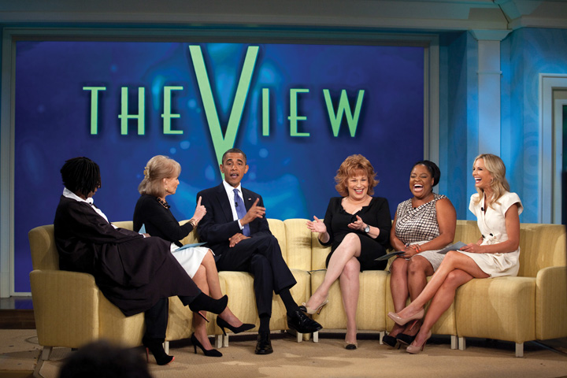
President Obama has ventured far and wide in the media landscape to find audiences—including to The Daily Show and The View.
Source: Photo courtesy of the White House (Pete Souza),http://www.flickr.com/photos/whitehouse/4876619097/.
There are risks. Appearances on entertainment shows and casual familiarity with hosts can undermine the majesty of the office. Commercial interruptions can diminish presidential dignity. Some interviewers may question the president’s policies and competence, as Jon Stewart has done. Others may even challenge the president’s authority, as Bill O’Reilly did in a fifteen-minute interview conducted just before Fox televised the 2011 Super Bowl.

Media Consequences
The president’s visibility in the news is a double-edged sword. The news personalizes the presidency and presents the office through the individual president. There is high pressure for dramatic action and quick results. The constant presence of the White House press corps means that reporters clamor for presidential reaction to and action about any breaking news—which can easily overwhelm the president’s agenda.
The media encourage presidents to find policy areas that enable them to play the role of bold, public-minded leader. But because reporters seek conflict and drama at the White House newsbeat, stories are subject to what columnist Jonathan Alter has termed “the manic-depressive media.”^{[20]} In the way the media frame stories, each event is a make-or-break moment for the president, suitable for triumph or humiliation. Highs are higher; lows are lower. New issues that emerge can change the president’s depiction in the news.
Success in news coverage should not be equated with policy success. Consider the news image of the elder George Bush in the fall of 1990. The news contrasted his glory in the Gulf War against his bungle on the budget. From the start, Bush laid out a straightforward line in the 1990 crisis leading up to the war—push Iraq out of Kuwait—with such clarity and intransigence that it perfectly fit the media frame of decisive action. But when Bush engaged in complex budget negotiations with key members of Congress, the news media found him looking confused and waffling. The war was a media success; the budget was a media failure. But was the war a policy success and the budget a policy failure? Not necessarily. The war solved few of the problems that provoked Iraq’s invasion of Kuwait and almost led to civil war in Iraq. The budget agreement stanched the growth of the budget deficit and led to its later erasure.
It is hard for presidents to resist the temptation to appear in the news constantly, even though chasing after the readily available publicity might push them in policy directions that are far from desirable. If they want media attention, they must either opt for charged, straightforward issues and clear-cut commitments or make complex issues seem simpler than they are. They and their staffers try to package actions to balance the complexity of policies against the simplicity of news (and commentary), the need to keep options open as long as possible against the news media’s desire for drama, conflict, and closure.

KEY TAKEAWAYS
Presidents interact with the media through press conferences, the press secretary, the Office of Communications, manipulation by inundation, and end runs around White House reporters. The White House press corps, in search of dramatic stories, is engaged in ongoing conflict and cooperation with the White House. President Obama encountered several problems with the media that he tried to resolve through new technologies and appearing in many media venues. It can be difficult for presidents to balance their policy interests with the media’s criteria of news and expectations of dramatic action and quick results.

EXERCISES
- What are the functions of the White House communications operation? What are the main ways the White House communicates with the media and the public?
- What are some of the ways the White House can “stage” the news? Why are reporters sometimes reluctant to take the way the White House presents the news at face value?
- How does the way President Obama interacts with the media differ from the way other presidents have interacted with the media? What new challenges does President Obama face in dealing with the media?

[1] These are taken from Martha Joynt Kumar, Managing the President’s Message: The White House Communications Operation (Baltimore: Johns Hopkins University Press, 2007), xx–xxi and chap. 1.
[2] Jarol B. Manheim, “The Honeymoon’s Over: The News Conference and the Development of Presidential Style,” Journal of Politics 41 (1979): 55–74.
[3] Steven Clayman and John Heritage, “Questioning Presidents: Deference and Adversarialness in the Press Conferences of Eisenhower and Reagan,” Journal of Communication 52 (2002): 749–75.
[4] Martha Joynt Kumar, “The Daily White House Press Briefings: A Reflection of the Enduring Elements of a Relationship,” unpublished paper, April 1999, 9.
[5] Woody Klein, All the President’s Spokesmen (Westport, CT: Praeger, 2008).
[6] Martha Joynt Kumar, Managing the President’s Message: The White House Communications Operation (Baltimore: Johns Hopkins University Press, 2007), 179.
[7] Martha Joynt Kumar, Managing the President’s Message: The White House Communications Operation (Baltimore: Johns Hopkins University Press, 2007), 180.
[8] See Howard Kurtz, Spin Cycle: Inside the Clinton Propaganda Machine (New York: Free Press, 1998), and Kumar, “Daily White House Press Briefings: A Reflection of the Enduring Elements of a Relationship,” unpublished paper, April 1999.
[9] Quoted in Elisabeth Bumiller, “Bush Aides Set Strategy to Sell Policy on Iraq,”New York Times, September 7, 2002, A1.
[10] Les Janka, quoted in Mark Hertsgaard, On Bended Knee: The Press and the Reagan Presidency (Boston: Houghton Mifflin Harcourt, 1988), 52.
[11] Quoted in Elisabeth Bumiller, “Trying to Bypass the Good-News Filter,” New York Times, October 20, 2003, A12.
[12] Stephen J. Farnsworth and S. Robert Lichter, The Mediated Presidency: Television News and Presidential Governance (Lanham, MD: Rowman & Littlefield, 2006).
[13] Martha Joynt Kumar, “The President and the News Media,” in The Presidency and the Political System, 6th ed., ed. Michael Nelson (Washington, DC: CQ Press, 2000) 835–80 at 867.
[14] Quoted in Anne E. Kornblut, “President Is Keeping His Messages Front and Center,” Boston Globe, July 23, 2002, A4.
[15] Quoted in Andrew Miga, “White House Drama More Colorful than the Real White House,” Boston Herald, September 23, 1999, 3.
[16] Peter Baker, “What Does He Do Now?,” New York Times Magazine, October 17, 2010, 42.
[17] Joe S. Foote, Television Access and Political Power: The Networks, the Presidency, and the “Loyal Opposition” (New York: Praeger, 1990); and Matthew A. Baum and Samuel Kernell, “Has Cable Ended the Golden Age of Presidential Television?” American Political Science Review 93 (March 1999): 99–114.
[18] CBS, Face the Nation, September 20, 2009.
[19] This discussion is based on Ken Auletta, “Non-Stop News,” New Yorker, January 25, 2010, 38–47.
[20] Jonathan Alter, “The Manic-Depressive Media,” Newsweek, February 8, 1993, 29.

13.4 Recommended Reading
Cameron, Charles M. Veto Bargaining: Presidents and the Politics of Negative Power. New York: Cambridge University Press, 2000. How presidents can and do use the power of the veto.
Hinckley, Barbara. Less than Meets the Eye: Foreign Policy Making and the Myth of the Assertive Congress. Chicago: University of Chicago Press, 1994. How Congress rarely blocks presidents’ foreign policy initiatives.
Howell, William G. Power without Persuasion: The Politics of Direct Presidential Action. Princeton, NJ: Princeton University Press, 2003. What presidents can get done with unilateral powers.
Kernell, Samuel. Going Public: New Strategies of Presidential Leadership, 4th ed. Washington, DC: CQ Press, 2007. What presidents can—and cannot—get done with speechmaking.
Kessel, John H. Presidents, the Presidency, and the Political Environment. Washington, DC: CQ Press, 2001. An overview of the presidency beyond the president.
Kumar, Martha Joynt. Managing the President’s Message: The White House Communications Operation. Baltimore: Johns Hopkins University Press, 2007. The definitive study of White House–media relations.
Lewis, David E. The Politics of Presidential Appointments: Political Control and Bureaucratic Performance. Princeton, NJ: Princeton University Press, 2008. An analysis of the evolution and increasing politicization of the appointment process.
Light, Paul C. The President’s Agenda: Domestic Policy Choice from Kennedy to Clinton, 3rd. ed. Baltimore: Johns Hopkins University Press, 1999. A compelling study of what goes into presidents’ decisions on recommendations to Congress.
Neustadt, Richard E. Presidential Power and the Modern Presidents. New York: Macmillan, 1990. The classic 1960 treatise on presidential power and presidential weakness, updated with postscripts and emendations on presidents from JFK to Reagan.
Peterson, Mark A. Legislating Together: The White House and Capitol Hill from Eisenhower to Reagan. Cambridge, MA: Harvard University Press, 1990. A painstaking account of conflict and cooperation between president and Congress.
Ragsdale, Lyn. Vital Statistics on the Presidency, 3rd ed. Washington, DC: CQ Press, 2008. A compendium of everything that can be numerically measured about the presidency, further illuminated by incisive interpretive essays.
Smith, Jeff. The Presidents We Imagine. Madison: University of Wisconsin Press, 2009. A detailed survey of two centuries of imaginings of US presidents.

13.5 Recommended Viewing
Air Force One (1997). Air Force One is hijacked by Russian terrorists, and the president (Harrison Ford) must physically recapture the plane himself.
All the Presidents’ Movies (2009). A documentary about which presidents watched what movies when—based on the logs of the White House theater.
The American President (1995). A liberal what-might-have-been fantasy of the Clinton presidency: a widowed president (Michael Douglas), amid a tough reelection fight, falls in love with an environmental lobbyist. Written by Aaron Sorkin, creator of the series The West Wing.
Dave (1993). A nice-guy body double for a president (Kevin Kline) shows that all he needs to live up to his responsibilities are common sense and decency.
Gabriel Over the White House (1933). The classic White House film: a party-hack president (Walter Huston), comatose after a car accident, awakes under the guidance of the angel to end crime, unemployment, and accomplish disarmament.
Independence Day (1996). The president (Bill Pullman) reclaims his military past to rid the world of an alien invasion.
Kisses for My President (1964). Curious comedy about the first woman president and her husband’s gender panic as the first man to be “first lady.”
Nixon (1995). Director Oliver Stone’s hallucinatory attempt to make sense of the Nixon presidency, with uncanny performances by Anthony Hopkins as Nixon and Joan Allen as his wife, Pat.
The Press Secretary (2001). An insightful fly-on-the-wall documentary about several days in the professional life of Joe Lockhart who was then President Clinton’s press secretary.
Reagan (2011). Eugene Jarecki’s documentary traces the fascinating life and career, while struggling to understand the personality, of the fortieth president.
W (2008). Oliver Stone’s restrained biopic of President George W. Bush.
Wag the Dog (1998). A political consultant (Robert De Niro) and Hollywood producer (Dustin Hoffman) try to distract attention from a presidential sex scandal by staging a fake war.

Chapter 14

The Bureaucracy

Preamble
On August 28, 2005, Hurricane Katrina inflicted widespread devastation on New Orleans and the Gulf Coast.
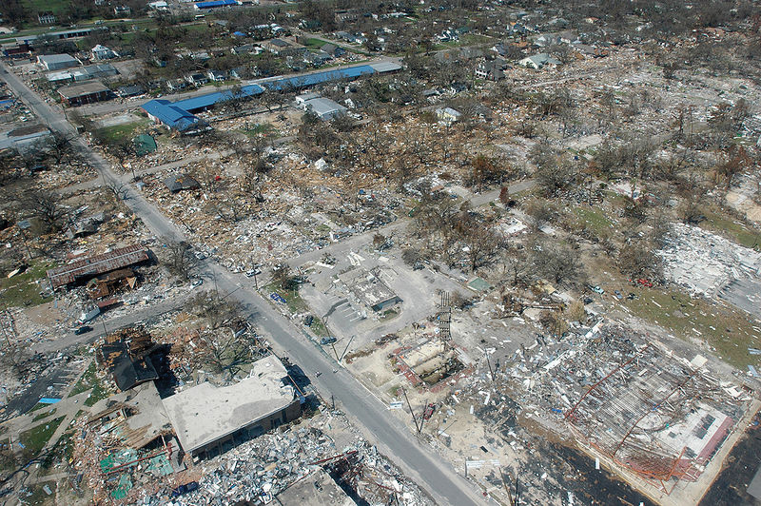
Devastation Wrought by Hurricane Katrina
Source: Photo courtesy of the Federal Emergency Management Agency,http://commons.wikimedia.org/wiki/File:Hurricane_katrina_damage_gulfport_mississippi.jpg.
Reporters from the networks and cable channels rushed to chronicle the catastrophe. They emotionally expressed their horror on camera and in print at the woefully tardy and inadequate response to the disaster by the government’s Federal Emergency Management Agency (FEMA). The head of FEMA confessing on television that he had only learned belatedly that thousands were stranded at the New Orleans’ convention center without food or water symbolized this incompetence. Through the media and the Internet, Americans and people throughout the world witnessed an inept federal agency and learned that it was led not by a disaster expert but by a political appointee whose previous employer was the International Arabian Horse Association.
FEMA is just one of over two thousand executive agencies—governmental organizations in the executive branch that are authorized and designed to apply the law. Collectively these agencies make up thefederal bureaucracy. The bureaucracy consists of career civil servants and of political appointees. Most of these bureaucrats competently carry out their duties largely unnoticed by the media. Few reporters cover agencies on a regular basis. Agencies sometimes get into the news on their own terms; all of them employ public relations experts to crank out press releases and other forms of mass communication containing information on their programs and to respond to reporters’ requests for facts and information. But the media often portray the bureaucracy negatively as a haven of incompetence and, as with their coverage of FEMA and Hurricane Katrina, are quick to chase after stories about bungling, blundering bureaucrats.

14.1 What Is Bureaucracy?

LEARNING OBJECTIVES
After reading this section, you should be able to answer the following questions:
- What is bureaucracy?
- How do the media depict the federal bureaucracy?
- How has the federal government bureaucracy evolved?
- What is the Pendleton Act? How has the merit system changed the makeup of federal bureaucracy?
- What are the four main types of federal agencies?
The influential early-twentieth-century sociologist Max Weber suggested that bureaucracy is an efficient way to govern large, complex societies. For Weber, the ideal form of bureaucracy has four characteristics:
- A rational division of labor into specialized offices with fixed jurisdictions
- Employees chosen for their skills, knowledge, or experience, not for their politics
- A chain of command wherein officials report to higher-ups
- Impersonal reliance on written rules to limit arbitrary variation from one case to the next ^{[1]}

Bureaucracy in the Media
Such a depiction of bureaucratic organization and effectiveness is rarely found in the news. When the media consider bureaucracy, it is most often to excoriate it. One scholar examined a recent year’s worth of newspaper editorials and concluded, “Mismanagement, wasteful spending, ethical lapses, and just plain incompetence stimulated editorial responses regularly.…By contrast, editors rarely devoted much space to agencies’ success.” ^{[2]} Likewise, television news zeroes in on waste, fraud, and abuse. Reporters provide new episodes of recurring segments such as ABC’s“Your Money” and NBC’s “The Fleecing of America.” The federal bureaucracy is a favorite target.
This frame finds government bureaucracies rife with incompetence and bureaucrats squandering public funds. The millions of dollars misspent are drops in the bucket of a federal budget that is more than a trillion dollars; but bureaucratic inefficiency, if not ineptitude, seems to be the rule, not the exception.
Such stories are easy for journalists to gather—from investigations by the Government Accountability Office of Congress, from congressional hearings, and from each agency’s inspector general. Thus the media widely covered the damning reports of the inspector general of the Securities and Exchange Commission on the reasons for the agency’s failure, despite many warnings and complaints from credible sources, to investigate Bernard Madoff’s $65 billion Ponzi scheme. ^{[3]}
Entertainment media depictions of bureaucracy are often negative. The movie The Right Stuff (1983), based on Tom Wolfe’s best-selling history, eulogizes an era of test pilots’ daring individualism. Test pilot Chuck Yeager bravely and anonymously breaks the sound barrier and then returns to the fraternity of fellow pilots in a tavern whose walls are covered with pictures of gallant men lost in the quest. But when the Soviet Union launches the Sputnik satellite in 1957, panic-stricken Washington sends buffoonish bureaucrats to recruit test pilots—excluding Yeager—into a stage-managed bureaucracy for the astronauts chosen to go into space.
The entertainment media do sometimes show bureaucracy as collectively effective and adaptable. Apollo 13 (1995) portrays NASA and its astronauts as bureaucratic and heroic. After a blown-out oxygen tank aboard the space capsule threatens the lives of three astronauts, the NASA staff works to bring them back to Earth. The solution to get the astronauts home is clearly an ingenious collective one thought up by the various NASA workers together.
Bureaucracy is the problem in The Right Stuff and the solution in Apollo 13. The Right Stuff tanked at the box office. Apollo 13 cleaned up, probably because of its reassuring story, tribute to the astronauts’ gallantry (it is hard to view astronauts as bureaucrats), and happy ending.
We will show that the federal bureaucracy is far more complex than the media allow. Then, at the end of the chapter, we will discuss the bureaucracy in the information age.

Evolution of the Federal Bureaucracy
The federal bureaucracy is not explicitly laid out in the Constitution. It was never instituted and planned; it evolved by the gradual accretion of agencies and tasks over time.
When Thomas Jefferson became president in 1801, the administrative civilian workers employed by the federal government—the civil service—numbered under three thousand. One-third of them were part-time employees. Nine-tenths worked outside Washington, DC. ^{[4]}

The Spoils System
When political parties developed, so did the practice of rewarding friends and allies with jobs and grants. It was also a democratic reaction to an era when the bureaucracy was run by aristocrats. Andrew Jackson made political patronage a matter of principle when he became president in 1829. He wanted to make sure that federal workers were accountable to the executive branch—and to him as president. ^{[5]} His ally, Senator William Marcy cried, “To the victors belong the spoils!” And Jackson’s detractors coined the term the spoils system: when the party in power changed, there was a full-scale replacement of officials by party faithful—who donated some of their salary to party coffers.
After the Civil War, the federal government grew enormously. Presidents and legislators were overwhelmed with finding jobs for party members. Representative James Garfield griped in 1870, “[O]ne-third of the working hours of senators and representatives is hardly sufficient to meet the demands made upon them in reference to appointments of office.” ^{[6]}Garfield was elected president ten years later, during which time the federal government workforce almost doubled (from 51,020 in 1870 to 100,020 in 1880). As president, Garfield was besieged with requests for patronage. He did not satisfy everyone. In 1881, Charles Guiteau, frustrated in his bid for a high-ranking appointment, shot Garfield in a Washington train station. Garfield’s long agony, eventual death, and state funeral made for a dramatic continuing story for newspapers and magazines seeking a mass audience. The media frenzy pushed Congress to reform and restrict the spoils system.

Link
The Garfield Assassination
Learn more about the Garfield assassination athttp://americanhistory.si.edu/presidency/3d1d.html.
Figure 14.1 Garfield’s Assassination
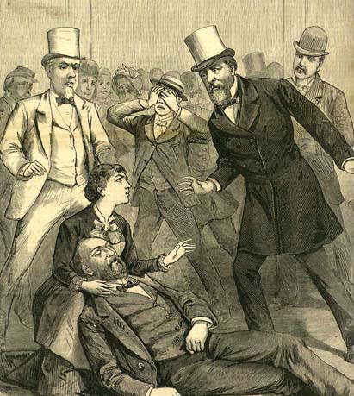
Source:http://commons.wikimedia.org/wiki/File:AssasinationPresGarfield.JPG.

The Merit System
Congress passed the Pendleton Act in 1883. ^{[7]} The act sorted federal employees into two categories: merit and patronage. In a merit system, jobs are classified and appointments are made on the basis of performance determined by exams or advanced training. The merit system at first covered only 10 percent of the civil service, but presidents and Congress gradually extended it to insulate agencies from each other’s political whims.^{[8]} By its peak in the 1920s, 80 percent of civil servants held merit positions.
The merit system has shrunk since the 1920s. ^{[9]} Just under half of today’s civilian federal workers are merit employees. A notable reform in 1978 instituted the Senior Executive Service, a merit pool of highly trained, highly experienced, highly educated, and highly paid officers that managers can move and transfer at will.
In 2002, President George W. Bush got Congress to give him discretion over whether 170,000 employees of the new Department of Homeland Security fall under the merit system; presidents can move employees in that department in or out of the civil service as they deem conditions dictate. Bush wished to go further: he unsuccessfully sought to transfer up to 850,000 government jobs to private companies, which he claimed would cut costs and enhance efficiency. ^{[10]}

The Line between Merit and Politics
The line between the merit system and politicized hiring and firing is not always clear. Consider US attorneys who prosecute federal crimes. They are appointed by the president, usually from his party, but it is understood that they will operate without partisanship. That is, they will not base their decisions on the interests of their party. In 2006, eight US attorneys were dismissed, allegedly at the direction of the Bush White House because of their reluctance to serve Republican interests by, for example, investigating Democratic officeholders and office seekers for corruption. The story was widely and, as new revelations appeared, continually reported in the media. It led to investigative hearings in the Democrat-controlled Congress.
Then, in July 2008, the Justice Department’s inspector general and internal ethics office revealed that senior aides to Attorney General Alberto R. Gonzalez had in fact broken civil service laws by using political criteria in making nonpolitical career appointments in the department; the inspector general and ethics office also revealed that White House officials were actively involved in some of the hiring decisions. Screened in interviews and through Internet searches, people had been hired if they were conservative on “god, guns + gays.” ^{[11]}

Who Are the Civil Servants?
Detailed rules and procedures govern hiring, promoting, and firing civil servants. To simplify and standardize the process, each position gets a GS (General Schedule) rating, ranging from GS 1 to GS 18, which determines its salary.
Unlike other parts of government, women and racial and ethnic minorities are well represented in the civil service. Women are 46 percent of the civilian workforce and 43 percent of the federal workforce. People of color are 26 percent of the civilian workforce and 29 percent of the federal workforce. But women and people of color are clustered at lower levels of the civil service. Those at higher levels are largely white and male. ^{[12]}Lifetime job security allows many civil servants to stay in government until retirement or death, so progress into high-level positions is slow.

The Variety of Agencies
It is hard to get an overall picture of the federal bureaucracy. First, rather than unfold from a master plan, the bureaucracy developed piecemeal, with agencies and departments added one at a time. Second, many federal responsibilities are not carried out by federal employees but by state and local government workers under federal mandates and by private companies contracted for services.
The thousands of agencies in the federal bureaucracy are divided into rough, often overlapping areas of specialization. The division of labor easily defies logic. A food writer’s overview of government regulation of food found thirty-five distinct laws implemented by twelve offices within six cabinet departments. For instance, “The Department of Agriculture oversees production of hot dogs cooked in pastry dough and corn dogs, while for no discernible reason, the Food and Drug Administration regulates bagel dogs and hot dogs meant to be served in buns.” ^{[13]}
Any attempt to make sense of this complex structure and to find an agency’s place in the overall bureaucracy does little more than bolster an image of mind-numbing intricacy.

Enduring Image
The Nightmare Organizational Chart
Organizational charts were designed to give clear and easy indications of the chain of command and who reports to whom. They are equally byzantine for large corporations as for government. But they are often used in political debate to show the sheer incomprehensibility of bureaucracy.
This tactic was famously used in 1993 by Senate Republican leader Bob Dole (R-KS) when he opposed First Lady Hillary Rodham Clinton’s ambitious health-care reform proposal. The picture of Dole and the nightmare organizational chart was widely circulated and contributed to the proposal’s demise the next year. Ten years later, Republicans in the Senate proposed a reform of the Medicare system. Then-senator Hillary Rodham Clinton (D-NY) took to the floor of the Senate with nightmare organizational charts of what the Medicare system would look like if Republicans had their way.
Images endure when they can be used again and again for multiple purposes by multiple players. Hillary Clinton showed that, in politics as in life, turnabout is fair play.
Bob Dole (1993) on Senate Floor in Front of Chart Depicting Hillary Clinton’s Health-Care Proposal
Watch Bob Dole use a complex chart to explain Hillary Clinton’s health care proposal.
http://www.c-spanvideo.org/program/UnionRespon
Complicating the federal bureaucracy, there are several types of agencies. We look at the four main ones: (1) cabinet departments, (2) independent executive agencies, (3) government corporations, and (4) regulatory commissions.

Cabinet Departments
Fifteen agencies are designated by law as cabinet departments: major administrative units responsible for specified areas of government operations. Each department controls a detailed budget appropriated by Congress and has a designated staff. Each is headed by a department secretary appointed by the president and confirmed by the Senate. Many departments subsume distinct offices directed by an assistant secretary. For instance, the Interior Department includes the National Park Service, the Bureau of Indian Affairs, and the US Geological Survey.
Department secretaries are automatically members of the president’s cabinet. For other agency heads, it is up to the president’s discretion: President Clinton elevated the head of the Federal Emergency Management Agency (FEMA) to the cabinet, but the position lost cabinet status under President George W. Bush.
Cabinet departments are not equally prominent in the news. A few, such as the Departments of State, Defense, Treasury, and Justice, are covered by newsbeat reporters who regularly focus on their activities and personnel. Other departments attract consistent interest of reporters of specialized publications. No department can assume obscurity, since crises and unexpected events may thrust it into the news. For example, the Department of Energy was suddenly newsworthy after a massive power blackout in the Northeast in the summer of 2003.

Independent Executive Agencies
The remaining government organizations in the executive branch outside the presidency are independent executive agencies. The best known include NASA, the Environmental Protection Agency (EPA), and the Social Security Administration (SSA). Apart from a smaller jurisdiction, such agencies resemble cabinet departments. Their heads are appointed by (and report directly to) the president and confirmed by Congress. They simply lack the symbolic prestige—and literal place at the table—of a cabinet appointment. Independent executive agencies can smoothly become cabinet departments: in 1990, Congress upgraded the Veterans Administration to the cabinet-level Department of Veterans Affairs.

Government Corporations
Some agencies, such as the US Postal Service and the national rail passenger system Amtrak, are government corporations. They charge fees for services too far-reaching or too unprofitable for private corporations to handle. Ideally, they bring in enough funds to be self-sustaining. To help them make ends meet, Congress may give government corporations a legal monopoly over given services, provide subsidies, or both. ^{[14]} Government corporations are more autonomous in policymaking than most agencies. For instance, the Postal Rate Commission sets rates for postage on the basis of revenues and expenditures.
Complicating the picture are the Federal National Mortgage Association (FNMA), known as Fannie Mae, and the Federal Home Loan Mortgage Corporation (FHLMC), known as Freddie Mac. These were government-sponsored enterprises and also stockholder-owned corporations. As of 2008, they owned or guaranteed about half of the country’s $12 trillion mortgage market. Thus, as we discuss in Chapter 16 "Policymaking and Domestic Policies", they were both partly responsible for and victims of the severe decline in the housing market. In September 2008, as their stock prices declined precipitously and they sank ever deeper into debt, they were taken over by the Federal Housing Finance Agency (FHFA). This was an extraordinary intervention by the federal government in the financial market.

Regulatory Commissions
In the late nineteenth century, the Industrial Revolution provoked economic regulation, the use of governmental power to protect the public interest and try to ensure the fair operation of the economy. This new domain was paired with an innovation, the regulatory commission, an agency charged with writing rules and arbitrating disputes in a specific part of the economy. Chairs and members of commissions are named by the president and confirmed by the Senate to terms of fixed length from which they cannot be summarily dismissed. (Probably the most prominent regulatory commission in the news is the Federal Reserve Board [known as “the Fed”]. We discuss it in Chapter 16 "Policymaking and Domestic Policies".)
Regulatory commissions’ autonomy was meant to take the politics out of regulation. But “most regulatory commissions face united, intensely interested industries, and passive, fragmented, and large consumer groups.” ^{[15]} They may become unsympathetic to the regulations they are supposed to enforce, even liable to being captured by the industries they are supposed to regulate. Consider the Federal Communications Commission (FCC). It grants licenses to radio and television broadcast frequencies in exchange for vague promises to pursue “the public interest.” Broadcasters are well organized, but viewers and listeners are not; the FCC’s policies have favored commercial broadcasters. If the FCC does diverge from industry views, its decisions can be repealed by Congress. Broadcasters’ power is weak only when the industry itself is divided.

The Size of the Federal Bureaucracy
Politicians pledge to shrink the size and enhance the efficiency of the federal bureaucracy. By one measure—how many civilian federal employees there are—they have succeeded: the number has not increased since the 1960s.
How, then, are politicians able to proclaim that “the era of big government is over” while providing the increase in government services that people expect? They have accomplished this by vastly expanding the number of workers owing jobs to federal money. As a result, over sixteen million full-time workers administer federal policy.
There is the federal civilian workforce of 1.9 million, uniformed military personnel of 1.5 million, and 850,000 postal workers. Add “the federal shadow workforce,” state and local government workers subject to federal mandates (discussed in Chapter 4 "Civil Liberties"). They devote, on the average, one-fourth of their work carrying out federal directives. There are 16.2 million state and local government workers, so the federal government does not need to hire approximately 4.05 million workers to carry out its policies.
There are billions of dollars annually in federal grants and contracts. Grants, such as those for highway construction, scholarly research, job training, and education, go through state and local government to private contractors. The government contracts with private companies to provide goods and, more recently, services in ways rarely reported in the news. The fact that the Defense Department contracted out for military interrogators and security officers in war zones did not become public knowledge until the Abu Ghraib prison abuse scandal broke in April 2004. The federal government directly supports 5.6 million jobs through contracts and 2.4 million jobs through grants. ^{[16]}

Thickening Government
As a result of the reliance on mandates and contracts, fewer and fewer civil servants directly interact with and provide services to the public as “street-level bureaucrats.” ^{[17]} Instead, federal employees are, more and more, professionals and managers. From the 1960s to the 1990s, even as the size of the civil service stayed constant, the number of senior executives and political appointees in the bureaucracy more than quintupled. ^{[18]}
This proliferation of managers creates “thickening government.” The average number of layers between president and street-level bureaucrat swelled from seventeen in 1960 to thirty-two in 1992, as new administrative titles multiplied in bewildering combinations of “assistant,” “associate,” “deputy,” and “principal” to monitor, streamline, and supervise state and local workers, contractors, and grantees—and each other. Consequently, much of the federal bureaucracy now consists of “managers managing managers.”

KEY TAKEAWAYS
The federal bureaucracy is the sum total of all executive agencies and personnel. It is a complicated mix. It contains civil servants with lifetime merit appointments and political appointees. It includes distinct kinds of agencies. And its small size is misleading because some federal responsibilities are carried out through mandates to state and local governments and by the contracting out of goods and services.

EXERCISES
- What did the sociologist Max Weber think the function of a bureaucracy was? How did he think bureaucrats should differ from political leaders?
- What was the spoils system? How did the Pendleton Act change the rules to prevent politicians from using political appointments for personal gain?
- How have politicians managed to keep the number of federal employees the same since the 1960s? In what sense has the federal bureaucracy “thickened”?

[1] Donald P. Warwick, A Theory of Public Bureaucracy: Politics, Personality, and Organization in the State Department (Cambridge, MA: Harvard University Press, 1975), 4.
[2] Jan P. Vermeer, The View from the States: National Politics in Local Newspaper Editorials (Lanham, MD: Rowman & Littlefield, 2002), 93–94.
[3] Zachery Kouwe, “In Harsh Reports on S.E.C.’s Fraud Failures, a Watchdog Urges Sweeping Changes,” New York Times, September 30, 2009, B10.
[4] Paul P. Van Riper, History of the United States Civil Service (Evanston, IL: Row, Peterson and Company, 1958), 19.
[5] Matthew A. Crenson, The Federal Machine: Beginnings of Bureaucracy in Jacksonian America (Baltimore: Johns Hopkins University Press, 1975); Daniel P. Carpenter, The Forging of Bureaucratic Autonomy: Reputations, Networks, and Policy Innovation in Executive Agencies, 1862–1928 (Princeton, NJ: Princeton University Press, 2001), chap. 2.
[6] Ronald N. Johnson and Gary D. Libecap, The Federal Civil Service System and the Problem of Bureaucracy: The Economics and Politics of Institutional Change(Chicago: University of Chicago Press, 1994), 18.
[7] Ourdocuments.gov, “Pendleton Act (1883),” accessed April 4, 2011,http://www.ourdocuments.gov/doc.php?flash=old&doc=48.
[8] Ronald N. Johnson and Gary D. Libecap, Federal Civil Service System and the Problem of Bureaucracy: The Economics and Politics of Institutional Change(Chicago: University of Chicago Press, 1994); Stephen Skowronek, Building a New Administrative State: The Expansion of National Administrative Capacities, 1877–1920 (New York: Cambridge University Press, 1982), chap. 3.
[9] Patricia Wallace Ingraham, The Foundation of Merit: Public Service in American Democracy (Baltimore: Johns Hopkins University Press, 1995).
[10] Richard W. Stevenson, “The Incredible Shrinking Government, Bush Style,”New York Times, December 8, 2002, Week in Review, 4.
[11] Eric Lichtblau, “Report Faults Aides In Hiring At Justice Department,” New York Times, July 29, 2008, A1 and 16.
[12] Katherine C. Naff, To Look Like America: Dismantling Barriers for Women and Minorities in Government (Boulder, CO: Westview Press, 2001).
[13] Marion Burros, “Something to Read Before Your Next Meal,” New York Times, April 23, 2003, D3.
[14] John T. Tierney, “Government Corporations and Managing the Public’s Business,” Political Science Quarterly 99 (Spring 1984): 73–92.
[15] Jack H. Knott and Gary J. Miller, Reforming Bureaucracy: The Politics of Institutional Choice (Englewood Cliffs, NJ: Prentice Hall, 1987), 127.
[16] Paul C. Light, The True Size of Government (Washington, DC: Brookings, 1999), 19–30; also Donald F. Kettl, Sharing Power: Public Governance and Private Markets (Washington, DC: Brookings, 1993).
[17] Michael Lipsky, Street-Level Bureaucracy: Dilemmas of the Individual in Public Services (New York: Russell Sage Foundation, 1980).
[18] Paul C. Light, Thickening Government: Federal Hierarchy and the Diffusion of Accountability (Washington, DC: Brookings, 1995), 7.

14.2 Policymaking, Power, and Accountability in the Bureaucracy

LEARNING OBJECTIVES
After reading this section, you should be able to answer the following questions:
- How do government agencies exercise power through rulemaking, implementation, and adjudication?
- What role does standard operating procedure play in agency accountability?
- How do agencies and the president influence each other?
- How do agencies and Congress influence each other?
The federal bureaucracy is a creature of Congress and the president. But agencies independently make policy and exert power: legislating by rulemaking; executing by implementation; and adjudicating by hearing complaints, prosecuting cases, and judging disputes.

Rulemaking
Congresses and presidents often enact laws setting forth broad goals with little idea of how to get there. They get publicity in the media and take credit for addressing a problem—and pass tough questions on how to solve the problem to the bureaucracy.
Take the Occupational Safety and Health Act of 1971. It seeks “to assure so far as possible every working man and woman in the Nation safe and healthy work conditions.” Congress created the Occupational Safety and Health Administration (OSHA) and directed it to “establish regulations suitable and necessary for carrying this law into effect, which regulations shall be binding.” OSHA began a process of rulemaking: issuing statements to clarify current and future policy in an area authorized by the law. It had to decide on answers for questions: What work conditions produce or endanger safety? What work conditions threaten workers’ health? How far is “so far as possible”? ^{[1]}

Link
OSHA
Learn more about the history of OSHA athttp://www.dol.gov/oasam/programs/history/mono- osha13introtoc.htm.
When not all specified goals are equally simple to pursue, agencies gravitate toward those easier to put into effect. OSHA was championed by labor organizations that deemed health hazards on the job to be a bigger problem than safety. But OSHA’s rulemaking focused more on safety than on health. It is simpler to calculate short-term costs and benefits of safety hazards than long-term costs and benefits of health hazards: for example, it’s easier to install protective railings than it is to lessen exposure to potentially carcinogenic chemicals. ^{[2]}
Congress requires agencies to follow prescribed detailed procedures in issuing a rule. The explosion of New Deal agencies in the 1930s created inconsistency from one agency to the next. In 1934, theFederal Register, which prints all rules and decisions made by agencies, was launched to provide a common source. The ever-rising number of pages annually in the Register shows ever lengthier, ever more intricate rules.

Link
The Federal Register
The Federal Register is available at http://www.gpoaccess.gov/fr.
In the first round, the agency interprets the statute to be applied and lists grounds for a preliminary decision. Next, it invites feedback: holding hearings or eliciting written comments from the public, Congress, and elsewhere in the executive branch. Then it issues a final rule, after which litigation can ensue; the rule may be annulled if courts conclude that the agency did not adequately justify it. Thus in March 2009 a federal judge ordered the Food and Drug Administration to lower the minimum age at which women could obtain the Plan B birth control pill without prescription from eighteen to seventeen. He ruled the agency had improperly bowed to pressure from the Bush administration in setting the limit at eighteen.
Any rule listed in the Federal Register has the status and force of law. The agency can modify the rule only by the same arduous process. The Bush administration worked diligently over its first three years to repeal the Clinton administration’s policy forcing utility plants to spend billions of dollars on pollution upgrades during any renovations that, in the language of the Clean Air Act, exceeded “routine maintenance.” ^{[3]} Environmental Protection Agency (EPA) administrator Christine Todd Whitman sought to make a “clarification” of “routine maintenance” that was more lenient to the power plants than her predecessor’s strict interpretation. The new rule, first unveiled in 2002, went through lengthy review before being finally issued in late 2003. Several states in the Northeast subject to acid rain caused by Midwestern power plants promptly sued but did not win in court. Such rulemaking deep in the federal bureaucracy rarely achieves the media attention that an open debate and decision in Congress would attract—making it an unobtrusive way for officials to accomplish something politically unpopular, such as relaxing clean-air standards. ^{[4]}

Implementing Policy
The bureaucracy makes policy through implementation, or applying general policies to given cases. Agencies transform abstract legal language into specific plans and organizational structures. There are rarely simple tests to assess how faithfully they do this. So even the lowliest bureaucrat wields power through implementation. Immigration agents decide which foreigners to grant asylum in the United States. Internal Revenue Service agents decide which tax returns to audit.
Some implementation can be easily measured. Examples are the Postal Service’s balance sheet of income and expenditures or the average number of days it takes to deliver a first-class letter over a certain distance in the United States. But an agency’s goals often conflict. Congress and presidents want the Postal Service to balance its budget but also to deliver mail expeditiously and at low cost to the sender and to provide many politically popular but costly services—such as Saturday delivery, keeping post offices open at rural hamlets, and adopting low postal rates for sending newspapers and magazines. ^{[5]}
Ambiguous goals also pose problems for agencies. When the Social Security Administration (SSA) was formed in the 1930s, it set up an efficient way to devise standards of eligibility (such as age and length of employment) for retirement benefits. In the 1970s, Congress gave the SSA the task of determining eligibility for supplementary security income and disability insurance. Figuring out who was disabled enough to qualify was far more complex than determining criteria of eligibility for retirement. Enmeshed in controversy, the SSA lost public support. ^{[6]}

Adjudicating Disputes
Agencies act like courts through administrative adjudication: applying rules and precedents to individual cases in an adversarial setting with a defense and prosecution. Some, like the National Labor Relations Board (NLRB), act as both prosecutor and judge. ^{[7]} Federal law directs workers complaining about unfair labor practices to go to regional directors of NLRB, who decide if there is probable cause that the law has been violated. If so, NLRB’s general counsel brings a case on behalf of the complainant before NLRB’s special administrative law judges, who hear both sides of the dispute and issue a decision. That ruling may be appealed to the full NLRB. Only then may the case go to federal court.

Standard Operating Procedures
How can civil servants prove they are doing their jobs? On a day-to-day basis, it is hard to show that vague policy goals are being met. Instead, they demonstrate that the agency is following agreed-on routines for processing cases—standard operating procedures (SOPs). ^{[8]} So it is hard for agencies to “think outside the box”: to step back and examine what they are doing, and why. The news media’s lack of day-to-day interest in the vast majority of agencies only further dampens attention to the big picture. Sometimes, only severe crises jar agencies out of their inertia. For example, following the terrorist attacks of 9/11 the Central Intelligence Agency (CIA) moved to revive old-fashioned forms of human intelligence, such as planting spies in terrorist camps and increasing its number of Arabic-language speakers, when it became clear that its standard operating procedure of using high-tech forms of intelligence, such as satellite images and electronic eavesdropping, had been inadequate to forecast, let alone prevent, the attacks.

Agencies’ Power
Agencies are alert to and heed the power of the president and Congress over their activities. But agencies can effectively influence Congress and presidents as much as the other way around. And if Congress and presidents disagree, agencies are in the happy situation of responding to the branch that is closer to what they want to do. ^{[9]}
The signs of an agency’s power include (1) the legal authority Congress and presidents accord it, (2) the size and continuity of its budget, and (3) the deference it gains from expertise. But each of these hallmarks amounts to little without political support—especially from those individuals and groups most interested in or affected by an agency’s decisions. Without such support, agencies find their programs confined by others, their budgets slashed, and their claims to expertise doubted.
Agencies “are not helpless, passive pawns in the game of politics as it affects their lives; they are active, energetic, persistent participants.” ^{[10]}They work to create and maintain political support from the president, Congress, and the public. Favorable media coverage is instrumental in building this political support.
Agencies also obtain political support by shifting policies when new political participants challenge their standard approach. ^{[11]} For example, in the 1970s the Army Corps of Engineers moved away from a rigid prodevelopment stance when environmental groups arose and lobbied for a law requiring the Corps to draft environmental impact statements.

How Presidents Influence the Federal Bureaucracy
Agencies are part of the executive branch. Presidents select heads of agencies and make numerous other political appointees to direct and control them. But political appointees have short careers in their offices; they average just over two years. ^{[12]} Civil servants’ long careers in government in a single agency can easily outlast any political appointee who spars with them. ^{[13]}
Presidents are tempted to pursue implementation by agencies to accomplish policy goals that Congress has frustrated. Tools of thisadministrative presidency include establishing agencies, strategic appointments, internal reorganization, and budget cuts. ^{[14]}

Establishing Agencies
Presidents can set up an agency by executive order—and dare Congress not to authorize and fund it. President John F. Kennedy issued an executive order to launch the Peace Corps after Congress did not act on his legislative request. Only then did Congress authorize, and allocate money for, the new venture. Agencies created by presidents are smaller than those begun by Congress; but presidents have more control of their structure and personnel. ^{[15]}

Strategic Appointments
Presidents make strategic appointments. Agency personnel are open to change when new appointees take office. Presidents can appoint true-believer ideologues to the cabinet who become prominent in the news, stand firm against the sway of the civil service, and deflect criticism away from the president. ^{[16]} After the 9/11 attacks, President Bush let Attorney General John Ashcroft take the lead—and the flak—on aggressive law enforcement policies that many saw as threats to civil liberties. ^{[17]}
Presidents also can and do fire agency officials who question the White House line. In 2002, Mike Parker, head of the Army Corps of Engineers and former member of Congress, testified on Capitol Hill that the president’s budget for the Corps was too low. His remarks were covered heavily in the news—as was his dismissal. ^{[18]}
Presidents who dislike an agency’s programs can decide not to replace departing staffers. Early in his term, George W. Bush (the first president to graduate from business school) made few appointments to the Securities and Exchange Commission that regulates the stock market; he only boosted its staff after financial scandals rocked Wall Street in 2002. ^{[19]}

Internal Reorganization
Presidents can rearrange an agency’s organizational chart. President Richard Nixon faced a ballooning welfare budget after taking office in 1969. Congress failed to act on welfare reform. Nixon turned to administrative measures to slow federal outlays. Deeply conservative appointees initiated new rules; instead of worrying about denying welfare to someone who was qualified, they stressed reducing the number of ineligible persons receiving benefits. Civil servants were moved out of offices devoted to specific programs and reported to managers who graded them on their ability to cut costs. The result? Welfare rolls leveled off despite a worsening economy. ^{[20]}

Backlash
Presidents pursue the administrative presidency most effectively with programs that are obscure or unpopular with the public. Otherwise, they risk reactions on Capitol Hill. For example, President Ronald Reagan, seeking more leeway for business, successfully restrained the EPA in his first term. He appointed loyal, lightning-rod individuals who went to Congress and asked for budget reductions. He left positions vacant. He shifted authority to the states. He subjected environmental laws to cost-benefit calculations that emphasized tangible costs of regulation over intangible benefits. After two years, fewer new regulations were issued, and environmental standards and enforcement were relaxed.
These victories produced a backlash. Civil servants felt excluded. Environmental interest groups made Reagan’s appointees into villains they railed against in media campaigns. The resultant shift in public opinion made itself known to Congress, which eventually led Reagan to fire the agency heads. Under new, more moderate leadership, the EPA veered away from its relentlessly probusiness stance. ^{[21]}
The administrative presidency does not work unless presidents and their political appointees clearly articulate what they wish to accomplish at the outset. Bureaucrats cannot respond to conflicting or confused signals from political appointees. Communicating clearly to a far-flung executive branch is a key reason why presidents are determined to craft a “line of the day” and disseminate it through the executive branch.
George W. Bush carried coordination of presidential and agency communication one step further by ensuring that the White House, not the department secretary, would appoint the press officers in each cabinet department. As Bush’s first chief of staff, Andrew Card, explained, “Our communications team is not just a team for the White House. It is a communications team for the executive branch of government.” ^{[22]}

How Agencies Influence Presidents
Presidential appointments, especially of cabinet secretaries, are one way to control the bureaucracy. But cabinet secretaries have multiple loyalties. The Senate’s power to confirm nominees means that appointees answer to Congress as well as the president. In office, each secretary is not based at the White House but at a particular agency “amid a framework of established relations, of goals already fixed, of forces long set in motion [in] an impersonal bureaucratic structure resistant to change.” ^{[23]}

Cabinet Secretaries
Surrounded by civil servants who justify and defend department policies, cabinet secretaries are inclined to advocate the departments’ programs rather than presidential initiatives. For example, while Republicans have long proposed abolishing the Department of Energy, Republican energy secretaries resist such an effort. As a senator, Spencer Abraham (R-MI) proposed the abolition of the Department of Energy. After Abraham was defeated for reelection in 2000, President Bush offered him a cabinet post as energy secretary as a consolation prize. With what a reporter termed “the enthusiasm of a convert,” Secretary Abraham changed his tune: “We have a clearer mission…and the department is…a much more effective place to do business.” ^{[24]}
Some cabinet secretaries value their independence and individuality above the president’s agenda. Treasury secretaries often come to Washington directly from success as chief executive officers of corporations. In 2001, Paul O’Neill left Alcoa to become George W. Bush’s first treasury secretary. O’Neill was unprepared for the scrutiny his frank, off-the-cuff public comments would attract. At odds with the public relations approach of the Bush administration and sometimes out of step with presidential statements, O’Neill was marginalized and ultimately dismissed in late 2002. O’Neill got his revenge by giving inside information critical of President Bush for a “kiss and tell” memoir published in 2004.
Cabinet secretaries craft strategies of getting into the news to boost their reputations and influence both inside and outside their departments. But seeking an image of being “in charge” of their agency does not always work. Homeland Security Secretary Tom Ridge’s mission included reassuring an anxious public after 9/11. But his attempts to do so, such as devising a color-coded system of terrorism alerts and suggesting that plastic sheeting and duct tape could effectively shield houses from the dangers of biological warfare, were mocked in the media and did more damage than good to that effort and Ridge’s reputation.

Civil Servants Shape Policies
Cabinet members are high-profile officials known to the news media and the president. With the executive branch’s increasing layers, civil servants often shape outcomes as much as presidents and cabinet secretaries. The decisions they make may or may not be in line with their superiors’ intentions. Or they may structure information to limit the decisions of those above them, changing ambiguous shades of gray to more stark black and white. As a political scientist wrote, “By the time the process culminates at the apex, the top-level officials are more often than not confronted with the task of deciding which set of decisions to accept. These official policy-makers, in many respects, become policy ratifiers.” ^{[25]}

How Congress Influences the Federal Bureaucracy
Congress makes laws fixing the functions, jurisdictions, and goals of agencies. It sets agency budgets and conditions for how funds must be used. It can demote, merge, or abolish any agency it finds wanting; longevity does not guarantee survival. ^{[26]} Every agency’s challenge is to find ways to avoid such sanctions.
If an agency’s actions become politically unpopular, Congress can cut its budget, restrict the scope of regulation or the tools used, or specify different procedures. For example, the National Endowment for the Arts (NEA) in the early 1990s made a series of controversial decisions to fund gay and lesbian performance artists. The NEA’s budget was cut by Congress and its existence threatened. If such sanctions are seldom applied, their presence coaxes bureaucrats to anticipate and conform to what Congress wants.
Figure 14.2 Karen Finley
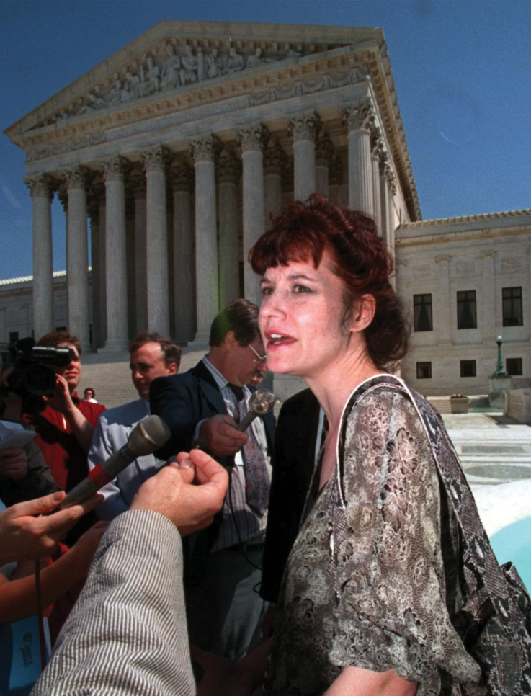
The National Endowment for the Arts kept itself going by shifting away from controversial arts projects awarded to lesbian and gay performance artists such as Karen Finley (pictured here) to safer, more widespread community-based arts organizations.
Source: Used with permission from AP Photo/William Philpott.
Congress monitors agency activities bycongressional oversight: members gather information on agency performance and communicate to agencies about how well or, more often, how poorly they are doing. ^{[27]} Oversight ranges from a lone legislator’s intervention over a constituent’s late social security check to high-profile investigations and committee hearings. It is neither centralized nor systematic. Rather than rely on a “police-patrol” style of oversight—dutifully seeking information about what agencies are doing—Congress uses a “fire alarm” approach: interest groups and citizens alert members to problems in an agency, often through reports in the news. ^{[28]}

How Agencies Influence Congress
Agencies can work for continued congressional funding by building public support for the agency and its programs. The huge budget of the Defense Department is facilitated when public opinion polls accord high confidence to the military. To keep this confidence high is one reason the Defense Department aggressively interacts with the media to obtain favorable coverage.
Agencies can make it hard for Congress to close them down or reduce their budget even when public opinion is mixed. Agencies choose how much money to spend in implementing a program; they spread resources across many districts and states in the hope that affected legislators will be less inclined to oppose their programs. ^{[29]} For example, numerous presidents have proposed that the perennially money-losing government corporation Amtrak be “zeroed out.” But Amtrak has survived time and again. Why? Although train riders are few outside the Northeast, Amtrak trains regularly serve almost all the continental forty-eight states, providing local pressure to keep a national train system going.
Figure 14.3 Amtrak Map
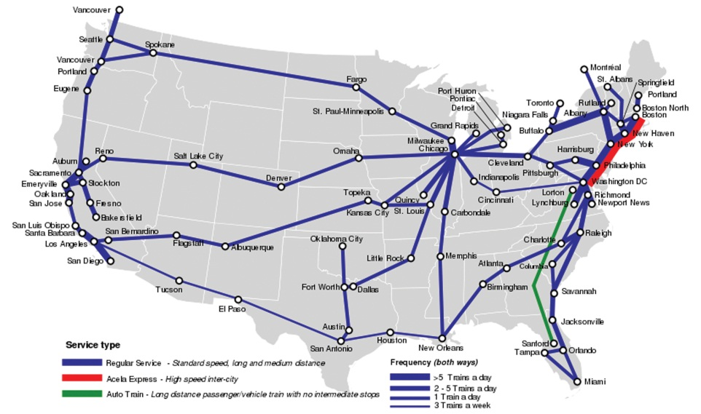
Source: Photo courtesy of Samuell Theshibboleth,http://commons.wikimedia.org/wiki/File:Amtrakfreqmap.svg.
Likewise, when faced with extinction, an agency can alter its policies to affect more congressional constituencies. For example, after the NEA was threatened with extinction, it shifted funding away from supporting artists in trendy urban centers and toward building audiences for community-sponsored arts found in a multitude of districts and states—whose residents could push Congress to increase the NEA’s budget. Sure enough, President Bush’s tight budgets saw rises for the NEA.

KEY TAKEAWAYS
The bureaucracy often makes sweeping policy decisions. It legislates by rulemaking, executes the law by implementing it, and adjudicates by addressing individual cases in adversarial settings with defense and prosecution. Agencies constantly search for political support to ensure an adequate budget and enhance their independence. They are subject to control by but also influence the president, who proposes their budgets, creates new agencies, and appoints their leaders; agencies are also subject to control by Congress, which funds their programs and determines their scope.

EXERCISES
- What government agencies have you had to deal with? How much authority do you think they had to decide what to do in your case?
- What is the value of standard operating procedures? What are the limitations of having bureaucracies follow standard procedures?
- How can agencies influence policymakers? How does the perspective of bureaucrats working in government agencies tend to differ from the perspective of the president and members of Congress?

[1] Cornelius M. Kerwin, Rulemaking: How Government Agencies Write Law and Make Policy, 3rd ed. (Washington, DC: CQ Press, 2003), 7–8 and chap. 2.
[2] James Q. Wilson, Bureaucracy: What Government Agencies Do and Why They Do It (New York: Basic Books, 1989), 42–43.
[3] Katharine Q. Seelye, “White House Seeks Changes in Rules on Air Pollution,”New York Times, June 14, 2002, A1.
[4] Bruce Barcott, “Changing All the Rules,” New York Times Magazine, April 4, 2004, 38–44ff.
[5] John T. Tierney, The U.S. Postal Service: Status and Prospects of a Public Enterprise (Dover, MA: Auburn House, 1988), 2.
[6] The distinction of “goal” and “task” is well described in James Q. Wilson,Bureaucracy: What Government Agencies Do and Why They Do It (New York: Basic Books, 1989), chap. 3. On the SSA, see Martha Derthick, Agency under Stress: The Social Security Administration in American Government (Washington, DC: Brookings, 1990).
[7] See William B. Gould IV, A Primer on American Labor Law, 2nd ed. (Cambridge, MA: MIT Press, 1986), especially chap.4.
[8] Charles E. Lindblom, “The Science of ‘Muddling Through,’” Public Administration Review 19 (1959): 79–88.
[9] Dan B. Wood and Richard W. Waterman, Bureaucratic Dynamics: The Role of Bureaucracy in a Democracy (Boulder, CO: Westview Press, 1994), 96.
[10] Herbert Kaufman, Are Government Organizations Immortal? (Washington, DC: Brookings, 1976), 9.
[11] Daniel A. Mazmanian and Jeanne Nienaber, Can Organizations Change?: Environmental Protection, Citizen Participation, and the Corps of Engineers(Washington, DC: Brookings, 1979); and John Brehm and Scott Gates, Working, Shirking, and Sabotage: Bureaucratic Response to a Democratic Public (Ann Arbor: University of Michigan Press, 1997).
[12] Joel D. Aberbach and Bert A. Rockman, In the Web of Politics: Three Decades of the U.S. Federal Executive (Washington, DC: Brookings, 2000), chap.4.
[13] Joel D. Aberbach and Bert A. Rockman, In the Web of Politics: Three Decades of the U.S. Federal Executive (Washington, DC: Brookings, 2000), 74.
[14] The term was coined by Richard Nathan, The Plot that Failed: Nixon and the Administrative Presidency (New York: Wiley, 1975). Richard Nathan developed it beyond the Nixon case in The Administrative Presidency (New York: Wiley, 1983).
[15] William G. Howell and David E. Lewis, “Agencies By Presidential Design,”Journal of Politics 64 (2002): 1095–1114.
[16] Richard J. Ellis, Presidential Lightning Rods: The Politics of Blame Avoidance(Lawrence: University Press of Kansas, 1994).
[17] Todd S. Purdum, “Mr. Heat Shield Keeps Boss Happy,” New York Times, December 6, 2001, B7.
[18] Joan McKinney, “Too Much Mouth—Or a New Policy?,” Baton Rouge Sunday Advocate, March 10, 2002, 9B.
[19] Stephen Labaton, “S.E.C. Suffers from Legacy of Nonbenign Neglect,” New York Times, September 20, 2002, B1.
[20] Ronald Randall, “Presidential Power versus Bureaucratic Intransigence: The Influence of the Nixon Administration on Welfare Policy,” American Political Science Review 73 (1979): 795–810.
[21] This case study draws from Richard Waterman, Presidential Influence and the Administrative State (Knoxville: University of Tennessee Press, 1989), chap. 5; and Marissa Martino Golden, What Motivates Bureaucrats? (New York: Columbia University Press, 2000), chap. 6.
[22] Quoted in Martha Joynt Kumar, “Communications Operations in the White House of President George W. Bush: Making News on His Terms,” Presidential Studies Quarterly 33 (2003).
[23] Richard F. Fenno, Jr., The President’s Cabinet (Cambridge, MA: Harvard University Press, 1959), 226.
[24] Katharine Q. Seelye, “Steward of a Department He Once Sought to Scrap,”New York Times, August 31, 2003, 24.
[25] Louis C. Gawthrop, Bureaucratic Behavior in the Executive Branch: An Analysis of Organizational Change (New York: Free Press, 1969), 18.
[26] David E. Lewis, “The Politics of Agency Termination: Confronting the Myth of Agency Immortality,” Journal of Politics 64 (2002): 89–107.
[27] See Christopher H. Foreman, Jr., Signals from the Hill: Congressional Oversight and the Challenge of Social Regulation (New Haven, CT: Yale University Press, 1988), 13.
[28] Mathew D. McCubbins and Thomas Schwartz, “Congressional Oversight Overlooked: Police Patrols and Fire Alarms,” American Journal of Political Science28 (February 1984): 165–79.
[29] This section is based on R. Douglas Arnold, Congress and the Bureaucracy: A Theory of Influence (New Haven, CT: Yale University Press, 1979).

14.3 The Federal Bureaucracy in the Information Age

LEARNING OBJECTIVES
After reading this section, you should be able to answer the following questions:
- How do the bureaucracy and the media interact?
- Why and when do agencies need the media?
- Why and when do the media need agencies?
- What impact do media depictions of the bureaucracy have on public opinion and on agencies themselves?
We have seen the many ways the federal bureaucracy makes crucial contributions to government and public policies. Yet its depiction in the media is mixed. On the one hand, emphasizing waste, incompetence, malfeasance, and abuse, the media tend to be critical, even dismissive. On the other hand, many agencies are portrayed as competent and effective. This can be explained with an analysis of agency-media interactions.

Media Interactions
There is so much variety in the agencies, commissions, and offices that make up the federal bureaucracy that we might expect their interactions with the media to differ greatly. After all, some agencies, such as the Department of Defense, have enormous budgets that require constant public justification. Others, like the far leaner Department of State, do not. Some, like the National Institutes of Health, deal with technical and intricate policy areas and their officials fear that their work will be distorted when it is translated by journalists. Others, like the Federal Trade Commission, are deemed by reporters to be dull, narrow, and not suitable for dramatic, exciting news.
In practice, media operations from one agency to the next resemble each other. Media scholar Stephen Hess studied those of the Food and Drug Administration (FDA) and Departments of Defense, State and Transportation. Hess concluded, “Regardless of how they were organized or how different their sizes, each performed the same duties in a similar manner.…The Pentagon’s press operations appears much like the FDA’s writ large.” ^{[1]}
As in the White House, the relationship of bureaucrats and reporters is both adversarial and cooperative. Political appointees and civil servants may be anxious about reporters’ powers to frame and reinterpret policy decisions. Yet they understand the importance of maintaining a friendly relationship with reporters to try to get their agency reported favorably to boost public support for their programs and budgets. Moreover, they can never assume that the media will ignore them; they must be prepared to deal with reporters at a moment’s notice. In practice, both sides usually need each other—journalists for information, bureaucrats for favorable news or at least to mitigate negative news.
To meet the media’s never-ending appetite for news, reporters turn to readily accessible press officers, who serve as official spokespersons for their agencies. Press officers, who are often former journalists, sympathize with the reporters who cover agencies and strive to represent their needs within the agency. They work to provide information, a quick quote, or a tidbit on a given topic that will satisfy any and all reporters that contact them.
At the same time, reporters often search for and thrive on leaks (unauthorized anonymous disclosures). These may come from high-ranking appointees in the agency seeking to float trial balloons or to place decisions in context. The source may be deep in the bureaucracy, as in the Abu Ghraib prisoner abuse scandal. Reporters also gain revelations through official reports and investigations conducted by officials in an agency.

Why and When Agencies Need the Media
Agencies need the media for external and internal communication.

External Communication
An agency may need favorable media depictions (1) to help it enhance its public image and build public support, (2) to ensure that the budget it receives from Congress is adequate for its mission, and (3) to reduce interference from presidents and their political appointees. Media stories that laud an agency’s indispensable skill at solving important problems affecting a large public discourage such threats. For example, if the Centers for Disease Control and Prevention swiftly send out warnings about a new outbreak of illness, they not only alert the public but also provide clear evidence of their competence—and justification for an ample budget.
Agencies foster public support by cooperating with reporters but guiding them toward information and framing subjects boosting their image. Take the Department of Transportation (DOT), which reporters usually find boring. In 1982, a passenger jet took off from Washington’s National Airport and crashed in the Potomac River. Linda Gosden, DOT’s director of public affairs, weeded out unconfirmed information about the causes of the crash, thereby helping reporters in their jobs of ensuring accuracy and avoiding panic. She also quietly steered reporters away from any hint that the crash might have been caused by inexperienced air-traffic controllers hired after her boss, the transportation secretary, fired striking unionized air-traffic controllers in 1981. ^{[2]}
The agencies’ attention to the media goes beyond the news. Hollywood directors shooting a war movie routinely contact the Defense Department for assistance, ranging from technical advice to the use of military equipment. Nothing obliges the Pentagon to cooperate with an applicant, so it grants requests only to projects that depict it favorably. Hollywood classics raising serious questions about the military—Fail-Safe, Dr. Strangelove, and Apocalypse Now, for example—asked for but did not receive Pentagon help. By contrast, Top Gun, the top-grossing film of 1986, ended up acting as a recruiting poster for Navy pilots: it gained box-office cachet from aerial sequences filmed in several $37 million F-14 jets the navy provided free of charge. ^{[3]}

Internal Communication
Agencies find it hard to communicate internally as they grow bigger. Top agency officials worry that subordinates will not grasp what the agency is doing or that leaks from deep in the bureaucracy will characterize policy. So they have incentives to communicate what the agency’s policy is, stifle disagreement, and remind its personnel of its mission. What appears on the surface to be a service to reporters actually meets these crucial internal needs of a bureaucracy. For instance, the State Department’s daily noon briefing for reporters is indispensable for the State Department; it sets a deadline to establish US foreign policy and uses the news media to communicate that policy throughout government and to foreign service officers around the globe. ^{[4]}
Agency press officers communicate internally by searching for news stories bearing on the agency and reproducing them in compilations circulated through the agency called “the clips.” Since the clips exaggerate the prominence—and importance—of news coverage of each agency, an agency’s personnel becomes ever more sensitive to—and influenced by—media attention.

Why and When the Media Need Agencies
At the few agencies regularly covered by news outlets—for example, the “inner cabinet” of the Departments of State, Defense, Treasury, and Justice—dynamics resemble the White House. Cabinet secretaries heading these departments become the public faces of their agencies, even celebrities worthy of mockery on The Daily Show, jokes on late-night talk shows, and mimicry on Saturday Night Live. Like presidents, their influence is constantly monitored and measured by the observing media.
Reporters covering inner cabinet departments use their assignments to benefit both them and the department they cover. To land a front-page or lead story, they stress the importance of the agency’s policy area within their news organizations. But to get the information that impresses editors and producers, reporters must rely on the input of top officials. Based at the department itself and interacting heavily with its personnel, inner cabinet reporters begin to reflect the department’s procedures, approaches, and priorities (see Note 14.32 "Comparing Content").
Reporters gravitate to the Pentagon for stories about operational guns-and-ammo firepower. This approach is handy for the Defense Department, which tries to “educate” reporters—and through them, the public—on the benefits of sophisticated weapons systems (and reasons for a huge budget). The Pentagon fosters favorable coverage by giving conditional access: providing captivating video to reporters of successful military sorties, sending them to reporters’ boot camp to help them appreciate the soldier’s life, or “embedding” them in military units, which enables them to file compelling human interest stories of brave warriors. Even skeptical reporters find the drama and vividness of such content irresistible for the news.

Comparing Content
A Tale of Three Newsbeats
In foreign policy, officials at the State Department, in charge of diplomacy, and the Pentagon, directing military options, are often at odds. There is a similar division between State Department correspondents and Pentagon reporters, who at times sound like spokespersons for the agencies they cover.
A revealing example comes from the early weeks of the first Persian Gulf War, provoked by Iraq’s 1990 invasion of Kuwait. American forces and allies had launched an air attack on Iraq and were readying an assault on land. On February 21, 1991, ABC’s Moscow correspondent revealed that Iraqi Foreign Minister Tariq Aziz and Soviet President Mikhail Gorbachev had reached a proposed agreement to forestall a ground war. This unexpected news broke into Peter Jennings’s nightly broadcast. His team, facing the tough task of making sense of breaking news, declared a “Special Report” through a tour of newsbeats in Washington. ^{[5]} Jennings talked to three reporters.
None of them had a chance to interview anyone; they relied on hunches of how the people they cover might react. White House correspondent Brit Hume gave what he thought would be an official response from President George H. W. Bush: “Well, Peter, it occurs to me that given the president’s insistence all along that all—all—U.N. resolutions be adhered to…the administration will immediately find fault with this proposal.”
Jennings next asked State Department reporter John McWethy for a “first reaction” to the news. McWethy suggested that the ground war would have to be postponed and that the possibility for neutral forces to supervise Iraq’s withdrawal from Kuwait would be attractive to the United States.
Pentagon correspondent Bob Zelnick retorted, “I would disagree, at least from the Pentagon’s perspective, with Jack’s [McWethy’s] comments that it will be likely be acceptable to have forces supervising that are not involved in the fighting.”
The rivalry of diplomacy at state and guns and ammo at defense and the tension between the policy focus of State and the political focus of the White House was being played out in the disagreements of the three reporters.
Hume, McWethy, and Zelnick presented themselves as impartial, knowledgeable observers at their newsbeats. A great strength of the newsbeat system is the ability of reporters to grasp and convey the essence of the office and officials they cover. The downside is they may simply report from the perspective of the institution as if they were official spokespersons rather than holding the occupants of that institution accountable. Of course, as mainstream media reduce their beat reporting, it is unclear who will replace reporters. Bloggers, perhaps?

The Media Expose an Agency
But what happens when a dramatic event develops into a crisis and thrusts an obscure agency into the news?
On April 20, 2010, the Deepwater Horizon oil rig in the Gulf of Mexico exploded, killing eleven workers. For the next several months, millions of gallons of oil poured into the Gulf of Mexico. A giant oil slick destroyed the ecology, polluted coastlines, killed animals and ruined their habitats, and damaged the fishing industry, tourism, and real estate businesses. It was the worst oil spill in American history.
The federal government, which had leased the area to British Petroleum (BP), initially deferred to the oil company, relying on it for the technology, personnel, and financing to stem the flood of oil and initiate the cleanup. But BP’s efforts were woefully ineffective, and it drastically underestimated the amount of oil pouring into the Gulf and the rate at which the oil leaked.
The media, led by the New York Times, looked for the government agency most responsible for the disaster. Their pursuit led them to the Minerals Management Service (MMS) of the Interior Department. MMS is required by the Outer Continental Shelf Act to inspect the approximately four thousand offshore platform facilities in the Gulf for safety and operational compliance.
The Times reported that MMS had approved at least three huge lease sales, 103 seismic blasting projects and 346 drilling plans, including Deepwater Horizon, without getting required permits from the National Oceanic and Atmospheric Administration (NOAA). The newspaper also reported that the MMS routinely overruled the safety and environmental concerns of its staff biologists and engineers, pressuring them to change their findings that predicted accidents. The MMS was reported to have routinely exempted BP and other companies from having to provide environmental impact statements. ^{[6]} Yet “from 2001 to 2007, there were 1,443 serious drilling accidents in off-shore operations, leading to 41 deaths, 302 injuries and 356 oil spills.” ^{[7]}
MMS essentially allowed the oil industry to regulate itself. With respect to the Deepwater Horizon rig, as reported in the Times, MMS gave BP permission to test the blowout preventer at a lower pressure than federally required and granted another exception to the company to delay mandatory testing of the preventer because it had lost well control. It did not require BP to keep a containment dome on the rig: BP took seventeen days to build one on shore and ship it to sea, where it did not work. ^{[8]}
Investigating MMS, the Interior Department’s inspector general reported on coziness with the industry, such as the MMS’s allowance of oil and gas personnel to fill out inspection forms that would then be completed or signed by the MMS inspector. Many MMS inspectors had worked for the oil and gas industry. They accepted gifts from the companies and were friends with its employees. ^{[9]}
The Obama administration had not totally ignored MMS, which had a reputation for scandal and corruption. New Secretary of the Interior Ken Salazar had started to try to reform the agency with ethics standards. A new head had been appointed, but she apparently did little to fix or even change the agency.
After the revelations, she resigned. That was not enough. The conflict (contradiction) between the MMS missions of policing and supporting the oil industry was too blatant. The agency was responsible for oversight of safety and environmental protection in all offshore activities, including oil drilling, and for leasing energy resources in federal waters. But at the same time it collected and distributed royalties of $13 billion annually from these leases. Thus it had a vested financial interest in the industry. On May 19, 2010, Salazar announced the separation of the three responsibilities into different divisions.
The agency’s name was changed to the Bureau of Ocean Energy Management, Regulation and Enforcement. Its new director issued guidelines to tighten the regulation of drilling and end or at least curtail the bribery, favoritism, and cozy relationship with the oil companies. ^{[10]}

Media Consequences
The media’s depictions of the federal bureaucracy, ranging from highly positive to direly negative, provoke mixed feelings in the public. ^{[11]} Asked to choose in polls between “a smaller government providing fewer services” or “a bigger government providing more services,” Americans opt for the former by a two-to-one margin. Like the media, the public finds waste, fraud, and abuse to be endemic to the bureaucracy. Year after year of National Election Studies surveys reveal that when asked, “Do you think that people in the government waste a lot of the money we pay in taxes, waste some of it, or don’t waste very much of it?” the majority answers “a lot.”
Yet year after year polls also show the public strongly in favor of many specific programs and agencies. The General Social Survey, regularly conducted since 1973, has asked the public if it thinks too much money, not enough money, or about the right amount is being spent on particular policies. With few exceptions (welfare, foreign aid, and sometimes the space program), the public overwhelmingly favors keeping the level of funding the same or increasing it. Public opinion surveys asking respondents to evaluate individual agencies routinely show most people giving them favorable grades.
Like the portrayal in the news media, Americans scorn bureaucracy as a whole and admire many individual agencies. Such ambivalent public opinion provides opportunities for both shrinking and growing government responsibilities and activities. Amid a budget standoff with the Republican Congress during the government shutdown of late 1995, President Clinton was able to prevail and force the Republicans to accept fewer government cutbacks than they demanded. Clinton’s victory was not simply the superior position of the president over Congress vis-à-vis the news media, it was also due to the news media’s prominent coverage of the government’s withdrawal of key services.
Figure 14.4 Closed Public Building during 1995–96 Government Shutdown
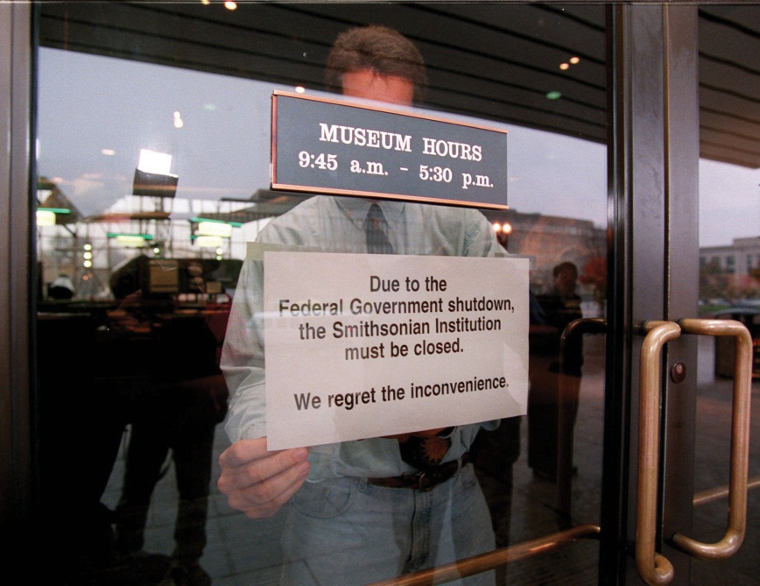
During the 1995–96 government shutdown caused by a deadlock over the federal budget between Democrats in the White House and Republicans in Congress, the news media prominently featured images of closed government facilities like the Washington Monument, the Smithsonian Institution, and many national parks. These reminders of what the federal bureaucracy provides led public opinion to pressure the Republicans to back down.
Source: Used with permission from AP Photo/Doug Mills.
Federal bureaucrats are sensitive to media content because they have few gauges of public opinion apart from what is in the news. A revealing survey by the Pew Research Center for the People and the Press interviewed members of Congress, presidential appointees, and civil servants in the Senior Executive Service. These officials all said they were heavy consumers of the news. When asked about their principal sources of information on how the public feels about issues—and allowed multiple responses—an overwhelming majority of presidential appointees and civil servants cited the media as their main source of information about public opinion. ^{[12]}
Bureaucrats not only respond to but try to craft media content that will serve their interests. When agency personnel note public distrust, they do not say that the answer is to engage in dialogue with the public so much as explaining effectively the good jobs they see themselves as already performing. ^{[13]} As a result, most agency websites avoid the huge potential of the Internet for interactivity. Instead, they are designed to make it easier for the agency to communicate with the public than the other way around. ^{[14]}
When the news media do spotlight a particular agency, this attention often makes the wheels of bureaucracy turn fast and be more responsive to public opinion. Positive coverage provides an opportunity for an agency to further its public image and enhance its programs. Even more strongly negative coverage, such as the Obama administration’s response to the revelations about MMS, becomes a prod to do something to get the bad news off the front page. Either way, news coverage speeds up decision making by pushing it to higher levels of officials. ^{[15]}

KEY TAKEAWAYS
Agencies need the media for external and internal communication. They try to maintain and enhance their independence and power by fostering public approval that makes it hard for the president and Congress to challenge decisions or to cut budgets. Agencies pursue such approval by seeking positive images in the media of themselves and the programs they run. Reporters rely on official spokespersons and leaks. Media depictions encourage Americans to scorn the bureaucracy but value individual bureaucrats and programs. They motivate agencies to anticipate the needs of news in their decision making and to speed up their policymaking processes.

EXERCISES
- In what sense do government agencies and the media need each other? In what ways do their interests differ?
- Why do you think the public tends to believe the federal bureaucracy is too large, even though it generally has a favorable opinion of most government agencies? Why might the media help create this impression in the public?

Civic Education
The Lesson of Room 421
In 2003, a class of fifth grade students at Byrd Academy, a school in Chicago’s Cabrini-Green housing project, took on the city’s bureaucracy in an effort to improve conditions at their dilapidated school. Byrd Academy was a magnet school for students with high academic credentials who lived in one of the most rundown and crime-ridden neighborhoods in the city. The students’ ultimate goal was the building of the new school that had been promised—a sign announcing the planned construction was visible from their classroom window.
Their teacher, Brian Schultz, encouraged the class to take part in Project Citizen, a program that stresses working together to get government to act on a problem. The students identified the difficulties with their current facility, developed a series of concrete action plans, conducted research to support their position, and began a fund-raising campaign. They placed their need for a new facility within the larger context of the difficulties facing their community. They wrote letters and sent e-mails to public officials, earned the support of high-profile figures, including Ralph Nader, and enlisted over nine hundred students from other schools to take up their cause. They circulated petitions, including an online version that was signed by thousands of people. The students appeared before the city council. They worked different bureaucratic avenues, including city officials charged with education, buildings and facilities, and finances.
The students engaged the media in a variety of ways to draw attention to their campaign for a new school. They sent press releases to local and national media, which generated television and newspaper coverage. They did interviews and wrote pieces that were published in print and online. They documented their progress on a website that served as a resource for journalists. They created a video documentary titledSpectacular Things Happen Along the Way, which they posted on video-sharing sites such as YouTube and linked to on websites.
Not all actions end in success. Despite the best efforts of the students in Room 421, Byrd Academy was closed down, and no new school was built. Still, some good things came out of the experience. The students were relocated to schools for the gifted and talented throughout the city. They went on to relate their story to other groups and inform people about how to work the bureaucracy. Some became involved in other projects to improve their community that were successful. ^{[16]}

[1] Stephen Hess, The Government/Press Connection: Press Officers and their Offices (Washington, DC: Brookings, 1984), 17.
[2] Stephen Hess, The Government/Press Connection: Press Officers and their Offices (Washington, DC: Brookings, 1984), 55–56.
[3] Lawrence H. Suid, Guts and Glory: The Making of the American Military Image in Film (Lexington: University Press of Kentucky, 2002).
[4] On the State Department’s noon briefings as policymaking occasions, see Stephen Hess, The Government/Press Connection: Press Officers and their Offices(Washington, DC: Brookings, 1984). On the role of news in an agency’s internal communication, see Doris A. Graber, The Power of Communication: Managing Information in Public Organizations (Washington, DC: CQ Press, 2003), chap. 8.
[5] These excerpts are taken from the videotape of the February 21, 1991, ABC News broadcast available through the Vanderbilt Television News Archive. Emphases are in the original broadcast.
[6] Ian Urbina, “U.S. Said to Allow Drilling Without Needed Permits, New York Times, May 13, 2010, A1.
[7] Erik Lipton and John M. Broder, “Regulators’ Warnings Weren’t Acted On,”New York Times, May 8, 2010, A12.
[8] Ian Urbina, “In Gulf, It Was Unclear Who Was in Charge of Oil Rig,” New York Times, June 5, 2010, A1.
[9] Mary L. Kendall, “Investigative Report—Island Operating Company, et al.,” U.S. Department of the Interior, Office of Inspector General, March 31, 2010, posted to web May 25, 2010, accessed November 11, 2010,http://abcnews.go.com/images/Politics/MMS_inspector_general_report_pdf.pdf.
[10] John M. Broder, “Rules Tighten for Oil Regulators to Avoid Favoritism to Drillers,” New York Times, September 1, 2010, A14.
[11] Lloyd Fair and Hadley Cantril, The Political Beliefs of Americans (New York: Free Press, 1967); and Albert H. Cantril and Susan Davis Cantril, Reading Mixed Signals: Ambivalence in American Public Opinion Toward Government(Washington, DC: Woodrow Wilson Center Press, 1999).
[12] Pew Research Center on the Press and the Public, “Washington Leaders Wary of Public Opinion: Public Appetite for Government Misjudged,” news release, April 17, 1998, http://www.people-press.org/leadrpt.htm with questionnaire results at http://www.people-press.org/leadque.htm.
[13] Pew Research Center on the Press and the Public, “Washington Leaders Wary of Public Opinion: Public Appetite for Government Misjudged,” April 17, 1998, http://www.people-press.org/leadrpt.htm.
[14] Darrell M. West, Digital Government: Technology and Public Sector Performance (Princeton, NJ: Princeton University Press, 2005), 179.
[15] Martin Linsky, Impact: How the Press Affects Federal Policy Making (New York: Norton, 1988), 97.
[16] Brian D. Schultz, Spectacular Things Happen Along the Way (New York: Teachers College Press, 2008).

14.4 Recommended Reading
Fenno, Richard F., Jr. The President’s Cabinet. Cambridge, MA: Harvard University Press, 1959. The best study of how cabinet secretaries “go native.”
Golden, Marissa Martino. What Motivates Bureaucrats? New York: Columbia University Press, 2000. An illuminating study of four agencies amid Reagan’s administrative presidency.
Goodsell, Charles T. The Case for Bureaucracy: A Public Administration Polemic, 4th ed. Washington, DC: CQ Press, 2004. A corrective to misconceptions about government bureaucracies.
Heclo, Hugh. A Government of Strangers. Washington, DC: Brookings Institution, 1977. The classic guide to the relationship between political appointees and civil servants.
Hess, Stephen. The Government/Press Connection. Washington, DC: Brookings Institution, 1984. A penetrating, readable account of press operations in the bureaucracy, comparing four disparate agencies.
Light, Paul C. The True Size of Government. Washington, DC: Brookings Institution, 1999. An innovative look at how bureaucratic tasks grow even as the civil service stays small.
Wilson, James Q. Bureaucracy: What Government Agencies Do and Why They Do It. New York: Basic Books, 2000. An examination of the bureaucracy from “the bottom up” that synthesizes experiences from examples.

14.5 Recommended Viewing
Apollo 13 (1995). A jeopardized NASA moon mission saved by bureaucratic ingenuity.
Catch-22 (1970). Joseph Heller’s classic tale of army bureaucracy gone awry.
A Certain Kind of Death (2003). A remarkable documentary showing the bureaucrats of the Los Angeles Coroner’s Office efficiently and effectively at work.
Dr. Strangelove (1964). The ultimate dark comedy: how a bureaucracy unravels after a demented general named Jack D. Ripper sends jets to drop nuclear bombs on the Soviet Union.
The Right Stuff (1983). An elegy for the passing of the era of the lone hero of the desert test pilot and its succession by politics-bedazzled and publicity-minded astronautics.
Top Gun (1986). Probably the most famous hit movie as military recruiting poster. Tom Cruise plays a wild-living American who settles down and grows up to be a navy pilot.
Welfare (1975). The great fly-on-the-wall documentarian Frederick Wiseman’s inspection of the welfare system and how it affects well-meaning civil servants and welfare recipients alike.
Well-Founded Fear (2000). A brilliantly revealing documentary showing how Immigration and Naturalization Service (INS) officers interview people seeking political asylum to the United States and decide their fate.

Chapter 15

The Courts

Preamble
A brief item in the Washington Post titled “A Nation of Stooges” reported that, in a nationwide poll, fewer than 50 percent of Americans could name one justice of the Supreme Court and only 17 percent could name three. In contrast, 59 percent of the people could identify the character names of the comedic trio The Three Stooges. ^{[1]}
This is the kind of cute item the media relish reporting; they have, as noted in the aforementioned article, fun with “new facts and hot stats from the social sciences.” But the comparison is unfair. The Stooges appeared in close to two hundred short movies still shown on television. Years after their deaths, they remain cult figures with apparel, toys, and candy merchandised in their name. In contrast, Supreme Court justices usually crave anonymity, avoid publicity, keep cameras out of their courtroom, and rarely appear on television.
In fact, the public’s knowledge of the Supreme Court and the justices is greater than most surveys indicate. ^{[2]} Moreover, the media are much to blame that it is not higher: their coverage of the Court is sparse compared to that of the president and Congress.

[1] Richard Morin, “A Nation of Stooges,” Washington Post, October 8, 1995, C5.
[2] James L. Gibson and Gregory A. Caldeira, Citizens, Courts and Confirmations: Positivity Theory and the Judgments of the American People (Princeton, NJ: Princeton University Press, 2009).

15.1 The US Legal System

LEARNING OBJECTIVES
After reading this section, you should be able to answer the following questions:
- What are the differences between civil and criminal cases, and how are these cases usually resolved?
- How do the news and entertainment media depict trials?
- How are the federal courts organized?
- How does the Supreme Court work?
The American legal system handles a vast number of disputes and controversies. Our concern in this text is with civil and criminal cases, the main ways by which courts wield power and influence and make policy. ^{[1]}

Civil Cases
In civil cases, plaintiffs (people or organizations) initiate lawsuits against defendants; courts resolve disputes by deciding or mediating between the two sides. Civil cases can involve money, contracts, property, personal injury, divorce, or child custody. “I’ll sue you” is a threat to instigate a civil action.
The vast majority of civil cases, some seventeen million annually, are filed in state courts, compared to around four hundred thousand in federal courts. State and federal laws establish the type of civil cases their courts can hear. For example, because there is no federal divorce law, all divorce cases are heard in state courts; because Social Security is a federal program, all civil disputes involving it are heard in federal courts.
Because of their costs and the often lengthy delays until they are heard in court, only about 1.3 percent of civil suits filed go to trial. Most civil cases are resolved by other means, such as settlements, plea deals, mediation, or arbitration.

Criminal Cases
Criminal cases are initiated by the government. They run the gamut from misdemeanors, such as trespassing and disorderly conduct, to felonies, such as armed robbery, rape, and murder. Unlike civil cases, criminal cases can result in the loss of liberty: a jail sentence. Around seven million people in the United States are either in prison, on probation, or on parole for crimes committed.
Most criminal laws are passed by states, and the vast majority of criminal cases originate in state courts: roughly twenty-one million criminal cases annually, compared to about seventy-six thousand in federal courts.
Around 27 percent of the criminal cases heard in federal courts involve alleged violations of federal drug laws. Often requiring mandatory sentences without parole, these federal laws are much tougher than state laws, so it makes an enormous difference whether a drug offense case is tried in a federal or state court.
Only about 4 percent of criminal cases are decided by trial. Prosecutors drop, or do not continue with charges, on another 25 percent. Most of the rest are resolved by guilty pleas without going to trial. Even for murder or manslaughter, a majority of defendants plead guilty. This often entails aplea bargain, in which defendants plead guilty in exchange for a reduced charge. The judge must approve the plea bargain.
Except for affluent defendants with high-powered and well-paid attorneys, people involved in criminal cases have an incentive to plea bargain. Defendants who insist on going to trial face sentences that can be far longer than those received by defendants who plead guilty and cooperate with the government. For lawyers and judges, plea bargains save both time and trial costs and also lighten their workloads. Because so many plead guilty, forty-seven million Americans have criminal records. ^{[2]}

Media Depictions of Trials
Dubbed “tabloid justice,” news depictions of the criminal justice system, especially on cable television, focus on dramatic, sensational, and lurid cases. ^{[3]} A notorious instance was the Duke University lacrosse team rape story, which provoked a prodigious amount of often erroneous news coverage as well as outrageous opinions and judgments (notoriously from television commentator Nancy Grace) from March 2006 until April 2007, when all charges against the students were dropped and the case dismissed.
The types of cases receiving excessive and inflammatory coverage include those of a basketball star (Kobe Bryant) charged with rape; an actor (Robert Blake) accused of killing his wife; a decorating diva (Martha Stewart) charged with lying to the FBI; a pop star (Michael Jackson) accused of molesting children; and a mother (Casey Anthony) accused of killing her daughter. The media want, as the chief executive of truTV (formerly Court TV) put it, “the type of trials that have all the melodrama of a soap opera.” ^{[4]}
Figure 15.1 Judge Judy and Judge Joe Brown
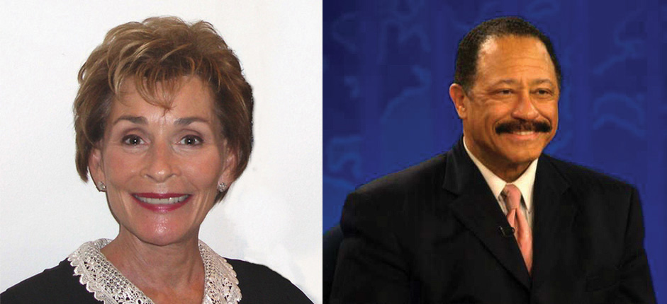
Many people’s understanding of and opinions about courts are based on watching television’s fictional judges.
Source: Photo (left) courtesy of Susan Roberts,http://commons.wikimedia.org/wiki/File:Judge_Judy.jpg. Photo (right) courtesy of Phil Konstantin,http://en.wikipedia.org/wiki/File:Joebrown.jpg.
Even trials covered live on television may be unrealistic examples of how the US criminal justice system operates. The trial of O. J. Simpson, accused of the murder of his ex-wife and a friend of hers, attracted huge attention from the news media and the public during the mid-1990s. Simpson was a celebrity defendant with sufficient wealth to hire a cast of attorneys and undergo a lengthy trial. In reality, most criminal trials take little time. The Los Angeles Superior Court disposed of nearly fifty-two thousand cases between the time of Simpson’s arrest and his acquittal. ^{[5]}
Trials are a staple of entertainment drama. ^{[6]}Many television series and their spin-offs involve trials. These shows differ drastically from the reality of courts and trials through the addition of drama and emotion: the highlights of cross-examination, attorneys browbeating witnesses and making speeches, and the guilty confessing. They rarely contain procedural elements, and the issues of “jurisdiction, notices to defendants, pleadings, discovery, and choice of a judge or jury trial, all of which can be argued, replied to, and motioned against.” ^{[7]} As David E. Kelley, creator of The Practice and a former lawyer said, “I am writing the world of law in the way I would like it to be. It’s all a conceit, because most trials are boring.” ^{[8]}
Relatedly, trial judges are usually portrayed on television as legitimate and judicious, and their decisions almost always as correct. Consider the pseudorealistic television courtroom shows represented by Judge Judy andJudge Joe Brown.
The prevalence of courtroom shows is a testament to their appeal and to television’s need for cheap and relatively easy-to-produce programming. Frequent viewers believe that judges should—as these “judges” do—ask questions, be aggressive with litigants, express views about their testimony, and make known their opinions about the outcome of the cases.^{[9]} This is, in fact, the opposite of how most real judges behave.

Organization of the Federal Courts
The first sentence of Article III of the US Constitution created the US Supreme Court—a major innovation. The Articles of Confederation made no provision for a federal judiciary, only for courts created and controlled by the states.
Article III also gave Congress the authority to create lower federal courts. After the Constitution was ratified in 1789, Congress quickly did so through the Judiciary Act of 1789.

Link
The Judiciary Act
Learn more about the Judiciary Act of 1789 online athttp://www.loc.gov/rr/program/bib/ourdocs/judiciary.html.

The Federal District and Appeals Courts
There are 94 federal district courts staffed by 667 permanent and several temporary judges. Every state has at least one district with a district court in it responsible for hearing cases that arise within that geographic area.
Above the district courts are the federal courts of appeal. They decide whether or not district courts have made an error in conducting a trial. Judges on appeal courts base their rulings on written and oral legal arguments presented by lawyers for each side. There are no witnesses, no testimony, and no jury. Appellate courts answer questions of law rather than questions of fact.
There are currently thirteen courts of appeals, twelve of them based on geographic districts called “circuits.” There are eleven numbered circuits, each of which has jurisdiction over several states. No state straddles more than one circuit.
There is a twelfth circuit for the District of Columbia (known as the “DC Circuit”). The thirteenth circuit is the court of appeals for the “Federal Circuit,” which hears appeals from US Courts of Federal Claims, International Trade, the Patent and Trademark Office, and others. There are approximately 179 judges on the courts of appeals.
A case in district court is usually presided over by one judge, whereas an appeal before a court of appeals is typically heard by a panel of three judges. A majority vote of the panel is necessary to overturn a lower-court ruling. The court of appeals issues a written ruling explaining its decision.
Every litigant in federal court has the right to appeal an unfavorable ruling from the district court. However, because it is expensive to appeal, only about 17 percent of eligible litigants do so. Moreover, higher courts hear few of the cases appealed and rarely reverse lower-court decisions. ^{[10]}

The Supreme Court
The Supreme Court, the nation’s highest tribunal, hears cases arising under the Constitution or the laws of the United States. The Constitution gives Congress the authority to set the number of Supreme Court justices, and it has changed the number several times. The Court started with five justices; it now has nine.
The Constitution does not stipulate any specific qualifications, not even a minimum age or legal training, for Supreme Court justices and other federal judges. Of the over one hundred individuals who have served on the Supreme Court, all except four women and two African American males have been white men.

How the US Supreme Court Works
Article III and the Eleventh Amendment of the Constitution require that the Supreme Court be the first court to hear certain types of cases. This original jurisdiction is limited to cases
- between the United States and one of the states,
- between two or more states,
- involving foreign ambassadors or other ministers,
- brought by one state against citizens of another state or against a foreign country.
Only about 1 percent of the Supreme Court’s cases fall under its original jurisdiction. The rest reach it as appeals from civil and criminal cases that have been decided by lower federal and by state courts. As the highest appellate court in the nation, the Supreme Court is the ultimate arbiter in many areas of the law.
If the case involves a federal question, an appeal can be made from the state’s appellate court of last resort to the US Supreme Court. A federal question exists if a state law is alleged to violate federal law (an act of Congress), a treaty ratified by the US Senate, or the US Constitution; or because something that state officials do is claimed to violate the Constitution or federal law. Grounds for appeal include evidence gathered from an unreasonable search and seizure, a coerced confession, and infringement of a constitutional right to a fair trial.
With rare exceptions, the Supreme Court has absolute control over the appeals it chooses to hear. Of the roughly eight thousand cases appealed to the Court every year, the justices typically agree to review a few hundred.
The justices normally decide around seventy of these with comprehensive written opinions during the Court’s annual term from October through late June to early July. The Court occasionally issues per curiam decisions: brief unsigned opinions, usually for cases it decides without oral argument.
The justices do not have to give any reasons for accepting or rejecting a case. Even after deciding to hear a case, they can change their minds and“DIG” (dismiss as improvidently granted) it: in other words, they say that they won’t decide the case after all, again without giving any reason.

Writ of Certiorari
Most cases reach the Court by way of a writ of certiorari. Certiorari is Latin for “to make more certain.” Litigants who receive an adverse ruling in the federal appeals courts or, in cases involving a federal question, from a state’s highest appellate court can submit a petition for a writ of certiorari to the Supreme Court, asking it to review the case.
It takes four of the nine justices to “grant cert.” This is called theRule of Four. If the Supreme Court does not grant cert, the lower court ruling is left standing. This does not mean that the Supreme Court agrees with that ruling, only that the Court has chosen not to review it.
When the Supreme Court grants cert, it is usually because four or more of the justices believe the case represents an important issue, such as an unresolved constitutional or statutory question on which they are interested in ruling. Sometimes disputes between different courts need to be resolved, or Congress and lower courts need the Court’s guidance on the Constitution. However, it is not unknown for justices to avoid granting cert to important cases because they do not want to rule on them. ^{[11]}

The Solicitor General
The case for cert is strengthened if it is backed by the solicitor general, the presidential appointee in the justice department responsible for presenting the position of the US government to the courts. The solicitor general screens cases before most agencies of the federal government can appeal them to the Court. Consequently, more than half of the Supreme Court’s workload comes from cases under the solicitor general. The justices pay special attention to the recommendations of the solicitor general, nicknamed “the 10th Justice” in the news.

Link
The Solicitor General’s Office
Visit the solicitor general’s office online at http://www.justice.gov/osg.

Briefs
When cert is granted, the lawyers for each side file a brief making their arguments. Others with a stake in the outcome of the case may, with the permission of the Court, each file an amicus curiae brief on behalf of one or the other parties to the case. (They may also persuade the Court to take a case.) These “friend of the court” briefs expose the justices to additional arguments and enable them, should they be so inclined, to gauge interest-group attention to a case and the amount of support from the different sides. ^{[12]}

Oral Arguments
After reviewing the briefs, the justices hear oral arguments, usually limited to an hour split equally between the sides. The justices often interrupt the attorneys with questions, probe arguments made in the briefs, and raise new issues; they may indicate their thinking about the case and possible decision. The arguments can be used by the justices to reach the legal and policy decisions that they prefer ^{[13]}—unless, that is, one side’s lawyer makes a more convincing argument than the other. ^{[14]} Oral arguments are the only public part of the Supreme Court’s work.

Link
Oral Arguments Heard by the Supreme Court
Find and listen to archived oral arguments online athttp://www.oyez.org.

Law Clerks
Each justice selects a few law clerks (usually four) to assist in researching cases, deciding which ones to accept, and drafting opinions. These clerks are usually honors graduates from the most prestigious law schools.
A clerkship betokens a promising future in the legal profession. Because the clerks’ work is confidential and rarely revealed, the extent of justices’ reliance on their clerks is uncertain. One former clerk writing about the Court charged that the justices granted “great and excessive power to immature, ideologically driven clerks, who in turn use that power to manipulate their bosses.” ^{[15]} Yet, most justices are so self-confident and versed in the law that it is hard to imagine them being led to make decisions against their will.

Opinions
Some time after oral arguments, the justices meet in a conference and vote in order of seniority, starting with the chief justice, on how the case should be decided.

Link
Supreme Court Decisions
Read archived Supreme Court decisions online athttp://www.findlaw.com/casecode/supreme.html.
The Supreme Court decides cases by majority rule: at least five of the nine justices need to agree for a majority opinion. They do not, however, have to agree on the reasons for their decision. It is possible for a majority to be composed of justices who agree on their rationale for the decision plus justices who join the decision (but for other reasons) and thus write a joint or individual concurring opinion. Justices who disagree with the majority opinion almost always write a dissenting opinion or join in a colleague’s dissenting opinion, explaining why they think the majority was wrong. On rare occasions, when a justice wants to make a dramatic statement arguing that the majority is profoundly wrong, she or he will read this written dissent aloud.
Figure 15.2 Conference Room of the Supreme Court
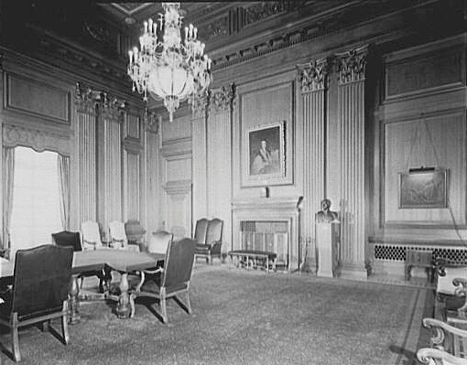
The intimacy of the Supreme Court is best captured by the conference room where the nine justices meet to vote on which cases to hear, to discuss opinions, and to decide cases. The junior member of the Court is responsible for opening and closing the doors.
Source: Photo by Theodor Horydczak,http://www.loc.gov/pictures/item/thc1995011442/PP/.
Bargaining and compromise sometimes ensue in an effort to create a majority coalition. ^{[16]} A study of justices’ conference notes concludes that the Court’s decisions come from “an intricate and shifting composite of law, politics, policy, principle, efficiency, expedience, pragmatism, dogmatism, reason, passion, detachment, individual personality, group psychology, institutional forces, and external pressures.” ^{[17]} To this list, we would add the desire for approval from social groups with which they identify or associate and from the legal community of law professors and law students.^{[18]}
The chief justice, if voting with the majority, determines who will write its opinion. Thus many of the Court’s most important decisions are penned by the chief justice. If the chief justice is not in the majority, the justice in the majority who has served on the Court the longest takes on the assignment.

KEY TAKEAWAYS
Coverage of most criminal cases is decided by plea bargains. A few trials attract abundant coverage in news and entertainment media, which depict them unrealistically. The federal court system consists of ninety-four district courts, with at least one in each state, and thirteen appeals courts, each one with jurisdiction over several states. At the top of the judicial system is the Supreme Court. The Supreme Court’s decisions entail briefs, oral arguments, conferences, clerks, and opinions.

EXERCISES
- Why do you think the media devotes more coverage to the president and to Congress than to the Supreme Court? What impression of our legal system do you get from the media?
- Why do you think our legal system makes a distinction between civil and criminal cases? What are the key differences between the two types of cases?
- How many Supreme Court decisions can you name? How might your life be different if those cases had been decided differently?

[1] Patricia Ewick and Susan S. Silbey, The Common Place of Law (Chicago: University of Chicago Press, 1998), 18–19.
[2] Amy Beach, Ordinary Injustice: How America Holds Court (New York: Metropolitan, 2009).
[3] Richard L. Fox, Robert W. Van Sickel, and Thomas L. Steiger, Tabloid Justice: Criminal Justice in an Age of Media Frenzy, 2nd ed. (Boulder, CO: Lynne Rienner Publishers, 2007).
[4] Quoted in Lola Ogunnaike, “As Court TV Gets Even Bolder, So Does Its Star,”New York Times, December 2, 2004, B1.
[5] “Simpson Trial and Trivia,” US News & World Report, October 15, 1995, 43.
[6] See Timothy O. Lenz, Changing Images of Law in Film & Television Crime Stories (New York: Peter Lang, 2003); and Anthony Chase, Movies on Trial: The Legal System on the Silver Screen (New York: New Press, 2002).
[7] Wende Vyborney Dumble, “And Justice for All,” in Television Studies, ed. Gary Burns and Robert J. Thompson (Westport, CT: Praeger, 1989), 106.
[8] Thane Rosenbaum, “Where Lawyers with a Conscience Get to Win Cases,”New York Times, May 12, 2002, AR 23.
[9] Kimberlianne Podlas, “Should We Blame Judge Judy? The Messages TV Courtrooms send Viewers,” Judicature 86, no. 1 (July–August 2002): 38–43.
[10] Donald R. Songer, Reginald S. Sheehan, and Susan B. Haire, Continuity and Change on the United States Courts of Appeals (Ann Arbor: University of Michigan Press, 2000).
[11] Lisa A. Kloppenberg, Playing It Safe: How the Supreme Court Sidesteps Hard Cases and Stunts the Development of Law (New York: New York University Press, 2001).
[12] Paul M. Collins Jr., Friends of the Court: Interest Groups and Judicial Decision Making (New York: Oxford University Press, 2008).
[13] Timothy R. Johnson, Oral Arguments and Decision Making on the United States Supreme Court (Albany: State University of New York Press, 2004).
[14] Timothy R. Johnson, Paul J. Wahlbeck, James F. Spriggs II, “The Influence of Oral Arguments on the U.S. Supreme Court,” American Political Science Review100 (February 2006): 99–113.
[15] Edward Lazarus, Closed Chambers: The First Eyewitness Account of the Epic Struggles Inside the Supreme Court (New York: Times Books, 1998), 6.
[16] The classic early study of such bargaining is Walter Murphy’s Elements of Judicial Strategy (Chicago: University of Chicago Press, 1964); see also Forrest Maltzman, James F. Spriggs II, and Paul J. Wahlbeck, Crafting Law on the Supreme Court (New York: Cambridge University Press, 2000); and Saul Brenner and Joseph W. Whitmeyer, Strategy on the United States Supreme Court (New York: Cambridge University Press, 2009).
[17] Del Dickson, ed., The Supreme Court in Conference (1940–1985): The Private Discussions Behind Nearly 300 Supreme Court Decisions (New York: Oxford University Press, 2001), xxvii.
[18] Lawrence Baum, Judges and Their Audiences: A Perspective on Judicial Behavior (Princeton, NJ: Princeton University Press, 2006).

15.2 Power of the US Supreme Court

LEARNING OBJECTIVES
After reading this section, you should be able to answer the following questions:
- What is judicial review?
- Why is Marbury v. Madison important?
- What is judicial power and how is it constrained?
- What are the leading judicial philosophies?
In Federalist No. 78, Alexander Hamilton described the courts as “the least dangerous” branch of government. Yet, they do possess considerable power. For example, because of the Court’s 5–4 decision in 2002, the more than seven million public high school students engaged in “competitive” extracurricular activities—including cheerleading, Future Farmers of America, Spanish club, and choir—can be required to submit to random drug testing. ^{[1]}

Judicial Review
The federal courts’ most significant power is judicial review. Exercising it, they can refuse to apply a state or federal law because, in their judgment, it violates the US Constitution.

Marbury v. Madison
Judicial review was asserted by the US Supreme Court in 1803 in the decision of Chief Justice John Marshall in the case of Marbury v. Madison(5 US 137, 1803).
Figure 15.3 John Marshall
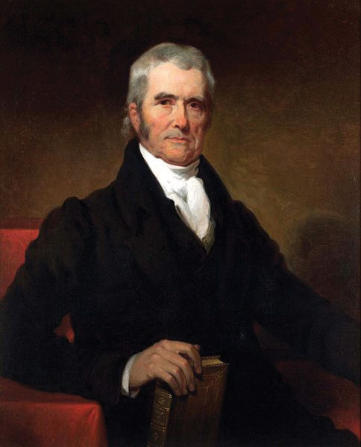
Marshall was chief justice of the Supreme Court from 1801 to 1835 and the author of many decisions, including Marbury v. Madison.
Source: Painting by Henry Inman,http://commons.wikimedia.org/wiki/File:John_Marshall_by_Henry _Inman,_1832.jpg.
After losing the election of 1800, John Adams made a flurry of forty-two appointments of justices of the peace for Washington, DC in the last days of his presidency. His purpose in doing so was to ensure that the judiciary would remain dominated by his Federalist party. The Senate approved the appointments, and Secretary of State John Marshall stamped the officials’ commissions with the Great Seal of the United States. But no one in the outgoing administration delivered the signed and sealed commissions to the appointees. The new president, Thomas Jefferson, instructed his secretary of state, James Madison, not to deliver them. One appointee, William Marbury, sued, asking the Supreme Court to issue a writ of mandamus, a court order requiring Madison to hand over the commission.
The case went directly to the Supreme Court under its original jurisdiction. John Marshall was now chief justice, having been appointed by Adams and confirmed by the Senate. He had a dilemma: a prominent Federalist, he was sympathetic to Marbury, but President Jefferson would likely refuse to obey a ruling from the Court in Marbury’s favor. However, ruling in favor of Madison would permit an executive official to defy the provisions of the law without penalty.
Marshall’s solution was a political masterpiece. The Court ruled that Marbury was entitled to his commission and that Madison had broken the law by not delivering it. But it also ruled that the part of the Judiciary Act of 1789 granting the Court the power to issue writs of mandamus was unconstitutional because it expanded the original jurisdiction of the Supreme Court beyond its definition in Article III; this expansion could be done only by a constitutional amendment. Therefore, Marbury’s suit could not be heard by the Supreme Court. The decision simultaneously supported Marbury and the Federalists, did not challenge Jefferson, and relinquished the Court’s power to issue writs of mandamus. Above all, it asserted the prerogative of judicial review for the Supreme Court. ^{[2]}

Judicial Review Assessed
For forty years after Marbury, the Court did not overturn a single law of Congress. And when it finally did, it was the Dred Scott decision, which dramatically damaged the Court’s power. The Court ruled that people of African descent who were slaves (and their descendants, whether or not they were slaves) were not protected by the Constitution and could never be US citizens. The Court also held that the US Congress had no authority to prohibit slavery in federal territories. ^{[3]}
The pace of judicial review picked up in the 1960s and continues to this day. The Supreme Court has invalidated an average of eighteen federal laws per decade. The Court has displayed even less compunction about voiding state laws. For example, the famous Brown v. Board of Education of Topeka, Kansas desegregation case overturned statutes from Kansas, Delaware, South Carolina, and Virginia that either required or permitted segregated public schools. The average number of state and local laws invalidated per decade is 122, although it has fluctuated from a high of 195 to a low for the period 2000–2008 of 34. ^{[4]}
Judicial review can be seen as reinforcing the system of checks and balances. It is a way of policing the actions of Congress, the president, and state governments to make sure that they are in accord with the Constitution. But whether an act violates the Constitution is often sharply debated, not least by members of the Court.

Constraints on Judicial Power
There are three types of constraints on the power of the Supreme Court and lower court judges: they are precedents, internal limitations, and external checks.

Ruling by Precedent
Judges look to precedent, previously decided cases, to guide and justify their decisions. They are expected to follow the principle of stare decisis, which is Latin for “to stand on the decision.” They identify the similarity between the case under consideration and previous ones. Then they apply the rule of law contained in the earlier case or cases to the current case. Often, one side is favored by the evidence and the precedents.
Precedents, however, have less of an influence on judicial power than would be expected. According to a study, “justices interpret precedent in order to move existing precedents closer to their preferred outcomes and to justify new policy choices.” ^{[5]}
Precedents may erode over time. The 1954 Brown school desegregation decision overturned the 1896 Plessy decision that had upheld the constitutionality of separate but equal facilities and thus segregation. ^{[6]} Or they may be overturned relatively quickly. In 2003, the Supreme Court by 6–3 struck down a Texas law that made homosexual acts a crime, overruling the Court’s decision seventeen years earlier upholding a similar antisodomy law in Georgia. The previous case “was not correct when it was decided, and it is not correct today,” Justice Kennedy wrote for the majority. ^{[7]}
Judges may disagree about which precedents apply to a case. Consider students wanting to use campus facilities for prayer groups: if this is seen as violating the separation of church and state, they lose their case; if it is seen as freedom of speech, they win it. Precedents may allow a finding for either party, or a case may involve new areas of the law.

Internal Limitations
For the courts to exercise power, there must be a case to decide: a controversy between legitimate adversaries who have suffered or are about to suffer in some way. The case must be about the protection or enforcement of legal rights or the redress of wrongs. Judges cannot solicit cases, although they can use their decisions to signal their willingness to hear (more) cases in particular policy areas.
Judges, moreover, are expected to follow the Constitution and the law despite their policy preferences. In a speech to a bar association, Supreme Court Justice John Paul Stevens regretted two of his majority opinions, saying he had no choice but to uphold the federal statutes. ^{[8]} That the Supreme Court was divided on these cases indicates, however, that some of the other justices interpreted the laws differently.
A further internal limitation is that judges are obliged to explain and justify their decisions to the courts above and below. The Supreme Court’s written opinions are subject to scrutiny by other judges, law professors, lawyers, elected officials, the public, and, of course, the media.

External Checks on Power
The executive and legislative branches can check or try to check judicial power. Through their authority to nominate federal judges, presidents influence the power and direction of the courts by filling vacancies with people likely to support their policies.
They may object to specific decisions in speeches, press conferences, or written statements. In his 2010 State of the Union address, with six of the justices seated in front of him, President Obama criticized the Supreme Court’s decision that corporations have a First Amendment right to make unlimited expenditures in candidate elections. ^{[9]}
Presidents can engage in frontal assaults. Following his overwhelming reelection victory, President Franklin D. Roosevelt proposed to Congress in February 1937 that another justice be added to the Supreme Court for each sitting justice over the age of seventy. This would have increased the number of justices on the court from nine to fifteen. His ostensible justification was the Court’s workload and the ages of the justices. Actually, he was frustrated by the Court’s decisions, which gutted his New Deal economic programs by declaring many of its measures unconstitutional.
The president’s proposal was damned by its opponents as unwarranted meddling with the constitutionally guaranteed independence of the judiciary. It was further undermined when the justices pointed out that they were quite capable of coping with their workload, which was not at all excessive. Media coverage, editorials, and commentary were generally critical, even hostile to the proposal, framing it as “court packing” and calling it a “scheme.” The proposal seemed a rare blunder on FDR’s part. But while Congress was debating it, one of the justices shifted to the Roosevelt side in a series of regulatory cases, giving the president a majority on the court at least for these cases. This led to the famous aphorism “a switch in time saves nine.” Within a year, two of the conservative justices retired and were replaced by staunch Roosevelt supporters.
Congress can check judicial power. It overcomes a decision of the Court by writing a new law or rewriting a law to meet the Court’s constitutional objections without altering the policy. It can threaten to—and sometimes succeed in—removing a subject from the courts’ jurisdiction, or propose a constitutional amendment to undo a Court decision.
Indeed, the first piece of legislation signed by President Obama overturned a 5–4 Supreme Court 2007 decision that gave a woman a maximum of six months to seek redress after receiving the first check for less pay than her peers. ^{[10]} Named after the woman who at the end of her nineteen-year career complained that she had been paid less than men, the Lilly Ledbetter Fair Pay Act extends the period to six months after anydiscriminatory paycheck. It also applies to anyone seeking redress for pay discrimination based on race, religion, disability, or age.
The Constitution grants Congress the power to impeach judges. But since the Constitution was ratified, the House has impeached only eleven federal judges, and the Senate has convicted just five of them. They were convicted for such crimes as bribery, racketeering, perjury, tax evasion, incompetence, and insanity, but not for wrongly interpreting the law.
The Supreme Court may lose power if the public perceives it as going too far. Politicians and interest groups criticize, even condemn, particular decisions. They stir up public indignation against the Court and individual justices. This happened to Chief Justice Earl Warren and his colleagues during the 1950s for their school desegregation and other civil rights decisions.
Figure 15.4
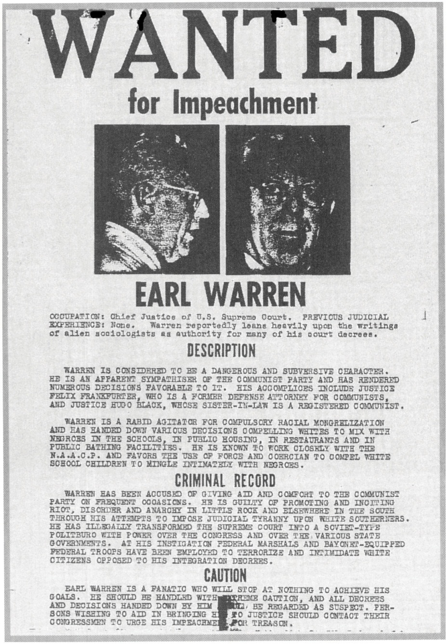
The controversial decisions of the Warren Court inspired a movement to impeach the chief justice.
Source: http://en.wikipedia.org/wiki/File:Impeach_Warren.png.
How the decisions and reactions to them are framed in media reports can support or undermine the Court’s legitimacy (Note 15.23 "Comparing Content").

Comparing Content
Brown v. Board of Education of Topeka, Kansas
How a decision can be reported and framed differently is illustrated by news coverage of the 1954 Supreme Court school desegregation ruling.
The New York Times of May 18, 1954, presents the decision as monumental and historic, and school desegregation as both necessary and desirable. Southern opposition is acknowledged but downplayed, as is the difficulty of implementing the decision. The front-page headline states “High Court Bans School Segregation; 9–0 Decision Grants Time to Comply.” A second front-page article is headlined “Reactions of South.” Its basic theme is captured in two prominent paragraphs: “underneath the surface…it was evident that many Southerners recognized that the decision had laid down the legal principle rejecting segregation in public education facilities” and “that it had left open a challenge to the region to join in working out a program of necessary changes in the present bi-racial school systems.”
There is an almost page-wide photograph of the nine members of the Supreme Court. They look particularly distinguished, legitimate, authoritative, decisive, and serene.
In the South, the story was different. The Atlanta Constitutionheadlined its May 18, 1954, story “Court Kills Segregation in Schools: Cheap Politics, Talmadge Retorts.” By using “Kills” instead of theTimes’s “Bans,” omitting the fact headlined in the Times that the decision was unanimous, and including the reaction from Georgia Governor Herman E. Talmadge, the Constitution depicted the Court’s decision far more critically than the Times. This negative frame was reinforced by the headlines of the other stories on its front page. “Georgia’s Delegation Hits Ruling” announces one; “Segregation To Continue, School Officials Predict” is a second. Another story quotes Georgia’s attorney general as saying that the “Ruling Doesn’t Apply to Georgia” and pledging a long fight.
The Times’ coverage supported and legitimized the Supreme Court’s decision. Coverage in the Constitution undermined it.
External pressure is also applied when the decisions, composition, and future appointments to the Supreme Court become issues during presidential elections. ^{[11]} In a May 6, 2008, speech at Wake Forest University, Republican presidential candidate Senator John McCain said that he would nominate for the Supreme Court “men and women with…a proven commitment to judicial restraint.” Speaking to a Planned Parenthood convention on July 17, 2007, Senator Barack Obama identified his criteria as “somebody who’s got the heart, the empathy, to recognize what it’s like…to be poor or African American or gay or disabled or old.”

Judges as Policymakers
Judges have power because they decide cases: they interpret the Constitution and laws, and select precedents. These decisions often influence, even make, public policy and have important ramifications for social conflict. For example, the Supreme Court has effectively established the ground rules for elections. In 1962 it set forth its “one person, one vote” standard for judging electoral districts. ^{[12]} It has declared term limits for members of Congress unconstitutional. It has upheld state laws making it extremely difficult for third parties to challenge the dominance of the two major parties. ^{[13]}

Judicial Philosophies
How willing judges are to make public policy depends in part on their judicial philosophies. ^{[14]} Some follow judicial restraint, deciding cases on the narrowest grounds possible. In interpreting federal laws, they defer to the views expressed in Congress by those who made the laws. They shy away from invalidating laws and the actions of government officials. They tend to define some issues as political questions that should be left to the other branches of government or the voters. When the Constitution is silent, ambiguous, or open ended on a subject (e.g., “freedom of speech,” “due process of law,” and “equal protection of the laws”), they look to see whether the practice being challenged is a long-standing American tradition. They are inclined to adhere to precedent.
Judicial restraint is sometimes paired with strict constructionism. Judges apply the Constitution according to what they believe was its original meaning as understood by a reasonable person when the Constitution was written.
Other judges follow a philosophy of judicial activism (although they may not call it that). Activist judges are willing to substitute their policy views for the policy actions or inaction of the other branches of government.
Judicial activism is often paired with loose constructionism, viewing the Constitution as a living document that the founders left deliberately ambiguous. In interpreting the Constitution, these judges are responsive to what they see as changes in society and its needs. A plurality of the Supreme Court found a right to privacy implicit in the Constitution and used it to overturn a Connecticut law prohibiting the use of contraceptives.^{[15]} The justices later used that privacy right as a basis for the famous Roe v. Wade decision, “discovering” a woman’s constitutional right to an abortion.
The distinction between judicial restraint and strict constructionism on the one hand and judicial activism and loose constructionism on the other can become quite muddy. In 1995, the Supreme Court, by a 5–4 vote, struck down the Gun-Free School Zone Act—an attempt by Congress to keep guns out of schools. ^{[16]} The ruling was that Congress had overstepped its authority and that only states had the power to pass such laws. This decision by the conservative majority, interpreting the Constitution according to what it believed was the original intentions of the framers, exemplified strict constructionism. It also exemplified judicial activism: for the first time in fifty years, the Court curtailed the power of Congress under the Constitution’s commerce clause to interfere with local affairs. ^{[17]}A 5–4 conservative majority has also interpreted the Second Amendment to prohibit the regulation of guns. ^{[18]} This decision, too, could be seen as activist.

Political Views in Action
One doesn’t have to believe that justices are politicians in black robes to understand that some of their decisions are influenced, if not determined, by their political views. ^{[19]} Judges appointed by a Democratic president are more liberal than those appointed by a Republican president on labor and economic regulation, civil rights and liberties, and criminal justice. ^{[20]}Republican and Democratic federal appeals court judges decide differently on contentious issues such as abortion, racial integration and racial preferences, church-state relations, environmental protection, and gay rights.
On rare occasions, the Supreme Court renders a controversial decision that graphically reveals its power and is seen as motivated by political partisanship. In December 2000, the Court voted 5–4, with the five most conservative justices in the majority, that the Florida Election Code’s “intent of the voter” standard provided insufficient guidance for manually recounting disputed ballots and that there was no time left to conduct recounts under constitutionally acceptable standards. ^{[21]} This ensured that Republican George W. Bush would become president.
The decision was widely reported and discussed in the media. Defenders framed it as principled, based on legal considerations. Critics deplored it as legally frail and politically partisan. They quoted the bitter comment of dissenting Justice Stevens: “Although we may never know with complete certainty the identity of the winner of this year’s presidential election, the identity of the loser is perfectly clear. It is the nation’s confidence in the judge as an impartial guardian of the rule of law.” ^{[22]}

KEY TAKEAWAYS
In this section, we have explained how judicial review originated, how it is exercised, and what its effects are. We described the power of the courts, especially of the Supreme Court, and how it may be constrained by precedent, internal limitations, and external pressures. Justices make policy and are influenced by their ideological views and judicial philosophies.

EXERCISES
- What role does judicial review play in our legal system? Why might it be important for the Supreme Court to have the power to decide if laws are unconstitutional?
- In Marbury v. Madison, how did Chief Justice Marshall strike a balance between asserting the Supreme Court’s authority and respecting the president’s authority? Do you think justices should take political factors into account when ruling on the law?
- Why do you think it might be important for judges to follow precedent? What do you think would happen if judges decided every case differently?
- Which of the four judicial philosophies described in the text makes the most sense to you? What do you think the advantages and disadvantages of that philosophy might be?

[1] Board of Education v. Earls, 536 US 822 (2002).
[2] This discussion is based in part on Jean Edward Smith, John Marshall: Definer of a Nation (New York: Holt, 1996), introduction and chap. 13. For an analysis of the distinction between judicial review and judicial supremacy (the obligation of officials to follow the Court’s reasoning in the future), and the politics involved in the latter, see Keith E. Whittington, Political Foundations of Judicial Supremacy: The Presidency, the Supreme Court, and Constitutional Leadership in US History(Princeton, NJ: Princeton University Press, 2007).
[3] Dred Scott v. Sandford, 60 US 393 (1857).
[4] Lawrence Baum, The Supreme Court, 10th ed. (Washington, DC: CQ Press, 2010).
[5] Thomas G. Hansford and James F. Spriggs II, The Politics of Precedent on the U.S. Supreme Court (Princeton, NJ: Princeton University Press, 2006), 130.
[6] Plessy v. Ferguson, 153 US (1896); Brown v. Board of Education of Topeka, Kansas, 347 US 484 (1954).
[7] The earlier case was Bowers v. Hardwick, 478 US 1861 (1986); it was overruled by Lawrence v. Texas, 02-102 (2003).
[8] Linda Greenhouse, “Justice Weighs Desire v. Duty (Duty Prevails),” New York Times, August 25, 2005, A1.
[9] Citizens United v. Federal Election Commission, 558 US 50 (2010), discussed inChapter 11 "Campaigns and Elections".
[10] Ledbetter v. Goodyear Tire & Rubber Co. 550 US (2007).
[11] Donald Grier Stephenson Jr., Campaigns and the Court: The U.S. Supreme Court in Presidential Elections (New York: Columbia University Press, 1999).
[12] Baker v. Carr, 369 US 186 (1962).
[13] See David K. Ryden, ed., The U.S. Supreme Court and the Electoral Process(Washington, DC: Georgetown University Press, 2000), especially the editor’s “Overview,” 1–4.
[14] For the argument that the justices’ behavior is largely determined by their individual policy preferences, see Jeffrey A. Segal and Harold J. Spaeth, The Supreme Court and the Attitudinal Model Revisited (New York: Cambridge University Press, 2002); see also Brian Z. Tamanaha, Beyond the Formalist-Realist Divide: The Role of Politics in Judging (Princeton, NJ: Princeton University Press, 2009).
[15] Griswold v. Connecticut, 381 US 479 (1965).
[16] United States, Petitioner v. Alfonso Lopez, Jr., 514 US 549 (1995).
[17] In The Supreme Court and the American Elite, 1789–2008 (Cambridge, MA: Harvard University Press, 2009), Lucas A. Powe Jr. argues that the Court “serves ruling political coalitions” and attacks the conservative Rehnquist Court for overturning legislation that extended rights and privileges, and protected and improved society.
[18] The cases are District of Columbia et al. v. Heller, 554 US (2008) andMcDonald et al. v. City of Chicago et al. 561 US (2010).
[19] For the argument that there is nothing wrong with a political court or with political motives in constitutional adjudication, see Terri Jennings Peretti, In Defense of a Political Court (Princeton, NJ: Princeton University Press, 1999), 73.
[20] Robert A. Carp, Kenneth L. Manning, and Ronald Stidham, “President Clinton’s District Judges: ‘Extreme Liberals’ or Just Plain Moderates?” Judicature84, no. 5 (March–April 2001): 282–88; and “The Decision-Making Behavior of George W. Bush’s Judicial Appointees: Far-Right, Conservative, or Moderate?”Judicature 88, no. 1 (July–August 2004): 20–29.
[21] Bush v. Gore, 121 S. Ct. 525 (2000); also see David Margolick, Evgenia Peretz, and Michael Shnayerson, “The Path to Florida,” Vanity Fair, October 2004.
[22] Quoted in Linda Greenhouse’s analysis “Bush v. Gore: A Special Report; Election Case a Test and a Trauma for Justices,” New York Times, February 20, 2001, A1.

15.3 Selecting Federal Judges

LEARNING OBJECTIVES
After reading this section, you should be able to answer the following questions:
- What factors influence the selection of federal judges?
- What is the confirmation process?
- Under what circumstances are the media important in the confirmation (or not) of Supreme Court nominees?
- Why are some nominations unsuccessful and others successful?
The president nominates all federal judges, who must then be approved by the Senate. President George W. Bush’s nominees were screened by a committee of fifteen White House and justice department officials headed by the White House legal counsel. They looked for ideological purity, party affiliation, and agreement with the president on policy issues and often turned to the Federalist Society, a conservative lawyers’ group, for nominees.
The appointments of judges to the lower federal courts are important because almost all federal cases end there. ^{[1]} Through lower federal judicial appointments, a president “has the opportunity to influence the course of national affairs for a quarter of a century after he leaves office.”^{[2]}
Once in office, federal judges can be removed only by impeachment and conviction. Unless compelled to retire due to illness or incapacity, judges may time their departures so that their replacements are appointed by a president who shares their political views and policy preferences. ^{[3]}Supreme Court Justice Souter retired in 2009 and Justice Stevens retired in 2010, enabling President Obama to nominate, and the Democratic-controlled Senate to confirm, their successors.

Choosing Supreme Court Justices
In nominating Supreme Court justices, presidents seek to satisfy their political, policy, and personal goals. ^{[4]} They do not always succeed; justices sometimes change their views over time or may surprise the president from the start. “Biggest damfool mistake I ever made” said President Dwight D. Eisenhower about his appointment of Chief Justice Earl Warren, who led the Supreme Court’s liberal decisions on civil rights and criminal procedure.
The following are some other factors that can influence presidents’ choices of Supreme Court nominees: ^{[5]}
- Senate composition. Whether the president’s party has a majority or a minority in the Senate is a factor. In 1990, when the Democrats had a majority, Republican President George H. W. Bush nominated the judicially experienced and reputedly ideologically moderate David H. Souter, who was easily approved.
- Timing. The closer to an upcoming presidential election the appointment occurs, the more necessary it is to appoint a highly qualified, noncontroversial figure acceptable to the Senate, or at least someone senators would be reluctant to reject. Otherwise, senators have an incentive to stall until after the election, when it may be too late to obtain confirmation.
- Public approval of the president. The higher the president’s approval ratings, the more nominating leeway the president possesses. But even presidents riding a wave of popularity can fail to get their nominees past the Senate, as was the case with Richard Nixon and his failed nominations of Clement Haynesworth and G. Harrold Carswell in 1970. So lacking were Carswell’s qualifications that a senator defended him saying “Even if he were mediocre, there are a lot of mediocre judges and people and lawyers. They are entitled to a little representation…and a little chance.” ^{[6]}
- Interest groups. Nominees must usually be acceptable to interest groups that support the president and invulnerable (or at least resistant) to being depicted negatively—for example, as ideological extremists—by opposition groups, in ways that would significantly reduce their chances of Senate approval.
Nominations go to the Senate Judiciary Committee, which usually holds hearings. Whether senators should concern themselves with anything more than the nominee’s professional qualifications is often debated. Arguably, “nothing in the Constitution, historical experience, political practice, ethical norms, or statutory enactments prohibits senators from asking questions that reveal judicial nominees’ views on political and ideological issues.” ^{[7]}
The next step is for the Judiciary Committee to vote on whether or not to send the nomination to the Senate floor. If it reaches the floor, senators then can vote to confirm or reject the nomination, or filibuster so that a vote is delayed or does not take place. Fewer than half of recent nominees to the federal appeals courts have been confirmed. ^{[8]}

The Media and Supreme Court Nominees
Presidents have few opportunities to nominate Supreme Court justices, so the media provide intensive coverage of every stage of the nomination, from the time an incumbent justice leaves office until a replacement is confirmed by the Senate. The scrutiny is not necessarily damaging. President Clinton’s nominees, Ruth Bader Ginsberg and Stephen Breyer, enjoyed Senate confirmation by votes of 97–3 and 87–9, respectively.
Sometimes the media determine a nominee’s fate. President Reagan’s nominee Douglas H. Ginsburg withdrew when news stories reported that he had smoked marijuana with some of his Harvard Law School students. The media were also intimately involved with the fates of Robert H. Bork and Clarence Thomas, particularly through their coverage of the Senate Judiciary Committee’s hearings.

The Failed Nomination of Robert H. Bork
Bork was a distinguished lawyer who had taught at Yale University, served as solicitor general and acting attorney general of the United States, and was a judge on the US Court of Appeals for the DC Circuit. He opposed civil rights laws and such Supreme Court decisions as Roe v. Wade allowing abortion. More than three hundred, mostly liberal, interest groups publicly opposed him.
The anti-Bork coalition adroitly used the media against him. It barraged two thousand journalists and seventeen hundred editorial writers with detailed packets of material criticizing him. It sponsored television and newspaper advertisements attacking him and asking Americans to urge their senators to vote against him. ^{[9]}
Figure 15.5 Robert Bork with President Reagan
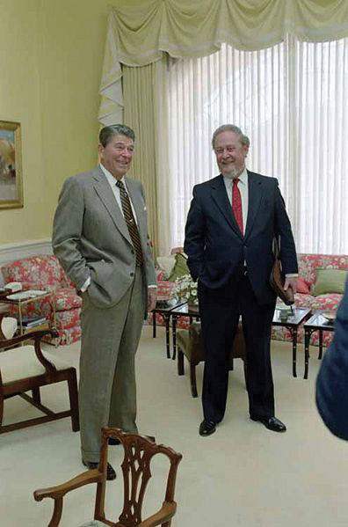
Self-confident at his public nomination by President Reagan, Bork would be defeated by the campaign waged against him by his opponents.
Source:http://commons.wikimedia.org/wiki/File:Reagan_with_Robert_Bork_1987.jpg.
The nominee, touted by his supporters as urbane, witty, and brilliant, contributed to his demise by the impression he made on national television during five contentious days, during which he candidly testified about his legal and political philosophy, defended his views on issues and cases, and responded to questions from members of the Senate Judiciary Committee. Having refused the practice sessions (known as “murder boards”) and coaching offered by the White House, the professorial, scraggly bearded Bork was outmaneuvered by his opponents on the committee, who came up with such sound bites—featured on the evening television news—as, “You are not a frightening man, but you are a man with frightening views.” ^{[10]}
The Senate rejected the nominee on October 23, 1987, by a vote of 58–42. The process generated a new verb in politics: “to bork,” which means to unleash a lobbying and public relations campaign, using and facilitated by the media.

Link
The Bork Hearings
Watch video of the Bork hearings online at http://www.c-spanarchives.org/program/994-2&showFullAbstract=1.

The Successful Nomination of Clarence Thomas
When a similar attack was waged against Clarence Thomas in the fall of 1991, the White House and the nominee’s defenders were ready with a highly organized public relations campaign.
President George H. W. Bush nominated Clarence Thomas for the seat of retiring Justice Thurgood Marshall. Both were African Americans. But in contrast to the liberal Democrat Marshall, Thomas was a conservative Republican. The nomination was opposed by leaders of liberal and feminist organizations, and supported by their conservative counterparts. It divided the civil rights community, which wanted an African American justice, but not one as conservative as Thomas.
Because the nomination was shrewdly announced on the Monday afternoon preceding the Fourth of July weekend, reporters had time to transmit only the favorable story, spoon-fed from the White House, of the nominee’s rise from poverty to prominence. Later, they reported some of his more controversial decisions during his one-year tenure as a federal appeals court judge.
News coverage of the nomination resumed with the Senate Judiciary Committee’s hearings during which Thomas, in contrast to Bork, steadfastly avoided taking clear stands on controversial issues. He had been advised by his White House advisors to “(1) stress his humble roots; (2) [not] engage Senators in ideological debate; and (3) stonewall on abortion.” ^{[11]} At the conclusion of the hearings, Senate confirmation seemed narrowly assured. Then law professor Anita Hill accused Thomas of having engaged in sexual improprieties when she worked for him at the Department of Education and the Equal Employment Opportunity Commission.
With the salacious accusations, media coverage skyrocketed, especially when the hearings reopened featuring Hill’s testimony and Thomas’s rebuttals. Entertainment media made light of the issue: on Saturday Night Live, Chris Rock observed that “if Clarence Thomas looked like Denzel Washington this thing would never have happened.” Thomas angrily accused his detractors of attempting “a high-tech lynching for uppity blacks.” In the end, most senators voted as they had been leaning prior to Hill’s testimony. Thomas was confirmed by a vote of 52–48.

Link
The Thomas Hearings
Watch the Thomas hearings online at http://www.c-spanarchives.org/program/Day1Part1.

Nomination of John G. Roberts Jr.
In July 2005, President George W. Bush made the first Supreme Court nomination in eleven years. He chose John G. Roberts Jr., a federal appeals court judge on the DC Circuit, to replace the moderate Republican Sandra Day O’Connor, who was retiring. Roberts was then nominated to be chief justice after the death of incumbent William H. Rehnquist.

Figure 15.6
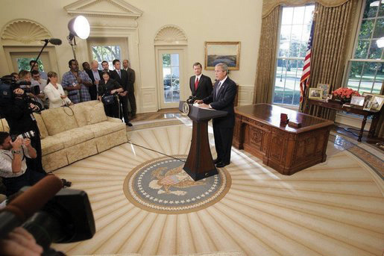
The media’s intense attention to Supreme Court nominees is caught in this photograph showing the gaggle of journalists around John G. Roberts as he meets with the president.
Source: Photo courtesy of the White House (Paul Morse),http://commons.wikimedia.org/wiki/File:Johnroberts3.jpeg.
During three days of testifying before the Senate Judiciary Committee, the erudite and engaging Roberts deflected questions by comparing judges to umpires and saying that he would be guided by the law. On September 29, 2005, the Republican-controlled Senate approved him as chief justice of the US Supreme Court by a vote of 78–22.

Link
John G. Roberts’ Opening Statement
Watch the opening statement of John G. Roberts online athttp://www.c-spanclassroom.org/Video/44/Judge+John+Roberts+Opening+Statement+at+Confirmation+Hearing+for+US+Chief+Justice.aspx.

Nominations of Harriet Miers and Samuel A. Alito Jr.
Bush next turned to fill Sandra Day O’Connor’s vacant seat. He was under pressure, even in public statements from his wife, to appoint a woman to succeed O’Connor. He nominated his White House general counsel and close friend, Harriet Miers. She had never served as a judge, had little expertise on constitutional matters, and held few reported positions on important issues.
Conservatives, including officeholders, interest-group leaders, columnists, pundits, and bloggers, rejected the president’s assurance that she was a candidate they could trust. Leaders of the Senate Judiciary Committee rejected her answers to their questions as “inadequate, insufficient and insulting.” Senators expressed doubts to the news media about her qualifications and knowledge of the Constitution. After twenty-four days of a ferocious barrage of criticism, all reported and amplified by the media, Ms. Miers withdrew from consideration.
President Bush then nominated a federal appeals court judge, Samuel A. Alito Jr. The judge had a record from his time in the Reagan administration and from fifteen years of judicial decisions of deferring to the executive branch, favoring business, and rejecting abortion rights.
In testifying before the members of the Senate Judiciary Committee, Judge Alito followed the stonewalling script. Nothing he said could be used against him by Democratic senators on the committee or by the media. A dramatic moment in his favor, shown on television, occurred when his wife, upset by the questioning directed at him, walked out of the hearings in tears. Soon after the hearings, Judge Alito was approved by 58–42 (54 Republicans plus 4 Democrats against 40 Democrats plus 1 Republican and 1 Independent).

Link
The Miers Nomination
Learn more about the Miers nomination online athttp://www.npr.org/series/4933926/harriet- miers-withdraws-as-high-court-nominee.
Learn more about the Alito nomination online athttp://www.npr.org/series/4982475/alito-s- supreme-court-nomination-confirmed.

Nominations of Sonia Sotomayor and Elena Kagan
When Justice Souter resigned from the Court, President Obama, making his first nomination, picked Sonia Sotomayor to replace him. Her confirmation hearings in July 2009 followed the script that had worked for Roberts and Alito. She refused to opine about cases or identify a judicial philosophy other than “fidelity to the law.” Sotomayor would be the first Hispanic and third woman ever appointed to the Court. She would not change its ideological balance, and there were no media revelations to derail her prospects. Since the Democrats had sixty votes in the Senate, it came as no surprise that she was confirmed by a vote of 68–31.
A similar pattern followed the resignation of Justice John Paul Stevens. Obama’s nominee, Solicitor General and former Dean of the Harvard Law School Elena Kagan, was unlikely to change the ideological balance on the Court. She, too, largely stonewalled the hearings and was confirmed by the Senate on August 5, 2010, by a vote of 63–37.

Link
The Sotomayor Nomination
Learn more about the Sotomayor nomination online athttp://www.npr.org/series/106462774/sonia- sotomayor-s-supreme-court-nomination.
Learn more about the Kagan nomination online athttp://www.npr.org/series/126664425/elena- kagan-s-supreme-court-nomination.

KEY TAKEAWAYS
Presidents usually look to nominate as federal judges people who share their ideological, policy, and partisan views. Nominations attract intense scrutiny from interest groups and the media and can be controversial and contentious. They are subject to confirmation by the Senate, which may delay, block, or approve them. We explain why the nominations of Robert H. Bork and Harriet Miers failed and why those of Clarence Thomas, John G. Roberts Jr., Samuel A. Alito Jr., Sonia Sotomayor, and Elena Kagan were successful.

EXERCISES
- What qualities do you think are important in Supreme Court justices? Do you think the confirmation process is a good way of selecting justices?
- How does public opinion affect who gets appointed to the Supreme Court? What role do you think public opinion should play?
- Imagine you were helping prepare a nominee for the nominations process. What advice would you give?

[1] For a study of lower federal court selection, see Sheldon Goldman, Picking Federal Judges (New Haven, CT: Yale University Press, 1997).
[2] From Tom Charles Huston to President Richard Nixon, 25 March 1969, in WHCF ExFG 50, the Judicial Branch (1969–1970), Box 1, White House Central Files, FG 50, Nixon Presidential Materials Project, College Park, Maryland.
[3] Lee Epstein and Jeffrey A. Segal, The Politics of Judicial Appointments (New York: Oxford University Press, 2005).
[4] Michael Comiskey, Seeking Justices: The Judging of Supreme Court Nominees(Lawrence: University Press of Kansas, 2004), thinks the confirmation process is acceptable and effective; but Christopher L. Eisgruber, The Next Justice: Repairing The Supreme Court Appointments Process (Princeton, NJ: Princeton University Press, 2007), wants the selection process to produce justices with moderate judicial philosophies; and Richard Davis, Electing Justice: Fixing the Supreme Court Nomination Process (New York: Oxford University Press, 2005), thinks the process is a mess and proposes various ways of electing Supreme Court justices.
[5] See David Alistair Yalof, Pursuit of Justices: Presidential Politics and the Selection of Supreme Court Nominees (Chicago: University of Chicago Press, 1999), 4–7 and 17.
[6] Warren Weaver Jr., “Carswell Nomination Attacked and Defended as Senate Opens Debate on Nomination,” New York Times, March 17, 1970, A11.
[7] Albert P. Melone, “The Senate’s Confirmation Role in Supreme Court Nominations and the Politics of Ideology versus Impartiality,” Judicature 75, no. 2 (August–September 1991): 529; also Nancy Scherer, Scoring Points: Political Activists and the Lower Federal Court Confirmation Process (Palo Alto, CA: Stanford University Press, 2005).
[8] Sarah A. Binder and Forrest Maltzman, Advice and Dissent: The Struggle to Shape the Federal Judiciary (Washington, DC: Brookings Institution Press, 2009).
[9] Michael Pertschuk and Wendy Schaetzel, The People’s Rising (New York: Thunder’s Mouth Press, 1989), 155; also Ethan Bronner, Battle for Justice: How the Bork Nomination Shook America (New York: Norton, 1989).
[10] Senator Howard Metzenbaum (D.-Ohio), cited in Mark Gitenstein, Matters of Principle (New York: Simon & Schuster, 1992), 239.
[11] Mark Gitenstein, Matters of Principle (New York: Simon & Schuster, 1992), 337.

15.4 The Courts in the Information Age

LEARNING OBJECTIVES
After reading this section, you should be able to answer the following questions:
- How do Supreme Court justices interact with the media?
- How do reporters go about covering the Supreme Court?
- How are the Supreme Court and its decisions depicted in the information age?
- What are the consequences of these depictions?

Media Interactions
Occasionally, Supreme Court justices give speeches about broad constitutional issues, talk off the record with a journalist, or rarely, engage in an on-the-record interview. ^{[1]} They may write a book setting forth their judicial philosophies and go on television to publicize it. ^{[2]} Justice Stephen Breyer appeared on Larry King Live to promote his latest book. He was circumspect, carefully avoiding discussing cases in any detail or revealing the Court’s deliberations. ^{[3]}
The more flamboyant Justice Antonin Scalia has appeared on 60 Minutesto promote a book he coauthored on how to persuade judges. During the interview, he did discuss some of his views. ^{[4]} Also, he does not shy away from voicing controversial opinions in statements and speeches, saying, for example, “you would have to be an idiot” to believe that the Constitution is a living document. ^{[5]} (Watch the Scalia interview online athttp://www.cbsnews.com/stories/2008/04/24/60minutes/main4040290.shtml.) Justice Ruth Bader Ginsberg, in a speech that could be seen as a response and that was posted on the Court’s website, expressed her preference for “dynamic” over “static, frozen-in-time constitutional interpretation.” ^{[6]}
Withal, most judges shun the media. They rarely hold press conferences or discuss current cases. ^{[7]} Toni House, who served as the Supreme Court’s public information officer for many years, described her job as “peculiar in Washington because this office doesn’t spin, it doesn’t flap, it doesn’t interpret…When an opinion comes down, we put it in the hands of a reporter.” ^{[8]} Nowadays, the court does frequently release audio of the oral arguments.
The main way in which justices communicate with the media is through the legal language of their written opinions. Even when a case is controversial and the Supreme Court is divided 5–4, the justices use such language in their opinions to justify their decisions. No matter how impassioned, this legal language makes it difficult for reporters to raise the subjects of partisanship or politics when writing stories about the Court’s actions.

Majesty and Secrecy
The justices have two powerful weapons that help them present to the public an image of themselves as above politics and partisanship: majesty and secrecy.
Figure 15.7 US Supreme Court Building
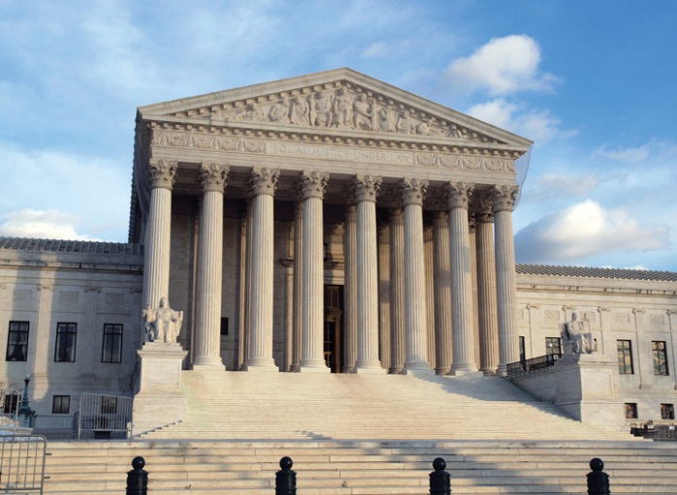
The Supreme Court building: so magisterial and redolent of justice achieved away from the hurly-burly of politics.
© Thinkstock
Majesty begins with the Supreme Court building, which commands awe and respect. It continues with what reporters see inside the courtroom—all that they see—which is designed to elevate the justices and the judicial process to a magisterial and impersonal status: the ornate setting, the ritual, the ceremony, the justices presiding in their robes, seated on high-backed chairs, physically and metaphorically raised up. This effect is conveyed most visibly in the official photograph of the nine justices (Note 15.41 "Enduring Image").

Enduring Image
Photos of the Supreme Court Justices
The traditional group photograph that the members of the Supreme Court allow to be taken shows them arrayed and authoritative in their impressive institutional setting. This enduring image enhances the justices’ standing and contributes to people’s acceptance of their rulings.
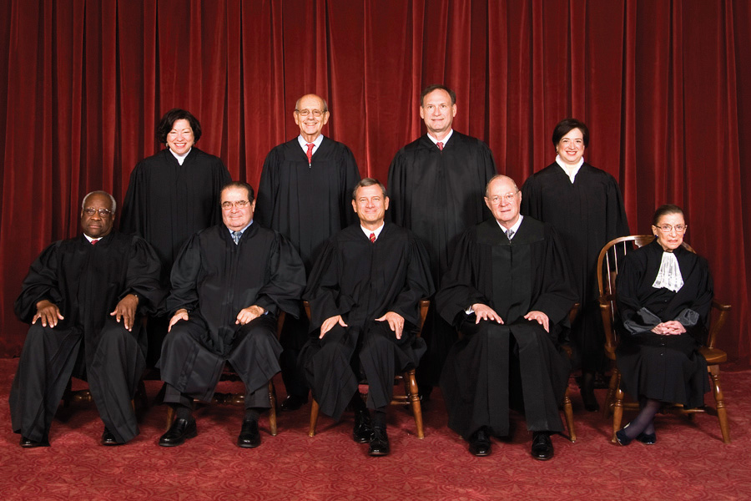
Official Photo of the Supreme Court Justices
Source: Photo courtesy of Steve Petteway, Collection of the Supreme Court of the United Stateshttp://commons.wikimedia.org/wiki/File:Supreme_Court_US_2010.jpg.
But what if they were shown discussing cases as bargainers? Or engaged in a nonjudicial activity? Or caught in an embarrassing moment in the way that celebrities are trapped by the tabloids? Such photographs would detract from the justices’ authority and the Court’s legitimacy.
Note the furor provoked by America (The Book) ^{[9]} by Jon Stewart and the writers of The Daily Show with Jon Stewart. Wal-Mart refused to stock it. The reason: one page of this parody of a civics textbook shows the faces of the Supreme Court justices superimposed over naked elderly bodies. The facing page has cutouts of the justices’ robes and a caption asking readers to “restore their dignity by matching each justice with his or her respective robe.”
The second way in which judges obtain favorable media coverage is through secrecy. Denied to reporters—and therefore absent from the news—are the justices’ discussions on granting review, conference proceedings, and the process of creating a majority through opinion writing. The press is not privy to the decision-making processes, the informal contacts among the justices, the appeals and persuasion, the negotiation and bargaining, and the sometimes pragmatic compromises. ^{[10]}

Cameras in the Courtroom
Cameras are prohibited in the Supreme Court during public sessions. The stated reasons for the ban are that it prevents lawyers and justices from playing to the cameras and avoids any physical disruption of the chamber. There is also concern that news coverage would emphasize the brief oral arguments, which can be misleading—since the essence of appellate advocacy before the Court is in the written briefs. The unstated reasons are that cameras might not only cause the justices to lose their cherished anonymity and privacy but also undermine the Court’s mystique by allowing people to see and judge the justices’ behavior.
Television cameras are excluded from most other federal courts for many of the same reasons. They are allowed in all state courts under conditions and restrictions, for example, consent of the judge, agreement of the attorneys for both sides, fixed placement, and a prohibition against showing jurors.

Reporters
Reporters covering the Supreme Court tend to be protective of the institution and the justices. In part, this is because they see law and politics as separate and different. Also, they do not have access to the kind of behavior and information that might lead them to think of and frame the Court in terms of policy and, particularly, politics.
Even when reporters at the Court are familiar with the facts and the oral arguments and have read the briefs of cases, they have more than enough to do just summarizing the justices’ decisions. These decisions can be complex, containing fifty to a hundred or more pages of dense text, often with detailed concurring and dissenting opinions. At its busiest time of the year, the Court releases several opinions at once; over 40 percent are issued during the last three weeks of the Court’s term. Reporters have little time to check over the cases and opinions, decide which ones are important, and prepare a report in layperson’s language.
On controversial cases, reporters are bombarded by reactions and analyses from the parties to the case, their attorneys, legal experts, and interest groups. Most of these people are usually available on the plaza in front of the Supreme Court, where microphones are set up for them.

Figure 15.8Supreme Court Plaza
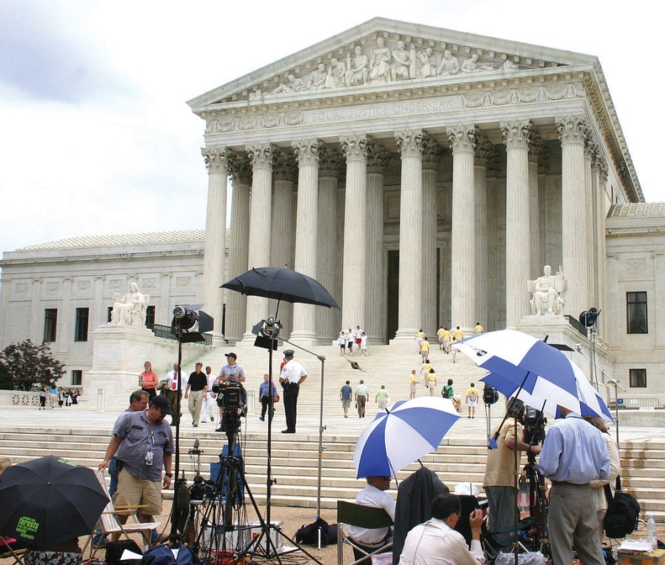
After a controversial Supreme Court decision, reporters can interview the attorneys, their clients, and interest-group spokespersons.
Source: Photo courtesy of dbking,http://www.flickr.com/photos/bootbearwdc/22009192/.
Reporters may include some of these views in their stories and show that the justice’s decisions have effects on people’s lives. But they usually lack the time and space to explain the decisions in explicitly political terms.

Media Depictions of the Supreme Court
After the acrimony of Bush v. Gore, the four dissenting justices returned to collegiality. Media and public discussion of the decision as partisan politics died down. The authority and legitimacy of the Court and the justices were reaffirmed.

Apolitical Coverage
Contributing to the return to normalcy, the media usually depict the Supreme Court as apolitical, that is, above and beyond politics and partisanship.
Only infrequently do stories about individual cases decided by the Supreme Court mention their political implications and the justices’ partisan positions. ^{[11]} Our analysis of all Associated Press (AP) wire-service reports of the Supreme Court’s significant rulings during a typical term (2002–3) for cases decided by a majority of 5–4 through 7–2 revealed that the terms “partisan” or “partisanship” were rare and the words “Democrat,” “Republican,” “political,” and “politics” never appeared. Editorial writers in newspapers across the country infrequently “use ideological labels to identify voting coalitions on the Court and to characterize individual justices…The Court and its members are set apart.”^{[12]}
Journalists do refer to ideology when covering Supreme Court confirmation battles, that is, in the time before the nominees become members of the Court. And when the Court is obviously ideologically divided, the media characterize the blocs as conservative and liberal: for example, the 2006–7 term, when a third of all the cases (twenty-four) were decided by a 5–4 vote, with Chief Justice Roberts leading the identical five-man conservative majority on nineteen of them. A fresh reporter at the Court can see it politically. Thus the New York Times’s Adam Liptak, summarizing the 2010 term, cited studies by and data from political scientists to identify the Court as “the most conservative one in living memory.” ^{[13]} He subsequently wrote an article documenting that the justices usually selected law clerks who shared their ideological views. ^{[14]} But such a perspective is exceptional.

Limited Coverage
Media coverage of the Supreme Court is limited. Many of the Court’s decisions are not reported by the news media or are recounted only briefly. The television networks give less than 4 percent of their coverage of the three branches of government to the Supreme Court. The leading news magazines focus on only 10 percent of the cases. Even a reader relying on the New York Times would not know about many of the Court’s decisions.
A few cases, unrepresentative of the Court’s docket, usually those involving the First Amendment or other rights, receive extensive coverage, as do cases arousing intense interest-group involvement. Typical is the widespread coverage given to the Court’s 5–4 decision upholding a voucher system that partially pays tuition at religious schools. ^{[15]} Missing are decisions about contracts and taxes, criminal law and procedure, and federal statutes and regulations, except for cases involving big-name litigants. ^{[16]}

Oversimplified Coverage
Coverage of the Court is often oversimplified. For example, in news accounts, the Court’s refusal to grant certiorari is said to endorse the lower court’s decision, when all it means is that the Court has refused to review the case. In a typical example, an NBC news anchor misleadingly announced that “the Court upheld a ban on dances in the public school of Purdy, Missouri, where many people are Southern Baptists who believe that dancing is sinful and satanic.” ^{[17]}

New Media
The new media can breach the bulwark of majesty and secrecy protecting the Supreme Court. They can provide political and critical perspectives and cover more cases in more detail.
Reluctantly and cautiously, the Supreme Court has entered the information age. The Court’s official website now contains transcripts of oral arguments on the same day they are made. It also provides the complete opinions of each case on the docket since the 2003 term and instructions on how to obtain opinions for earlier cases. In 2009, former Justice O’Connor launched a website called “Our Courts,” which explains courts in relation to the Constitution. Much of the other information now available, however—such as on Scotusblog.com, the go-to site for Supreme Court coverage—is intended for the legal community.
The Internet does contain commentary on the Court’s decisions. Blogs range from the lighthearted and gossipy “Underneath Their Robes,” which breaks with judges’ aloofness and inaccessibility, to the academic “Becker-Posner” blog with essays by the two authors and a comment forum for reader response. There is now even an “Anti-Becker-Posner-Blog.”
In an example of new-media innovation in covering a politically significant trial, six bloggers joined together to create Firedoglake. The site offered, from a liberal perspective, intensive, real-time coverage of the perjury trial of Lewis Libby Jr., former top aide to Vice President Dick Cheney. The coverage went beyond anything provided by the mainstream media.

Media Consequences
The news media’s coverage makes it hard for people to see the political orientation of judges engaged in making and changing public policies. This is likely to reinforce the legitimacy of the courts and confidence in judges.
Indeed, 80 percent of the people in a survey conducted for the American Bar Association strongly agreed or agreed that “in spite of its problems, the American justice system is still the best in the world.” ^{[18]} Fifty-four percent strongly agreed that “most judges are extremely well qualified for their jobs.” Most faith was expressed in the Supreme Court, with 50 percent having strong confidence in it and only 15 percent having slight or no confidence.
However, reports of dramatic and sensational cases and their depictions in popular culture do make people quite critical of the way the legal system appears to operate. ^{[19]} Fifty-one percent of those surveyed agreed that it “needs a complete overhaul.” Close to 80 percent agreed that “it takes too long for courts to do their job” and “it costs too much to go to court.”
Tabloid trials can increase people’s knowledge of some aspects of the legal system. In a survey conducted in the wake of the overwhelmingly publicized criminal and civil cases involving O. J. Simpson, almost everyone knew that anyone accused of a crime has the right to be represented in court by a lawyer and that a defendant found not guilty in a criminal trial can be sued in a civil trial. Two-thirds knew that a criminal defendant is innocent until proven guilty, although one-third mistakenly believed the reverse.

KEY TAKEAWAYS
The justices of the Supreme Court interact with reporters mainly through the legal language of their written decisions. They accentuate the Court’s majesty while concealing its inner workings and excluding cameras. Reporters perceive the Supreme Court primarily as a legal institution. They lack the time and space to report in detail on its activities. News media coverage of the Supreme Court is incomplete and oversimplified, usually depicting the justices as apolitical. These depictions reinforce the legitimacy of courts and people’s confidence in judges. Americans believe that the legal system is the best in the world, but are critical of how it operates.

EXERCISES
- How does the way the Supreme Court presents itself enhance its authority? Are there any disadvantages to seeing the Supreme Court this way?
- Imagine that Congress kept its deliberations as secret as the Supreme Court does. Why might it be more acceptable for the Supreme Court to keep its deliberations secret than it would be for Congress to do the same thing?
- Do you think it would be a good thing if reporters and bloggers told us more about the inner workings of the Supreme Court? What are the advantages and disadvantages of keeping the workings of the Court secret?

Civic Education
Students in Professor David Protess’s “Miscarriage of Justice” class at Northwestern University not only study the criminal justice system but also get the chance to influence it. Protess and his students use investigative reporting techniques to unearth information that is then used to reverse wrongful convictions in Illinois, including death-penalty sentences. They pore over case documents, reinterview witnesses, and track down tips from informants.
Their work has helped change public opinion about the death penalty, as people have become less supportive of a policy that could result in the execution of innocent people. In 2000, Governor George Ryan of Illinois issued a moratorium halting executions in the state, sparing the lives of 157 inmates on death row. ^{[20]}
The media contributed to the erosion of support for the death penalty by putting these stories into a new (irresistible) innocence frame: that of an error-prone, sometimes corrupt, judicial system that executed innocent defendants. This frame became far more prevalent than one less sympathetic to the convicted, for example of murderers and their victims. ^{[21]}
Students enrolled in Protess’s course sometimes complain about the heavy workload, but most devote the time and energy willingly. “Once you get that involved in a case, you make it your life’s work. You know you could have an innocent life at stake, and if you don’t save it, nobody will,” states one graduate. ^{[22]} Some of Protess’s students go on to cover the criminal court beat or become lawyers working for the rights of the accused.
Programs in which students and faculty work together have accounted for the vast majority of the exonerations of death-row inmates since the 1970s. A few programs, such as the Innocence Project at the Benjamin Cardozo Law School of Yeshiva University, specialize in death-penalty cases. Legal clinics associated with many law schools help those who cannot afford representation with their cases. You do not have to be a law student to be involved.

[1] An exception was Justice William J. Brennan Jr., who, in 1986, engaged in sixty hours of candid interviews with reporter Stephen Wermiel and allowed him to go through his papers. The agreement was that, after Brennan retired, the reporter would write his biography. Brennan retired in 1990. The book finally appeared in 2010: Sol Stern and Stephen Wermiel, Justice Brennan: Liberal Champion (Boston: Houghton Mifflin Harcourt, 2010).
[2] Antonin Scalia, with replies by scholars, A Matter of Interpretation: Federal Courts and the Law (Princeton, NJ: Princeton University Press, 1998); also Stephen G. Breyer, Active Liberty: Interpreting Our Democratic Constitution (New York: Knopf, 2005).
[3] Stephen G. Breyer, Making Our Democracy Work: A Judge’s View (New York: Knopf, 2010); the interview was on September 15, 2010.
[4] April 27, 2008; the book is Antonin Scalia and Bryan Garner, Making Your Case: The Art of Persuading Judges (Eagan, MN: Thomson West, 2008).
[5] Justice Scalia appeared on the American Civil Liberties Union (ACLU) panel on the state of civil liberties televised by C-SPAN (October 15, 2006), explaining and defending some of his decisions.
[6] Adam Liptak, “Public Comments by Justices Veer Toward the Political,” New York Times, March 19, 2006, 22.
[7] Our discussion of interactions draws from Richard Davis, Decisions and Images: The Supreme Court and the Press (New York: Prentice Hall, 1994); also Robert E. Drechsel, News Making in the Trial Courts (New York: Longman, 1983).
[8] Quoted in Elliot E. Slotnick and Jennifer A. Segal, Television News and the Supreme Court (New York: Cambridge University Press, 1998), 33–34.
[9] Jon Stewart, America (The Book) (New York: Warner Brothers, 2004).
[10] When he retired in 1994, Justice Harry Blackman gave his papers to the Library of Congress on the condition that they remained closed for five years.
[11] A study of all decisions handed down by the Court during its 1998 term corroborates our findings: see Rorie L. Spill and Zoe M. Oxley, “Philosopher Kings or Political Actors? How the Media Portray the Supreme Court,” Judicature 87, no. 1 (July–August 2003): 22–29.
[12] Jan P. Vermeer, The View from the States: National Politics in Local Newspaper Editorials (Lanham, MD: Rowman & Littlefield, 2002), 110.
[13] Adam Liptak, “Court Under Roberts Is Most Conservative in Decades,” New York Times, July 24, 2010, A1.
[14] Adam Liptak, “Choice of Clerks Highlights Court’s Polarization,” New York Times, September 7, 2010, A1, 14, and 15.
[15] Zelman v. Simmons-Harris, US Lexis 4885 (June 27, 2002).
[16] Susan Michelich, “Media Coverage of the Supreme Court, 1999–2000 Term inUSA Today and ABC News” (paper for “Politics and the Media,” Duke University, November 2000), 7–8.
[17] NBC News, April 15, 1990, cited in Elliot E. Slotnick and Jennifer A. Segal,Television News and the Supreme Court (New York: Cambridge University Press, 1998), 205 (their emphasis).
[18] The American Bar Association, “Perceptions of the U.S. Justice System,”http://www.abanet.org/media/perception/perception.html.
[19] These data come from Richard L. Fox and Robert W. Van Sickel, Tabloid Justice: Criminal Justice in an Age of Media Frenzy (Boulder, CO: Lynne Rienner Publishers, 2001), chap. 4 and the second edition, coauthored with Thomas L. Steiger (2007), chap. 4.
[20] David Moberg, “Carrying Justice,” Salon.com, March 1, 2000,http://www.salon.com/books/it/2000/0301/deathpenalty.
[21] Frank R. Baumgartner, Suzanna L. De Boef, and Amber E. Boydstun, The Politics of the Death Penalty (New York: Cambridge University Press, 2008).
[22] David Moberg, “Carrying Justice,” Salon.com, March 1, 2000,http://www.salon.com/books/it/2000/0301/deathpenalty.

15.5 Recommended Reading
Bergman, Paul, and Michael Asimow. Reel Justice: The Courtroom Goes to the Movies. Kansas City, KS: Andrews and McMeel, 1996. A droll discussion of the (mainly inaccurate) depictions in movies of various aspects of the judicial process.
Carp, Robert A., Ronald Stidham, and Kenneth L. Manning. Judicial Process In America, 7th ed. Washington, DC: CQ Press, 2007. A comprehensive and enlightening text.
Davis, Richard. Decisions and Images: The Supreme Court and the Press. New York: Prentice Hall, 1994. An authoritative study of the relationship between the Supreme Court and the press.
Dickson, Del, ed. The Supreme Court in Conference (1940–1985): The Private Discussions Behind Nearly 300 Supreme Court Decisions. New York: Oxford University Press, 2001. Justices’ conference notes organized and annotated around key decisions.
Fox, Richard L., Robert W. Van Sickel, and Thomas L. Steiger. Tabloid Justice: Criminal Justice in an Age of Media Frenzy. Boulder, CO: Lynne Rienner Publishers, 2007. Documents how the media’s obsession with high-profile trials has distorted the public’s understanding of the judicial system.
Gilman, Howard. The Votes That Counted: How the Court Decided the 2000 Presidential Election. Chicago: University of Chicago Press, 2001. The single best book on the subject.
Goldman, Sheldon. Picking Federal Judges: Lower Court Selection from Roosevelt Through Reagan. New Haven, CT: Yale University Press, 1999. The definitive analysis of the process.
Irons, Peter H., and Stephanie Guitton. May It Please The Court…: 23 Live Recordings of Landmark Cases as Argued Before The Supreme Court. New York: New Press, 1993. Historical treasures—tapes of oral arguments before the Supreme Court.
Johnson, Timothy R., and Jerry Goldman, ed. A Good Quarrel: America’s Top Legal Reporters Share Stories From Inside the Supreme Court. Ann Arbor: University of Michigan Press, 2009. Provides a website with audio links to excerpts of the oral arguments discussed in the book.
Maltese, John Anthony. The Selling of Supreme Court Nominees. Baltimore: Johns Hopkins University Press, 1995. A study of the evolution and condition of the nomination and confirmation process.
Sherwin, Richard K. When Law Goes Pop: The Vanishing Line Between Law and Popular Culture. Chicago: University of Chicago Press, 2000. Argues that high-profile trials and programs with judges on television threaten to turn law into spectacle.
Slotnick, Elliot E., and Jennifer A. Segal. Television News and the Supreme Court. New York: Cambridge University Press, 1998. Shows that Supreme Court rules and television news norms produce coverage that is infrequent, brief, and sometimes inaccurate.

15.6 Recommended Viewing
Adam’s Rib (1949). A classic comedy in which a woman defense attorney (Katharine Hepburn) and her prosecutor husband (Spencer Tracy) battle in court and at home over law, justice, and her client, a woman accused of shooting her husband.
Erin Brockovich (2000). Based on a true story. Marginal, nonlawyer employee (Julia Roberts) at small law firm battles successfully against a polluting corporation to achieve justice for decent, ordinary people.
First Monday in October (1981). Romance blossoms between a crusty, conservative Supreme Court justice and his new, liberal, female colleague.
Inherit the Wind (1960). Based on true story. In a steamy Southern courtroom, celebrated lawyer Clarence Darrow (Spencer Tracy) defends a schoolteacher accused of violating the law by teaching evolution.
Juvenile Court (1973). Frederick Wiseman’s fascinating documentary reveals a juvenile court in action (and inaction).
Philadelphia (1993). A lawyer with AIDS (Tom Hanks) sues the sanctimonious law firm that dismissed him.
The Verdict (1982). An alcoholic, failed lawyer (Paul Newman) struggles to regain his dignity and win a medical malpractice case against an unscrupulous law firm and a corrupt judge.
To Kill a Mockingbird (1962). Small-town Southern lawyer (Gregory Peck) braves the hostility of his fellow citizens by defending a black man falsely accused of raping a white woman.
Twelve Angry Men (1957). One man (Henry Fonda) convinces the other jury members to change their verdict to innocent.

Chapter 16

Policymaking and Domestic Policies

Preamble
During the 1990s, the US crime rate declined precipitously. ^{[1]} Yet the amount of coverage of crime in the news media increased dramatically. Crime shows filled television. Hollywood films moved from a liberal to a conservative image of law. ^{[2]} The media broadened what is considered “criminal behavior.” ^{[3]} This abundance of fictional depictions and factual reports framed crime as a threat, increased the public’s fear, and primed crime as a problem demanding a response from policymakers.
Public officials designed tough policies to stop this imagined outbreak of crime. These included treating juvenile offenders like adults, instituting mandatory minimum and longer sentences, the imposition of a lengthy prison term after a third conviction no matter how minor the crime (the catchy “three strikes” provision), and increasing the number of offenses subject to the death penalty. ^{[4]} These policies made little sense to experts as ways of preventing crime. They also cost a lot of money: California spent more on prisons than on all its public universities combined.
Clearly, media depictions—amount of coverage, framing, and priming—can influence public policies for better or worse.
This chapter is devoted to policymaking and domestic policies. It covers the economic crisis and economic policies; the influences on policies of political parties, interest groups, and public opinion; and the major policies. It concludes with policymaking and domestic policies in the information age and with civic education.

[1] David L. Altheide, Creating Fear: News and the Construction of Crisis (New York: Walter de Gruyter, 2002).
[2] Timothy O. Lenz, Changing Images of Law in Film & Television Crime Stories(New York: Peter Lang, 2003).
[3] Elayne Rapping, Law and Justice as Seen on TV (New York: New York University Press, 2003).
[4] Sara Sun Beale, “The News Media’s Influence on Criminal Justice Policy: How Market-Driven News Promotes Punitiveness,” William and Mary Law Review 48, no. 2 (2006): 397–480.

16.1 The US Economy

LEARNING OBJECTIVES
After reading this section, you should be able to answer the following questions:
- What are some of the major economic disparities in the United States?
- How did mortgage, credit, and regulatory policies contribute to the most recent economic crisis?
- How has the government responded to the economic crisis?
- Who makes economic policies in the United States?
The US economic system is capitalism. It encourages individual enterprise, a free market, and relatively low taxation. It discourages government intervention in and regulation of the economy.
Capitalism can produce vast wealth and vast economic inequality. The top 300,000 earners pocket almost as much income as the bottom 150 million. This inequality has been increasing in recent years. From 1980 to 2001 the income of the top 5 percent of Americans went up from eleven to twenty times the income of the poorest fifth.
Economic inequality is related to social inequality. Women and men now attain similar levels of education. The earnings gap between them is shrinking, but it still exists. On average, working women earn seventy-eight cents to every dollar earned by working men. Professions most populated by women usually pay less than professions most populated by men. For instance, in medicine, nurses (mostly women) are paid less than physicians (mostly men); in the airline industry, flight attendants (mostly women) are paid less than pilots (mostly men). ^{[1]} Income gaps exist even in the same profession. Female university professors are generally paid less than male university professors, even at the same rank and with similar years of service.
Income differs dramatically by race and ethnicity. The household income of whites, Asian Americans, and Pacific Islanders averages well above $50,000; for African Americans and Latinos it is under $32,000. African American families and Latino families are three times more likely to live in poverty than white families, although this gap, particularly between black and white individuals, has shrunk over time.
In 2007, the US economy was humming along with the stock market soaring, employment high, and inflation (increases in the cost of living) low. Earlier in the decade, the media had reported the financial frauds and scandals of individual companies such as Enron and WorldCom and the failure of the companies’ accountants to catch them. Now, especially in theWall Street Journal and on cable channel CNBC, they reported the booming economy, especially housing.

Home Ownership
Public policies encouraged the dream of home ownership by enabling people to deduct on their tax returns the interest they paid on their mortgage loan and by a Clinton-era law excluding from tax all or most of the profit they made from selling their homes. But these policies did little for people unable to obtain mortgages because of low income and poor credit records. So President George W. Bush, promoting an “ownership society,” pushed policies to enable the disadvantaged and those with poor credit, especially minorities, to buy homes.

Video Clip

http://www.youtube.com/watch?v=kNqQx7sjoS8

Home Ownership and President Bush
President Bush pursued policies making it easier for minority Americans to buy their homes. The results were far different than he expected.
This vastly increased the number of subprime mortgages—home loans made to people usually unqualified to receive them. Lenders peddled easy credit, asked for low or no down payments, and did not require incomes to be documented. Some borrowers were given adjustable mortgages with low initial teaser interest rates, which would later rise much higher, and charged big fees hidden in the interest rates.
The Federal National Mortgage Association (Fannie Mae) and Federal Home Loan Mortgage Association (Freddie Mac) were shareholder-owned and profit-driven corporations sponsored by the government to buy mortgages from banks, thereby freeing up cash for new mortgages. They financed most of the home loans made in America. They plunged deeply into the market for subprime mortgages, relaxing credit requirements on the loans they bought from lenders. They also spent heavily on lobbying so that Congress did not raise their capital requirements.

Complicated and Opaque Securities
Propelling the subprime mortgage market was the tremendous growth in complicated and opaque securities. Lenders sold the original mortgages to Wall Street and then used the cash to make still more loans. The investment and commercial banks sold packages of mortgages as mortgage-backed securities (MBS). These were then combined with other securities (e.g., commercial mortgages, credit card debt, and student loans) and sold as collateral debt obligations (CDOs).
Taking fees each time a loan was sold, packaged, securitized, and resold, the sellers made rich profits. They reaped even more by leveraging—borrowing to invest in more loans and packages. In 2004, the Securities and Exchange Commission allowed large investment banks to increase their leverage, a policy change the media barely reported. At its height the ratio of borrowed funds compared to total assets soared to 33:1. Investors thereby vastly increased their purchases and profits—but also their potential losses.
Protecting investors from losses, each package could be insured by a credit default swap (CDS). These guaranteed that if any borrowers in an MBS defaulted, the seller of the swap would pay the loss. The leading issuer was the American Insurance Group (AIG), with insurance on more than $400 billion in securities.
These arcane securities were rated “very safe” by the rating agencies. But these raters had an obvious conflict of interest: they were paid by the institutions whose securities they rated—rather like a movie producer paying a reviewer to write favorable reviews of his movies.

Regulation
Gripped by a fervor for deregulation, the government had reduced its oversight of the financial system. In 1999, Congress enacted and President Clinton signed legislation enabling commercial banks, which collect deposits and loan money, to deal in securities—and thereby engage in speculative investments. The government also abolished many restrictions on affiliations between banks, investment companies, and insurance companies.
Regulation was the responsibility of an “alphabet soup” of federal agencies. These included the Federal Reserve Board, the Securities and Exchange Commission, the Office of the Comptroller of the Currency, the Office of Thrift Supervision, and the Federal Deposit Insurance Corporation. Their jurisdictions were splintered and confusing. Some mortgage lenders did not fall under any regulatory agency.
The government sometimes refused to seek regulatory authority even when it was desirable. The Federal Reserve Board, the Securities Exchange Commission, the Clinton administration, and bipartisan majorities in Congress blocked proposals to regulate credit default swaps. Even when they had regulatory authority, agencies failed to use it. The Federal Reserve Board did not investigate mortgage risks, and the Securities and Exchange Commission did not restrict the amount of debt assumed by investment banks.

Disaster and Collapse
As long as home prices went up, the value of homes increased, and interest rates remained low, homeowners could continue to pay their mortgages or sell at a profit. Flipping, or buying and selling property repeatedly to make money, became common.
Disaster loomed beneath this glittering surface. The American dream of home ownership turned into a nightmare. The Federal Reserve Board raised interest rates, thus increasing monthly payments for the many people with adjustable-rate mortgages. Some of them defaulted on their loans, losing their homes. House prices fell by around 25 percent in many major markets. Lenders or mortgage holders repossessed property, reselling it for less than the amount owed on the mortgage and thus taking a loss. There were so many failed mortgages that the sellers of credit default swaps did not have enough money to pay the claims.
Starting in June 2007 but only fully acknowledged in the fall of 2008, the financial system failed. Investment firms and banks declared bankruptcy or were taken over at fire-sale prices. The stock market collapsed. People’s retirement accounts and the endowments of universities and colleges dropped precipitously. Fannie Mae and Freddie Mac, which had taken on debt to finance their purchases of mortgages, experienced huge losses on the defaults and were on the verge of insolvency.
There was a liquidity crisis: the credit market froze, making credit unavailable. Banks hoarded their capital and refused to lend. They assumed that other financial institutions were in financial trouble and would not be able to repay them. State and local governments, businesses, and families had difficulty borrowing and thus spending. There was a drastic fall in the demand for construction, investments, goods, and services.
Millions of Americans lost their jobs and thus their employer-provided health insurance. The crisis affected not only those with subprime mortgages but also those with regular mortgages; both groups often faced foreclosure on their homes. Nearly a quarter of all homes with mortgages became worth less than the money owed; these homeowners were thereby encouraged to default on (i.e., walk away from) their loans. Governments at all levels faced massive budget deficits as their income from taxes decreased and their expenditures to pay for the safety net of unemployment compensation and welfare increased.

Policy Responses
The federal government’s involvement in the economy, once controversial, is now tolerated if not expected. It was spurred by the Great Depressionof the late 1920s and 1930s in which the unemployment rate reached 25 percent. The task of policymakers faced with the new crisis was to rescue the economy and try to prevent the meltdown from happening again. This would entail far more government action to manage the economy than ever before.
Policymakers’ responses initially lagged behind the crisis and were improvised and contradictory. The Bush administration requested $700 billion to buy up toxic mortgage securities but then used the funds to purchase stock in banks.
The responses became more focused. The Federal Reserve Board slashed interest rates to lower borrowing costs, bolster the real estate market, and encourage spending. Intervening in Wall Street in unprecedented ways, it committed trillions of dollars to rescue (bail out) the financial system and prevent the failure of major financial institutions. It gave them loans, guaranteed their liabilities, and brokered deals (e.g., takeovers or sales of one financial institution to another). It carried out these actions on the grounds that an economic collapse would cost millions of jobs.
President Obama’s Treasury Secretary Timothy Geithner devised a Public-Private Investment Program (PPIP) to buy up and hold as much as $1 trillion in toxic assets. The Treasury and Federal Reserve Board carried out stress tests to determine whether individual banks had the resources to survive a recession.
The government took over Fannie Mae and Freddie Mac. It extended as much as $400 billion credit to them and spurred them to refinance millions of homeowners at risk of losing homes. It left their future and fate to be decided later. The government also funneled $185 billion into AIG to keep it in business.
The Obama administration sought to create 2.5 million new jobs or at least protect existing jobs with a stimulus recovery plan of $787 billion. It invested in infrastructure—roads, bridges—and alternative sources of energy. It sent billions to the states for public schools, higher education, and child-care centers.
These programs would take time to be effective. So for immediate relief the administration provided funds for some people unable to pay their mortgages and sent the states additional monies for the safety net: unemployment insurance and other benefits.
On July 21, 2010, President Obama signed legislation imposing new regulations on the financial industry. The law was the result of detailed negotiations, compromises, and intense lobbying.
- It established a council consisting of government officials led by the Treasury secretary to track risks to the financial system.
- It set up a Bureau of Consumer Financial Protection inside the Federal Reserve Board.
- It empowered the board to liquidate failing large banks.
- It authorized the Securities and Exchange Commission to oversee private equity and hedge funds with assets of more than $150 million.
- It regulated some of the riskiest business practices and exotic investments (including credit derivatives).
- It curbed commercial banks’ ability to make speculative investments for themselves (proprietary trading), although they could still make them for their clients. ^{[2]}
It was up to the regulators to work out the numerous details and implement the new law. Their actions would most certainly be subject to intensive lobbying by those affected. Meanwhile, the law was attacked by Republicans and the financial industry for creating more government bureaucracy and, they argued, undermining the economy’s competitiveness. Advocates of more stringent regulation criticized it for, they claimed, doing little to reduce economic risk and not ending the likelihood of government bailouts. ^{[3]}

Economic Policies
The government’s response to the economic crisis was unusual. We now turn to the government’s usual economic policies and the institutions, most of which we have already mentioned, responsible for deciding on and implementing the policies.

Monetary Policy
Monetary policy involves the amount of money available to the economy from such sources as banks, savings and loans, and credit unions. TheFederal Reserve Board (the Fed) is responsible for monetary policy. The Fed supervises and regulates banking institutions and maintains the financial system to attain economic stability and promote growth. It uses three tools: the discount rate, reserve requirements, and open market operations.

Link
Federal Reserve Board (the Fed)
Learn more about the Fed at http://www.federalreserve.gov.
The discount rate is what the Fed charges commercial banks for short-term loans. Lowering rates increases the banks’ access to money, allowing banks to offer cheaper credit to businesses and the public, thereby stimulating the economy. The Fed does the reverse to slow down an “overheating” economy.
Reserve requirements stipulate the portions of deposits that banks must hold in reserve. By reducing reserve requirements, the Fed increases the money supply, thereby stimulating economic activity. Increasing the reserve requirements combats inflationary pressures.
Through its open market operations the Fed controls the money supply by buying and selling US government securities. To stimulate the economy, the Fed increases the money supply by buying back government securities. To combat inflation, the Fed sells securities to the public and to businesses. This reduces the money supply as the Fed can take the cash paid out of circulation.

Fiscal Policy
Fiscal policy is the government taxing, spending, and borrowing. In theory, cutting taxes and increasing spending expand the economy and increase employment, while raising taxes and decreasing spending contract the economy and reduce inflation. Reality is more complex. Higher corporate and personal tax rates reduce the profit margins for companies and the disposable income for the population at large. But the higher tax rates may be necessary for the government to afford its expenditure program, much of which can also increase demand and activity in the economy.
Fiscal policies are inherently political, favoring some people and groups more than and often at the expense of others. No wonder fiscal policies are debated and disputed by politicians and the political parties and lobbied by interest groups. Some of these policies, such as tax cuts, tax increases, and tax deductions (e.g., the oil and gas depreciation allowance), are reported and discussed in the media.

The Administration
The main devisers of President Obama’s economic program, in consultation with his political advisers, are the director of the White House National Economic Council (NEC), the secretary of the Treasury, the chair of theCouncil of Economic Advisors (CEA), and the director of the Office of Management and Budget (OMB). The president’s Economic Recovery Advisory Board, composed of outside economists, CEOs, and labor officials, was introduced in November 2008.
The NEC coordinates domestic and international economic policymaking. Its director has an office in the West Wing and is responsible for brokering the ideas of the other economic policy advisers and controlling the president’s daily economic briefings.
The secretary of the Treasury usually comes from the financial or business world. The degree to which a Treasury secretary influences economic policy depends on his political skill and relations with the president. The Treasury Department is largely responsible for tax collection, payments and debt services, and enforcing federal finance and tax laws. Its interests include trade and monetary policy, international finance, and capital movements.
The CEA consists of three economists, usually academics. Ostensibly nonpartisan, they are appointed by the president and are members of the presidential staff. The chair of the CEA represents it at the president’s economic briefings. The CEA’s job is to diagnose the health of the economy, analyze trends and developments, and offer recommendations. It also helps produce the president’s annual economic report to Congress stating and justifying the administration’s fiscal and monetary policy and priorities.
The OMB is largely responsible for preparing the president’s budget and for establishing the budgets of federal agencies. It has substantial authority to control the bureaucracies and to enact the presidential policy agenda. It reviews every piece of proposed legislation submitted to Congress. Changes in agency regulations require OMB approval.

Congress
The legislative branch influences fiscal policy through its “power of the purse” and authority over approval of the president’s budget. The president needs congressional consent on all taxes and nearly all federal expenditures as well as any increase of the national debt limit. Congressional committees revise and alter the president’s policies. Congress can also check the Fed by lessening its autonomy in setting monetary policy.
Members of Congress have party preferences, constituency needs, and interest group objectives in mind when considering policies. One or more of these may cause them to oppose or support the president’s proposals. For example, Congress has historically been more protectionist (of domestic industries) on trade policies than presidents.

The Budget
The budget is a statement of the president’s policy goals and priorities for the next fiscal year. It consists of two main parts. Receipts are the amounts anticipated in taxes and other revenue sources. Expenditures (outlays) are what the federal government expects to spend. ^{[4]}
The budget is supposed to be submitted to Congress by February 1 of each year. It is studied by the House and Senate Budget Committees with the help of the Congressional Budget Office (CBO). The two committees prepare a budget resolution that sets ceilings for each of the items in the budget. In May, Congress adopts these budget resolutions. Over the summer, the House and Senate Appropriations Committees and their subcommittees decide on the specific appropriations. In September, Congress passes a second budget resolution that reconciles the overall and itemized budget ceilings with the overall and itemized appropriations. By the end of this process the specific budgetary allocations to various spending areas such as health, education, and defense have been approved by Congress. The modified document is then submitted to the president for signing, which he does if he accepts the congressional modifications. The president may choose to veto them, compelling the process of reconciliation to continue.
In reality, the timing of the passage of budget resolutions and the budget itself are dependent on the degree and intensity of partisan conflict, disagreement between Congress and the White House, disagreement between the House and Senate, and other clashes.

KEY TAKEAWAYS
In recent years, credit, mortgage, and regulatory policies contributed to an economic crisis in the United States. Responding to the economic crisis, the government has become more involved in managing the economy than ever before. Monetary policy is mainly determined by the Federal Reserve Board. Fiscal policy is mainly made by the president’s economic advisors and Congress. Deciding the federal budget is a complicated and often contentious process involving the presidency and Congress.

EXERCISES
- What are some of the major social and economic inequalities in the United States? What do you think creates these inequalities?
- What policies contributed to the recent economic crisis? What were those policies intended to achieve?
- How did the federal government respond to the economic crisis? Who were the main actors behind formulating the government’s response?

[1] Nancy McGlen and Karen O’Connor, Women, Politics and American Society(Englewood Cliffs, NJ: Prentice Hall, 1995), table 4-11.
[2] Binyamin Appelbaum and David M. Herszenhorn, “Congress Passes Major Overhaul of Finance Rules,” New York Times, July 16, 2010, A1.
[3] Joe Nocera, “Dubious Way to Prevent Fiscal Crisis,” New York Times, June 5, 2010, B1, 7.
[4] For a comprehensive analysis of federal budgeting, see Dennis S. Ippolito,Why Budgets Matter: Budget Policy and American Politics (University Park, PA: Penn State University Press, 2003).

16.2 Making Public Policies

LEARNING OBJECTIVES
After reading this section, you should be able to answer the following questions:
- What government actions make public policies?
- Why and how do the political parties differ on policies, particularly on the budget, the deficit, and unemployment?
- How do interest groups and public opinion influence policymaking?
- What are the reasons for policy stability?
- What are the reasons for policy change?
All the institutions of government are involved in making public policies. They do so through enacting laws, imposing or cutting taxes, funding programs or not, issuing and enforcing regulations and rulings or not, and their use of force.
Deciding on public policies can be daunting. Consider the complexity of energy and immigration policies.
Energy policy involves a host of issues, including (1) US dependence on foreign oil, (2) subsidies for oil and gas companies, (3) the risks and costs of allowing off-shore drilling for oil (see discussion of the Gulf of Mexico oil “spill” in Chapter 14 "The Bureaucracy"), (4) the dangers posed by nuclear reactors (vivid in the March 2011 catastrophe at Japan’s Fukushima Daiichi power station), (5) coal mine disasters, (6) the development of alternative technologies, and (7) global warming. There are policy disagreements, especially between the parties, about such policy proposals as raising energy efficiency standards, requiring utilities to derive 15 percent or more of their power from renewable sources, imposing a limited cap on carbon emissions from power plants, and increasing taxes on gasoline. President after president has addressed energy issues and committed the US to energy independence, all without success. (This was mocked by Jon Stewart showing eight presidents’ rhetoric in a segment called “An Energy-Independent Future” on the June 16, 2010, episode ofThe Daily Show; view the segment athttp://www.thedailyshow.com/watch/wed-june-16-2010/an-energy-independent-future.)
Presidents and Congress have struggled over immigration policy.
- How do we protect the nation’s border?
- What do we do about illegal immigration?
- What do we do about those immigrants staying in the country after their temporary visas expire?
- Should illegal immigrants who have been living in America for some time be granted citizenship?
- Under what conditions should they be granted citizenship?
- Should employers who hire illegal immigrants be penalized—even when they claim they cannot distinguish real documents from fakes?
Proposed legislation, even with presidential support to tackle such issues, has encountered divisions between (and sometimes within) the parties; passionate support (e.g., from many Hispanic organizations) and opposition (e.g., from NumbersUSA) from interest groups; intense hostility from talk show hosts; and public attention. The Senate did pass an immigration bill in 2006, but it was defeated in the House of Representatives. The Senate then defeated a similar bill in June 2007. ^{[1]} Some states have taken action: Arizona passed a law in 2010 requiring the police, during a “lawful stop, detention or arrest,” to check the immigration status of people they suspect are in the country illegally.
As our discussion of energy and immigration policy shows, political parties, interest groups, public opinion, and the media influence public policy.

Political Parties and Policies
As we detailed in Chapter 10 "Political Parties", the political parties differ on many policy issues. These differences may stem from conflicting values: on abortion, the Republican Party is mostly pro-life, while Democrats are mostly pro-choice.
Politicians also espouse or oppose policies in their search for political advantage: while most leaders of the Republican Party oppose gay marriage from religious or ideological conviction, this position also represents the views of many of the party’s adherents and a majority of the public.
The policy differences between the parties are clearly expressed in how they favor their constituencies. When Republicans gained control of the House of Representatives in 1994, the average Democratic district was receiving $35 million more annually in federal spending. By 2000, the average Republican district was receiving $612 million more than the average Democratic district. This change was based on policy: the Republicans increased business loans and farm subsidies and reduced public housing grants and funding for food stamps. It was also a conscious strategy of directing federal spending toward districts where the Republican incumbents were vulnerable to election defeat. ^{[2]}

The Deficit
The policy differences between the parties are most visible in their attitudes toward what to do about the government’s several years of trillion-dollar budget deficits. President Obama blames the deficits on the spending for two wars, huge tax cuts for the wealthy, and the expensive prescription drug program of the George W. Bush presidency. Republicans blame them on the Obama stimulus recovery plan and additional spending on government programs. The economic disaster worsened the deficit by increasing the government’s expenditures for unemployment compensation and, because many more people are unemployed, reducing the government’s income from taxes.
Complicating the situation, roughly two-thirds of the budget’s expenditures go to entitlements. These are obligations the government has incurred and must pay, such as for Social Security, Medicare, Medicaid, veterans benefits, and interest payments on the national debt. Most of the rest isdiscretionary spending, funds expended for defense, education, law enforcement, energy programs, and the like. Many of these expenditures can be considered investments.
Reducing the deficit will, therefore, likely require shrinking the growth of entitlement programs, cutting the defense budget, increasing taxes, and eliminating some tax deductions (for example the interest people pay for their mortgages, charitable donations, nonbusiness state and local taxes).
The Republican majority in the House of Representatives desires to cut government discretionary spending drastically while retaining the Bush era tax cuts, including for the wealthiest 2 percent, and not increasing taxes. President Obama and the Democrats accept some cuts to government expenditures but far less than what was sought by the Republicans. Obama and his fellow Democrats want to end the Bush tax cuts for the wealthiest Americans, or those earning over $250,000 annually.

Unemployment
The economic issue with the most potent political repercussions for President Obama and both parties is unemployment. People’s unhappiness about the lack of jobs helps explain the Republicans’ victories and the Democrats’ defeats in the 2010 elections. The official unemployment rate hovered around 9 percent in 2011. Adding some eleven million people who have given up looking for jobs or accepted part-time work increased unemployment to around 17 percent. Almost half of the unemployed had been without work for six months or more. The public sector laid off workers as state and local governments reduced their budget deficits. Although the private sector added jobs, it was barely adequate to absorb people entering the workforce. Many of these jobs paid barely enough to live on, if that.
The parties differ on the best policies to create jobs and reduce unemployment. For Republicans, it is cutting taxes and reducing regulation of business. For Democrats, the federal government should stimulate the economy by “investing” (Republicans replace that positive term with the negative “spending”) in infrastructure, education, child care, and other programs and undertaking public works projects, perhaps also an emergency jobs program. But doing so would likely increase the budget deficit. Given Republican opposition, neither a jobs program nor increases in government spending are likely.

Interest Groups and Policies
As detailed in Chapter 9 "Interest Groups", interest groups strive to influence public policy. They seek access to and provide information to policymakers, lobby the institutions of government, and try to use the media to transmit their perspectives and arguments.
Here, we would mention interest groups, known as think tanks. They have an impact on policy because they advocate ideas and specialize in research. They cover the ideological spectrum—the Brookings Institution is centrist, the Center for American Progress is liberal—but, until the advent of the Obama administration, ones promoting conservative views, such as theAmerican Enterprise Institute, were the most influential. Think tanks market their policy prescriptions to policymakers and the public through public relations and media outreach strategies. Their claimed policy expertise, access to and contacts with policymakers, and visibility in the media contribute to their influence on policy. ^{[3]}

Public Opinion and Policies
Policymakers track public opinion using polls and the media. They are likely to follow public opinion in enacting a policy when the issue is prominent, receives widespread media coverage, and public opinion on it is clear. In response to public outrage, the Federal Trade Commission (FTC) established the National Do Not Call Registry in 2003. Prior to the registry’s setup, telemarketers were making 104 million calls to consumers and businesses every day. For fear of substantial fines, telemarketers no longer call the approximately 109 million telephone numbers on the registry.

Link
Join the Registry
To put yourself on the registry, go to http://www.donotcall.gov or call 888-382-1222.
At the same time, policymakers are skeptical about public opinion, which, as we discussed in Chapter 7 "Public Opinion", can be contradictory or unclear. Few of a representative sample of members of Congress, presidential appointees, and civil servants in the Senior Executive Service agreed with the statement that “Americans know enough about issues to form wise opinions about what should be done.” ^{[4]}
So policymakers often track public opinion less as a guide to policies they should adopt than to find the frames, arguments, and phrases to try to move it and other policymakers closer to their policy preferences. (See our discussion in Chapter 13 "The Presidency"). Republicans and conservatives increased support for repeal of the estate tax by framing it as the “death tax,” leading people to think that it applied to far more Americans than the 2 percent who fell under it. ^{[5]}

Policy Stability
Much policymaking consists of continuing existing policies or of making incremental, that is small, changes to them. Obstacles to change include the separation of powers, the bicameral legislature, the filibuster in the Senate, and the presidential veto.
Members of Congress may resist a president’s initiative because they view it as bad policy, or think it will damage their reelection prospects, or believe it will hurt their party. ^{[6]} Bureaucrats, existing in a stable hierarchy, are usually comfortable administering existing policies. The federal courts exercise judicial review finding new policies constitutional or not—as they have been doing with the health-care law of 2010. Powerful interest groups often benefit from prevailing policies and therefore want to maintain rather than change them.
Another reason for policy stability is the existence of policy subsystems in a policy area. (See the discussion of iron triangles in Chapter 9 "Interest Groups".) These consist of the leading members and staff of the congressional committee or subcommittee that make the laws, the bureaucrats responsible for enforcing the laws, and the interest groups affected by the laws. The participants in these subsystems may compete over specifics, but they agree on core beliefs, control information, and have a low profile. Too complex and detailed to attract much media attention and thus public mobilization against them, the policies of these subsystems are infrequently changed significantly. Thus the government continued to subsidize agriculture to the sum of some $16 billion annually.

Policy Change
Policy stability is sometimes punctuated. Significant policy changes and innovations do take place. ^{[7]} There are several causes that often overlap. They are (1) changes in control of the government, (2) crises and disasters, and (3) media depictions and framing. They are abetted by public awareness, the involvement of advocacy and interest groups, and policy ideas about what the changes should be.
A dramatic shift in policies often follows a sweeping election victory of a president and his party, as with the enactment of the Voting Rights Act and the antipoverty program of President Lyndon Johnson’s Great Society after the 1964 election. Or it happens after a change of party control of Congress: the Republicans enacted elements of their Contract with America after they won Congress in 1994. Policy change can follow a change in party control of the presidency, as in the tax cuts and increases in defense spending after Republican Ronald Reagan was elected president in 1980 and George W. Bush was elected in 2000.
Rapid policymaking takes place after crises or situations portrayed by the president and the media as crises. ^{[8]} The Patriot Act was passed on October 29, 2001, less than two months after the 9/11 attack on the World Trade Center and the Pentagon.
For events to change an existing policy or produce a new one, there usually must be media attention. Useful is a “focusing event” that puts or elevates an issue onto the policy agenda. The near-catastrophic 1979 accident at a nuclear power plant at Three Mile Island in Pennsylvania raised awareness of nuclear power as a problem rather than a solution to America’s energy needs. The accident was framed by the news media with alarmist coverage and by “I told you so” warnings from antinuclear groups, which increased public fear about nuclear safety. It stopped new construction of nuclear plants for many years.
Policy changes may become entrenched, eroded, reversed, or reconfigured.^{[9]} In particular, general interest reforms “to rationalize governmental undertakings or to distribute benefits to some broad constituency” such as changes in taxation are not necessarily sustained. The politicians who achieve them leave the scene or move on to other issues.

KEY TAKEAWAYS
Policymaking involves government deciding on laws, taxing and spending, regulations and rulings, and responding to and dealing with situations and events. It often requires negotiation and compromise and is influenced by interest groups, the media, and public opinion. Policy stability is common but policy change can take place, particularly after a crisis or when party control of the presidency or Congress (or both) changes.

EXERCISES
- How does the debate over how to reduce the deficit and create jobs reflect the different philosophies of the two major parties? Which party’s philosophy makes more sense to you?
- What are the obstacles to making major changes in federal government policy? What kinds of things can lead to dramatic changes in policy?

[1] Christopher Jencks, “The Immigration Charade,” New York Review, September 27, 2009, 49–52.
[2] David Pace, “House Takeover Led to Spending Plan,” Associated Press Online, August 6, 2002.
[3] Trudy Lieberman, Slanting the Story (New York: New Press, 2000).
[4] Pew Research Center survey in association with the National Journal. Not surprisingly, members of Congress were more positive toward the public, with 31 percent agreeing and an additional 17 percent volunteering that “it depends,” compared to 13 percent and 7 percent, respectively, of presidential appointees and 14 percent and 3 percent, respectively, of civil servants. Pew Research Center 1998: 1.
[5] Brian F. Schaffner and Mary Layton Atkinson, “Taxing Death or Estates? When Frames Influence Citizens’ Issue Beliefs,” in Winning with Words: The Origins and Impact of Political Framing, ed. Brian F. Schaffner and Patrick J. Sellers (New York: Routledge, 2010), 121–35.
[6] Stephen J. Farnsworth, Spinner in Chief: How Presidents Sell Their Policies and Themselves (Boulder, CO: Paradigm Publishers, 2009), 22.
[7] For their development of the idea of “punctuated equilibrium” applied to public policies, see Bryan D. Jones and Frank R. Baumgartner, The Politics of Attention: How Government Prioritizes Problems (Chicago: University of Chicago Press, 2005).
[8] Thomas A. Birkland, Lessons of Disaster: Policy Change after Catastrophic Events (Washington, DC: Georgetown University, 2006).
[9] Eric M. Patashnik, Reforms at Risk: What Happens after Major Policy Changes Are Enacted (Princeton, NJ: Princeton University Press, 2008), especially 2–6, 11–15, and 155–75.

16.3 Major Domestic Policies

LEARNING OBJECTIVES
After reading this section, you should be able to answer the following questions:
- What were the main changes in welfare policy?
- What are the main problems with Social Security, and what are the proposals to rectify them?
- What are the strengths and weaknesses of No Child Left Behind?
- What are the differences between Medicare and Medicaid?
- What are the significant provisions of the health-care law enacted in 2010?
We now describe the development and current condition of four of the federal government’s main domestic policies: welfare, social security, education, and health care.

Welfare Policies
The services and benefits governments provide through their social policies vary widely. Scandinavian countries, such as Norway, establish a safety net from the cradle to the grave. Americans rely more on employment and private sources (insurance policies) than the government for their income and to protect them against economic misfortune.
For some American policymakers, poverty stems in part from the failure of the economic system to provide enough jobs at a living wage and from racism and sexism. They support policies to alleviate poverty’s causes (e.g., increasing the minimum wage or lengthening the period of unemployment compensation). From this perspective, people are not much to blame for needing public assistance (welfare).
An alternative view blames people for their fate. Public assistance violates the American values of individual enterprise and responsibility. It is believed that recipients would rather collect government handouts than work. No wonder welfare is one of the most reviled social programs. It is often given grudgingly and with stringent conditions attached.

Aid to Families with Dependent Children (AFDC)
Title IV of the Social Security Act of 1935 provided funds for the states to help the destitute elderly, the blind, and children. Its primary purpose was to assist poverty-stricken families with children during the heart of the Great Depression. Over time, it became Aid to Families with Dependent Children (AFDC), granting financial assistance to low-income mothers and their children. ^{[1]}
With expansion came criticisms, often conveyed and amplified by the media. The program was seen as supporting “unwed motherhood, idleness, and dishonesty.” ^{[2]} It was disparaged for providing aid to individuals without requiring anything in return. Families were given levels of assistance on the basis of their size: the more children families had, the more aid they received. Women were deterred from attempting to leave welfare by getting jobs because they were limited in the number of hours they could work without losing some of their benefits.

Changes in Welfare Policies
In his successful 1991 campaign for the presidency, Bill Clinton preempted what had been a Republican issue by promising to “put an end to welfare as we know it.” In 1996, after rejecting previous versions, he signed a Republican bill, the Personal Responsibility and Work Opportunity and Reconciliation Act (PRWORA). This helped him get reelected in 1996.
This law replaced AFDC with the Temporary Assistance to Needy Families (TANF) program. The federal government gives states grants in aid and greater autonomy in structuring their welfare systems if they follow rules. Adult welfare recipients are limited to a lifetime total of five years of TANF benefits. State governments lose some of their TANF funding unless they show that significant numbers of their welfare recipients are entering the workforce. To receive benefits, children under eighteen must live with their parents or in an adult-supervised setting.

Link
Welfare Policies
Read PRWORA at http://thomas.loc.gov/cgi-bin/query/z?c104:H.R.3734.ENR: and TANF athttp://www.acf.hhs.gov/programs/ofa/tanf/about.html
Since the law was passed, some states have reported decreases of over 50 percent in their number of welfare recipients. However it remains to be seen if the changes in welfare policy have led to less poverty or simply removed people from the welfare rolls ^{[3]} and what the effects of the policy are now that the economy has declined and people who had moved from welfare to employment have lost their jobs.
The federal government does pay the cost of food stamps. Nearly one in seven Americans receives them, with an average benefit of $500 a month for a family of four. Removing the stigma of welfare from the stamps, the government changed the program’s name to Supplemental Nutrition Assistance. Making it even more acceptable, it is supported by farmers and grocery stores. ^{[4]}

Social Security
Some policies are controversial at the start, then build up powerful support from their current and future beneficiaries, becoming widely accepted, even treasured, by the public. Over time, they grow in complexity and cost.Social Security is a notable example.

Link
Social Security
For more information about Social Security, visit http://www.ssa.gov.
Among Americans most distressed by the Great Depression were the nation’s elderly, many of whom lost their savings and were unable to support themselves. President Franklin D. Roosevelt and Congress attempted to address this problem through the Social Security Act of 1935.
Figure 16.1
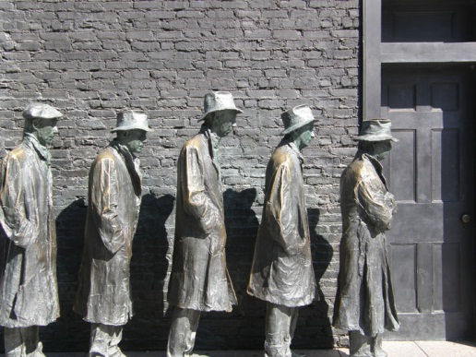
These figures, part of the memorial to President Franklin D. Roosevelt, symbolize the desperate conditions of the elderly during the Great Depression and President Roosevelt’s Social Security policy in response.
Source: Photo courtesy of Jim Bowen,http://commons.wikimedia.org/wiki/File:New_Deal_Memorial.jpg.
It established a system of social insurance in which taxes on payrolls were used to provide benefits to the elderly. Social Security was soon expanded to cover benefits for “survivors,” including widows, dependent children, and orphans. In 1956, disabled Americans were added to the list of beneficiaries, thus formally creating the Old Age, Survivors and Disability Insurance (OASDI) system. ^{[5]} In 1972, benefit levels were tied to the consumer price index—benefit levels go up when the consumer price index does.
Social Security now provides benefits to over forty-eight million Americans. It is the main source of economic survival for two-thirds of the elderly and the only source of income for over 30 percent of the aged.

Social Security’s Solvency
Traditionally, more money has been paid into the Social Security Trust Fund than drawn out, leading to a revenue surplus. But Americans are living longer than ever. Longer lives mean larger payouts from the fund, as there is no limit on the number of years people receive benefits. Also, recent generations entering the workforce are generally smaller in size than their predecessors. By 2040, there will not be enough money in the fund to finance recipients at the current level. ^{[6]}
Special commissions have issued reports, prominently covered with alarmist stories by the press, about these problems. Proposals to “fix” Social Security have been developed by these commissions, think tanks, other interest groups, and a few politicians. Policymakers are wary of suggesting that they may tamper with the revered system; they make change with delicacy. Thus in 1983, the age of eligibility for full retirement benefits was increased from 65 to 66, but the change wasn’t effective until 2009; the age increases to 67 in 2027.
Additional revenue could be generated by increasing the percentage of the payroll tax or the amount to which it is applied on employees’ wages and employers’ contributions. However, tax increases are never popular among elected officials, so these options lack advocates in Congress.

President Bush’s Proposals
Thinking to trade on the momentum of his 2004 reelection, President George W. Bush went public with a campaign to inspire public and congressional support for his proposals to “save” Social Security. ^{[7]}Launching his campaign in his State of the Union address, he embarked on a high-profile “60 Cities in 60 Days” tour. His theme: Social Security was in perilous condition. He proposed to save it through personal (private) savings accounts. People would be allowed to invest a third of their Social Security withholdings into a variety of investment options such as the stock market.
The argument for privatization is that the stock market greatly outperforms Social Security’s trust fund over the long term. ^{[8]} Over time, therefore, privatized investment would be a boon to the overall size of the trust fund and protect the solvency of the system.
The president appeared at town hall meetings with handpicked, sympathetic audiences. Signs saying “Protecting our Seniors” flanked him. He used the positive and evocative words “choice” and “ownership” to describe his proposals.
President Bush was supported by such powerful interest groups as the US Chamber of Commerce and the Business Roundtable. He also received support from potential beneficiaries of his proposed changes: Wall Street firms would receive billions of dollars to manage personal accounts.
The president faced opposition from Democrats and powerful interest groups such as organized labor and AARP (formerly the American Association of Retired Persons). They were bolstered by experts in Social Security policy who provided information challenging and undermining Bush’s arguments and claims.
Critics of the president’s proposals argued that there was no crisis; that the stock market goes down as well as up, so investing in it is risky and people could end up with reduced retirement income; and that private investment accounts would require the government to borrow about $2 trillion to offset the reduction in payroll taxes to avoid a shortfall in payments owed to current retirees. Most dramatically, the president’s opponents contended that his proposals would destroy the program.

Media Coverage
It was a perfect setup for the news media. On one side were the president and his nationwide campaign; on the other side was the opposition. Experts could be called on to assess the validity of both sides’ arguments. This was all done on a policy issue—the future of Social Security—of public interest and concern.
From the start, media coverage undermined the president. The very first story in the New York Times set the pattern. It was headlined “As White House Begins Campaign for Overhauling Social Security, Critics Claim Exaggeration.” ^{[9]} It cited “outside analysts,” including the nonpartisan Congressional Budget Office and academics casting doubt on the president’s arguments. It contained this devastating paragraph: “White House officials privately concede that the centrepiece of Mr. Bush’s approach to Social Security—letting people invest some of their payroll taxes in private accounts—would do nothing in itself to eliminate the long-term gap.”
Perhaps because there was no new news in the president’s appearances and statements, stories reporting them focused on the rigged audiences, the “carefully screened panelists,” and “meticulously staged “conversations.” ^{[10]}
The more the president spoke, the less the public supported his proposals. From early January into May 2005, public opinion about the way Bush was handling Social Security decreased from 41 to 31 percent approval, and disapproval increased from 52 to 64 percent. ^{[11]}
The president ended his campaign. Personal retirement accounts disappeared from Congress’s policy agenda.

Education Policies
Traditionally, education policy has been the domain of state and local governments. Schools are funded mainly by local property taxes. Consequently, schools’ resources and thus their quality of education depend on their location, with vast differences between and often within school districts.
Figure 16.2
Because much of their funding comes from property taxes, the quality of schools differs drastically, even in the same city and district.
Source:http://commons.wikimedia.org/wiki/File:WestsideHSHouston.JPG andhttp://commons.wikimedia.org/wiki/File:LeeHighSchoolHouston.JPG.
The federal government’s limited involvement began to change in the 1960s as part of President Lyndon Johnson’s War on Poverty. The 1965 Elementary and Secondary Education Act (ESEA) allotted funds for developing remedial programs, hiring teachers and aides, and purchasing supplies and equipment. The Head Start Program, also established in 1965, provided low-income children with preschool education. The Department of Education was created in 1979.

No Child Left Behind (NCLB)
Fulfilling his campaign pledge, repeated in his inaugural address, to close the gap in achievement between poor and minority children and children attending primarily white schools in the suburbs and to improve school performance, President George W. Bush obtained passage of significant amendments to the ESEA in the No Child Left Behind Act of 2002. He signed the legislation into law in an elaborate ceremony accompanied by his bipartisan congressional allies.

Link
The No Child Left Behind Act of 2002
Read the complete No Child Left Behind Act athttp://www2.ed.gov/policy/elsec/leg/esea02/index.html.
The law was a major policy accomplishment by the president. Placing its administration in the Education Department, he overcame the opposition of some his party’s leaders who wanted to abolish the department. Imposing federal requirements on schools, he radically changed federal-state relations in education. ^{[12]}
The law called for states to implement accountability systems covering all public schools and students and to test all students in grades 3–8 in reading and math. Schools failing to make adequate yearly progress toward goals are subject to corrective actions and restructuring. To increase parental choice for children attending an underperforming school, schools are required to let low-income parents use allotted federal funding to pay for tuition at a school in the district that has attained acceptable standards.

Comparing Content
No Child Left Behind
President Bush touted No Child Left Behind as a great domestic accomplishment of his administration. He promoted it from the White House, on radio, and in speeches. ^{[13]} Education Secretary Rod Paige talked it up throughout the country. The Department of Education created a website and issued publications and press releases describing the act and how its objectives were being achieved.
The New York Times persistently contradicted the administration’s beguiling rhetoric. Reporters detailed problems in how the program was administered and implemented. The newspaper’s education writer critically evaluated the policy, and the editorial page’s verdict on the program was caustic.
The newspaper pointed out that states have widely different standards for measuring students’ progress—there is no agreement on how much students need to know to be considered proficient. Many states have low proficiency standards. Students ace these state tests only to fail more rigorous federal exams. ^{[14]} States with high standards could be penalized by having many failing schools, while states with low standards and poor performance would be left alone. ^{[15]}
According to the newspaper, schools reported implausibly high graduation rates and low dropout rates even as they were pushing out low achievers in order to keep up test scores. School districts were not enforcing and failed to meet a provision in the law requiring a “highly qualified” teacher in every classroom by 2006. ^{[16]} Only 12 percent of the two million students in public schools eligible for free tutoring were receiving it. Above all, the Bush administration’s funding of the program was billions of dollars short of the amount authorized by Congress.
The Times printed an op-ed about the Department of Education’s rankings of reporters on a one hundred–point scale “depending on whether their stories were critical or favorable toward the law.” ^{[17]}And repeated revelations (first reported in USA Today) came up that media commentators had been paid to promote the policy, including one pundit who received $240,000 and often appeared on television and radio without mentioning the payment.
The Times’ coverage focused on the program’s inadequacies and failures, its duplicity and deception. Exposure is a news value, common in journalism; the Times’ reporters were doing their job. Missing, though, was an adequate acknowledgment and appreciation of the program’s accomplishments and the difficulty of achieving its goals.

The Obama Administration
President Obama’s Secretary of Education Arne Duncan promised to rectify the defects of NCLB. He embraced competition, accountability, parental choice, and incentives. Specifically, he proposed to raise academic standards, end the misleading identification of thousands of schools as failing, turn around schools that were truly failing, recruit and retain effective teachers, track students’ and teachers’ performance, and tie teacher evaluation to students’ test scores. He wanted to increase the number of charter schools—a broad term describing the more than five thousand private schools set up mainly in urban areas, with local and state and private funds, to compete with public schools. ^{[18]}
Duncan encouraged the development of national standards in English and math to be adopted by the states, specifying the skills students should have at each grade level. Although the timetable for implementing the standards is uncertain, states will have to rethink teacher training, textbooks, and testing.
Duncan also created the Race to the Top competition allocating $4.3 billion in education aid to states that comply with the administration’s educational goals. But this is a modest sum, won by only a few states, compared with the approximately $650 billion spent on K–12 education annually.
At the same time, states and localities beset by budget deficits are slashing their expenditures for education. They are doing this by dismissing teachers, hiring few new ones, increasing class sizes, and cutting programs.
So even though the federal government is now far more involved in education than ever before, it prods but cannot compel the states and localities to do its bidding. Moreover, some states and school districts still object to federal intrusion and mandates. Besides, the quality of education often depends more on a student’s family and community than the schools, starting with whether children are healthy enough to learn.

Health-Care Policies
Program by program, the federal government has contributed to the costs of medical care for some of the people who have difficulty paying their medical bills or have no health insurance. The media encouraged the creation of such government policies by consistently reporting about the large number of uninsured Americans who, it was assumed, were without adequate doctor, prescription drug, and hospital care.

Medicare
In 1965, the most extensive health coverage legislation in American history became law. Medicare helps citizens sixty-five and older meet their primary medical care needs. It covers around forty million people.
Medicare has two parts. Part A pays some of the hospital charges for individuals who are eligible for Social Security benefits. It is funded by payroll deductions and matching contributions from a patient’s employer. People are responsible for both a deductible charge that must be paid before Medicare payments are authorized and copayments for many hospital-related services. There are no limits on the total costs people can incur.
Part B is an optional insurance system covering health-care costs outside of hospital stays for physician services, medical tests, and outpatient visits. Participants pay a monthly fee, deductible charges, and copayments. The government contributes about three-fourths of the overall costs.

Prescription Drugs
Medicare’s lack of a prescription drug benefit was particularly hard on the elderly and disabled, who commonly take several prescription drugs. Responding to this need, the Medicare Prescription Drug and Modernization Act of 2003 contains two types of assistance programs. The first is a prescription drug discount card program saving Social Security recipients roughly 15 percent to 25 percent annually.
In the program’s more substantial part, individuals pay an annual premium and deductible in return for the federal government paying 75 percent of their prescription drug costs up to $2,250.
Because of exploding health costs and the new prescription drug benefit, Medicare may be in worse financial shape than Social Security. According to the program’s trustees, its hospital insurance trust funds will run out of money in 2019. ^{[19]}

Medicaid
Medicaid was created in 1965. It provides health-care coverage for approximately fifty million poor and disabled Americans. More than a third of them are over sixty-five. The federal government pays about half the costs of their medical care, including hospital stays, physician fees, and various diagnostic services. States pay the remainder of the costs of the coverage.

Link
Medicaid
Learn more about Medicaid at http://www.cms.hhs.gov/medicaid.
The federal government requires coverage of the blind, the disabled, and children (Children’s Health Insurance Program,https://www.cms.gov/home/chip.asp) under the age of eighteen whose family’s income is below the poverty level. Otherwise, states decide eligibility for inclusion in Medicaid. State standards vary significantly; someone eligible in California might be excluded in Texas. Nonetheless, Medicaid pays approximately two-thirds of the costs of nursing home care in this country.
Because of the high cost of health-care services covered under Medicaid, state governments have become increasingly burdened financially. Other than education, Medicaid takes up the single greatest percentage of state budgets, a cost that is increasing annually. This situation has caused states to cut back on a number of the program’s optional medical services.

The Uninsured
Around fifty-one million Americans lacked health insurance. This figure included approximately nine million under the age of eighteen who were eligible for but not enrolled in Medicaid or the Children’s Health Insurance Program. Some twenty-eight million people came from households with income above the poverty line but whose employers did not provide them with health insurance. Their work was often temporary or part time and low-paid. About fifteen million of the uninsured had income below the poverty line yet were not receiving Medicaid.
Politicians proposed policies in response to the lack of health care. Most notably, the Clinton administration, led by First Lady Hillary Clinton, proposed health-care coverage for all United States citizens. This 1994 initiative died for lack of support in Congress, in part because of its complexity and a negative advertising campaign by interest groups against it. ^{[20]}

President Obama and Health Care
After he assumed office in 2009, President Obama took up health care as a major policy initiative. His administration negotiated (i.e., bargained) with every major sector of the health-care industry to support its health-care proposals. Motivating the industry was the drop in the number of employers insuring their employees or providing generous coverage and the number of employees who could afford to pay their share of the cost of insurance. This resulted in fewer Americans with insurance coverage and thus able to pay for hospital care, doctors, and drugs.
At the heart of the bargain “was a simple quid quo pro: accept greater public regulation and involvement in return for greater guaranteed financing.” ^{[21]} That is, the government would require people to have insurance, thereby greatly expanding the market. This bargain did not prevent each industry group from lobbying to modify or scuttle provisions in the legislation that might reduce its members’ income. The drug industry opposed studying the effectiveness of treatment; the American Medical Association lobbied to kill the proposal for a government-run insurer (i.e., the public option); hospital lobbyists objected to a Medicare oversight board that could reduce payments. ^{[22]}
In March 2010, the Democratic majority in Congress passed the Patient Protection and Affordable Care Act, arguably the most important domestic legislation in decades. It passed without a single Republican vote and despite millions of dollars of advertising aimed at the forty Democrats in the House deemed vulnerable to defeat if they voted for the bill. In this instance, party loyalty, appeals from party leaders (especially the president), advertisements from supporters of the legislation, and the realization that this was the most propitious opportunity to enact health reform in many years overcame the opponents’ arguments and advertising.
The law is complicated; many provisions do not go into effect until 2014 or later. Bureaucrats will have to write the thousands of pages of rules, define terms such as “benefits,” and clarify the details. States will have to implement many provisions. Lobbying will be intense. The Republican majority in the House of Representative voted in 2011 to repeal the law and is likely to strip away funds for putting the law into effect. The law’s constitutionality has been challenged in court—cases that, probably consolidated, will likely reach the US Supreme Court.
If it remains in effect, the law will eventually provide health insurance for around thirty-two million uninsured Americans. It will expand eligibility and subsidize lower premiums for Medicaid, transforming it from a government health-insurance program just for poor families into a much wider program to include millions of the poorest Americans, including able-bodied adults under sixty-five who earn no more than 133 percent of the federal poverty level. People not covered by their employers and who earn too much to qualify for Medicaid can buy coverage from state-based insurance purchasing organizations. The law prohibits insurance companies from rejecting people for preexisting medical conditions, removes annual and lifetime limits on payments by insurance companies, and enables children to stay on their parents’ policy until they turn twenty-six.
Such a complicated law raises a host of criticisms and questions. Are its costs affordable? Can Medicaid absorb the additional people, especially when—even now—many doctors do not accept Medicaid patients on the grounds that the reimbursement it pays is too low? Will insurance premiums continue to rise substantially? Is it constitutional to fine people who remain uninsured? Can the law curb unnecessary care (whatever “unnecessary” means in practice)?

KEY TAKEAWAYS
In this section, we discussed the development and current condition of four of the main domestic policies: welfare, social security, education, and health care. We explained why and how the federal government, particularly the presidency, became involved, the policies it pursued, which ones were enacted into law, and their effects.

EXERCISES
- What led the federal government to consider major changes to its welfare, social security, education, and health-care policies? What were the obstacles to change in each case?
- What major issue do you think the government needs to take action on? What factors do you think prevent the government from acting?

[1] Michael B. Katz, In the Shadow of the Poorhouse: A Social History of Welfare in the United States (New York: Basic Books, 1997).
[2] Christopher Jencks, “What Happened to Welfare?” New York Review, December 15, 2005, 74.
[3] “Welfare Reform: With TANF Flexibility, States Vary in How They Implement Work” (Washington, DC: General Accounting Office, 2002), accessed June 6, 2011, http://www.gao.gov/new.items/d02770.pdf.
[4] Jason DeParle and Robert Gebeloff, “The Safety Net: Across U.S., Food Stamp Use Soars and Stigma Fades,” New York Times, November 8, 2009, accessed June 6, 2011, http://www.nytimes.com/2009/11/29/us/29foodstamps; and Jason DeParle and Robert Gebeloff, “Once Stigmatized, Food Stamps Find New Users and Acceptance,” New York Times, February 11, 2010, A1.
[5] For an overview of the origin of the Social Security System, see Edward D. Berkowitz, Robert Ball and the Politics of Social Security (Madison: University of Wisconsin Press, 2003).
[6] For a contrary view, see Joseph White, False Alarm: Why the Greatest Threat to Social Security and Medicare Is the Campaign to “Save” Them (Baltimore: Johns Hopkins University Press, 2001).
[7] For details of President Bush’s campaign, see George C. Edwards III,Governing by Campaigning: The Politics of the Bush Presidency (New York: Longman, 2007), 216–80.
[8] The Cato Institute, a conservative think tank, has been a major proponent of privatization. Its recommendations can be found at Cato Institute, “Social Security,” http://www.socialsecurity.org.
[9] Edmund L. Andrews, “As White House Begins Campaign for Overhauling Social Security, Critics Claim Exaggeration,” New York Times, January 10, 2005, A15.
[10] Jim VandeHei and Peter Baker, “Social Security: On with the Show: President’s ‘Conversations’ on Issue Are Carefully Orchestrated, Rehearsed,”Washington Post, March 12, 2005, A3.
[11] Gallup/CNN/USA Today poll, January and May 2005.
[12] An account of education policy and politics is Patrick J. McGuinn, No Child Left Behind and the Transformation of Federal Education Policy (Lawrence: University Press of Kansas, 2006); a critique of the law and suggestions of ways to improve it is Scott Franklin Abernathy, No Child Left Behind and the Public Schools (Ann Arbor: University of Michigan Press, 2007); and a slashing attack on education policy, including NCLB, as more spectacle than rational is Mary Lee Smith with Linda Miller-Kahn, Walter Heinecke, Patricia F Jarvis, and Audrey Noble, Political Spectacle and the Fate of American Schools (New York: Routledge/Falmer, 2004).
[13] For example, see the radio addresses of January 4, 2003, September 6, 2003, and January 3, 2004; the Rose Garden speech of June 10, 2003; and the speech on May 12, 2004.
[14] Sam Dillon, “Students Ace State Tests, but Earn D’s From U.S.,” New York Times, November 26, 2005, A1, 10.
[15] Ford Fessenden, “How to Measure Student Proficiency? States Disagree on Tests,” New York Times, December 31, 2003, A16; and for a typical piece by education writer Michael Winerip, see “On Education; A Pervasive Dismay on a Bush School Law,” New York Times, March 19, 2003, A24.
[16] Sam Dillon, “Most States Fail Demands Set Out in Education Law,” New York Times July 25, 2006, A14.
[17] Andrew J. Rotherham, “No Pundit Left Behind,” New York Times, January 12, 2005, A23.
[18] Carlo Rotella, “Class Warrior,” New Yorker, February 1, 2010, 24–29.
[19] Robert Pear, “Medicare Costs Expected to Soar in Coming Years,” New York Times, March 24, 2004, A1, 15.
[20] Jacob S. Hacker, The Road to Nowhere: The Genesis of President Clinton’s Plan for Health Security (Princeton, NJ: Princeton University Press, 1997).
[21] Jacob S. Hacker, “The Road to Somewhere: Why Health Reform Happened,”Perspectives on Politics 8, no. 3 (September 2010): 865.
[22] David D. Kirkpatrick, “Groups Back Health Overhaul, but Seek Cover,” New York Times, September 12, 2009, A1.

16.4 Policymaking and Domestic Policies in the Information Age

LEARNING OBJECTIVES
After reading this section, you should be able to answer the following questions:
- What are the five stages of the policymaking process?
- What are some of the ways the media depict policymaking?
- What are some of the ways the media influence policymaking?
According to a former White House staffer in the George W. Bush administration, the shifts “from discussing any actual policy pros and cons to discussing political communications, media strategy” were “near instant.” ^{[1]} The Bush administration may have gone to extremes, but as we have documented throughout this book, people in government and politics interact with the media in myriad ways to promote their interests and policy preferences. Rather than describe these interactions again, we focus here on their consequences.

Media Consequences
All elements of the media can influence public policy: news, opinion and commentary, fiction and documentary films, and advertising. But their attention is intense on some subjects, intermittent on others, and nonexistent in regard to many policies. This is understandable and predictable, given the abundance of policies and the several stages and complexity of the policymaking process.
We break this policy process into five stages: (1) agenda setting, (2) formulation, (3) adoption, (4) implementation and administration, and (5) evaluation. Naturally, reality is more complex: stages overlap, do not necessarily follow in this order, and are not fulfilled for every policy. Nonetheless, the breakdown does ease understanding.

Agenda Setting
People have many concerns. These become part of the policy agenda when they are seen as requiring government attention and action (e.g., global warming). In agenda setting, then, what were conditions ignored or to be endured become problems requiring government intervention. ^{[2]}
The media move a subject onto the policy agenda when they give it extensive coverage and frame it as a problem demanding a response by policymakers. For example, widespread reporting of how many Americans were sickened by tainted eggs and spinach eventually resulted in a law that overhauled the food safety system and gave more authority to the Food and Drug Administration.
The media can put a topic on the policy agenda by transforming it into anews icon. A garbage barge that for three months unsuccessfully sought a port on the East Coast to unload its cargo received extensive news coverage, was joked about in the monologues of late-night talk show hosts and mentioned in comedy shows, and became the subject of polls. With environmental interest groups weighing in, the barge grew into an icon symbolizing a wasteful society with ever-mounting garbage and nowhere to dump it. It put garbage firmly on the policy agenda. ^{[3]}

Video Clip
The Odyssey of the Mobro 4000
This barge and its load became a media icon, putting the garbage problem on the policy agenda.
The media can keep subjects off the policy agenda or enable policymakers to keep them off by ignoring or downplaying them. Or their coverage can give the impression, rightly or wrongly, that a subject does not require resolution through the policy process. Coverage may be insufficient when policymakers are disinterested: the scant media attention to the AIDS epidemic during its early years did not put it on the policy agenda in the face of the Reagan administration’s indifference.

Formulation
When an issue is on the agenda, policymakers often propose policies to solve it. They sometimes have several alternative policies from which to choose. Traffic safety can be sought by “building more highways (the solution of the 1950s), requiring safer cars (the solution of the 1960s), putting drunk drivers behind bars (that of the 1980s and 1990s).” ^{[4]}
The media influence policy formulation by how they frame the subject, their coverage of policymakers’ arguments and debates, and the policy alternatives they report. Thus the production, distribution, and consumption of illegal drugs can be framed as a law-and-order problem or a health issue (e.g., medical marijuana) or as an everyday recreational activity.
Media coverage of policy formulation infrequently dwells on substantive arguments and alternatives. Depiction of the legislative process is typical: the news media usually frame it as conflict and strategy. And because the news media cover only a few major issues, policymakers are often able to formulate the details of policies without much scrutiny or public awareness.
The media spotlight can speed up policy formulation on major issues. But speed tends not to work well for deliberation: deciding what to do about a problem can take sifting and winnowing. News coverage pushes for a quick response from policymakers, thereby often favoring the most available alternative, perhaps regardless of whether it effectively addresses the problem.

Adoption
For formulated policies to be put into effect, they must be adopted by the relevant institutions of government. The media can be a forum in which various sides argue their cases for policy adoption. But coverage is sometimes one-sided. When favorable, it enhances a policy proposal’s likelihood of adoption. When unfavorable, it can undermine a proposal, as we documented in our discussion of President Bush’s proposals to change Social Security. As we also noted, negative advertising helped kill the Clinton administration’s health-care proposal.
Adoption of a policy legitimizes it. ^{[5]} The media usually give positive coverage to the enactment of significant laws, thereby adding to their legitimacy. But not always—remember the criticism of and attacks on the new health law disparaged as “ObamaCare.”

Enduring Image
The Law-Signing Ceremony
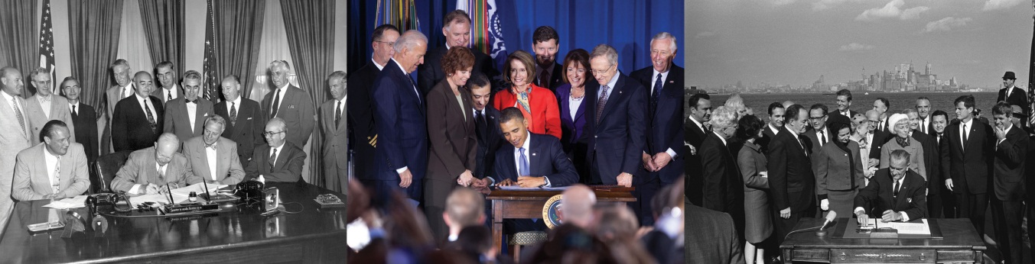
These ceremonies give the impression of harmony and finality in the policy process.
Source: Photos courtesy of the White House. Adapted fromhttp://commons.wikimedia.org/wiki/File:Obama_signs_DADT_repeal.jpg,http://commons.wikimedia.org/wiki/File:EisenhowerAtomicEnergyAct.jpg, and http://commons.wikimedia.org/wiki/File:Immigration _Bill_Signing_-_A1421-33a_-_10-03-1965.jpg.
An enduring image of the US government is the president signing into law a piece of legislation just passed by Congress. The president is surrounded by the members of Congress responsible for and citizens benefiting from the law’s passage. The ceremony requires many pens because after each stroke the president gives one to someone associated with the legislation.
The ceremony is a photo op for all the participants. It presents the president as intimately involved in policymaking as head of the government, Congress and its members as effective lawmakers, and the law as final.
The image is compelling, but the impressions it conveys are disputable. The president may not have been intimately involved in proposing the law, deciding on the law’s key details, and pushing for passage of the legislation. Members of Congress are more or less satisfied with the law, which may have been jerry-built out of compromises, concessions, the dropping of vital provisions, and the inclusion of unnecessary or damaging ones as favors to legislators who would otherwise oppose passage. And with implementation and administration to come, the effects of the law are far from final.

Implementation and Administration
Policy decisions require policy implementation and administration. Congress relies on the bureaucracy to develop the specific standards and procedures that fulfill the intent of the policy.
Messy reality can make administration and implementation difficult for even the most conscientious and dedicated bureaucrat. Nor are bureaucratic incompetence, dereliction, ineptitude, and scandals unknown. Policies may be ignored or subverted at the state or local level.
The media can be a significant force at this stage of the policy process. But most policy implementation and administration take place out of the media’s view and are time consuming to find and expose, even with investigative reporting. Thus media coverage is sporadic and focused on a few policies.

Evaluation
Policy evaluation, or assessing a policy’s effectiveness, can be complicated. ^{[6]} Many public policies aim to achieve broad conceptual goals such as “healthy air quality.” Or a policy may have multiple, not necessarily compatible, objectives. The 1996 Telecommunications Act was intended to unleash the power of competition, spur technological innovation, create jobs, and reduce cable rates. ^{[7]}
As we showed in our box on No Child Left Behind, the media can evaluate policies through their reporting. They also report and therefore publicize some of the policy assessments of government agencies, policy oversight studies by congressional committees, and congressional hearings. They report the findings of public interest groups (e.g., that many of the recipients of tobacco subsidies do not grow tobacco) and transmit the revelations of whistle-blowers (e.g., documents showing that the tobacco companies long knew that smoking causes diseases).
Such journalism can lead to outrage from the public and from policymakers, demands for reform, and governmental action. Policies are reappraised, changed, and even junked.

KEY TAKEAWAYS
The five stages of the policy process are (1) agenda setting, (2) formulation, (3) adoption, (4) implementation and administration, and (5) evaluation. The media are more or less involved and influential at every stage.

EXERCISES
- How can media coverage put an issue on the policy agenda? What issue can you think of that has been brought to the public attention by media coverage?
- How do the media depict the policymaking process in the United States? Why do you think the media portray it that way?

Civic Education
Student Loans
Many students take out loans to finance their education. Their college’s financial aid office guides them through the process, often steering them to certain lenders.
The government paid billions annually to subsidize lenders and guaranteed repayment of up to 97 percent of the loan. Lenders were guaranteed a rate of return by law. They therefore made large profits with minimal risk.
Raza Khan and Vishal Garg, then twenty-nine, founded MyRichUncle in 2005 on the assumption that their company would prosper in this $85 billion business by offering students lower interest rates and a better deal. But they soon discovered that students followed the recommendations of their college’s financial aid officers and that MyRichUncle was excluded from many of the lists of recommended lenders. So they ran advertisements questioning and challenging the cozy relationship between financial aid officials and large lenders.
In January 2007, New York Attorney General Andrew M. Cuomo (who in 2010 would be elected governor) investigated the industry. His findings were widely reported. The media frame was the dubious and possibly illegal ways some student-loan companies used “payola” and “bribery” (e.g., giving stocks, consulting fees, gifts, trips) to financial aid officers to put them on preferred lender lists, push their loans, and exclude other lenders. They had also entered into revenue-sharing agreements (i.e., kickbacks) giving institutions a cut of all the loans their students took out with the lender.
The revelations had consequences. In May 2007, the House of Representatives voted by 414 to 3 to ban student loan companies from giving gifts and payments to universities. The directors of financial aid at several universities, including the University of Texas at Austin, Columbia University, Johns Hopkins University, and the University of Southern California, left their positions. New York University, the University of Pennsylvania, and other schools repaid students the money that lenders had given to the universities for steering loans to them. ^{[8]} In New York and other states, lenders promised to adhere to a code of conduct prohibiting the dubious practices.
In August 2007, the Government Accountability Office issued a report criticizing the Department of Education for failing to detect misconduct by lenders and failing to protect student borrowers. It was released by congressional Democrats and widely reported. ^{[9]}
In September 2007, President Bush signed legislation reducing the size of the federal government’s subsidy to lenders and halving interest rates on student loans the government originated. ^{[10]} But the new law did not significantly change the relationship between the government and the student loan industry.
In March 2010, President Obama signed a law to end the loan program, eliminate the fees paid to private banks, and allocate the $80 billion saved over ten years to expand the Pell grants program for needy students. ^{[11]} The federal government would make loans directly to students through their college’s financial aid office. As a consolation, the banks, which had lobbied fiercely against the changes, would continue to earn income by servicing the loans.
This story tells us that ordinary Americans can challenge the established powers and long-standing cozy relations of an industry that affects the lives—and debts—of students and their families. Media depictions and frames influence the policies adopted. Sadly, the challengers themselves are not always financially rewarded: MyRichUncle went bankrupt in February 2009.

[1] Ron Suskind, quoting John DiIulio, in “Why Are These Men Laughing?” Esquire, January 2003, 99.
[2] Regina G. Lawrence, “Defining Events: Problem Definition in the Media Arena,” in Politics, Discourse, and American Society, ed. Roderick P. Hart and Bartholomew H. Sparrow (Lanham, MD: Rowman & Littlefield, 2001), 92.
[3] W. Lance Bennett and Regina G. Lawrence, “News Icons and the Mainstreaming of Social Change,” Journal of Communication 45, no. 3 (Summer 1995): 20.
[4] Frank R. Baumgartner and Bryan D. Jones, Agenda and Instability in American Politics (Chicago: University of Chicago Press, 1993), 124.
[5] Rodney Barker, Political Legitimacy and the State (Oxford: Clarendon Press, 1990).
[6] For an overview of policy evaluation, see B. Guy Peters, American Public Policy: Promise and Performance, 8th ed. (Washington, DC: CQ Press, 2010).
[7] Patricia Aufderheide, Communications Policy and the Public Interest (New York: Guilford Press, 1999).
[8] Jonathan D. Glater, “Texas U. Fires Aid Officer over His Ties to Lender,” New York Times, May 15, 2007, A13; and Karen W. Arenson, “Columbia Will Pay $1.1 Million to State Fund in Student Lending Scandal,” New York Times, June 1, 2007, A23.
[9] Jonathan D. Glater, “G.A.O. Study Cites Loose Oversight of College Loans,”New York Times, August 2, 2007, A1.
[10] Diana Jean Schemo, “Congress Passes Overhaul of Student Aid Programs,”New York Times, September 8, 2007, A12.
[11] Peter Baker and David M. Herszenhorn, “Obama Signs Overhaul of Student Loan Program,” New York Times, March 31, 2010, A14.

16.5 Recommended Reading
Baumgartner, Frank R., and Bryan D. Jones. Agendas and Instability in American Politics, 2nd ed. Chicago: University of Chicago Press, 2009. Theory and evidence showing that, in part because of the media, sudden policy changes occur.
Day, Phyllis, J. A New History of Social Welfare, 6th ed. New York: Pearson, 2008. Social welfare policies from a historical perspective.
Howard, Christopher. The Hidden Welfare State: Tax Expenditures and Social Policy in the United States. Princeton, NJ: Princeton University Press, 1997. A compelling argument that government welfare (defined broadly) policies overwhelmingly favor business and the affluent.
Jones, Bryan D., and Frank R. Baumgartner. The Politics of Attention: How Government Prioritizes Problems. Chicago: University of Chicago Press, 2005. An information-processing approach to policymaking.
Mayer, Martin. FED: The Inside Story of How the World’s Most Powerful Financial Institution Drives the Markets. New York: Free Press, 2001. A detailed discussion of the Fed’s history, workings, and influence.
Speth, James Gustave. Red Sky at Morning: America and the Crisis of the Global Environment, 2nd ed. New Haven, CT: Yale University Press, 2005. A scholarly and frightening overview of threats to the environment.
Wilson, William Julius. When Work Disappears: The World of the New Urban Poor. New York: Knopf, 1996. An analysis of poverty and jobs in the inner city.

16.6 Recommended Viewing
The China Syndrome (1978). Television news reporters (Jane Fonda and Michael Douglas) uncover a nuclear power scandal.
The Day after Tomorrow (2004). Hollywood’s hyperbolic depiction of the horrors of global warming (e.g., New York City is devastated by a huge tidal wave and an ice storm) in the face of an indifferent US president and a reactionary vice president.
Grass (1999). A documentary about the government’s marijuana policy in the twentieth century.
Green (2000). A disturbing documentary about the effects of the 150 petrochemical plants between Baton Rouge and New Orleans.
Inside Job (2010). Charles Ferguson’s riveting, powerful, and polemical documentary argues that the financial crisis of 2008 was avoidable and casts the blame on Wall Street.
The Insider (1999). True story of a tobacco industry whistle-blower who works with a 60 Minutes producer on a story that CBS executives only broadcast belatedly.
Patch Adams (1998). Robin Williams treats patients with humor in this sentimental examination of US health policy.
Public Housing (1997). Fred Wiseman’s patient and probing documentary on life in public housing.
Silkwood (1983). Story of Karen Silkwood, who died mysteriously after exposing radiation leaks at the nuclear plant where she worked.
Stand and Deliver (1988). New teacher at a drugs and guns–dominated Los Angeles barrio school elevates his students into an educational elite.
Traffic (2000). A conservative judge, appointed by the president to lead the war against drugs, discovers his daughter is a user.
Wall Street (1987). Megavillain financier draws naive broker into his immensely profitable illegal practices (insider trading) but gets his comeuppance when the conscience-stricken broker informs the Securities and Exchange Commission.

Chapter 17

Foreign and National Security Policies

Preamble
On January 31, 2001, the US Commission on National Security/21st Century released its report warning that foreign terrorists would soon attack and kill many people in the United States. ^{[1]} The commission was the brainchild of President Bill Clinton and Speaker of the House Newt Gingrich, mandated by Congress, and chaired by two former senators, Warren Rudman (R-NH), and Gary Hart (D-CO). It spent $10 million and worked for three and a half years. To ensure widespread coverage of the report, its chairmen hired a public relations firm, visited newspapers’ news bureaus in New York and Washington, DC, briefed key members of Congress, and unveiled it at a news conference on Capitol Hill.
The report was not entirely ignored but never received the media attention it warranted. The wire services reported it, as did the Washington Post, the Los Angeles Times, and CNN. USA Today published a short piece on the report. But there were few stories in the rest of the news media when the commission reported or later. Nothing about it was reported in theNew York Times. Most Americans were unaware of the report and of the deadly danger it warned of.
Interviewed a year later, journalists regretted the limited coverage. They attributed it to various factors. One was timing: the press covers only a few major stories at any time and the cut in interest rates and the electricity crisis in California were deemed more newsworthy because of their immediate effects on people. The apparent lack of interest from public officials was another explanation. The news media would have covered the report far more if President Clinton, who had just left office, had promoted it or if his recently inaugurated successor George W. Bush had held a news conference about it or invited the two senators to the White House or had highlighted terrorism in a speech. President Bush did none of these things. Nor did Congress hold a hearing on the report or make terrorism a priority. The report also lacked immediacy: it was a prediction about an event thatmight happen.
The media failed to connect the report to past events: terrorists had previously staged several attacks against the United States, including destroying two US embassies and damaging the World Trade Center. “In the three months leading up to 9/11, the phrase Al Qaeda was never mentioned on any of the three evening news broadcasts—not once.” ^{[2]}
This case shows that not reporting or insufficiently reporting stories can be significant. The news media put no pressure on President George W. Bush to take action to try to forestall terrorist attacks. They denied people information and understanding about the terrorist threat and limited their ability to hold the administration accountable for a policy failure when the attacks occurred. After the attacks, they arguably gave excessive and positive coverage to the Bush administration’s responses to terrorists and terrorism.

Enduring Image
The Twin Towers
On 9/11 Al Qaeda terrorists armed with simple box cutters took over four passenger planes, transforming them into lethal weapons. They flew two of the jets into the Twin Towers of the World Trade Center in New York City, killing 2,823 people from around the world and injuring many others. They flew the third jet into the Pentagon, causing more casualties and serious damage to the building. Passengers prevented the terrorists from flying the fourth plane to Washington, DC, and the plane crashed in the Pennsylvania countryside. Shown throughout the world, the horrifying shots of the planes flying into the Twin Towers and of the towers’ destroyed remnants are enduring images of a spectacular attack on the symbols of US economic might. They graphically exposed the ability of terrorists from abroad to attack on US soil. They shocked Americans into realizing their country’s vulnerability, with its six thousand miles of land borders and three hundred ports of entry.
Clear Shot of Plane Hitting Tower Two
To a nation accustomed to Hollywood disaster blockbusters, the 9/11 attack was harsh reality. ^{[3]} Yet the phrases used by television commentators had an eerie familiarity: they recalled Hollywood’s fictional movie The Siege, a 1998 thriller about terrorists attacking targets in New York City.
President Bush and other US government and military leaders responded to the attacks depicted in the devastating images and words of the media. Their themes were American national identity, strength, and power. Their purpose was to unite the American public and mobilize support for a “war on terrorism” to be waged abroad and at home. In their stories, journalists repeated and thereby reinforced these themes and supported the purposes. ^{[4]}
The United States is the global superpower and world leader. It operates in a world beset by famine, poverty, disease, and catastrophes both natural (tsunamis, earthquakes) and man-made (climate change, pollution of the seas and skies, and release of radioactive materials from nuclear plants). It is a world of genocide, regional and ethnic strife, and refugees. Terrorism, conflicts in Iraq and Afghanistan, the nuclear weapons programs of Iran and North Korea, the proliferation of weapons of mass destruction (“loose nukes”), the Arab-Israeli conflict, and instability and challenges to autocratic rulers in the Middle East are only the most obvious of the foreign policy issues that affect the United States. Others are economic upheavals, the rise of China to world economic and political power, relations with Russia, AIDS in Africa, dependence on oil from undemocratic states, the importation of illegal drugs, and the annual US trade deficit of around $800 billion.
At the same time, the United States is extraordinarily active, often militarily, in international affairs. Since 1989, it has intervened in Panama, Kuwait, Somalia, Bosnia, Haiti, Kosovo, Afghanistan, and Iraq. ^{[5]} On the other hand, it stood aside as hundreds of thousands of people were killed in the Rwandan genocide. President Clinton later apologized for doing nothing in Rwanda.
America’s military expenditures are enormous. The annual defense budget is around $711 billion plus more billions for Homeland Security. That’s about ten times greater than any other nation. The United States has around eighty major weapons programs under development with a collective price tag of $1.3 trillion. It has formal or informal agreements to defend thirty-seven countries. It has more than 700 military installations abroad in approximately 130 countries, including South Korea, Germany, and dictatorships such as Uzbekistan. Excluding Iraq and Afghanistan, some 200,000 American military personnel plus a roughly equal number of dependents and civilians are stationed abroad. The United States is the world’s leading supplier of weapons to the rest of the world.

Link
US Department of Defense Budget
View the defense budget athttp://comptroller.defense.gov/budget.html.
According to an investigation by the Washington Post, the government responding to the terrorist attacks of 9/11 has created a top-secret America:
- “1,271 government organizations and 1,931 private companies work on programs related to counterterrorism, homeland security and intelligence in about 10,000 locations across the United States.”
- “An estimated 854,000 people…hold top-secret security clearances.”
- “Many security and intelligence agencies do the same work.…For example, 51 federal organizations and military commands…track the flow of money to and from terrorist networks.” ^{[6]}
This chapter explains why the United States has become so involved in the world, how the government is organized to make foreign and national security policies, and the most important policies that result.

[1] This account and the interviews appear in Stephen Hess and Marvin Kalb, eds., The Media and the War on Terrorism (Washington, DC: Brookings Institution Press, 2003), 113–20.
[2] Tom Fenton, Bad News (New York: Regan Books, 2005), 4.
[3] See Anthony Lane, “This Is Not a Movie,” New Yorker, September 24, 2001, 79.
[4] John Hutcheson, David Domke, Andre Billeaudeaux, and Philip Garland, “U.S. National Identity, Political Elites, and a Patriotic Press Following 9/11,” Political Communication 21, no. 1 (January–March 2004): 27–50.
[5] On the justifications for war since 1990, see Nicholas Kerton-Johnson,Justifying America’s Wars: The Conduct and Practice of US Military Intervention(New York: Routledge, 2010).
[6] Dana Priest and William M. Arkin, “Top Secret America,” Washington Post, July 19, 2010, 1ff.

17.1 The Executive Branch Makes Foreign and Military Policies

LEARNING OBJECTIVES
After reading this section, you should be able to answer the following questions:
- Who is involved in making foreign policy?
- How do the president and the bureaucracy interact in constructing foreign policy?
- What are some of the causes of competition or disagreement among makers of foreign policy?
Foreign policy is made by the president, presidential advisors, and foreign policy bureaucracies.

The President
Formal powers specified in the Constitution put the president at the center of foreign policy. They include being commander in chief of the armed forces, negotiating treaties, and appointing ambassadors. The president is also the spokesperson for and to the nation: notable presidential addresses have been made by Franklin D. Roosevelt after the Japanese attack on Pearl Harbor in 1941 and by George W. Bush following the 9/11 attacks.
How presidents manage the bureaucracy influences the information they receive and their range of policy options. ^{[1]} Franklin Roosevelt opted for overlapping jurisdictions, with departments competing for influence and his attention. Other presidents established rules and procedures for processing information and vetting opinions. President Clinton sought out independent-minded advisors and gave them some leeway to decide policy. President George W. Bush relied on a few advisors, particularly Vice President Dick Cheney and Secretary of Defense Donald Rumsfeld. ^{[2]}

National Security Advisor
Foremost among the president’s foreign policy advisors is thenational security advisor. Issues the advisor faces include how to serve and protect the president’s interests and how to deal with other makers of foreign and defense policy in the government.
Some national security advisors have built a large staff to help them formulate options and oversee policy implementation. They have been vocal in espousing and expressing their views. One of the most powerful and forceful national security advisors was Henry Kissinger, who served President Richard Nixon. He understood the job as requiring him to interact frequently with the media to communicate his and the president’s policy views. He was famously successful in dealing with reporters, especially the three television networks’ correspondents and the influential Washington columnists specializing in foreign affairs. He was able to “disarm them with his wit, intimidate them with his brilliance, flatter them with his confidences and charm them with his attention.” ^{[3]} His critics were likely to be telephoned, cajoled, stroked, invited to dine, and visited at their homes.
The national security advisor is often in competition with the secretary of state. In the starkest example, President Jimmy Carter’s national security advisor, Zbigniew Brzezinski, clashed frequently with Secretary of State Cyrus Vance. He tried to manage policy in the White House and did not always communicate decisions to other policymakers. Vance resigned in protest over not being informed in advance about the attempt to rescue the American embassy personnel held hostage in Iran in 1980.
Some national security advisors try to be neutral facilitators in policy debates between the heads of the major foreign policy bureaucracies. They are not always successful. President Ronald Reagan’s national security advisors were unable to mediate between the constantly warring Secretary of State George Shultz and Secretary of Defense Casper Weinberger or control Director of Central Intelligence William Casey.
The trend in recent administrations has been to select knowledgeable and low-key individuals who can provide the president with expert advice but not invite or engage in running conflicts with the other foreign policy bureaucracies. Sometimes this turns into catering to the president’s wishes, as Condoleezza Rice did with President George W. Bush’s wish to go to war with Iraq. After his reelection in 2004, he appointed her secretary of state.
Led by the national security advisor, the National Security Council’s Principals Committee consists of the president’s senior security advisors, relevant cabinet members, and military and intelligence advisors. The president’s principal forum for considering national security and foreign policies, it is supposed to ensure consensus on and coordinate the policies among the various government agencies. But it is not easy to avoid internecine warfare among its participants, and discourage (let alone prevent) the secretaries of defense and state and the vice president, as well as special envoys to trouble spots, from communicating to the president unilaterally to influence and make policy.

The State Department
The State Department is the oldest cabinet-level department. It has primary responsibility for managing the foreign affairs budget and resources, leading and coordinating other US agencies in developing and implementing foreign policy, leading and coordinating US representation abroad, and negotiating with foreign countries.
In none of these areas is its leadership unchallenged. Within the United States, the national security advisor has often eclipsed the secretary of state and the State Department as the principal source of policy ideas. The Defense Department has long been a competitor in national security policy and the US Special Trade Representative provides an alternative source of economic advice for the president. Abroad, the ambassador’s authority in the US embassy is often resisted by personnel assigned to it by other agencies, such as those responsible for spying.
The State Department’s lead position in foreign affairs has also been compromised by congressional reluctance to pass foreign affairs appropriations, restrictions it imposes on how the funds can be spent, and micromanaging of the foreign affairs budget.
Congress also requires the State Department annually to certify countries as meeting targets on human rights, arms control, reducing drug trafficking, and other areas in order to remain eligible for foreign aid. An escape hatch does allow presidents to certify a country for aid if it is in the “national interest” to do so.

Defense Department
For most of its history, the military was organized under separate commands of the War Department and Navy Department. No political or military authority other than the president existed above these departments to coordinate and direct them. This changed after World War II, when the 1947 National Security Act established the cabinet-rank position of the secretary of defense. In 1949, an amendment to the 1947 National Security Act established the Defense Department and the post of chair of the Joint Chiefs of Staff .
Exercising command authority over the military on behalf of the president, the secretary of defense participates in making and executing foreign policy, especially when it requires the use of force. Thus Secretary of Defense Donald Rumsfeld was intimately involved in the decision to attack Iraq in 2002 and was responsible for the execution of the policy.
The chair of the Joint Chiefs of Staff plans and coordinates the deployment of American forces, the unified commands conduct these operations, and the military services train and equip the necessary forces. Since the 1980s, a dominant issue within the Defense Department has been improving the operational efficiency of the armed forces. ^{[4]} The concern for operational efficiency is joined by a concern for cost. Almost half of the Defense Department’s annual budget goes to salaries and a quarter to operating and maintaining military forces.
The twin concerns for efficiency and cost have been combined in three debates over the ability of the United States to fight wars today. One debate is between defense hawks, who want increased defense spending to ensure US security, and deficit hawks, who wish to reduce all areas of government spending. A second debate is over military readiness. Does the military consist of “hollow forces” that look robust on paper but lack training, modern weapons, and effectiveness? The third debate is over the impact of modern technology on how the United States organizes, prepares for, and fights wars.
All three debates took place over the Iraq War. Deficit hawks reacted with great concern to the Bush administration’s continuously rising price tag for the war and the occupation and reconstruction of Iraq. The second debate was seen in the concerns expressed by National Guard units over the length of time they were serving in Iraq and the refusal of the military to allow many career soldiers to leave, resign, or retire. The debate over the role of technology in warfare was central to the dispute between Secretary of Defense Donald Rumsfeld and many senior military officers over how to conduct the war and how large a military force was necessary.

The Central Intelligence Agency
The Central Intelligence Agency (CIA) was created by the National Security Act of 1947. Its main task was to correlate, evaluate, and disseminate intelligence. ^{[5]} It was not explicitly authorized to engage in covert action or to collect its own information. Both of these tasks, however, quickly became part of its mission.
The CIA’s directorate for operations engages in covert operations. By the 1970s, the cumulative effect of two decades of covert action and of news stories about them produced a media and thus public image of the CIA as a “rogue elephant” that was out of control. Congress then created two special committees, one in each chamber, to oversee intelligence. It also insisted that covert actions be accompanied by an explicit “Presidential Finding” that the cover actions are in the national interest.

Other Intelligence Agencies
The CIA is one of several intelligence agencies. Others are
- the State Department’s Bureau of Intelligence and Research;
- the agencies of the military services;
- the Defense Department’s National Security Agency (NSA), which is charged with maintaining the security of US message traffic and intercepting, analyzing, and cryptanalyzing the messages of other states;
- the Defense Intelligence Agency (DIA);
- the Federal Bureau of Investigation (FBI);
- the Department of Homeland Security.
They operate independently of the CIA.
After the 9/11 terrorist attacks, the CIA’s intelligence estimating abilities and procedures came into question. Of concern was the absence of clandestine collection capabilities (spies) in many parts of the world that harbor anti-American terrorist movements or possess weapons of mass destruction. Also questioned was the CIA’s lack of cooperation with the FBI and other intelligence agencies. Perhaps most devastating was the finding of the 9/11 Commission that investigated the terrorist attacks: “a failure of imagination” kept the intelligence agencies from anticipating and thwarting the attacks.

Link
The 9/11 Commission
Read the findings of the 9/11 Commission athttp://www.9/11commission.gov/.
The Iraq War brought forward new charges of intelligence failures. At issue here was the quality of the intelligence that contributed to the decision to go to war and the failure to find evidence of weapons of mass destruction in Iraq. Their supposed existence and the imminent threat posed by them to the United States had figured heavily in President Bush’s justification to Congress and the American people for the war.

Director of National Intelligence
In response to intelligence failures, Congress passed and President Bush signed legislation creating a Director of National Intelligence (DNI) in December 2004; the DNI was to be the president’s chief intelligence advisor, with substantial control over the government’s intelligence budget of approximately $40 billion. The DNI would be the overall leader of fifteen independent and rival agencies. The CIA director now reports to the DNI. In practice, the power of the intelligence job depends on the director’s relationship with the president.

Department of Homeland Security
This newest part of the foreign policy bureaucracy was conceived in response to the 9/11 attacks and became effective in November 2002. ^{[6]}
The Department of Homeland Security combines activities from 22 different federal agencies with a total workforce of 170,000 employees. Agencies incorporated in the department include the Immigration and Naturalization Service (INS), the Secret Service, the Customs Service, the Federal Emergency Management Agency (FEMA), the Transportation Security Administration, the Coast Guard, and the Border Patrol. Some observers are concerned that the combination of foreign policy and domestic missions in the same department limits its effectiveness. That is, the capacities to meet the challenges posed by earthquakes, floods, blackouts, and storms (tasks that are central to FEMA’s mission) have been underdeveloped as more resources and attention are given to fighting terrorism or that the need to respond to these catastrophes will divert attention away from fighting terrorism.

The US Trade Representative (USTR)
This is the title given to both an agency located within the Executive Office of the President and to the individual who heads the agency. ^{[7]}
Congress created the office in 1962 largely out of frustration with the State Department’s handling of international trade. It felt that the State Department was too concerned with the policy positions of foreign states and was not responsive enough to American business interests. The USTRis responsible for developing and coordinating US international trade policy. This includes all matters that fall within the jurisdiction of the World Trade Organization, which establishes the rules of trade between states.

KEY TAKEAWAYS
Foreign and military policies are made and carried out by the executive branch, particularly the president, with the national security advisor, the State Department, the Defense Department, the Department of Homeland Security, and the intelligence agencies. The National Security Act of 1947 and recent bureaucratic reorganization after 9/11 reshaped the structure of foreign policymaking. Parties involved in making foreign policy often disagree over policies, military spending and military goals, and much more.

EXERCISES
- What formal powers put the president at the center of foreign policy? How might being the head of the executive branch give the president an informal advantage in making foreign policy?
- How did the National Security Act reorganize the national security establishment? What do you think the idea behind the National Security Act was?
- What are the responsibilities of the Department of Homeland Security? Do you think it makes sense to have one department handle all those jobs? Why or why not?

[1] Gary R. Hess, Presidential Decisions for War: Korea, Vietnam, and the Persian Gulf. (Baltimore: Johns Hopkins University Press, 2001).
[2] Thomas Preston and Margaret G. Hermann, “Presidential Leadership Style and the Foreign Policy Advisory Process,” in The Domestic Sources of American Foreign Policy, 4th ed., ed. Eugene R. Wittkopf and James M. McCormick (Lanham, MD: Rowman & Littlefield, 2004), 363–80.
[3] Walter Isaacson, “The Senior Official,” Washington Journalism Review 14, no. 9 (November 1992): 30; see also Walter Isaacson, Kissinger (New York: Simon & Schuster, 1992).
[4] Eliot A. Cohen, “A Revolution in Warfare,” Foreign Affairs 75 (1996): 37–54; and Thomas G. Mahnken and James R. FitzSimonds, “Revolutionary Ambivalence,” International Security 28 (2003): 112–48.
[5] John Ranelagh, The Agency: The Rise and Decline of the CIA (New York: Simon & Schuster, 1986); and Arthur S. Hulnick, Fixing the Spy Machine: Preparing American Intelligence for the Twenty-First Century (Westport, CT: Praeger,1999).
[6] Glenn P. Hastedt, “Homeland Security,” in Contemporary Cases in U.S. Foreign Policy: From Terrorism to Trade, 2nd ed., ed. Ralph G. Carter (Washington, DC: CQ Press, 2005); Harold Relyea, “Organizing for Homeland Security,” Presidential Studies Quarterly 33 (2003): 602–24.
[7] Steven Dryden, Trade Warriors (New York: Oxford University Press, 1995).

17.2 Influence from Congress and Outside Government

LEARNING OBJECTIVES
After reading this section, you should be able to answer the following questions:
- How does Congress influence foreign policy?
- How have presidents attempted to deal with congressional involvement in international affairs?
- What nongovernmental groups influence foreign policy and how?
The constitutional division of power between the president and Congress is an “invitation to struggle over the privilege of directing U.S. foreign policy.”^{[1]} This struggle is most likely to take place when different political parties control the presidency and Congress, when powerful members of Congress disagree with the administration’s policies, and when these policies are controversial or unpopular.
The president’s ability on occasion to make decisions and take action quickly gives him more power over foreign policy than Congress, which takes more time. Nonetheless, Congress can be influential by asserting its amending, oversight, and budgetary powers.
By attaching amendments to pieces of legislation, Congress has directed foreign aid funding for specific countries or purposes such as aid for Israel, buying products made in America, and prohibiting money from being spent on family planning programs. ^{[2]} But amendments are normally limited to relatively minor policies.
Congress can also exercise influence through oversight of the executive branch’s implementation of foreign or military policy. ^{[3]} During the Vietnam War, the Senate Foreign Relations Committee, chaired by Senator J. W. Fulbright (D-AR), held hearings critical of the administration’s conduct of the war. During the George W. Bush administration, committees in the House and Senate held hearings on the abusive treatment of prisoners by US soldiers at the Abu Ghraib prison in Iraq and what higher-ups in the command knew about them. But hearings usually take place after policies have been implemented or too late to change them significantly.
Congress can also influence foreign policy through its budgetary powers. It can reduce or even refuse to fund programs. But congressional budgetary powers are blunt and not fine-tuned to the particulars of a policy. Cutting off funding is particularly difficult when it makes members vulnerable to accusations (especially in campaign advertisements directed against them by their opponent) of failing to fund the troops, as happened during the Iraq War. Budgetary controls also do little to offset the president’s authority to commit the United States to a course of action by announcing such policy decisions as a war on terrorism.
The struggle between Congress and the president to control American foreign and military policy can also take place over three constitutional powers that the president and Congress share: appointments, treaties, and war.

Appointments
The president appoints, but the Senate has the constitutional authority to approve the appointment of ambassadors and those charged with running government departments that conduct foreign policy, such as the Departments of State and Defense. This gives the Senate a voice in how these organizations are run. The Senate does readily and routinely confirm most appointees, but this is often because the president, anticipating objections, usually makes unobjectionable appointments.
In addition, presidents often evade the appointment problem by using people whose appointment is not subject to Senate approval as negotiators. These people may be trusted allies of the president or have expertise in the issue being negotiated. In the Reagan administration, National Security Council staffer Lt. Col. Oliver North was the driving force in the ill-fated Iran-Contra deal that would have freed the American hostages in Iran and funded the Contras in Nicaragua through secret weapons sales to Iran.

Link
Oliver North
Read a related interview with Oliver North online athttp://www.pbs.org/wgbh/pages/frontline/shows/drugs/special/north.html.

Treaties
The Constitution states that it is the president who by and with the advice and consent of the Senate negotiates treaties. The approval of two-thirds of the senators voting is required. The Senate does not always consent. The Republican-controlled Senate, for example, rejected the Treaty of Versailles negotiated by Democratic President Woodrow Wilson following the end of World War I. This treaty created the League of Nations, the forerunner to the United Nations, but with the treaty’s rejection the United States did not join. Today, presidents routinely include key members of the Senate on negotiating teams as a means of obtaining advice before and easing consent after a treaty is signed.
The Senate has rejected few treaties outright, but presidents have learned that approval is not assured even when senators are involved or at least consulted in advance. ^{[4]} For example, in 1999 the Senate rejected, by a vote of fifty-one to forty-eight, the Comprehensive Nuclear Test Ban Treaty, which would have banned all tests of nuclear weapons. ^{[5]} Even without rejecting a treaty, the Senate may modify it by making amendments and thereby undermining a complex international agreement and bringing about a diplomatic or security crisis.
The Senate’s power of advice and consent is somewhat negated by the president’s increased reliance on executive agreements over treaties as a means of entering into agreements with other states. ^{[6]} Unlike treaties,executive agreements do not require the consent of the Senate before becoming law. Presidents are free to enter into them at their own discretion and to end them when they see fit. Congress has tried to curb this power but with little effect. In the 1970s, it passed the Case-Zablocki Act that required presidents to inform Congress of any and all executive agreements they entered into.

War Powers
The Constitution grants Congress the power to declare war and to raise and maintain armed forces. But when does a state of war come into existence? The United States has sent troops into battle over 125 times in its history, yet Congress has declared war only five times: the War of 1812, the Spanish-American War, the Mexican War, World War I, and World War II. No declaration of war preceded the entry of American forces into the Korean War. President Harry Truman all but ignored Congress, basing his use of force on a UN Security Council resolution, an argument that would be used again later in the Persian Gulf War and the Iraq War. Vietnam too was fought without a declaration of war. When the legality of this war was challenged, defenders pointed to the Gulf of Tonkin Resolution, in which Congress authorized the president to take whatever steps he felt necessary to protect and defend American forces in South Vietnam; the war’s defenders also pointed to congressional votes authorizing funds for fighting the war. The argument was that if Congress did not support the war, all it had to do was stop authorizing funds to fight it. Such an action is far easier said than done.
The congressional–presidential struggle over war-making powers came to a head during the Vietnam era and led to Congress passing the War Powers Resolution over President Richard Nixon’s veto. This resolution effectively allows the president ninety days to wage war without congressional approval. No president has recognized the constitutionality of the War Powers Resolution, though none has openly challenged it either. (SeeChapter 13 "The Presidency".) ^{[7]}

Influence from Outside Government
Influence can be exerted on foreign and national security policy by think tanks, interest groups, and the public through opinion polls and elections.

Think Tanks
Think tanks are private research organizations that seek to influence public policy. They have been referred to as “idea brokers” because they help define the issues on the policy agenda and options for addressing them. ^{[8]}
Foreign policy is an area in which think tanks have become especially active for several reasons. First, it has become much more complex: no longer restricted to national security, foreign policy encompasses trade, finance, human rights, the environment, and cultural issues. Second, the information abilities of the government have been overwhelmed by this expanded foreign policy agenda. Long-range planning and strategic speculation are now commonly produced by think tanks, as is current information on breaking issues. Third, think tanks provide multiple and competing policy recommendations backed up with supporting information.

Interest Groups
A wide variety of groups try to influence US foreign policy. There are economic groups such as the Chamber of Commerce and the American Farm Bureau Federation. There are ethnic groups representing Arab, Greek, Turkish, Chinese, Cuban, and Eastern European Americans. ^{[9]}Ideological and public interest groups seek to influence US foreign policy in such areas as human rights (Amnesty International) and the environment (the Sierra Club).
As documented in Chapter 9 "Interest Groups", foreign governments can also behave as interest groups. After 9/11 and during the Iraq War, Saudi Arabia came under harsh criticism in the United States for its failure to crack down on terrorist groups. Part of the Saudi response was to engage in a large-scale media and lobbying campaign to improve its image and relations with government in the United States.
Interest groups often conflict on an issue. In the debate over creating free trade areas such as the North American Free Trade Agreement (NAFTA), business groups were pitted against labor and environmental groups. In other cases, one interest group seems to dominate a policy area. This has long been the case with the Arab-Israeli conflict, where Jewish-American groups, notably the American-Israeli Public Affairs Committee (AIPAC), have been particularly influential.

Public Opinion
Americans have “limited attention and low levels of knowledge about the details of foreign affairs.” ^{[10]} Nonetheless, they have views about foreign policy. These are influenced by the opinions of trusted elites as communicated, not always accurately, by the media. ^{[11]}
More generally, Americans would like their country to pursue national security and international justice through participation in treaties and agreements and collective decision making within international organizations. They would also like the country to combat international terrorism, prevent the spread of nuclear weapons, reduce levels of immigration, and protect Americans’ jobs.
Many of these opinions are neither detailed nor intensely held. The public therefore usually goes along with America’s foreign policies or at least gives policymakers the benefit of the doubt unless the media tell them that things have gone wrong. Nonetheless, the public can sometimes initiate and constrain foreign policy. ^{[12]}
The timing of elections is one way public opinion influences the president’s willingness to undertake foreign policy initiatives and exercise military force. Presidents become increasingly hesitant to take foreign policy risks as elections approach for fear of having their leadership called into question. Even successes can be criticized as being too costly. So deep-seated is this reluctance to act that a common complaint from foreign leaders is that US foreign policymaking grinds to a halt every four years. For a different view, there is the film Wag the Dog (1997), in which a president’s aides invent a war with Albania to distract media and public attention from his involvement in a sex scandal that is about to derail his reelection.
One question that has received considerable attention is the American public’s opinions about the use of military force. The conventional wisdom after Vietnam was that Americans would not support military action if it resulted in significant casualties to US troops. This was called theVietnam syndrome.
As a result, any military involvement in the future would have to be short and involve the overwhelming application of force. ^{[13]} The George W. Bush administration’s decision to minimize the number of US forces on the ground in the Iraq War and the heavy use of air power as a prelude to the ground war reflected this syndrome.
The American public’s willingness to tolerate casualties depends on the reasons for military action. ^{[14]} People are most supportive of the use of military force when they believe it is to protect the United States against attack. Nonetheless, protracted conflicts lower presidential popularity: witness Korea and President Truman, Vietnam and President Johnson, and Iraq and President George W. Bush.

KEY TAKEAWAYS
Congress is involved in foreign and military policies through its amending, oversight, and budgetary powers and through the constitutional power related to appointments, treaties, and war it shares with the president. While Congress has sometimes worked to limit the president’s autonomy in foreign policy, the use of executive orders and the ability to enter military engagements without formal declarations of war have ensured the president’s continued primacy in international affairs. Forces that sometimes influence foreign and military policies from outside government are think tanks, interest groups, and public opinion.

EXERCISES
- What formal constitutional powers does Congress have that allow it to influence foreign policy?
- Why might it be difficult for Congress to limit the president’s power to send troops into combat, even though it is Congress that has the formal power to declare war?
- Why do you think the American public is relatively uninterested in foreign affairs? What foreign policy issues do you think Americans care about the most?

[1] Louis Henkin, Foreign Affairs and the Constitution (Mineola, NY: Foundation Press, 1972), 131; and Lee Hamilton, A Creative Tension: The Foreign Policy Roles of the President and Congress (Washington DC: Woodrow Wilson Center Press, 2002).
[2] Ruth Berins Collier, “Foreign Policy by Reporting Requirements,” Washington Quarterly 11 (1988): 74–84.
[3] Loch K. Johnson, “The U.S. Congress and the CIA: Monitoring the Dark Side of Government,” Legislative Studies Quarterly 4 (1980): 477–99.
[4] Loch K. Johnson, The Making of International Agreements: Congress Confronts the Executive (New York: New York University Press, 1984).
[5] Stephen I. Schwartz, “Outmaneuvered, Out Gunned, and Out of View,” The Bulletin of the Atomic Scientists 56 (January 2000): 24–31.
[6] Lawrence W. Margolis, Executive Agreements and Presidential Power in Foreign Policy (New York: Praeger, 1986).
[7] See William G. Howell and Jon C. Pevehouse, While Dangers Gather: Congressional Checks on Presidential War Powers (Princeton, NJ: Princeton University Press, 2007).
[8] Donald E. Abelson, Think Tanks and Their Role in U.S. Foreign Policy (New York: St. Martins, 1996).
[9] Tony Smith, Foreign Attachments: The Power of Ethnic Groups in the Making of American Foreign Policy (Cambridge, MA: Harvard University Press, 2000); and Alexander DeConde, Ethnicity, Race, and American Foreign Policy (Boston: Little Brown. 1992).
[10] Benjamin I. Page with Marshall M. Bouton, The Foreign Policy Disconnect: What Americans Want from Our Leaders but Don’t Get (Chicago: University of Chicago Press, 2006), 226.
[11] Matthew A. Baum and Tim J. Groeling, War Stories: The Causes and Consequences of Public Views of War (Princeton, NJ: Princeton University Press, 2010).
[12] Andrew Johnstone and Helen Laville, eds., The US Public and American Foreign Policy (New York: Routledge, 2010).
[13] Bruce W. Jentleson, “The Pretty Prudent Public: Post Vietnam Public Opinion on the Use of Military Force,” International Studies Quarterly 36 (1990): 49–74.
[14] Peter D. Feaver and Christopher Gelpi, Choosing Your Battles: American Civil-Military Relations and the Use of Force (Princeton, NJ: Princeton University Press, 2004).

17.3 The Major Foreign and National Security Policies

LEARNING OBJECTIVES
After reading this section, you should be able to answer the following questions:
- What are isolationism and internationalism? How have they been incorporated into US foreign policy?
- How did World War II change the direction of US international involvement?
- What policies guided US action during the Cold War and the Vietnam War?
In this section we move from the makers of US foreign and national security policies to the policies they have made.

From Isolationism to Internationalism
Two visions have competed for how the United States should orient itself to world politics. They are isolationism and internationalism. Isolationism, the policy of trying to stay aloof from foreign entanglements, has long roots in American foreign policy. ^{[1]} Many date it back to George Washington’sFarewell Address, which warned Americans to “steer clear of permanent alliances with any portion of the foreign world.”
During the period between World War I and World War II, the United States pursued a largely isolationist foreign policy. It refused to join theLeague of Nations, and Congress passed a series of bills in the 1930s that imposed a policy of neutrality on the United States in foreign conflicts.
Isolationism ended with US involvement in World War II. It may regain some favor now as Americans react negatively to the financial and human cost of involvement in Iraq and Afghanistan. Media stories about outsourcing, in which American companies give the jobs of their American employees to low-paid workers overseas, may add to the isolationist impulse.
Meanwhile, internationalism reigns. Internationalism means involvement in events beyond one’s borders to accomplish and protect the national interest. ^{[2]} It has dominated American foreign policy since 1955, a decade after World War II ended. Internationalists favor democratization, free trade, and a policy of global military activism designed to maintain America’s dominant position in world affairs. But specific policies have varied depending on the administration in power.
We discuss the most important of these policies: containment, deterrence, détente and arms control, and the use of military force by the United States, particularly in Vietnam and Iraq.

Containment
The World War II alliance between the United States and the Soviet Union soon gave way to a series of international crises that divided the victors into two opposing blocs. The result was a Cold War of the United States and its allies against the Soviet Union and other Communist countries.
The concept guiding American foreign policy in this global struggle with the Soviet Union and its allies was containment. ^{[3]} It held that the United States did not need to engage in a war to defeat the Soviet Union. Instead it could adopt a policy of constant vigilance and the creation of alliances in which American power would be used to contain and counter Soviet aggressive moves.

Link
Containment Strategy
Read about containment strategy athttp://www.nuclearfiles.org/menu/key-issues/nuclear-weapons/history/cold-war/strategy/strategy-containment.htm.
During the Cold War, the news media focused on the conflict between the United States and Communist countries. The main stories were the Communist takeover of China, the Korean War, US relations with Cuba, and the Vietnam War. Thus until the collapse of the Soviet Union in 1991, the US media depicted the world in general and the preceding stories in particular from the American side of the Cold War frame.

Deterrence
Another concept guiding US foreign and military policy during the Cold War was deterrence. ^{[4]} According to deterrence theory, nuclear weapons were too powerful and destructive to be used as instruments of warfare. They were best suited to holding an opponent (here, the Soviet Union) in check by threatening it with destruction should it engage in an act of nuclear aggression.
Deterrence strategies are designed to prevent an opponent from undertaking an objectionable course of action. It was an article of faith during the Cold War that nuclear deterrence could not be assumed to exist through the possession of a large nuclear arsenal. The United States adopted a second strike strategy: to deter an attack by possessing the capability to absorb an enemy’s nuclear attack and retaliate with so much force that it could inflict an unacceptable level of damage on its society. Stability was assumed to be assured when both sides adopted such a strategy.

Link
Deterrence Strategy
Read about deterrence strategy athttp://americanhistory.si.edu/subs/history/timeline/different/nuclear_ deterrence.html.
This created a situation of mutual assured destruction. Thus a major concern of policymakers in the United States was that the Soviet Union not be allowed to gain a significant advantage over the United States in the size of its nuclear inventory. Because Soviet leaders shared the same goal, the result was an arms race.

Vietnam
As the Cold War expanded in the late 1950s and early 1960s, containment entered the third world. Already the United States had helped bring down anti-American governments in Guatemala and Indonesia. Now newly independent states in Africa and Asia became political and military battlegrounds in which the United States and Soviet Union supported competing local leaders.
The most enduring and significant extension of containment to the third world came in Vietnam. ^{[5]} The Geneva Peace Accords envisioned a country temporarily divided at the seventeenth parallel with Communist forces in control of North Vietnam and pro-Western forces in control of South Vietnam. But North Vietnam and its Communist allies in South Vietnam began a military campaign to unify all of Vietnam.

US Involvement in Vietnam
When President Dwight Eisenhower left office, the United States had one thousand military advisors in South Vietnam. President John F. Kennedy authorized an additional fifteen thousand advisors. Under President Lyndon Johnson, the war became increasingly Americanized as US forces carried out sustained and massive bombing campaigns against the North and US ground troops began fighting in the South.

The Tet Offensive
A turning point in the war came in late January 1968. Seeking a final, decisive victory, the Communists launched a massive simultaneous attack, known as the Tet Offensive, on major cities throughout the country. In the attack on Saigon, the South Vietnamese capital, soldiers temporarily invaded the American embassy grounds, in full view of American reporters and television news crews.
From a purely military standpoint, Tet was a disaster. Nearly two-thirds of the Communist troops were killed or captured. The expected popular uprising against the Americans and South Vietnamese government did not take place.

Media Response to Tet
Yet by the end of the Tet Offensive, significant segments of the media and thus the American public had turned against the administration’s conduct of the war, if not the war itself. In February 1968, the Wall Street Journalwarned readers in an editorial that the effort in Vietnam may be “doomed.” Following a visit to Vietnam, CBS Evening News anchor Walter Cronkite famously declared that “it is increasingly clear to this reporter that the only rational way out will be to negotiate, not as victors, but as an honorable people who lived up to their pledge to defend democracy and did the best they could.” And a special report on NBC television declared the war a failure. ^{[6]}
Even before Tet, media coverage of the war was becoming more critical. The media’s response was driven by a cumulative reaction to the “credibility gap” that had existed for many months between the optimistic statements of the administration and the military command and the experiences of reporters and soldiers in the field. This critical reporting was indexed to growing dissent within the Johnson administration and the Democratic party, evidenced by Minnesota Senator Eugene McCarthy seeking the presidential nomination on an antiwar platform. It was also represented and reinforced by images capturing the brutality and horror of the war.
Figure 17.1
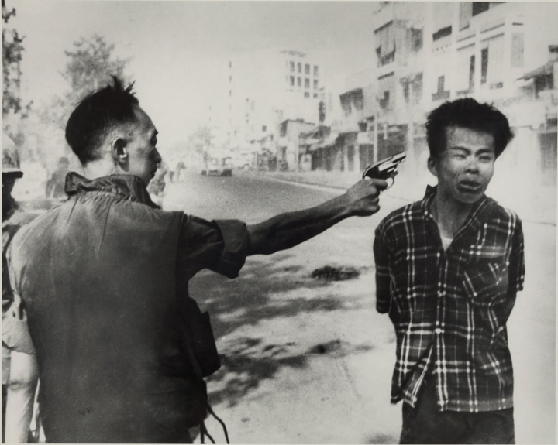
The director of South Vietnam’s national police force executes a bound Viet Cong prisoner.
The photograph and television footage of the execution by the director of South Vietnam’s national police force of a Viet Cong prisoner on the streets of Saigon during the Tet Offensive helped galvanize US opposition to the Vietnam War.
Source: Photo by Eddie Adams,http://www.loc.gov/pictures/item/2009632258/.

Link
A photo of a naked Vietnamese girl and other children fleeing napalm challenged the justification for the US involvement in Vietnam by graphically exposing the cruelty of the war on innocent children. See the legendary image athttp://en.wikipedia.org/wiki/File:TrangBang.jpg.
By late March, approval of President Johnson’s “handling of the situation in Vietnam” had dropped to 26 percent and disapproval swelled to 63 percent. ^{[7]} On March 31, 1968, the president announced he would not run for reelection and that US bombing of North Vietnam would be restricted.
After he took office in 1969, President Richard Nixon pursued a policy ofVietnamization. It was designed to create conditions so that by 1972 the South Vietnamese army would be able to hold its own when supported by US air and sea power. Congress held hearings and cut off some funds. There were demonstrations against the war, especially on college campuses. Nixon’s strategy failed, and in spring 1972 North Vietnam attacked South Vietnam, forcing Nixon to re-Americanize the war. By the time the war finally ended, 55,000 US troops had lost their lives in Vietnam; as many as 541,000 Americans were fighting there at the war’s height, and $150 billion was spent on the war effort.

Détente and Arms Control
President Nixon redirected American foreign and national security policy. He sought to minimize future Soviet challenges by treating the Soviet Union less as a rival and more as a partner in the international system. Known as détente, the goal was to create a framework of limited cooperation between the two superpowers within the context of ongoing competition and conflict. ^{[8]}
Détente’s greatest success was in the area of arms control, most notably with the signing of the SALT I and SALT II agreements, which placed outer limits on the size of the American and Soviet nuclear forces. ^{[9]} These agreements slowed the arms race while maintaining the fundamental symmetry in US and Soviet nuclear forces around which deterrence had been built decades before.

The Carter Administration
President Jimmy Carter’s foreign policy emphasis on human rights pushed US–Soviet competition into the background. ^{[10]} He criticized the human rights abuses of leaders who had loyally stood by the United States in its containment of the Soviet Union. One of those criticized was the shah of Iran. Put into power through a coup engineered by the Central Intelligence Agency (CIA) in 1953, the shah had been one of America’s staunchest Cold War allies. But by the 1970s, he had become increasingly isolated within his own country. ^{[11]}
In January 1979, a revolution ousted the shah, who was replaced as leader in Iran by the exiled Ayatollah Ruhollah Khomeini. When news broke in October that the shah was coming to the United States for medical treatment, Iranian militants seized the US embassy and held fifty-two Americans hostage. The Carter administration placed economic sanctions on Iran and undertook a failed hostage rescue mission in 1980. The hostages were not released until January 20, 1981, thirty minutes after Ronald Reagan became president.
The media reported the crisis night after night under such titles as “America Held Hostage.”

Link
“America Held Hostage” Logo of ABC’s Nightline
Night after night, the media reminded American policymakers and the public of the continuing hostage situation in Iran and of the inability of the US government to end it.
View the logo at http://pdxretro.com/wp-content/uploads/2011/03/nightline-iran.jpg.
Only a few diplomats were being held hostage, not the entire nation. Nonetheless, the media depiction conveying the impression of American impotence probably precipitated the rescue mission and contributed to making Jimmy Carter a one-term president.

The Reagan Administration
President Reagan rejected the notion that the United States could cooperate or work with the Soviet Union. Under Reagan, détente and arms control ceased guiding American foreign policy.
The deathblow to détente had come during the Carter administration when the Soviet Union invaded Afghanistan in 1979 in order to prop up pro-Russian Communist political forces. Within a year, the Soviet Union occupation army grew to 110,000, and it had to bear the primary responsibility for fighting the guerrillas, or Mujahedin, who were supported by US funds. American military aid to the Mujahedin rose from $120 million in 1984 to $630 million in 1987.
Support for the Mujahedin was consistent with the Reagan Doctrine that the purpose of American foreign policy not only was to contain the spread of Communism but also was to assist in bringing down Communist rulers.^{[12]}
Most controversial was the administration’s support for anticommunist forces in Nicaragua, where the Sandinistas had overthrown forty years of arbitrary, oppressive, and corrupt family rule in July 1979. The Sandinistas were sympathetic to Cuba’s Castro and hostile to the United States. In November 1981, Reagan authorized spending $19 million to transform a small and largely ineffective fighting force into one (the Contras) that would be more capable of ousting the Sandinista regime. In response, Congress passed the Boland Amendments, which barred the use of CIA or Defense Department funds for the purpose of overthrowing the Nicaraguan government or provoking a military exchange between it and Honduras. Chafing under this restriction, the Reagan administration devised a covert plan for increasing the amount of funds available to the Contras. At the heart of the administration’s plan was a scheme to divert money to the Contras from the covert sale of weapons to Iran. When it became public, the Iran-Contra affair produced widespread and mainly critical negative media coverage and a storm of controversy.

An Uncertain New World Order
On December 26, 1991, the Soviet Union collapsed. The end of the Cold War brought forward expressions of hope that America’s military involvement in the world might be lessened. For some this meant that a return to isolationism was possible; for others it meant that the United States would be able to engage in building democracy and promoting peaceful change.
These alternative visions of America’s role in the world were soon challenged by the reemergence of traditional national security concerns. The event that sparked this challenge was Iraq’s August 2, 1990, invasion of Kuwait. It led to the Persian Gulf War, the first major international conflict of the post–Cold War era. ^{[13]}
The UN Security Council set January 15, 1991, as the deadline for Iraq’s peaceful exit from Kuwait and authorized member states to “use all means necessary” to bring about Iraq’s complete and unconditional withdrawal. When Iraq did not withdraw, the United States launched Operation Desert Storm. On February 28, after less than one month of fighting, Iraq announced a cease fire; on April 6, Iraq accepted the UN’s terms to formally end the war. The war was a diplomatic and military success for the United States, which put together a global coalition against Iraq and conducted a military campaign that produced relatively few American casualties.
Before the war, media coverage generally reflected the views of US policymakers and the military; it generated little debate over policy alternatives. The war itself was overwhelmingly reported from the perspectives of US policymakers and the military. ^{[14]}

KEY TAKEAWAYS
Two visions of foreign policy are isolationism and, dominant since World War II, internationalism. The main policies during the Cold War were containment, deterrence, détente and arms control, and the use of military force, as in Vietnam.

EXERCISES
- Why do you think the United States has historically been isolationist? Why might this have changed after World War II?
- What was the idea behind the Cold War policy of containment? How did the United States try to contain Soviet influence?
- What was the Reagan Doctrine? How did Reagan put it into practice?

[1] Selig Adler, The Isolationist Impulse (New York: Praeger, 1957).
[2] David A. Baldwin, ed., Neorealism and Neoidealism: The Contemporary Debate (New York: Columbia University Press, 1993); and Joseph S. Nye Jr., The Paradox of American Power (New York: Oxford University Press, 2002).
[3] John Lewis Gaddis, Strategies of Containment (New York: Oxford University Press, 1993).
[4] Patrick M. Morgan, Deterrence: A Conceptual Analysis (Beverly Hills: Sage, 1977).
[5] Robert L. Gallucci, Neither Peace nor Honor (Baltimore: Johns Hopkins University Press, 1975); and Leslie H. Gelb with Richard K. Betts, The Irony of Vietnam: The System Worked (Washington, DC: Brookings Institution Press, 1979).
[6] Editorial, Wall Street Journal, February 23, 1968, 14; CBS News Special: Report From Vietnam, February 27, 1968; and NBC News Special Report, March 10, 1968.
[7] Gallup Organization, Vietnam War: A Compilation, 1964–1990. Public Opinion and the Vietnam War: National and International Opinion, vol. II (Princeton, NJ: Gallup, 1992).
[8] Coral Bell, The Diplomacy of Détente: The Kissinger Era (New York: St. Martin’s, 1977).
[9] Thomas C. Schelling and Morton H. Halperin, Strategy and Arms Control (New York: Pergamon-Brassey’s Classic, 1985).
[10] Robert C. Johansen, The National Interest and the Human Interest: An Analysis of U.S. Foreign Policy (Princeton, NJ: Princeton University Press, 1980); Debra Liang-Fenton, ed., Implementing U.S. Human Rights Policy (Washington, DC: United States Institute of Peace Press, 2004).
[11] Stephen Kinzer, All the Shah’s Men: An American Coup and the Roots of Middle East Terror (New York: John Wiley & Sons, 2002).
[12] James M. Scott, Deciding to Intervene: The Reagan Doctrine and American Foreign Policy (Durham, NC: Duke University Press, 1996).
[13] Michael J. Mazarr, Don M. Snider, and James A. Blackwell Jr., Desert Storm: The Gulf War and What We Learned (Boulder, CO: Westview, 1993).
[14] W. Lance Bennett and David L. Paletz, eds., Taken By Storm: The Media, Public Opinion, and U.S. Foreign Policy in the Gulf War (Chicago: University of Chicago Press, 1994).

17.4 The George W. Bush Administration

LEARNING OBJECTIVES
After reading this section, you should be able to answer the following questions:
- What was the Bush Doctrine?
- How did military operations in Afghanistan and Iraq under George W. Bush begin?
- How have the media portrayed military engagements in Afghanistan and Iraq?
After the 9/11 terrorist attacks, President George W. Bush focused on a policy of global leadership in a war on terrorism. ^{[1]} Media coverage and depictions would exaggerate terrorism and add to the importance of the war. ^{[2]}

The Afghanistan War
The first confrontation in this war came in Afghanistan, where Osama bin Laden, the acknowledged mastermind of the 9/11 attacks had taken refuge and where his terrorist organization, Al Qaeda, enjoyed support and protection from the ruling Taliban government. ^{[3]}
Figure 17.2 Osama bin Laden
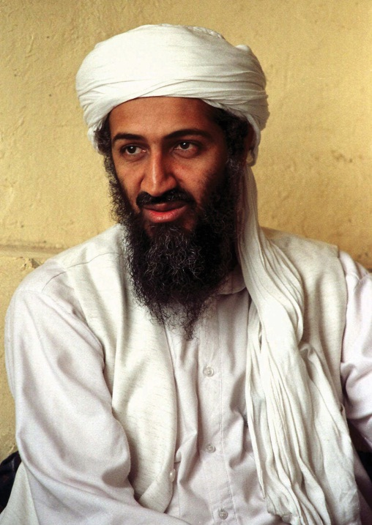
The Saudi Arabian leader of Al Qaeda and mastermind of the 9/11 attacks symbolized terrorism for US policymakers and the media.
Source: Used with permission from AP Photo.
President Bush demanded that the Taliban expel Osama bin Laden and Al Qaeda and sever its ties with international terrorism. When this did not happen, the United States and its allies began aerial strikes against terrorist facilities and Taliban military targets inside Afghanistan on October 7, 2001. Ground forces were supplied largely by the Northern Alliance, a coalition group that had opposed Taliban rule. Its efforts were aided and guided by the Central Intelligence Agency (CIA) and US military forces. The Taliban soon surrendered, but its leader and Osama bin Laden remained at large.
Figure 17.3 The Death of Osama bin Laden
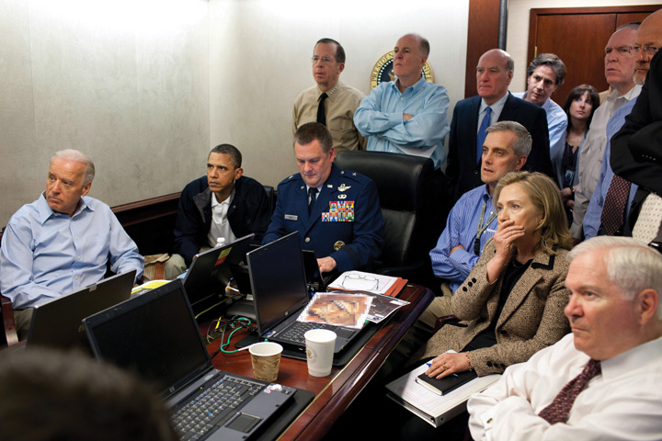
Osama bin Laden would be killed on May 1, 2011, by US Navy Seals in his hideaway in Pakistan. In this photograph, released by the White House and shown around the world, we see the president, Vice President Joe Biden, Secretary of State Hillary Clinton, Secretary of Defense Robert Gates, and other members of the president’s national security team in the Situation Room as cameras mounted on the helmets of the attackers send video footage of the assault narrated from CIA headquarters by Director Leon Panetta.
Source: Photo courtesy of the White House (Pete Souza)http://www.flickr.com/photos/whitehouse/5680724572/.
In covering the war in Afghanistan, the US media reported a consensus among policymakers and the public on the need to defeat the Taliban; the media also focused on military strategy and its execution and paid little attention to the loss of life and destruction caused by the war. As CNN chairman Walter Isaacson wrote in a memo instructing its correspondents not to focus excessively on Afghan suffering, “We must redouble our efforts to make sure we do not seem to be simply reporting from their vantage or perspective.” ^{[4]}
Nation-building turned out to be far more difficult than overthrowing the Taliban. Some roads and buildings were rebuilt, and some girls, excluded from education by the Taliban, returned to school. Presidential elections, held in 2004 and 2009, were won by the more or less pro-US Hamid Karzai. There was little “security, stability, prosperity, or the rule of law.”^{[5]} Outside the capital of Kabul, Afghanistan was a collection of fiefdoms run by warlords and an opium-growing economy that fueled lawlessness and funded terrorists. The country’s Supreme Court was controlled by Islamic fundamentalists. Except for the election, Afghanistan was mostly forgotten and ignored by the US news media, whose attention largely turned to Iraq.

The Bush Doctrine
President George W. Bush outlined a new direction for American foreign and military policy. Known as the Bush Doctrine, it contained three interrelated themes. ^{[6]}
First, predominance is the necessary foundation of American military strategy. The United States must possess a significant military power advantage over all other states so that it can act unilaterally (alone) to defend its national interests when and where it sees fit.
Second, the strategy for employing military power is preemption. Rather than containment and deterrence, the United States will act first to remove threats before they are capable of harming it.
Third, in addition to reducing the military threat posed by other states, preemption has a goal of fostering regime change. Regime change is necessary because hostile states and terrorist organizations, the two principal threats to the United States through their possession of or attempts to possess weapons of mass destruction, are unlikely to change their ways. Only by removing them from power can the threat be eliminated.
Critics pointed out the limitations of preemption as a policy. In theory it should be applied to Iran and North Korea, which are hostile to the United States. But Iran could attack Israel and strike back against US forces in the region; and North Korea could unleash its nuclear weapons and invade South Korea. So under what circumstances and when should the policy be applied?
Given its heavy involvement of military and money in Iraq, moreover, did the United States have the resources to apply a preemption policy to any other countries? The National Guard and Reserve made up approximately 40 percent of US forces in Iraq and Afghanistan. The system is not designed to keep reservists on duty in a campaign against terrorism and fighting abroad for an extended period. Reservists train one weekend a month and two weeks a year, accelerated before deployment; thus many of them are ill prepared and lack combat skills. ^{[7]}

The Iraq War
The Bush Doctrine provided the strategic rationale for the Iraq War. ^{[8]}The diplomatic maneuvering leading up to war entered into the final phase on March 17, 2003, when President Bush addressed the nation and gave Saddam Hussein forty-eight hours to leave Iraq. Hussein rejected Bush’s ultimatum.
The first blow in the war was struck in the early morning hours of March 20, when President Bush ordered an air strike against the Iraqi leadership. The ground war began early in the evening of the same day, as American and British forces crossed into Iraq from Kuwait. Baghdad fell on April 9. On May 1, aboard the USS Abraham Lincoln, President Bush declared an end to major hostilities. In Iraq, celebrations of peace were short-lived as looting and anarchy soon became the order of the day, followed by insurgency and sectarian conflict. The United States soon went from liberator to occupier.
To build support for the war, the administration had claimed that Iraqi dictator Saddam Hussein was a major threat to the United States because he possessed biological, chemical, and perhaps nuclear weapons of mass destruction and was likely to supply them to terrorists. To make its case, the administration treated unclear or ambiguous information as certain facts (e.g., that Iraq had attempted to obtain uranium from Africa). It ignored intelligence questioning whether Iraq possessed weapons of mass destruction and implied links between Saddam Hussein, 9/11, and terrorists that were never proven. The administration also used inflammatory language (e.g., “We don’t want the smoking gun to be a mushroom cloud” said National Security Advisor Condoleezza Rice).

The Media in Support
Before the war, the media transmitted, parroted, promulgated, generally confirmed, and rarely challenged the administration’s scare campaign. ^{[9]}The television networks’ coverage of domestic dissent was minimal, although they did report opposition from countries such as France arguing for a diplomatic solution. ^{[10]}
The New York Times in particular supported the administration’s rationale for going to war with Iraq by accepting US government sources and Iraqi exiles’ claims at face value, displaying them on the front page under heavy-breathing headlines. The Times gave glowing coverage to Secretary of State Colin Powell’s speech and presentation of February 5, 2003, to the United Nations supposedly documenting Iraq’s weapons of mass destruction.
The Times undermined the credibility of Iraqi government denials by following them with challenges from US officials, and it discredited US and foreign sources critical of the administration’s argument. Stories challenging the administration’s case for war were downplayed: James Risen’s “C.I.A. Aides Feel Pressure in Preparing Iraqi Reports,” completed several days prior to the invasion, was not printed until three days after the start of the war and was then relegated to page B10. ^{[11]} Dissenters received little coverage.
Because the Times has a reputation for occasional skepticism about people in authority, its coverage gave credibility to the administration’s arguments. Moreover, many news organization, such as CNN and National Public Radio, follow the Times’ lead.
The lack of vigorous challenges by leaders of the Democratic Party to the Bush administration in the run-up to the war left little criticism of the Bush policy for the news media to transmit. But the Times’ coverage contributed to the Democrats’ docility. If the Times had published more critical stories, some Democrats could have been emboldened to attack the war policy.

Comparing Coverage
The Iraq War
Media coverage of the war itself was dramatically different depending on whether one was exposed to US or Arab media. ^{[12]}
In general, the US media supported the war, presenting it as “America against the enemy,” or as “us versus them.” Complexities were ignored: there were no in-depth stories on the history of Iraq, its factions (Kurds, Shiite, and Sunni Muslims); no understanding that, despite their hatred of Saddam Hussein, many Iraqis would not welcome the United States.
Television was most enthusiastic. Morning shows depicted the attack on Iraq as right and proper. Cable stations were unabashedly patriotic: Fox News titled its coverage “Op. Iraqi Freedom: War on Terror.” American flags were part of on-screen logos and backdrops. Many of the expert commentators were former high-ranking officers in the US military who were enthusiastically or at least guardedly prowar.
American reporters embedded with the invasion forces gave the troops’ perspective to their American audience. Reporters framed the conflict the same way as US officials and military commanders.
The war shown on American television networks and on cable was almost entirely bloodless. It featured the “video game” aspects of the technical wizardry of American military power. ^{[13]} There was a dearth of gruesome or grisly footage. Reports repeated the Pentagon’s sanitized language: “degraded” for slaughtered Iraqi units, “softening up” for the exploding of Iraqi soldiers in their bunkers.
In dramatic contrast was the depiction of the war by Al Jazeera, the Qatar-based satellite television channel, dominated by Arab nationalists and Islamists, transmitting to a daily audience of thirty-five million across the Arab world. (The channel is barely seen in the United States.) It showed a different version of the war with different subjects and frames.
Al Jazeera had access to the Iraqi leadership. It placed correspondents and cameras in the Iraqi cities under attack and reported from the inhabitants’ perspectives. Its staff gave an Arab point of view to an Arab audience.
Al Jazeera did not ignore the American side. It reported the allied advances, had a reporter embedded with US forces, and broadcast sound bites from President Bush. But it debated rather than interviewed American spokespersons. It featured critics of the United States, took Iraqi government statements at face value, and highlighted any setbacks of the coalition forces.
Al Jazeera barely mentioned that the United States was opposing a brutal dictatorship. It depicted the US military as an invading, occupying force of ruthless killers. It broadcast a report from Iraqi television of pictures of dead US soldiers and interviews with captured ones. It showed raw and graphic footage of the destruction inflicted on Iraq and the pain and suffering of its civilians: charred bodies, mourning families, hospitals choked with bleeding and burned civilians.

It’s Not Over Until It’s Over
President Bush announced victory, but Iraq remained a country with ethnic and tribal divisions and religious fanatics following the dictates of clerics. Conflict continued, with insurgents attacking and killing US troops, Iraqi police, and public officials. Weapons of mass destruction were not found. The condition of the country’s infrastructure was dire. Many more billions of dollars were needed to pay for the war and reconstruction and to keep US troops in Iraq.
Elite consensus over the war evaporated. The revitalized Democratic opposition was reflected in Vermont Governor Howard Dean’s campaign for the party’s 2004 presidential nomination. He called the war precipitous and poorly prepared. The 9/11 Commission found that Iraq had no collaborative relationship with Al Qaeda and no involvement in the attacks on the World Trade Center. The former head of counterterrorism at the National Security Council contended that before the attacks, the Bush White House did not treat the danger of Osama bin Laden and Al Qaeda as urgent. He confirmed that the possibility of attacking Iraq was on the administration’s policy agenda before 9/11. ^{[14]}
Media coverage of Iraq turned critical. There were frequent reports of bombings, suicide attacks, and stories of people kidnapped and beheaded. There was a media feeding frenzy of revelations about and photographs of torture by US personnel and private contractors in the Abu Ghraib prison in Iraq and in Afghanistan. ^{[15]}
Figure 17.4 Abu Ghraib Prisoner “Gilligan” Hooded, Caped, and Wired on His Box
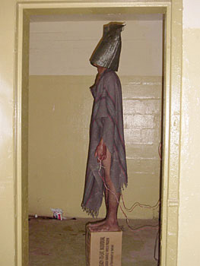
Photographs such as this, shown around the world, undermined the US claim to be a liberator not an occupier of Iraq.
Source: http://commons.wikimedia.org/wiki/File:Abu_Ghraib_34.JPG.

KEY TAKEAWAYS
The Bush Doctrine was three-pronged: it featured predominance, preemption, and regime change as the pillars of US foreign policy. The US therefore conducted military operations in Afghanistan in response to the 9/11 attacks. President George W. Bush’s doctrine of preemption then involved the United States in a war to overthrow the ruling regime in Iraq. While the media initially gave favorable coverage to the decision to go to war and to the military operations in Iraq, subsequent revelations about errors made both before and during the war brought about media criticism of the administration’s decision to go to war and its conduct of the war.

EXERCISES
- What is meant by preemption? What are some the potential problems with a policy of preemption?
- What was the justification for invading Afghanistan? How did the American media cover the war in Afghanistan?
- What was the justification for invading Iraq? Why do you think the American media were reluctant to challenge the Bush administration’s arguments for going to war in Iraq?

[1] For criticism of the Bush policy, see John E. Mueller, Overblown: How Politicians and the Terrorism Industry Inflate National Security Threats, and Why We Believe Them (New York: Free Press, 2006); and Louise Richardson, What Terrorists Want: Understanding the Enemy, Containing the Threat (New York: Random House, 2005).
[2] Brigitte L. Nacos, Mass-Mediated Terrorism: The Central Role of the Media in Terrorism and Counterterror (Lanham, MD: Rowman & Littlefield, 2007).
[3] Bob Woodward, Bush at War (New York: Simon & Schuster, 2002).
[4] Alessandra Stanley, “Battling the Scepticism of a Global Audience,” New York Times, November 1, 2001, B4.
[5] The quote and information in this paragraph come from J. Alexander Thier, “A Chance of Success Slips Away,” New York Times, September 23, 2004, A27.
[6] John Lewis Gaddis, “A Grand Strategy of Transformation,” Foreign Policy 130 (2002): 50–57.
[7] Ivo H. Daalder, James M. Lindsay, and James B. Steinberg, “The Bush National Security Strategy: An Evaluation,” Policy Brief #109 (Washington, DC: Brookings Institution Press, 2002).
[8] Glenn P. Hastedt, Understanding the War in Iraq (Upper Saddle River, NJ: Prentice Hall, 2004); Bob Woodward, Plan of Attack (New York: Simon & Schuster, 2004).
[9] Michael Massing, “Now They Tell Us,” New York Review, February 26, 2004, 43–49; also his exchanges with journalists from the New York Times, March 25, 2004, 45–46, and the Washington Post, April 8, 2004, 74–77; and Massing’s “Unfit to Print?,” New York Review, May 27, 2004, 6–10. For a strong dissent, arguing that media coverage of his speeches was biased against President Bush, see Jim A. Kuypers, Bush’s War: Media Bias and Justifications for War in a Terrorism Age (Lanham, MD: Rowman & Littlefield, 2006).
[10] Danny Hayes and Matt Guardino, “Whose Views Made the News? Coverage and the March to War in Iraq,” Political Communication 27 (2010): 59–87.
[11] Daniel Okrent, “Weapons of Mass Destruction? Or Mass Distraction?,” New York Times, May 30, 2004, sec. 4, p. 2.
[12] This is based on Rami G. Khouri, “For the Full Story, Watch US & Arab TV,”Pacific News Service, March 26, 2003; James Poniewozik, “What You See vs. What They See,” Time, April 7, 2003, 68–69; and Jacqueline E. Sharkey, “The Television War,” American Journalism Review 25 (May 2003): 18.
[13] Sean Aday, “The Real World Will Never Get on Television: An Analysis of Casualty Imagery in American Television Coverage of the Iraq War,” in Media and Conflict in the 21st Century, ed Philip Seib (New York: Palgrave Macmillan, 2005), 141–56.
[14] Richard A. Clarke, Against All Enemies: Inside America’s War on Terror (New York: Free Press, 2004); for a more sympathetic view of President Bush, see Bob Woodward, Bush at War (New York: Simon & Schuster, 2002).
[15] Seymour M. Hersh, Chain of Command: The Road from 9/11 to Abu Ghraib(New York: HarperCollins, 2004).

17.5 Foreign and National Security Policies in the Information Age

LEARNING OBJECTIVES
After reading this section, you should be able to answer the following questions:
- What are the foreign and national security issues the Obama administration faces?
- What are some of the differences between George W. Bush’s and Obama’s policies?
- How and what do the media report from abroad?
- How do the media interact with the military?
- What are the consequences of the media’s depictions of US foreign and national security policies?
This brings us to the present day. We start with the foreign and national security policies of the Obama administration.

The Obama Administration
President Barack Obama faced situations left by his predecessor—notably the wars in Afghanistan and Iraq, the Arab-Israeli conflict, and the global economic crisis. Obama also inherited persistent problems, such as the proliferation of nuclear weapons, their possession by North Korea, and their development by Iran. These issues were further complicated by unexpected challenges, as in the explosion of popular outrage against some of the autocratic rulers of the Middle Eastern states—states replete with corruption, unemployment, and inequality—of Bahrain, Egypt, Libya, Syria, Tunisia, and Yemen. (For a parody of how US policies differ toward each state, depending on US interests, see “John Oliver, America’s Freedom Package,” The Daily Show with Jon Stewart, March 21, 2011,http://www.thedailyshow.com/watch/mon-march-21-2011/america-s-freedom-packages.)
As with all his predecessors, the national interest was the essential criterion he would apply in deciding US foreign and national security policies. A state’s national interest does not necessarily change when a new president takes office. But what might that national interest be? How much flexibility would the president and his administration have (or display) to redefine it? To what extent would the Obama administration, especially the president and Secretary of State Hillary Rodham Clinton, continue, change, or even repudiate some of the Bush policies?
In May 2010, the White House released a white paper detailing the Obama administration’s National Security Strategy. It endorsed engagement, cooperation, and coordination with other states. It rejected the unilateralism, the go it alone policy, of the Bush administration. It committed to exhausting other options before war whenever possible. It identified the proliferation of weapons of mass destruction as the gravest danger facing the country.
So the Obama administration’s foreign and national security policies are not identical with his predecessor’s. They are less bellicose and unilateral, more diplomatic and multilateral. Examples are the pursuit of the nonproliferation of nuclear weapons, an arms control agreement with Russia resulting in a substantial reduction in the countries’ nuclear weapons, and reengagement with the United Nations. The president does not speak about “spreading democracy around the world” and has expressed a willingness to talk directly with Iran and other countries with which the United States has disagreements.
But in practice, the Obama administration’s changes have been more in tone and language, less so in substance. ^{[1]} It has continued the war on terrorism against Al Qaeda and its allies (although without torture), expanding the use of drones against them in Pakistan’s tribal areas. (Arguably, these attacks are targeted assassinations). The administration has continued to give billions of dollars to Pakistan to combat terrorism despite questions about their effectiveness and effects. ^{[2]}
President Obama did remove US combat brigades from Iraq by August 2010 and promised that all US troops would be out by the end of 2011; but personnel were likely to remain in the country after that time to help ensure its stability and favorable relations with the United States. He increased the number of US troops in Afghanistan by thirty thousand, doubling the overall American deployment (President Bush had begun a more modest buildup), but announced that the troops would start being withdrawn in July 2011. He sought to avoid getting the United States bogged down in a conflict quagmire as it had in Vietnam, thinking that he would otherwise lose a lot of support in his party. ^{[3]}
Nor did the Obama administration’s changes necessarily produce significant successes. Stalemates continued in the peace negotiations it brokered between Israel and the Palestinians and in relations with Iran and North Korea. Little progress was made on preventing, let alone reducing, the effects of climate change.

Libya
In March 2011, President Obama ventured into uncharted territory by intervening militarily in Libya. His announced purpose was humanitarian: to prevent the dictator Muammar Gaddafi from massacring the Libyans rebelling against his regime. The intervention, taken over by the North Atlantic Treaty Organization (NATO), of which the United States is the most important power, involved missile strikes against Gaddafi’s forces, then the imposition of a no-fly zone.
Its ultimate intention, indicated by the bombing of Gaddafi’s compound and by the president’s later statements, was regime change—that is, to force Gaddafi to give up his rule. Given his superior firepower and the rebels’ disorganization and lack of weapons, it was not clear that Gaddafi would depart voluntarily without further pressure from the United States and its allies or what any successor regime might be.
Libya, Afghanistan, Iraq, 9/11, and the other cases we have discussed show the ability of the executive branch to impose its preferred frames on international crises. Four factors are involved. ^{[4]}
First, the executive branch has an enormous advantage in the early collection and analysis of information, especially when crisis erupts on short notice. Second, when they are united and their campaign is coordinated, the president and his senior advisors can dominate the rhetoric and speeches about the crisis. The alternatives are leaks and breakdowns in message cohesion. Third, the administration can manipulate intelligence reports favoring its views and discount ones that contradict or weaken them. Fourth, if the crisis is brief, opponents lack the time and opportunity to mobilize public opinion. But if the crisis lingers, they can obtain their own information and undermine the administration’s initial framing.
As explained in Chapter 1 "Communication in the Information Age", the news media usually index story frames to the range of viewpoints—the agreement and disagreement—among high-ranking US officials. ^{[5]} As time goes on, however, they may collect and disseminate information critical of the administration’s frame and expose any disconnect between official claims and the reality on the ground. This assumes they have access to the events, resources to cover, and the expertise to understand them.

Media Interactions
US foreign and national security policies are made and largely articulated in the United States. Policymakers and members of the media interact in Washington and in related places such as the United Nations in New York City.

Reporting from Abroad
But the effects of US foreign and national security policies take place and so must be reported from abroad. Aside from the New York Times, most US newspapers, magazines, and television networks and stations have few foreign bureaus with correspondents. Some television news operations (e.g., ABC, CBS, NBC, and CNN) send reporters (known as “one-man bands”) equipped with computers and cameras to report from foreign locations, thereby gathering the news while avoiding the costs of bureaus. For foreign news, the bulk of US news media rely primarily on the wire services such as the Associated Press and, for visuals, on Associated Press Television News (APTN) and Reuters Television.
For US news organizations with reporters abroad, London is the central location: it is the source of around 25 percent of all bureau-based reporting. Bureaus, or half-bureaus with no permanently stationed correspondent, are established at other locations for several reasons: in Moscow, Beijing, and Tokyo because of their important relations with the United States; in jumping-off points such as Johannesburg, South Africa, for covering the rest of the region; and in Jerusalem to cover the continuing story of the Arab–Israeli conflict. Roughly a quarter of foreign correspondents are stringers or freelancers—more or less knowledgeable locals. Most of them receive low pay, no benefits, and have a precarious relationship with their employers. ^{[6]}
Around 50 percent of television’s foreign coverage portrays violence. ^{[7]}Man-made and natural disasters—with their villains, victims, and heroes—are also news. ^{[8]} These often occur where news bureaus are not located. For example, the main news in late December 2004 and on into 2005 concerned the horrifying death of at least 150,000 people and the destruction at the shorelines of several Asian countries caused by the tsunami waves that resulted from underwater earthquakes in the Indian Ocean.
Figure 17.5Devastation Caused by the Tsunami of Late December 2004
Because the US news media do not have bureaus in most countries, they must dispatch reporters to cover disasters such as the tsunami waves that wreaked death and destruction on the countries bordering the Indian Ocean.
Source: Photo by Michael L. Bak,http://commons.wikimedia.org/wiki/File:Bodies_in_Banda_Aceh_after_2004_tsunami_DD-SD-06-07373.JPEG.
To cover stories from such “hot spots,” reporters often have to parachute (not literally) in from their bases. They spend time on logistics, getting from place to place, booking hotel rooms, and hiring drivers and translators. ^{[9]} Because they lack knowledge of local conditions and don’t stay long, they tend to rely on a few sources, mainly the US embassy, aid workers, and spokespersons from the government of the country.
Wars and conflicts involving the United States (e.g., the Iraq War) are the exception: they are covered extensively by journalists assigned there. But even in Iraq, most reporters for the US news media had little knowledge of the region’s history, Islamic fundamentalism, the resurgence of Arab nationalism, or, indeed, of Iraq. Nor did they speak or read Arabic, which limited their ability to obtain information from native sources.
Accurate and comprehensive or not, news from overseas can be transmitted instantly to twenty-four-hour cable channels and thus to American policymakers and the public. This is facilitated by the combination of new communications technologies and global media systems. Satellite telephones, digital cameras, videophones, laptops with uplink capacities, computers, and blogs from people on the scenes provided vivid images and descriptions of events as instant news for the media to transmit and for people to access on the Internet.

Media Interactions with the Military
The Defense Department interacts with the media to produce highly positive depictions in two ways. One is through the Hollywood films that “depict and glorify the heroic exploits of US military power.” ^{[10]}
The second way the Pentagon generates positive coverage of an administration’s national security policies is through the special briefings it provides to the retired officers who appear thousands of times on television and radio as “military analysts.” ^{[11]} Many of them have ideological agreements with and allegiance to the Pentagon. They also have financial ties, as lobbyists for, senior executive or board members of, or consultant to military contractors who benefit from the policies the “analysts” assess. It is in their interests to maintain their access to and stay on the Pentagon’s right side. Consequently, many of them repeat administration talking points on the air. The largest group was affiliated with Fox News, then NBC and CNN. The Pentagon paid a private contractor to search databases and track all the analysts’ comments.
Positive portrayals of the military by the media may be unusual. The view of Civil War Union General William Tecumseh Sherman may be more typical: upon hearing that the Confederate army had shot two reporters, he remarked, “Great. Now we’ll have the news from Hell by noon.”
This suggests the perennial conflict between the military and the media. From the military perspective, reporters should be “part of the team.” For most correspondents, their coverage can only be restrained if it would jeopardize an operation or the lives of troops. Traditionally, however, the military has denies them access, limits their reporting to official sources, engages in obfuscation and delay, and censors their stories.
So it may seem surprising that the military allowed some six hundred reporters to be embedded with the US troops during the war in Iraq. Secretary of Defense Donald Rumsfeld and Assistant Defense Secretary for Public Affairs Victoria Clarke pushed the decision through. It turned out to be very shrewd. Reporters were co-opted by the troops with whom they were embedded. They reported from the perspective of the US forces winning the war. And they were kept away from places the Pentagon did not want them to be.
Reporters who were not embedded had a tough time getting into and around Iraq and obtaining cooperation from the US military. Many of them were located at US Central Command forward headquarters in Doha, Qatar, where at press conferences generals summarized the success of military operations on a high-tech set designed by a show-business professional at an estimated cost of $250,000.
Reporting from war zones abroad is dangerous. Journalists live and work under constant threat of kidnapping and murder. Many have been killed, many more wounded. As one horrifying example, in April 2011, photojournalists Tim Hetherington (see Diary and Restrepo in Section 17.7 "Recommended Viewing") and Chris Hondros were killed by a grenade in Libya.
Figure 17.6
The dangers of reporting conflicts in the death of photojournalist Chris Hondros, who was killed by a grenade in Libya not long after taking this photo of a rebel fighter in Misurata.
Photo by Chris Hondros of a Rebel Fighter in Misurata, Libya, from Front Page of the New York TimesApril 21, 2011, Getty Images.

Public Diplomacy
American policymakers wage the battle for public opinion abroad with public diplomacy aimed at policymakers and the public in foreign countries. Over the years, a bevy of organizations has existed. They include the International Broadcasting Bureau, the Voice of America (VOA), Worldnet television service, Radio and TV Marti, Radio Free Europe/Radio Liberty, and Radio Free Asia.
During and after the Iraq War, the State Department’s Office of Public Diplomacy and Public Affairs promoted what it called “Brand America” to the Islamic world, especially to young people who have reservations about US policy but also admire elements of American life and culture.
These efforts were unsuccessful. Voice of America broadcast Radio Sawa (Radio Together), which offered rock and pop and some news framed from the US perspective. People listened to the music but turned to regional media for the news. The US-sponsored Al Hurra (the Free One), a satellite television station that broadcast a mix of news and pop culture. It was derided in the Arab press as “Fox News in Arabic.” The public diplomacy campaign also featured testimonial advertisements from Muslims living in America describing it as a tolerant, multicultural society with religious freedom. But most major Arab networks refused or demanded too high a price to air them. Finally, American spokespersons and high-ranking officials such as Secretary of State Colin Powell and National Security Advisor Condoleezza Rice gave interviews to Arab media. But the channel showing Rice’s interview on October 2001 preceded it by repeatedly playing pro-Israel statements she had made so that she was discredited even before the interview was aired.

New Technology
A wealth of information about international affairs is available on the Internet from domestic and foreign media: television clips, radio interviews, and reports and stories in newspapers and magazines. People interested can obtain information about policymakers from around the world and the contents and effects of their foreign and national security policies.
Camcorders, cell phones, and satellite phones are used to gather and report the news. The first video and photos of the tsunami and its dire destruction of late 2004 came from the camcorders of tourists caught in the deluge. The destruction and horror of terrorists’ attacks on the London subway on July 7, 2005 (known commonly as 7/7), was reported first by people trapped underground. ^{[12]}

WikiLeaks
As we discussed in Chapter 1 "Communication in the Information Age",WikiLeaks was founded by Julian Assange to achieve transparency in government activities by exposing official secrets. In 2010, it released to selected news organizations about 90,000 documents prepared by the US military about the wars in Iraq and Afghanistan; then later in the year, WikiLeaks released a trove of around 260,000 US diplomatic cables. The cables show that candor exists behind closed doors: they reveal confidential conversations, accounts of meetings, and appraisals of foreign leaders.
The New York Times, which received the reports directly from WikiLeaks and the cables from the United Kingdom’s Guardian newspaper, published articles detailing and interpreting the leaked documents. ^{[13]} It also put selected items online, as did WikiLeaks, with redactions to remove the names of the diplomats’ confidential sources.
Some of the material consists of low-level gossip. But there are revelations, such as the following:
- The Saudi royalty encouraged the United States to attack Iran, as did the leaders of Egypt, Jordan, and Israel.
- The Yemeni government covered up the US missile strikes against the country’s local branch of Al Qaeda by claiming that its own forces had carried out the attacks.
- The US ambassador made scathing comments about the lavish lifestyle of the rulers of Tunisia.
- Corruption exists in the Afghan government.
- China’s global computer hacking.
- How to placate China if North Korea collapsed and was unified with South Korea.
There have been repercussions. The US ambassador to Mexico resigned as a result of information released. Ecuador expelled the US ambassador, who in a cable had referred to high-level police corruption that the country’s president possibly knew about. The US government identified security gaps and further limited the availability of classified information. Pfc. Bradley Manning, the army intelligence analyst who had downloaded the documents from a military computer system and given them to WikiLeaks, was incarcerated in solitary confinement for several months before trial. Meanwhile, it was revealed that WikiLeaks had fragile finances and management problems and its founder had legal difficulties.

Terrorists’ Use of New Technology ^{[14]}
Osama bin Laden’s associates in their compound watched Hollywood movies, including The Siege (see Section 17.7 "Recommended Viewing") as they devised and refined the plot that would result in 9/11. ^{[15]} But their use of new technology is far more advanced than that. They use it to collect information about targets such as ports, airports, and nuclear power plants and to communicate about, plan, and coordinate attacks. They circulated a manual prepared by Al Qaeda, nicknamed “The Encyclopedia of Jihad,” that detailed how to establish an underground organization and engage in attacks.
There are more than four thousand terrorist websites in different languages. They change their addresses to avoid being hacked by intelligence agencies and freelance vigilantes but still retain much of their content. These sites free the terrorists from dependence on the media for coverage and framing of their deeds. They are aimed at current and potential supporters, governments they oppose, and worldwide public opinion. They are used to raise funds, recruit terrorists, and mobilize support; they are also used to express the terrorists’ views and objectives, threaten their enemies, and show videos of their actions.
Through their video unit, the terrorists send video messages to receptive broadcasters like Al Jazeera, messages that are reported and rebroadcast by media outlets throughout the world. These videos are carefully staged: the backdrop is designed, weapons pointed, and the shot framed. When kidnapped victims are shown, their statements are scripted as they plead for their lives before sometimes being decapitated on camera. Western media do not show the horror, but the videos are sold in Iraq and throughout the world.

Media Consequences
The media can undermine US foreign and national security policies. By depicting the Tet Offensive as successful, the media made it difficult for President Johnson to send more troops to Vietnam and encouraged the eventual withdrawal of US forces. The nightly stories about US embassy personnel captive in Iran, often under the heading “America Held Hostage,” probably provoked President Carter into allowing a risky rescue effort that turned into a debacle.
Media depictions of events abroad can encourage or compel US policymakers to take action by sending aid personnel, even troops. This is called the CNN Effect. ^{[16]} It occurs under two conditions. The first condition is when policymakers have not decided or are uncertain about what to do or their policy preferences are contested by other policymakers. The second condition is when the media’s news frames and commentary are critical of the government’s actions or inaction, and the coverage empathizes with the victims. Thus policy uncertainty combined with negative news (e.g., coverage of slaughter and starvation) increase the likelihood of US intervention in humanitarian crises abroad. ^{[17]}
Media coverage, however, often comes after—not before—the government’s decision to take action. Thus news coverage of the humanitarian crises in Somalia was a response to the first President Bush’s decision to deploy ground troops. Then news stories supported the decision by framing the famine there as a desperate crisis in which the United States had an obligation to intervene. Later news coverage, however, did affect policy. Reports of the killing of eighteen US Army Rangers and the showing of the body of one of them being dragged through the country’s capital of Mogadishu, resulted in the Clinton administration’s decision to withdraw US troops.
Media coverage or lack of coverage of an event can allow and even encourage government inaction. In Rwanda in 1994, Hutu extremists slaughtered eight hundred thousand Tutsis and Hutu moderates, their countrymen, women, and children. The news media depicted this genocide, when they covered it at all, as part of an endless tribal struggle the United States could not much affect. Besides, it was only a few months since the media had reported the killing of American soldiers in Somalia. The United States never intervened in Rwanda. As National Security Advisor Anthony Lake said later, “We didn’t make any decision.” He did not ask his staff to consider options and make a policy recommendation to President Clinton.^{[18]}
But generally, by what they cover and how they frame it, the US media support the president’s foreign and national security policies and priorities.^{[19]} Their coverage of the terrorist attacks of 9/11 helped justify the war on terrorism against Osama bin Laden and Al Qaeda and the attack on the Taliban in Afghanistan. By depicting war against Iraq as desirable, the media facilitated the Bush administration’s policies of preemption and regime change. When military operations began on March 19, 2003, nearly two-thirds of Americans polled favored the president’s policies toward Iraq and 71 percent supported the use of force. ^{[20]}

KEY TAKEAWAYS
The Obama administration inherited foreign and national security policy issues such as the wars in Afghanistan and Iraq. Accordingly, it must engage with these preexisting challenges as well as newly emerging threats. While the Obama administration has attempted to distance itself from the policies of the Bush administration, the actual differences are smaller than reflected in presidential rhetoric and speeches. The president’s policymaking ability is buttressed by advantages in information gathering, public appeal, manipulation of intelligence, and the opposition’s struggle to mobilize public opinion. While the media usually support the administration’s policies, at least at first, they can also provide important criticism and have influenced decisions.

EXERCISES
- How does President Obama’s national security policy differ in tone from President Bush’s? How has Obama’s policy been similar to Bush’s in practice?
- How does the Defense Department influence the way the media report military actions? What is the advantage of allowing reporters to “embed” in military units?
- What is public diplomacy? How has the State Department attempted to improve the image of the United States around the world?

[1] Peter Baker, “On Foreign Policy, Obama Shifts, but Only a Bit,” New York Times, April 17, 2009, A1ff.
[2] Lawrence Wright, “The Double Game,” New Yorker, May 16, 2011, 91–94.
[3] Bob Woodward, Obama’s Wars (New York: Simon & Schuster, 2010).
[4] This discussion is based on Jon Western, Selling Intervention and War: The President, the Media, and the American Public (Baltimore: Johns Hopkins University Press, 2005), 224.
[5] W. Lance Bennett, Regina G. Lawrence, and Steven Livingston, “None Dare Call It Torture: Indexing and the Limits of Press Independence in the Abu Ghraib Scandal,” Journal of Communication 56 (2006): 467–85; for a different approach, see Robert M. Entman, Projections of Power: Framing News, Public Opinion, and U.S. Foreign Policy (Chicago: University of Chicago Press, 2004).
[6] Stephen Hess, International News & Foreign Correspondents (Washington, DC: Brookings Institution Press, 1996).
[7] William A. Hachten and James F. Scotton, The World News Prism: Global Information in a Satellite Age, 7th ed. (Malden, MA: Blackwell, 2007), 9.
[8] Robert I. Rotbeg and Thomas G. Weiss, eds., From Massacres to Genocide(Washington, DC: Brookings Institution Press, 1996).
[9] Ulf Hannerz, Foreign News: Exploring the World of Foreign Correspondents(Chicago: University of Chicago Press, 2004), 44.
[10] Carl Boggs and Tom Pollard, The Hollywood War Machine: U.S. Militarism and Popular Culture (Boulder, CO: Paradigm Publishers, 2007), ix.
[11] This paragraph is based on David Barstow, “Message Machine: Behind TV Analysts, Pentagon’ Hidden Hand,” New York Times, April 28, 2008, A1ff.
[12] William A. Hachten and James F. Scotton, The World News Prism: Global Information in a Satellite Age, 7th ed. (Malden, MA: Blackwell, 2007), 47.
[13] For example, Scott Shane and Andrew W. Lehren, “Leaked Cables Offer a Raw Look Inside U.S. Diplomacy: Dispatches Chronicle Threats and Tensions,”New York Times, November 29, 2010, A1ff.
[14] Gabriel Weimann, “www.terror.net: How Modern Terrorism Uses the Internet,” Special Report 116, United States Institute of Peace, March 2004; and Danny Schechter, Media Wars: News at a Time of Terror (Lanham, MD: Rowman & Littlefield, 2003).
[15] Lawrence Wright, The Looming Tower: Al-Qaeda and the Road to 9/11 (New York: Knopf, 2006).
[16] Eytan Gilboa, “The CNN Effect: The Search for a Communication Theory of International Relations,” Political Communication 22, no. 1 (January–March 2005).
[17] Piers Robinson, The CNN Effect: The Myth of News, Foreign Policy and Intervention (New York: Routledge, 2002).
[18] John Darnton, “Revisiting Rwanda’s Horrors with a Former National Security Advisor,” New York Times, December 20, 2004, E1.
[19] Jonathan Mermin, Debating War and Peace: Media Coverage of U.S. Intervention in the Post-Vietnam Era (Princeton, NJ: Princeton University Press, 1999).
[20] Richard Morin and Claudia Deane, “71% of Americans Support War, Poll Shows,” Washington Post, March 9, 2003, A14.

17.6 Recommended Reading
Art, Robert J. A Grand Strategy for America. Ithaca, NY: Cornell University Press, 2003. A forceful presentation of America’s national interests and how to defend them.
Baum, Matthew A., and Tim J. Groeling. War Stories: The Causes and Consequences of Public Views of War. Princeton, NJ: Princeton University Press, 2010. Argues that journalists’ assessments of stories’ newsworthiness and people’s assessments of the stories’ persuasiveness influence public support for US foreign policy.
Bennett, W. Lance, and David L. Paletz, eds. Taken by Storm: The Media, Public Opinion, and U.S. Foreign Policy in the Gulf War. Chicago: University of Chicago Press, 1994. Essays by leading scholars on the war’s political communication elements.
Entman, Robert M. Projections of Power: Framing News, Public Opinion, and U.S. Foreign Policy. Chicago: University of Chicago Press, 2004. A thoughtful effort to explain why the media accept or reject the White House version of foreign policy.
Hallin, Daniel C. The “Uncensored War”: The Media and Vietnam. New York: Oxford University Press, 1986. The definitive study of media coverage of the Vietnam War.
Hannerz, Ulf. Foreign News: Exploring the World of Foreign Correspondents. Chicago: University of Chicago Press, 2004. Based on interviews, describes the backgrounds and working lives of foreign correspondents.
Hess, Gary R. Presidential Decisions for War: Korea, Vietnam, and the Persian Gulf. Baltimore: Johns Hopkins University Press, 2001. How Presidents Truman, Johnson, and the first President Bush brought the United States into and conducted these wars.
Hess, Stephen, and Marvin Kalb, eds. The Media and the War on Terrorism. Washington, DC: Brookings Institution Press, 2003. Journalists discuss and comment on media coverage of the war on terrorism.
Mermin, Jonathan. Debating War and Peace: Media Coverage of U.S. Intervention in the Post-Vietnam Era. Princeton, NJ: Princeton University Press, 1999. Finds that the government sets the terms and boundaries for media coverage of the policy debate about military intervention.
Thrall, A. Trevor. War in the Media Age. Cresskill, NJ: Hampton Press, 2000. A critical study of the evolution and implementation of government press strategy from Vietnam through the Gulf War.
Western, Jon. Selling Intervention and War: The President, the Media, and the American Public. Baltimore: Johns Hopkins University Press, 2005. Discusses and explains how presidents often succeed in selling their intervention and war policies to the media and the public.

17.7 Recommended Viewing
Apocalypse Now (1979). In Francis Ford Coppola’s visually dazzling take on the Vietnam War, an American captain is sent to assassinate a renegade colonel waging an unsanctioned war.
Atomic Café (1982). A compilation of film clips mocks the propaganda films made in the 1940s and 1950s to reassure Americans about nuclear weapons.
Bearing Witness (2005). A moving documentary on the lives and experiences of five war correspondents, all of them women.
Casablanca (1942). Classic Hollywood film with memorable dialogue and acting, in which a cynical American expatriate in Morocco embraces idealism and engagement. A metaphor for the United States moving from isolationism to internationalism in World War II.
Control Room (2003). A documentary on the war in Iraq from the Al Jazeera and Arab perspective.
Diary (2011). Photojournalist Tim Hetherington (codirector of Restrepo) contrasts scenes from the war zones he covered to his life in London and New York. Soon after making the film he was killed in Libya.
Dr. Strangelove, or: How I Learned to Stop Worrying and Love the Bomb(1964). In Stanley Kubrick’s (and Terry Southern’s) nightmarishly comic assault on the Cold War, the results of military paranoia and bravado are nuclear war.
Duck Soup (1933). The Marx brothers spoof diplomacy, nationalism, patriotism, law, and—above all—America’s wars. President of Freedonia Rufus T. Firefly (played by Groucho Marx) justifies war: “It’s too late. I’ve already paid a month’s rent on the battlefield.”
The Fog of War (2003). In Errol Morris’s documentary, former Secretary of Defense Robert McNamara reflects on his involvement in decisions that resulted in death and destruction (the fire bombing of Japan during the Second World War, the Cuban Missile Crisis, the Vietnam War).
Hearts and Minds (1974). A remorseful anti–Vietnam War documentary with devastating images and interviews with policymakers, militarists, and ordinary people involved.
Home of the Brave—Land of the Free (2003). Mordant documentary look at a US Special Forces unit in Afghanistan.
The Missiles of October (1974). Documentary that profiles President John F. Kennedy and his associates and describes their actions during the Cuban missile crisis.
Reporting America at War (2003). A basic history of the reporting of American wars from the Spanish-American War through the invasion of Iraq that focuses on legendary correspondents and thus minimizes reporters’ self-censorship and the acceptance of official perspectives and naive notions of wartime glory.
Restrepo (2010). This harrowing documentary follows a combat team of American soldiers deployed in a lethally dangerous remote valley in Afghanistan.
Return with Honor (1998). First-person survival accounts of US pilots held captive in North Vietnam and testimonies of their wives are joined to Vietnamese archival footage in a moving documentary of mental, physical, and emotional resilience.
Seven Days in May (1964). Military leaders plot to overthrow the president after he concludes what they think is a disastrous nuclear disarmament treaty with the Soviet Union.
The Siege (1998). Terrorists blow up a federal building in Manhattan, resulting in a crackdown on civil liberties and terror suspects.
War Feels Like War (2003). Firsthand immediacy and detail fill this documentary showing “unilateral” correspondents (those not embedded) as they report the Iraq War.

